Lampiran 2. Surat Permohonan Izin Melaksanakan Penelitian dari Fakultas Kepada Laboratorium Farmasi Terpadu

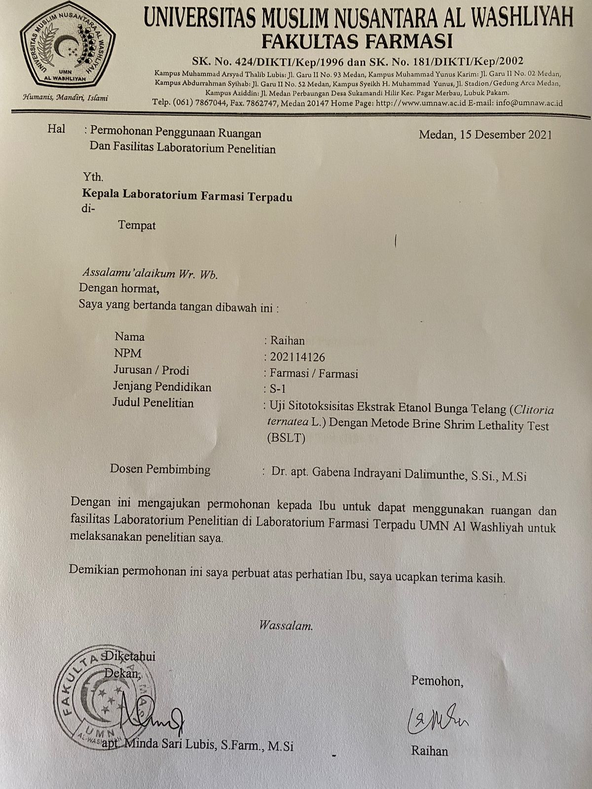

Lampiran 2. Surat Permohonan Determinasi

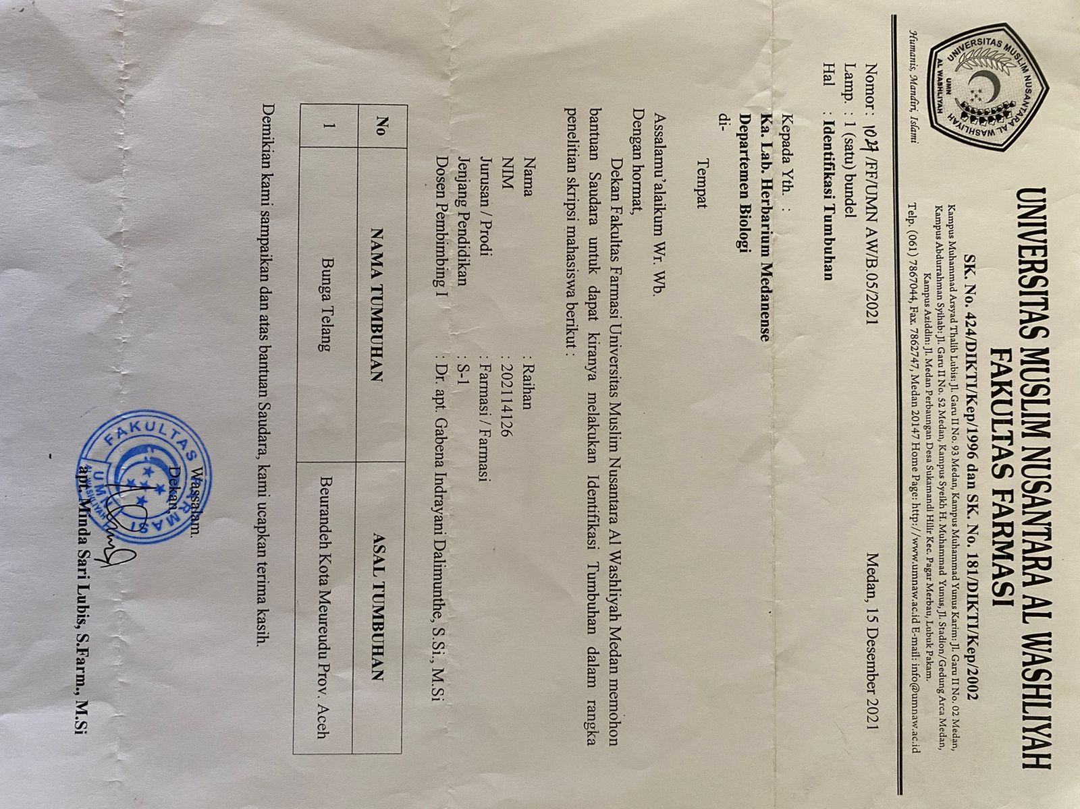

Lampiran 3. Hasil Identifikasi Tumbuhan

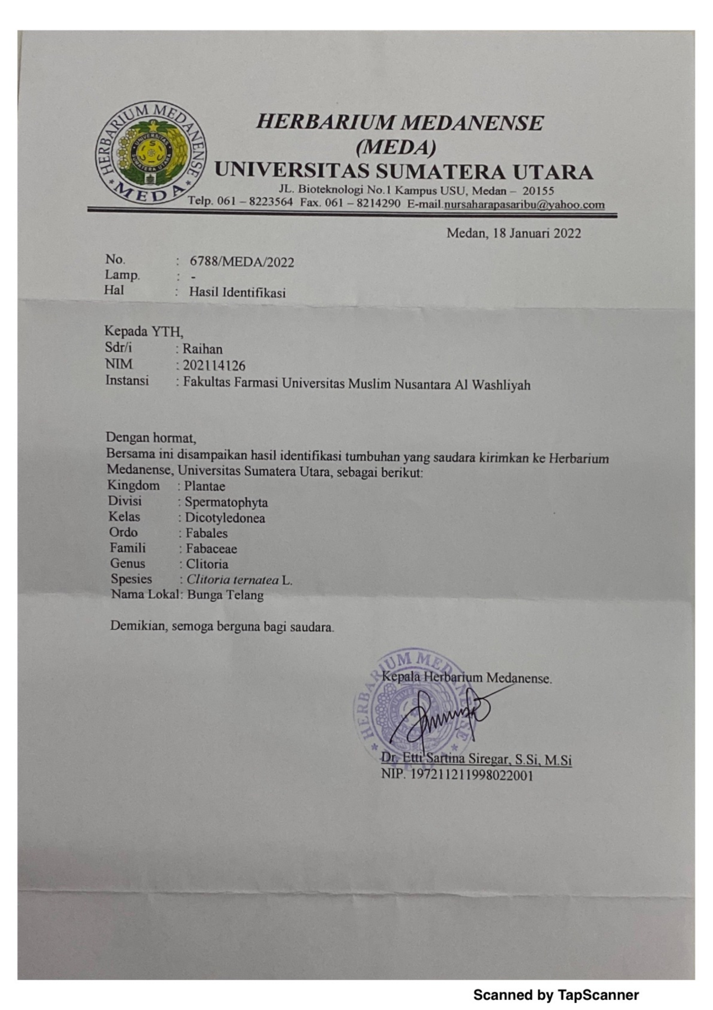

Lampiran 4. Bagan Alir Prosedur Kerja

Pengumpulan sampel bunga telang (*Clitoria ternatea* L.)

Bunga telang segar

- Disortasi basah

- Dicuci dengan air kran mengalir

- Ditiriskan

- Dirajang tipis-tipis

- Dikeringkan dalam lemari pengering dengan suhu ±40oC

- Disortasi kering

- Dihaluskan menggunakan blender

- Disimpan dalam wadah tertutup rapat

- Ditimbang

Serbuk simplisia bunga telang

Karakterisasi simplisia

Lampiran 5. Bagan Alir Karakterisasi Simplisia Bunga Telang

Simplisia daun bunga telang

Pemeriksaan Makroskopik

Pemeriksaan Mikroskopis

1. Kadar air
2. Kadar sari larut air
3. Kadar sari larut etanol
4. Kadar abu total
5. Kadar abu tidak larut asam

Lampiran 6. Bagan Alir Ekstraksi Serbuk Simplisia Bunga Telang

Serbuk simplisia bunga telang

- Ditimbang serbuk simplisia 500 gram

- Dimasukkan kedalam bejana maserasi

- Ditambahkan 75 bagian pelarut yaitu C3750 ml etanol 96%

- Didiamkan selama 5 hari sambil diaduk

- Disaring

Maserat I

Ampas

Dibilas dengan 25 ml pelarut yaitu 1250 ml etanol 96%

Maserat II

Maserat I dan II

Di campur

Diamkan selama 2 hari lalu di enap tuangkan

Ekstrak cair

Dipekatkan dengan rotary evaporator

Ekstrak kental

Lampiran 7. Bagan Alir Skrining Fitokimia Simplisia dan Ekstrak Bunga Telang

Serbuk simplisia bunga telang

Ekstrak bunga telang

Skrining fitokimia

Golongan saponin

Golongan tanin

Golongan flavonoid

Golongan alkaloid

Golongan glikosida

Golongan triterpenoid/steroid

Lampiran 8. Bagan Alir Uji Sitotoksisitas Ekstrak Bunga Telang

0,2 g ekstrak bunga telang

Dilarutkan dengan air garam hingga 100 ml

Konsentrasi 2000 ppm

Dibuat dalam beberapa variasi konsetrasi

kontrol

900 µg/ml

300 µg/ml

500 µg/ml

700 µg/ml

100 µg/ml

1000 µg/ml

800 µg/ml

600 µg/ml

400 µg/ml

200 µg/ml

- Disiapkan vial yang telah berisi 10 ekor larva artemia salina dalam 10 ml ekstrak yang sudah dilarutkan dengan air garam.

- Masing-masing konsentrasi dibuat dengan 3 kali pengulangan.

-Mortalitas dihitung setelah 24 jam

LC50

264,7890 µg/mL.

Lampiran 9. Pengelolaan Sampel Bunga Telang

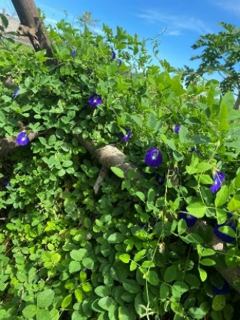 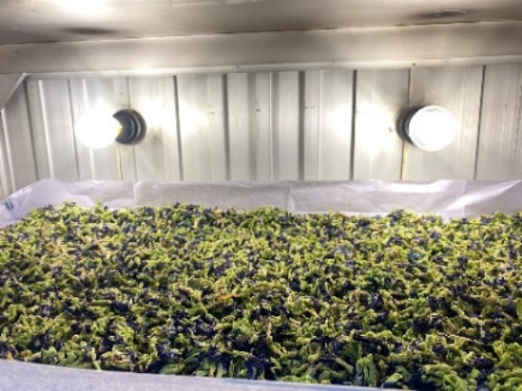

Pengambilan sampel Pengeringan sampel

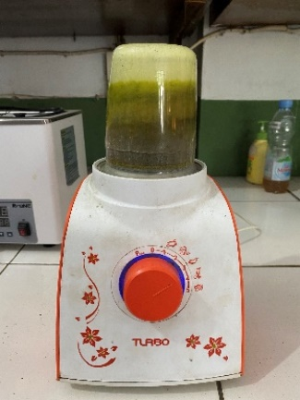 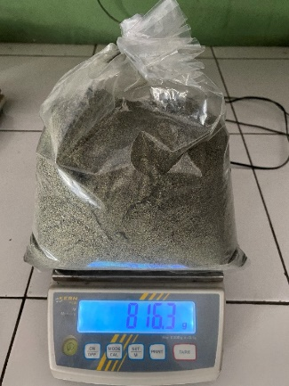

Penghalusan sampel Serbuk bunga telang

Lampiran 10. Proses Ekstraksi Bunga Telang

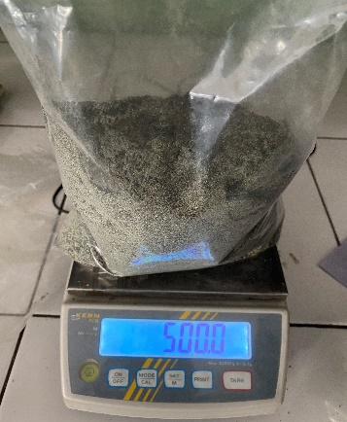 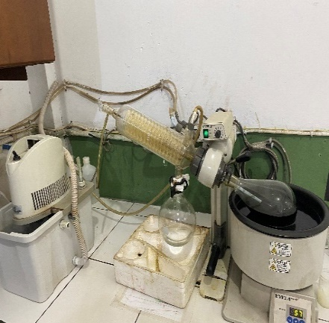

500 g Serbuk bunga telang Rotari Evaporator

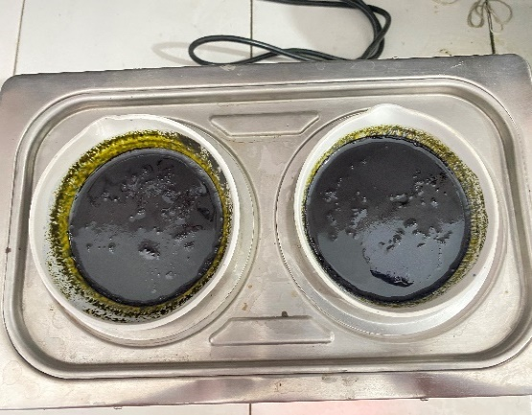 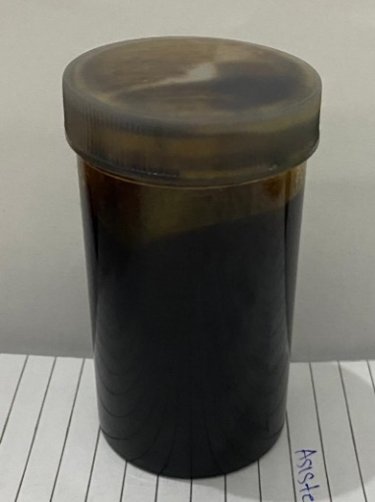

Penguapan Ekstrak bunga telang

Lampiran 11. Pemeriksaan Mikroskopik Bunga Telang

|  |  |  |  |
| --- | --- | --- | --- |
| No | Hasil | Literatur Dan Nama Fragmen  (Departemen Kesehatan Republik Indonesia(Depkes RI) 1989) | Ket |
| 1 | Rambut Penutup Panjang |  | + |
| 2 | Hablur Kalsium Oksalat |  | + |

Lampiran 12. Perhitungan Susut Pengeringan

Diketahui :

Bobot tumbuhan segar = 7000 gram

Bobot simplisia = 816 gram

% susut pengeringan = $\frac{Berat tumbuhan segar - bobot simplisia}{berat tumbuhan segar}$ x 100%

% susut pengeringan = $\frac{7000 gram - 816 gram}{7000 gram}$ x 100%

= 88 %

Lampiran 13. Perhitungan Rendemen Ekstrak Bunga telang

Perhitungan Rendemen Ekstrak Bunga telang *(Clitoria ternatea* L.)

Rendemen Ekstrak Bunga telang *(Clitoria ternatea* L.)

Berat simplisia Bunga Telang = 500 gram

Berat ekstrak = 69,5366 gram

% Rendemen = $\frac{Berat Ekstrak Kental}{Berat Simplisia kering}$ x 100%

= $\frac{69,5366 gram}{500 gram }$ x 100%

= 13,90 %

Lampiran 14. Perhitungan Hasil Karakterisasi Bunga telang

Perhitungan kadar air menurut (Depkes RI, 1989) :

$$Kadar air=\frac{Volume akhir air-Volume awal air}{Berat sample mula-mula (g)}x100\%$$

**Perhitungan Kadar Air**

**Pegulangan 1.**

Volume awal air (V0) = 1,5 ml

Volime akhir air (V1) = 1,9 ml

Berat sampel = 5 gram

Kadar air = $\frac{V1-V0}{Berat sampel}x 100\%$

= $\frac{1,9 ml – 1,5 ml}{5 gram}x 100\%$

= 8 %

**Pengulangan 2.**

Volume awal air (V0) = 1,7 ml

Volime akhir air (V1) = 2 ml

Berat sampel = 5 gram

Kadar air = $\frac{V1-V0}{Berat sampel}x 100\%$

= $\frac{2 ml – 1,7ml}{5 gram}x 100\%$

= 6 %

**Pengulangan 3.**

Volume awal air (V0) = 1,5 ml

Volime akhir air (V1) = 1,8 ml

Berat sampel = 5 gram

**Lampiran 14.** (Lanjutan)

Kadar air = $\frac{V1-V0}{Berat sampel}x 100\%$

= $\frac{1,8 ml – 1,5 ml}{5 gram}x 100\%$

= 6 %

Rata-rata kadar air = $\frac{8\% + 6\%+6\%}{3}$

= 6,66 %

**Perhitungan Penetapan Kadar Sari Larut Air**

Perhitungan kadar sari larut air menurut (Depkes RI, 1989) :

$$Kadar sari larut air=\frac{Berat sari setelah dikeringkan \left(g\right) x 100 mL }{Berat sample mula-mula \left(g\right)x 20 mL}x100\%$$

**Pengulangan 1**.

Berat cawan kosong = 58,1296 gram

Berat cawan + sari = 58,6079 gram

Berat sari kering = (Berat cawan + sari) – (Berat cawan kosong)

= 58,6079 gram – 58,1296 gram

= 0,4783 gram

Kadar sari larut air = $\frac{0,4783 gram x 100 mL}{5 gram x 20 mL}x 100\%$

= 47,83 %

**Pengulangan 2.**

Berat cawan kosong = 59,7330 gram

Berat cawan + sari = 60,1966 gram

**Lampiran 14.**(Lanjutan)

Berat sari kering = (Berat cawan + sari) – (Berat cawan kosong)

= 60,1966 gram – 59,7330 gram

= 0,4636 gram

Kadar sari larut air = $\frac{0,4636 gram x 100 mL}{5 gram x 20 mL}x 100\%$

= 46,36 %

**Pengulangan 3.**

Berat cawan kosong = 54,5084 gram

Berat cawan + sari = 54,9975 gram

Berat sari kering = (Berat cawan + sari) – (Berat cawan kosong)

= 54,9975 gram – 54,5084 gram

= 0,4891 gram

Kadar sari larut air = $\frac{0,4891 gram x 100 mL}{5 gram x 20 mL}x 100\%$

= 48,91 %

Rata-rata kadar sari larut air = $\frac{47,83 \% +46,36\%+48,91 \%}{3}$

= 47,7 %

**Perhitungan Hasil Penetapan Kadar Sari Larut Etanol**

Perhitungan kadar sari larut etanol menurut (Depkes RI, 1989) :

$$Kadar sari larut etanol=\frac{Berat sari setelah dikeringkan \left(g\right) x 100 mL }{Berat sample mula-mula \left(g\right)x 20 mL}x100\%$$

**Lampiran 14.**(Lanjutan)

**Pengulangan 1**.

Berat cawan kosong = 56,2033 gram

Berat cawan + sari = 56,5825 gram

Berat sari kering = (Berat cawan + sari) – (Berat cawan kosong)

= 56,5825 gram – 56,2033 gram

= 0,3792 gram

Kadar sari larut etanol = $\frac{0,3792 gram x 100 mL}{5 gram x 20 mL}x 100\%$

= 37,92 %

**Pengulangan 2.**

Berat cawan kosong = 60,3332 gram

Berat cawan + sari = 60,7028 gram

Berat sari kering = (Berat cawan + sari) – (Berat cawan kosong)

= 60,7028 gram – 60,3332 gram

= 0,3696 gram

Kadar sari larut etanol = $\frac{0,3696 gram x 100 mL}{5 gram x 20 mL}x 100\%$

= 36,96 %

**Pengulangan 3.**

Berat cawan kosong = 46,9738 gram

Berat cawan + sari = 47,3655 gram

Berat sari kering = (Berat cawan + sari) – (Berat cawan kosong)

= 47,3655 gram – 46,9738 gram

= 0,3917 gram

Kadar sari larut etanol = $\frac{0,3917 gram x 100 mL}{5 gram x 20 mL}x 100\%$

= 39,17 %

**Lampiran 14.** (Lanjutan)

Rata-rata kadar sari larut etanol = $\frac{68,65\% +56,39\%+62,35 \%}{3}$

= 62, 46 %

**Perhitungan Hasil Penetapan Kadar Abu Total**

Perhitungan kadar abu total menurut (Depkes RI, 1989) :

$$Kadar Abu Total=\frac{Berat abu yang diperoleh \left(g\right) }{Berat sample mula-mula (g)}x100\%$$

**Perhitungan Hasil Penetapan Kadar Abu Total**

**Pengulangan 1**.

Berat krus kosong = 67,4187 gram

Berat krus + abu = 67,5401 gram

Berat abu = (Berat krus + abu) – (Berat krus kosong)

= 67,5401 gram – 67,4187 gram

= 0,1214 gram

Kadar Abu total = $\frac{0,1214 gram }{2 gram}x 100\%$

= 6,07 %

**Pengulangan 2.**

Berat krus kosong = 66,4281 gram

Berat krus + abu = 66,5478 gram

Berat abu = (Berat krus + abu) – (Berat krus kosong)

= 66,5478 gram – 66,4281 gram

= 0,1197 gram

**Lampiran 14** (Lanjutan)

Kadar Abu total = $\frac{0,1197 gram }{2 gram}x 100\%$

= 5,98 %

**Pengulangan 3.**

Berat krus kosong = 64,7107 gram

Berat krus + abu = 64,8317 gram

Berat abu = (Berat krus + abu) – (Berat krus kosong)

= 64,8317 gram – 64,7107 gram

= 0,121 gram

Kadar Abu total = $\frac{0,121 gram }{2 gram}x 100\%$

= 6,05 %

Rata-rata kadar Abu total = $\frac{6,07\% +5,98 \%+6,05 \%}{3}$

= 6,03 %

**Perhitungan Hasil Penetapan Kadar Abu Tidak Larut Asam**

Perhitungan kadar abu tidak larut asam menurut (Depkes RI, 1989) :

$$Kadar Abu Total=\frac{Berat abu sisa dipijar \left(g\right) }{Berat sample abu mula-mula (g)}x100\%$$

**Pengulangan 1**.

Berat krus kosong = 67,4187 gram

Berat krus + abu tidak larut asam = 67,4303 gram

Berat abu = (Berat krus + abu tidak larut asam) – (Berat krus kosong)

= 67,4303 gram – 67,4187 gram

= 0,0117 gram

**Lampiran 14.** (Lanjutan)

Kadar Abu tidak larut asam = $\frac{0,0117 gram }{2 gram}x 100\%$

= 0,585 %

**Pengulangan 2.**

Berat krus kosong = 66,4281 gram

Berat krus + abu tidak larut asam = 66,4403 gram

Berat abu = (Berat krus + abu tidak larut asam) – (Berat krus kosong)

= 66,4403 gram – 66,4281 gram

= 0,0122 gram

Kadar Abu tidak larut asam = $\frac{0,0122 gram }{2 gram}x 100\%$

= 0,61 %

**Pengulangan 3.**

Berat krus kosong = 64,7107 gram

Berat krus + abu tidak larut asam = 64,7230 gram

Berat abu = (Berat krus + abu tidak larut asam) – (Berat krus kosong)

= 64,7230 gram – 64,7107 gram

= 0,0123 gram

Kadar Abu tidak larut asam = $\frac{0,0123 gram }{2 gram}x 100\%$

= 0,615 %

Rata-rata kadar Abu total = $\frac{0,585 \% +0,61 \%+0,615\%}{3}$

= 0,60 %

Lampiran 15. Hasil Uji Skrining Fitokimia Bunga Telang

|  |  |  |  |  |  |
| --- | --- | --- | --- | --- | --- |
| **No** | **Golongan senyawa** | **Gambar** | | **Hasil Uji** | **Keterangan** |
| **Serbuk** | **Ekstrak** |
| 1. | Alkaloid |  |  | + | * Mayer   Tidak terbentuk endapan kuning   * Dragendrof   Terbentuk endapan berwarna jingga  (Depkes RI, 1995)   * Buochardat   Terbentuk endapan berwarna coklat  (Depkes RI, 1995) |
| 2. | Flavonoid |  |  | + | Terbentuk lapisan jingga-merah pada lapisan alkohol  (Depkes RI, 1995) |
| 3. | Tanin |  |  | + | Tidak Terbentuk Larutan biru kehitaman  (Depkes RI, 1995). |

**Lampiran 15.** (Lanjutan)

|  |  |  |  |  |  |
| --- | --- | --- | --- | --- | --- |
| 4. | Saponin |  |  | + | Terbentuk busa yang stabil  (Depkes RI, 1995). |
| 5. | Glikosida |  |  | - | Tidak terbentuk cincin berwarna ungu pada kedua batas cairan  (Depkes RI, 1995). |
| 6. | Steroid/Triterpenoid |  |  | + | Terbentuk warna hijau biru (steroid) (Depkes RI, 1995). |

**Lampiran 16.** Uji Sitotoksisitas Ekstrak Bunga telang (*Clitoria ternatea* L.)

1. Penetasan telur artemia

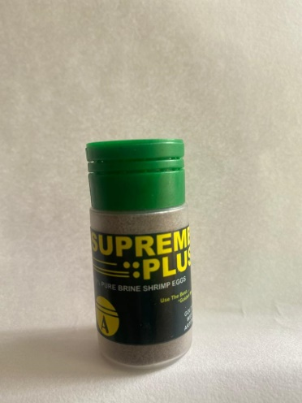

Telur artemia

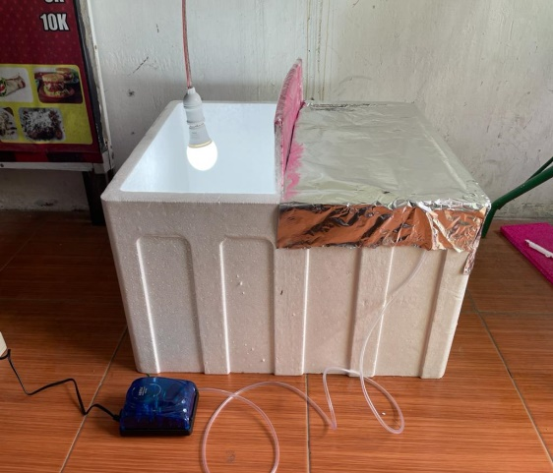

c

b

a

Proses penetasan

Keterangan :

1. Lampu *grow life*
2. Penghasil oksigen
3. Aquarium (Styrofoam)
4. Pengenceran ekstrak daun tapak dara dalam beberapa konsentrasi dan pengujian uji sitotoksisitas

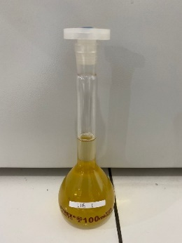 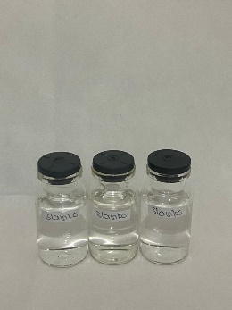 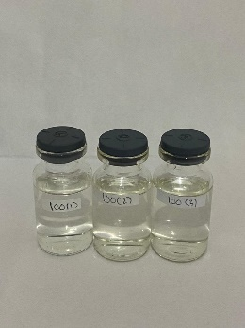

100 ppm

Kontrol Negatif

Larutan Induk Baku

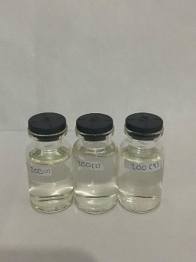 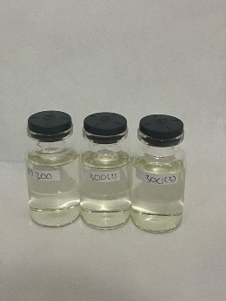 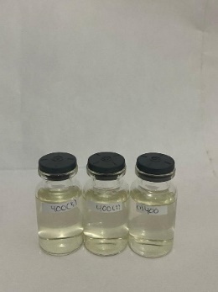

300 ppm

200 ppm

400 ppm

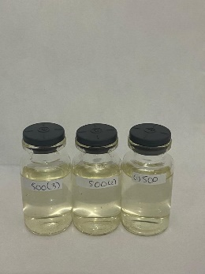 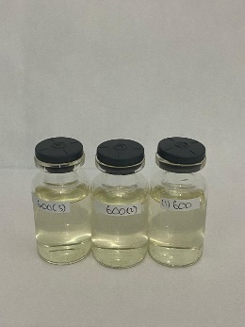 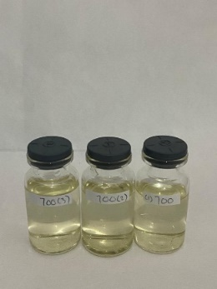

500 ppm

600 ppm

700 ppm

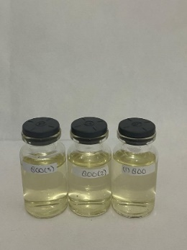 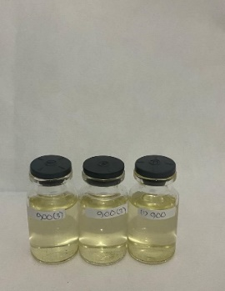 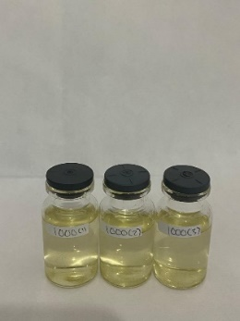

1000 ppm

900 ppm

800 ppm

Lampiran 17. Perhitungan Pembuatan Variasi Pengenceran Ekstrak Bunga Telang

LIB = 200 mg (200,000 µg / 100 mL) = 2000 µg/mL (2000 ppm)

a. 1000 µg/mL = V1.C1 = V2.C2

= x. 2000 µg/mL = 10 ml.1000 µg/mL

x = $\frac{100000 µg }{2000 µg/mL }$ = 5 mL

b. 900 µg/mL = V1.C1 = V2.C2

= x. 2000 µg/mL = 10 ml.900 µg/mL

x = $\frac{9000 µg }{2000 µg/mL }$ = 4,5 mL

c.800 µg/mL = V1.C1 = V2.C2

= x. 2000 µg/mL = 10 ml.800 µg/mL

x = $\frac{8000 µg }{2000 µg/mL }$ = 4 mL

d.700 µg/mL = V1.C1 = V2.C2

= x. 2000 µg/mL = 10 ml.700 µg/mL

x = $\frac{7000 µg }{2000 µg/mL }$ = 3,5 mL

e.600 µg/mL = V1.C1 = V2.C2

= x. 2000 µg/mL = 10 ml.600 µg/mL

x = $\frac{6000 µg }{2000 µg/mL }$ = 3 mL

f. 500 µg/mL = V1.C1 = V2.C2

= x. 2000 µg/mL = 10 ml.500 µg/mL

x = $\frac{5000 µg }{2000 µg/mL }$ = 2,5 mL

g.400 µg/mL = V1.C1 = V2.C2

= x. 2000 µg/mL = 10 ml.400 µg/mL

x = $\frac{4000 µg }{2000 µg/mL }$ = 2 mL

**Lampiran 17. (**Lanjutan)

h. 300 µg/mL = V1.C1 = V2.C2

= x. 2000 µg/mL = 10 ml.300 µg/mL

x = $\frac{3000 µg }{2000 µg/mL }$ = 1,5 mL

i.200 µg/mL = V1.C1 = V2.C2

= x. 2000 µg/mL = 10 ml.200 µg/mL

x = $\frac{2000 µg }{2000 µg/mL }$ = 1 mL

j.100µg/mL = V1.C1 = V2.C2

= x. 2000 µg/mL = 10 ml.100 µg/mL

x = $\frac{1000 µg }{2000 µg/mL }$ = 0,5 mL

Lampiran 18. Perhitungan LC50 Ekstrak Etanol Bunga Telang (*Clitoria ternatea* L.) dengan Metode BSLT

% Kematian Larva = $\frac{Jumlah rata-rata larva yang mati }{jumlah larva uji} x 100 \%$

% Rata-Rata kematian larva == $\frac{Jumlah total larva yang mati }{jumlah pengulangan }$

**Hasil Orientasi**

|  |  |  |  |  |  |  |  |
| --- | --- | --- | --- | --- | --- | --- | --- |
| **No** | **Konsentrasi (µg/mL)** | **Jumlah larva yang mati** | | | **Total larva yang mati** | **Rata-rata kematian larva** | **% Mortalitas** |
|
| **P1** | **P2** | **P3** |
| 1 | 0 | 0 | 0 | 0 | 0 | 0 | 0% |
| 2 | 100 | 3 | 3 | 2 | 8 | 2,66 | 26,7% |
| 3 | 200 | 4 | 4 | 4 | 12 | 4 | 40% |
| 4 | 300 | 5 | 4 | 5 | 14 | 4,66 | 46,7% |
| 5 | 400 | 7 | 6 | 5 | 18 | 6 | 60% |
| 5 | 500 | 6 | 7 | 8 | 21 | 7 | 70% |
| 6 | 600 | 8 | 6 | 8 | 22 | 7,3 | 73,3% |
| 7 | 700 | 8 | 9 | 7 | 24 | 8 | 80% |
| 8 | 800 | 9 | 9 | 9 | 27 | 9 | 90% |
| 9 | 900 | 10 | 10 | 10 | 30 | 10 | 100% |
| 11 | 1000 | 10 | 10 | 10 | 30 | 10 | 100% |

**Lampiran 18.** (Lanjutan)

**Hasil Pengujian**

|  |  |  |  |  |
| --- | --- | --- | --- | --- |
| **NO** | **Konsentrasi (µg/mL)** | **%Mortalitas** | **Log Konsentrasi** | **Nilai probit** |
| 1 | 100 | 26,7% | 2,000 | 4,3781 |
| 2 | 200 | 40% | 2,3010 | 4,7467 |
| 3 | 300 | 46,7% | 2,4771 | 4,9172 |
| 4 | 400 | 60% | 2,6020 | 5,2533 |
| 5 | 500 | 70% | 2,6989 | 5,5244 |
| 6 | 600 | 73,3 % | 2,7781 | 5,6219 |
| 7 | 700 | 80% | 2,8450 | 5,8416 |

|  |  |  |  |  |  |  |  |  |  |  |  |
| --- | --- | --- | --- | --- | --- | --- | --- | --- | --- | --- | --- |
| NO | d  (C(µg/mL) | N  (Jumlah Larva) | r  (Jumlah yg mati) | P  (%mortalitas) | X  (log C) | Y  (Nilai probit) | | XY | | X2 | |
| 1 | 100 | 30 | 8 | 26,7 % | 2,000 | 4,3781 | | 8,7562 | | 4,000 | |
| 2 | 200 | 30 | 12 | 40 % | 2,3010 | 4,7467 | | 10,9221 | | 5,2946 | |
| 3 | 300 | 30 | 14 | 46,7 % | 2,4771 | 4,9172 | | 12,1803 | | 6,1360 | |
| 4 | 400 | 30 | 18 | 60 % | 2,6020 | 5,2533 | | 13,6690 | | 6,7704 | |
| 5 | 500 | 30 | 21 | 70% | 2,6989 | 5,5244 | | 14,9098 | | 7,2840 | |
| 6 | 600 | 30 | 22 | 73,3 % | 2,7781 | 5,6219 | | 15,6182 | | 7,7178 | |
| 7 | 700 | 30 | 24 | 80 % | 2,8450 | 5,8416 | | 16,6193 | | 8,0940 | |
|  | **Jumlah** | | | | ∑X = 17,7021 | | ∑Y = 36,2832 | | ∑XY=  92,6749 | | ∑X2=  45,2968 | |
|  | **Rata – rata** | | | | 2,5288 | | 5,1833 | |  | |  | |

Keterangan :

D : Konsentrasi ekstrak

N : Jumblah larva yang digunakan

r : Jumblah larva yang mati

P : % mortalitas

C : Log konsentrasi

Y : Nilai probit

**Lampiran 18.** (Lanjutan)

Persamaan garis regresi linear :

Y = a x+ b

y = Konsentrasi Kematian

x = Log Konsentrasi

a = $\frac{ \left(∑xy\right)-(∑x∑y)/n}{ ∑x^{2}-{\left(∑x\right)}^{2}/n}$

a = $\frac{92,6749-\left(17,7021\right)(36,2832/7}{{45,2968-(17,7021)}^{2}/7}$

a = $\frac{0,9191}{0,5305}$

a = 1,7325

b = Y – aX

b = 5,1833 – 1,7325 (2,5288)

b = 5,1833 – 4,3811

b = 0,8022

Nilai LC50 diperoleh dari antilog x dimana x merupakan logaritma konsentrasi bahan toksik pada Y = 5, yaitu nilai probit 50 % hewan uji. Sehingga persamaan regresi diperoleh: Y = 1,7325x+0,8022

5 = 1,7325 x+ 0,8022

5 – 0,8022 = 1,7325 x

4,1978 = 1,7325x

X = $\frac{4,1978}{1,7325}$

X = 2,4229

LC50 = Anti Log x

**=** 264,7890 µg/mL

Maka nilai Lc50 antilog 2,4229 adalah 264,7890 µg/m

**Lampiran 18.** (Lanjutan)

Kurva Regresi Linier Antara Log Konsentrasi Ekstrak Etanol Bunga Telang Dengan Nilai Probit, sebagai berikut :

Suatu senyawa bersifat toksik dan berpotensi sebagai antikanker pada uji BSLT jika memiliki nilai LC50 <1000 µg/mL. Hasil LC50 yang didapat lebih kecil dari 1000 µg/mL yaitu 264,7890 µg/mL. Sehingga dapat disimpulkan bahwa ekstrak etanol bunga telang bersifat toksik dan berpotensi sebagai antikanker (Meyer, 1982).

Lampiran 19. Nilai Probit Sesuai dengan Besarnya Presentase Kematian (Priyanto, 2009)

|  |  |  |  |  |  |  |  |  |  |  |
| --- | --- | --- | --- | --- | --- | --- | --- | --- | --- | --- |
| Persen kematian (%) | **0,0** | **0,1** | **0,2** | **0,3** | **0,4** | **0,5** | **0,6** | **0,7** | **0,8** | **0,9** |
| **0** | - | 1.0098 | 2.1218 | 2.2522 | 2.3479 | 2.4242 | 2.4879 | 2.5427 | 2.5914 | 2.6344 |
| **1** | 2.6737 | 2.7096 | 2.7429 | 2.7738 | 2.8027 | 2.8299 | 2.8556 | 2.8799 | 2.3031 | 2.9251 |
| **2** | 2.9463 | 2.9665 | 2.9859 | 3.0646 | 3.0226 | 3.0400 | 3.0569 | 3.0732 | 3.0896 | 3.1043 |
| **3** | 3.1192 | 3.1337 | 3.1478 | 3.1616 | 3.1750 | 3.1881 | 3.2009 | 3.2134 | 3.2256 | 3.2376 |
| **4** | 3.2493 | 3.2608 | 3.2721 | 3.2831 | 3.2940 | 3.3046 | 3.3151 | 3.3253 | 3.3354 | 3.3454 |
| **5** | 3.3351 | 3.3668 | 3.3742 | 3.3836 | 3.3028 | 3.4018 | 3.4107 | 3.4195 | 3.4282 | 3.4368 |
| **6** | 3.4452 | 3.4536 | 3.4618 | 3.4694 | 3.4780 | 3.4850 | 3.4937 | 3.5015 | 3.5091 | 3.5167 |
| **7** | 3.5242 | 3.5316 | 3.5380 | 3.5462 | 3.5534 | 3.5605 | 3.5675 | 3.5745 | 3.5813 | 3.5882 |
| **8** | 3.5949 | 3.6016 | 3.6083 | 3.6148 | 3.6213 | 3.6278 | 3.6342 | 3.6405 | 3.6408 | 3.6427 |
| **9** | 3.6692 | 3.6654 | 3.6715 | 3.6775 | 3.6835 | 3.6894 | 3.6953 | 3.7012 | 3.7070 | 3.7127 |
| **10** | 3.7182 | 3.7241 | 3.7298 | 3.7354 | 3.7409 | 3.7464 | 3.7519 | 3.7574 | 3.7628 | 3.7681 |
| **11** | 3.7735 | 3.7784 | 3.7840 | 3.7893 | 3.7945 | 3.7996 | 3.8048 | 3.8099 | 3.8150 | 3.8200 |
| **12** | 3.8250 | 3.8300 | 3.8350 | 3.8399 | 3.8848 | 3.8497 | 3.8545 | 3.8503 | 3.8641 | 3.8689 |
| **13** | 3.8736 | 3.8783 | 3.8830 | 3.8877 | 3.8923 | 3.8969 | 3.9015 | 3.9061 | 3.9107 | 3.9152 |
| **14** | 3.9197 | 3.9242 | 3.9286 | 3.9331 | 3.9375 | 3.9419 | 3.9463 | 3.9506 | 3.9550 | 3.9593 |
| **15** | 3.9636 | 3.9678 | 3.9721 | 3.9763 | 3.9800 | 3.9848 | 3.9890 | 3.9931 | 3.9933 | 4.0014 |
| **16** | 4.0055 | 4.0096 | 4.0137 | 4.0178 | 4.0218 | 4.0259 | 4.0299 | 4.0339 | 4.0379 | 4.0410 |
| **17** | 4.0458 | 4.0408 | 4.0537 | 4.0576 | 4.0615 | 4.0693 | 4.0693 | 4.0731 | 4.0770 | 4.0808 |
| **18** | 4.0846 | 4.0884 | 4.0960 | 4.0960 | 4.0998 | 4.1035 | 4.1073 | 4.1110 | 4.1147 | 4.1184 |
| **19** | 4.1221 | 4.1258 | 4.1331 | 4.1331 | 4.1367 | 4.1404 | 4.1440 | 4.1476 | 4.1512 | 4.1548 |
| **20** | 4.1684 | 4.1019 | 4.1035 | 4.1690 | 4.1726 | 4.1761 | 4.1796 | 4.1831 | 4.1866 | 4.1901 |
| **21** | 4.1936 | 4.1970 | 4.2005 | 4.2039 | 4.2074 | 4.2108 | 4.2142 | 4.2176 | 4.2110 | 4.2244 |
| **22** | 4.2278 | 4.2312 | 4.2345 | 4.2379 | 4.2412 | 4.2446 | 4.2479 | 4.2512 | 4.2546 | 4.2579 |
| **23** | 4.2612 | 4.2644 | 4.2677 | 4.2710 | 4.2743 | 4.2275 | 4.2808 | 4.2840 | 4.2872 | 4.2905 |
| **24** | 4.2937 | 4.2969 | 4.3001 | 4.3033 | 4.3065 | 4.3097 | 4.3129 | 4.3160 | 4.3192 | 4.3324 |
| **25** | 4.3255 | 4.3287 | 4.3318 | 4.3349 | 4.3380 | 4.3412 | 4.3443 | 4.3474 | 4.3505 | 4.3536 |
| **26** | 4.3567 | 4.3597 | 4.3628 | 4.3659 | 4.3869 | 4.3720 | 4.3750 | **4.3781** | 4.3811 | 4.3842 |
| **27** | 4.3872 | 4.3902 | 4.3932 | 4.3962 | 4.3992 | 4.4022 | 4.4052 | 4.4082 | 4.4112 | 4.4142 |
| **28** | 4.4172 | 4.4201 | 4.4231 | 4.4260 | 4.4290 | 4.4319 | 4.4349 | 4.4378 | 4.4408 | 4.4437 |
| **29** | 4.4466 | 4.4405 | 4.4524 | 4.4554 | 4.4583 | 4.4612 | 4.4641 | 4.4670 | 4.4698 | 4.4727 |
| **30** | 4.4756 | 4.4785 | 4.4813 | 4.4842 | 4.4871 | 4.4899 | 4.4928 | 4.4956 | 4.4985 | 4.5013 |
| **31** | 4.5041 | 4.5070 | 4.5098 | 4.5126 | 4.5155 | 4.5183 | 4.2511 | 4.5239 | 4.5267 | 4.5295 |
| **32** | 4.5323 | 4.5351 | 4.5370 | 4.5407 | 4.5435 | 4.5462 | 4.5490 | 4.5518 | 4.5546 | 4.5573 |
| **33** | 4.5601 | 4.5628 | 4.5656 | 4.5684 | 4.5711 | 4.5739 | 4.5766 | 4.5793 | 4.5821 | 4.5848 |

|  |  |  |  |  |  |  |  |  |  |  |
| --- | --- | --- | --- | --- | --- | --- | --- | --- | --- | --- |
| Persen kematian (%) | **0,0** | **0,1** | **0,2** | **0,3** | **0,4** | **0,5** | **0,6** | **0,7** | **0,8** | **0,9** |
| **34** | 4.5875 | 4.5903 | 4.5930 | 4.5957 | 4.5984 | 4.6011 | 4.6039 | 4.6066 | 4.6093 | 4.6120 |
| **35** | 4.6147 | 4.6174 | 4.6201 | 4.6288 | 4.6255 | 4.6281 | 4.6308 | 4.6335 | 4.6362 | 4.6389 |
| **36** | 4.6415 | 4.6442 | 4.6469 | 4.6495 | 4.6522 | 4.6549 | 4.6575 | 4.6602 | 4.6628 | 4.6655 |
| **37** | 4.6681 | 4.6708 | 4.6734 | 4.6761 | 4.6787 | 4.6814 | 4.6840 | 4.6866 | 4.6893 | 4.6919 |
| **38** | 4.6945 | 4.6971 | 4.6998 | 4.7024 | 4.7050 | 4.7078 | 4.7102 | 4.7129 | 4.7155 | 4.7181 |
| **39** | 4.7207 | 4.7233 | 4.7259 | 4.7285 | 4.7311 | 4.7337 | 4.7363 | 4.7389 | 4.7415 | 4.7441 |
| **40** | **4.7467** | 4.7402 | 4.7518 | 4.75f44 | 4.7570 | 4.7595 | 4.7622 | 4.7647 | 4.7673 | 4.7699 |
| **41** | 4.7725 | 4.7750 | 4.7776 | 4.7802 | 4.7827 | 4.7853 | 4.7879 | 4.7902 | 4.7930 | 4.7955 |
| **42** | 4.7981 | 4.8007 | 4.8032 | 4.8058 | 4.8083 | 4.8109 | 4.8134 | 4.8160 | 4.8185 | 4.8211 |
| **43** | 4.8230 | 4.8202 | 4.8278 | 4.8313 | 4.8338 | 4.8363 | 4.8389 | 4.8414 | 4.8440 | 4.8465 |
| **44** | 4.8490 | 4.8516 | 4.8541 | 4.8566 | 4.8592 | 4.8617 | 4.8624 | 4.8668 | 4.8693 | 4.8718 |
| **45** | 4.8743 | 4.8769 | 4.8704 | 4.8819 | 4.8844 | 4.8870 | 4.8895 | 4.8920 | 4.8945 | 4.8970 |
| **46** | 4.8996 | 4.9021 | 4.9046 | 4.9971 | 4.9996 | 4.9122 | 4.9147 | **4.9172** | 4.9197 | 4.9222 |
| **47** | 4.9247 | 4.9272 | 4.9298 | 4.9323 | 4.9348 | 4.9373 | 4.9308 | 4.9423 | 4.9448 | 4.9473 |
| **48** | 4.9408 | 4.9524 | 4.9549 | 4.9574 | 4.9599 | 4.9624 | 4.9649 | 4.9674 | 4.9699 | 4.9724 |
| **49** | 4.9740 | 4.9774 | 4.9799 | 4.9825 | 4.9850 | 4.9876 | 4.9900 | 4.9925 | 4.9950 | 4.9975 |
| **50** | 5.0000 | 5.0025 | 5.0050 | 5.0075 | 5.0100 | 5.0125 | 5.0150 | 5.0175 | 5.0201 | 5.0226 |
| **51** | 5.0251 | 5.0276 | 5.0301 | 5.0326 | 5.0351 | 5.0376 | 5.0401 | 5.0426 | 5.0451 | 5.0476 |
| **52** | 5.0502 | 5.0527 | 5.0552 | 5.0577 | 5.0602 | 5.0627 | 5.0652 | 5.0677 | 5.0702 | 5.0728 |
| **53** | 5.0753 | 5.0778 | 5.0803 | 5.0828 | 5.0853 | 5.0878 | 5.0904 | 5.0929 | 5.0954 | 5.0279 |
| **54** | 5.1004 | 5.1030 | 5.1055 | 5.1080 | 5.1105 | 5.1130 | 5.1156 | 5.1181 | 5.1206 | 5.1231 |
| **55** | 5.1257 | 5.1282 | 5.1307 | 5.1332 | 5.1358 | 5.1383 | 5.1408 | 5.1434 | 5.1459 | 5.1484 |
| **56** | 5.1510 | 5.1535 | 5.1560 | 5.1586 | 5.1614 | 5.1637 | 5.1662 | 5.1687 | 5.1713 | 5.1738 |
| **57** | 5.1764 | 5.1789 | 5.1815 | 5.1840 | 5.1866 | 5.1801 | 5.1917 | 5.1942 | 5.1968 | 5.1993 |
| **58** | 5.2019 | 5.2045 | 5.2070 | 5.2096 | 5.2121 | 5.2147 | 5.2173 | 5.2198 | 5.2224 | 5.2250 |
| **59** | 5.2275 | 5.2301 | 5.2327 | 5.2353 | 5.2378 | 5.2404 | 5.2430 | 5.2468 | 5.2482 | 5.2508 |
| **60** | **5.2533** | 5.2359 | 5.2585 | 5.2611 | 5.2637 | 5.2663 | 5.2689 | 5.2715 | 5.2741 | 5.2767 |
| **61** | 5.2793 | 5.2819 | 5.2845 | 5.2871 | 5.2808 | 5.2024 | 5.2050 | 5.2976 | 5.3002 | 5.3029 |
| **62** | 5.3055 | 5.3081 | 5.3107 | 5.3134 | 5.3160 | 5.3186 | 5.3213 | 5.3239 | 5.3266 | 5.3202 |
| **63** | 5.3319 | 5.3345 | 5.3372 | 5.3398 | 5.3425 | 5.3451 | 5.3478 | 5.3505 | 5.3531 | 5.3658 |
| **64** | 5.3585 | 5.3811 | 5.3638 | 5.3665 | 5.3692 | 5.3719 | 5.3745 | 5.3772 | 5.3799 | 5.3826 |
| **65** | 5.3853 | 5.3380 | 5.8007 | 5.3934 | 5.3961 | 5.3980 | 5.4016 | 5.4043 | 5.4070 | 5.4097 |
| **66** | 5.4125 | 5.4152 | 5.4170 | 5.4207 | 5.4234 | 5.4261 | 5.4289 | 5.4316 | 5.4344 | 5.4372 |
| **67** | 5.4399 | 5.4427 | 5.4454 | 5.4482 | 5.4510 | 5.4638 | 5.4565 | 5.4593 | 5.4621 | 5.4649 |
| **68** | 5.4677 | 5.4705 | 5.4733 | 5.4761 | 5.4780 | 5.4817 | 5.4845 | 5.4874 | 5.4002 | 5.4930 |
| **69** | 5.4959 | 5.4987 | 5.5015 | 5.5044 | 5.5072 | 5.5101 | 5.5129 | 5.5158 | 5.5187 | 5.3215 |

Lampiran 17. (Lanjutan)

|  |  |  |  |  |  |  |  |  |  |  |
| --- | --- | --- | --- | --- | --- | --- | --- | --- | --- | --- |
| Persen kematian (%) | **0,0** | **0,1** | **0,2** | **0,3** | **0,4** | **0,5** | **0,6** | **0,7** | **0,8** | **0,9** |
| **70** | **5.5244** | 5.5273 | 5.5302 | 5.5330 | 5.5350 | 5.5388 | 5.5417 | 5.5446 | 5.5476 | 5.6505 |
| **71** | 5.5534 | 5.5563 | 5.5592 | 5.5622 | 5.5651 | 5.5681 | 5.5710 | 5.5740 | 5.5760 | 5.7990 |
| **72** | 5.5828 | 5.5858 | 5.5888 | 5.5918 | 5.5948 | 5.5978 | 5.6008 | 5.6038 | 5.6068 | 5.6098 |
| **73** | 5.6128 | 5.6158 | 5.6189 | **5.6219** | 5.6250 | 5.6280 | 5.6311 | 5.6341 | 5.6372 | 5.6403 |
| **74** | 5.6435 | 5.6464 | 5.6405 | 5.6526 | 5.6557 | 5.6588 | 5.6620 | 5.6651 | 5.6682 | 5.6713 |
| **75** | 5.6745 | 5.6776 | 5.6808 | 5.6840 | 5.6871 | 5.6903 | 5.6935 | 5.6967 | 5.6998 | 5.7031 |
| **76** | 5.7083 | 5.7095 | 5.7128 | 5.7160 | 5.7192 | 5.7225 | 5.7257 | 5.7200 | 5.7323 | 5.7356 |
| **77** | 5.7388 | 5.7424 | 5.7454 | 5.7488 | 5.7521 | 5.7554 | 5.7588 | 5.7621 | 5.7666 | 5.7688 |
| **78** | 5.7722 | 5.7756 | 5.7796 | 5.7824 | 5.7858 | 5.7892 | 5.7926 | 5.7961 | 5.7995 | 5.8030 |
| **79** | 5.8834 | 5.8099 | 5.8134 | 5.8169 | 5.8204 | 5.8239 | 5.8274 | 5.8310 | 5.8345 | 5.8381 |
| **80** | **5.8416** | 5.8452 | 5.8488 | 5.8524 | 5.8560 | 5.8596 | 5.8633 | 5.8669 | 5.8705 | 5.8742 |
| **81** | 5.8779 | 5.8816 | 5.8853 | 5.8890 | 5.8927 | 5.8965 | 5.9002 | 5.9040 | 5.9078 | 5.9116 |
| **82** | 5.9154 | 5.9192 | 5.9230 | 5.9269 | 5.9307 | 5.9346 | 5.9386 | 5.9424 | 5.9463 | 5.9502 |
| **83** | 5.9540 | 5.9581 | 5.9624 | 5.9661 | 5.9701 | 5.9471 | 5.9782 | 5.9822 | 5.9863 | 5.9904 |
| **84** | 5.9945 | 5.9986 | 6.0027 | 6.0069 | 6.0110 | 6.0152 | 5.0194 | 6.0273 | 6.0279 | 6.0322 |
| **85** | 6.0364 | 6.0407 | 6.0450 | 6.0494 | 6.0537 | 6.0581 | 6.0625 | 6.0669 | 6.0714 | 6.0758 |
| **86** | 6.0803 | 6.0818 | 6.0893 | 6.0939 | 6.0985 | 6.1031 | 6.1077 | 6.1123 | 6.1170 | 6.1217 |
| **87** | 6.1264 | 6.1311 | 6.1359 | 6.1407 | 6.1455 | 6.1503 | 6.1552 | 6.1601 | 6.1650 | 6.1700 |
| **88** | 6.1750 | 6.1800 | 6.1856 | 6.1901 | 6.1952 | 6.2004 | 6.2055 | 6.2107 | 6.2160 | 6.2212 |
| **89** | 6.2205 | 6.2319 | 6.2372 | 6.2426 | 6.2481 | 6.2536 | 6.2591 | 6.2646 | 6.2702 | 6.2750 |
| **90** | 6.2816 | 6.2873 | 6.2936 | 6.2988 | 6.3047 | 6.3106 | 6.3165 | 6.3225 | 6.3285 | 6.3346 |
| **91** | 6.3408 | 6.3469 | 6.3532 | 6.3595 | 6.3658 | 6.3722 | 6.3787 | 6.3852 | 6.3917 | 6.3984 |
| **92** | 6.4031 | 6.4118 | 6.4187 | 6.4255 | 6.4325 | 6.4395 | 6.4466 | 6.4538 | 6.4611 | 6.4684 |
| **93** | 6.4758 | 6.4833 | 6.4909 | 6.4985 | 6.5063 | 6.5141 | 6.5220 | 6.5301 | 6.5382 | 6.5464 |
| **94** | 6.8548 | 6.5632 | 6.5718 | 6.5805 | 6.5893 | 6.5982 | 6.6078 | 6.6164 | 6.6258 | 6.6352 |
| **95** | 6.6449 | 6.6546 | 6.6646 | 6.6747 | 6.6849 | 6.6954 | 6.7060 | 6.7169 | 6.7279 | 6.7302 |
| **96** | 6.7507 | 6.7624 | 6.7784 | 6.7806 | 6.7991 | 6.8119 | 6.8260 | 6.8084 | 6.8522 | 6.8663 |
| **97** | 6.8808 | 6.8957 | 6.9110 | 6.9268 | 6.9431 | 6.9600 | 6.9774 | 6.9954 | 7.0141 | 7.0335 |
| **98** | 7.0537 | 7.0558 | 7.0579 | 7.0660 | 7.0621 | 7.0612 | 7.0663 | 7.0684 | 7.0706 | 7.0727 |
| **98.1** | 7.0749 | 7.0770 | 7.0792 | 7.0814 | 7.0836 | 7.0858 | 7.0880 | 7.0902 | 7.0924 | 7.0947 |
| **98.2** | 7.0969 | 7.0992 | 7.1015 | 7.1038 | 7.1061 | 7.1084 | 7.1107 | 7.1130 | 7.1154 | 7.1177 |
| **98.3** | 7.1204 | 7.1224 | 7.1248 | 7.1272 | 7.1297 | 7.1321 | 7.1345 | 7.1370 | 7.1384 | 7.1419 |
| **98.4** | 7.1444 | 7.1469 | 7.1494 | 7.1520 | 7.1545 | 7.1571 | 7.1996 | 7.1622 | 7.1648 | 7.1675 |
| **98.5** | 7.1701 | 7.1727 | 7.1754 | 7.1781 | 7.1808 | 7.1835 | 7.1862 | 7.1890 | 7.1917 | 7.1945 |
| **98.6** | 7.1973 | 7.2001 | 7.2029 | 7.2058 | 7.2086 | 7.2115 | 7.2144 | 7.2173 | 7.2203 | 7.2232 |
| **98.7** | 7.2262 | 7.2292 | 7.2322 | 7.2353 | 7.2383 | 7.2414 | 7.2445 | 7.2476 | 7.2508 | 7.2539 |

Lampiran 17. (Lanjutan)

|  |  |  |  |  |  |  |  |  |  |  |
| --- | --- | --- | --- | --- | --- | --- | --- | --- | --- | --- |
| Persen kematian (%) | **0,0** | **0,1** | **0,2** | **0,3** | **0,4** | **0,5** | **0,6** | **0,7** | **0,8** | **0,9** |
| **98.8** | 7.2374 | 7.2663 | 7.2636 | 7.2668 | 7.2701 | 7.2734 | 7.2768 | 7.2801 | 7.2835 | 7.2869 |
| **98.9** | 7.2904 | 7.2938 | 7.2973 | 7.3009 | 7.3044 | 7.3080 | 7.3116 | 7.3152 | 7.3189 | 7.3226 |
| **98** | 7.3263 | 7.3301 | 7.3339 | 7.3378 | 7.3416 | 7.3455 | 7.3495 | 7.3535 | 7.3575 | 7.3615 |
| **99.1** | 7.3656 | 7.3698 | 7.3739 | 7.3781 | 7.3824 | 7.3867 | 7.3911 | 7.3954 | 7.3999 | 7.4044 |
| **99.2** | 7.4059 | 7.4135 | 7.4181 | 7.4228 | 7.4276 | 7.4324 | 7.4372 | 7.4422 | 7.4474 | 7.4522 |
| **99.3** | 7.4373 | 7.4624 | 7.4677 | 7.4730 | 7.4783 | 7.4838 | 7.4893 | 7.4940 | 7.5006 | 7.5063 |
| **99.4** | 7.5121 | 7.5181 | 7.5241 | 7.5302 | 7.5364 | 7.5427 | 7.5401 | 7.5550 | 7.5622 | 7.5690 |
| **99.5** | 7.5758 | 7.5828 | 7.5890 | 7.5972 | 7.6045 | 7.6121 | 7.6107 | 7.6276 | 7.6356 | 7.6437 |
| **99.6** | 7.6521 | 7.6606 | 7.6693 | 7.6783 | 7.6874 | 7.6968 | 7.7065 | 7.7104 | 7.7266 | 7.7370 |
| **99.7** | 7.7478 | 7.7589 | 7.7703 | 7.7822 | 7.7944 | 7.8070 | 7.8202 | 7.8338 | 7.8480 | 7.8027 |
| **99.8** | 7.8782 | 7.8943 | 7.9112 | 7.9299 | 7.9478 | 7.9677 | 7.9889 | 8.0115 | 8.0357 | 8.0618 |
| **99.9** | 8.0902 | 8.1214 | 8.1550 | 8.1847 | 8.2380 | 8.2905 | 8.3528 | 8.4316 | 8.5401 | 8.7190 |