# Lampiran 1. Hasil Identifikasi Tumbuhan



# Lampiran 2. Proses Pembuatan Ekstrak Daun Salam

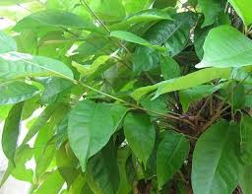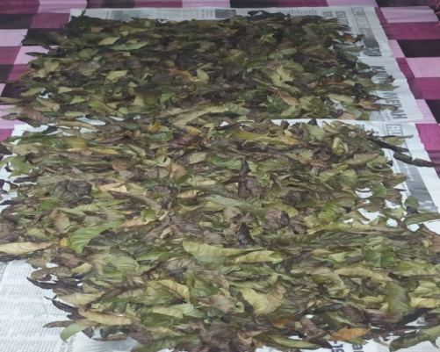

Daun segar daun salam Pengeringan daun salam

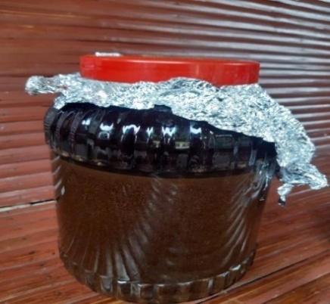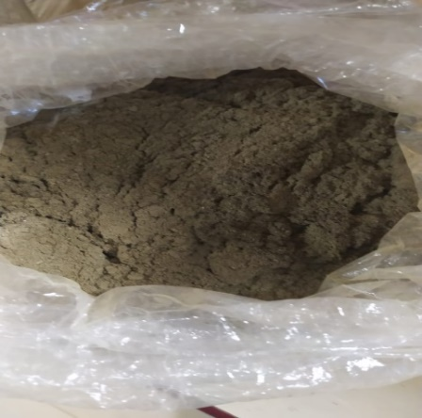

Serbuk simplisia daun salam 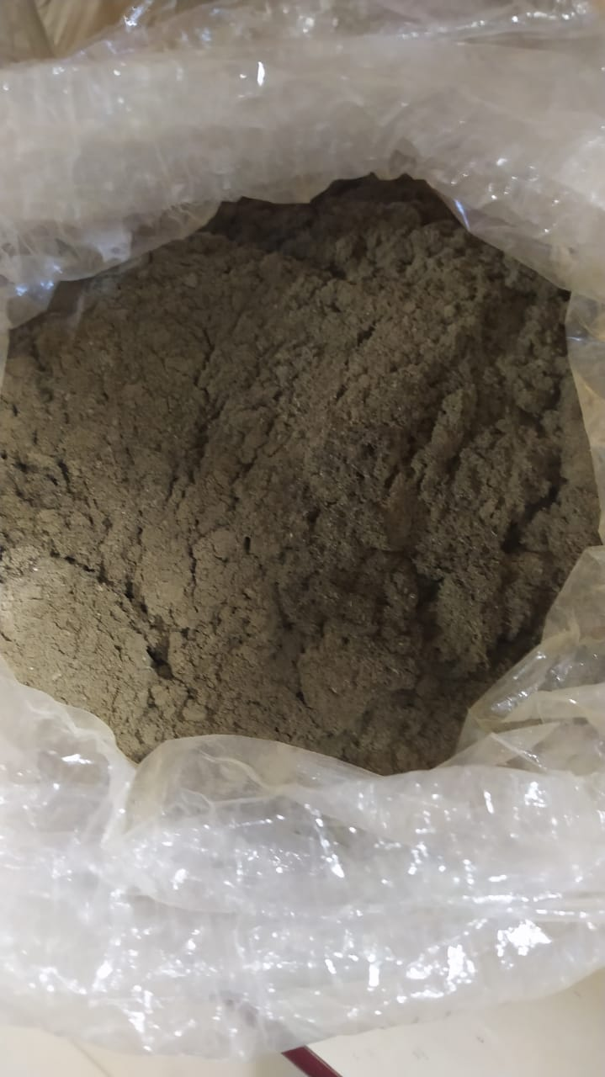 Proses maserasi serbuk daun salam

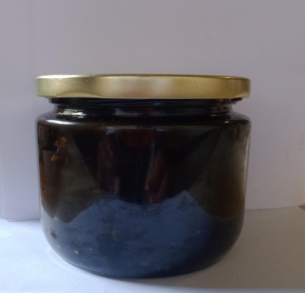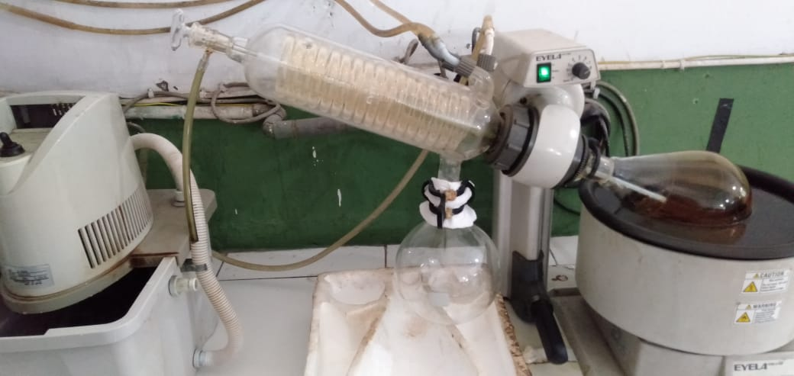

Proses rotary daun salam Ekstrak kental daun salam

# Lampiran 3. Hasil pengukuran daun salam dan bentuk daun salam yang dilihat secara makrokopis

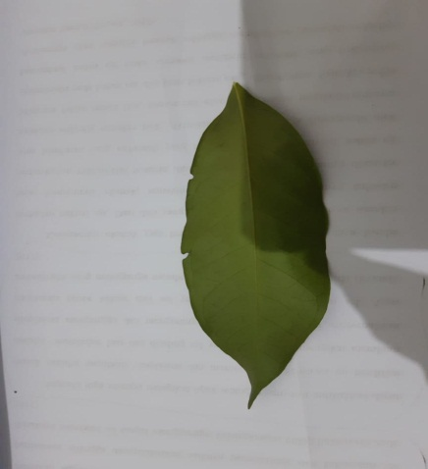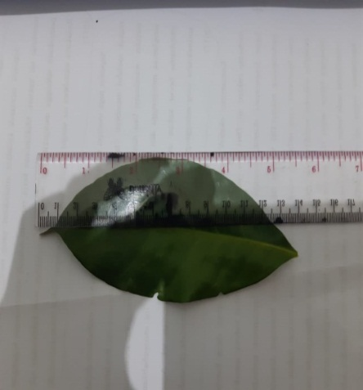

Bentuk helai daun salam Hasil pengukuran daun salam segar

# Lampiran 4. Hasil Skrining fitokimia.

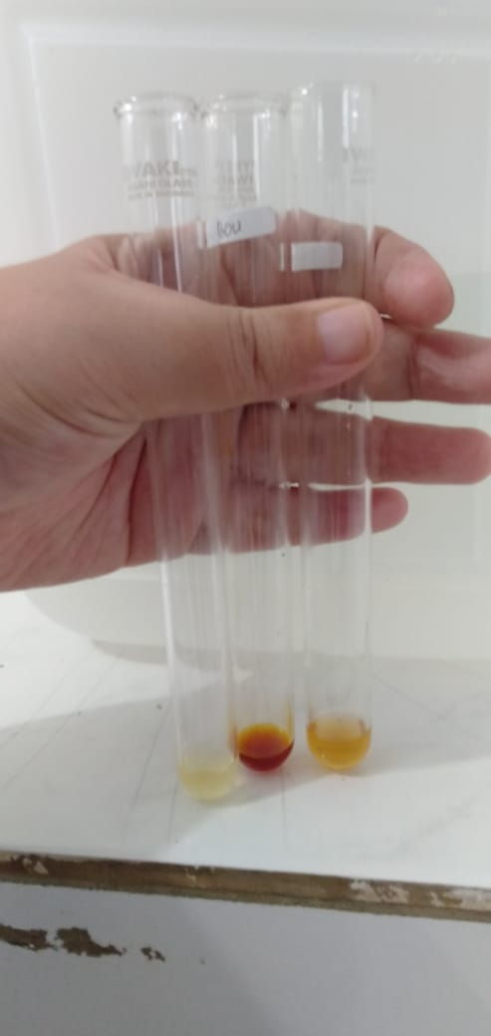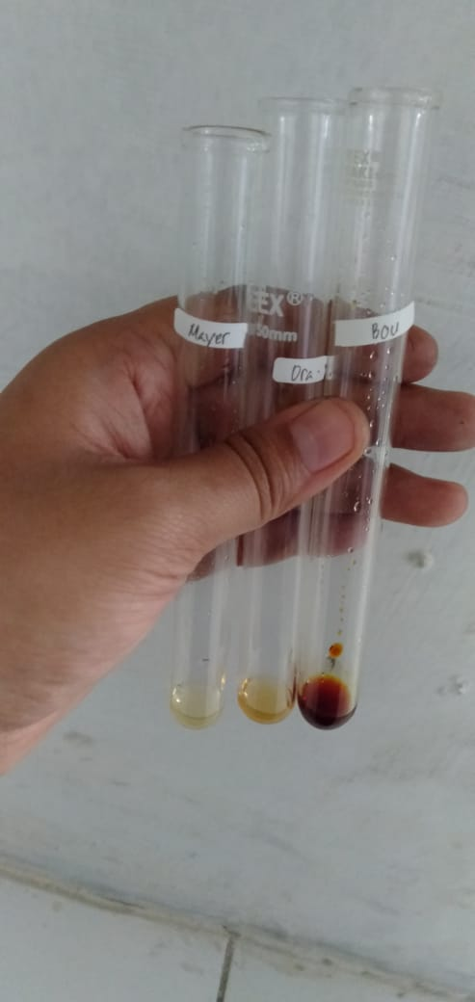

Uji alkaloid Uji alkaloid

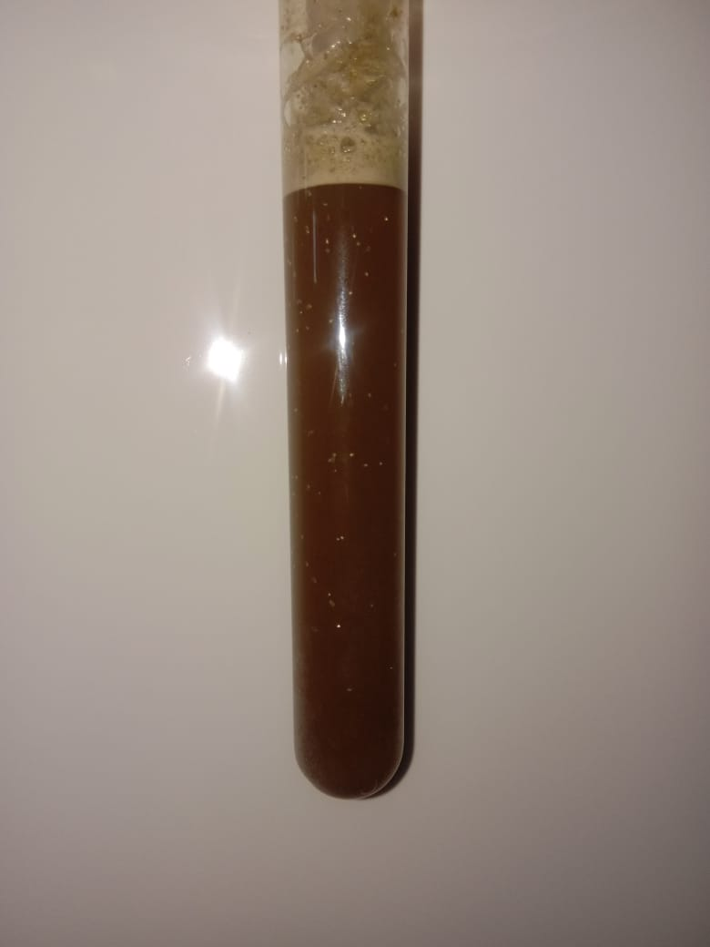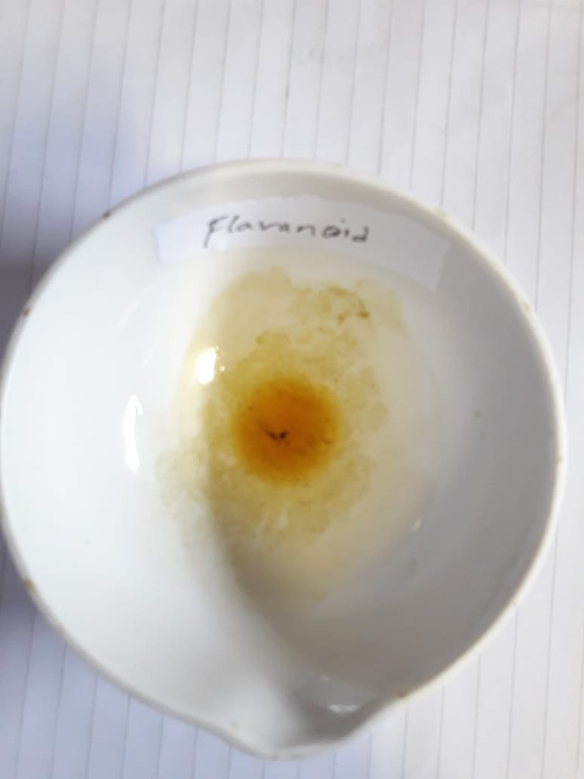

Uji flavonoid Uji saponin

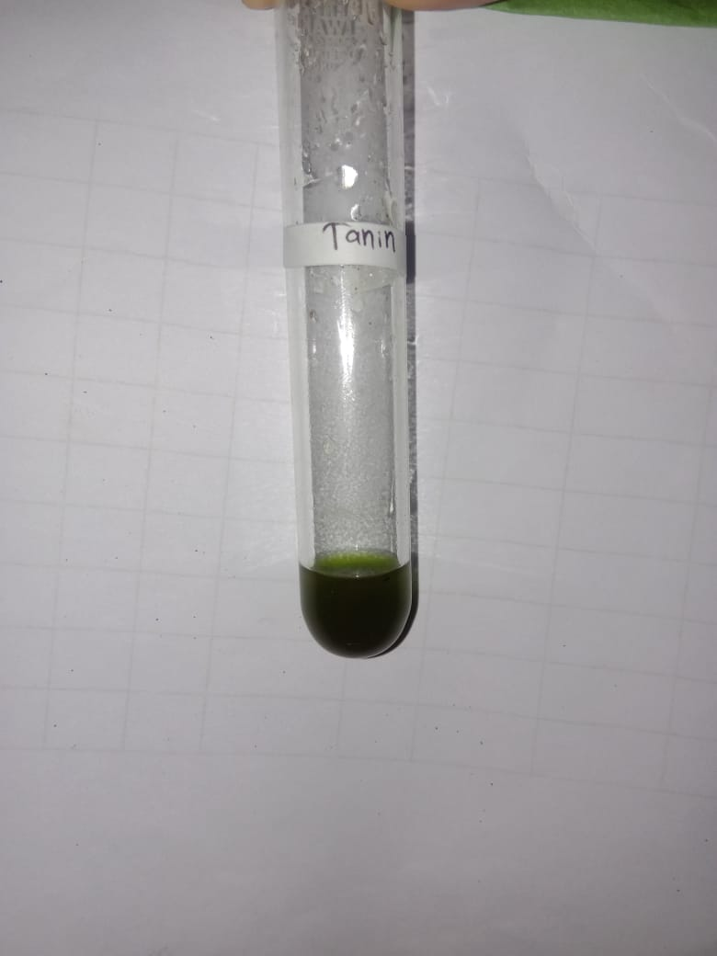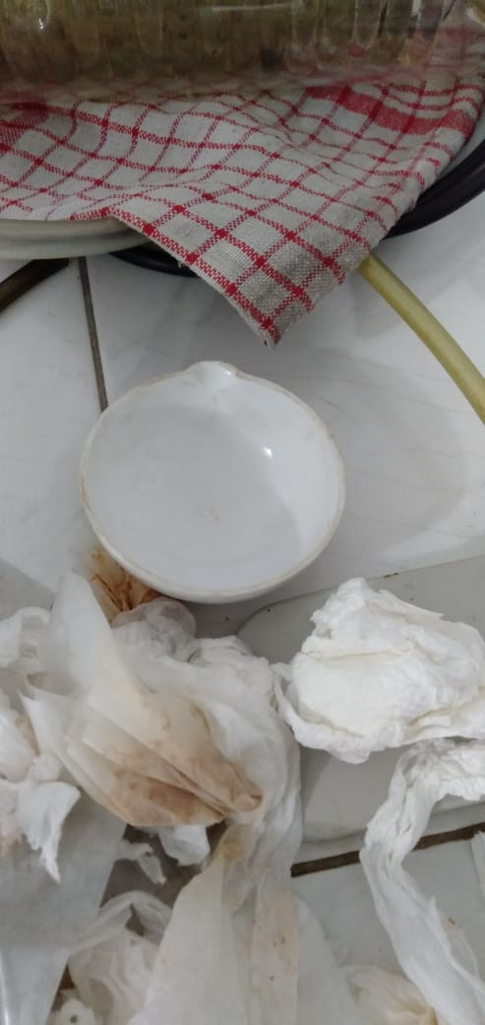

Uji Steroid/triterpenoid Uji tanin

# Lampiran 5. Penimbangan bahan dan ekstrak daun salam.

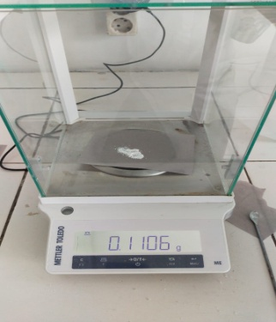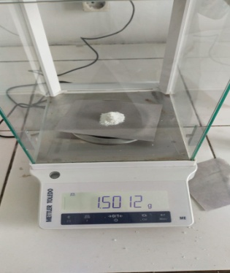

Na.CMC Natrium Benzoat

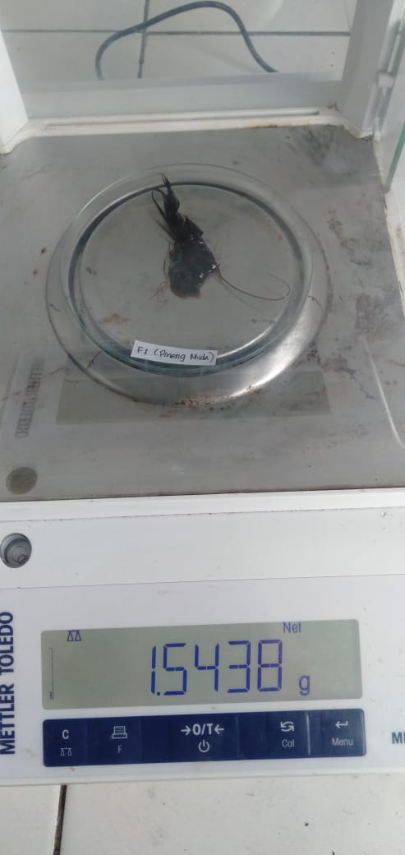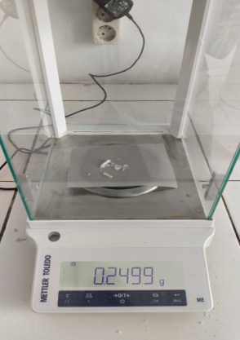

Menthol Ekstrak daun salam

# Lampiran 6. Hasil Formulasi Pasta Gigi Gel Ekstrak Daun Salam

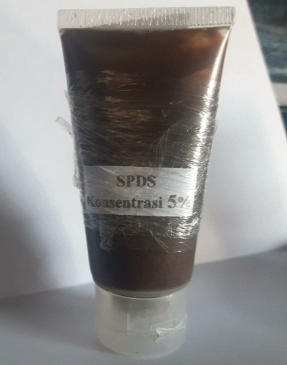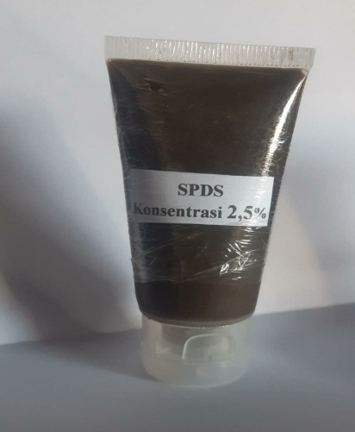

Pasta gigi konsentrai 2,5 % pasta gigi konsentrasi 5 %

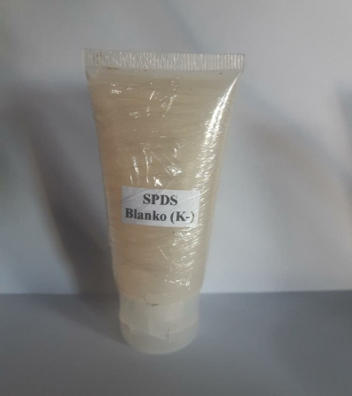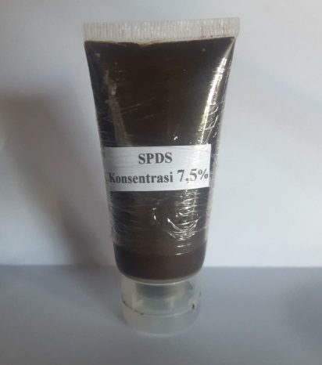

Pasta gigi konsentrasi 7% Pasta gigi Blanko (-)

# Lampiran 7. Uji pH dan uji tinggi busa pasta gigi ekstrak daun salam dan daya sebar pasta gigi

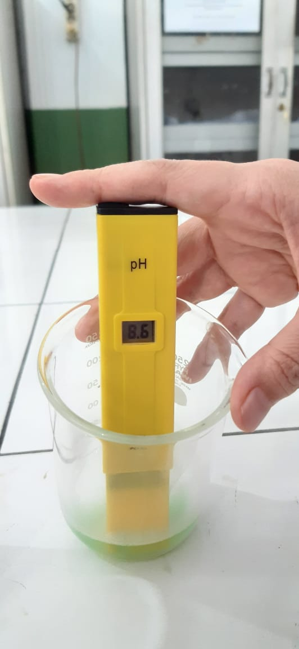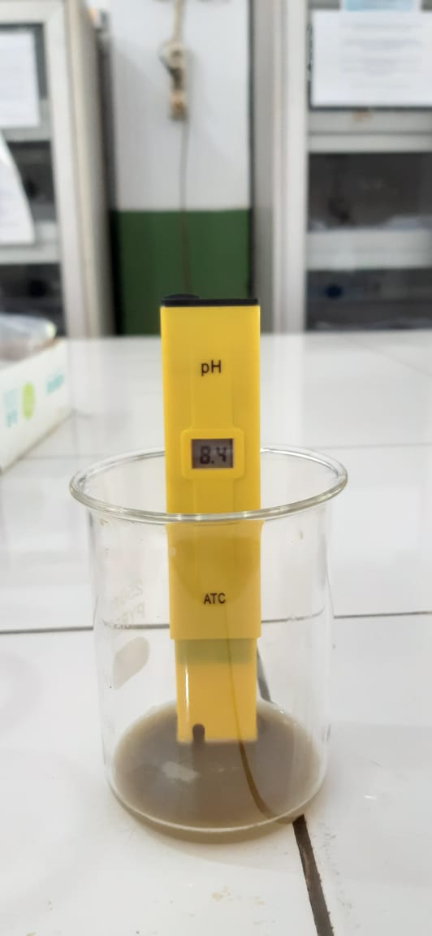

Hasil uji (PH) K (+) Hasil uji (PH) sediaan pasta gigi

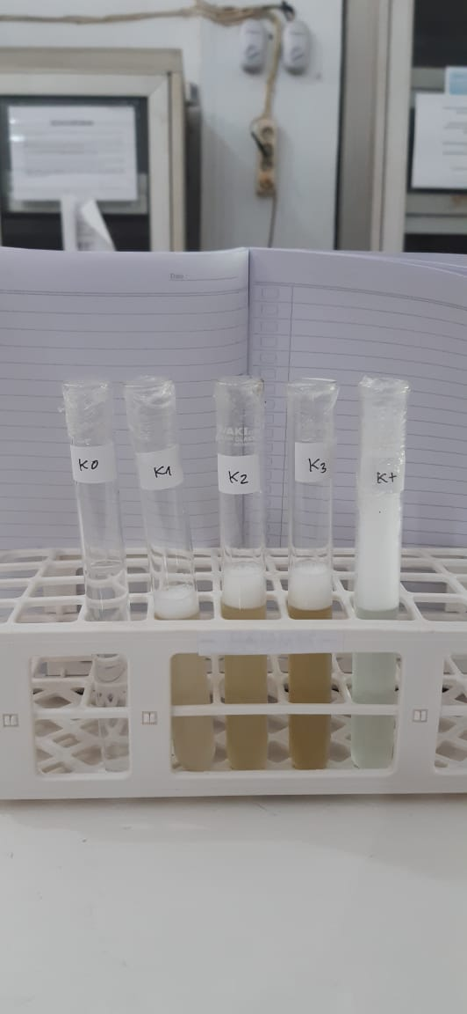

Hasil uji tinggi busa sediaan dan k (+)

# Lampiran 8. Uji Daya Sebar Pasta Gigi Gel Ekstrak Daun Salam

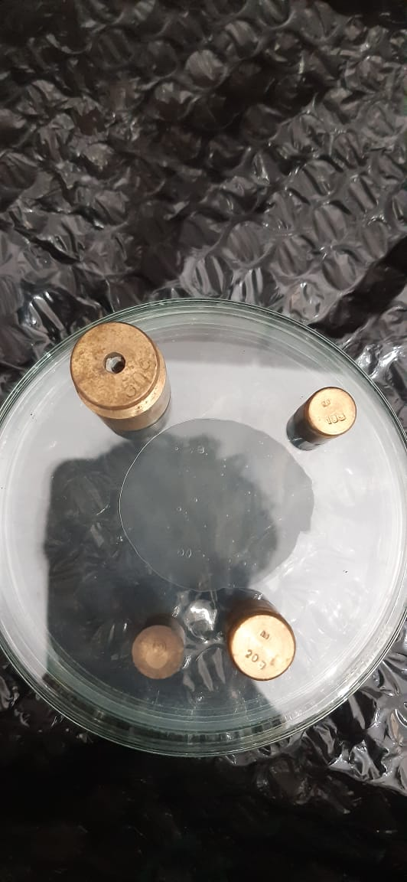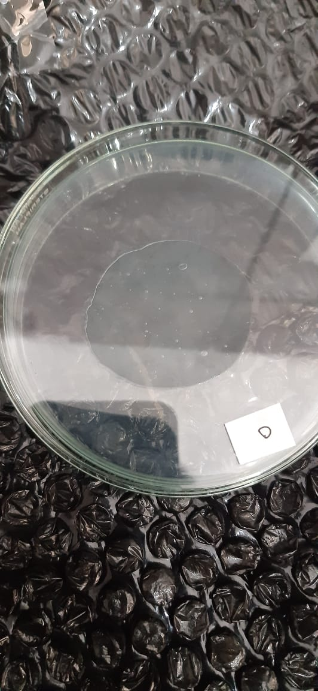

Uji daya sebar Blanko sediaan pata gigi Dengan beban 250 g

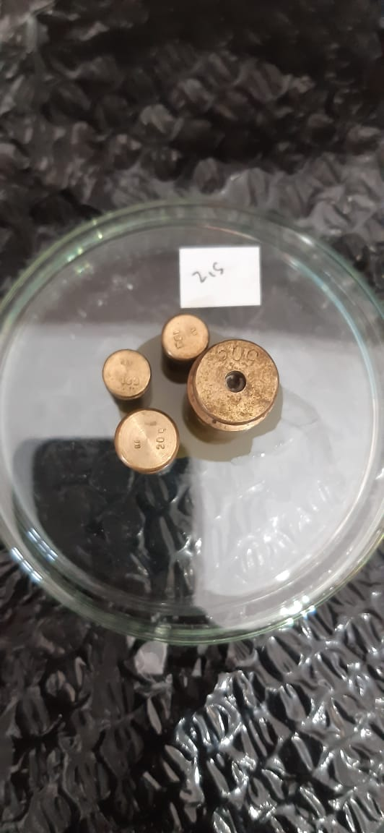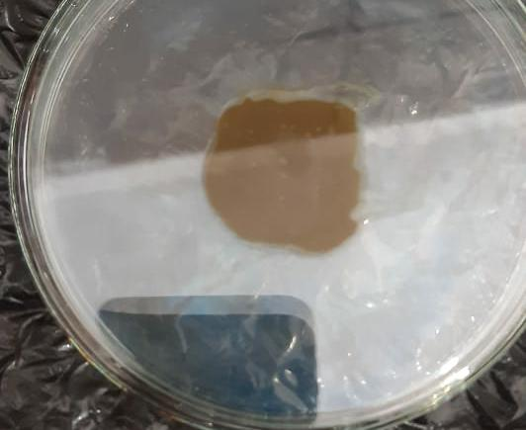

Uji daya sebar konsentrasi 2,5 % Dengan beban 250 gr

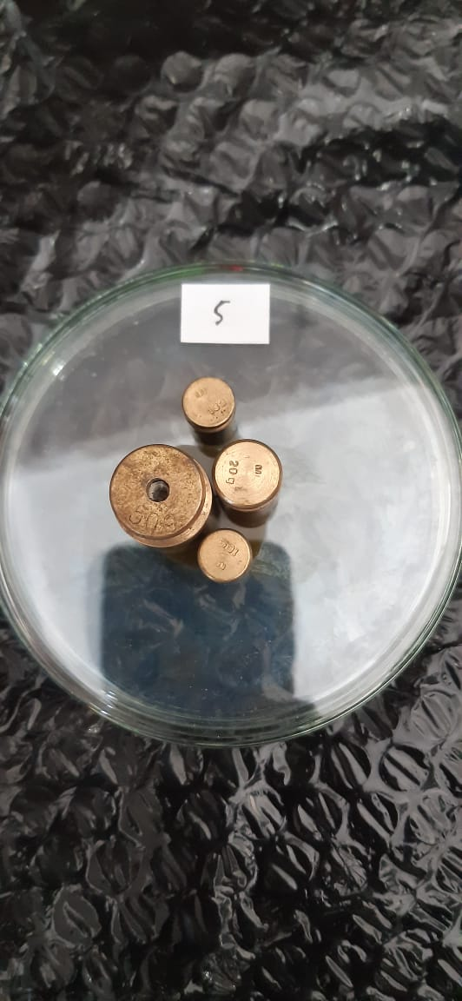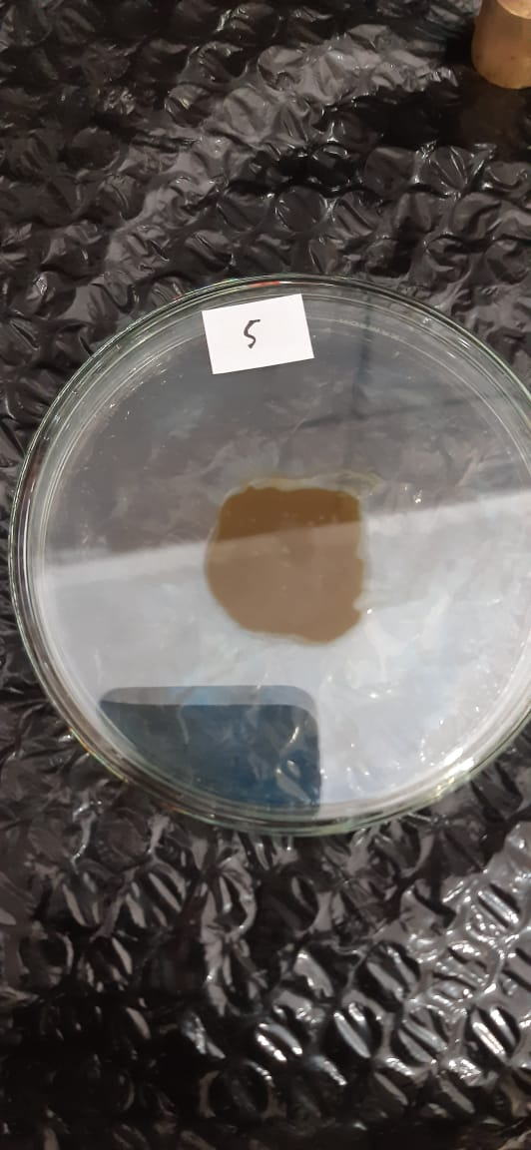

Uji daya sebar konsentrasi 5% Dengan beban 250 gr

Lampiran 8. **(Lanjutan)**

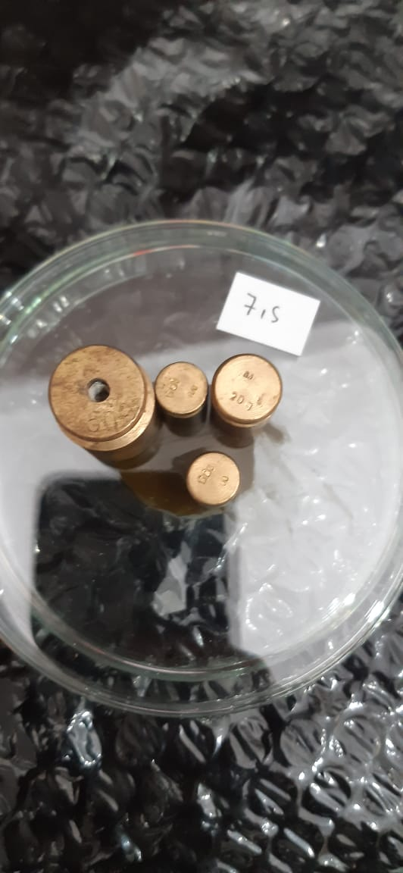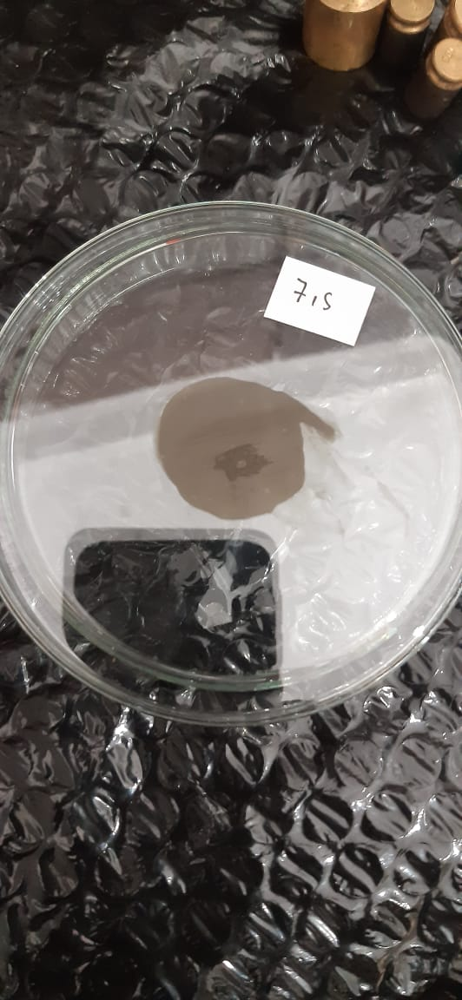

Uji daya sebar konsentrasi 7,5 % Dengan beban 250 gr

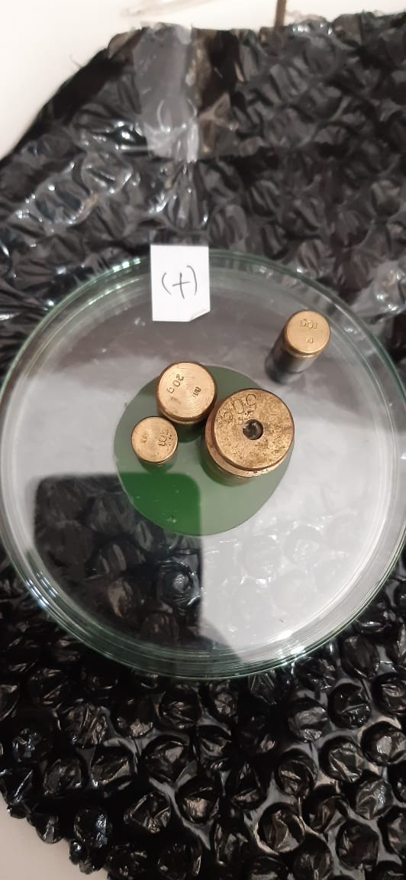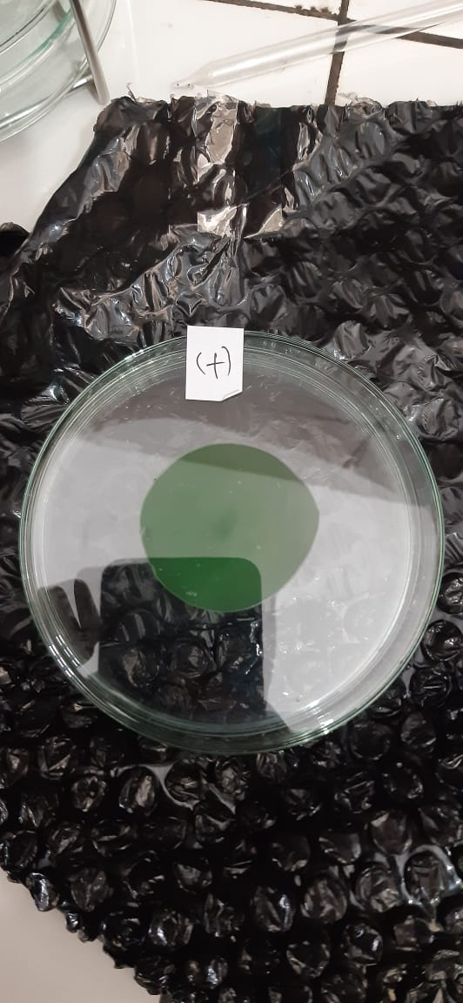

Uji daya sebar K (+) Dengan beban 250 gr

Lampiran 9. Hasil uji aktivitas antibakteri sediaan daun salam (*Syzygium polyanthum*) terhadap bakteri *Straptococcus mutans*

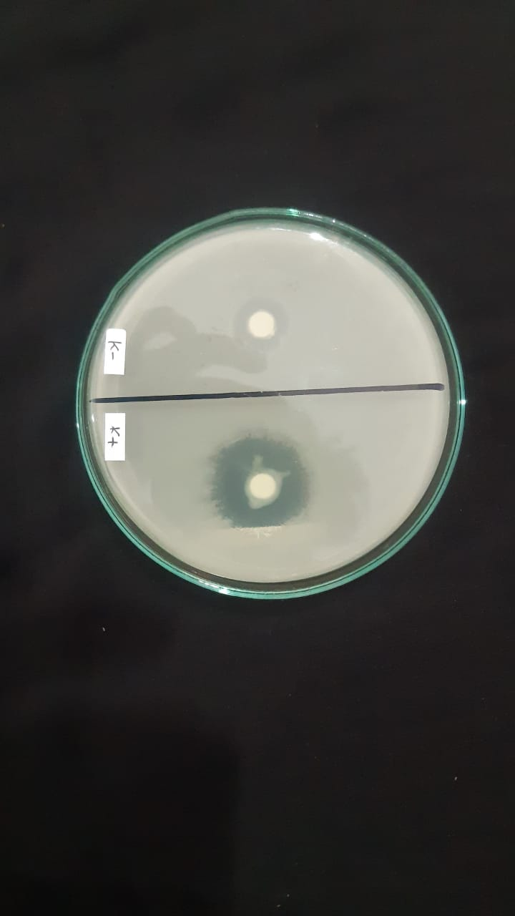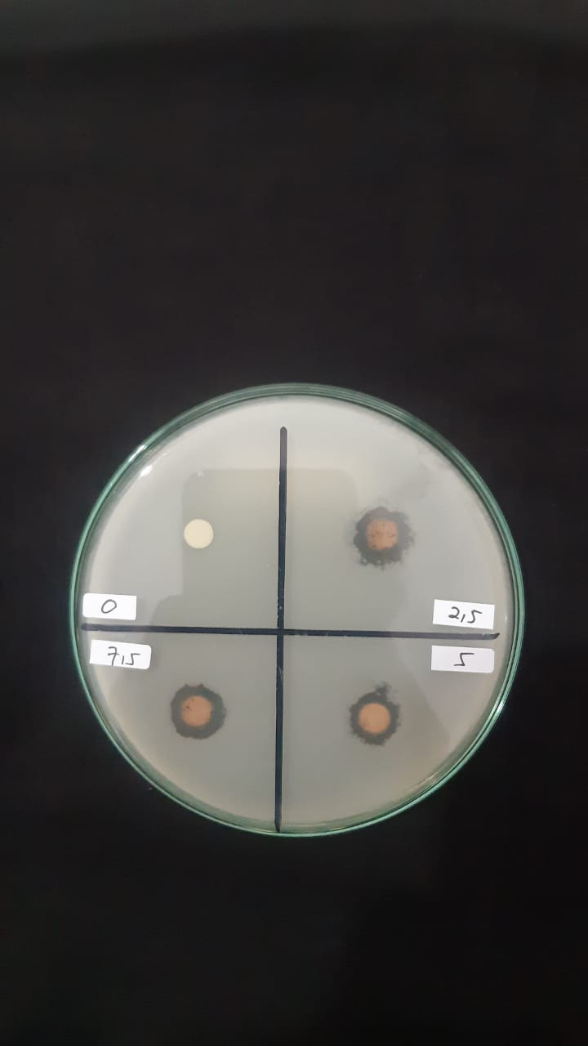

Uji aktivitas antibakteri pasta gigi gel Blanko dan K(+)

Ekstrak daun salam

# Lampiran 10. Perhitungan Karakteristik Simplisia

1. Penetapan kadar sari yang larut dalam air daun salam

$$\% Kadar sari larut air= \frac{berat cawan sari-berat cawan kosong (g)}{berat sampel (g)} ×\frac{100}{20}×100\%$$

|  |  |  |  |
| --- | --- | --- | --- |
| **NO** | **Berat Sempel (g)** | **Berat Cawan Kosong (g)** | **Berat Cawan Sari (g)** |
| 1.  2.  3. | 5,0753 g  5,0544 g  5,0097 g | 55,8040 g  56,2792 g  55,7976 g | 56,0750 g  56,5372 g  56,0556 g |

1. Berat simplisia = 5,0753 g

Berat sari = 0,271 g

Kadar sari = $\frac{0,271}{5,0753}×\frac{100}{20}×100\%=26,09 \%$

1. Berat simplisia = 5, 0544 g

Berat sari = 0,258 g

Kadar sari = $\frac{0,258}{5,0544}×\frac{100}{20}×100\%=25,52 \%$

1. Berat simplisia = 5,0097 g

Berat sari = 0,256 g

Kadar sari =

2. Penetapan kadar sari yang larut dalam etanol daun salam

$$\% Kadar sari = \frac{berat cawan sari-berat cawan kosong (g)}{berat sampel (g)} ×\frac{100}{20}×100\%$$

|  |  |  |  |
| --- | --- | --- | --- |
| **NO** | **Berat Sempel (g)** | **Berat Cawan Kosong (g)** | **Berat Cawan Sari (g)** |
| 1.  2.  3. | 5,0831 g  5,0342 g  5,0177 g | 57,8743 g  56,6332 g  56,3923 g | 58,1053 g  56,6332 g  56,5963 g |

1. Berat simplisia = 5,0831 g

Berat sari = 0,231 g

Kadar sari = $\frac{0,231}{5,0831}×\frac{100}{20}×100\%=22,72\%$

**Lampiran 10.** (Lanjutan)

1. Berat simplisia = 5, 0342 g

Berat sari = 0,199 g

Kadar sari = $\frac{0,199}{5,0342}×\frac{100}{20}×100\%=19,76\%$

1. Berat simplisia = 5,0177 g

Berat sari = 0,204 g

Kadar sari =

3. Penetapan kadar abu total daun salam

$$\% Kadar sari = \frac{berat abu}{berat sampel (g)} ×100\%$$

|  |  |  |  |
| --- | --- | --- | --- |
| **NO** | **Berat Sempel (g)** | **Berat Cawan Kosong (g)** | **Berat Cawan Sari (g)** |
| 1.  2.  3. | 5,0672 g  5,0130 g  5,0045 g | 53,5329 g  61,9726 g  63,6553 g | 53,6359 g  62,071 g  63,7643 g |

1. Berat simplisia = 5,0672 g

Berat abu = 0,103 g

Kadar sari = $\frac{0,103}{5,0672}×100\%=2,03\%$

1. Berat simplisia = 5,0130 3

Berat abu = 0,0985 g

Kadar sari = $\frac{0,0985}{5,0130}×100\%=1,96\%$

1. Berat simplisia = 5,0045 g

Berat abu = 0,109g

Kadar sari = $\frac{0,109}{5,0045}×100\%=2,17\%$

$$\%Rata-rata kadar abu total=\frac{2,03\%+1,96\%+2,17\%}{3}=2,05 \%$$

**Lampiran 10.** (Lanjutan)

4. Penetapan kadar abu total tidak larut asam daun salam

$$\% Kadar sari = \frac{berat abu}{berat sampel (g)} ×100\%$$

|  |  |  |
| --- | --- | --- |
| **NO** | **Berat Sempel (g)** | **Berat abu (g)** |
| 1.  2.  3. | 5,0071 g  5,0611 g  5,0036 g | 0,051 g  0,037 g  0,068 g |

1. Berat simplisia = 5,0071 g

Berat abu = 0,051 g

Kadar sari = $\frac{0,051}{5,0071}×100\%=1,01\%$

1. Berat simplisia = 5,0611 g

Berat abu = 0,037 g

Kadar sari = $\frac{0,037}{5,0611}×100\%=0,73\%$

1. Berat simplisia = 5,0036 g

Berat abu = 0,037 g

Kadar sari = $\frac{0,037}{5,0036}×100\%=1,3\%$

$$\% Rata-rata kadar abu total tidak larut asam=\frac{1,01\%+0,73\%+1,3\%}{3}=1,01\%$$

# 

# Lampiran 11. Bagan Alir Prosedur Kerja

Pengumpulan dan pengolahan sampel daun salam (*Syzygium polyanthum*)

# dikumpulkan

dicuci dan dibersihkan

# disortasi

# ditimbang

Daun salam segar

# dikeringkan

# 

Pengeringan dengan lemari pengering

Daun salam kering

dihaluskan

ditimbang

# 

Serbuk simplisia

Dimaserasi dengan etanol 96% (Maserat)

# 

Ekstrak kental

Skrining Fitokimia

Pembuatan Pasta Gigi gel dengan berbagai konsentrasi

# 

Evaluasi sediaan pasta gigi gel daun salam

Uji Aktivitas Antibakteri Pasta Gigi gel

# Lampiran 12. Cara Kerja Skematis Pembuatan Ekstrak Daun Salam

Serbuk Simplisia 1000 Gram

Masukkan dalam bejana

# 

Dimasukkan dalam bejana 2 hari dan disaring

Diuapkan diatas waterbath

Dipekatkan dengan bantuan alat rotary evaporator pada suhu 60 $℃$

Maserasi kedua dituangkan dengan 25 bagian penyari etanol 96% sebanyak 2500 ml

Setelah 5 hari campuran diserkai dan ampasnya diperas

Ditutup dan dibiarkan selama 5 hari, sambal sesekali di aduk

Maserasi pertama dituangakan dengan 75 bagian cairan penyari etanol 96% sebanyak 7500 ml

Maserat I+II

Maserat II

Ampas

Maserat I

EKSTRAK KENTAL DAUN SALAM

# Lampiran 13. Cara Kerja Skematis Pembuatan Ekstrak Pasta Gigi Gel Daun Salam

Ekstrak Daun Salam

(2,5 %; 5 %; 7,5 %)

M2

Na.CMC

Ekstrak Daun Salam

**+** Aquadest panas **+** Ekstrak daun salam

**+** Etanol 96%

M1

**+** Papermint

**+** Menthol

M1+M2

+ Na. Benzoat

SPDS

2,5%; 5%; 7,5%

DIMASUKAN KEDALAM TUBE PASTA

Keterangan :

M1 = Massa I

M2 = Massa II

SPDS = Sediaan Pasta Gigi Gel Daun Salam

# Lampiran 14. Hasil Analisi Data

|  |  |  |  |  |  |  |  |  |
| --- | --- | --- | --- | --- | --- | --- | --- | --- |
| **Descriptives** | | | | | | | | |
| Diameter | | | | | | | | |
|  | N | Mean | Std. Deviation | Std. Error | 95% Confidence Interval for Mean | | Minimum | Maximum |
| Lower Bound | Upper Bound |
| Kontrol Negatif | 3 | ,0000 | ,00000 | ,00000 | ,0000 | ,0000 | ,00 | ,00 |
| F1 (SPDS 2,5 %) | 3 | 12,5667 | 1,58219 | ,91348 | 8,6363 | 16,4971 | 11,20 | 14,30 |
| F2 (SPDS 5 %) | 3 | 14,3000 | ,87178 | ,50332 | 12,1344 | 16,4656 | 13,30 | 14,90 |
| F3 (SPDS 7,5 %) | 3 | 16,1667 | ,35119 | ,20276 | 15,2943 | 17,0391 | 15,80 | 16,50 |
| Kontrol Positif | 3 | 17,8667 | ,35119 | ,20276 | 16,9943 | 18,7391 | 17,50 | 18,20 |
| Total | 15 | 12,1800 | 6,60467 | 1,70532 | 8,5225 | 15,8375 | ,00 | 18,20 |

|  |  |  |  |  |  |
| --- | --- | --- | --- | --- | --- |
| **Test of Homogeneity of Variances** | | | | | |
|  | | Levene Statistic | df1 | df2 | Sig. |
| Diameter | Based on Mean | 4,714 | 4 | 10 | ,021 |
| Based on Median | 1,349 | 4 | 10 | ,318 |
| Based on Median and with adjusted df | 1,349 | 4 | 4,013 | ,389 |
| Based on trimmed mean | 4,378 | 4 | 10 | ,027 |

|  |  |  |  |  |  |
| --- | --- | --- | --- | --- | --- |
| **ANOVA** | | | | | |
| Diameter | | | | | |
|  | Sum of Squares | df | Mean Square | F | Sig. |
| Between Groups | 603,684 | 4 | 150,921 | 214,987 | ,000 |
| Within Groups | 7,020 | 10 | ,702 |  |  |
| Total | 610,704 | 14 |  |  |  |

|  |  |  |  |  |  |  |
| --- | --- | --- | --- | --- | --- | --- |
| **Diameter** | | | | | | |
| Duncana | | | | | | |
| Konsentrasi | N | Subset for alpha = 0.05 | | | | |
| 1 | 2 | 3 | 4 | 5 |
| Kontrol Negatif | 3 | ,0000 |  |  |  |  |
| F1 (SPDS 2,5 %) | 3 |  | 12,5667 |  |  |  |
| F2 (SPDS 5 %) | 3 |  |  | 14,3000 |  |  |
| F3 (SPDS 7,5 %) | 3 |  |  |  | 16,1667 |  |
| Kontrol Positif | 3 |  |  |  |  | 17,8667 |
| Sig. |  | 1,000 | 1,000 | 1,000 | 1,000 | 1,000 |
| Means for groups in homogeneous subsets are displayed. | | | | | | |
| a. Uses Harmonic Mean Sample Size = 3,000. | | | | | | |