**Lampiran 1** Surat Hasil Identifikasi Tumbuhan

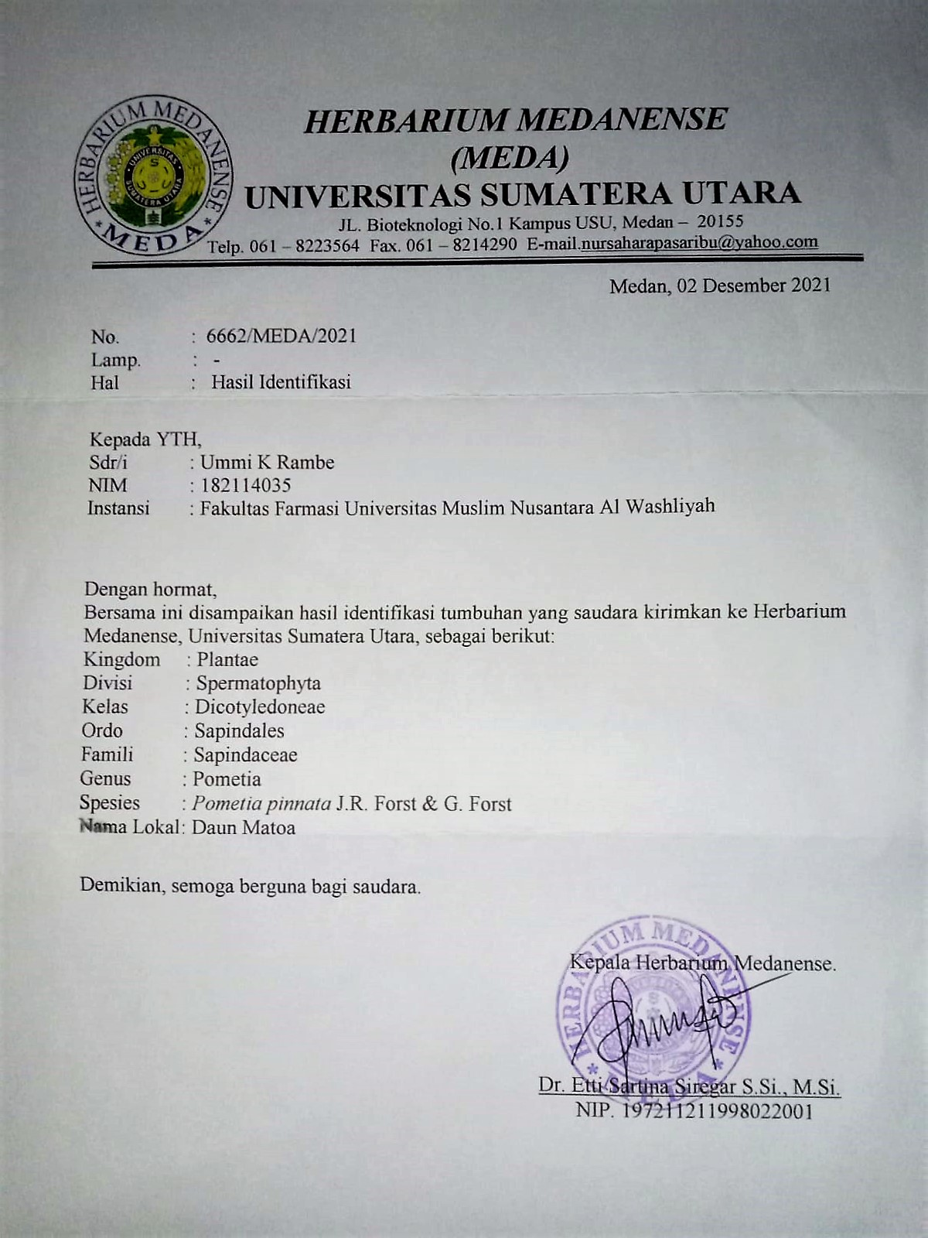

**Lampiran 2** Surat Persetujuan Kode Etik Penelitian Hewan Percobaan

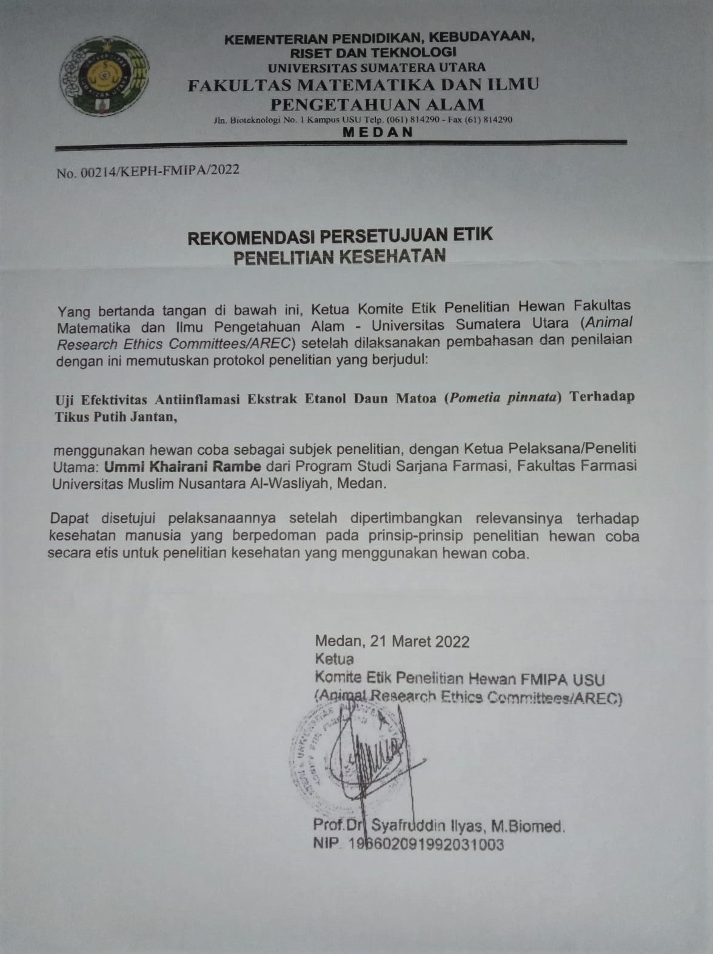

**Lampiran 3** Tabel Konversi Dosis

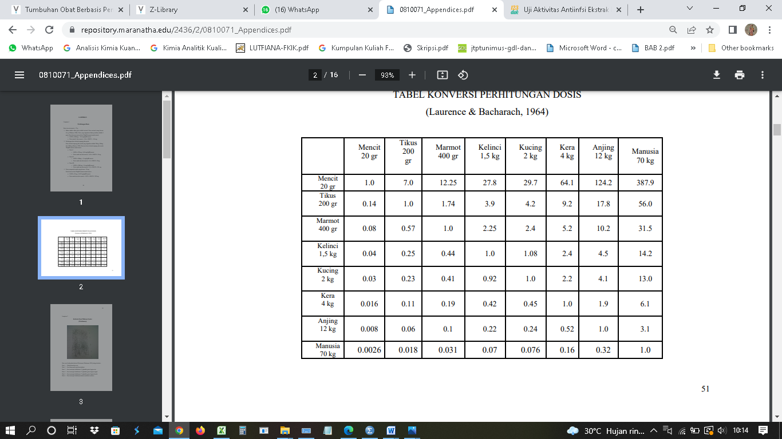

**Lampiran 4** Makroskopik Daun Matoa

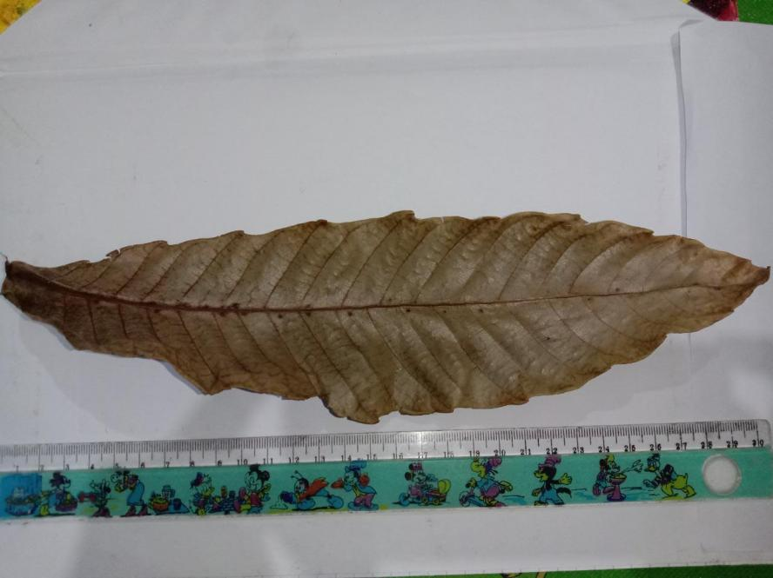

Simplisia Daun matoa (*Pometia pinnata* J. R. Forst & G. Forst)

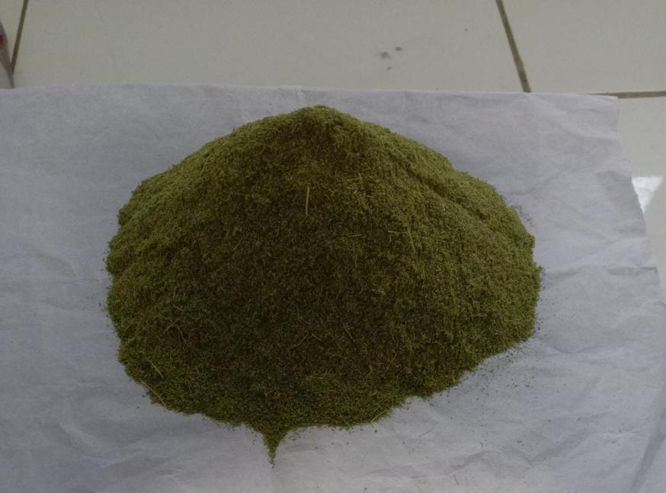

Serbuk simplisia daun matoa

**Lampiran 5** Hasil Pemeriksaan Mikroskopik Daun Matoa

|  |  |
| --- | --- |
| Penampang Melintang | 1  2  3 |
| Penampang Membujur | 4 |

Keterangan :

1. Epidermis atas
2. Jaringan palisade
3. Epidermis bawah
4. Stomata (tipe parasitic)

**Lampiran 6** Bagan Pembuatan Simplisia, Karakterisasi Dan Skrining Fitokimia Daun Matoa

Daun Matoa

Simplisia

Serbuk simplisia

karakterisasi simplisia

Skrining fitokimia

Ekstraksi

Terdiri dari :

1. kadar air
2. kadar abu total
3. kadar abu tidak larut asam
4. kadar sari larut air
5. kadar sari larut etanol

Pemeriksaan golongan senyawa yaitu :

1. Alkaloid
2. Flavonoid
3. Tannin
4. Saponin
5. Steroid/triterpenoid
6. glikosida

Ekstrak kental etanol 96%

Dicuci, ditiriskan, dan ditimbang berat basah. Lalu dikeringkan dalam lemari pengering

ditimbang berat kering. Lalu dihaluskan

**Lampiran 7** Bagan Pembuatan Ekstrak Etanol Daun Matoa

500 g serbuk simplisia Daun Matoa

Dimaserasi dengan 3750 ml etanol 96% dalam bejana tertutup

Dibiarkan selama 5 hari terlindung dari cahaya sambil sering diaduk, disaring

Ampas

Maserat I

direndam dengan 1250 ml etanol 96% dibiarkan selama 2 hari

disaring

Maserat II

digabung,dituang dan disaring

diuapkan dengan rotary evaporator

dipekatkan diatas waterbath

ekstrak kental dengan berat 121 g

**Lampiran 8** Bagan Kerja Antiinflamasi

25 ekor tikus

EEDM 50, 100, 200 mg/kg BB

CMC 0,5%

Na. Diklofenak 4,5 mg/kg BB

Hasil

Pada hari pengujian masing-masing hewan ditimbang dan diberi tanda pada ekor dan kakinya

Sebagai volume awal (Vo) yaitu volume kaki sebelum diberi induksi dengan larutan karagenan, kaki yang telah diberi tanda dimasukkan kedalam alat plestimometer lalu pedal ditahan dan dicatat angka pada monitor.

Masing-masing tikus diberi suspense bahan uji secara oral sesuai dengan kelompoknya

Setelah 1 jam, masing-masing telapak kaki tikus disuntik secara intraplantar dengan 0,1 ml larutan karagenan 1%. Setelah 1 jam dilakukan pengukuran dengan alat pletismometer.

Dicatat angka pada monitor plestimometer. Perubahan volume cairan yang terjadi dicatat sebagai volume telapak kaki pada waktu tertentu (Vt)

**Lampiran 9** Perhitungan Karakterisasi Simplisia Daun Matoa

1. Penetapan kadar air

%kadar air = $\frac{V. Akhir-V. Awal}{berat sampel} x 100\%$

|  |  |  |  |
| --- | --- | --- | --- |
| No. | Berat Sampel | Volume awal | Volume akhir |
|  | 5 g | 1,7 ml | 1,9 ml |
|  | 5 g | 1,7 ml | 1,9 ml |
|  | 5 g | 1,8 ml | 2 ml |

%kadar air sampel 1 = $\frac{1,9 ml-1,7 ml}{5 g} x 100\%$ = 4 $\%$

%kadar air sampel II = $\frac{1,9 ml-1,7 ml}{5 g} x 100\%$ = 4 $\%$

%kadar air Sampel III = $\frac{2 ml-1,8 ml}{5 g} x 100\%$ = 4 $\%$

%rata-rata kadar air = $\frac{4 \%+4 \%+4 \% }{3 }$ = 4 $\%$

1. Penetapan kadar sari larut air

%kadar sari larut air = $\frac{\left((berat cawan+isi\right)-berat cawan)x 5}{berat sampel} x 100\%$

|  |  |  |  |
| --- | --- | --- | --- |
| No. | Berat Sampel | Berat cawan kosong | Berat cawan + isi |
| I. | 5,001 g | 69,778 g | 69,972 g |
| II. | 5,002 g | 64,693 g | 64,905 g |
| III. | 5 g | 67,061 g | 67,274 g |

%kadar sari larut air (I) = $\frac{(69,972 g-69,778 g)x 5}{5,001 g} x 100\%$ = 19,396 %

%kadar sari larut air (II) = $\frac{( 64,905 g- 64,693g)x 5}{5,002 g} x 100\%$ = 21,191 %

%kadar sari larut air (III) = $\frac{( 67,274 g- 67,061g)x 5}{5 g} x 100\%$ = 21,3 %

%rata-rata = $\frac{19,396\%+21,191 \%+ 21,3\% }{3 }$ = 20,629 %

1. Penetapan kadar sari larut etanol

%kadar sari larut etanol = $\frac{\left((berat cawan+isi\right)-berat cawan)x 5}{berat sampel} x 100\%$

|  |  |  |  |
| --- | --- | --- | --- |
| No. | Berat Sampel | Berat cawan kosong | Berat cawan + isi |
| I. | 5 g | 64,693 g | 64,922 g |
| II. | 5 g | 69,781 g | 70,007 g |
| III. | 5,001 g | 65,185 g | 65,416 g |

%kadar sari larut etanol I = $\frac{(64,922 g-64,693g)x 5}{5 g} x 100\%$ = 22,9 %

%kadar sari larut etanol II = $\frac{(70,007 g-70,007 g)x 5}{5 g} x 100\%$ = 22,6 %

%kadar sari larut etanol III = $\frac{(65,416 g-65,185 g)x 5}{5,001 g} x 100\%$ = 23,095 %

%rata-rata = $\frac{22,9 \%+22,6 \%+ 23,095 \% }{3 }$ = 22,865 %

1. Penetapan kadar abu total

%kadar abu = $\frac{\left((berat cawan+isi\right)-berat cawan)}{berat sampel} x 100\%$

|  |  |  |  |
| --- | --- | --- | --- |
| No. | Berat Sampel | Berat cawan kosong | Berat cawan + isi |
| I | 2 g | 66,722 g | 66,915 g |
| II | 2 g | 70,747 g | 70,948 g |
| III | 2 g | 66,020 g | 66,179 g |

%kadar abu I = $\frac{(66,915 g-66,722g)}{2 g} x 100\%$ = 9,65 %

%kadar abu II = $\frac{(70,948 g-70,747g)}{2 g} x 100\%$ = 10,05 %

%kadar abu III = $\frac{(66,179 g-66,020g)}{2 g} x 100\%$ = 9,21 %

%rata-rata = $\frac{9,65 \%+10,05 \%+ 9,21\% }{3 }$ = 9,21%

1. Penetapan kadar abu tidak larut asam

%kadar abu = $\frac{\left((berat cawan+isi\right)-berat cawan)}{berat sampel} x 100\%$

|  |  |  |  |
| --- | --- | --- | --- |
| No. | Berat Sampel | Berat cawan kosong | Berat cawan + isi |
| I | 2 g | 66,0166 g | 66,0654 g |
| II | 2 g | 66,7852 g | 66,7852 g |
| III | 2 g | 70,7576 g | 70,7968 g |

%kadar abu tidak larut asam I = $\frac{(66,0654 g-66,0166 g)}{2 g} x 100\%$ = 2,44 %

%kadar abu tidak larut asam II = $\frac{(66,7852 g-66,7852 g)}{2 g} x 100\%$ = 1,08 %

%kadar abu tidak larut asam III = $\frac{(70,7968 g-70,7576 g)}{2 g} x 100\%$ = 1,96 %

%rata-rata = $\frac{2,44 \%+1,08 \%+ 1,96 \% }{3 }$ = 1,82 %

**Lampiran 10** Penapisan Fitokimia Ekstrak Dan Serbuk Daun Matoa

| **No.** | **Golongan Senyawa** | **Hasil** | **Keterangan** |
| --- | --- | --- | --- |
|  | Alkaloid | C:\Users\SascomJy3\Downloads\WhatsApp Image 2022-03-27 at 16.26.17.jpeg | (+)  Adanya endapan |
|  | Flavonoid | C:\Users\SascomJy3\Downloads\WhatsApp Image 2022-03-22 at 21.09.39.jpeg | (+)  Terbentuk warna jingga di amyl alcohol |
|  | Tannin | C:\Users\SascomJy3\Downloads\WhatsApp Image 2022-03-22 at 21.09.38.jpeg | (+)  Terbentuk warna biru kehitaman |
|  | Saponin | C:\Users\SascomJy3\Downloads\WhatsApp Image 2022-03-22 at 21.09.38 (2).jpeg  C:\Users\SascomJy3\Downloads\WhatsApp Image 2022-03-22 at 21.09.38 (1).jpeg | (+)  Terbentuk busa lebih dari 1 cm |
|  | Steroid/triterpenoid | C:\Users\SascomJy3\Downloads\WhatsApp Image 2022-03-22 at 21.09.37.jpeg | (+)  Terbentuk warna biru hijau |
|  | Glikosida | C:\Users\HP\Downloads\WhatsApp Image 2022-04-13 at 21.30.21.jpeg | (-)  Tidak terbentuk |

**Lampiran 11** Perhitungan Dosis

1. Perhitungan bahan suspense Na. diklofenak 0,1%

Suspense Na. diklofenak 0,1% = jumlah Na. diklofenak / volume suspense

= 0,1 g / 100 ml

= 100 mg / 100 ml

= 1 mg/ml

Konversi dosis Na. diklofenak dari manusia (70 kg) ke tikus (200 g) = 0,018

Dosis Na. diklofenak untuk manusia dewasa BB (70 kg) = 50 mg

maka dosis pada tikus Na. diklofenak = dosis terapi manusia x 0,018

= 50 mg x 0,018

= 0,9 mg

Bb tikus misal 200 g (0,2 kg) = Dosis / BB tikus

= 0,9 mg / 0,2 kg

= 4,5 mg/kg BB

**Hewan 1** BB 159 g

Dosis untuk hewan 1 = 4,5 mg/1000g x 159 g

= 0,175 mg

Volume suspense yang diambil = Dosis / konsentrasi

= 0,175 mg / 1 mg/ml

= 0,175 ml

**Hewan 2** BB 223 g

Dosis untuk hewan 1 = 4,5 mg/1000g x 223 g

= 1,0035 mg

Volume suspense yang diambil = Dosis / konsentrasi

= 1,0035 mg / 1 mg/ml

= 1,0035 ml

**Lampiran 11.** Lanjutan

1. Perhitungan dosis CMC 0,5%

CMC 0,5% = $\frac{jumlah CMC}{Volume}$

= $\frac{0,5 g}{100 ml}$

= $\frac{500 mg}{100 ml}$

= 5 mg/ml

**Hewan 1** BB 197 g

Volume suspense yang diambil = 0,5g/100ml x 197 g

= 0,985 ml

**Hewan 2** BB 202 g

Volume suspense yang diambil = 0,5g/100ml x 202 g

= 1,01 ml

**Hewan 3** BB 140 g

Volume suspense yang diambil = 0,5g/100ml x 140 g

= 0,7 ml

**Hewan 4** BB 177 g

Volume suspense yang diambil = 0,5g/100ml x 177 g

= 0,885 ml

**Hewan 5** BB 160 g

Volume suspense yang diambil = 0,5g/100ml x 160 g

= 0,8 ml

1. Ekstrak etanol daun matoa (EEDM) 50 mg/kg BB

Konsentrasi suspense EEDM

Konsentrasi EEDM 0,5% = Jumlah EEDM / Volume suspense

= 0,5 g / 100 ml

**Lampiran 11.** Lanjutan

= 500 mg/ 100 ml

= 5 mg/ml

**Hewan 1** BB 210 g

Dosis EEDM 50 mg/kg = 50 mg/1000 g x 210 g

= 10,5 mg

Volume suspense yang diambil = 10,5 mg / 5 mg/ml

= 2,1 ml

**Hewan 2** BB 218 g

Dosis EEDM 50 mg/kg = 50 mg/1000 g x 218 g

= 10,9 mg

Volume suspense yang diambil = 10,9 mg / 5 mg/ml

= 2,18 ml

**Hewan 3** BB 209 g

Dosis EEDM 50 mg/kg = 50 mg/1000 g x 209 g

= 10,45 mg

Volume suspense yang diambil = 10,45 mg / 5 mg/ml

= 2,09 ml

1. Perhitungan EEDM 100 mg/kg BB

Konsentrasi suspensi EEDM

Konsentrasi EEDM 1% = jumlah EEDM / volume

= 1g / 100ml

= 1000mg / 100ml

= 10 mg/ml

**Lampiran 11**. Lanjutan

**Hewan 1** BB 159 g

Dosis EEDM 100 mg/kg = 100 mg/1000 g x 159 g

= 15,9 mg

Volume suspense yang diambil = 15,9 mg / 10 mg/ml

= 1,59 ml

**Hewan 2** BB 234 g

Dosis EEDM 100 mg/kg = 100 mg/1000 g x 234 g

= 23,4 mg

Volume suspense yang diambil = 23,4 mg / 10 mg/ml

= 2,34 ml

**Hewan 3** BB 185 g

Dosis EEDM 100 mg/kg = 100 mg/1000 g x 185 g

= 18,5 mg

Volume suspense yang diambil = 18,5 mg / 10 mg/ml

= 1,85 ml

1. Perhitungan EEDM 200 mg/kg BB

Konsentrasi EEDM 2% = jumlah EEDM / volume

= 2g / 100ml

= 2000mg / 100ml

= 20 mg/ml

Hewan 1 BB 251 g

Dosis EEDM 200 mg/kg = 200 mg/1000 g x 251 g

= 50,2 mg

Volume suspense yang diambil = 50,2 mg / 20 mg/ml

= 2,51 ml

**Lampiran 11.** Lanjutan

Hewan 2 BB 261 g

Dosis EEDM 200 mg/kg = 200 mg/1000 g x 261 g

= 52,2 mg

Volume suspense yang diambil = 52,2 mg / 20 mg/ml

= 2,61 ml

**Lampiran 12** Perlakuan Hewan Uji Saat Penelitian

| **No.** | **Gambar** | **Keterangan** |
| --- | --- | --- |
|  | C:\Users\HP\Downloads\WhatsApp Image 2022-04-16 at 23.50.07.jpeg | Kaki hewan sebelum di beri induksi karagenan 1% |
|  | C:\Users\HP\Downloads\WhatsApp Image 2022-04-16 at 23.50.08.jpeg | Kaki hewan setelah diinduksi karagenan terjadi udem |
|  | C:\Users\HP\Downloads\WhatsApp Image 2022-04-16 at 23.50.08 (1).jpeg | Pengukuran volume udem |
|  | C:\Users\HP\Downloads\WhatsApp Image 2022-04-04 at 12.05.47.jpeg | Pemberian secara oral |

**Lampiran 13** Perhitungan Persen Radang Dan Inhibisi Radang

1. Persen radang

% Radang = $\frac{Vt-Vo}{Vo}$ x 100%

Dimana :

Vt = volume radang setelah waktu t

Vo = volume awal kaki tikus

Misal : ekstrak etanol daun matoa dosis 50 mg/kg BB pada jam ke 1

Diketahui :

Vt = $05,16$

Vo = 05,04

Persen radang = $\frac{05,16- 05,04}{05,04}$ x 100%

= 2,38%

1. Persen inhibisi radang

Persen inhibisi radang (%IR) = $\frac{a-b}{a}$ x 100%

Dimana :

a = % rata-rata radang kelompok control

b = % rata-rata kelompok perlakuan yang mendapat bahan uji atau obat pembanding

Misalnya : ekstrak etanol daun matoa 50 mg/kg BB pada jam ke 1

Diketahui a = 7,76%, b = 2,38%

Persen inhibisi radang = $\frac{7,76 - 2,38}{7,76}$ x 100%

= 69,32%

**Lampiran 14** Hasil Analisis Data Persentase Radang Dengan SPSS

|  |  |  |  |  |  |  |  |
| --- | --- | --- | --- | --- | --- | --- | --- |
| **Multiple Comparisons** | | | | | | | |
| Tukey HSD | | | | | | | |
| Dependent Variable | (I) kelompok | (J) kelompok | Mean Difference (I-J) | Std. Error | Sig. | 95% Confidence Interval | |
| Lower Bound | Upper Bound |
| jam_ke_1 | Kontrol Negatif | Na. Diklofenak | 5.78800* | .76981 | .000 | 3.4844 | 8.0916 |
| EEDM 50 mg/kg BB | 8.67200* | .76981 | .000 | 6.3684 | 10.9756 |
| EEDM 100 mg/kg BB | 8.03400* | .76981 | .000 | 5.7304 | 10.3376 |
| EEDM 200 mg/kg BB | 7.15800* | .76981 | .000 | 4.8544 | 9.4616 |
| Na. Diklofenak | Kontrol Negatif | -5.78800* | .76981 | .000 | -8.0916 | -3.4844 |
| EEDM 50 mg/kg BB | 2.88400* | .76981 | .010 | .5804 | 5.1876 |
| EEDM 100 mg/kg BB | 2.24600 | .76981 | .058 | -.0576 | 4.5496 |
| EEDM 200 mg/kg BB | 1.37000 | .76981 | .412 | -.9336 | 3.6736 |
| EEDM 50 mg/kg BB | Kontrol Negatif | -8.67200* | .76981 | .000 | -10.9756 | -6.3684 |
| Na. Diklofenak | -2.88400* | .76981 | .010 | -5.1876 | -.5804 |
| EEDM 100 mg/kg BB | -.63800 | .76981 | .919 | -2.9416 | 1.6656 |
| EEDM 200 mg/kg BB | -1.51400 | .76981 | .317 | -3.8176 | .7896 |
| EEDM 100 mg/kg BB | Kontrol Negatif | -8.03400* | .76981 | .000 | -10.3376 | -5.7304 |
| Na. Diklofenak | -2.24600 | .76981 | .058 | -4.5496 | .0576 |
| EEDM 50 mg/kg BB | .63800 | .76981 | .919 | -1.6656 | 2.9416 |
| EEDM 200 mg/kg BB | -.87600 | .76981 | .785 | -3.1796 | 1.4276 |
| EEDM 200 mg/kg BB | Kontrol Negatif | -7.15800* | .76981 | .000 | -9.4616 | -4.8544 |
| Na. Diklofenak | -1.37000 | .76981 | .412 | -3.6736 | .9336 |
| EEDM 50 mg/kg BB | 1.51400 | .76981 | .317 | -.7896 | 3.8176 |
| EEDM 100 mg/kg BB | .87600 | .76981 | .785 | -1.4276 | 3.1796 |
| jam_ke_2 | Kontrol Negatif | Na. Diklofenak | 6.01600* | .77514 | .000 | 3.6965 | 8.3355 |
| EEDM 50 mg/kg BB | 8.94000* | .77514 | .000 | 6.6205 | 11.2595 |
| EEDM 100 mg/kg BB | 8.30200* | .77514 | .000 | 5.9825 | 10.6215 |
| EEDM 200 mg/kg BB | 7.34800* | .77514 | .000 | 5.0285 | 9.6675 |
| Na. Diklofenak | Kontrol Negatif | -6.01600* | .77514 | .000 | -8.3355 | -3.6965 |
| EEDM 50 mg/kg BB | 2.92400* | .77514 | .009 | .6045 | 5.2435 |
| EEDM 100 mg/kg BB | 2.28600 | .77514 | .055 | -.0335 | 4.6055 |
| EEDM 200 mg/kg BB | 1.33200 | .77514 | .446 | -.9875 | 3.6515 |
| EEDM 50 mg/kg BB | Kontrol Negatif | -8.94000* | .77514 | .000 | -11.2595 | -6.6205 |
| Na. Diklofenak | -2.92400* | .77514 | .009 | -5.2435 | -.6045 |
| EEDM 100 mg/kg BB | -.63800 | .77514 | .920 | -2.9575 | 1.6815 |
| EEDM 200 mg/kg BB | -1.59200 | .77514 | .278 | -3.9115 | .7275 |
| EEDM 100 mg/kg BB | Kontrol Negatif | -8.30200* | .77514 | .000 | -10.6215 | -5.9825 |
| Na. Diklofenak | -2.28600 | .77514 | .055 | -4.6055 | .0335 |
| EEDM 50 mg/kg BB | .63800 | .77514 | .920 | -1.6815 | 2.9575 |
| EEDM 200 mg/kg BB | -.95400 | .77514 | .734 | -3.2735 | 1.3655 |
| EEDM 200 mg/kg BB | Kontrol Negatif | -7.34800* | .77514 | .000 | -9.6675 | -5.0285 |
| Na. Diklofenak | -1.33200 | .77514 | .446 | -3.6515 | .9875 |
| EEDM 50 mg/kg BB | 1.59200 | .77514 | .278 | -.7275 | 3.9115 |
| EEDM 100 mg/kg BB | .95400 | .77514 | .734 | -1.3655 | 3.2735 |
| jam_ke_3 | Kontrol Negatif | Na. Diklofenak | 6.09400* | .75289 | .000 | 3.8411 | 8.3469 |
| EEDM 50 mg/kg BB | 9.09800* | .75289 | .000 | 6.8451 | 11.3509 |
| EEDM 100 mg/kg BB | 8.54000* | .75289 | .000 | 6.2871 | 10.7929 |
| EEDM 200 mg/kg BB | 7.58800* | .75289 | .000 | 5.3351 | 9.8409 |
| Na. Diklofenak | Kontrol Negatif | -6.09400* | .75289 | .000 | -8.3469 | -3.8411 |
| EEDM 50 mg/kg BB | 3.00400* | .75289 | .006 | .7511 | 5.2569 |
| EEDM 100 mg/kg BB | 2.44600* | .75289 | .029 | .1931 | 4.6989 |
| EEDM 200 mg/kg BB | 1.49400 | .75289 | .309 | -.7589 | 3.7469 |
| EEDM 50 mg/kg BB | Kontrol Negatif | -9.09800* | .75289 | .000 | -11.3509 | -6.8451 |
| Na. Diklofenak | -3.00400* | .75289 | .006 | -5.2569 | -.7511 |
| EEDM 100 mg/kg BB | -.55800 | .75289 | .944 | -2.8109 | 1.6949 |
| EEDM 200 mg/kg BB | -1.51000 | .75289 | .299 | -3.7629 | .7429 |
| EEDM 100 mg/kg BB | Kontrol Negatif | -8.54000* | .75289 | .000 | -10.7929 | -6.2871 |
| Na. Diklofenak | -2.44600* | .75289 | .029 | -4.6989 | -.1931 |
| EEDM 50 mg/kg BB | .55800 | .75289 | .944 | -1.6949 | 2.8109 |
| EEDM 200 mg/kg BB | -.95200 | .75289 | .715 | -3.2049 | 1.3009 |
| EEDM 200 mg/kg BB | Kontrol Negatif | -7.58800* | .75289 | .000 | -9.8409 | -5.3351 |
| Na. Diklofenak | -1.49400 | .75289 | .309 | -3.7469 | .7589 |
| EEDM 50 mg/kg BB | 1.51000 | .75289 | .299 | -.7429 | 3.7629 |
| EEDM 100 mg/kg BB | .95200 | .75289 | .715 | -1.3009 | 3.2049 |
| jam_ke_4 | Kontrol Negatif | Na. Diklofenak | 6.37200* | .78020 | .000 | 4.0373 | 8.7067 |
| EEDM 50 mg/kg BB | 9.17600* | .78020 | .000 | 6.8413 | 11.5107 |
| EEDM 100 mg/kg BB | 8.69800* | .78020 | .000 | 6.3633 | 11.0327 |
| EEDM 200 mg/kg BB | 7.90400* | .78020 | .000 | 5.5693 | 10.2387 |
| Na. Diklofenak | Kontrol Negatif | -6.37200* | .78020 | .000 | -8.7067 | -4.0373 |
| EEDM 50 mg/kg BB | 2.80400* | .78020 | .014 | .4693 | 5.1387 |
| EEDM 100 mg/kg BB | 2.32600 | .78020 | .051 | -.0087 | 4.6607 |
| EEDM 200 mg/kg BB | 1.53200 | .78020 | .318 | -.8027 | 3.8667 |
| EEDM 50 mg/kg BB | Kontrol Negatif | -9.17600* | .78020 | .000 | -11.5107 | -6.8413 |
| Na. Diklofenak | -2.80400* | .78020 | .014 | -5.1387 | -.4693 |
| EEDM 100 mg/kg BB | -.47800 | .78020 | .971 | -2.8127 | 1.8567 |
| EEDM 200 mg/kg BB | -1.27200 | .78020 | .496 | -3.6067 | 1.0627 |
| EEDM 100 mg/kg BB | Kontrol Negatif | -8.69800* | .78020 | .000 | -11.0327 | -6.3633 |
| Na. Diklofenak | -2.32600 | .78020 | .051 | -4.6607 | .0087 |
| EEDM 50 mg/kg BB | .47800 | .78020 | .971 | -1.8567 | 2.8127 |
| EEDM 200 mg/kg BB | -.79400 | .78020 | .844 | -3.1287 | 1.5407 |
| EEDM 200 mg/kg BB | Kontrol Negatif | -7.90400* | .78020 | .000 | -10.2387 | -5.5693 |
| Na. Diklofenak | -1.53200 | .78020 | .318 | -3.8667 | .8027 |
| EEDM 50 mg/kg BB | 1.27200 | .78020 | .496 | -1.0627 | 3.6067 |
| EEDM 100 mg/kg BB | .79400 | .78020 | .844 | -1.5407 | 3.1287 |
| jam_ke_5 | Kontrol Negatif | Na. Diklofenak | 6.44200* | .81156 | .000 | 4.0135 | 8.8705 |
| EEDM 50 mg/kg BB | 9.30200* | .81156 | .000 | 6.8735 | 11.7305 |
| EEDM 100 mg/kg BB | 9.22400* | .81156 | .000 | 6.7955 | 11.6525 |
| EEDM 200 mg/kg BB | 7.71400* | .81156 | .000 | 5.2855 | 10.1425 |
| Na. Diklofenak | Kontrol Negatif | -6.44200* | .81156 | .000 | -8.8705 | -4.0135 |
| EEDM 50 mg/kg BB | 2.86000* | .81156 | .016 | .4315 | 5.2885 |
| EEDM 100 mg/kg BB | 2.78200* | .81156 | .020 | .3535 | 5.2105 |
| EEDM 200 mg/kg BB | 1.27200 | .81156 | .534 | -1.1565 | 3.7005 |
| EEDM 50 mg/kg BB | Kontrol Negatif | -9.30200* | .81156 | .000 | -11.7305 | -6.8735 |
| Na. Diklofenak | -2.86000* | .81156 | .016 | -5.2885 | -.4315 |
| EEDM 100 mg/kg BB | -.07800 | .81156 | 1.000 | -2.5065 | 2.3505 |
| EEDM 200 mg/kg BB | -1.58800 | .81156 | .322 | -4.0165 | .8405 |
| EEDM 100 mg/kg BB | Kontrol Negatif | -9.22400* | .81156 | .000 | -11.6525 | -6.7955 |
| Na. Diklofenak | -2.78200* | .81156 | .020 | -5.2105 | -.3535 |
| EEDM 50 mg/kg BB | .07800 | .81156 | 1.000 | -2.3505 | 2.5065 |
| EEDM 200 mg/kg BB | -1.51000 | .81156 | .369 | -3.9385 | .9185 |
| EEDM 200 mg/kg BB | Kontrol Negatif | -7.71400* | .81156 | .000 | -10.1425 | -5.2855 |
| Na. Diklofenak | -1.27200 | .81156 | .534 | -3.7005 | 1.1565 |
| EEDM 50 mg/kg BB | 1.58800 | .81156 | .322 | -.8405 | 4.0165 |
| EEDM 100 mg/kg BB | 1.51000 | .81156 | .369 | -.9185 | 3.9385 |
| *. The mean difference is significant at the 0.05 level. | | | | | | | |

**Lampiran 14**. (Lanjutan)

|  |  |  |  |  |
| --- | --- | --- | --- | --- |
| **jam_ke_1** | | | | |
| Tukey HSDa | | | | |
| kelompok | N | Subset for alpha = 0.05 | | |
| 1 | 2 | 3 |
| EEDM 50 mg/kg BB | 5 | 2.4620 |  |  |
| EEDM 100 mg/kg BB | 5 | 3.1000 | 3.1000 |  |
| EEDM 200 mg/kg BB | 5 | 3.9760 | 3.9760 |  |
| Na. Diklofenak | 5 |  | 5.3460 |  |
| Kontrol Negatif | 5 |  |  | 11.1340 |
| Sig. |  | .317 | .058 | 1.000 |
| Means for groups in homogeneous subsets are displayed. | | | | |
| a. Uses Harmonic Mean Sample Size = 5,000. | | | | |

|  |  |  |  |  |
| --- | --- | --- | --- | --- |
| **jam_ke_2** | | | | |
| Tukey HSDa | | | | |
| kelompok | N | Subset for alpha = 0.05 | | |
| 1 | 2 | 3 |
| EEDM 50 mg/kg BB | 5 | 2.3840 |  |  |
| EEDM 100 mg/kg BB | 5 | 3.0220 | 3.0220 |  |
| EEDM 200 mg/kg BB | 5 | 3.9760 | 3.9760 |  |
| Na. Diklofenak | 5 |  | 5.3080 |  |
| Kontrol Negatif | 5 |  |  | 11.3240 |
| Sig. |  | .278 | .055 | 1.000 |
| Means for groups in homogeneous subsets are displayed. | | | | |
| a. Uses Harmonic Mean Sample Size = 5,000. | | | | |

|  |  |  |  |  |
| --- | --- | --- | --- | --- |
| **jam_ke_3** | | | | |
| Tukey HSDa | | | | |
| kelompok | N | Subset for alpha = 0.05 | | |
| 1 | 2 | 3 |
| EEDM 50 mg/kg BB | 5 | 2.2260 |  |  |
| EEDM 100 mg/kg BB | 5 | 2.7840 |  |  |
| EEDM 200 mg/kg BB | 5 | 3.7360 | 3.7360 |  |
| Na. Diklofenak | 5 |  | 5.2300 |  |
| Kontrol Negatif | 5 |  |  | 11.3240 |
| Sig. |  | .299 | .309 | 1.000 |
| Means for groups in homogeneous subsets are displayed. | | | | |
| a. Uses Harmonic Mean Sample Size = 5,000. | | | | |

|  |  |  |  |  |
| --- | --- | --- | --- | --- |
| **jam_ke_4** | | | | |
| Tukey HSDa | | | | |
| kelompok | N | Subset for alpha = 0.05 | | |
| 1 | 2 | 3 |
| EEDM 50 mg/kg BB | 5 | 2.2260 |  |  |
| EEDM 100 mg/kg BB | 5 | 2.7040 | 2.7040 |  |
| EEDM 200 mg/kg BB | 5 | 3.4980 | 3.4980 |  |
| Na. Diklofenak | 5 |  | 5.0300 |  |
| Kontrol Negatif | 5 |  |  | 11.4020 |
| Sig. |  | .496 | .051 | 1.000 |
| Means for groups in homogeneous subsets are displayed. | | | | |
| a. Uses Harmonic Mean Sample Size = 5,000. | | | | |

|  |  |  |  |  |
| --- | --- | --- | --- | --- |
| **jam_ke_5** | | | | |
| Tukey HSDa | | | | |
| kelompok | N | Subset for alpha = 0.05 | | |
| 1 | 2 | 3 |
| EEDM 50 mg/kg BB | 5 | 1.9100 |  |  |
| EEDM 100 mg/kg BB | 5 | 1.9880 |  |  |
| EEDM 200 mg/kg BB | 5 | 3.4980 | 3.4980 |  |
| Na. Diklofenak | 5 |  | 4.7700 |  |
| Kontrol Negatif | 5 |  |  | 11.2120 |
| Sig. |  | .322 | .534 | 1.000 |
| Means for groups in homogeneous subsets are displayed. | | | | |
| a. Uses Harmonic Mean Sample Size = 5,000. | | | | |

|  |  |  |  |  |  |  |  |
| --- | --- | --- | --- | --- | --- | --- | --- |
| **Lampiran 15** Hasil Analisis Data Persentase Inhibisi Radang Dengan SPSS  **Multiple Comparisons** | | | | | | | |
| Tukey HSD | | | | | | | |
| Dependent Variable | (I) kelompok | (J) kelompok | Mean Difference (I-J) | Std. Error | Sig. | 95% Confidence Interval | |
| Lower Bound | Upper Bound |
| jam_ke_1 | Na. diklofenak | EEDM 50 mg/kg BB | -27.38600* | 5.55596 | .001 | -43.2817 | -11.4903 |
| EEDM 100 mg/kg BB | -22.02000* | 5.55596 | .006 | -37.9157 | -6.1243 |
| EEDM 200 mg/kg BB | -13.08400 | 5.55596 | .127 | -28.9797 | 2.8117 |
| EEDM 50 mg/kg BB | Na. diklofenak | 27.38600* | 5.55596 | .001 | 11.4903 | 43.2817 |
| EEDM 100 mg/kg BB | 5.36600 | 5.55596 | .770 | -10.5297 | 21.2617 |
| EEDM 200 mg/kg BB | 14.30200 | 5.55596 | .086 | -1.5937 | 30.1977 |
| EEDM 100 mg/kg BB | Na. diklofenak | 22.02000* | 5.55596 | .006 | 6.1243 | 37.9157 |
| EEDM 50 mg/kg BB | -5.36600 | 5.55596 | .770 | -21.2617 | 10.5297 |
| EEDM 200 mg/kg BB | 8.93600 | 5.55596 | .402 | -6.9597 | 24.8317 |
| EEDM 200 mg/kg BB | Na. diklofenak | 13.08400 | 5.55596 | .127 | -2.8117 | 28.9797 |
| EEDM 50 mg/kg BB | -14.30200 | 5.55596 | .086 | -30.1977 | 1.5937 |
| EEDM 100 mg/kg BB | -8.93600 | 5.55596 | .402 | -24.8317 | 6.9597 |
| jam_ke_2 | Na. diklofenak | EEDM 50 mg/kg BB | -27.07200* | 5.67616 | .001 | -43.3116 | -10.8324 |
| EEDM 100 mg/kg BB | -22.12000* | 5.67616 | .006 | -38.3596 | -5.8804 |
| EEDM 200 mg/kg BB | -13.17000 | 5.67616 | .135 | -29.4096 | 3.0696 |
| EEDM 50 mg/kg BB | Na. diklofenak | 27.07200* | 5.67616 | .001 | 10.8324 | 43.3116 |
| EEDM 100 mg/kg BB | 4.95200 | 5.67616 | .819 | -11.2876 | 21.1916 |
| EEDM 200 mg/kg BB | 13.90200 | 5.67616 | .107 | -2.3376 | 30.1416 |
| EEDM 100 mg/kg BB | Na. diklofenak | 22.12000* | 5.67616 | .006 | 5.8804 | 38.3596 |
| EEDM 50 mg/kg BB | -4.95200 | 5.67616 | .819 | -21.1916 | 11.2876 |
| EEDM 200 mg/kg BB | 8.95000 | 5.67616 | .418 | -7.2896 | 25.1896 |
| EEDM 200 mg/kg BB | Na. diklofenak | 13.17000 | 5.67616 | .135 | -3.0696 | 29.4096 |
| EEDM 50 mg/kg BB | -13.90200 | 5.67616 | .107 | -30.1416 | 2.3376 |
| EEDM 100 mg/kg BB | -8.95000 | 5.67616 | .418 | -25.1896 | 7.2896 |
| jam_ke_3 | Na. diklofenak | EEDM 50 mg/kg BB | -27.42800* | 5.72361 | .001 | -43.8034 | -11.0526 |
| EEDM 100 mg/kg BB | -23.44200* | 5.72361 | .004 | -39.8174 | -7.0666 |
| EEDM 200 mg/kg BB | -13.61200 | 5.72361 | .122 | -29.9874 | 2.7634 |
| EEDM 50 mg/kg BB | Na. diklofenak | 27.42800* | 5.72361 | .001 | 11.0526 | 43.8034 |
| EEDM 100 mg/kg BB | 3.98600 | 5.72361 | .897 | -12.3894 | 20.3614 |
| EEDM 200 mg/kg BB | 13.81600 | 5.72361 | .114 | -2.5594 | 30.1914 |
| EEDM 100 mg/kg BB | Na. diklofenak | 23.44200* | 5.72361 | .004 | 7.0666 | 39.8174 |
| EEDM 50 mg/kg BB | -3.98600 | 5.72361 | .897 | -20.3614 | 12.3894 |
| EEDM 200 mg/kg BB | 9.83000 | 5.72361 | .347 | -6.5454 | 26.2054 |
| EEDM 200 mg/kg BB | Na. diklofenak | 13.61200 | 5.72361 | .122 | -2.7634 | 29.9874 |
| EEDM 50 mg/kg BB | -13.81600 | 5.72361 | .114 | -30.1914 | 2.5594 |
| EEDM 100 mg/kg BB | -9.83000 | 5.72361 | .347 | -26.2054 | 6.5454 |
| jam_ke_4 | Na. diklofenak | EEDM 50 mg/kg BB | -25.96400* | 5.99328 | .003 | -43.1109 | -8.8171 |
| EEDM 100 mg/kg BB | -22.52000* | 5.99328 | .008 | -39.6669 | -5.3731 |
| EEDM 200 mg/kg BB | -14.09400 | 5.99328 | .128 | -31.2409 | 3.0529 |
| EEDM 50 mg/kg BB | Na. diklofenak | 25.96400* | 5.99328 | .003 | 8.8171 | 43.1109 |
| EEDM 100 mg/kg BB | 3.44400 | 5.99328 | .938 | -13.7029 | 20.5909 |
| EEDM 200 mg/kg BB | 11.87000 | 5.99328 | .236 | -5.2769 | 29.0169 |
| EEDM 100 mg/kg BB | Na. diklofenak | 22.52000* | 5.99328 | .008 | 5.3731 | 39.6669 |
| EEDM 50 mg/kg BB | -3.44400 | 5.99328 | .938 | -20.5909 | 13.7029 |
| EEDM 200 mg/kg BB | 8.42600 | 5.99328 | .514 | -8.7209 | 25.5729 |
| EEDM 200 mg/kg BB | Na. diklofenak | 14.09400 | 5.99328 | .128 | -3.0529 | 31.2409 |
| EEDM 50 mg/kg BB | -11.87000 | 5.99328 | .236 | -29.0169 | 5.2769 |
| EEDM 100 mg/kg BB | -8.42600 | 5.99328 | .514 | -25.5729 | 8.7209 |
| jam_ke_5 | Na. diklofenak | EEDM 50 mg/kg BB | -28.93400* | 5.77952 | .001 | -45.4693 | -12.3987 |
| EEDM 100 mg/kg BB | -28.65000* | 5.77952 | .001 | -45.1853 | -12.1147 |
| EEDM 200 mg/kg BB | -13.30200 | 5.77952 | .139 | -29.8373 | 3.2333 |
| EEDM 50 mg/kg BB | Na. diklofenak | 28.93400* | 5.77952 | .001 | 12.3987 | 45.4693 |
| EEDM 100 mg/kg BB | .28400 | 5.77952 | 1.000 | -16.2513 | 16.8193 |
| EEDM 200 mg/kg BB | 15.63200 | 5.77952 | .067 | -.9033 | 32.1673 |
| EEDM 100 mg/kg BB | Na. diklofenak | 28.65000* | 5.77952 | .001 | 12.1147 | 45.1853 |
| EEDM 50 mg/kg BB | -.28400 | 5.77952 | 1.000 | -16.8193 | 16.2513 |
| EEDM 200 mg/kg BB | 15.34800 | 5.77952 | .074 | -1.1873 | 31.8833 |
| EEDM 200 mg/kg BB | Na. diklofenak | 13.30200 | 5.77952 | .139 | -3.2333 | 29.8373 |
| EEDM 50 mg/kg BB | -15.63200 | 5.77952 | .067 | -32.1673 | .9033 |
| EEDM 100 mg/kg BB | -15.34800 | 5.77952 | .074 | -31.8833 | 1.1873 |
| *. The mean difference is significant at the 0.05 level. | | | | | | | |

|  |  |  |  |
| --- | --- | --- | --- |
| **Lampiran 15.** lanjutan  **jam_ke_1** | | | |
| Tukey Ba | | | |
| kelompok | N | Subset for alpha = 0.05 | |
| 1 | 2 |
| Na. diklofenak | 5 | 49.7560 |  |
| EEDM 200 mg/kg BB | 5 | 62.8400 | 62.8400 |
| EEDM 100 mg/kg BB | 5 |  | 71.7760 |
| EEDM 50 mg/kg BB | 5 |  | 77.1420 |
| Means for groups in homogeneous subsets are displayed. | | | |
| a. Uses Harmonic Mean Sample Size = 5,000. | | | |

|  |  |  |  |
| --- | --- | --- | --- |
| **jam_ke_2** | | | |
| Tukey Ba | | | |
| kelompok | N | Subset for alpha = 0.05 | |
| 1 | 2 |
| Na. diklofenak | 5 | 50.9040 |  |
| EEDM 200 mg/kg BB | 5 | 64.0740 | 64.0740 |
| EEDM 100 mg/kg BB | 5 |  | 73.0240 |
| EEDM 50 mg/kg BB | 5 |  | 77.9760 |
| **Lampiran 15.** (lanjutan)  Means for groups in homogeneous subsets are displayed. | | | |
| a. Uses Harmonic Mean Sample Size = 5,000. | | | |

|  |  |  |  |
| --- | --- | --- | --- |
| **jam_ke_3** | | | |
| Tukey Ba | | | |
| kelompok | N | Subset for alpha = 0.05 | |
| 1 | 2 |
| Na. diklofenak | 5 | 52.2760 |  |
| EEDM 200 mg/kg BB | 5 | 65.8880 | 65.8880 |
| EEDM 100 mg/kg BB | 5 |  | 75.7180 |
| EEDM 50 mg/kg BB | 5 |  | 79.7040 |
| Means for groups in homogeneous subsets are displayed. | | | |
| a. Uses Harmonic Mean Sample Size = 5,000. | | | |

|  |  |  |  |
| --- | --- | --- | --- |
| **jam_ke_4** | | | |
| Tukey Ba | | | |
| kelompok | N | Subset for alpha = 0.05 | |
| 1 | 2 |
| Na. diklofenak | 5 | 53.5440 |  |
| EEDM 200 mg/kg BB | 5 | 67.6380 | 67.6380 |
| EEDM 100 mg/kg BB | 5 |  | 76.0640 |
| EEDM 50 mg/kg BB | 5 |  | 79.5080 |
| Means for groups in homogeneous subsets are displayed. | | | |
| a. Uses Harmonic Mean Sample Size = 5,000. | | | |

|  |  |  |  |
| --- | --- | --- | --- |
| **jam_ke_5** | | | |
| Tukey Ba | | | |
| kelompok | N | Subset for alpha = 0.05 | |
| 1 | 2 |
| Na. diklofenak | 5 | 53.6520 |  |
| EEDM 200 mg/kg BB | 5 | 66.9540 | 66.9540 |
| EEDM 100 mg/kg BB | 5 |  | 82.3020 |
| EEDM 50 mg/kg BB | 5 |  | 82.5860 |
| Means for groups in homogeneous subsets are displayed. | | | |
| a. Uses Harmonic Mean Sample Size = 5,000. | | | |