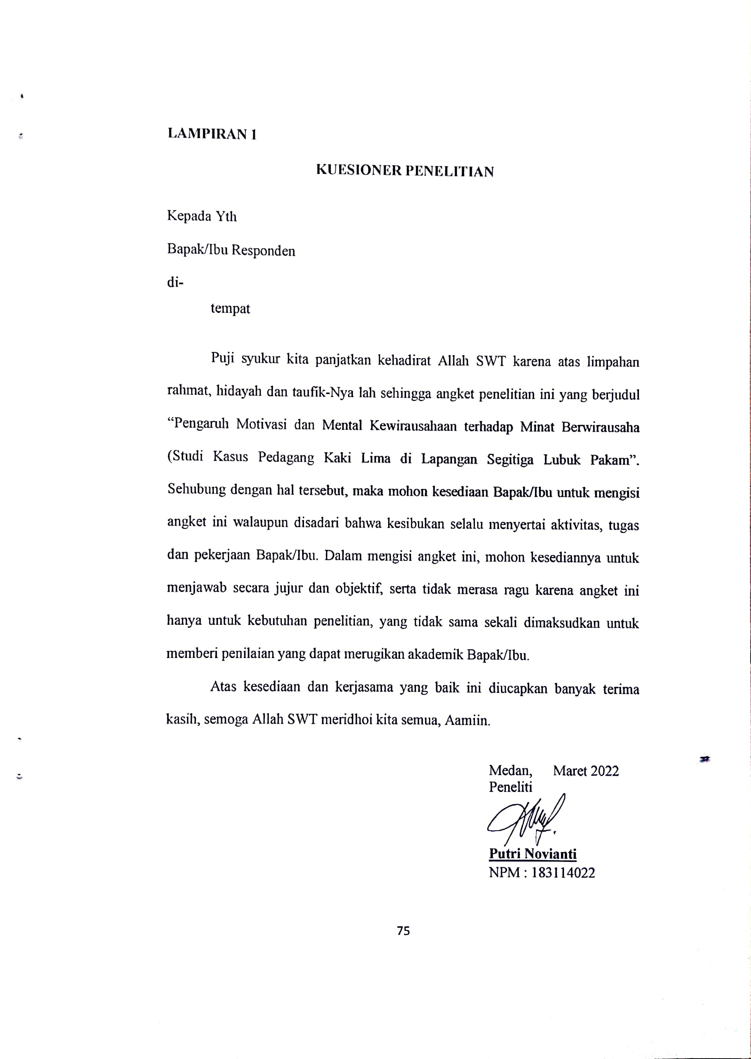
- IDENTITAS RESPONDEN

- IDENTITAS RESPONDEN
Nama :
Jenis Kelamin :
Umur :
Lama Usaha :

- PETUNJUK PENGISIAN
- Bacalah baik-baik setiap pernyataan dalam angket ini sebelum menjawabnya.
- Berilah jawaban dengan memberi tanda () pada kolom yang tersedia.
SS = Sangat Setuju
S = Setuju
KS = Kurang Setuju
TS = Tidak Setuju
STS = Sangat Tidak Setuju
- Bila ada sesuatu yang kurang jelas, mohon ditanyakan pada peneliti.
Motivasi (X₁)
No | Pernyataan | SS | S | KS | KS | STS
Pekerja Keras
1 | Saya akan tetap bekerja keras walaupun penghasilan tidak menentu.
2 | Wirausaha melatih saya dalam menghadapi situasi yang sulit.
3 | Saya yakin ketika ingin mendapatkan kesuksesan dibutuhkan kerja keras.
Pantang Menyerah
4 | Berwirausaha mengajarkan saya tentang pantang menyerah untuk mencapai kesuksesan.
5 | Tidak mudah menyerah adalah kunci keberhasilan suatu wirausaha.
6 | Saya tidak menyerah jika nanti usaha saya mengalami kerugian.
Memiliki Semangat
7 | Menjadi wirausaha yang sukses harus memiliki tingkat semangat yang tinggi.
8 | Saya beranggapan bahwa semakin tinggi semangat kerja maka akan semakin tinggi keberhasilan.
9 | Berwirausaha akan meningkatkan ekonomi keluarga saya.
10 | Saya berusaha keras mengembangkan inovasi baru.

Mental Kewirausahaan (X₂)
No | Pernyataan | SS | S | KS | KS | STS
Percaya Diri
1 | Pribadi yang percaya diri dalam melakukan segala hal harus dimiliki seorang wirausaha
2 | Wirausaha dengan kepercayaan diri yang tinggi saya berani dalam mengambil resiko.
3 | Saya yakin berwirausaha akan membuat saya menjadi mandiri.
Optimis
4 | Saya optimis bisa sukses apabila saya menjadi wirausahawan.
5 | Menjadi wirausaha yang sukses merupakan hal yang saya impikan.
Berani Mengambil Resiko
6 | Dalam berwirausaha saya perlu memiliki kepribadian yang berani mengambil resiko.
7 | Saya menyukai tantangan menghadapi risiko ketidakpastian hasil dalam berwirausaha
8 | Dalam menjalankan usaha harus mampu mengatasi rintangan atau permasalahan didalam lingkungan usaha.
Jujur
9 | Jujur dalam berwirausaha dapat meningkatkan kepercayaan konsumen.

Minat Berwirausaha (Y)
No | Pernyataan | SS | S | KS | KS | STS
Perasaan Senang
1 | Rasa senang atau suka terhadap suatu kegiatan usaha akan menarik seseorang mempelajari usaha tersebut
2 | Seseorang akan berwirausaha bila menyukainya dan bukan karena terpaksa
3 | Minat wirausaha akan muncul bila senang mempelajari hal-hal yang berbaur dengan bisnis
Ketertarikan
4 | Ketertarikan mempelajari bidang yang disukai dapat menarik minat untuk berwirausaha
5 | Seseorang tertarik untuk melakukan kegiatan usaha seiring dengan pengalaman sebelumnya
6 | Seseorang akan tertarik berwirausaha bila menggagap usaha tersebut sebagai hobi yang menyenangkan
Perhatian
7 | Seseorang yang memilki minat pada kegiatan usaha tertentu dengan penuh perhatian akan menumbuhkan rasa ingin berwirausaha
8 | Memberikan perhatian dengan mempelajari suatu usaha dapat menarik minat berwirausaha seseorang
Keterlibatan
9 | Minat wirausaha seseorang muncul bila pernah terlibat dalam menjalankan suatu usaha
10 | Keterlibatan dalam seminar bisnis dapat menumbuhkan minat wirausaha seseorang

LAMPIRAN 02

Data Pelaku Pedagang Kaki Lima Lapangan Segitiga Lubuk Pakam
NO | NAMA | BIDANG USAHA
1 | Riski | Ayam penyet
2 | Muhammad Indra | Bakso bakar
3 | Miswanto | Bakso bakar
4 | Dewi Sartika | Bakso urat mini
5 | Muhammad Eko | Burger
6 | Saut Jantur Sinaga | Gorengan
7 | Eri Setiawan | Gulali, pop corn, pop ice
8 | Munasni Tanjung | Jajanan
9 | Puspa Sari | Jajanan korea
10 | Dewi Sartika | Jajanan korea sate bakso sea food
11 | Rina Umami | Jagung & kacang rebus
12 | Putri Wulandari | Jasuke
13 | Yanti | Kebab Turki
14 | Faradila | Kentang goreng
15 | Husaini Sinaga | Kerupuk
16 | Elfira Febianti | Lontong
17 | Pipin Alningsih | Lontong
18 | May Puji Nasution | Lontong dan nasi gurih
19 | Fitri Rahayu | Nasi goreng
20 | Keisya Aulia Putri | Roti panggang
21 | Rosliani | Sate padang
22 | Anti | Sate padang
23 | Efana Yosita | Pop corn & pop ice
24 | Popy Sundari | Tela-tela/ubi goreng
25 | Sari Susanti | Tempura
26 | Hendra | Tahu crispi
27 | Tiara | Takoyaki
28 | Dewi Mandayanti | Telur gulung
29 | Fitri Dewi | Telur gulung
30 | Lia | Seblak
31 | Muhammad Ridho | Coffee Boba
32 | Iqbal | Coffee Boba
33 | Erna Wati | Es tebu
34 | Edo | Ice Boba
35 | Roni | Ice Boba
36 | Dea Ayu Pratiwi | Ice Coffee Blend
37 | Tarieni | Jus buah
38 | Tedi Syahputra | Jus buah
39 | Irfan | Jus buah
40 | Sri Rosmala Sari | Jus buah
41 | Heri Susanto | Jus buah
42 | Eva Israyani | Jus buah & Pop Ice
43 | Mini | Pop Ice
44 | Eli Susanti | Pokat kocok
45 | Saipul Bahri | Pokat kocok
46 | Andriani | Thai Tea Boba
47 | Junaidi | Kacamata & dompet
48 | Irma Yanti | Kartu paket
49 | Rasnawati | Kartu paket
Sumber :Dinas Koperasi Usaha Mikro Kecil dan Menengah Kec. Lubuk Pakam, Kab. Deli Serdang

LAMPIRAN 03
Tabulasi Data Variabel Motivasi (X1)
No Pertanyaan | Nomor Item Pernyataan |  |  |  |  |  |  |  |  |  | Total X₁
 | 1 | 2 | 3 | 4 | 5 | 6 | 7 | 8 | 9 | 10
1 | 4 | 4 | 4 | 4 | 3 | 4 | 4 | 4 | 4 | 4 | 39
2 | 4 | 4 | 4 | 4 | 4 | 4 | 4 | 4 | 4 | 4 | 40
3 | 4 | 4 | 4 | 4 | 5 | 5 | 5 | 5 | 5 | 5 | 46
4 | 4 | 4 | 4 | 4 | 4 | 5 | 5 | 5 | 5 | 5 | 45
5 | 5 | 5 | 5 | 5 | 5 | 4 | 4 | 4 | 4 | 4 | 45
6 | 5 | 4 | 5 | 4 | 4 | 4 | 4 | 4 | 4 | 4 | 42
7 | 4 | 4 | 5 | 5 | 4 | 4 | 4 | 4 | 4 | 4 | 42
8 | 4 | 4 | 4 | 4 | 4 | 5 | 5 | 5 | 5 | 5 | 45
9 | 3 | 3 | 3 | 3 | 3 | 3 | 3 | 3 | 3 | 3 | 30
10 | 5 | 5 | 5 | 4 | 5 | 5 | 5 | 4 | 4 | 5 | 47
11 | 5 | 5 | 4 | 4 | 4 | 5 | 5 | 4 | 4 | 4 | 44
12 | 4 | 4 | 4 | 4 | 4 | 4 | 4 | 4 | 3 | 4 | 39
13 | 4 | 4 | 4 | 4 | 4 | 4 | 4 | 4 | 5 | 5 | 42
14 | 4 | 4 | 4 | 4 | 4 | 4 | 4 | 4 | 4 | 4 | 40
15 | 5 | 4 | 3 | 4 | 4 | 4 | 4 | 4 | 3 | 4 | 39
16 | 4 | 3 | 5 | 4 | 4 | 5 | 4 | 4 | 4 | 4 | 41
17 | 5 | 5 | 5 | 5 | 5 | 4 | 4 | 4 | 5 | 5 | 47
18 | 3 | 3 | 3 | 5 | 4 | 4 | 4 | 4 | 5 | 5 | 40
19 | 5 | 5 | 5 | 5 | 5 | 5 | 5 | 5 | 4 | 4 | 48
20 | 4 | 2 | 4 | 4 | 4 | 4 | 4 | 4 | 4 | 4 | 38
21 | 4 | 4 | 4 | 4 | 4 | 4 | 4 | 4 | 3 | 4 | 39
22 | 5 | 5 | 5 | 5 | 5 | 5 | 5 | 5 | 5 | 5 | 50
23 | 5 | 4 | 5 | 5 | 4 | 5 | 5 | 4 | 5 | 4 | 46
24 | 5 | 4 | 5 | 5 | 5 | 5 | 5 | 5 | 5 | 4 | 48
25 | 5 | 4 | 4 | 4 | 5 | 5 | 4 | 4 | 5 | 5 | 45
26 | 4 | 4 | 5 | 4 | 4 | 4 | 4 | 4 | 4 | 4 | 41
27 | 4 | 4 | 4 | 4 | 4 | 3 | 4 | 3 | 3 | 3 | 36
28 | 5 | 5 | 5 | 5 | 5 | 5 | 5 | 5 | 5 | 5 | 50
29 | 5 | 5 | 5 | 4 | 4 | 4 | 4 | 4 | 4 | 4 | 43
30 | 4 | 3 | 4 | 4 | 4 | 3 | 3 | 3 | 3 | 3 | 34
31 | 3 | 3 | 3 | 4 | 3 | 3 | 3 | 3 | 3 | 3 | 31
32 | 5 | 5 | 5 | 5 | 3 | 4 | 5 | 4 | 4 | 4 | 44
33 | 4 | 4 | 4 | 4 | 4 | 5 | 4 | 4 | 3 | 4 | 40
34 | 4 | 4 | 4 | 3 | 3 | 3 | 4 | 3 | 4 | 3 | 35
35 | 4 | 5 | 4 | 4 | 3 | 4 | 5 | 4 | 4 | 5 | 42
36 | 4 | 5 | 4 | 4 | 3 | 5 | 5 | 4 | 4 | 5 | 43
37 | 5 | 5 | 4 | 4 | 4 | 5 | 5 | 3 | 4 | 4 | 43
38 | 4 | 4 | 5 | 4 | 3 | 5 | 4 | 4 | 4 | 4 | 41
39 | 4 | 5 | 5 | 5 | 5 | 5 | 5 | 3 | 4 | 4 | 45
40 | 5 | 5 | 5 | 5 | 5 | 5 | 5 | 5 | 5 | 5 | 50
41 | 3 | 4 | 5 | 5 | 5 | 3 | 3 | 4 | 5 | 5 | 42
42 | 5 | 5 | 5 | 5 | 5 | 5 | 5 | 5 | 5 | 5 | 50
43 | 5 | 5 | 5 | 5 | 5 | 5 | 5 | 5 | 5 | 5 | 50
44 | 5 | 5 | 5 | 5 | 5 | 4 | 4 | 4 | 4 | 4 | 45
45 | 4 | 3 | 3 | 4 | 4 | 4 | 4 | 3 | 3 | 4 | 36
46 | 3 | 4 | 3 | 4 | 3 | 3 | 3 | 3 | 3 | 3 | 32
47 | 4 | 4 | 4 | 4 | 4 | 4 | 4 | 4 | 4 | 4 | 40
48 | 4 | 5 | 5 | 4 | 4 | 5 | 5 | 4 | 4 | 4 | 44
49 | 4 | 4 | 4 | 4 | 4 | 4 | 4 | 4 | 4 | 4 | 40
 | $\sum{X}$₁ |  |  |  |  |  |  |  |  |  | 2064

Tabulasi Data Variabel Mental Kewirausahaan (X₂)
No Pertanyaan | Nomor Item Pernyataan |  |  |  |  |  |  |  |  | Total X₂
 | 1 | 2 | 3 | 4 | 5 | 6 | 7 | 8 | 9
1 | 4 | 4 | 4 | 4 | 4 | 4 | 4 | 4 | 4 | 36
2 | 4 | 4 | 4 | 4 | 4 | 4 | 4 | 4 | 4 | 36
3 | 5 | 5 | 5 | 5 | 5 | 5 | 5 | 5 | 5 | 45
4 | 4 | 4 | 4 | 4 | 4 | 4 | 4 | 4 | 4 | 36
5 | 5 | 5 | 5 | 5 | 5 | 5 | 5 | 5 | 5 | 45
6 | 4 | 4 | 4 | 4 | 4 | 4 | 4 | 4 | 4 | 36
7 | 4 | 4 | 4 | 4 | 4 | 4 | 4 | 4 | 4 | 36
8 | 4 | 4 | 4 | 4 | 4 | 4 | 4 | 4 | 4 | 36
9 | 4 | 4 | 4 | 4 | 4 | 4 | 4 | 5 | 5 | 38
10 | 4 | 4 | 5 | 5 | 5 | 4 | 4 | 4 | 5 | 40
11 | 4 | 5 | 4 | 4 | 5 | 4 | 4 | 4 | 4 | 38
12 | 4 | 4 | 3 | 3 | 3 | 4 | 4 | 3 | 4 | 32
13 | 4 | 4 | 4 | 4 | 4 | 4 | 4 | 4 | 4 | 36
14 | 2 | 4 | 4 | 4 | 4 | 4 | 4 | 4 | 4 | 34
15 | 3 | 4 | 4 | 4 | 4 | 4 | 4 | 4 | 4 | 35
16 | 3 | 4 | 3 | 3 | 4 | 4 | 4 | 3 | 4 | 32
17 | 5 | 5 | 5 | 5 | 4 | 5 | 5 | 4 | 5 | 43
18 | 4 | 4 | 4 | 4 | 4 | 4 | 4 | 4 | 4 | 36
19 | 2 | 2 | 2 | 4 | 4 | 4 | 4 | 4 | 4 | 30
20 | 2 | 2 | 2 | 4 | 4 | 4 | 4 | 4 | 4 | 30
21 | 4 | 4 | 4 | 4 | 4 | 4 | 4 | 4 | 4 | 36
22 | 4 | 4 | 4 | 4 | 4 | 4 | 4 | 4 | 4 | 36
23 | 5 | 4 | 5 | 5 | 4 | 5 | 5 | 4 | 5 | 42
24 | 5 | 4 | 5 | 5 | 5 | 4 | 5 | 4 | 5 | 42
25 | 5 | 4 | 5 | 5 | 4 | 5 | 5 | 4 | 5 | 42
26 | 4 | 3 | 4 | 4 | 4 | 4 | 4 | 4 | 4 | 35
27 | 4 | 3 | 4 | 4 | 4 | 4 | 4 | 4 | 4 | 35
28 | 4 | 4 | 4 | 4 | 4 | 5 | 4 | 5 | 5 | 39
29 | 4 | 4 | 4 | 4 | 4 | 5 | 4 | 5 | 5 | 39
30 | 4 | 4 | 4 | 4 | 4 | 4 | 4 | 4 | 4 | 36
31 | 4 | 4 | 4 | 4 | 4 | 4 | 3 | 3 | 3 | 33
32 | 4 | 4 | 4 | 4 | 4 | 5 | 4 | 4 | 5 | 38
33 | 4 | 4 | 4 | 4 | 4 | 4 | 4 | 4 | 4 | 36
34 | 5 | 5 | 5 | 5 | 5 | 5 | 5 | 5 | 5 | 45
35 | 4 | 4 | 4 | 4 | 4 | 5 | 4 | 5 | 4 | 38
36 | 3 | 3 | 4 | 4 | 4 | 5 | 5 | 5 | 4 | 37
37 | 4 | 4 | 4 | 4 | 4 | 5 | 4 | 5 | 4 | 38
38 | 5 | 5 | 5 | 5 | 5 | 5 | 5 | 5 | 5 | 45
39 | 4 | 5 | 5 | 5 | 5 | 5 | 5 | 5 | 5 | 44
40 | 4 | 4 | 4 | 4 | 4 | 4 | 4 | 4 | 4 | 36
41 | 5 | 4 | 4 | 4 | 3 | 3 | 3 | 3 | 3 | 32
42 | 4 | 4 | 4 | 4 | 4 | 4 | 3 | 3 | 3 | 33
43 | 3 | 3 | 3 | 3 | 3 | 3 | 3 | 4 | 5 | 30
44 | 4 | 4 | 4 | 4 | 4 | 4 | 4 | 4 | 4 | 36
45 | 5 | 5 | 5 | 5 | 5 | 5 | 5 | 5 | 5 | 45
46 | 5 | 5 | 5 | 5 | 5 | 5 | 5 | 5 | 5 | 45
47 | 2 | 4 | 4 | 4 | 3 | 4 | 3 | 3 | 3 | 30
48 | 3 | 4 | 4 | 4 | 5 | 5 | 5 | 5 | 5 | 40
49 | 4 | 4 | 4 | 4 | 4 | 4 | 4 | 4 | 4 | 36
 | $\sum{X}$₂ |  |  |  |  |  |  |  |  | 1829

Tabulasi Data Variabel Minat Berwirausaha (Y)
No Pertanyaan | Nomor Item Pernyataan |  |  |  |  |  |  |  |  |  | Total Y
 | 1 | 2 | 3 | 4 | 5 | 6 | 7 | 8 | 9 | 10
1 | 4 | 4 | 4 | 4 | 4 | 4 | 4 | 4 | 4 | 4 | 40
2 | 4 | 4 | 4 | 4 | 4 | 4 | 4 | 4 | 4 | 4 | 40
3 | 5 | 5 | 5 | 5 | 5 | 5 | 5 | 5 | 5 | 5 | 50
4 | 4 | 4 | 4 | 4 | 5 | 5 | 5 | 5 | 5 | 4 | 45
5 | 5 | 5 | 5 | 5 | 5 | 5 | 5 | 5 | 5 | 5 | 50
6 | 4 | 4 | 4 | 4 | 4 | 4 | 4 | 4 | 4 | 4 | 40
7 | 4 | 4 | 4 | 4 | 4 | 4 | 4 | 4 | 4 | 4 | 40
8 | 4 | 4 | 4 | 4 | 5 | 5 | 5 | 5 | 5 | 5 | 46
9 | 4 | 4 | 5 | 5 | 4 | 4 | 4 | 4 | 4 | 4 | 42
10 | 4 | 4 | 4 | 5 | 5 | 5 | 5 | 4 | 4 | 4 | 44
11 | 4 | 4 | 4 | 5 | 5 | 5 | 4 | 4 | 4 | 5 | 44
12 | 5 | 4 | 3 | 4 | 3 | 4 | 3 | 3 | 3 | 3 | 35
13 | 4 | 4 | 4 | 4 | 4 | 4 | 4 | 4 | 4 | 4 | 40
14 | 4 | 4 | 4 | 4 | 4 | 4 | 4 | 4 | 4 | 4 | 40
15 | 4 | 4 | 3 | 3 | 4 | 4 | 4 | 4 | 4 | 4 | 38
16 | 4 | 5 | 4 | 5 | 5 | 4 | 4 | 4 | 4 | 4 | 43
17 | 5 | 4 | 4 | 4 | 5 | 4 | 4 | 4 | 4 | 4 | 42
18 | 3 | 3 | 3 | 3 | 4 | 3 | 4 | 4 | 4 | 4 | 35
19 | 4 | 4 | 4 | 4 | 4 | 4 | 4 | 4 | 4 | 4 | 40
20 | 4 | 4 | 4 | 4 | 4 | 4 | 3 | 3 | 3 | 3 | 36
21 | 4 | 4 | 4 | 4 | 5 | 4 | 4 | 4 | 4 | 4 | 41
22 | 5 | 4 | 5 | 5 | 5 | 4 | 5 | 5 | 4 | 5 | 47
23 | 5 | 4 | 5 | 5 | 4 | 5 | 5 | 5 | 4 | 5 | 47
24 | 5 | 4 | 5 | 5 | 4 | 5 | 5 | 4 | 5 | 5 | 47
25 | 5 | 4 | 5 | 5 | 4 | 5 | 5 | 4 | 5 | 5 | 47
26 | 4 | 4 | 4 | 4 | 4 | 4 | 4 | 4 | 4 | 4 | 40
27 | 4 | 4 | 4 | 4 | 4 | 4 | 4 | 4 | 4 | 4 | 40
28 | 4 | 4 | 5 | 5 | 5 | 5 | 4 | 4 | 4 | 4 | 44
29 | 4 | 4 | 5 | 5 | 5 | 5 | 4 | 4 | 4 | 4 | 44
30 | 4 | 4 | 4 | 4 | 4 | 4 | 4 | 4 | 4 | 4 | 40
31 | 4 | 4 | 4 | 4 | 4 | 4 | 3 | 4 | 3 | 4 | 38
32 | 4 | 4 | 5 | 4 | 4 | 4 | 4 | 5 | 4 | 4 | 42
33 | 5 | 5 | 5 | 5 | 5 | 5 | 5 | 5 | 5 | 5 | 50
34 | 4 | 4 | 3 | 3 | 3 | 3 | 3 | 3 | 3 | 3 | 32
35 | 4 | 4 | 3 | 4 | 5 | 5 | 5 | 5 | 4 | 4 | 43
36 | 5 | 5 | 3 | 5 | 5 | 5 | 4 | 4 | 4 | 4 | 44
37 | 3 | 3 | 3 | 3 | 3 | 3 | 3 | 4 | 3 | 4 | 32
38 | 5 | 5 | 5 | 5 | 5 | 5 | 5 | 5 | 5 | 5 | 50
39 | 4 | 4 | 3 | 4 | 5 | 5 | 4 | 4 | 3 | 4 | 40
40 | 4 | 4 | 4 | 4 | 4 | 4 | 4 | 4 | 4 | 4 | 40
41 | 5 | 5 | 5 | 5 | 5 | 5 | 5 | 5 | 5 | 5 | 50
42 | 3 | 3 | 3 | 3 | 3 | 3 | 3 | 4 | 3 | 4 | 32
43 | 3 | 3 | 3 | 3 | 3 | 3 | 3 | 3 | 3 | 3 | 30
44 | 4 | 4 | 4 | 4 | 4 | 4 | 4 | 4 | 4 | 4 | 40
45 | 5 | 4 | 3 | 4 | 3 | 4 | 3 | 3 | 3 | 3 | 35
46 | 4 | 3 | 4 | 3 | 3 | 3 | 3 | 3 | 3 | 3 | 32
47 | 3 | 3 | 3 | 3 | 3 | 3 | 3 | 3 | 3 | 3 | 30
48 | 5 | 5 | 5 | 5 | 5 | 5 | 5 | 5 | 5 | 5 | 50
49 | 4 | 5 | 4 | 5 | 5 | 3 | 4 | 4 | 4 | 4 | 42
 | $$\sum{Y}$$ |  |  |  |  |  |  |  |  |  | 2019

LAMPIRAN 04
Hasil Output SPSS Validitas Dan Reliabilitas

Output Reliabilitas Motivasi (X₁)
Reliability Statistics
Cronbach's Alpha | N of Items
0.909 | 10

Output Data Validitas Motivasi (X₁)
Correlations
 |  | X1.1 | X1.2 | X1.3 | X1.4 | X1.5 | X1.6 | X1.7 | X1.8 | X1.9 | X1.10 | Total_X1
X1.1 | Pearson Correlation | 1 | .621** | .582** | .418** | .523** | .548** | .600** | .447** | .342* | .307* | .727**
 | Sig. (2-tailed) |  | 0.000 | 0.000 | 0.003 | 0.000 | 0.000 | 0.000 | 0.001 | 0.016 | 0.032 | 0.000
 | N | 49 | 49 | 49 | 49 | 49 | 49 | 49 | 49 | 49 | 49 | 49
X1.2 | Pearson Correlation | .621** | 1 | .565** | .427** | .357* | .446** | .621** | .351* | .316* | .394** | .693**
 | Sig. (2-tailed) | 0.000 |  | 0.000 | 0.002 | 0.012 | 0.001 | 0.000 | 0.013 | 0.027 | 0.005 | 0.000
 | N | 49 | 49 | 49 | 49 | 49 | 49 | 49 | 49 | 49 | 49 | 49
X1.3 | Pearson Correlation | .582** | .565** | 1 | .584** | .523** | .446** | .442** | .465** | .481** | .316* | .729**
 | Sig. (2-tailed) | 0.000 | 0.000 |  | 0.000 | 0.000 | 0.001 | 0.001 | 0.001 | 0.000 | 0.027 | 0.000
 | N | 49 | 49 | 49 | 49 | 49 | 49 | 49 | 49 | 49 | 49 | 49
X1.4 | Pearson Correlation | .418** | .427** | .584** | 1 | .625** | .327* | .359* | .473** | .517** | .427** | .682**
 | Sig. (2-tailed) | 0.003 | 0.002 | 0.000 |  | 0.000 | 0.022 | 0.011 | 0.001 | 0.000 | 0.002 | 0.000
 | N | 49 | 49 | 49 | 49 | 49 | 49 | 49 | 49 | 49 | 49 | 49
X1.5 | Pearson Correlation | .523** | .357* | .523** | .625** | 1 | .435** | .338* | .518** | .519** | .500** | .716**
 | Sig. (2-tailed) | 0.000 | 0.012 | 0.000 | 0.000 |  | 0.002 | 0.018 | 0.000 | 0.000 | 0.000 | 0.000
 | N | 49 | 49 | 49 | 49 | 49 | 49 | 49 | 49 | 49 | 49 | 49
X1.6 | Pearson Correlation | .548** | .446** | .446** | .327* | .435** | 1 | .822** | .643** | .519** | .600** | .783**
 | Sig. (2-tailed) | 0.000 | 0.001 | 0.001 | 0.022 | 0.002 |  | 0.000 | 0.000 | 0.000 | 0.000 | 0.000
 | N | 49 | 49 | 49 | 49 | 49 | 49 | 49 | 49 | 49 | 49 | 49
X1.7 | Pearson Correlation | .600** | .621** | .442** | .359* | .338* | .822** | 1 | .601** | .523** | .558** | .792**
 | Sig. (2-tailed) | 0.000 | 0.000 | 0.001 | 0.011 | 0.018 | 0.000 |  | 0.000 | 0.000 | 0.000 | 0.000
 | N | 49 | 49 | 49 | 49 | 49 | 49 | 49 | 49 | 49 | 49 | 49
X1.8 | Pearson Correlation | .447** | .351* | .465** | .473** | .518** | .643** | .601** | 1 | .691** | .709** | .791**
 | Sig. (2-tailed) | 0.001 | 0.013 | 0.001 | 0.001 | 0.000 | 0.000 | 0.000 |  | 0.000 | 0.000 | 0.000
 | N | 49 | 49 | 49 | 49 | 49 | 49 | 49 | 49 | 49 | 49 | 49
X1.9 | Pearson Correlation | .342* | .316* | .481** | .517** | .519** | .519** | .523** | .691** | 1 | .768** | .764**
 | Sig. (2-tailed) | 0.016 | 0.027 | 0.000 | 0.000 | 0.000 | 0.000 | 0.000 | 0.000 |  | 0.000 | 0.000
 | N | 49 | 49 | 49 | 49 | 49 | 49 | 49 | 49 | 49 | 49 | 49
X1.10 | Pearson Correlation | .307* | .394** | .316* | .427** | .500** | .600** | .558** | .709** | .768** | 1 | .751**
 | Sig. (2-tailed) | 0.032 | 0.005 | 0.027 | 0.002 | 0.000 | 0.000 | 0.000 | 0.000 | 0.000 |  | 0.000
 | N | 49 | 49 | 49 | 49 | 49 | 49 | 49 | 49 | 49 | 49 | 49
Total_X1 | Pearson Correlation | .727** | .693** | .729** | .682** | .716** | .783** | .792** | .791** | .764** | .751** | 1
 | Sig. (2-tailed) | 0.000 | 0.000 | 0.000 | 0.000 | 0.000 | 0.000 | 0.000 | 0.000 | 0.000 | 0.000
 | N | 49 | 49 | 49 | 49 | 49 | 49 | 49 | 49 | 49 | 49 | 49
**. Correlation is significant at the 0.01 level (2-tailed).
*. Correlation is significant at the 0.05 level (2-tailed).

Output Reliabilitas Mental Kewirausahaan (X₂)
Reliability Statistics
Cronbach's Alpha | N of Items
0.914 | 9

Output Data Validitas Mental Kewirausahaan (X₂)
Correlations
 |  | X2.1 | X2.2 | X2.3 | X2.4 | X2.5 | X2.6 | X2.7 | X2.8 | X2.9 | Total_X2
X2.1 | Pearson Correlation | 1 | .659** | .754** | .599** | .392** | .355* | .447** | 0.259 | .399** | .726**
 | Sig. (2-tailed) |  | 0.000 | 0.000 | 0.000 | 0.005 | 0.012 | 0.001 | 0.072 | 0.004 | 0.000
 | N | 49 | 49 | 49 | 49 | 49 | 49 | 49 | 49 | 49 | 49
X2.2 | Pearson Correlation | .659** | 1 | .778** | .527** | .517** | .443** | .419** | .295* | .346* | .729**
 | Sig. (2-tailed) | 0.000 |  | 0.000 | 0.000 | 0.000 | 0.001 | 0.003 | 0.040 | 0.015 | 0.000
 | N | 49 | 49 | 49 | 49 | 49 | 49 | 49 | 49 | 49 | 49
X2.3 | Pearson Correlation | .754** | .778** | 1 | .813** | .580** | .526** | .577** | .399** | .476** | .856**
 | Sig. (2-tailed) | 0.000 | 0.000 |  | 0.000 | 0.000 | 0.000 | 0.000 | 0.004 | 0.001 | 0.000
 | N | 49 | 49 | 49 | 49 | 49 | 49 | 49 | 49 | 49 | 49
X2.4 | Pearson Correlation | .599** | .527** | .813** | 1 | .711** | .595** | .705** | .477** | .544** | .845**
 | Sig. (2-tailed) | 0.000 | 0.000 | 0.000 |  | 0.000 | 0.000 | 0.000 | 0.001 | 0.000 | 0.000
 | N | 49 | 49 | 49 | 49 | 49 | 49 | 49 | 49 | 49 | 49
X2.5 | Pearson Correlation | .392** | .517** | .580** | .711** | 1 | .553** | .710** | .609** | .567** | .787**
 | Sig. (2-tailed) | 0.005 | 0.000 | 0.000 | 0.000 |  | 0.000 | 0.000 | 0.000 | 0.000 | 0.000
 | N | 49 | 49 | 49 | 49 | 49 | 49 | 49 | 49 | 49 | 49
X2.6 | Pearson Correlation | .355* | .443** | .526** | .595** | .553** | 1 | .745** | .704** | .603** | .770**
 | Sig. (2-tailed) | 0.012 | 0.001 | 0.000 | 0.000 | 0.000 |  | 0.000 | 0.000 | 0.000 | 0.000
 | N | 49 | 49 | 49 | 49 | 49 | 49 | 49 | 49 | 49 | 49
X2.7 | Pearson Correlation | .447** | .419** | .577** | .705** | .710** | .745** | 1 | .662** | .733** | .839**
 | Sig. (2-tailed) | 0.001 | 0.003 | 0.000 | 0.000 | 0.000 | 0.000 |  | 0.000 | 0.000 | 0.000
 | N | 49 | 49 | 49 | 49 | 49 | 49 | 49 | 49 | 49 | 49
X2.8 | Pearson Correlation | 0.259 | .295* | .399** | .477** | .609** | .704** | .662** | 1 | .693** | .709**
 | Sig. (2-tailed) | 0.072 | 0.040 | 0.004 | 0.001 | 0.000 | 0.000 | 0.000 |  | 0.000 | 0.000
 | N | 49 | 49 | 49 | 49 | 49 | 49 | 49 | 49 | 49 | 49
X2.9 | Pearson Correlation | .399** | .346* | .476** | .544** | .567** | .603** | .733** | .693** | 1 | .754**
 | Sig. (2-tailed) | 0.004 | 0.015 | 0.001 | 0.000 | 0.000 | 0.000 | 0.000 | 0.000 |  | 0.000
 | N | 49 | 49 | 49 | 49 | 49 | 49 | 49 | 49 | 49 | 49
Total_X2 | Pearson Correlation | .726** | .729** | .856** | .845** | .787** | .770** | .839** | .709** | .754** | 1
 | Sig. (2-tailed) | 0.000 | 0.000 | 0.000 | 0.000 | 0.000 | 0.000 | 0.000 | 0.000 | 0.000
 | N | 49 | 49 | 49 | 49 | 49 | 49 | 49 | 49 | 49 | 49
**. Correlation is significant at the 0.01 level (2-tailed).
*. Correlation is significant at the 0.05 level (2-tailed).

Output Reliabilitas Minat Berwirausaha (Y)
Reliability Statistics
Cronbach's Alpha | N of Items
0.949 | 10

Output Data Validitas Minat Berwirausaha (Y)
Correlations
 |  | Y.1 | Y.2 | Y.3 | Y.4 | Y.5 | Y.6 | Y.7 | Y.8 | Y.9 | Y.10 | Total_Y
Y.1 | Pearson Correlation | 1 | .714** | .549** | .695** | .422** | .646** | .556** | .395** | .534** | .507** | .718**
 | Sig. (2-tailed) |  | 0.000 | 0.000 | 0.000 | 0.003 | 0.000 | 0.000 | 0.005 | 0.000 | 0.000 | 0.000
 | N | 49 | 49 | 49 | 49 | 49 | 49 | 49 | 49 | 49 | 49 | 49
Y.2 | Pearson Correlation | .714** | 1 | .504** | .764** | .688** | .604** | .574** | .525** | .627** | .525** | .779**
 | Sig. (2-tailed) | 0.000 |  | 0.000 | 0.000 | 0.000 | 0.000 | 0.000 | 0.000 | 0.000 | 0.000 | 0.000
 | N | 49 | 49 | 49 | 49 | 49 | 49 | 49 | 49 | 49 | 49 | 49
Y.3 | Pearson Correlation | .549** | .504** | 1 | .746** | .491** | .545** | .639** | .585** | .688** | .676** | .780**
 | Sig. (2-tailed) | 0.000 | 0.000 |  | 0.000 | 0.000 | 0.000 | 0.000 | 0.000 | 0.000 | 0.000 | 0.000
 | N | 49 | 49 | 49 | 49 | 49 | 49 | 49 | 49 | 49 | 49 | 49
Y.4 | Pearson Correlation | .695** | .764** | .746** | 1 | .716** | .750** | .680** | .522** | .634** | .664** | .867**
 | Sig. (2-tailed) | 0.000 | 0.000 | 0.000 |  | 0.000 | 0.000 | 0.000 | 0.000 | 0.000 | 0.000 | 0.000
 | N | 49 | 49 | 49 | 49 | 49 | 49 | 49 | 49 | 49 | 49 | 49
Y.5 | Pearson Correlation | .422** | .688** | .491** | .716** | 1 | .716** | .740** | .686** | .665** | .640** | .820**
 | Sig. (2-tailed) | 0.003 | 0.000 | 0.000 | 0.000 |  | 0.000 | 0.000 | 0.000 | 0.000 | 0.000 | 0.000
 | N | 49 | 49 | 49 | 49 | 49 | 49 | 49 | 49 | 49 | 49 | 49
Y.6 | Pearson Correlation | .646** | .604** | .545** | .750** | .716** | 1 | .764** | .617** | .678** | .664** | .846**
 | Sig. (2-tailed) | 0.000 | 0.000 | 0.000 | 0.000 | 0.000 |  | 0.000 | 0.000 | 0.000 | 0.000 | 0.000
 | N | 49 | 49 | 49 | 49 | 49 | 49 | 49 | 49 | 49 | 49 | 49
Y.7 | Pearson Correlation | .556** | .574** | .639** | .680** | .740** | .764** | 1 | .841** | .901** | .841** | .911**
 | Sig. (2-tailed) | 0.000 | 0.000 | 0.000 | 0.000 | 0.000 | 0.000 |  | 0.000 | 0.000 | 0.000 | 0.000
 | N | 49 | 49 | 49 | 49 | 49 | 49 | 49 | 49 | 49 | 49 | 49
Y.8 | Pearson Correlation | .395** | .525** | .585** | .522** | .686** | .617** | .841** | 1 | .767** | .838** | .817**
 | Sig. (2-tailed) | 0.005 | 0.000 | 0.000 | 0.000 | 0.000 | 0.000 | 0.000 |  | 0.000 | 0.000 | 0.000
 | N | 49 | 49 | 49 | 49 | 49 | 49 | 49 | 49 | 49 | 49 | 49
Y.9 | Pearson Correlation | .534** | .627** | .688** | .634** | .665** | .678** | .901** | .767** | 1 | .818** | .882**
 | Sig. (2-tailed) | 0.000 | 0.000 | 0.000 | 0.000 | 0.000 | 0.000 | 0.000 | 0.000 |  | 0.000 | 0.000
 | N | 49 | 49 | 49 | 49 | 49 | 49 | 49 | 49 | 49 | 49 | 49
Y.10 | Pearson Correlation | .507** | .525** | .676** | .664** | .640** | .664** | .841** | .838** | .818** | 1 | .865**
 | Sig. (2-tailed) | 0.000 | 0.000 | 0.000 | 0.000 | 0.000 | 0.000 | 0.000 | 0.000 | 0.000 |  | 0.000
 | N | 49 | 49 | 49 | 49 | 49 | 49 | 49 | 49 | 49 | 49 | 49
Total_Y | Pearson Correlation | .718** | .779** | .780** | .867** | .820** | .846** | .911** | .817** | .882** | .865** | 1
 | Sig. (2-tailed) | 0.000 | 0.000 | 0.000 | 0.000 | 0.000 | 0.000 | 0.000 | 0.000 | 0.000 | 0.000
 | N | 49 | 49 | 49 | 49 | 49 | 49 | 49 | 49 | 49 | 49 | 49
**. Correlation is significant at the 0.01 level (2-tailed).

Tabel Persentase Distribusi R Tabel
N | The Level of Significance |  | N | The Level of Significance
 | 5% | 1% |  | 5% | 1%
3 | 0.997 | 0.999 | 38 | 0.32 | 0.413
4 | 0.95 | 0.99 | 39 | 0.316 | 0.408
5 | 0.878 | 0.959 | 40 | 0.312 | 0.403
6 | 0.811 | 0.917 | 41 | 0.308 | 0.398
7 | 0.754 | 0.874 | 42 | 0.304 | 0.393
8 | 0.707 | 0.834 | 43 | 0.301 | 0.389
9 | 0.666 | 0.798 | 44 | 0.297 | 0.384
10 | 0.632 | 0.765 | 45 | 0.294 | 0.38
11 | 0.602 | 0.735 | 46 | 0.291 | 0.376
12 | 0.576 | 0.708 | 47 | 0.288 | 0.372
13 | 0.553 | 0.684 | 48 | 0.284 | 0.368
14 | 0.532 | 0.661 | 49 | 0.281 | 0.364
15 | 0.514 | 0.641 | 50 | 0.279 | 0.361
16 | 0.497 | 0.623 | 55 | 0.266 | 0.345
17 | 0.482 | 0.606 | 60 | 0.254 | 0.33
18 | 0.468 | 0.59 | 65 | 0.244 | 0.317
19 | 0.456 | 0.575 | 70 | 0.235 | 0.306
20 | 0.444 | 0.561 | 75 | 0.227 | 0.296
21 | 0.433 | 0.549 | 80 | 0.22 | 0.286
22 | 0.432 | 0.537 | 85 | 0.213 | 0.278
23 | 0.413 | 0.526 | 90 | 0.207 | 0.267
24 | 0.404 | 0.515 | 95 | 0.202 | 0.263
25 | 0.396 | 0.505 | 100 | 0.195 | 0.256
26 | 0.388 | 0.496 | 125 | 0.176 | 0.23
27 | 0.381 | 0.487 | 150 | 0.159 | 0.21
28 | 0.374 | 0.478 | 175 | 0.148 | 0.194
29 | 0.367 | 0.47 | 200 | 0.138 | 0.181
30 | 0.361 | 0.463 | 300 | 0.113 | 0.148
31 | 0.355 | 0.456 | 400 | 0.098 | 0.128
32 | 0.349 | 0.449 | 500 | 0.088 | 0.115
33 | 0.344 | 0.442 | 600 | 0.08 | 0.105
34 | 0.339 | 0.436 | 700 | 0.074 | 0.097
35 | 0.334 | 0.43 | 800 | 0.07 | 0.091
36 | 0.329 | 0.424 | 900 | 0.065 | 0.086
37 | 0.325 | 0.418 | 1000 | 0.062 | 0.081

Tabel Persentase Distribusi Tabel F_{0,05}
Degrees Of Freedom For Nominator
Degrees of freedom for Denominator |  | 1 | 2 | 3 | 4 | 5 | 6 | 7 | 8 | 9 | 10 | 12 | 15 | 20 | 24 | 30 | 40 | 60 | 120 | ∞
 | 1 | 161 | 200 | 216 | 225 | 230 | 234 | 237 | 239 | 241 | 242 | 244 | 246 | 248 | 249 | 250 | 251 | 252 | 253 | 254
 | 2 | 18,5 | 19,0 | 19,2 | 19,2 | 19,3 | 19,3 | 19,4 | 19,4 | 19,4 | 19,4 | 19,4 | 19,4 | 19,4 | 19,5 | 19,5 | 19,5 | 19,5 | 19,5 | 19,5
 | 3 | 10,1 | 9,55 | 9,28 | 9,12 | 9,01 | 8,94 | 8,89 | 8,85 | 8,81 | 8,79 | 8,74 | 8,70 | 8,66 | 8,64 | 8,62 | 8,59 | 8,57 | 8,55 | 8,53
 | 4 | 7,71 | 6,94 | 6,59 | 6,39 | 6,26 | 6,16 | 6,09 | 6,04 | 6,00 | 5,96 | 5,91 | 5,86 | 5,80 | 5,77 | 5,75 | 5,72 | 5,69 | 5,66 | 5,63
 | 5 | 6,61 | 5,79 | 5,41 | 5,19 | 5,05 | 4,95 | 4,88 | 4,82 | 4,77 | 4,74 | 4,68 | 4,62 | 4,56 | 4,53 | 4,50 | 4,46 | 4,43 | 4,40 | 4,37
 | 6 | 5,99 | 5,14 | 4,76 | 4,53 | 4,39 | 4,28 | 4,21 | 4,15 | 4,10 | 4,06 | 4,00 | 3,94 | 3,87 | 3,84 | 3,81 | 3,77 | 3,74 | 3,70 | 3,67
 | 7 | 5,59 | 4,74 | 4,35 | 4,12 | 3,97 | 3,87 | 3,79 | 3,73 | 3,68 | 3,64 | 3,57 | 3,51 | 3,44 | 3,41 | 3,38 | 3,34 | 3,30 | 3,27 | 3,23
 | 8 | 5,32 | 4,46 | 4,07 | 3,84 | 4,69 | 3,58 | 3,50 | 3,44 | 3,39 | 3,35 | 3,28 | 3,22 | 3,15 | 3,12 | 3,08 | 3,04 | 3,01 | 2,97 | 2,93
 | 9 | 5,12 | 4,26 | 3,86 | 3,63 | 3,48 | 3,37 | 3,29 | 3,23 | 3,18 | 3,14 | 3,07 | 3,01 | 2,94 | 2,90 | 2,86 | 2,83 | 2,79 | 2,75 | 2,71
 | 10 | 4,96 | 4,10 | 3,71 | 3,48 | 3,33 | 3,22 | 3,14 | 3,07 | 3,02 | 2,98 | 2,91 | 2,85 | 2,77 | 2,74 | 2,70 | 2,66 | 2,62 | 2,58 | 2,54
 | 11 | 4,84 | 3,98 | 3,59 | 3,36 | 3,20 | 3,09 | 3,01 | 2,95 | 2,90 | 2,85 | 2,79 | 2,72 | 2,65 | 2,61 | 2,57 | 2,53 | 2,49 | 2,45 | 2,40
 | 12 | 4,75 | 3,89 | 3,49 | 3,26 | 3,11 | 3,00 | 2,91 | 2,85 | 2,80 | 2,75 | 2,69 | 2,62 | 2,54 | 2,51 | 2,47 | 2,43 | 2,38 | 2,34 | 2,30
 | 13 | 4,67 | 3,81 | 3,41 | 3,13 | 3,03 | 2,92 | 2,83 | 2,77 | 2,71 | 2,67 | 2,60 | 2,53 | 2,46 | 2,42 | 2,38 | 2,34 | 2,30 | 2,25 | 2,21
 | 14 | 4,60 | 3,74 | 3,34 | 3,11 | 2,96 | 2,85 | 2,76 | 2,70 | 2,65 | 2,60 | 2,53 | 2,46 | 2,39 | 2,35 | 2,31 | 2,27 | 2,22 | 2,18 | 2,13
 | 15 | 4,54 | 3,68 | 3,29 | 3,06 | 2,90 | 2,79 | 2,71 | 2,64 | 6,59 | 2,54 | 2,48 | 2,40 | 2,33 | 2,29 | 2,25 | 2,20 | 2,16 | 2,11 | 2,07
 | 16 | 4,49 | 3,63 | 3,24 | 3,01 | 2,85 | 2,74 | 2,66 | 2,59 | 2,54 | 2,49 | 2,42 | 2,35 | 2,28 | 2,24 | 2,19 | 2,15 | 2,11 | 2,06 | 2,01
 | 17 | 4,45 | 3,59 | 3,20 | 2,96 | 2,81 | 2,70 | 2,61 | 2,55 | 2,49 | 2,45 | 2,38 | 2,31 | 2,23 | 2,19 | 2,15 | 2,10 | 2,06 | 2,01 | 1,96
 | 18 | 4,41 | 3,55 | 3,16 | 2,93 | 2,77 | 2,66 | 2,58 | 2,51 | 2,46 | 2,41 | 2,34 | 2,27 | 2,19 | 2,15 | 2,11 | 2,06 | 2,02 | 1,97 | 1,92
 | 19 | 4,38 | 3,52 | 3,13 | 2,90 | 2,74 | 2,63 | 2,54 | 2,48 | 2,42 | 2,38 | 2,31 | 2,23 | 2,16 | 2,11 | 2,07 | 2,03 | 1,98 | 1,93 | 1,88
 | 20 | 4,35 | 3,49 | 3,10 | 2,87 | 2,71 | 2,60 | 2,51 | 2,45 | 2,39 | 2,35 | 2,28 | 2,20 | 2,12 | 2,08 | 2,04 | 1,99 | 1,95 | 1,90 | 1,84
 | 21 | 4,32 | 3,47 | 3,07 | 2,84 | 2,68 | 2,57 | 2,49 | 2,42 | 2,37 | 2,32 | 2,25 | 2,18 | 2,10 | 2,05 | 2,01 | 1,96 | 1,92 | 1,87 | 1,81
 | 22 | 4,30 | 3,44 | 3,05 | 2,82 | 2,66 | 2,55 | 2,46 | 2,40 | 2,34 | 2,30 | 2,23 | 2,15 | 2,07 | 2,03 | 1,98 | 1,94 | 1,89 | 1,84 | 1,78
 | 23 | 4,28 | 3,42 | 3,03 | 2,80 | 2,64 | 2,53 | 2,44 | 2,37 | 2,32 | 2,27 | 2,20 | 2,13 | 2,05 | 2,01 | 1,96 | 1,91 | 1,86 | 1,81 | 1,76
 | 24 | 4,26 | 3,40 | 3,01 | 2,78 | 2,62 | 2,51 | 2,42 | 2,36 | 2,30 | 2,25 | 2,18 | 2,11 | 2,03 | 1,98 | 1,94 | 1,89 | 1,84 | 1,79 | 1,73
 | 25 | 4,24 | 3,39 | 2,99 | 2,76 | 2,60 | 2,49 | 2,40 | 2,34 | 2,28 | 2,24 | 2,16 | 2,09 | 2,01 | 1,96 | 1,92 | 1,87 | 1,82 | 1,77 | 1,71
 | 30 | 4,17 | 3,32 | 2,92 | 2,69 | 2,53 | 2,42 | 2,33 | 2,27 | 2,21 | 2,16 | 2,09 | 2,01 | 1,93 | 1,89 | 1,84 | 1,79 | 1,74 | 1,68 | 1,62
 | 40 | 4,08 | 3,23 | 2,84 | 2,61 | 2,45 | 2,34 | 2,25 | 2,18 | 2,12 | 2,08 | 2,00 | 1,92 | 1,84 | 1,79 | 1,74 | 1,69 | 1,64 | 1,58 | 1,51
 | 50 | 4,08 | 3,18 | 2,79 | 2,56 | 2,40 | 2,29 | 2,20 | 2,13 | 2,07 | 2,02 | 1,95 | 1,87 | 1,78 | 1,74 | 1,69 | 1.63 | 1,56 | 1,50 | 1,41
 | 60 | 4,00 | 3,15 | 2,76 | 2,53 | 2,37 | 2,25 | 2,17 | 2,10 | 2,04 | 1,99 | 1,92 | 1,84 | 1,75 | 1,70 | 1,65 | 1,59 | 1,53 | 1,47 | 1,39
 | 100 | 3,94 | 3,09 | 2,70 | 2,46 | 2,30 | 2,19 | 2,10 | 2,03 | 1,97 | 1,92 | 1,85 | 1,80 | 1,68 | 1,63 | 1,57 | 1,51 | 1,46 | 1,40 | 1,28
 | 120 | 3,92 | 3,07 | 2,68 | 2,45 | 2,29 | 2,18 | 2,09 | 2,02 | 1,96 | 1,91 | 1,83 | 1,75 | 1,66 | 1,61 | 1,55 | 1,50 | 1,43 | 1,35 | 1,22
 | ∞ | 3,84 | 3,00 | 2,60 | 2,37 | 2,21 | 2,10 | 2,01 | 1,94 | 1,88 | 1,83 | 1,75 | 1,67 | 1,57 | 1,52 | 1,46 | 1,39 | 1,32 | 1,22 | 1,00

Tabel Distribusi T Tabel
d.f | t_{0.10} | t_{0.05} | t_{0.025} | t_{0.01} | t_{0.005} |  | d.f | t_{0.10} | t_{0.05} | t_{0.025} | t_{0.01} | t_{0.005}
1 | 3.078 | 6.314 | 12.71 | 31.82 | 63.66 |  | 61 | 1.296 | 1.671 | 2.000 | 2.390 | 2.659
2 | 1.886 | 2.920 | 4.303 | 6.965 | 9.925 |  | 62 | 1.296 | 1.671 | 1.999 | 2.389 | 2.659
3 | 1.638 | 2.353 | 3.182 | 4.541 | 5.841 |  | 63 | 1.296 | 1.670 | 1.999 | 2.389 | 2.658
4 | 1.533 | 2.132 | 2.776 | 3.747 | 4.604 |  | 64 | 1.296 | 1.670 | 1.999 | 2.388 | 2.657
5 | 1.476 | 2.015 | 2.571 | 3.365 | 4.032 |  | 65 | 1.296 | 1.670 | 1.998 | 2.388 | 2.657
6 | 1.440 | 1.943 | 2.447 | 3.143 | 3.707 |  | 66 | 1.295 | 1.670 | 1.998 | 2.387 | 2.656
7 | 1.415 | 1.895 | 2.365 | 2.998 | 3.499 |  | 67 | 1.295 | 1.670 | 1.998 | 2.387 | 2.655
8 | 1.397 | 1.860 | 2.306 | 2.896 | 3.355 |  | 68 | 1.295 | 1.670 | 1.997 | 2.386 | 2.655
9 | 1.383 | 1.833 | 2.262 | 2.821 | 3.250 |  | 69 | 1.295 | 1.669 | 1.997 | 2.386 | 2.654
10 | 1.372 | 1.812 | 2.228 | 2.764 | 3.169 |  | 70 | 1.295 | 1.669 | 1.997 | 2.385 | 2.653
11 | 1.363 | 1.796 | 2.201 | 2.718 | 3.106 |  | 71 | 1.295 | 1.669 | 1.996 | 2.385 | 2.653
12 | 1.356 | 1.782 | 2.179 | 2.681 | 3.055 |  | 72 | 1.295 | 1.669 | 1.996 | 2.384 | 2.652
13 | 1.350 | 1.771 | 2.160 | 2.650 | 3.012 |  | 73 | 1.295 | 1.669 | 1.996 | 2.384 | 2.651
14 | 1.345 | 1.761 | 2.145 | 2.624 | 2.977 |  | 74 | 1.295 | 1.668 | 1.995 | 2.383 | 2.651
15 | 1.341 | 1.753 | 2.131 | 2.602 | 2.947 |  | 75 | 1.295 | 1.668 | 1.995 | 2.383 | 2.650
16 | 1.337 | 1.746 | 2.120 | 2.583 | 2.921 |  | 76 | 1.294 | 1.668 | 1.995 | 2.382 | 2.649
17 | 1.333 | 1.740 | 2.110 | 2.567 | 2.898 |  | 77 | 1.294 | 1.668 | 1.994 | 2.382 | 2.649
18 | 1.330 | 1.734 | 2.101 | 2.552 | 2.878 |  | 78 | 1.294 | 1.668 | 1.994 | 2.381 | 2.648
19 | 1.328 | 1.729 | 2.093 | 2.539 | 2.861 |  | 79 | 1.294 | 1.668 | 1.994 | 2.381 | 2.647
20 | 1.325 | 1.725 | 2.086 | 2.528 | 2.845 |  | 80 | 1.294 | 1.667 | 1.993 | 2.380 | 2.647
21 | 1.323 | 1.721 | 2.080 | 2.518 | 2.831 |  | 81 | 1.294 | 1.667 | 1.993 | 2.380 | 2.646
22 | 1.321 | 1.717 | 2.074 | 2.508 | 2.819 |  | 82 | 1.294 | 1.667 | 1.993 | 2.379 | 2.645
23 | 1.319 | 1.714 | 2.069 | 2.500 | 2.807 |  | 83 | 1.294 | 1.667 | 1.992 | 2.379 | 2.645
24 | 1.318 | 1.711 | 2.064 | 2.492 | 2.797 |  | 84 | 1.294 | 1.667 | 1.992 | 2.378 | 2.644
25 | 1.316 | 1.708 | 2.060 | 2.485 | 2.787 |  | 85 | 1.294 | 1.666 | 1.992 | 2.378 | 2.643
26 | 1.315 | 1.706 | 2.056 | 2.479 | 2.779 |  | 86 | 1.293 | 1.666 | 1.991 | 2.377 | 2.643
27 | 1.314 | 1.703 | 2.052 | 2.473 | 2.771 |  | 87 | 1.293 | 1.666 | 1.991 | 2.377 | 2.642
28 | 1.313 | 1.701 | 2.048 | 2.467 | 2.763 |  | 88 | 1.293 | 1.666 | 1.991 | 2.376 | 2.641
29 | 1.311 | 1.699 | 2.045 | 2.462 | 2.756 |  | 89 | 1.293 | 1.666 | 1.990 | 2.376 | 2.641
30 | 1.310 | 1.697 | 2.042 | 2.457 | 2.750 |  | 90 | 1.293 | 1.666 | 1.990 | 2.375 | 2.640
31 | 1.309 | 1.696 | 2.040 | 2.453 | 2.744 |  | 91 | 1.293 | 1.665 | 1.990 | 2.374 | 2.639
32 | 1.309 | 1.694 | 2.037 | 2.449 | 2.738 |  | 92 | 1.293 | 1.665 | 1.989 | 2.374 | 2.639
33 | 1.308 | 1.692 | 2.035 | 2.445 | 2.733 |  | 93 | 1.293 | 1.665 | 1.989 | 2.373 | 2.638
34 | 1.307 | 1.691 | 2.032 | 2.441 | 2.728 |  | 94 | 1.293 | 1.665 | 1.989 | 2.373 | 2.637
35 | 1.306 | 1.690 | 2.030 | 2.438 | 2.724 |  | 95 | 1.293 | 1.665 | 1.988 | 2.372 | 2.637
36 | 1.306 | 1.688 | 2.028 | 2.434 | 2.719 |  | 96 | 1.292 | 1.664 | 1.988 | 2.372 | 2.636
37 | 1.305 | 1.687 | 2.026 | 2.431 | 2.715 |  | 97 | 1.292 | 1.664 | 1.988 | 2.371 | 2.635
38 | 1.304 | 1.686 | 2.024 | 2.429 | 2.712 |  | 98 | 1.292 | 1.664 | 1.987 | 2.371 | 2.635
39 | 1.304 | 1.685 | 2.023 | 2.426 | 2.708 |  | 99 | 1.292 | 1.664 | 1.987 | 2.370 | 2.634
40 | 1.303 | 1.684 | 2.021 | 2.423 | 2.704 |  | 100 | 1.292 | 1.664 | 1.987 | 2.370 | 2.633
41 | 1.303 | 1.683 | 2.020 | 2.421 | 2.701 |  | 101 | 1.292 | 1.663 | 1.986 | 2.369 | 2.633
42 | 1.302 | 1.682 | 2.018 | 2.418 | 2.698 |  | 102 | 1.292 | 1.663 | 1.986 | 2.369 | 2.632
43 | 1.302 | 1.681 | 2.017 | 2.416 | 2.695 |  | 103 | 1.292 | 1.663 | 1.986 | 2.368 | 2.631
44 | 1.301 | 1.680 | 2.015 | 2.414 | 2.692 |  | 104 | 1.292 | 1.663 | 1.985 | 2.368 | 2.631
45 | 1.301 | 1.679 | 2.014 | 2.412 | 2.690 |  | 105 | 1.292 | 1.663 | 1.985 | 2.367 | 2.630
46 | 1.300 | 1.679 | 2.013 | 2.410 | 2.687 |  | 106 | 1.291 | 1.663 | 1.985 | 2.367 | 2.629
47 | 1.300 | 1.678 | 2.012 | 2.408 | 2.685 |  | 107 | 1.291 | 1.662 | 1.984 | 2.366 | 2.629
48 | 1.299 | 1.677 | 2.011 | 2.407 | 2.682 |  | 108 | 1.291 | 1.662 | 1.984 | 2.366 | 2.628
49 | 1.299 | 1.677 | 2.010 | 2.405 | 2.680 |  | 109 | 1.291 | 1.662 | 1.984 | 2.365 | 2.627
50 | 1.299 | 1.676 | 2.009 | 2.403 | 2.678 |  | 110 | 1.291 | 1.662 | 1.983 | 2.365 | 2.627
51 | 1.298 | 1.675 | 2.008 | 2.402 | 2.676 |  | 111 | 1.291 | 1.662 | 1.983 | 2.364 | 2.626
52 | 1.298 | 1.675 | 2.007 | 2.400 | 2.674 |  | 112 | 1.291 | 1.661 | 1.983 | 2.364 | 2.625
53 | 1.298 | 1.674 | 2.006 | 2.399 | 2.672 |  | 113 | 1.291 | 1.661 | 1.982 | 2.363 | 2.625
54 | 1.297 | 1.674 | 2.005 | 2.397 | 2.670 |  | 114 | 1.291 | 1.661 | 1.982 | 2.363 | 2.624
55 | 1.297 | 1.673 | 2.004 | 2.396 | 2.668 |  | 115 | 1.291 | 1.661 | 1.982 | 2.362 | 2.623
56 | 1.297 | 1.673 | 2.003 | 2.395 | 2.667 |  | 116 | 1.290 | 1.661 | 1.981 | 2.362 | 2.623
57 | 1.297 | 1.672 | 2.002 | 2.394 | 2.665 |  | 117 | 1.290 | 1.661 | 1.981 | 2.361 | 2.622
58 | 1.296 | 1.672 | 2.002 | 2.392 | 2.663 |  | 118 | 1.290 | 1.660 | 1.981 | 2.361 | 2.621
59 | 1.296 | 1.671 | 2.001 | 2.391 | 2.662 |  | 119 | 1.290 | 1.660 | 1.980 | 2.360 | 2.621
60 | 1.296 | 1.671 | 2.000 | 2.390 | 2.660 |  | 120 | 1.290 | 1.660 | 1.980 | 2.360 | 2.620
Dari "Table of Percentage Points of the t-Distribution." Biometrika, Vol. 32. (1941), p. 300. Reproduced by permission of the Biometrika Trustess.

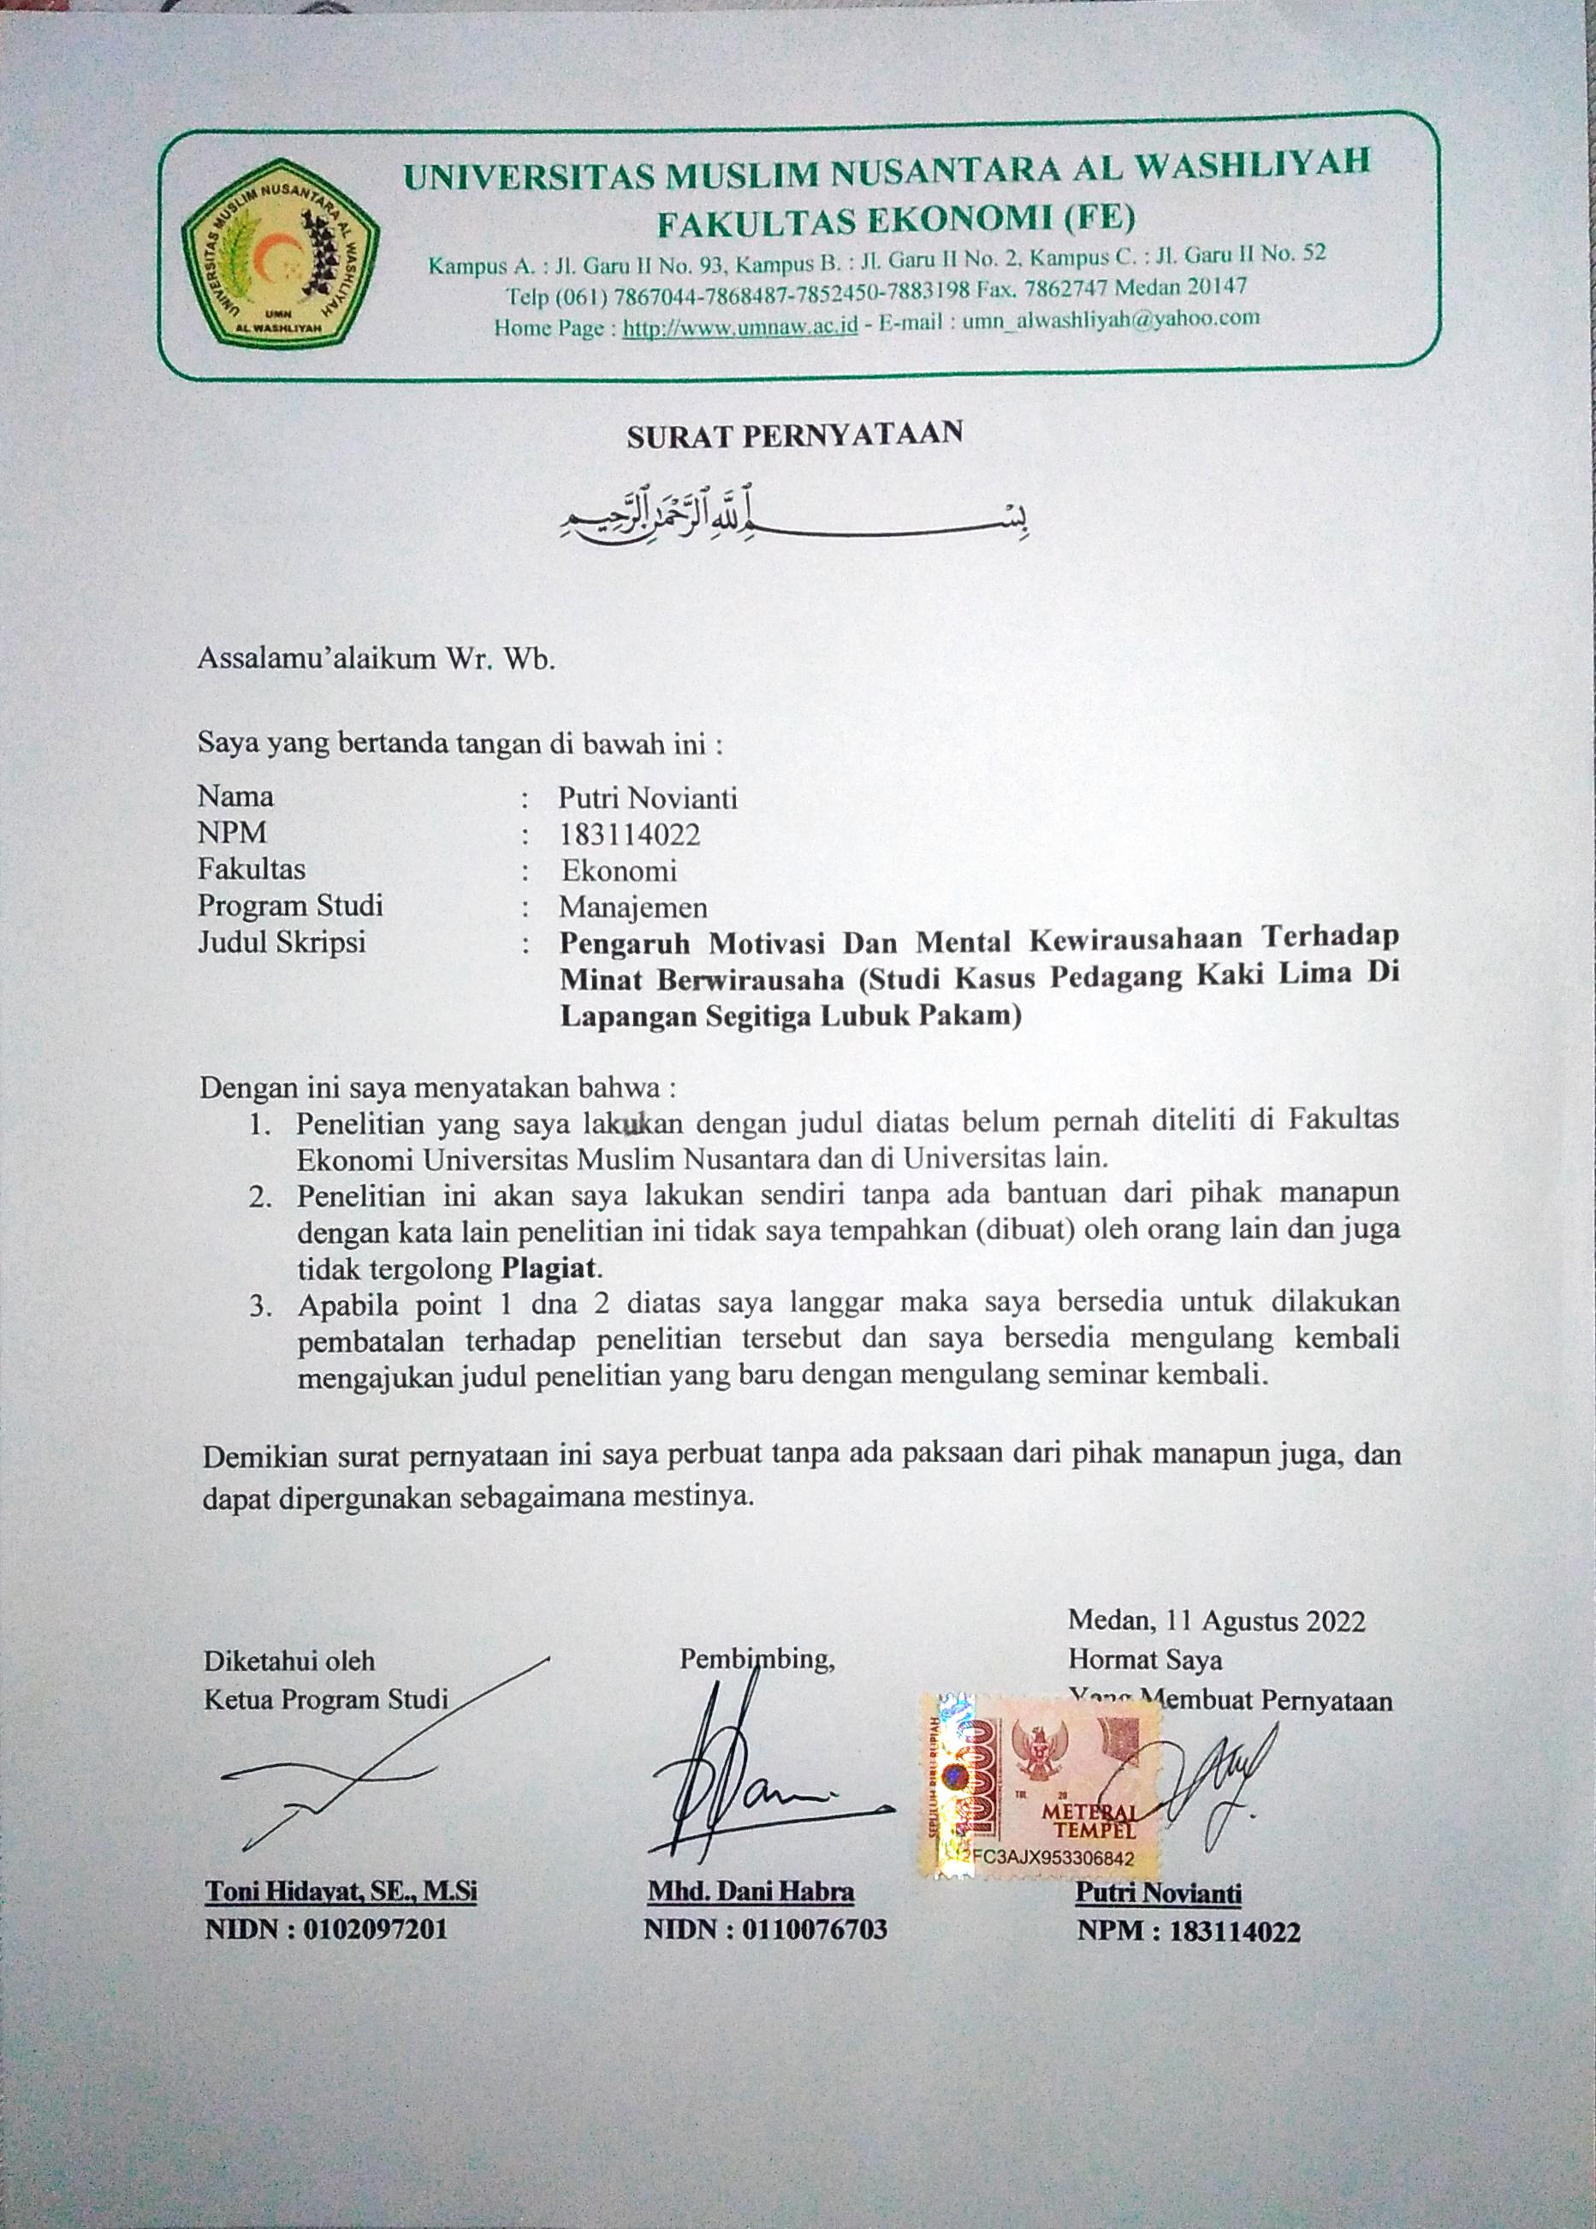

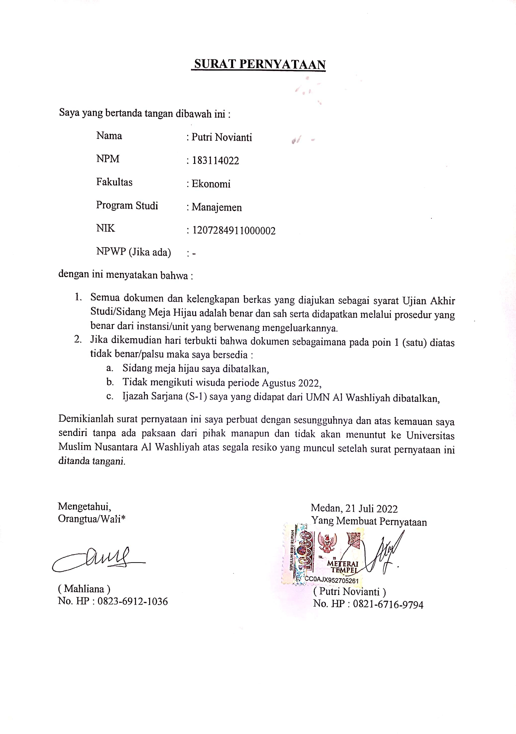

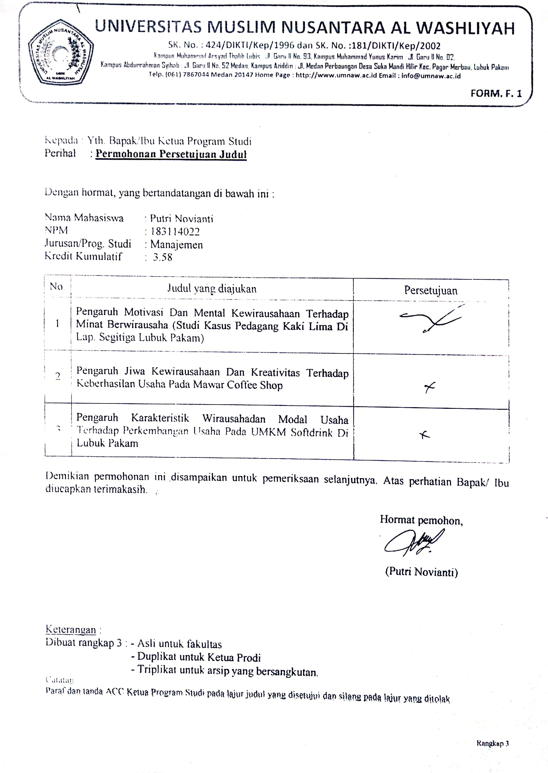

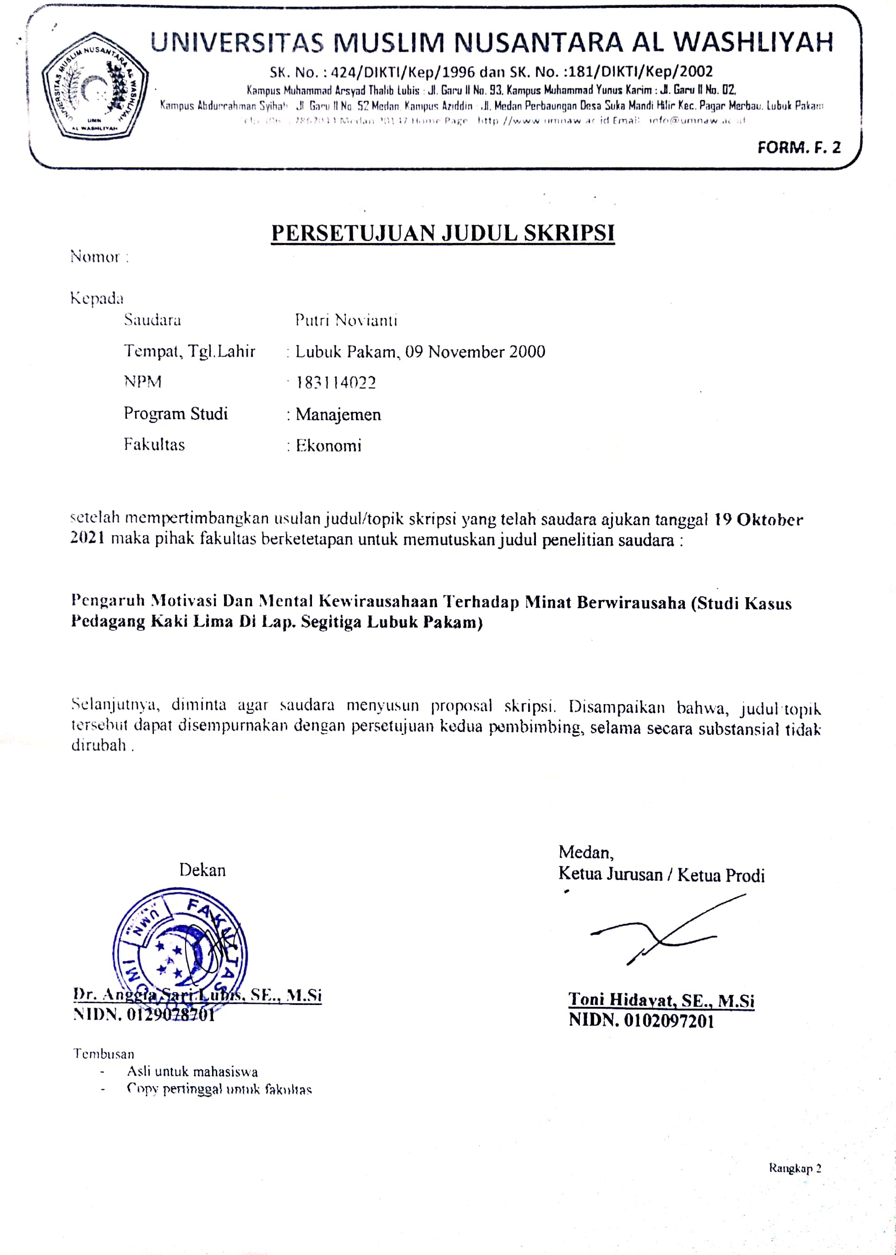
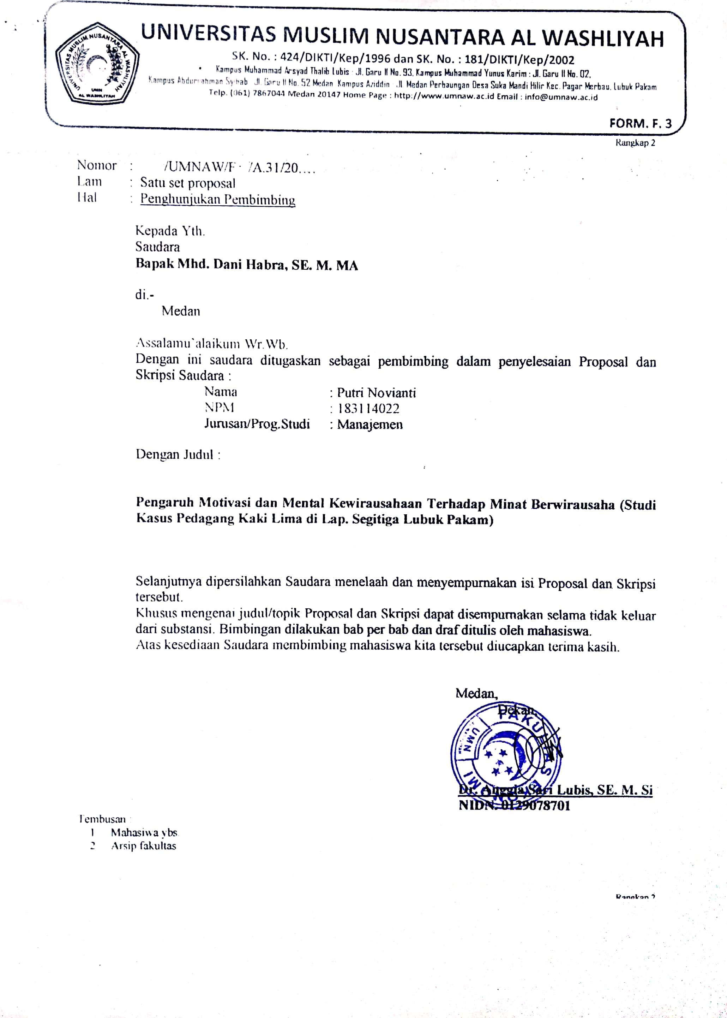

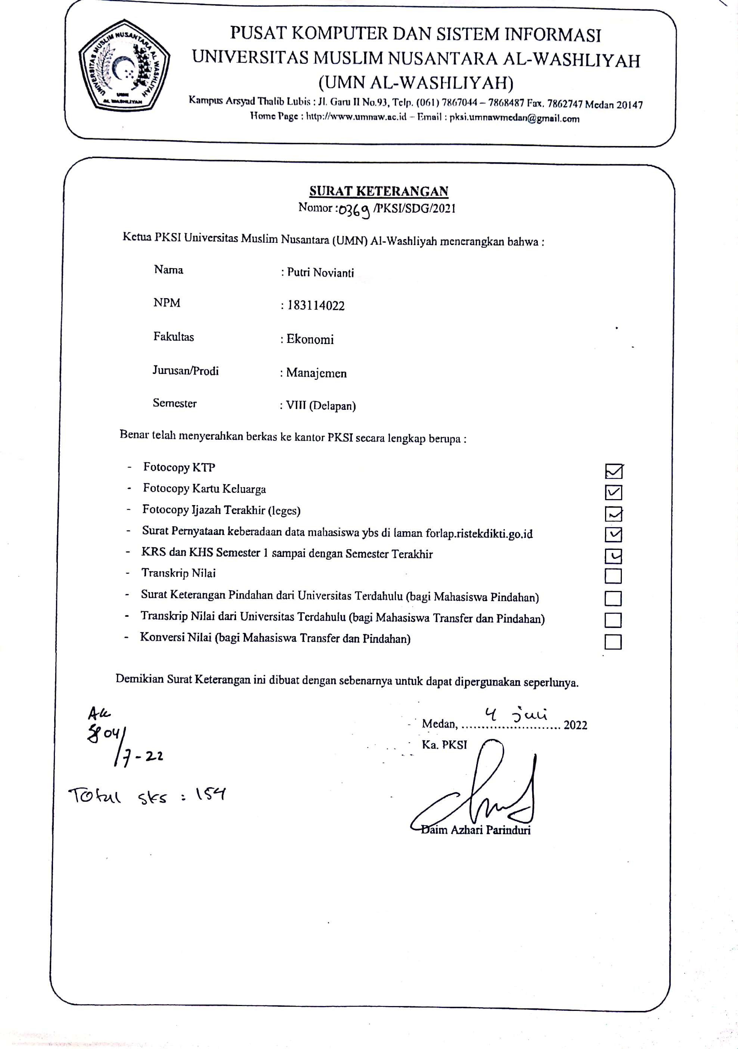
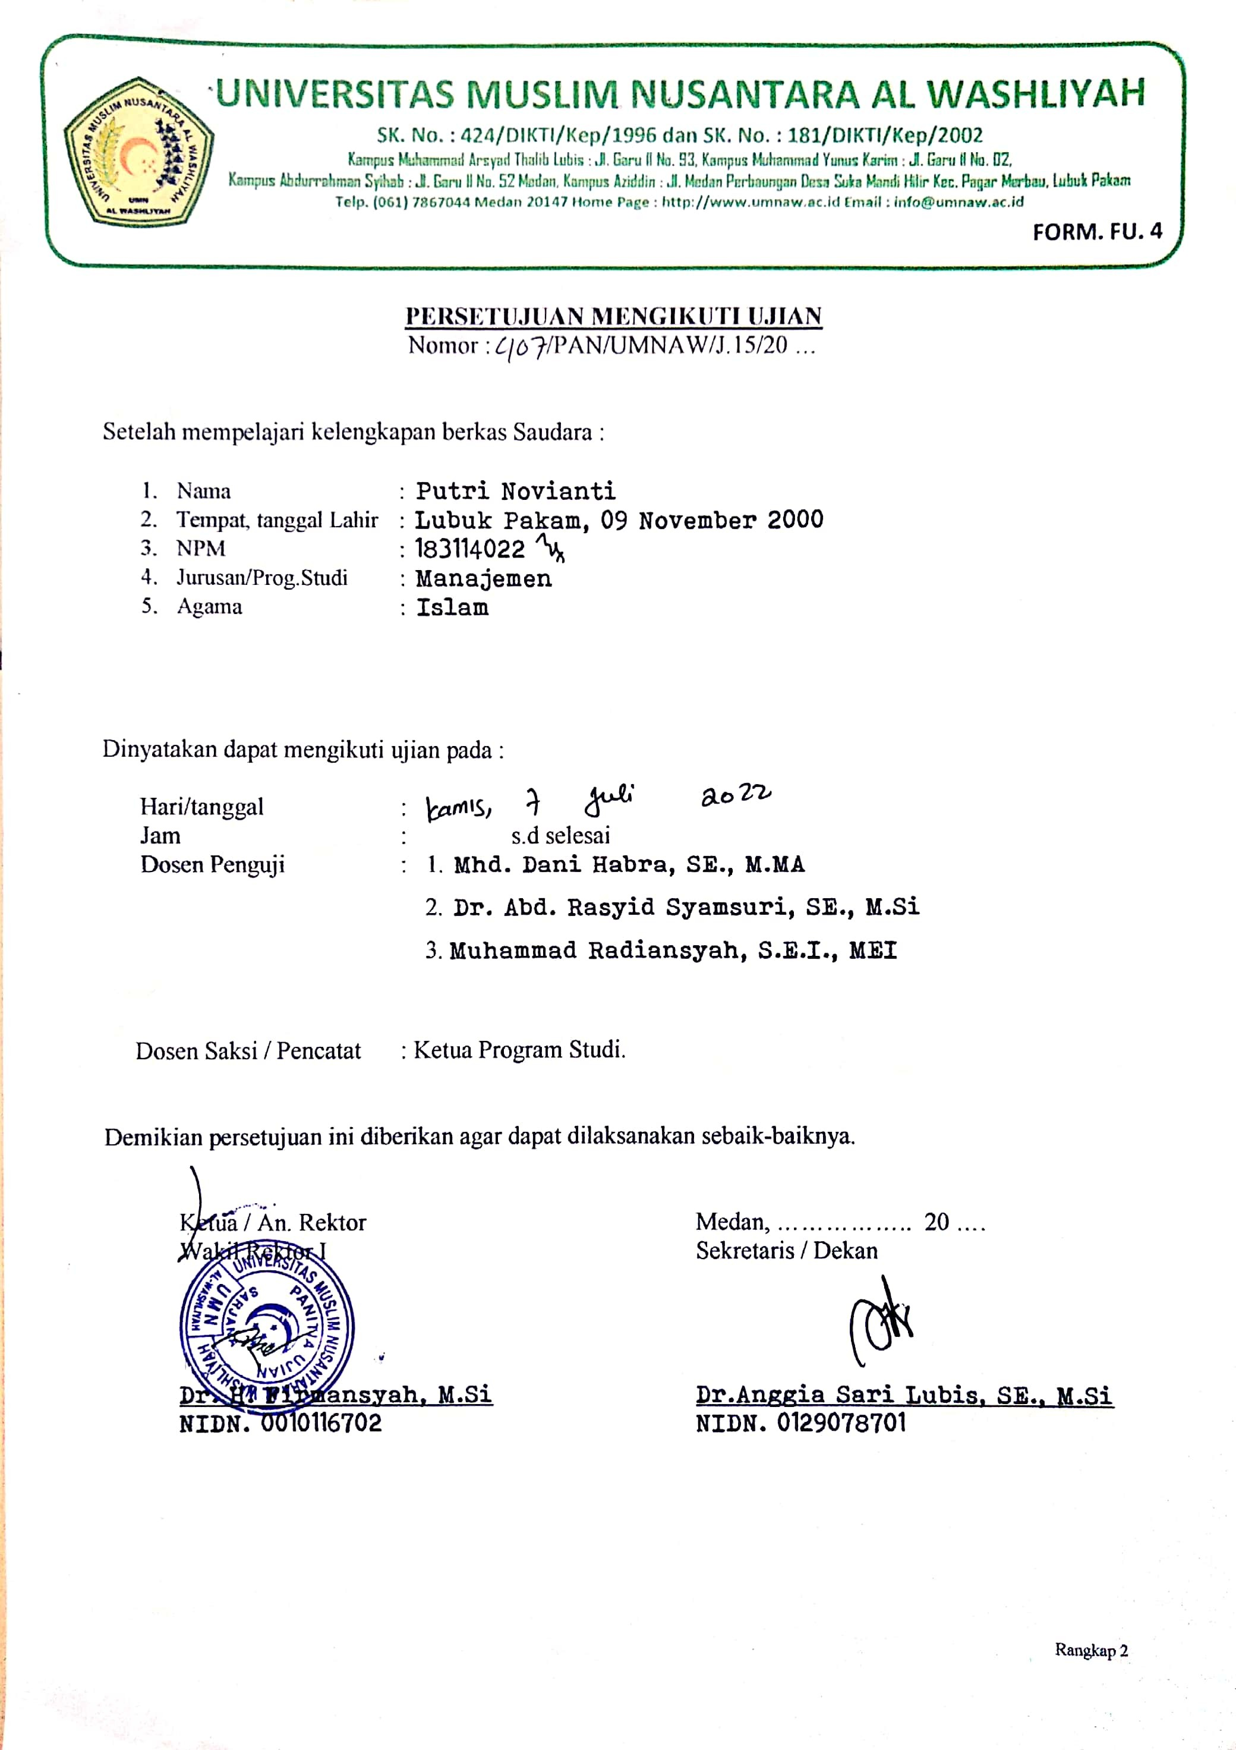
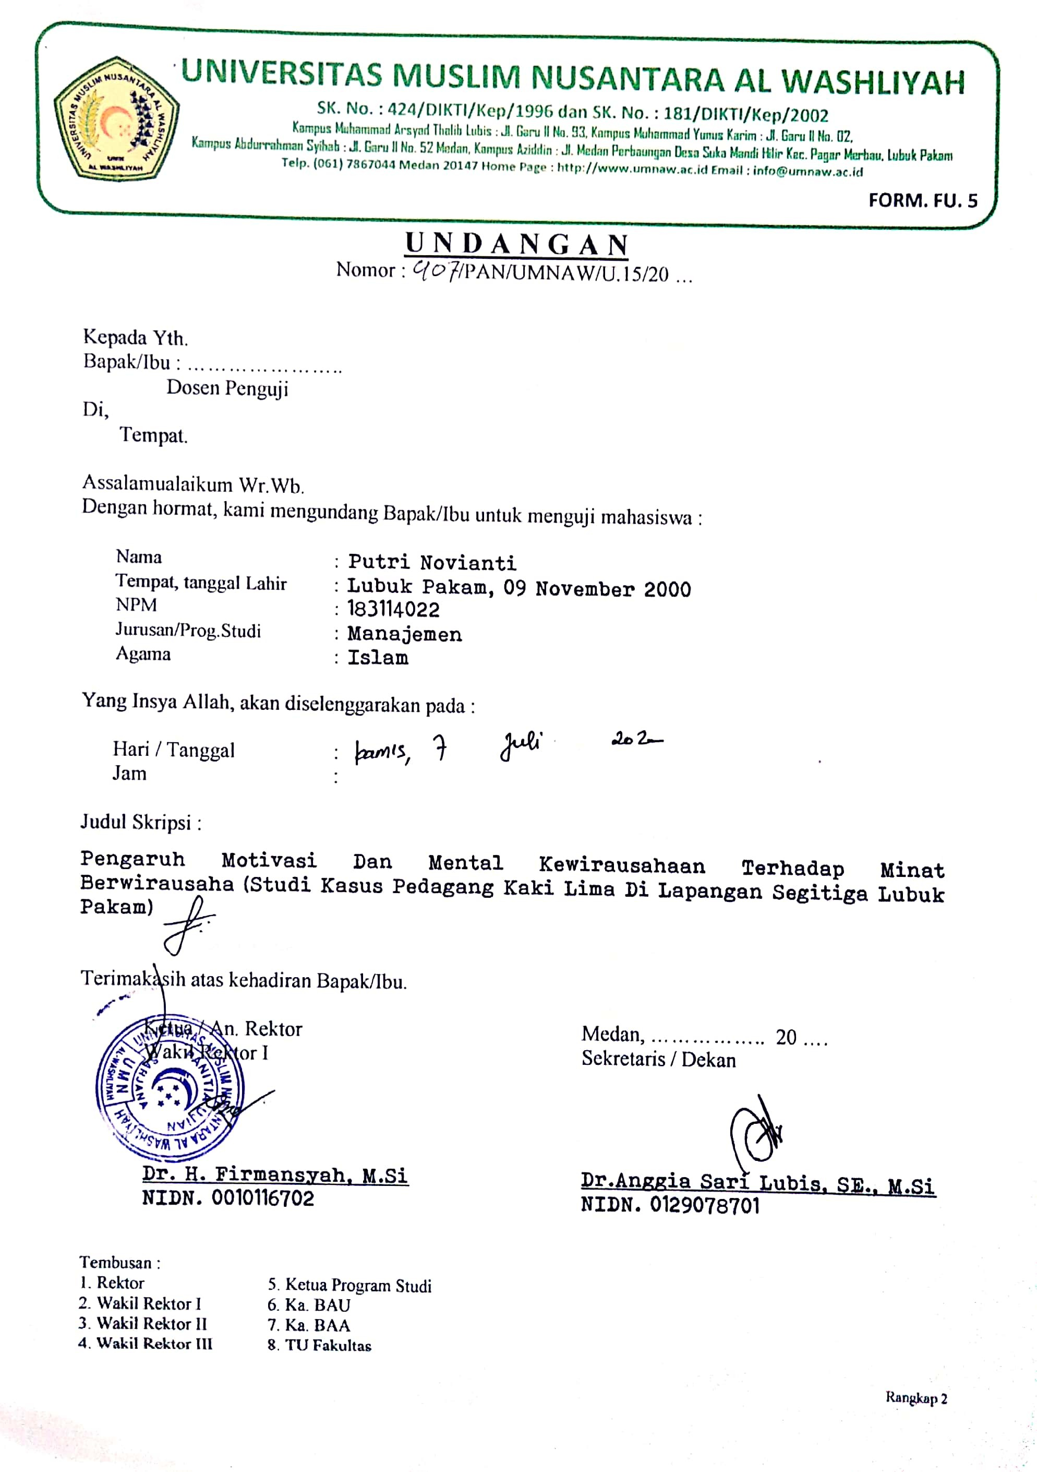
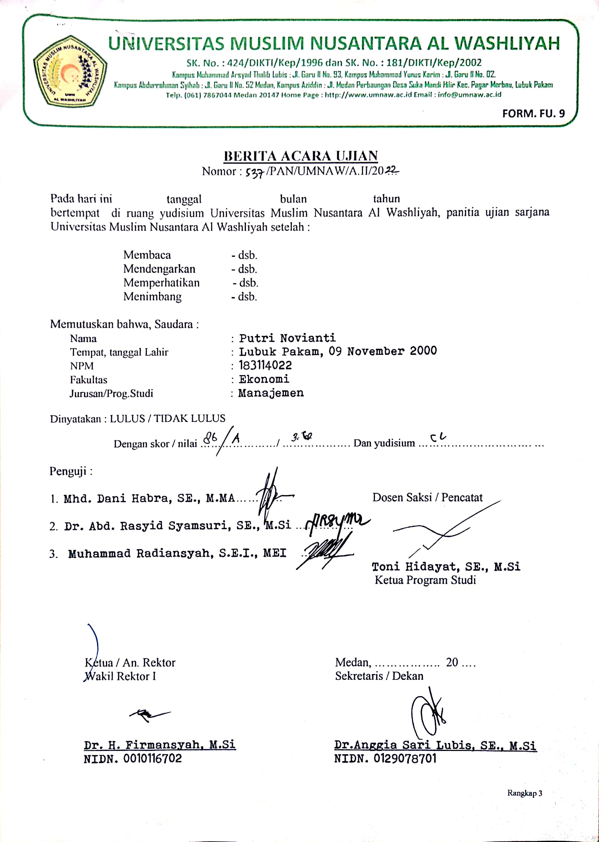
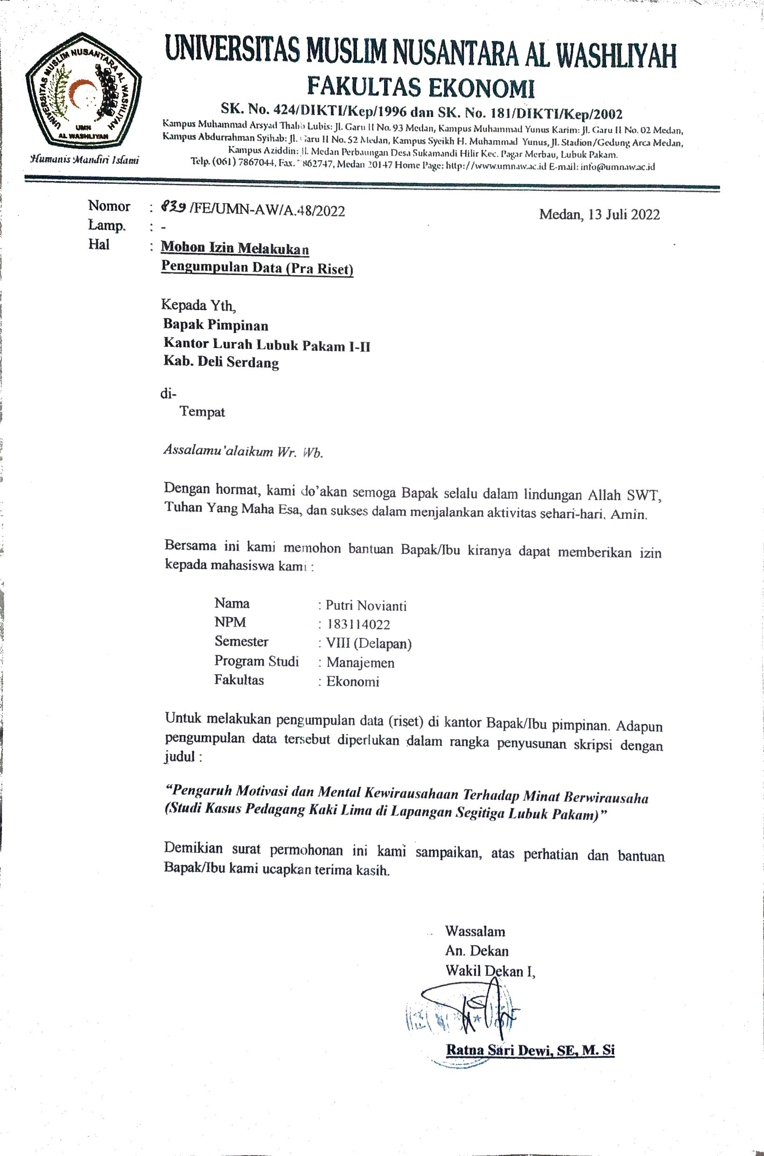
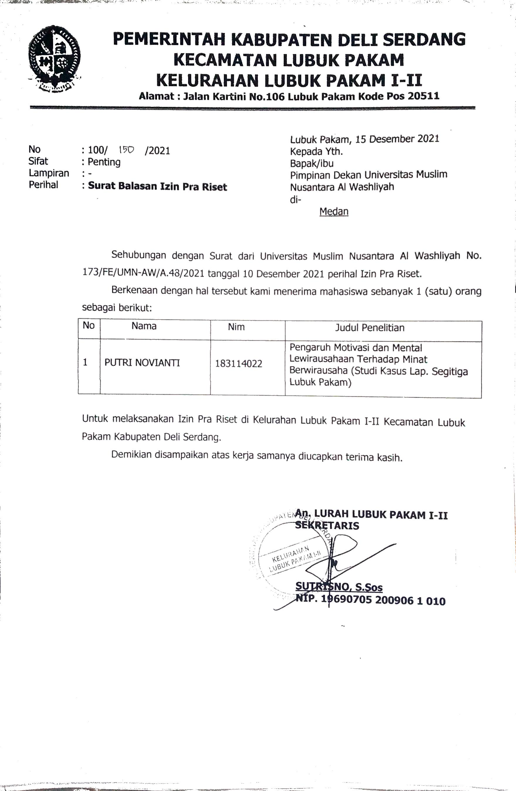
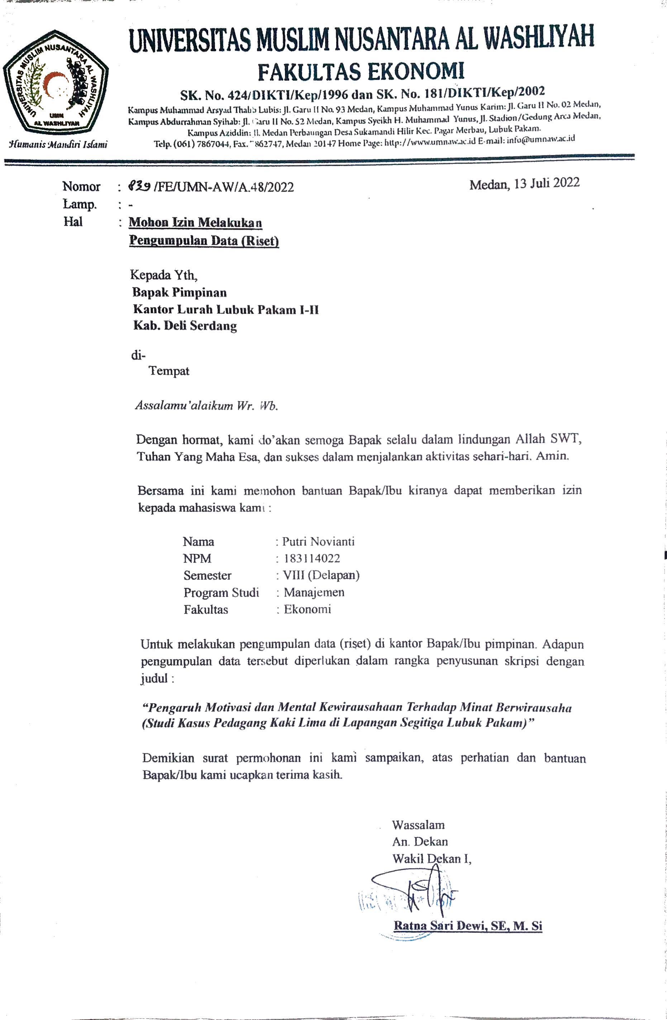

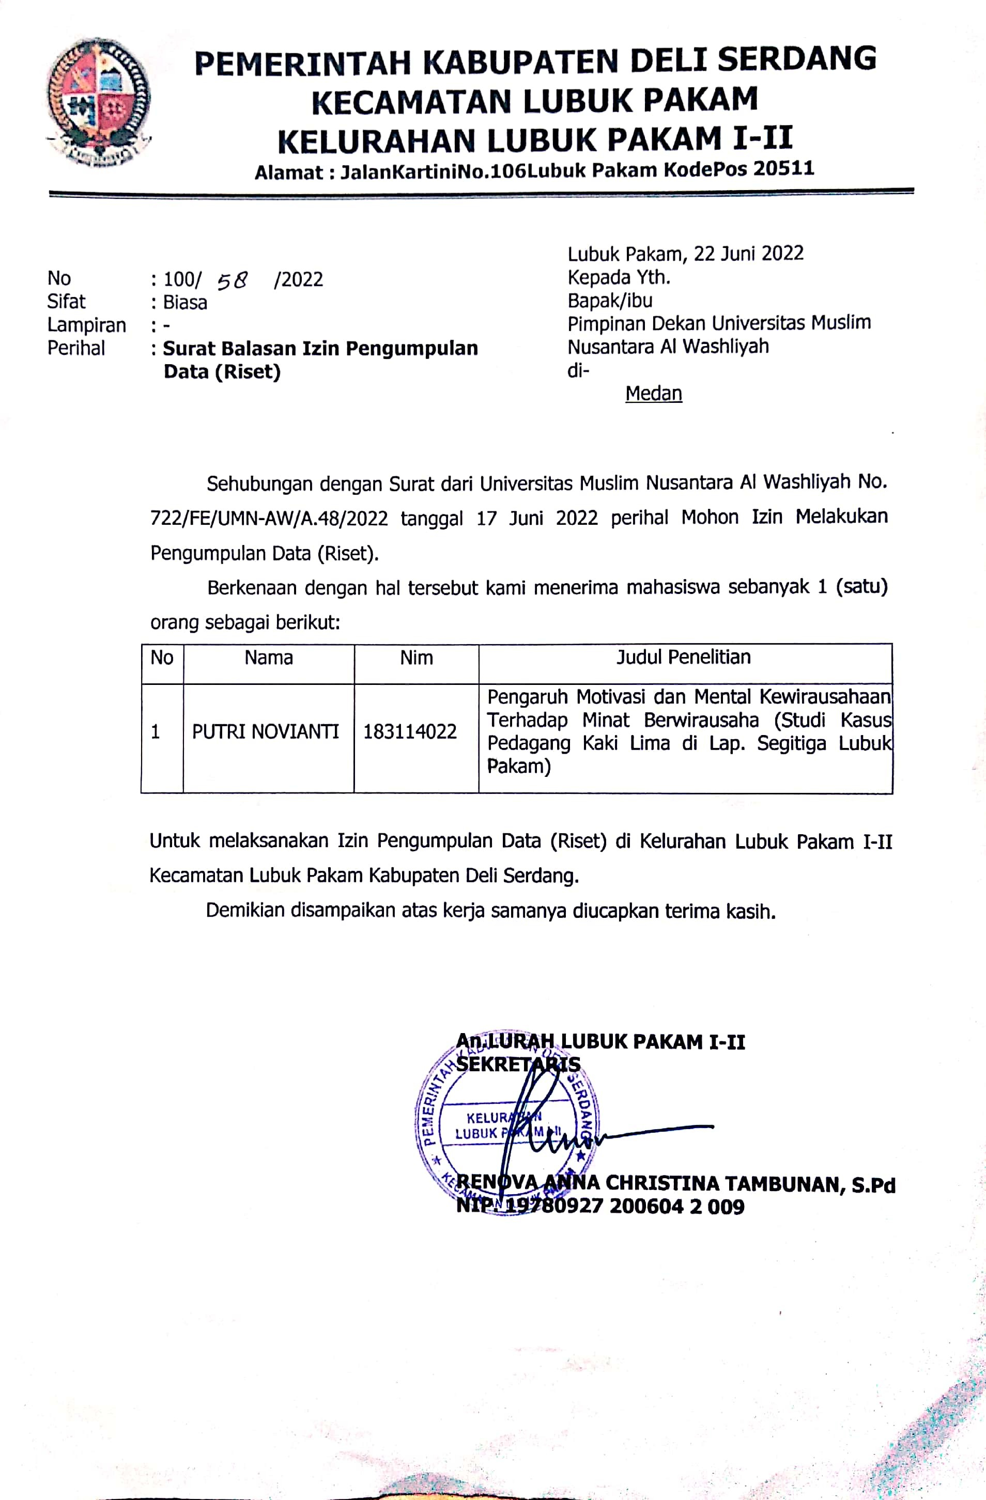

BIODATA

      - Identitas Diri
Nama : Putri Novianti
NPM : 183114022
Tempat/Tanggal Lahir : Medan, 09 November 2000
Jenis Kelamin : Perempuan
Agama : Islam
Status : Belum Menikah
Pekerjaan : Mahasiswa
Anak Ke : 3(Tiga) Dari 4 (Empat) Bersaudara
Alamat : Jl. Sultan Hasanuddin Kec. LubukPakam I-II
Kab.Deli Serdang
No.Hp : +6288261055909
      - Pendidikan
SD : SD Negeri 108384 Lubuk Pakam
SMP : SMP Negeri 1 Lubuk Pakam
SMA : SMA Negeri 1 Lubuk Pakam
Perguruan Tinggi : Universitas Muslim Nusantara Al-Washliyah Medan
Fakultas : Ekonomi
Jurusan/Prodi : Manajemen
Judul Skripsi : Pengaruh Motivasi Dan Mental Kewirausahaan
Terhadap Minat Berwirasaha (Studi Kasus Pedagang Kaki Lima Di Lapangan Segitiga Lubuk Pakam)
      - Orang tua
Nama Ayah : Alm. Amir Kasman, SP.
Pekerjaan : Pensiunan PNS
Nama Ibu : Mahliana
Pekerjaan : Ibu Rumah Tangga
Alamat : Jl. Sultan Hasanuddin Kec. Lubuk Pakam I-II
Kab.Deli Serdang

Medan, 11 Agustus 2022
Hormat Saya,

Putri Novianti
183114022

