Lampiran 1 Certificate of Analysis (COA) Minyak Nyamplung
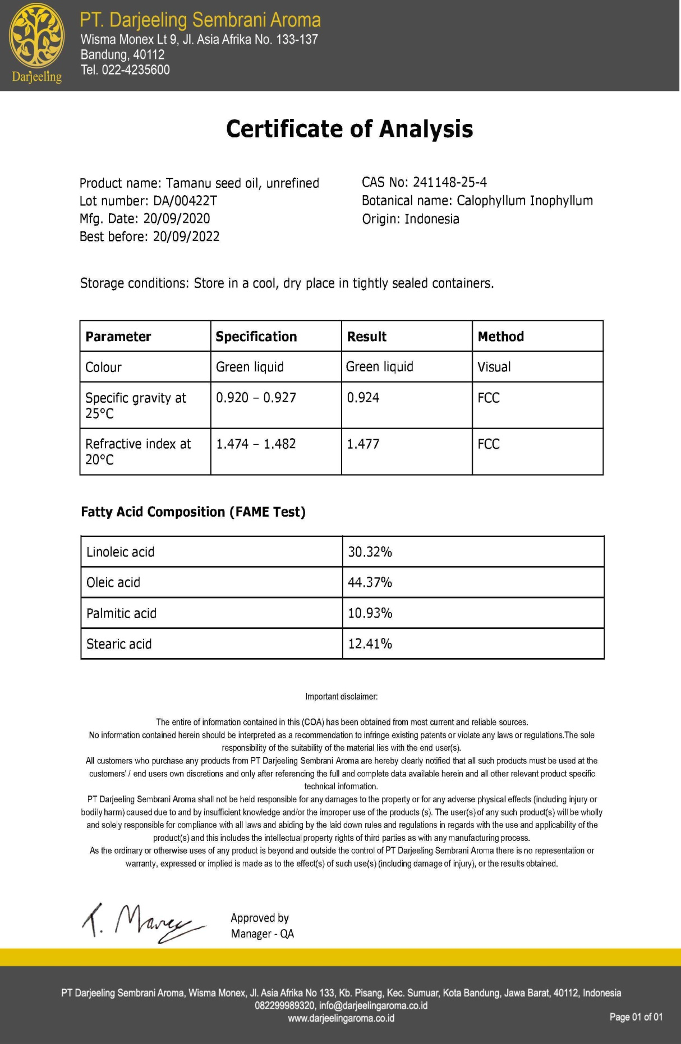

Lampiran 2 Minyak Nyamplung
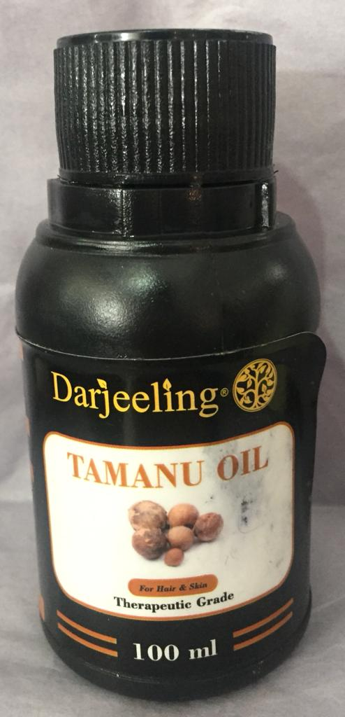

Kemasan minyak nyamplung

Minyak nyamplung

Lampiran 3 Bagan Alir Kerja (Flowsheet) Pembuatan sediaan skin balm
Jumlah masing-masing bahan
Cawan Penguap I
Cawan penguap II
Massa 1
Massa 2
Cawan Penguap III
Wadah sediaan skin balm
Sediaan skin balm minyak nyamplung
Dimasukkan Vaselin Album
Dimasukkan parafin liquidum
Dimasukkan cera alba
Dimasukkan BHT dan Na. Bisulfit
Diletakkan di penangas air sampai melebur sempurna
Minyak Nyamplung
Dimasukkan massa 2 ke massa 1
Campuran massa diaduk homogen
Didiamkan pada suhu ruang hingga membeku
Timbangan/ Neraca Analitik
Ditimbang seluruh bahan

Dituangkan massa ke dalam wadah

Lampiran 4 Perhitungan Formula sediaan skin balm
Formula F0 (blanko) sediaan tanpa Minyak Nyamplung
- Paraffin liquidum = $\frac{20}{100}×100 g$ = 20 g
- Cera alba = $\frac{15}{100}×100 g$ = 15 g
- BHT = $\frac{0,1}{100}×100 g$ = 0,1 g
- Natrium metabisulfit = $\frac{0,1}{100}×100 g$ = 0,1 g
- Vaselin album ad 100 = 100-(20+15+0,1+0,1)g = 64,8 g
Formula F1 yaitu sediaan menggunakan minyak nyamplung 14%
- Paraffin liquidum = $\frac{20}{100}×100 g$ = 20 g
- Cera alba = $\frac{15}{100}×100 g$ = 15 g
- BHT = $\frac{0,1}{100}×100 g$ = 0,1 g
- Natrium metabisulfit = $\frac{0,1}{100}×100 g$ = 0,1 g
- Minyak Nyamplung = $\frac{14}{100}×100 g$ = 14 g
- Vaselin album ad 100 = 100- (20+15+0,1+0,1+14)g = 50,8 g
Formula F2 yaitu sediaan menggunakan minyak nyamplung 17%
- Paraffin liquidum = $\frac{20}{100}×100 g$ = 20 g
- Cera alba = $\frac{15}{100}×100 g$ = 15 g
- BHT = $\frac{0,1}{100}×100 g$ = 0,1 g
- Natrium metabisulfit = $\frac{0,1}{100}×100 g$ = 0,1 g
- Minyak Nyamplung = $\frac{17}{100}×100 g$ = 17 g
- Vaselin album ad 100 = 100-(20+15+0,1+0,1+17)g = 47,8 g

Lampiran 5 Hasil Sedian Skin Balm Minyak Nyamplung
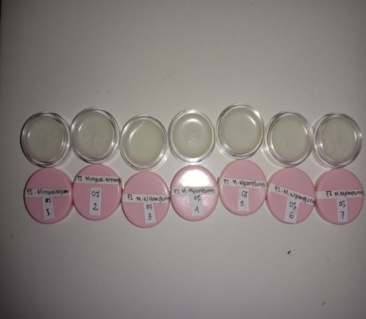

Sediaan skin balm minyak nyamplung konsentrasi 0%

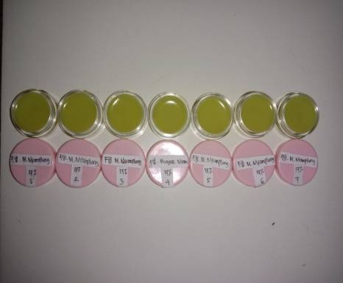

Sediaan skin balm minyak nyamplung konsentrasi 14%

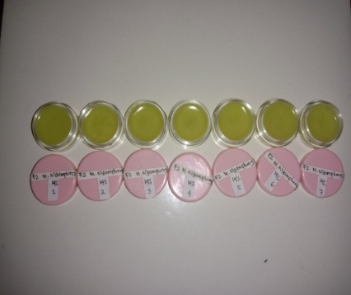

Sediaan skin balm minyak nyamplung konsentrasi 17%

Lampiran 6 Hasil Nilai pH Sediaan Skin Balm Selama 4 Minggu Dengan 6 Kali Pengulangan
pH Minggu Ke-0
No | Formula
 | F0 | F1 | F2
1 | 5,5 | 5,3 | 5,2
2 | 5,4 | 5,3 | 5,3
3 | 5,5 | 5,2 | 5,3
4 | 5,5 | 5,4 | 5,1
5 | 5,6 | 5,3 | 5,2
6 | 5,4 | 5,2 | 5,2
 | 5,5 ± 0,08 | 5,3 ± 0,08 | 5,2 ± 0,08

pH Minggu ke-1
No | Formula
 | F0 | F1 | F2
1 | 5,7 | 5,5 | 5,1
2 | 5,5 | 5,4 | 5,1
3 | 5,5 | 5,4 | 5,0
4 | 5,6 | 5,5 | 5,2
5 | 5,5 | 5,3 | 5,1
6 | 5.6 | 5,3 | 5,2
 | 5,6 ± 0,08 | 5,4 ± 0,09 | 5,1 ± 0,08

pH Minggu ke-2
No | Formula
 | F0 | F1 | F2
1 | 5,4 | 5,3 | 5,1
2 | 5,5 | 5,3 | 5,1
3 | 5,4 | 5,4 | 4,9
4 | 5,6 | 5,3 | 5,1
5 | 5,6 | 5,3 | 5,0
6 | 5,4 | 5,4 | 5,0
 | 5,5 ± 0,10 | 5,3 ± 0,05 | 5,0 ± 0,08
Lampiran 6 (Lanjutan)
pH Minggu ke-3
No | Formula
 | F0 | F1 | F2
1 | 5,5 | 5,3 | 5,0
2 | 5,4 | 5,4 | 4,9
3 | 5,6 | 5,4 | 5,2
4 | 5,6 | 5,3 | 5,0
5 | 5,5 | 5,3 | 5,2
6 | 5,6 | 5,2 | 4,9
 | 5,5 ± 0,08 | 5,3 ± 0,08 | 5,0 ± 0,14

pH Minggu ke-4
No | Formula
 | F0 | F1 | F2
1 | 5,5 | 5,4 | 5,2
2 | 5,6 | 5,4 | 5,2
3 | 5,6 | 5,3 | 5,1
4 | 5,5 | 5,3 | 5,1
5 | 5,5 | 5,5 | 5,1
6 | 5,4 | 5,4 | 5,0
 | 5,5 ± 0,08 | 5,4 ± 0,08 | 5,1 ± 0,08

Lampiran 7 Hasil Pemeriksaan Daya Sebar Sediaan Skin Balm Selama 4 Minggu Dengan 6 Kali Pengulangan
Daya Sebar Minggu Ke-0
No | Formula
 | F0 | F1 | F2
1 | 5.4 | 5.3 | 5.5
2 | 5.3 | 5.7 | 5.4
3 | 5.2 | 5.4 | 5.3
4 | 5.5 | 5.3 | 5.4
5 | 5.5 | 5.3 | 5.6
6 | 5.3 | 5.6 | 5.5
 | 5.4 ± 0.12 | 5.4 ± 0.18 | 5.5 ± 0.1

Daya Sebar Minggu Ke-1
No | Formula
 | F0 | F1 | F2
1 | 5.2 | 5.5 | 5.5
2 | 5.4 | 5.7 | 5.6
3 | 5.6 | 5.6 | 5.6
4 | 5.4 | 5.2 | 5.7
5 | 5.3 | 5.7 | 5.5
6 | 5.5 | 5.4 | 5.4
 | 5.4 ± 0.14 | 5.5 ± 0.19 | 5.6 ± 0.1

Daya Sebar Minggu Ke-2
No | Formula
 | F0 | F1 | F2
1 | 5.5 | 5.7 | 5.5
2 | 5.6 | 5.7 | 5.7
3 | 5.4 | 5.5 | 5.4
4 | 5.4 | 5.3 | 5.5
5 | 5.5 | 5.2 | 5.6
6 | 5.6 | 5.6 | 5.5
 | 5.5 ± 0.09 | 5.5 ± 0.21 | 5.5 ± 0.1

Lampiran 7 (Lanjutan)
Daya Sebar Minggu Ke-3
No | Formula
 | F0 | F1 | F2
1 | 5.4 | 5.6 | 5.7
2 | 5.5 | 5.4 | 5.6
3 | 5.5 | 5.7 | 5.5
4 | 5.4 | 5.6 | 5.3
5 | 5.4 | 5.5 | 5.5
6 | 5.6 | 5.3 | 5.2
 | 5.5 ± 0.08 | 5.5 ± 0.15 | 5.5 ± 0.19

Daya Sebar Minggu Ke-4
No | Formula
 | F0 | F1 | F2
1 | 5.4 | 5.3 | 5.6
2 | 5.2 | 5.7 | 5.7
3 | 5.3 | 5.4 | 5.4
4 | 5.4 | 5.6 | 5.4
5 | 5.5 | 5.7 | 5.6
6 | 5.5 | 5.7 | 5.7
 | 5.4 ± 0.12 | 5.6 ± 0.18 | 5.6 ± 0.14

Lampiran 8 Bagan Alir Kerja (Flowsheet) Uji Efektivitas Kelembaban Kulit
Selisih nilai kelembaban dibandingkan kelembaban awal
Hasil Rata – Rata Persentase Peningkatan Kelembaban Kulit
Hasil Analisis Data Kelembaban Kulit dengan Program SPSS
Diamati kondisi kulit
Menjelaskan tentang penelitian
Menanyakan apakah bersedia menjadi sukarelawan
Mengisi surat pernyataan bersedia menjadi sukarelawan
Diukur nilai kelembaban kulit
Diukur selama 4 minggu
Nilai Kelembaban Kulit
Nilai Kelembaban Kulit Minggu 4
Nilai Kelembaban Kulit Minggu 3
Nilai Kelembaban Kulit Minggu 2
Nilai Kelembaban Kulit Minggu 1
Sukarelawan
Nilai Kelembaban Kulit Minggu 0

Analisis data
Data kelembaban kulit dianalisi dengan program SPSS

Lampiran 9 Surat Pernyataan Bersedia Menjadi Sukarelawan
SURAT PERNYATAAN
Saya yang bertanda tangan di bawah ini:
Nama :
Umur :
Jenis Kelamin :
Alamat :
Telah mendapat penjelasan secukupnya bahwa kaki saya akan digunakan sebagai daerah yang akan diuji. Setelah mendapat penjelasan secukupnya tentang manfaat penelitian ini maka saya menyatakan SETUJU untuk ikut serta dalam penelitian Mirna Riama Siahaan dengan judul “Uji Efektivitas Sediaan Pelembab Minyak Nyamplung (Calophyllum inophyllum L.) Terhadap Xerosis Pada Tumit Kaki”. Saya bersedia untuk mengikuti prosedur penelitian yang telah diterapkan.
Persetujuan ini saya buat dengan penuh kesadaran dan tanpa paksaan dari pihak manapun. Demikian surat pernyataan ini dibuat untuk dapat dipergunakan sebagaimana mestinya.

Medan, Februari 2021

Sukarelawan Peneliti

(..............................) (Mirna Riama Siahaan)
Lampiran 10 Alat Yang Digunakan Untuk Mengukur Kelembaban Kulit (Skin Detector)
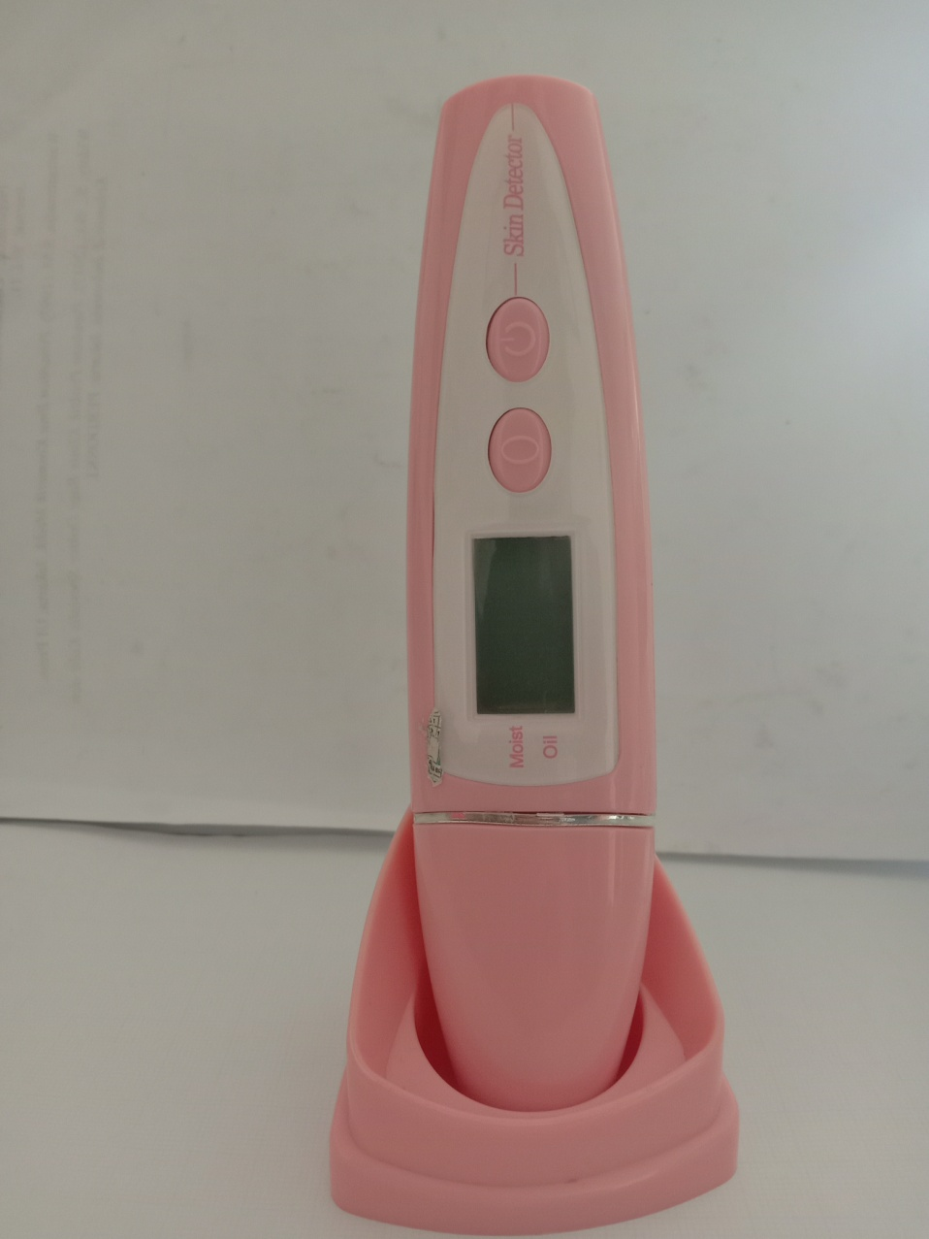
Alat skin detector

Lampiran 11 Perubahan Kaki Sukarelawan Selama Pemakaian Skin Balm
Blanko
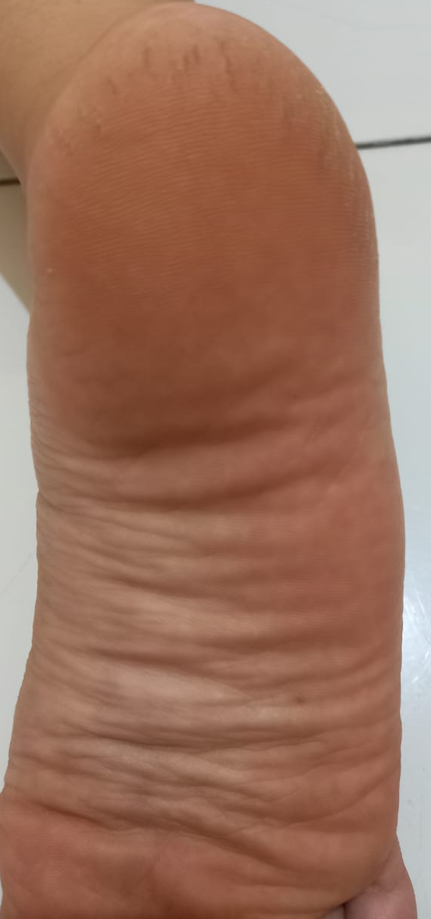
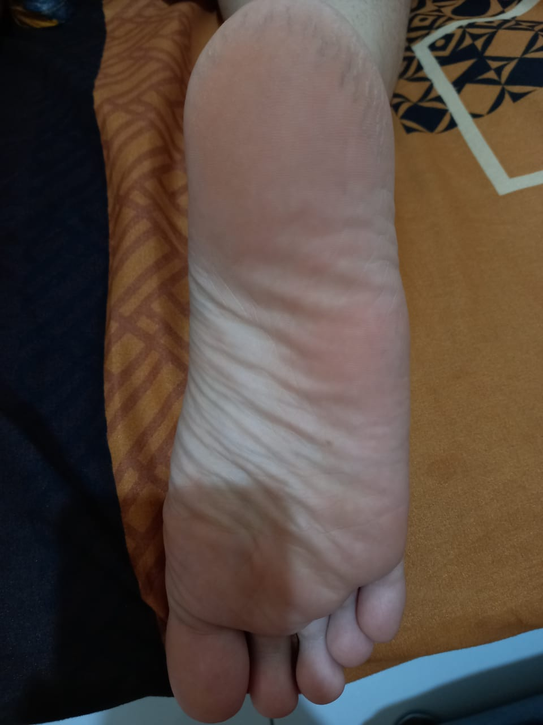

Minggu 4
Minggu 2
Minggu 0

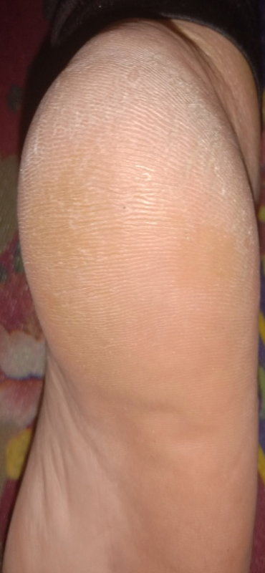
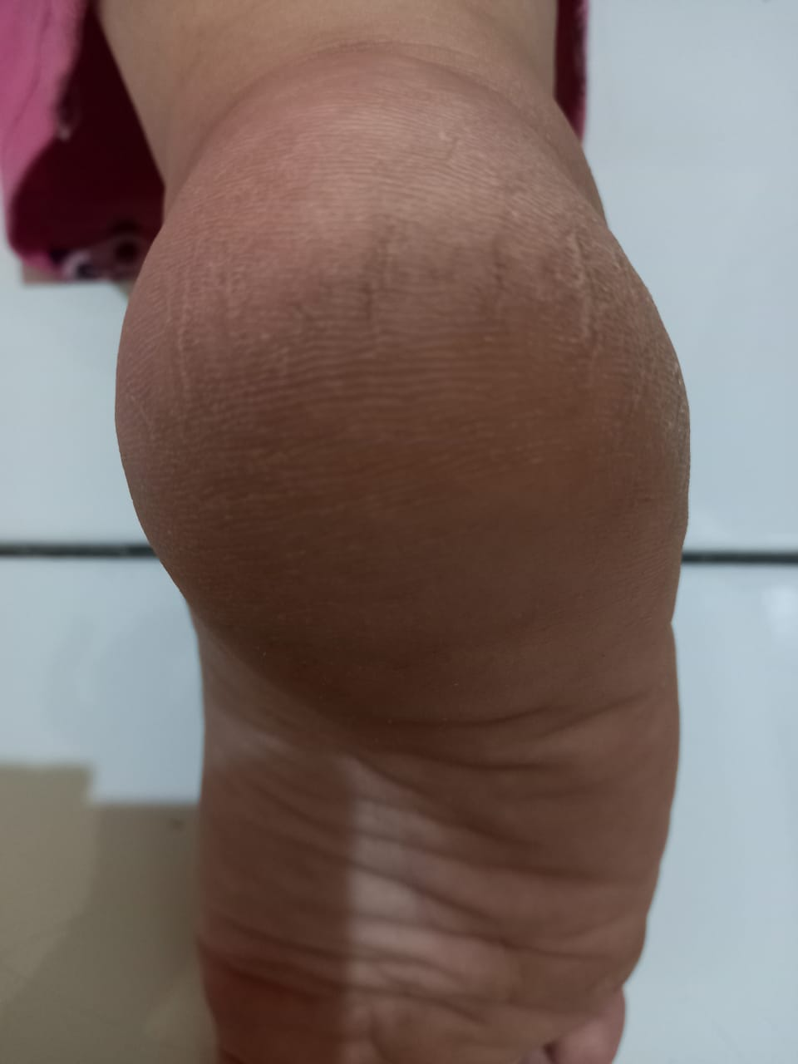
F1

Minggu 4
Minggu 2
Minggu 0

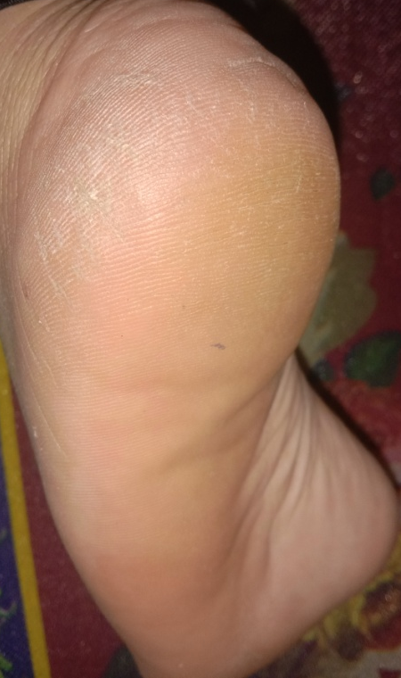
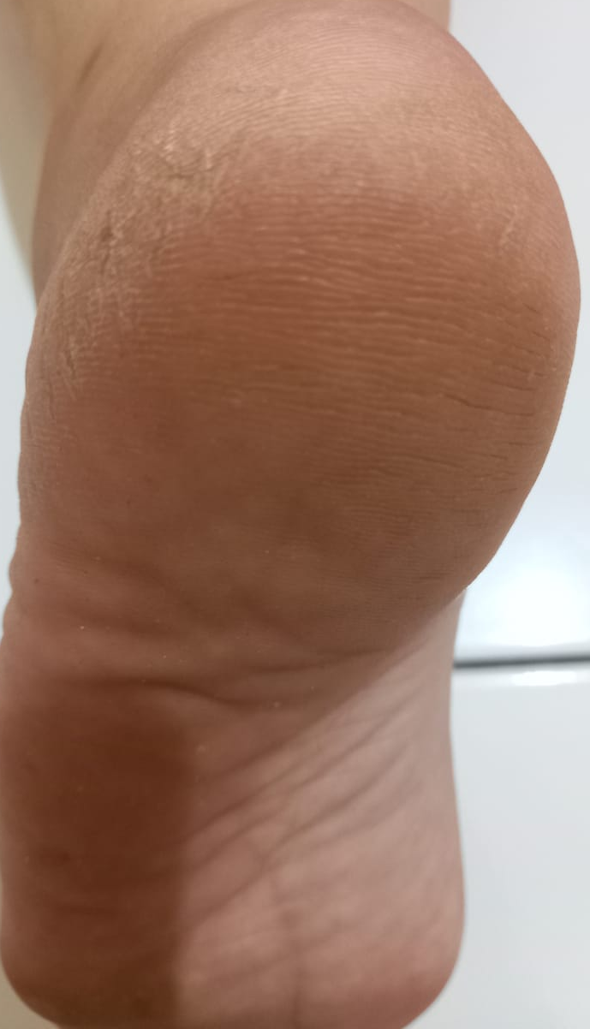
Lampiran 11 (Lanjutan)

Minggu 0
Minggu 2
Minggu 4

Lampiran 12 Hasil Efektivitas Kelembaban Kulit Selama 4 Minggu
Data Kelembaban Kulit (%)
NO | Formula | MINGGU 0 | MINGGU 1 | MINGGU 2 | MINGGU 3 | MINGGU 4
1 | F0 | 23.1 | 23.8 | 24.3 | 25.4 | 26.6
2 | F0 | 22.4 | 23.1 | 23.8 | 24.5 | 25.8
3 | F0 | 25.6 | 26.1 | 26.6 | 27.4 | 29.6
4 | F0 | 24.4 | 25.3 | 25.9 | 26.2 | 28.0
5 | F0 | 26.4 | 27.0 | 28.1 | 28.7 | 30.5
6 | F0 | 24.9 | 25.3 | 26.6 | 27.3 | 28.5
7 | F1 | 27.2 | 28.0 | 29.6 | 34.9 | 38.5
8 | F1 | 23.5 | 24.8 | 26.9 | 31.5 | 35.9
9 | F1 | 24.0 | 24.7 | 25.4 | 30.4 | 36.6
10 | F1 | 25.6 | 26.8 | 31.0 | 34.1 | 37.7
11 | F1 | 26.1 | 26.6 | 29.9 | 35.3 | 39.8
12 | F1 | 25.8 | 26.4 | 28.0 | 32.7 | 39.3
13 | F2 | 25.3 | 26.1 | 28.9 | 34.9 | 42.1
14 | F2 | 24.9 | 25.6 | 30.6 | 33.4 | 41.5
15 | F2 | 27.4 | 28.9 | 35.3 | 40.2 | 45.5
16 | F2 | 23.0 | 23.8 | 26.4 | 32.6 | 38.1
17 | F2 | 24.5 | 25.1 | 28.2 | 34.8 | 40.9
18 | F2 | 26.4 | 27.2 | 30.1 | 37.4 | 44.6

Lampiran 13 Hasil Analisa Statistik Data Kelembaban Dengan Uji Anova
Tests of Normality
 | FORMULA | Kolmogorov-Smirnovª |  |  | Shapiro-Wilk
 |  | Statistic | df | Sig. | Statistic | df | Sig.
MINGGU 0 | F0 | .151 | 6 | .200* | .970 | 6 | .889
 | F1 | .234 | 6 | .200* | .939 | 6 | .654
 | F2 | .154 | 6 | .200* | .987 | 6 | .981
MINGGU 1 | F0 | .222 | 6 | .200* | .958 | 6 | .803
 | F1 | .224 | 6 | .200* | .911 | 6 | .442
 | F2 | .170 | 6 | .200* | .982 | 6 | .962
MINGGU 2 | F0 | .173 | 6 | .200* | .943 | 6 | .681
 | F1 | .206 | 6 | .200* | .962 | 6 | .838
 | F2 | .244 | 6 | .200* | .923 | 6 | .524
MINGGU 3 | F0 | .181 | 6 | .200* | .977 | 6 | .936
 | F1 | .187 | 6 | .200* | .937 | 6 | .638
 | F2 | .258 | 6 | .200* | .920 | 6 | .508
MINGGU 4 | F0 | .145 | 6 | .200* | .973 | 6 | .914
 | F1 | .148 | 6 | .200* | .957 | 6 | .794
 | F2 | .169 | 6 | .200* | .961 | 6 | .827
a. Lilliefors Significance Correction
*. This is a lower bound of the true significance.

Lampiran 13 (Lanjutan)
Descriptives
 |  | N | Mean | Std. Deviation | Std. Error | 95% Confidence Interval for Mean |  | Minimum | Maximum
 |  |  |  |  |  | Lower Bound | Upper Bound
MINGGU 0 | F0 | 6 | 24.467 | 1.5069 | .6152 | 22.885 | 26.048 | 22.4 | 26.4
 | F1 | 6 | 25.367 | 1.3779 | .5625 | 23.921 | 26.813 | 23.5 | 27.2
 | F2 | 6 | 25.250 | 1.5294 | .6244 | 23.645 | 26.855 | 23.0 | 27.4
 | Total | 18 | 25.028 | 1.4434 | .3402 | 24.310 | 25.746 | 22.4 | 27.4
MINGGU 1 | F0 | 6 | 25.100 | 1.4408 | .5882 | 23.588 | 26.612 | 23.1 | 27.0
 | F1 | 6 | 26.217 | 1.2656 | .5167 | 24.889 | 27.545 | 24.7 | 28.0
 | F2 | 6 | 26.117 | 1.7657 | .7208 | 24.264 | 27.970 | 23.8 | 28.9
 | Total | 18 | 25.811 | 1.5060 | .3550 | 25.062 | 26.560 | 23.1 | 28.9
MINGGU 2 | F0 | 6 | 25.883 | 1.5993 | .6529 | 24.205 | 27.562 | 23.8 | 28.1
 | F1 | 6 | 28.467 | 2.0897 | .8531 | 26.274 | 30.660 | 25.4 | 31.0
 | F2 | 6 | 29.917 | 3.0275 | 1.2360 | 26.740 | 33.094 | 26.4 | 35.3
 | Total | 18 | 28.089 | 2.7710 | .6531 | 26.711 | 29.467 | 23.8 | 35.3
MINGGU 3 | F0 | 6 | 26.583 | 1.5198 | .6204 | 24.988 | 28.178 | 24.5 | 28.7
 | F1 | 6 | 33.150 | 1.9532 | .7974 | 31.100 | 35.200 | 30.4 | 35.3
 | F2 | 6 | 35.550 | 2.8055 | 1.1454 | 32.606 | 38.494 | 32.6 | 40.2
 | Total | 18 | 31.761 | 4.3961 | 1.0362 | 29.575 | 33.947 | 24.5 | 40.2
MINGGU 4 | F0 | 6 | 28.167 | 1.7716 | .7233 | 26.307 | 30.026 | 25.8 | 30.5
 | F1 | 6 | 37.967 | 1.5253 | .6227 | 36.366 | 39.567 | 35.9 | 39.8
 | F2 | 6 | 42.117 | 2.6686 | 1.0895 | 39.316 | 44.917 | 38.1 | 45.5
 | Total | 18 | 36.083 | 6.3183 | 1.4892 | 32.941 | 39.225 | 25.8 | 45.5

Lampiran 13 (Lanjutan)
Test of Homogeneity of Variances
 | Levene Statistic | df1 | df2 | Sig.
MINGGU 0 | .018 | 2 | 15 | .982
MINGGU 1 | .201 | 2 | 15 | .820
MINGGU 2 | .596 | 2 | 15 | .564
MINGGU 3 | 1.187 | 2 | 15 | .332
MINGGU 4 | .676 | 2 | 15 | .523

ANOVA
 |  | Sum of Squares | df | Mean Square | F | Sig.
MINGGU 0 | Between Groups | 2.874 | 2 | 1.437 | .662 | .530
 | Within Groups | 32.542 | 15 | 2.169
 | Total | 35.416 | 17
MINGGU 1 | Between Groups | 4.581 | 2 | 2.291 | 1.011 | .387
 | Within Groups | 33.977 | 15 | 2.265
 | Total | 38.558 | 17
MINGGU 2 | Between Groups | 50.088 | 2 | 25.044 | 4.669 | .027
 | Within Groups | 80.450 | 15 | 5.363
 | Total | 130.538 | 17
MINGGU 3 | Between Groups | 258.564 | 2 | 129.282 | 27.712 | .000
 | Within Groups | 69.978 | 15 | 4.665
 | Total | 328.543 | 17
MINGGU 4 | Between Groups | 615.730 | 2 | 307.865 | 73.377 | .000
 | Within Groups | 62.935 | 15 | 4.196
 | Total | 678.665 | 17

Lampiran 13 (Lanjutan)
MINGGU 0
Tukey HSDª
FORMULA | N | Subset for alpha = 0.05
 |  | 1
F0 | 6 | 24.467
F2 | 6 | 25.250
F1 | 6 | 25.367
Sig. |  | .553
Means for groups in homogeneous subsets are displayed.
a. Uses Harmonic Mean Sample Size = 6.000.

MINGGU 1
Tukey HSDª
FORMULA | N | Subset for alpha = 0.05
 |  | 1
F0 | 6 | 25.100
F2 | 6 | 26.117
F1 | 6 | 26.217
Sig. |  | .425
Means for groups in homogeneous subsets are displayed.
a. Uses Harmonic Mean Sample Size = 6.000.

Lampiran 13 (Lanjutan)

MINGGU 2
Tukey HSDª
FORMULA | N | Subset for alpha = 0.05
 |  | 1 | 2
F0 | 6 | 25.883
F1 | 6 | 28.467 | 28.467
F2 | 6 |  | 29.917
Sig. |  | .164 | .538
Means for groups in homogeneous subsets are displayed.
a. Uses Harmonic Mean Sample Size = 6.000.

MINGGU 3
Tukey HSDª
FORMULA | N | Subset for alpha = 0.05
 |  | 1 | 2
F0 | 6 | 26.583
F1 | 6 |  | 33.150
F2 | 6 |  | 35.550
Sig. |  | 1.000 | .166
Means for groups in homogeneous subsets are displayed.
a. Uses Harmonic Mean Sample Size = 6.000.

Lampiran 13 (Lanjutan)

MINGGU 4
Tukey HSDª
FORMULA | N | Subset for alpha = 0.05
 |  | 1 | 2 | 3
F0 | 6 | 28.167
F1 | 6 |  | 37.967
F2 | 6 |  |  | 42.117
Sig. |  | 1.000 | 1.000 | 1.000
Means for groups in homogeneous subsets are displayed.
a. Uses Harmonic Mean Sample Size = 6.000.

Lampiran 14 Produk Sediaan Skin Balm Minyak Nyamplung

