Lampiran 1. Bagan Alir Kerja (Flowsheet) Pembuatan sediaan skin balm.
Timbangan/ Neraca Analitik
Ditimbang seluruh bahan
Jumlah masing-masing bahan

Cawan penguap II
Cawan Penguap I
Dimasukkan Vaselin Album
Dimasukkan parafin liquidum
Minyak Sapi
Dimasukkan cera alba
Dimasukkan BHT dan Na. Bisulfit
Diletakkan di penangas air sampai melebur sempurna

Massa 2
Massa 1

Cawan Penguap III
Dimasukkan massa 2 ke massa 1

Campuran massa diaduk homogen
Dituangkan massa ke dalam wadah
Wadah sediaan skin balm
Didiamkan pada suhu ruang hingga membeku

Sediaan skin balm minyak sapi

Lampiran 2. Minyak Sapi

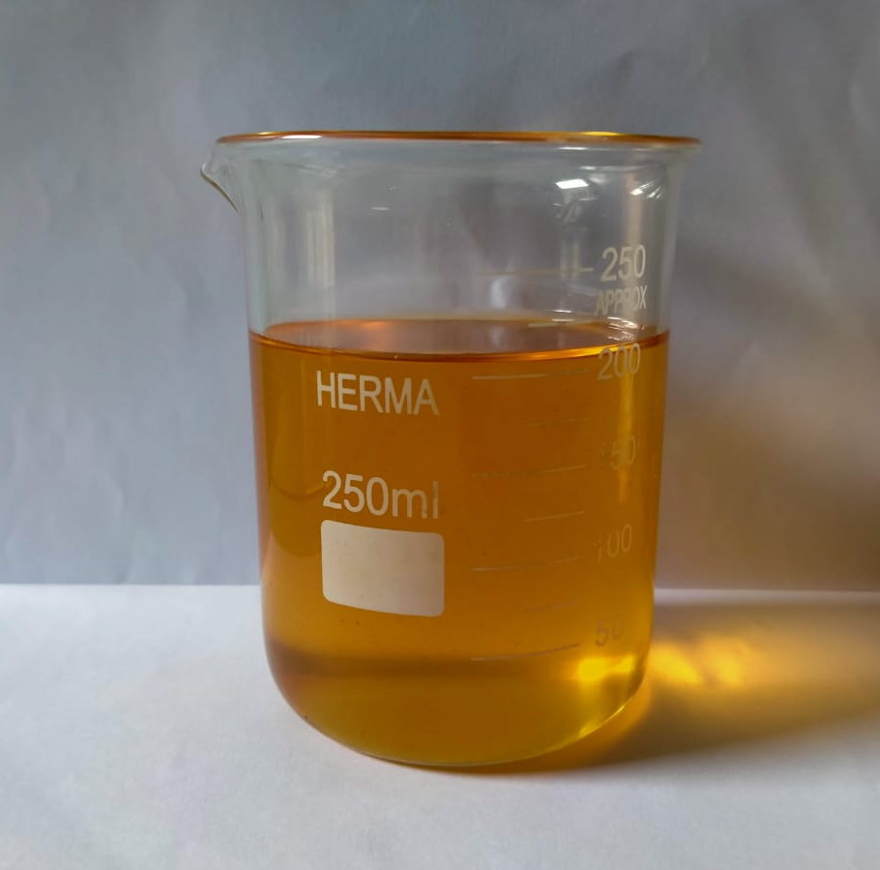

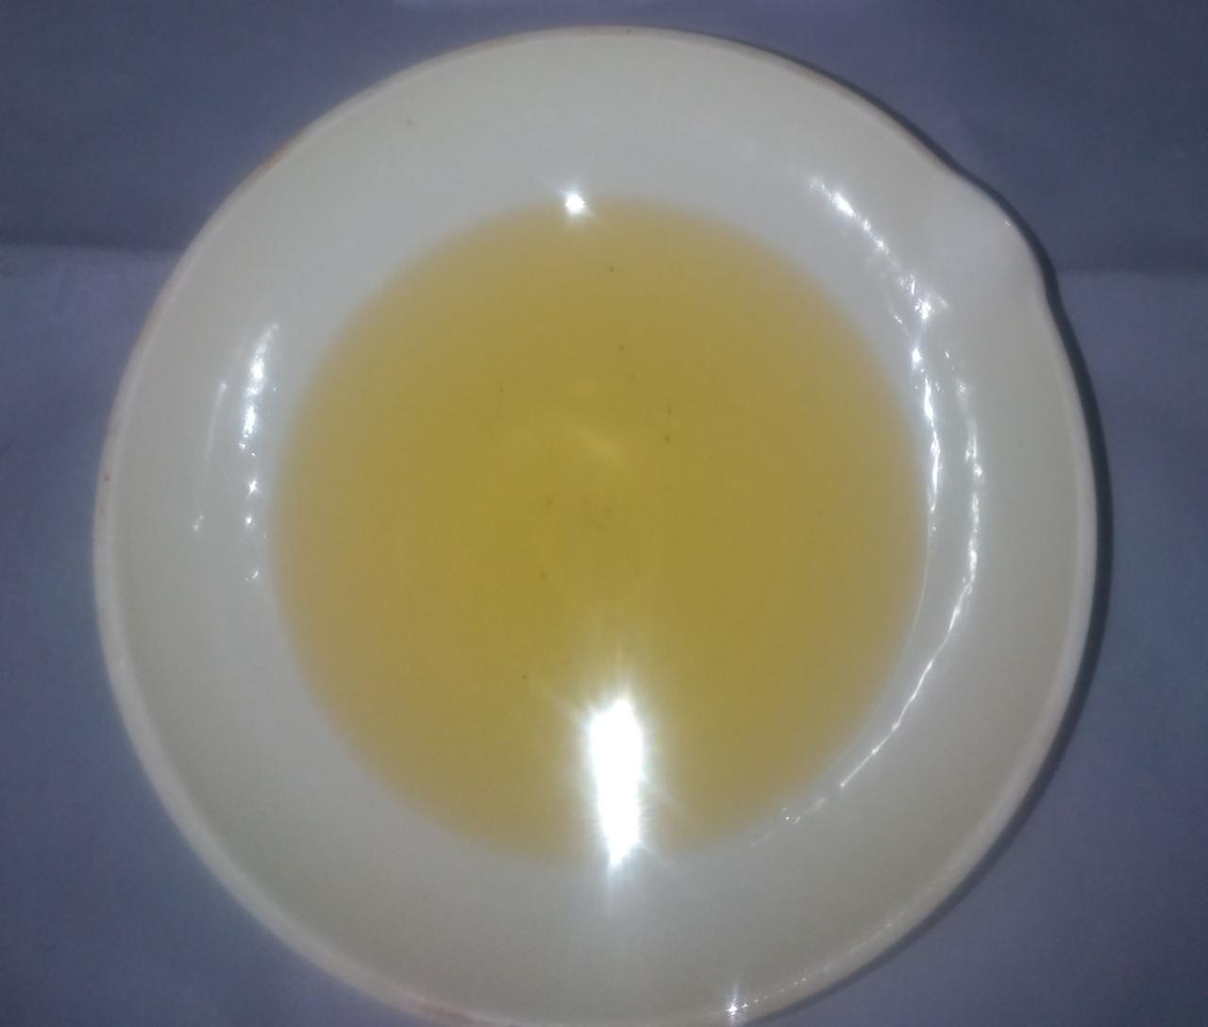
Lampiran 3. Perhitungan Formula Sediaan Skin Balm
Forrmula F0 (blanko) sediaan tanpa Minyak Sapi
- Paraffin liquidum = $\frac{20}{100}×100 g$ = 20 g
- Cera alba = $\frac{15}{100}×100 g$ = 15 g
- BHT = $\frac{0,1}{100}×100 g$ = 0,1 g
- Natrium metabisulfit = $\frac{0,1}{100}×100 g$ = 0,1 g
- Vaselin album ad 100 = 100-(20+15+0,1+0,1)g = 64,8 g
Formula F1 yaitu sediaan menggunakan minyak sapi 14%
- Paraffin liquidum = $\frac{20}{100}×100 g$ = 20 g
- Cera alba = $\frac{15}{100}×100 g$ = 15 g
- BHT = $\frac{0,1}{100}×100 g$ = 0,1 g
- Natrium metabisulfit = $\frac{0,1}{100}×100 g$ = 0,1 g
- Minyak Sapi = $\frac{14}{100}×100 g$ = 14 ml
- Vaselin album ad 100 = 100- (20+15+0,1+0,1+14)g = 50,8 g
Formula F2 yaitu sediaan menggunakan minyak sapi 17%
- Paraffin liquidum = $\frac{20}{100}×100 g$ = 20 g
- Cera alba = $\frac{15}{100}×100 g$ = 15 g
- BHT = $\frac{0,1}{100}×100 g$ = 0,1 g
- Natrium metabisulfit = $\frac{0,1}{100}×100 g$ = 0,1 g
- Minyak Sapi = $\frac{17}{100}×100 g$ = 17 ml
- Vaselin album ad 100 = 100-(20+15+0,1+0,1+17)g = 47,8 g

Lampiran 4. Hasil Sediaan Skin Balm
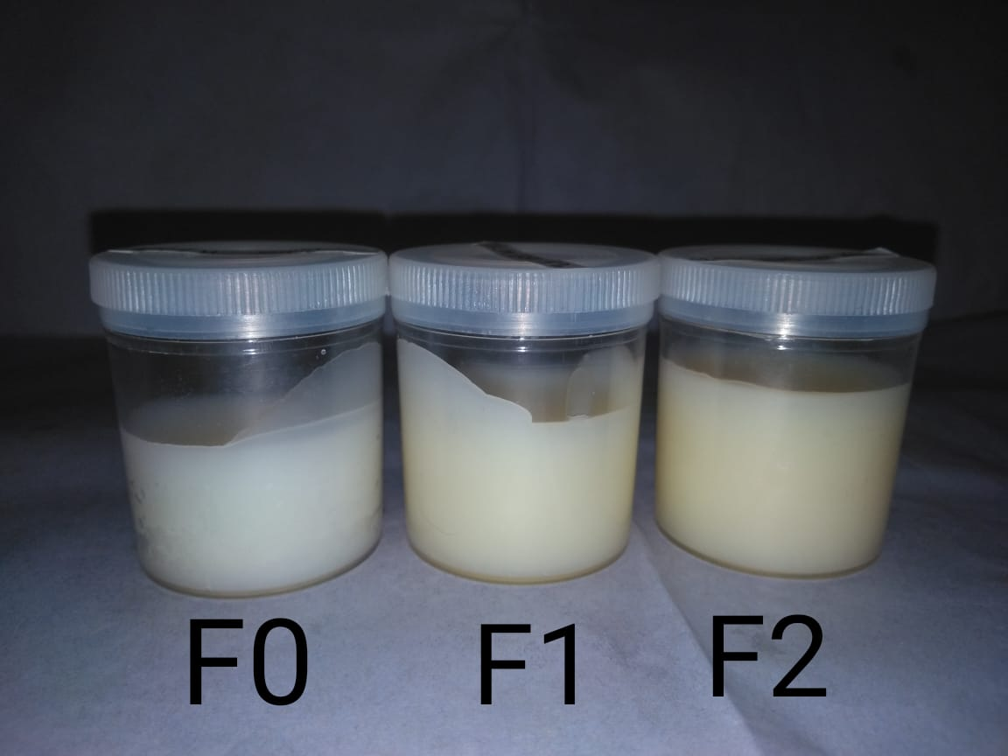
Keterangan : F0 : Sediaan skin balm tanpa Minyak Sapi
F1 : Sediaan skin balm konsentrasi Minyak Sapi 14%
F2 : Sediaan skin balm konsentrasi Minyak Sapi 17%

Lampiran 5. Hasil Nilai pH Selama 4 Minggu Dengan 6 Kali Pengulangan
Data pH Minggu Ke-0
NO | FORMULA
 | F0 | F1 | F2
1 | 5,5 | 5,3 | 5,2
2 | 5,4 | 5,3 | 5,3
3 | 5,4 | 5,2 | 5,2
4 | 5,5 | 5,3 | 5,3
5 | 5,5 | 5,3 | 5,2
6 | 5,4 | 5,2 | 5,3
 | 5,5 ± 0,05 | 5,3 ± 0,05 | 5,2 ± 0,05

Data pH Minggu ke-1
NO | FORMULA
 | F0 | F1 | F2
1 | 5,6 | 5,4 | 5,3
2 | 5,5 | 5,3 | 5,2
3 | 5,4 | 5,2 | 5,2
4 | 5,4 | 5,2 | 5,3
5 | 5,4 | 5,3 | 5,3
6 | 5,5 | 5,3 | 5,2
 | 5,6 ± 0,08 | 5,4 ± 0,07 | 5,3 ± 0,05

Data pH Minggu Ke-2
NO | FORMULA
 | F0 | F1 | F2
1 | 5,5 | 5,4 | 5,2
2 | 5,4 | 5,3 | 5,3
3 | 5,4 | 5,2 | 5,3
4 | 5,6 | 5,2 | 5,2
5 | 5,4 | 5,3 | 5,3
6 | 5,5 | 5,3 | 5,2
 | 5,5 ± 0,08 | 5,4 ± 0,07 | 5,2 ± 0,05

Lampiran 5. (Lanjutan)
Data pH Minggu Ke-3
NO | FORMULA
 | F0 | F1 | F2
1 | 5,5 | 5,3 | 5,3
2 | 5,4 | 5,3 | 5,2
3 | 5,5 | 5,2 | 5,2
4 | 5,4 | 5,2 | 5,3
5 | 5,4 | 5,3 | 5,3
6 | 5,5 | 5,2 | 5,2
 | 5,5 ± 0,05 | 5,3 ± 0,05 | 5,2 ± 0,05

Data pH Minggu Ke-4
NO | FORMULA
 | F0 | F1 | F2
1 | 5,6 | 5,3 | 5,3
2 | 5,4 | 5,2 | 5,2
3 | 5,5 | 5,3 | 5,2
4 | 5,4 | 5,3 | 5,3
5 | 5,5 | 5,2 | 5,2
6 | 5,4 | 5,2 | 5,2
 | 5,6 ± 0,08 | 5,3 ± 0,05 | 5,3 ± 0,05

Lampiran 6. Hasil Pemeriksaan Daya Sebar Selama 4 Minggu Dengan 6 Kali Pengulangan
Data Daya Sebar Minggu Ke-0
NO | FORMULA
 | F1 | F2 | F3
1 | 5,5 | 5,3 | 5,4
2 | 5,6 | 5,4 | 5,3
3 | 5,4 | 5,5 | 5,5
4 | 5,3 | 5,6 | 5,7
5 | 5,3 | 5,6 | 5,6
6 | 5,4 | 5,3 | 5,4
 | 5,5±0,11 | 5,3±0,13 | 5,4±0,14

Data Daya Sebar Minggu Ke-1
NO | FORMULA
 | F0 | F1 | F2
1 | 5,4 | 5,5 | 5,6
2 | 5,6 | 5,7 | 5,3
3 | 5,3 | 5,4 | 5,4
4 | 5,6 | 5,5 | 5,7
5 | 5,5 | 5,6 | 5,7
6 | 5,3 | 5,3 | 5,5
 | 5,4±0,13 | 5,5±0,14 | 5,6±0,16

Data Daya Sebar Minggu Ke-2
NO | FORMULA
 | F0 | F1 | F2
1 | 5,5 | 5,5 | 5,5
2 | 5,3 | 5,6 | 5,7
3 | 5,6 | 5,4 | 5,5
4 | 5,4 | 5,3 | 5,4
5 | 5,3 | 5,7 | 5,5
6 | 5,4 | 5,4 | 5,4
 | 5,5±0,11 | 5,5±0,14 | 5,5±0,10

Lampiran 6. (Lanjutan)
Data Daya Sebar Minggu Ke-3
NO | FORMULA
 | F0 | F1 | F2
1 | 5,5 | 5,5 | 5,5
2 | 5,5 | 5,6 | 5,7
3 | 5,4 | 5,5 | 5,6
4 | 5,3 | 5,7 | 5,7
5 | 5,6 | 5,4 | 5,6
6 | 5,3 | 5,3 | 5,4
 | 5,5±0,12 | 5,5±0,14 | 5,5±0,11

Data Daya Sebar Minggu Ke-4
NO | FORMULA
 | F0 | F1 | F2
1 | 5,4 | 5,6 | 5,6
2 | 5,3 | 5,7 | 5,7
3 | 5,4 | 5,5 | 5,3
4 | 5,6 | 5,4 | 5,4
5 | 5,3 | 5,3 | 5,3
6 | 5,5 | 5,5 | 5,5
 | 5,4±0,11 | 5,6±0,14 | 5,6±0,16

Lampiran 7. Bagan Alir Kerja (Flowsheet) Uji Efektivitas Kelembapan
Sukarelawan
- Diamati kondisi kulit
- Menjelaskan tentang penelitian
- Menanyakan apakah bersedia menjadi sukarelawan
- Mengisi surat pernyataan bersedia menjadi sukarelawan
- Diukur nilai kelembapan kulit
- Sediaan diberikan kepada Sukarelawan

Nilai Kelembapan Kulit
- Diukur selama 4 minggu

Nilai Kelembapan Kulit Minggu 4
Nilai Kelembapan Kulit Minggu 3
Nilai Kelembapan Kulit Minggu 2
Nilai Kelembapan Kulit Minggu 1
Nilai Kelembapan Kulit Minggu 0

- Analisis data

- Data kelembapan kulit dianalisi dengan program SPSS
- Selisih nilai kelembapan dibandingkan kelembapan awal

Hasil Analisis Data Kelembapan Kulit dengan Program SPSS
Hasil Rata – Rata Persentase Peningkatan Kelembapan Kulit

Lampiran 8. Surat Pernyataan Bersedia Menjadi Sukarelawan
SURAT PERNYATAAN
Saya yang bertanda tangan di bawah ini:
Nama :
Umur :
Jenis Kelamin :
Alamat :
Telah mendapat penjelasan secukupnya bahwa kaki saya akan digunakan sebagai daerah yang akan diuji. Setelah mendapat penjelasan secukupnya tentang manfaat penelitian ini maka saya menyatakan SETUJU untuk ikut serta dalam penelitian Nurulin Ginni Is Amini Siregar dengan judul “Uji Efektivitas Sediaan Skin Balm Minyak Sapi Terhadap Xerosis Pada Tumit Kaki”. Saya bersedia untuk mengikuti prosedur penelitian yang telah diterapkan.
Persetujuan ini saya buat dengan penuh kesadaran dan tanpa paksaan dari pihak manapun. Demikian surat pernyataan ini dibuat untuk dapat dipergunakan sebagaimana mestinya.

Medan, Februari 2021

Sukarelawan Peneliti

(..............................) (Nurulin Ginni Is Amini Siregar)

Lampiran 9. Alat Yang Digunakan Untuk Mengukur Kelembaban (Skin Detector)
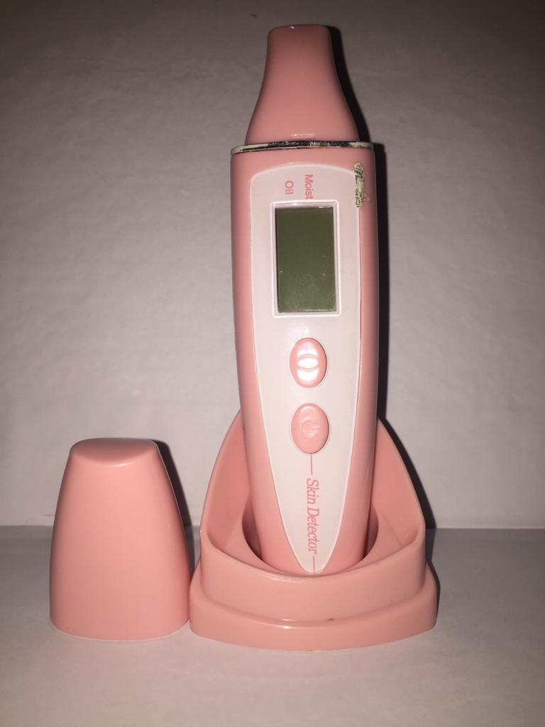

Lampiran 10. Perubahan Kaki Sukarelawan Selama Pemakaian Skin Balm
- Blanko
Minggu 0

Minggu ke-2

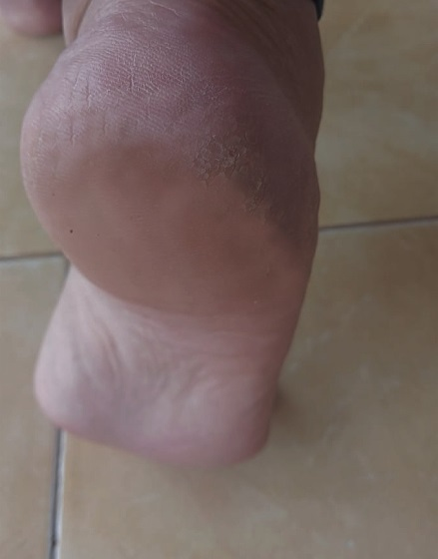
Minggu ke-4
Lampiran 10. (Lanjutan)

- Konsentrasi 14%
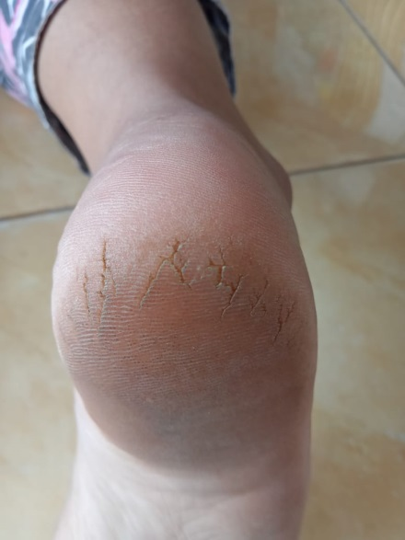
Minggu 0

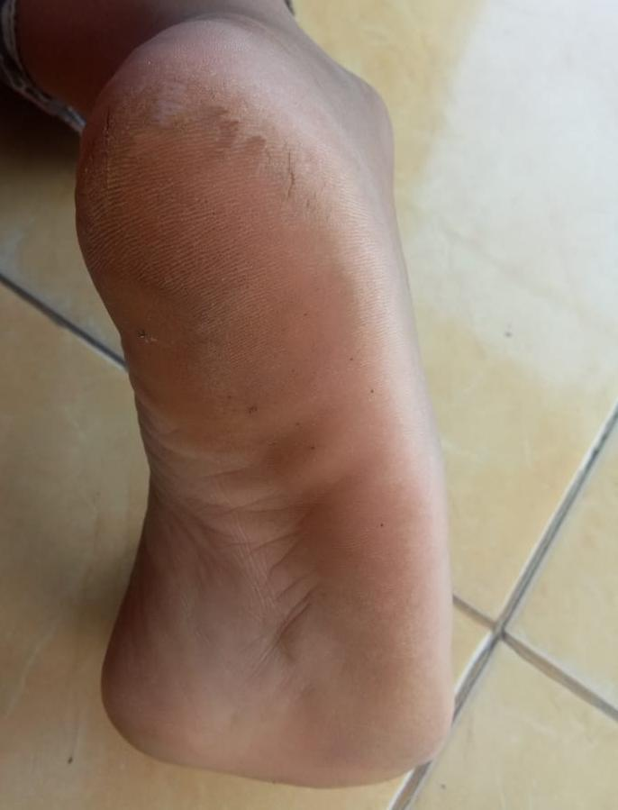
Minggu ke 2

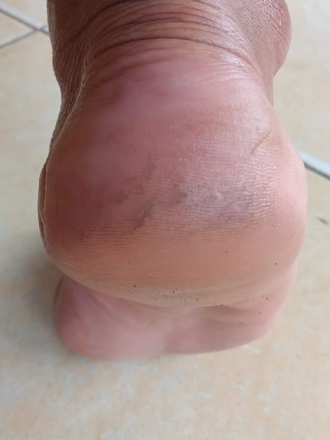
Minggu 4

Lampiran 10. (Lanjutan)

- Konsentrasi 17%
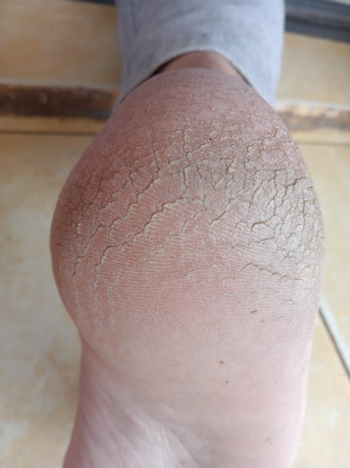
Minggu 0

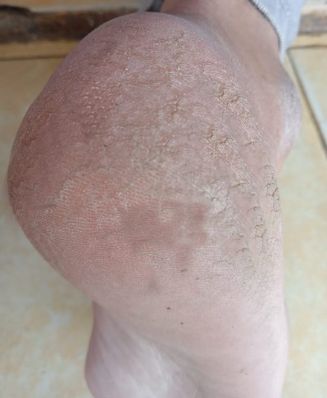
Minggu ke 2

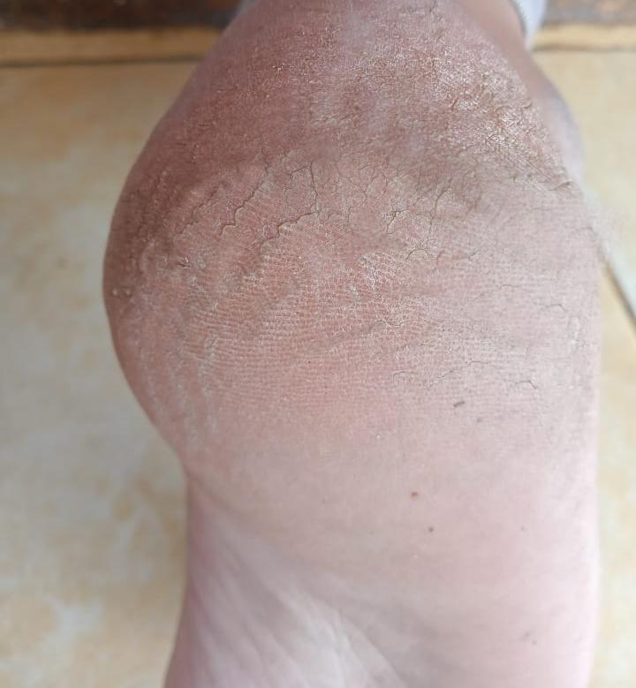
Minggu ke 4
Lampiran 11. Hasil Kelembapan Kulit Selama 4 Minggu.
Data Kelembapan Kulit (%)
NO | Formula | MINGGU 0 | MINGGU 1 | MINGGU 2 | MINGGU 3 | MINGGU 4
1 | F0 | 21,7 | 22 | 23,2 | 24,2 | 25,3
2 | F0 | 20,9 | 21,3 | 22,1 | 22,9 | 23,8
3 | F0 | 22,5 | 22,8 | 23,7 | 24,7 | 25,9
4 | F0 | 20,9 | 21,3 | 22,2 | 23 | 24,2
5 | F0 | 21,7 | 22,1 | 23 | 24,1 | 25,2
6 | F0 | 24,8 | 25,2 | 26 | 26,6 | 27,9
7 | F1 | 22,5 | 29,7 | 33,9 | 35,4 | 37
8 | F1 | 26,7 | 33,4 | 36,9 | 37,9 | 39,1
9 | F1 | 31,9 | 34,8 | 36,6 | 38,4 | 40,8
10 | F1 | 29,9 | 36,2 | 37,1 | 38 | 39,2
11 | F1 | 29,8 | 37,3 | 40,5 | 40,8 | 41,8
12 | F1 | 29,2 | 34,2 | 35,9 | 38,4 | 40,6
13 | F2 | 28,6 | 39,2 | 40,3 | 40,6 | 44,1
14 | F2 | 26,2 | 38,7 | 40,3 | 41,1 | 41,6
15 | F2 | 29 | 36,8 | 40,2 | 40,7 | 45
16 | F2 | 34,2 | 39,3 | 40,6 | 41,9 | 45,4
17 | F2 | 29,7 | 37,3 | 40,1 | 42,1 | 44,1
18 | F2 | 30,3 | 39,9 | 41,7 | 42,6 | 44,3

Lampiran 12. Hasil Analisa Statistik Data Kelembapan Kulit Dengan Uji Anova
Tests of Normality
 | FORMULA | Kolmogorov-Smirnovª |  |  | Shapiro-Wilk
 |  | Statistic | df | Sig. | Statistic | Df | Sig.
MINGGU 0 | F0 | .270 | 6 | .195 | .821 | 6 | .090
 | F1 | .270 | 6 | .196 | .893 | 6 | .336
 | F2 | .238 | 6 | .200* | .935 | 6 | .616
MINGGU 1 | F0 | .261 | 6 | .200* | .810 | 6 | .072
 | F1 | .205 | 6 | .200* | .941 | 6 | .668
 | F2 | .221 | 6 | .200* | .906 | 6 | .411
MINGGU 2 | F0 | .241 | 6 | .200* | .853 | 6 | .167
 | F1 | .281 | 6 | .151 | .921 | 6 | .511
 | F2 | .319 | 6 | .056 | .734 | 6 | .014
MINGGU 3 | F0 | .203 | 6 | .200* | .899 | 6 | .366
 | F1 | .276 | 6 | .173 | .899 | 6 | .370
 | F2 | .188 | 6 | .200* | .916 | 6 | .480
MINGGU 4 | F0 | .194 | 6 | .200* | .924 | 6 | .536
 | F1 | .192 | 6 | .200* | .950 | 6 | .737
 | F2 | .338 | 6 | .031 | .838 | 6 | .125
a. Lilliefors Significance Correction
*. This is a lower bound of the true significance.

Lampiran 12. (Lanjutan)
Descriptives
 |  | N | Mean | Std. Deviation | Std. Error | 95% Confidence Interval for Mean |  | Minimum | Maximum
 |  |  |  |  |  | Lower Bound | Upper Bound
MINGGU 0 | F0 | 6 | 22.083 | 1.4593 | .5958 | 20.552 | 23.615 | 20.9 | 24.8
 | F1 | 6 | 28.333 | 3.3098 | 1.3512 | 24.860 | 31.807 | 22.5 | 31.9
 | F2 | 6 | 29.667 | 2.6288 | 1.0732 | 26.908 | 32.425 | 26.2 | 34.2
 | Total | 18 | 26.694 | 4.1775 | .9846 | 24.617 | 28.772 | 20.9 | 34.2
MINGGU 1 | F0 | 6 | 22.450 | 1.4598 | .5960 | 20.918 | 23.982 | 21.3 | 25.2
 | F1 | 6 | 34.267 | 2.6394 | 1.0775 | 31.497 | 37.037 | 29.7 | 37.3
 | F2 | 6 | 38.533 | 1.2209 | .4984 | 37.252 | 39.815 | 36.8 | 39.9
 | Total | 18 | 31.750 | 7.2191 | 1.7016 | 28.160 | 35.340 | 21.3 | 39.9
MINGGU 2 | F0 | 6 | 23.367 | 1.4264 | .5823 | 21.870 | 24.864 | 22.1 | 26.0
 | F1 | 6 | 36.817 | 2.1470 | .8765 | 34.564 | 39.070 | 33.9 | 40.5
 | F2 | 6 | 40.533 | .5955 | .2431 | 39.908 | 41.158 | 40.1 | 41.7
 | Total | 18 | 33.572 | 7.7225 | 1.8202 | 29.732 | 37.413 | 22.1 | 41.7
MINGGU 3 | F0 | 6 | 24.250 | 1.3517 | .5518 | 22.832 | 25.668 | 22.9 | 26.6
 | F1 | 6 | 38.150 | 1.7202 | .7023 | 36.345 | 39.955 | 35.4 | 40.8
 | F2 | 6 | 41.500 | .8173 | .3337 | 40.642 | 42.358 | 40.6 | 42.6
 | Total | 18 | 34.633 | 7.7886 | 1.8358 | 30.760 | 38.507 | 22.9 | 42.6
MINGGU 4 | F0 | 6 | 25.383 | 1.4525 | .5930 | 23.859 | 26.908 | 23.8 | 27.9
 | F1 | 6 | 39.750 | 1.6920 | .6908 | 37.974 | 41.526 | 37.0 | 41.8
 | F2 | 6 | 44.083 | 1.3258 | .5412 | 42.692 | 45.475 | 41.6 | 45.4
 | Total | 18 | 36.406 | 8.3433 | 1.9665 | 32.257 | 40.555 | 23.8 | 45.4

Lampiran 12. (Lanjutan)

Test of Homogeneity of Variances
 | Levene Statistic | df1 | df2 | Sig.
MINGGU 0 | 1.229 | 2 | 15 | .321
MINGGU 1 | .991 | 2 | 15 | .394
MINGGU 2 | 1.175 | 2 | 15 | .336
MINGGU 3 | .229 | 2 | 15 | .798
MINGGU 4 | .422 | 2 | 15 | .663

ANOVA
 |  | Sum of Squares | Df | Mean Square | F | Sig.
MINGGU 0 | Between Groups | 196.694 | 2 | 98.347 | 14.756 | .000
 | Within Groups | 99.975 | 15 | 6.665
 | Total | 296.669 | 17
MINGGU 1 | Between Groups | 833.023 | 2 | 416.512 | 118.011 | .000
 | Within Groups | 52.942 | 15 | 3.529
 | Total | 885.965 | 17
MINGGU 2 | Between Groups | 978.821 | 2 | 489.411 | 209.777 | .000
 | Within Groups | 34.995 | 15 | 2.333
 | Total | 1013.816 | 17
MINGGU 3 | Between Groups | 1003.990 | 2 | 501.995 | 276.125 | .000
 | Within Groups | 27.270 | 15 | 1.818
 | Total | 1031.260 | 17
MINGGU 4 | Between Groups | 1149.738 | 2 | 574.869 | 256.244 | .000
 | Within Groups | 33.652 | 15 | 2.243
 | Total | 1183.389 | 17

Lampiran 12. (Lanjutan)
MINGGU 0
Tukey HSDª
FORMULA | N | Subset for alpha = 0.05
 |  | 1 |  | 2
F0 | 6 | 22.083
F1 | 6 |  |  | 28.333
F2 | 6 |  |  | 29.667
Sig. |  | 1.000 |  | .652
Means for groups in homogeneous subsets are displayed.
a. Uses Harmonic Mean Sample Size = 6.000.
MINGGU 1
Tukey HSDª
FORMULA | N | Subset for alpha = 0.05
 |  | 1 | 2 |  | 3
F0 | 6 | 22.450
F1 | 6 |  | 34.267
F2 | 6 |  |  |  | 38.533
Sig. |  | 1.000 | 1.000 |  | 1.000
Means for groups in homogeneous subsets are displayed.
a. Uses Harmonic Mean Sample Size = 6.000.
MINGGU 2
Tukey HSDª
FORMULA | N | Subset for alpha = 0.05
 |  | 1 | 2 |  | 3
F0 | 6 | 23.367
F1 | 6 |  | 36.817
F2 | 6 |  |  |  | 40.533
Sig. |  | 1.000 | 1.000 |  | 1.000
Means for groups in homogeneous subsets are displayed.
a. Uses Harmonic Mean Sample Size = 6.000.
Lampiran 12. (Lanjutan)
MINGGU 3
Tukey HSDª
FORMULA | N | Subset for alpha = 0.05
 |  | 1 | 2 | 3
F0 | 6 | 24.250
F1 | 6 |  | 38.150
F2 | 6 |  |  | 41.500
Sig. |  | 1.000 | 1.000 | 1.000
Means for groups in homogeneous subsets are displayed.
a. Uses Harmonic Mean Sample Size = 6.000.

MINGGU 4
Tukey HSDª
FORMULA | N | Subset for alpha = 0.05
 |  | 1 | 2 | 3
F0 | 6 | 25.383
F1 | 6 |  | 39.750
F2 | 6 |  |  | 44.083
Sig. |  | 1.000 | 1.000 | 1.000
Means for groups in homogeneous subsets are displayed.
a. Uses Harmonic Mean Sample Size = 6.000.

Lampiran 13. Produk Sediaan Skin Balm
