Lampiran 1. Certificate of Analysis (COA) Minyak Nyamplung
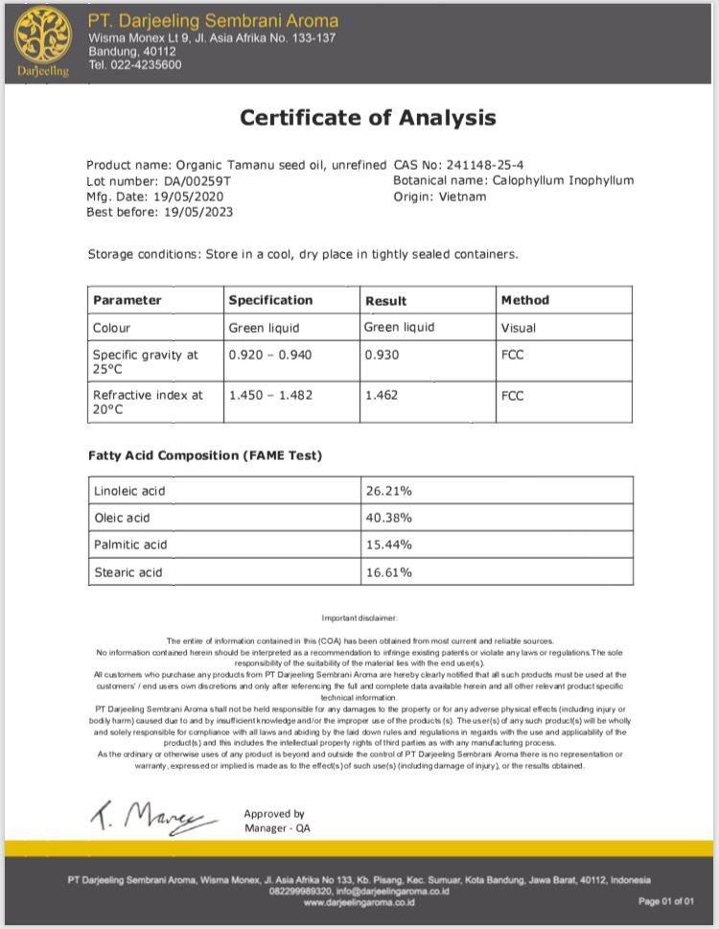

Lampiran 2. Minyak Nyamplung

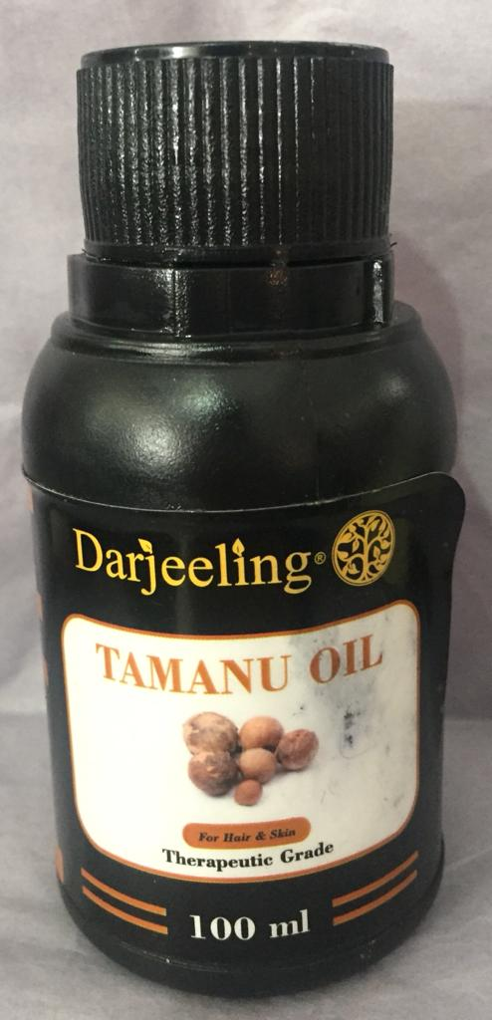
Minyak nyamplung yang beredar dipasaran
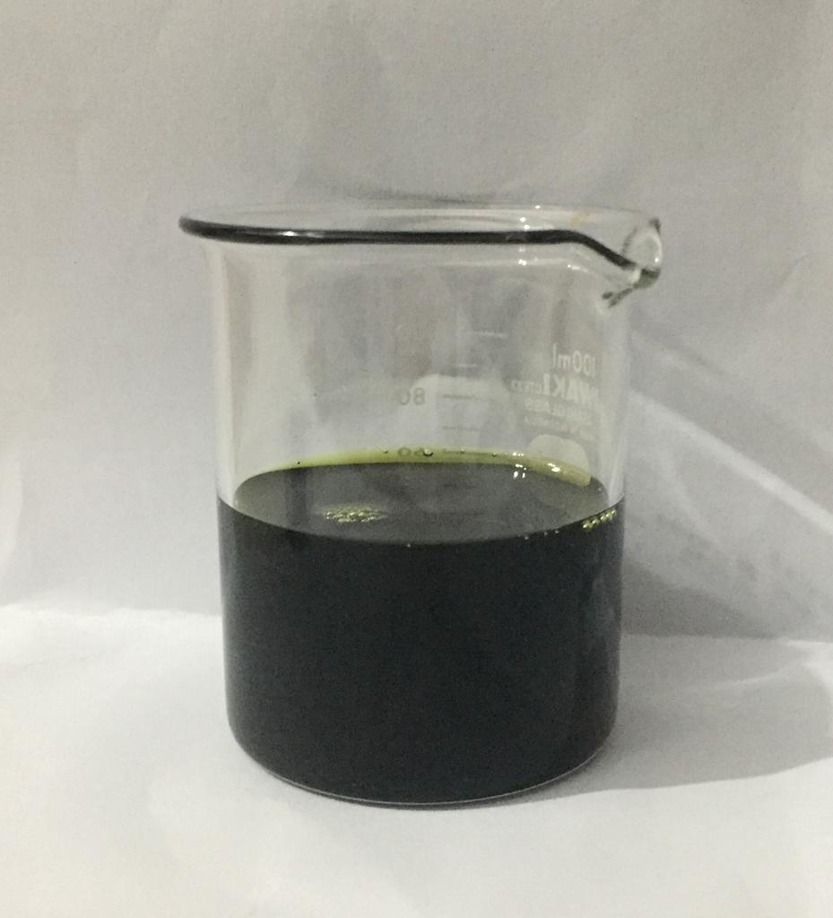
Minyak nyamplung dalam wadah

Lampiran 3. Bagan Alir (Flowsheet) Pembuatan Sediaan Lip Balm

Oleum cacao
Cera flava dan cera alba

- Ditimbang
- Masukkan ke dalam cawan penguap
- Lelehkan diatas penangas air sambil diaduk
- Ditimbang
- Masukkan ke dalam cawan penguap
- Lelehkan diatas penangas air sambil diaduk

Lelehan oleum cacao
Lelehan cera flava dan cera alba

- Masukkan lelehan cera flava dan cera alba kedalam lelehan oleum cacao
- Masukkan nipagin, nipasol, natrium metabisulfit, BHT dan gliserin sambil terus diaduk
- Masukkan minyak nyamplung sambil diaduk

Massa cair

- Masukkan ke dalam wadah lip balm
- Biarkan pada suhu ruangan sampai membeku

Sediaan lip balm minyak nyamplung

Lampiran 4. Perhitungan Formula Sediaan Lip Balm

- F0 yaitu sediaan lip balm tanpa minyak nyamplung (blanko)
  - Minyak nyamplung : -
  - Gliserin 5% : $\frac{5}{100}$ x 100g = 5 gram
  - Cera alba 5% : $\frac{5}{100}$ x 100g = 5 gram
  - Cera flava 6% : $\frac{6}{100}$ x 100g = 6 gram
  - Nipagin 0,18% : $\frac{0,18}{100}$ x 100g = 0,18 gram
  - Nipasol 0,02% : $\frac{0,02}{100}$ x 100g = 0,02 gram
  - Na.Metabisulfit 0,1% : $\frac{0,1}{100}$ x 100g = 0,1 gram
  - BHT 0,1% : $\frac{0,1}{100}$ x 100g = 0,1 gram
  - Oleum cacao ad 100% : $\frac{100}{100}$ x 100g = 100 gram
: 100 – (5+5+6+0,18+0,02+0,1+0,1)
: 100-16,4
: 83,6 gram
- F1 yaitu sediaan lip balm dengan konsentrasi minyak nyamplung 15%
  - Minyak nyamplung 15% :$\frac{15}{100}$ x 100g = 15 gram
  - Gliserin 5% : $\frac{5}{100}$ x 100g = 5 gram
  - Cera alba 5% : $\frac{5}{100}$ x 100g = 5 gram
  - Cera flava 6% : $\frac{6}{100}$ x 100g = 6 gram
  - Nipagin 0,18% : $\frac{0,18}{100}$ x 100g = 0,18 gram

Lampiran 4. (Lanjutan)
  - Nipasol 0,02% : $\frac{0,02}{100}$ x 100g = 0,02 gram
  - Na.Metabisulfit 0,1% : $\frac{0,1}{100}$ x 100g = 0,1 gram
  - BHT 0,1% : $\frac{0,1}{100}$ x 100g = 0,1 gram
  - Oleum cacao ad 100% : $\frac{100}{100}$ x 100g = 100 gram
: 100 – (15+5+5+6+0,18+0,02+0,1+0,1)
: 100-31,4
: 68,6 gram
- F2 yaitu sediaan lip balm dengan konsentrasi minyak nyamplung 20%
  - Minyak nyamplung 20% :$\frac{20}{100}$ x 100g = 20 gram
  - Gliserin 5% : $\frac{5}{100}$ x 100g = 5 gram
  - Cera alba 5% : $\frac{5}{100}$ x 100g = 5 gram
  - Cera flava 6% : $\frac{6}{100}$ x 100g = 6 gram
  - Nipagin 0,18% : $\frac{0,18}{100}$ x 100g = 0,18 gram
  - Nipasol 0,02% : $\frac{0,02}{100}$ x 100g = 0,02 gram
  - Na.Metabisulfit 0,1% : $\frac{0,1}{100}$ x 100g = 0,1 gram
  - BHT 0,1% : $\frac{0,1}{100}$ x 100g = 0,1 gram
  - Oleum cacao ad 100% : $\frac{100}{100}$ x 100g = 100 gram
: 100 – (20+5+5+6+0,18+0,02+0,1+0,1)
: 100-36,4
: 63,6 gram

Lampiran 5. Hasil Sediaan Lip Balm Minyak Nyamplung

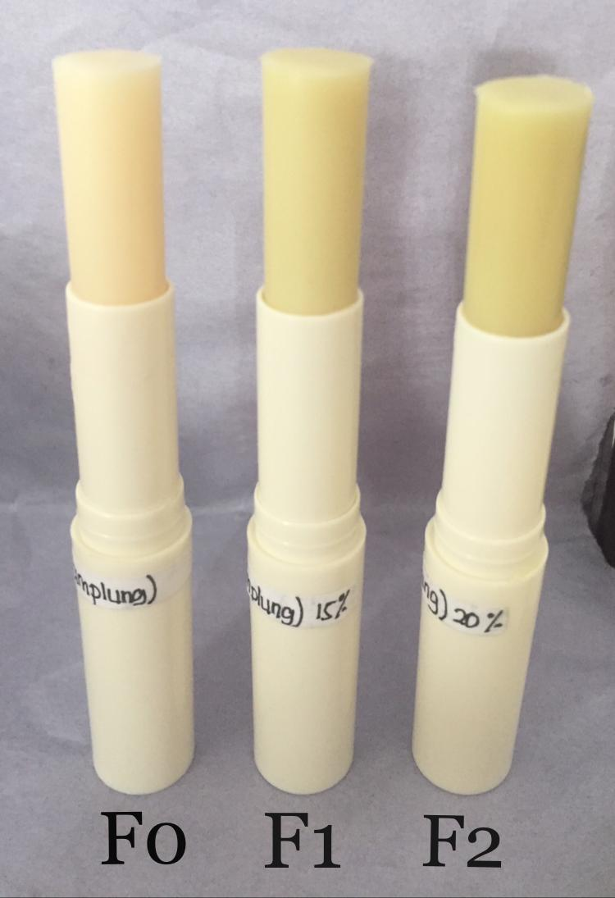
Keterangan: F0 : Sediaan lip balm tanpa minyak nyamplung (Blanko)
F1 : Sediaan lip balm dengan konsentrasi minyak nyamplung 15%
F2 : Sediaan lip balm dengan konsentrasi minyak nyamplung 20%

Lampiran 6. Hasil Nilai pH Sediaan Lip Balm Selama 4 Minggu dengan 6 Kali Pengulangan
pengulangan | Nilai pH
 | Minggu 0 |  |  | Minggu 1 |  |  | Minggu 2 |  |  | Minggu 3 |  |  | Minggu 4
 | F0 | F1 | F2 | F0 | F1 | F2 | F0 | F1 | F2 | F0 | F1 | F2 | F0 | F1 | F2
1 | 5,3 | 5,1 | 5 | 5,3 | 5,1 | 5 | 5,3 | 5,1 | 5 | 5,4 | 5,1 | 5 | 5,3 | 5,1 | 5
2 | 5,3 | 5,1 | 5 | 5,3 | 5,1 | 5 | 5,2 | 5,1 | 5 | 5,3 | 5,1 | 4,9 | 5,3 | 5,1 | 5,1
3 | 5,2 | 5 | 5 | 5,3 | 5,1 | 5 | 5,2 | 5,1 | 5,1 | 5,3 | 5 | 5 | 5,3 | 5,1 | 5
4 | 5,3 | 5 | 5 | 5,4 | 5 | 5 | 5,3 | 5 | 5 | 5,3 | 5,1 | 5 | 5,3 | 5 | 5
5 | 5,2 | 5,1 | 4,9 | 5,3 | 5,1 | 5 | 5,3 | 5,1 | 5 | 5,3 | 5,1 | 5 | 5,2 | 4,9 | 4,9
6 | 5,3 | 5,1 | 5 | 5,3 | 5,1 | 4,9 | 5,3 | 5,1 | 5 | 5,3 | 5 | 5 | 5,3 | 5 | 5

Lampiran 7. Hasil Pemeriksaan Suhu Lebur Sediaan Lip Balm Selama 4 Minggu dengan 6 Kali Pengulangan

pengulangan | Suhu lebur
 | Minggu 0 |  |  | Minggu 1 |  |  | Minggu 2 |  |  | Minggu 3 |  |  | Minggu 4
 | F0 | F1 | F2 | F0 | F1 | F2 | F0 | F1 | F2 | F0 | F1 | F2 | F0 | F1 | F2
1 | 52 | 53 | 54 | 52,5 | 53 | 55 | 52 | 53 | 54 | 52 | 53,5 | 54 | 52 | 53 | 54,5
2 | 52 | 53,5 | 54 | 52 | 53 | 54 | 52 | 53,5 | 54 | 52 | 53 | 54 | 52 | 53 | 54
3 | 52,5 | 53 | 54 | 52 | 53 | 54 | 52,5 | 54 | 54 | 52 | 53 | 54 | 52 | 53 | 54
4 | 52 | 53,5 | 54 | 52 | 53,5 | 54 | 52 | 53,5 | 54 | 52 | 53 | 54 | 52 | 53 | 54
5 | 52,5 | 53 | 54 | 52 | 54 | 54 | 52 | 53 | 54 | 52,5 | 53 | 54 | 52 | 53 | 54
6 | 52 | 53,5 | 54,5 | 52 | 53 | 54,5 | 52,5 | 53 | 54,5 | 52,5 | 53 | 54 | 52 | 53 | 54

Lampiran 8. Hasil nilai breaking point sediaan lip balm selama 4 minggu dengan 6 Kali Pengulangan
pengulangan | Breaking point
 | Minggu 0 |  |  | Minggu 1 |  |  | Minggu 2 |  |  | Minggu 3 |  |  | Minggu 4
 | F0 | F1 | F2 | F0 | F1 | F2 | F0 | F1 | F2 | F0 | F1 | F2 | F0 | F1 | F2
1 | 340 | 320 | 300 | 340 | 327 | 300 | 370 | 320 | 305 | 370 | 325 | 307 | 372 | 325 | 307
2 | 340 | 320 | 302 | 345 | 320 | 302 | 370 | 320 | 302 | 370 | 320 | 307 | 377 | 320 | 307
3 | 342 | 320 | 302 | 342 | 325 | 302 | 370 | 322 | 302 | 370 | 320 | 302 | 377 | 327 | 302
4 | 340 | 322 | 305 | 340 | 322 | 305 | 372 | 322 | 305 | 370 | 322 | 305 | 370 | 322 | 305
5 | 342 | 320 | 300 | 340 | 320 | 300 | 370 | 320 | 300 | 372 | 320 | 300 | 372 | 327 | 305
6 | 340 | 320 | 300 | 340 | 320 | 307 | 372 | 320 | 300 | 372 | 320 | 300 | 372 | 325 | 300

Lampiran 9. Bagan Alir (Flowsheet) Uji Efektivitas Kelembaban
Sukarelawan
Diamati kondisi kulit bibir
- Menjelaskan tentang penelitian
- Menanyakan apakah bersedia menjadi sukarelawan
- Mengisi surat pernyataan bersedia menjadi sukarelawan
- Diukur nilai kelembaban kulit bibir
- Sediaan diberikan pada sukarelawan
- Sukarelawan menggunakan sediaan lip balm
- Diukur selama 4 minggu
Nilai Kelembaban Kulit Bibir
Nilai Kelembaban Kulit Bibir Minggu 4
Nilai Kelembaban Kulit Bibir Minggu 3

Nilai Kelembaban Kulit Bibir Minggu 0
Nilai Kelembaban Kulit Bibir Minggu 2
Nilai Kelembaban Kulit Bibir Minggu 1

- Analisis data

- Data kelembaban kulit bibir dianalisis dengan program SPSS
- Selisih nilai kelembaban dibandingkan kelembaban awal

Hasil Rata – Rata Persentase Peningkatan Kelembaban Kulit Bibir
Hasil Analisis Data Kelembapan Kulit dengan Program SPSS

Lampiran 10. Surat Pernyataan Bersedia Menjadi Sukarelawan

Saya yang bertanda tangan di bawah ini:
Nama :
Umur :
Jenis kelamin :
Alamat :
No.Telp/HP :
Telah mendapat penjelasan secukupnya bahwa Bibir saya akan digunakan sebagai daerah yang akan diuji. Setelah mendapat penjelasan secukupnya tentang manfaat penelitian ini maka saya menyatakan SETUJU untuk ikut serta dalam penelitian Suka Ima Pakpahan dengan judul “Formulasi dan Evaluasi SediaanLip Balm Minyak Nyamplung (Calophylluminophyllum L.)” Saya bersedia untuk mengikuti prosedur penelitian yang telah diterapkan.
Persetujuan ini saya buat dengan penuh kesadaran dan tanpa paksaan dari pihak manapun. Demikian surat pernyataan ini dibuat untuk dapat dipergunakan sebagaimana mestinya.

Medan, Maret 2021

Sukarelawan Peneliti

(..............................) (Suka Ima Pakpahan)

Lampiran 11. Uji Efektivitas Kelembaban Terhadap Kulit Bibir Sukarelawan dengan Menggunakan Alat Skin Detector

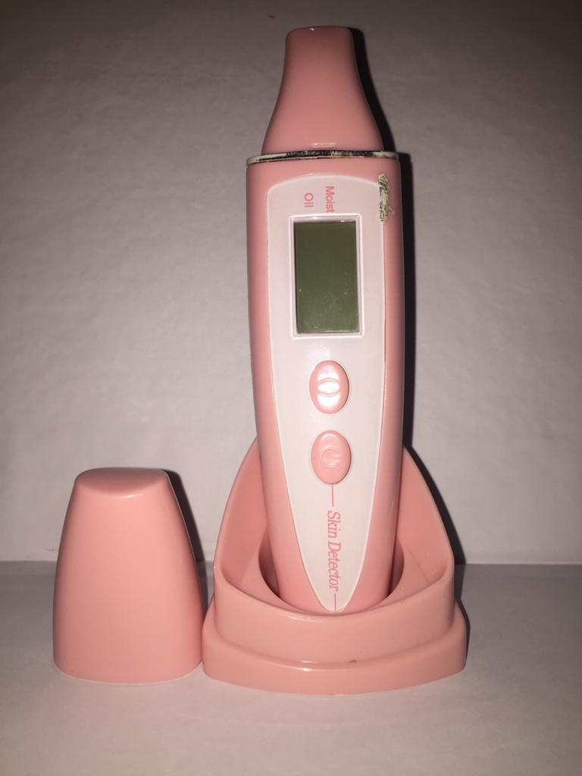

Alat yang digunakan Untuk Mengukur Kelembaban Kulit Bibir (Skin Detector)

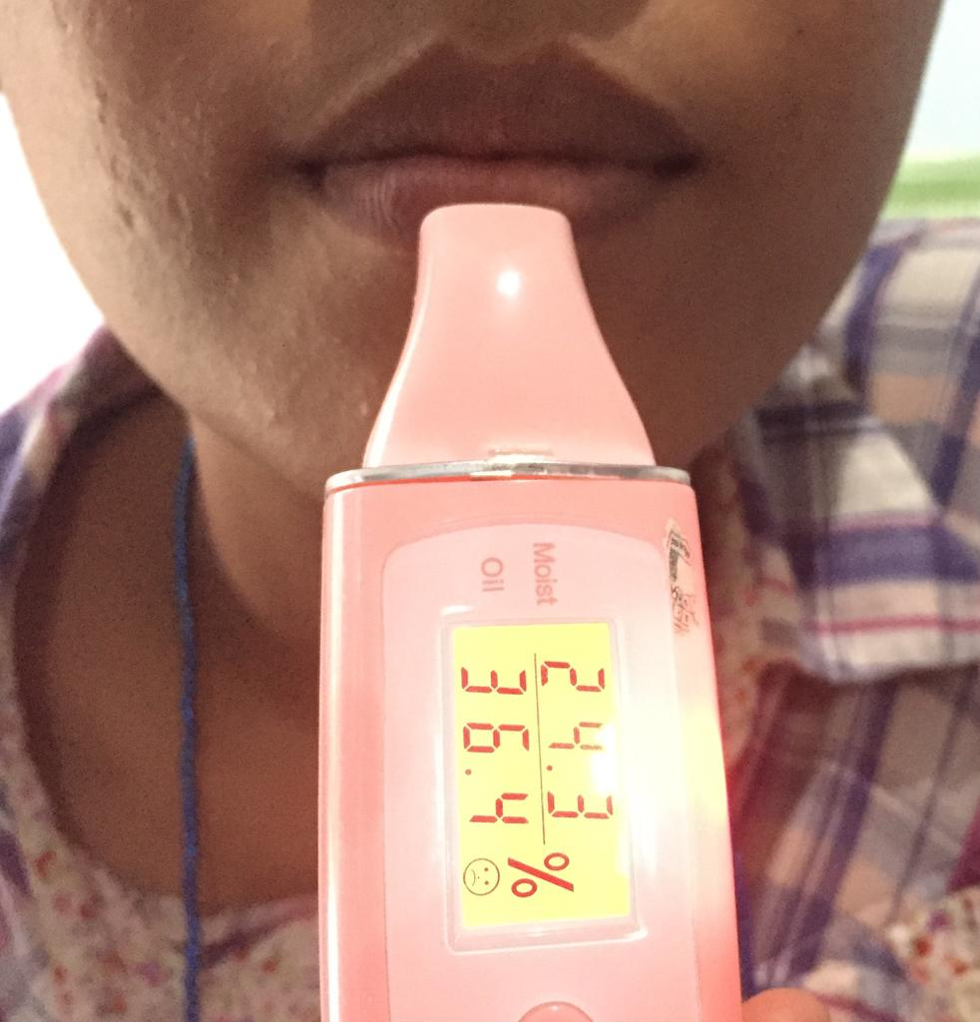

Pengukuran kulit bibir sukarelawan dengan menggunakan alat Skin Detector
Lampiran 12. Hasil Nilai Kelembaban Kulit Bibir Sukarelawan Selama 4 Minggu
pengulangan | Kelembaban kulit bibir (%)
 | Minggu 0 |  | Minggu 1 |  |  |  | Minggu 2 |  |  | Minggu 3 |  |  | Minggu 4
 | F0 | F1 | F2 | F0 | F1 | F2 | F0 | F1 | F2 | F0 | F1 | F2 | F0 | F1 | F2
1 | 34,2 | 37,0 | 31,4 | 34,3 | 40,2 | 34,9 | 34,6 | 44,8 | 34,9 | 34,7 | 50,7 | 46,9 | 34,9 | 54,1 | 52,4
2 | 22,9 | 26,4 | 31,4 | 23,1 | 29,7 | 34,2 | 23,4 | 33,9 | 34,2 | 23,7 | 37,4 | 46,0 | 23,9 | 40,2 | 51,4
3 | 39,0 | 32,6 | 32,6 | 39,2 | 35,9 | 35,1 | 39,3 | 40,8 | 35,1 | 39,8 | 45,1 | 47,5 | 39,8 | 51,9 | 53,2
4 | 24,3 | 35,4 | 32,1 | 24,9 | 38,1 | 35,9 | 25,2 | 41,8 | 35,9 | 25,3 | 46,0 | 47,7 | 25,5 | 52,0 | 54,7
5 | 36,8 | 35,7 | 31,2 | 37,0 | 39,0 | 34,1 | 37,3 | 42,9 | 34,1 | 37,5 | 47,4 | 46,7 | 37,7 | 50,5 | 53,3
6 | 26,4 | 31,7 | 31,6 | 26,6 | 34,2 | 34,2 | 26,9 | 39,6 | 34,2 | 27,2 | 43,5 | 46,3 | 34,5 | 47,0 | 54,5

Lampiran 13. Kulit Bibir Sukarelawan Sebelum dan Sesudah Pemakaian Sediaan Lip Balm
F0 : Sediaan lip balm blanko
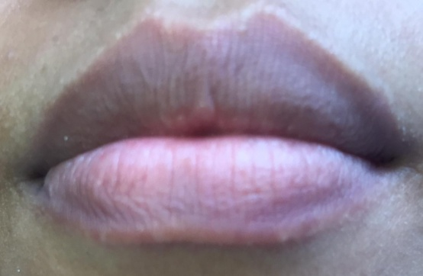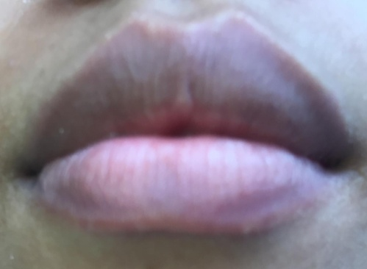
Sebelum pemakaian sediaan lip balm Sesudah pemakaian sediaan lip balm
selama 4 minggu

F1 : Sediaan lip balm dengan konsentrasi minyak nyamplung 15%
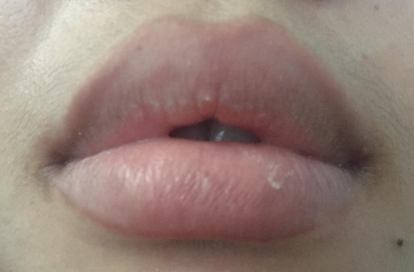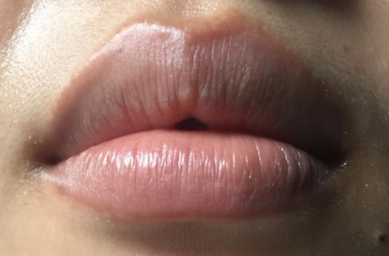
Sebelum pemakaian sediaan lip balm Sesudah pemakaian sediaan lip balm
selama 4 minggu

F2 : Sediaan lip balm dengan konsentrasi minyak nyamplung 20%
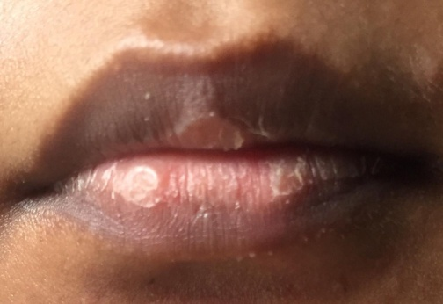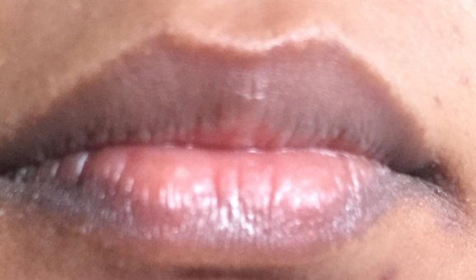
Sebelum pemakaian sediaan lip balm Sesudah pemakaian sediaan lip balm
Selama 4 minggu

Lampiran 14. Hasil Analisa Statistik Data Kelembaban Kulit Bibir dengan Program SPSS
Tests of Normality
 | FORMULA | Kolmogorov-Smirnovª |  |  | Shapiro-Wilk
 |  | Statistic | df | Sig. | Statistic | df | Sig.
MINGGU 0 | F0 | .228 | 6 | .200* | .887 | 6 | .304
 | F1 | .222 | 6 | .200* | .901 | 6 | .381
 | F2 | .254 | 6 | .200* | .882 | 6 | .277
MINGGU 1 | F0 | .233 | 6 | .200* | .894 | 6 | .337
 | F1 | .191 | 6 | .200* | .932 | 6 | .596
 | F2 | .275 | 6 | .175 | .869 | 6 | .221
MINGGU 2 | F0 | .233 | 6 | .200* | .890 | 6 | .320
 | F1 | .225 | 6 | .200* | .916 | 6 | .475
 | F2 | .265 | 6 | .200* | .847 | 6 | .148
MINGGU 3 | F0 | .229 | 6 | .200* | .896 | 6 | .348
 | F1 | .200 | 6 | .200* | .953 | 6 | .763
 | F2 | .170 | 6 | .200* | .955 | 6 | .778
MINGGU 4 | F0 | .225 | 6 | .200* | .895 | 6 | .343
 | F1 | .262 | 6 | .200* | .865 | 6 | .206
 | F2 | .219 | 6 | .200* | .969 | 6 | .886
a. Lilliefors Significance Correction
*. This is a lower bound of the true significance.

Lampiran 14. (Lanjutan)

Descriptives
 |  | N | Mean | Std. Deviation | Std. Error | 95% Confidence Interval for Mean |  | Minimum | Maximum
 |  |  |  |  |  | Lower Bound | Upper Bound
MINGGU 0 | F0 | 6 | 30.600 | 6.9077 | 2.8200 | 23.351 | 37.849 | 22.9 | 39.0
 | F1 | 6 | 33.133 | 3.8563 | 1.5743 | 29.086 | 37.180 | 26.4 | 37.0
 | F2 | 6 | 31.717 | .5307 | .2167 | 31.160 | 32.274 | 31.2 | 32.6
 | Total | 18 | 31.817 | 4.4304 | 1.0443 | 29.613 | 34.020 | 22.9 | 39.0
MINGGU 1 | F0 | 6 | 30.850 | 6.8261 | 2.7867 | 23.686 | 38.014 | 23.1 | 39.2
 | F1 | 6 | 36.183 | 3.8416 | 1.5683 | 32.152 | 40.215 | 29.7 | 40.2
 | F2 | 6 | 34.733 | .7062 | .2883 | 33.992 | 35.474 | 34.1 | 35.9
 | Total | 18 | 33.922 | 4.8538 | 1.1441 | 31.508 | 36.336 | 23.1 | 40.2
MINGGU 2 | F0 | 6 | 31.117 | 6.7774 | 2.7669 | 24.004 | 38.229 | 23.4 | 39.3
 | F1 | 6 | 40.633 | 3.7495 | 1.5307 | 36.698 | 44.568 | 33.9 | 44.8
 | F2 | 6 | 41.017 | .4708 | .1922 | 40.523 | 41.511 | 40.6 | 41.7
 | Total | 18 | 37.589 | 6.3177 | 1.4891 | 34.447 | 40.731 | 23.4 | 44.8
MINGGU 3 | F0 | 6 | 31.367 | 6.8234 | 2.7856 | 24.206 | 38.527 | 23.7 | 39.8
 | F1 | 6 | 45.017 | 4.4557 | 1.8191 | 40.341 | 49.693 | 37.4 | 50.7
 | F2 | 6 | 46.850 | .6626 | .2705 | 46.155 | 47.545 | 46.0 | 47.7
 | Total | 18 | 41.078 | 8.3775 | 1.9746 | 36.912 | 45.244 | 23.7 | 50.7
MINGGU 4 | F0 | 6 | 31.550 | 6.7622 | 2.7606 | 24.454 | 38.646 | 23.9 | 39.8
 | F1 | 6 | 49.283 | 5.0325 | 2.0545 | 44.002 | 54.565 | 40.2 | 54.1
 | F2 | 6 | 52.983 | 1.0907 | .4453 | 51.839 | 54.128 | 51.4 | 54.7
 | Total | 18 | 44.606 | 10.6724 | 2.5155 | 39.298 | 49.913 | 23.9 | 54.7

Lampiran 14. (Lanjutan)

Test of Homogeneity of Variances
 | Levene Statistic | df1 | df2 | Sig.
MINGGU 0 | 17.158 | 2 | 15 | .000
MINGGU 1 | 16.005 | 2 | 15 | .000
MINGGU 2 | 14.852 | 2 | 15 | .000
MINGGU 3 | 10.553 | 2 | 15 | .001
MINGGU 4 | 9.842 | 2 | 15 | .002

ANOVA
 |  | Sum of Squares | df | Mean Square | F | Sig.
MINGGU 0 | Between Groups | 19.343 | 2 | 9.672 | .462 | .639
 | Within Groups | 314.342 | 15 | 20.956
 | Total | 333.685 | 17
MINGGU 1 | Between Groups | 91.254 | 2 | 45.627 | 2.213 | .144
 | Within Groups | 309.257 | 15 | 20.617
 | Total | 400.511 | 17
MINGGU 2 | Between Groups | 377.448 | 2 | 188.724 | 9.403 | .002
 | Within Groups | 301.070 | 15 | 20.071
 | Total | 678.518 | 17
MINGGU 3 | Between Groups | 858.834 | 2 | 429.417 | 19.270 | .000
 | Within Groups | 334.257 | 15 | 22.284
 | Total | 1193.091 | 17
MINGGU 4 | Between Groups | 1575.098 | 2 | 787.549 | 32.704 | .000
 | Within Groups | 361.212 | 15 | 24.081
 | Total | 1936.309 | 17

Lampiran 14. (Lanjutan)

MINGGU 0
Tukey HSDª
FORMULA | N | Subset for alpha = 0.05
 |  | 1
F0 | 6 | 30.600
F2 | 6 | 31.717
F1 | 6 | 33.133
Sig. |  | .613
Means for groups in homogeneous subsets are displayed.
a. Uses Harmonic Mean Sample Size = 6.000.

MINGGU 1
Tukey HSDª
FORMULA | N | Subset for alpha = 0.05
 |  | 1
F0 | 6 | 30.850
F2 | 6 | 34.733
F1 | 6 | 36.183
Sig. |  | .138
Means for groups in homogeneous subsets are displayed.
a. Uses Harmonic Mean Sample Size = 6.000.

Lampiran 14. (Lanjutan)

MINGGU 2
Tukey HSDª
FORMULA | N | Subset for alpha = 0.05
 |  | 1 | 2
F0 | 6 | 31.117
F1 | 6 |  | 40.633
F2 | 6 |  | 41.017
Sig. |  | 1.000 | .988
Means for groups in homogeneous subsets are displayed.
a. Uses Harmonic Mean Sample Size = 6.000.

MINGGU 3
Tukey HSDª
FORMULA | N | Subset for alpha = 0.05
 |  | 1 | 2
F0 | 6 | 31.367
F1 | 6 |  | 45.017
F2 | 6 |  | 46.850
Sig. |  | 1.000 | .783
Means for groups in homogeneous subsets are displayed.
a. Uses Harmonic Mean Sample Size = 6.000.

Lampiran 14. (Lanjutan)

MINGGU 4
Tukey HSDª
FORMULA | N | Subset for alpha = 0.05
 |  | 1 | 2
F0 | 6 | 31.550
F1 | 6 |  | 49.283
F2 | 6 |  | 52.983
Sig. |  | 1.000 | .414
Means for groups in homogeneous subsets are displayed.
a. Uses Harmonic Mean Sample Size = 6.000.

Lampiran 15. Produk Sediaan Lip Balm Minyak Nyamplung

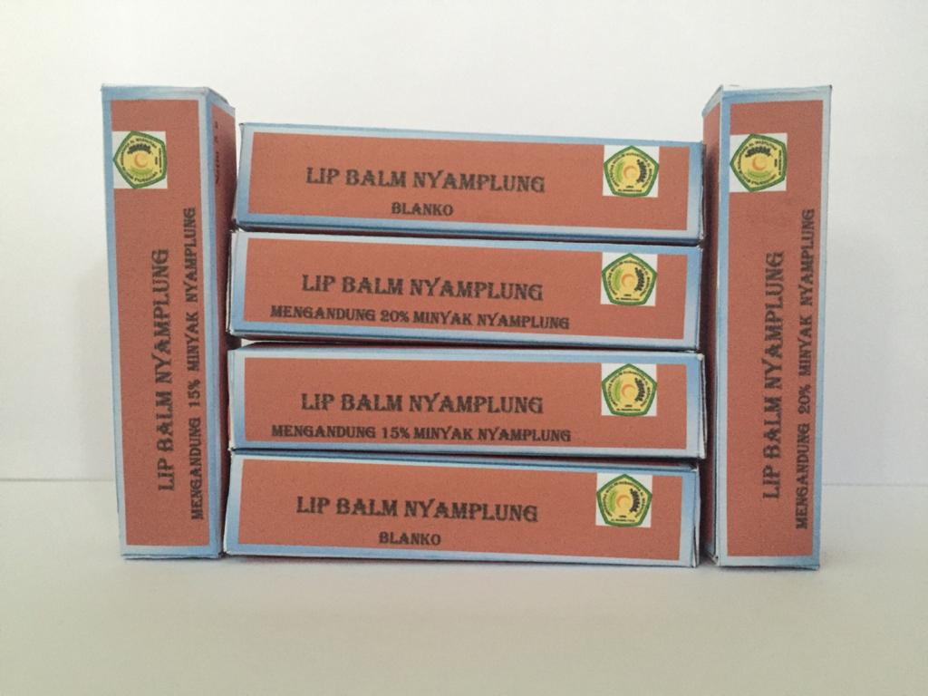
Keterangan: Lip balm yang sudah dikemas dalam kemasan dan sudah diberi etiket

