**Lampiran 1**

**KUESIONER**

Kepada Yth,

Bapak/Ibu Responden

Di

Tempat

Puji syukur kita panjatkan kehadirat Allah SWT karena atas limpahan rahmat, hidayah dan taufik-Nya lah sehingga angket penelitian ini yang berjudul “pengaruh *customer bonding* dan persepsi harga terhadap loyalitas pelanggan pada CV. Karya Sejati Utama (Dusun V, Desa Bandar Labuhan, Tanjung Morawa)”. Sehubungan dengan hal tersebut, maka mohon kesediaan Bapak/Ibu untuk mengisi angket ini walaupun disadari bahwa kesibukan selalu menyertai aktivitas, tugas dan pekerjaan Bapak/Ibu. Dalam mengisi angket ini, mohon kesediannya untuk menjawab secara jujur dan objektif, serta tidak merasa ragu karena angket ini hanya untuk kebutuhan penelitian, yang tidak sama sekali dimaksudkan untuk memberi penilaian yang dapat merugikan akademik Bapak/Ibu.

Atas kesediaan dan kerjasama yang baik ini diucapkan banyak terima kasih, semoga Allah SWT meridhoi kita semua, Amin.

Medan, Februari 2022 Peneliti

**Fras Setya**

Npm. 183114112

1. **IDENTITAS RESPONDEN**

Nama : .........................................................................

Jenis Kelamin : .........................................................................

Umur : .........................................................................

Pekerjaan : .........................................................................

1. **PETUNJUK PENGISIAN**

bacalah baik-baik setiap pernyataan dalam angket ini sebelum menjawabnya.

Berilah jawaban dengan memberi tanda (√) pada kolom yang tersedia.

SS = Sangat Setuju

S = Setuju

RR = Ragu-Ragu

TS = Tidak Setuju

STS = Sangat Tidak Setuju

bila ada sesuatu yang kurang jelas mohon ditanyakan pada peneliti.

***Customer Bonding* (X1)**

|  |  |  |  |  |  |  |
| --- | --- | --- | --- | --- | --- | --- |
| **No** | **Pernyataan** | **SS** | **S** | **RR** | **TS** | **STS** |
| ***Awareness bonding*** | | | | | | |
| 1 | Menurut saya CV. Karya Sejati Utama sudah melakukan promosi melalui periklanan baik media cetak maupun elektronik |  |  |  |  |  |
| ***Identifying Bonding*** | | | | | | |
| 2 | Saya puas akan kinerja yang diberikan oleh CV. Karya Sejati Utama |  |  |  |  |  |
| ***Relationship Bonding*** | | | | | | |

|  |  |  |  |  |  |  |
| --- | --- | --- | --- | --- | --- | --- |
| 3 | Saya mendapatkan potongan harga ketika memakai jasa dari CV. Karya Sejati Utama |  |  |  |  |  |
| ***Community bonding*** | | | | | | |
| 4 | Saya merekomendasikan kepada orang lain tentang CV. Karya Sejati Utama |  |  |  |  |  |
| ***Advocacy Bonding*** | | | | | | |
| 5 | Saya selalu memakai jasa dari CV. Karya Sejati Utama |  |  |  |  |  |

**Persepsi Harga (X2)**

|  |  |  |  |  |  |  |
| --- | --- | --- | --- | --- | --- | --- |
| **No** | **Pernyataan** | **SS** | **S** | **RR** | **TS** | **STS** |
| **Keterjangkaun harga** | | | | | | |
| 1 | Menurut saya harga pada CV. Karya Sejati Utama lebih terjangkau dan murah dari perusahaan pesaing lain. |  |  |  |  |  |
| **Kesesuaian harga dengan kualitas jasa** | | | | | | |
| 2 | Menurut saya harga yang diberikan oleh CV. Karya Sejati Utama sesuai dengan kualitas jasa yang diberikan |  |  |  |  |  |
| **Kesesuaian harga dengan manfaat** | | | | | | |
| 3 | Harga yang dibayarkan ke CV. Karya Sejati Utama sesuai dengan manfaat yang diperoleh |  |  |  |  |  |
| **Harga sesuai kemampuan atau daya saing harga** | | | | | | |
| 4 | Menurut saya harga pada CV. Karya Sejati Utama relatif lebih murah dari perusahaan pesaing lain. |  |  |  |  |  |
| 5 | Menurut saya harga yang diberikan oleh CV. Karya Sejati Utama sesuai dengan kualitas yang diberikan sehingga pelanggan merasa puas. |  |  |  |  |  |

**Loyalitas Pelanggan (Y)**

|  |  |  |  |  |  |  |
| --- | --- | --- | --- | --- | --- | --- |
| **No** | **Pernyataan** | **SS** | **S** | **RR** | **TS** | **STS** |
| ***Repeat purchase*** | | | | | | |
| 1 | Saya merasa puas karena harapan saya  sebagai seorang pelanggan dari CV. Karya Sejati Utama telah terpenuhi |  |  |  |  |  |
| 2 | Saya selalu memakai jasa dari CV. Karya Sejati Utama |  |  |  |  |  |
| ***Retention*** | | | | | | |
| 3 | Menurut saya CV. Karya Sejati Utama mempunyai keunggulan tersendiri dari pada perusahaan pesaing lainnya |  |  |  |  |  |
| 4 | Menurut saya CV. Karya Sejati Utama selalu memberikan yang terbaik kepada pelanggan. |  |  |  |  |  |
| ***Referrals*** | | | | | | |
| 5 | Saya selalu merekomendasikan kepada orang lain tentang CV. Karya Sejati Utama |  |  |  |  |  |
| 6 | CV. Karya Sejati Utama selalu memberikan insentif kepada orang yang merekomendasikan perusahaannya kepada oranglain. |  |  |  |  |  |

**Lampiran 2**

**Tabulasi Data Uji Regresi Berganda**

|  |  |  |  |  |  |  |
| --- | --- | --- | --- | --- | --- | --- |
| **No** | **X1.1** | **X1.2** | **X1.3** | **X1.4** | **X1.5** | **X1.TTL** |
| 1 | 5 | 5 | 5 | 5 | 5 | 25 |
| 2 | 5 | 5 | 5 | 4 | 5 | 24 |
| 3 | 4 | 4 | 5 | 5 | 4 | 22 |
| 4 | 5 | 5 | 4 | 4 | 4 | 22 |
| 5 | 4 | 4 | 5 | 5 | 5 | 23 |
| 6 | 5 | 5 | 4 | 5 | 5 | 24 |
| 7 | 4 | 4 | 5 | 4 | 4 | 21 |
| 8 | 5 | 5 | 4 | 5 | 5 | 24 |
| 9 | 4 | 4 | 5 | 4 | 4 | 21 |
| 10 | 4 | 4 | 4 | 5 | 4 | 21 |
| 11 | 3 | 3 | 4 | 4 | 4 | 18 |
| 12 | 4 | 4 | 3 | 4 | 5 | 20 |
| 13 | 4 | 4 | 4 | 3 | 4 | 19 |
| 14 | 4 | 4 | 4 | 4 | 3 | 19 |
| 15 | 5 | 5 | 4 | 4 | 4 | 22 |
| 16 | 5 | 5 | 5 | 4 | 4 | 23 |
| 17 | 4 | 4 | 5 | 5 | 4 | 22 |
| 18 | 5 | 5 | 4 | 5 | 5 | 24 |
| 19 | 4 | 4 | 5 | 4 | 5 | 22 |
| 20 | 3 | 3 | 4 | 5 | 4 | 19 |
| 21 | 4 | 4 | 3 | 4 | 5 | 20 |
| 22 | 4 | 4 | 4 | 3 | 4 | 19 |
| 23 | 3 | 3 | 4 | 4 | 3 | 17 |
| 24 | 2 | 2 | 3 | 4 | 4 | 15 |
| 25 | 3 | 3 | 2 | 3 | 4 | 15 |
| 26 | 5 | 4 | 3 | 2 | 3 | 17 |
| 27 | 2 | 4 | 5 | 3 | 2 | 16 |
| 28 | 3 | 3 | 5 | 2 | 3 | 16 |
| 29 | 2 | 2 | 3 | 4 | 4 | 15 |
| 30 | 3 | 3 | 2 | 3 | 4 | 15 |
| 31 | 5 | 4 | 3 | 2 | 3 | 17 |
| 32 | 2 | 4 | 5 | 3 | 2 | 16 |
| 33 | 3 | 3 | 5 | 2 | 3 | 16 |
| 34 | 4 | 4 | 5 | 5 | 5 | 23 |
| 35 | 4 | 4 | 4 | 4 | 4 | 20 |
| 36 | 5 | 5 | 3 | 3 | 3 | 19 |
| 37 | 5 | 5 | 4 | 4 | 4 | 22 |
| 38 | 4 | 4 | 4 | 4 | 4 | 20 |
| 39 | 5 | 5 | 3 | 3 | 3 | 19 |
| 40 | 4 | 4 | 4 | 4 | 4 | 20 |
| 41 | 3 | 3 | 3 | 3 | 3 | 15 |
| 42 | 4 | 4 | 4 | 4 | 4 | 20 |
| 43 | 4 | 4 | 4 | 4 | 4 | 20 |
| 44 | 3 | 3 | 3 | 3 | 3 | 15 |
| 45 | 3 | 4 | 4 | 4 | 3 | 18 |
| 46 | 2 | 5 | 5 | 3 | 4 | 19 |
| 47 | 3 | 5 | 5 | 4 | 5 | 22 |
| 48 | 5 | 4 | 4 | 4 | 5 | 22 |
| 49 | 5 | 4 | 4 | 4 | 4 | 21 |
| 50 | 5 | 4 | 4 | 5 | 4 | 22 |
| 51 | 4 | 4 | 4 | 4 | 4 | 20 |
| 52 | 4 | 4 | 4 | 5 | 4 | 21 |
| 53 | 4 | 4 | 4 | 4 | 4 | 20 |
| 54 | 4 | 5 | 4 | 4 | 4 | 21 |
| 55 | 4 | 5 | 4 | 4 | 4 | 21 |
| 56 | 4 | 4 | 4 | 4 | 4 | 20 |
| 57 | 4 | 5 | 4 | 4 | 4 | 21 |
| 58 | 4 | 5 | 4 | 4 | 4 | 21 |
| 59 | 5 | 4 | 4 | 5 | 4 | 22 |
| 60 | 5 | 4 | 4 | 4 | 4 | 21 |
| 61 | 4 | 4 | 4 | 5 | 4 | 21 |
| 62 | 4 | 4 | 4 | 4 | 4 | 20 |
| 63 | 5 | 4 | 4 | 5 | 4 | 22 |
| 64 | 5 | 4 | 4 | 4 | 4 | 21 |
| 65 | 4 | 4 | 4 | 5 | 4 | 21 |
| 66 | 4 | 4 | 4 | 4 | 4 | 20 |
| 67 | 5 | 5 | 4 | 4 | 4 | 22 |
| 68 | 4 | 5 | 4 | 4 | 4 | 21 |
| 69 | 4 | 4 | 4 | 5 | 4 | 21 |
| 70 | 5 | 4 | 4 | 4 | 4 | 21 |
| 71 | 5 | 5 | 4 | 4 | 4 | 22 |
| 72 | 4 | 5 | 4 | 4 | 4 | 21 |
| 73 | 4 | 4 | 4 | 4 | 4 | 20 |
| 74 | 5 | 4 | 4 | 4 | 4 | 21 |
| 75 | 5 | 5 | 4 | 4 | 4 | 22 |
| 76 | 4 | 4 | 4 | 5 | 4 | 21 |
| 77 | 4 | 4 | 4 | 4 | 4 | 20 |
| 78 | 4 | 5 | 4 | 4 | 4 | 21 |
| 79 | 4 | 5 | 4 | 4 | 4 | 21 |
| 80 | 5 | 4 | 4 | 5 | 4 | 22 |
| 81 | 4 | 4 | 4 | 4 | 4 | 20 |
| 82 | 4 | 5 | 4 | 4 | 4 | 21 |
| 83 | 5 | 5 | 4 | 4 | 4 | 22 |
| 84 | 5 | 4 | 4 | 4 | 4 | 21 |
| 85 | 4 | 4 | 5 | 4 | 4 | 21 |
| 86 | 4 | 4 | 4 | 5 | 5 | 22 |
| 87 | 5 | 4 | 4 | 4 | 4 | 21 |
| 88 | 5 | 5 | 4 | 4 | 4 | 22 |
| 89 | 4 | 4 | 4 | 5 | 4 | 21 |
| 90 | 4 | 4 | 4 | 4 | 4 | 20 |
| 91 | 4 | 5 | 4 | 4 | 4 | 21 |
| 92 | 4 | 5 | 4 | 4 | 4 | 21 |
| 93 | 4 | 4 | 4 | 5 | 4 | 21 |
| 94 | 5 | 4 | 4 | 4 | 4 | 21 |
| 95 | 5 | 5 | 4 | 4 | 4 | 22 |
| 96 | 4 | 5 | 4 | 4 | 4 | 21 |
| 97 | 4 | 4 | 4 | 4 | 4 | 20 |
| 98 | 5 | 4 | 5 | 4 | 4 | 22 |
| 99 | 5 | 4 | 4 | 5 | 5 | 23 |
| 100 | 4 | 4 | 4 | 5 | 4 | 21 |
| 101 | 4 | 4 | 4 | 4 | 4 | 20 |
| 102 | 4 | 5 | 4 | 4 | 4 | 21 |
| 103 | 4 | 5 | 4 | 4 | 4 | 21 |
| 104 | 5 | 4 | 4 | 5 | 4 | 22 |
| 105 | 4 | 4 | 4 | 4 | 4 | 20 |
| 106 | 4 | 5 | 4 | 4 | 4 | 21 |

|  |  |  |  |  |  |  |
| --- | --- | --- | --- | --- | --- | --- |
| **No** | **X2.1** | **X2.2** | **X2.3** | **X2.4** | **X2.5** | **X2.TTL** |
| 1 | 4 | 5 | 5 | 3 | 5 | 22 |
| 2 | 5 | 5 | 4 | 4 | 5 | 23 |
| 3 | 4 | 5 | 5 | 4 | 4 | 22 |
| 4 | 5 | 4 | 4 | 5 | 5 | 23 |
| 5 | 5 | 5 | 5 | 4 | 4 | 23 |
| 6 | 4 | 4 | 5 | 5 | 5 | 23 |
| 7 | 5 | 5 | 4 | 4 | 4 | 22 |
| 8 | 4 | 4 | 5 | 5 | 5 | 23 |
| 9 | 5 | 5 | 4 | 4 | 4 | 22 |
| 10 | 4 | 4 | 5 | 4 | 4 | 21 |
| 11 | 4 | 4 | 4 | 3 | 3 | 18 |
| 12 | 3 | 3 | 4 | 4 | 4 | 18 |
| 13 | 4 | 4 | 3 | 4 | 4 | 19 |
| 14 | 4 | 4 | 4 | 4 | 4 | 20 |
| 15 | 4 | 4 | 4 | 5 | 5 | 22 |
| 16 | 5 | 5 | 4 | 5 | 5 | 24 |
| 17 | 5 | 5 | 5 | 4 | 4 | 23 |
| 18 | 4 | 4 | 5 | 5 | 5 | 23 |
| 19 | 5 | 5 | 4 | 4 | 4 | 22 |
| 20 | 4 | 4 | 5 | 3 | 3 | 19 |
| 21 | 3 | 3 | 4 | 4 | 4 | 18 |
| 22 | 4 | 4 | 3 | 4 | 4 | 19 |
| 23 | 4 | 4 | 4 | 3 | 3 | 18 |
| 24 | 3 | 3 | 4 | 2 | 2 | 14 |
| 25 | 2 | 2 | 3 | 3 | 3 | 13 |
| 26 | 3 | 3 | 2 | 5 | 5 | 18 |
| 27 | 2 | 5 | 3 | 2 | 2 | 14 |
| 28 | 4 | 5 | 2 | 4 | 3 | 18 |
| 29 | 3 | 3 | 4 | 2 | 2 | 14 |
| 30 | 2 | 2 | 3 | 3 | 3 | 13 |
| 31 | 3 | 3 | 2 | 5 | 5 | 18 |
| 32 | 2 | 5 | 3 | 2 | 2 | 14 |
| 33 | 5 | 5 | 2 | 4 | 5 | 21 |
| 34 | 4 | 5 | 5 | 5 | 4 | 23 |
| 35 | 3 | 4 | 4 | 4 | 3 | 18 |
| 36 | 4 | 3 | 3 | 3 | 4 | 17 |
| 37 | 4 | 4 | 4 | 4 | 4 | 20 |
| 38 | 3 | 4 | 4 | 4 | 3 | 18 |
| 39 | 4 | 3 | 3 | 3 | 4 | 17 |
| 40 | 3 | 4 | 4 | 4 | 5 | 20 |
| 41 | 4 | 3 | 3 | 3 | 4 | 17 |
| 42 | 4 | 4 | 4 | 4 | 5 | 21 |
| 43 | 3 | 4 | 4 | 4 | 3 | 18 |
| 44 | 4 | 3 | 3 | 3 | 5 | 18 |
| 45 | 3 | 4 | 4 | 5 | 4 | 20 |
| 46 | 4 | 5 | 3 | 4 | 4 | 20 |
| 47 | 4 | 5 | 4 | 5 | 4 | 22 |
| 48 | 3 | 4 | 4 | 4 | 4 | 19 |
| 49 | 5 | 5 | 3 | 4 | 5 | 22 |
| 50 | 3 | 4 | 5 | 4 | 5 | 21 |
| 51 | 5 | 5 | 3 | 3 | 5 | 21 |
| 52 | 4 | 5 | 5 | 4 | 3 | 21 |
| 53 | 5 | 4 | 4 | 4 | 3 | 20 |
| 54 | 5 | 4 | 5 | 4 | 4 | 22 |
| 55 | 5 | 3 | 5 | 5 | 5 | 23 |
| 56 | 5 | 4 | 5 | 4 | 3 | 21 |
| 57 | 5 | 5 | 5 | 5 | 4 | 24 |
| 58 | 4 | 4 | 5 | 4 | 3 | 20 |
| 59 | 5 | 4 | 4 | 5 | 3 | 21 |
| 60 | 4 | 4 | 5 | 4 | 4 | 21 |
| 61 | 5 | 4 | 4 | 5 | 3 | 21 |
| 62 | 4 | 4 | 5 | 4 | 4 | 21 |
| 63 | 5 | 4 | 4 | 5 | 3 | 21 |
| 64 | 4 | 4 | 5 | 4 | 3 | 20 |
| 65 | 4 | 4 | 4 | 5 | 3 | 20 |
| 66 | 4 | 4 | 4 | 4 | 3 | 19 |
| 67 | 4 | 4 | 4 | 4 | 3 | 19 |
| 68 | 4 | 4 | 4 | 5 | 3 | 20 |
| 69 | 4 | 4 | 4 | 4 | 3 | 19 |
| 70 | 5 | 4 | 4 | 4 | 4 | 21 |
| 71 | 4 | 4 | 5 | 4 | 3 | 20 |
| 72 | 5 | 4 | 4 | 5 | 3 | 21 |
| 73 | 4 | 4 | 5 | 4 | 4 | 21 |
| 74 | 5 | 4 | 4 | 5 | 3 | 21 |
| 75 | 4 | 4 | 5 | 4 | 4 | 21 |
| 76 | 5 | 4 | 4 | 5 | 4 | 22 |
| 77 | 4 | 4 | 5 | 4 | 3 | 20 |
| 78 | 4 | 4 | 4 | 5 | 4 | 21 |
| 79 | 4 | 4 | 4 | 4 | 3 | 19 |
| 80 | 5 | 4 | 4 | 4 | 4 | 21 |
| 81 | 4 | 4 | 5 | 4 | 3 | 20 |
| 82 | 4 | 4 | 4 | 5 | 4 | 21 |
| 83 | 4 | 4 | 4 | 4 | 3 | 19 |
| 84 | 4 | 4 | 4 | 4 | 5 | 21 |
| 85 | 4 | 4 | 4 | 5 | 3 | 20 |
| 86 | 4 | 4 | 4 | 4 | 4 | 20 |
| 87 | 5 | 4 | 4 | 4 | 4 | 21 |
| 88 | 4 | 4 | 5 | 4 | 5 | 22 |
| 89 | 4 | 4 | 4 | 5 | 4 | 21 |
| 90 | 4 | 4 | 4 | 4 | 3 | 19 |
| 91 | 5 | 4 | 4 | 4 | 4 | 21 |
| 92 | 4 | 4 | 5 | 4 | 3 | 20 |
| 93 | 4 | 4 | 4 | 5 | 4 | 21 |
| 94 | 4 | 4 | 4 | 4 | 3 | 19 |
| 95 | 4 | 4 | 4 | 4 | 5 | 21 |
| 96 | 4 | 4 | 4 | 5 | 4 | 21 |
| 97 | 5 | 5 | 4 | 4 | 4 | 22 |
| 98 | 4 | 4 | 5 | 4 | 3 | 20 |
| 99 | 4 | 4 | 4 | 4 | 4 | 20 |
| 100 | 5 | 4 | 4 | 4 | 4 | 21 |
| 101 | 4 | 4 | 5 | 4 | 5 | 22 |
| 102 | 4 | 4 | 4 | 5 | 4 | 21 |
| 103 | 4 | 4 | 4 | 4 | 3 | 19 |
| 104 | 5 | 4 | 4 | 4 | 4 | 21 |
| 105 | 4 | 4 | 5 | 4 | 3 | 20 |
| 106 | 4 | 4 | 4 | 5 | 4 | 21 |

|  |  |  |  |  |  |  |  |
| --- | --- | --- | --- | --- | --- | --- | --- |
| **No** | **Y.1** | **Y.2** | **Y.3** | **Y.4** | **Y.5** | **Y.6** | **Y.TTL** |
| 1 | 4 | 4 | 5 | 5 | 5 | 4 | 27 |
| 2 | 5 | 5 | 5 | 5 | 4 | 5 | 29 |
| 3 | 4 | 4 | 4 | 5 | 5 | 4 | 26 |
| 4 | 5 | 5 | 5 | 4 | 4 | 5 | 28 |
| 5 | 4 | 4 | 4 | 5 | 5 | 5 | 27 |
| 6 | 4 | 4 | 5 | 4 | 5 | 4 | 26 |
| 7 | 3 | 3 | 4 | 5 | 4 | 5 | 24 |
| 8 | 4 | 4 | 5 | 4 | 5 | 4 | 26 |
| 9 | 4 | 4 | 4 | 5 | 4 | 5 | 26 |
| 10 | 4 | 4 | 4 | 4 | 5 | 4 | 25 |
| 11 | 5 | 5 | 3 | 4 | 4 | 4 | 25 |
| 12 | 5 | 5 | 4 | 3 | 4 | 3 | 24 |
| 13 | 4 | 4 | 4 | 4 | 3 | 4 | 23 |
| 14 | 5 | 5 | 4 | 4 | 4 | 4 | 26 |
| 15 | 4 | 4 | 5 | 4 | 4 | 4 | 25 |
| 16 | 3 | 3 | 5 | 5 | 4 | 5 | 25 |
| 17 | 4 | 4 | 4 | 5 | 5 | 5 | 27 |
| 18 | 4 | 4 | 5 | 4 | 5 | 4 | 26 |
| 19 | 3 | 3 | 4 | 5 | 4 | 5 | 24 |
| 20 | 2 | 2 | 3 | 4 | 5 | 4 | 20 |
| 21 | 3 | 3 | 4 | 3 | 4 | 3 | 20 |
| 22 | 5 | 5 | 4 | 4 | 3 | 4 | 25 |
| 23 | 2 | 2 | 3 | 4 | 4 | 4 | 19 |
| 24 | 4 | 3 | 2 | 3 | 4 | 3 | 19 |
| 25 | 2 | 2 | 3 | 2 | 3 | 2 | 14 |
| 26 | 3 | 3 | 4 | 3 | 2 | 3 | 18 |
| 27 | 5 | 5 | 4 | 5 | 3 | 2 | 24 |
| 28 | 2 | 2 | 3 | 5 | 2 | 4 | 18 |
| 29 | 4 | 5 | 2 | 3 | 4 | 3 | 21 |
| 30 | 5 | 4 | 3 | 2 | 3 | 2 | 19 |
| 31 | 4 | 3 | 4 | 3 | 2 | 3 | 19 |
| 32 | 3 | 4 | 4 | 5 | 3 | 2 | 21 |
| 33 | 4 | 4 | 3 | 5 | 2 | 5 | 23 |
| 34 | 4 | 3 | 4 | 5 | 5 | 4 | 25 |
| 35 | 3 | 4 | 4 | 4 | 4 | 3 | 22 |
| 36 | 4 | 5 | 5 | 3 | 3 | 4 | 24 |
| 37 | 3 | 4 | 5 | 4 | 4 | 4 | 24 |
| 38 | 4 | 5 | 4 | 4 | 4 | 3 | 24 |
| 39 | 4 | 3 | 5 | 3 | 3 | 4 | 22 |
| 40 | 3 | 5 | 4 | 4 | 4 | 3 | 23 |
| 41 | 5 | 4 | 3 | 3 | 3 | 4 | 22 |
| 42 | 4 | 4 | 4 | 4 | 4 | 4 | 24 |
| 43 | 5 | 4 | 4 | 4 | 4 | 3 | 24 |
| 44 | 4 | 4 | 3 | 3 | 3 | 4 | 21 |
| 45 | 4 | 5 | 4 | 4 | 4 | 3 | 24 |
| 46 | 4 | 5 | 5 | 5 | 3 | 4 | 26 |
| 47 | 3 | 5 | 5 | 5 | 4 | 4 | 26 |
| 48 | 4 | 3 | 4 | 4 | 4 | 3 | 22 |
| 49 | 4 | 3 | 5 | 5 | 3 | 5 | 25 |
| 50 | 4 | 4 | 4 | 4 | 5 | 3 | 24 |
| 51 | 5 | 5 | 5 | 5 | 3 | 5 | 28 |
| 52 | 4 | 3 | 4 | 5 | 5 | 4 | 25 |
| 53 | 5 | 4 | 5 | 4 | 4 | 5 | 27 |
| 54 | 4 | 3 | 4 | 4 | 5 | 5 | 25 |
| 55 | 5 | 3 | 5 | 3 | 5 | 5 | 26 |
| 56 | 4 | 4 | 5 | 4 | 5 | 5 | 27 |
| 57 | 5 | 3 | 3 | 5 | 5 | 5 | 26 |
| 58 | 4 | 4 | 4 | 4 | 5 | 4 | 25 |
| 59 | 5 | 3 | 4 | 4 | 4 | 5 | 25 |
| 60 | 4 | 3 | 4 | 4 | 5 | 4 | 24 |
| 61 | 5 | 3 | 4 | 4 | 4 | 5 | 25 |
| 62 | 4 | 3 | 4 | 4 | 5 | 4 | 24 |
| 63 | 4 | 3 | 4 | 4 | 4 | 5 | 24 |
| 64 | 5 | 3 | 4 | 4 | 5 | 4 | 25 |
| 65 | 4 | 3 | 4 | 4 | 4 | 4 | 23 |
| 66 | 4 | 4 | 5 | 4 | 4 | 4 | 25 |
| 67 | 4 | 3 | 5 | 4 | 4 | 4 | 24 |
| 68 | 5 | 3 | 4 | 4 | 4 | 4 | 24 |
| 69 | 4 | 4 | 5 | 4 | 4 | 4 | 25 |
| 70 | 5 | 3 | 5 | 4 | 4 | 5 | 26 |
| 71 | 4 | 4 | 4 | 4 | 5 | 4 | 25 |
| 72 | 5 | 4 | 4 | 4 | 4 | 5 | 26 |
| 73 | 4 | 3 | 4 | 4 | 5 | 4 | 24 |
| 74 | 5 | 4 | 4 | 4 | 4 | 5 | 26 |
| 75 | 4 | 3 | 4 | 4 | 5 | 4 | 24 |
| 76 | 4 | 4 | 4 | 4 | 4 | 5 | 25 |
| 77 | 4 | 3 | 4 | 4 | 5 | 4 | 24 |
| 78 | 5 | 4 | 4 | 4 | 4 | 4 | 25 |
| 79 | 4 | 3 | 5 | 4 | 4 | 4 | 24 |
| 80 | 4 | 5 | 5 | 4 | 4 | 5 | 27 |
| 81 | 5 | 3 | 4 | 4 | 5 | 4 | 25 |
| 82 | 4 | 4 | 4 | 4 | 4 | 4 | 24 |
| 83 | 4 | 4 | 5 | 4 | 4 | 4 | 25 |
| 84 | 4 | 5 | 5 | 4 | 4 | 4 | 26 |
| 85 | 5 | 4 | 4 | 4 | 4 | 4 | 25 |
| 86 | 4 | 3 | 4 | 4 | 4 | 4 | 23 |
| 87 | 4 | 4 | 5 | 4 | 4 | 5 | 26 |
| 88 | 4 | 3 | 4 | 4 | 5 | 4 | 24 |
| 89 | 5 | 4 | 4 | 4 | 4 | 4 | 25 |
| 90 | 4 | 3 | 5 | 4 | 4 | 4 | 24 |
| 91 | 4 | 5 | 5 | 4 | 4 | 5 | 27 |
| 92 | 5 | 4 | 4 | 4 | 5 | 4 | 26 |
| 93 | 4 | 4 | 4 | 4 | 4 | 4 | 24 |
| 94 | 4 | 3 | 5 | 4 | 4 | 4 | 24 |
| 95 | 4 | 4 | 5 | 4 | 4 | 4 | 25 |
| 96 | 4 | 4 | 4 | 4 | 4 | 4 | 24 |
| 97 | 4 | 5 | 4 | 5 | 4 | 5 | 27 |
| 98 | 5 | 4 | 4 | 4 | 5 | 4 | 26 |
| 99 | 4 | 3 | 4 | 4 | 4 | 4 | 23 |
| 100 | 4 | 4 | 5 | 4 | 4 | 5 | 26 |
| 101 | 4 | 3 | 4 | 4 | 5 | 4 | 24 |
| 102 | 5 | 4 | 4 | 4 | 4 | 4 | 25 |
| 103 | 4 | 3 | 5 | 4 | 4 | 4 | 24 |
| 104 | 4 | 5 | 5 | 4 | 4 | 5 | 27 |
| 105 | 5 | 4 | 4 | 4 | 5 | 4 | 26 |
| 106 | 4 | 4 | 4 | 4 | 4 | 4 | 24 |

**Lampiran 03**

**Tabulasi Data Uji Validitas Dan Reliabilitas**

|  |  |  |  |  |  |  |
| --- | --- | --- | --- | --- | --- | --- |
| **No** | **X1.1** | **X1.2** | **X1.3** | **X1.4** | **X1.5** | **X1.TTL** |
| 1 | 5 | 5 | 4 | 5 | 4 | 23 |
| 2 | 4 | 4 | 4 | 4 | 5 | 21 |
| 3 | 3 | 3 | 3 | 3 | 4 | 16 |
| 4 | 4 | 4 | 4 | 4 | 3 | 19 |
| 5 | 4 | 4 | 4 | 4 | 4 | 20 |
| 6 | 4 | 4 | 4 | 4 | 4 | 20 |
| 7 | 5 | 5 | 5 | 5 | 4 | 24 |
| 8 | 5 | 5 | 5 | 5 | 5 | 25 |
| 9 | 4 | 4 | 4 | 4 | 5 | 21 |
| 10 | 5 | 5 | 5 | 5 | 4 | 24 |
| 11 | 4 | 4 | 4 | 4 | 5 | 21 |
| 12 | 3 | 3 | 3 | 3 | 4 | 16 |
| 13 | 4 | 4 | 4 | 4 | 3 | 19 |
| 14 | 4 | 4 | 4 | 4 | 4 | 20 |
| 15 | 3 | 3 | 3 | 3 | 4 | 16 |
| 16 | 2 | 2 | 2 | 2 | 3 | 11 |
| 17 | 3 | 3 | 3 | 3 | 2 | 14 |
| 18 | 5 | 5 | 4 | 5 | 3 | 22 |
| 19 | 4 | 5 | 3 | 3 | 5 | 20 |
| 20 | 4 | 4 | 4 | 4 | 4 | 20 |
| 21 | 3 | 3 | 4 | 4 | 4 | 18 |
| 22 | 4 | 5 | 4 | 5 | 5 | 23 |
| 23 | 4 | 5 | 5 | 4 | 4 | 22 |
| 24 | 3 | 5 | 4 | 5 | 5 | 22 |
| 25 | 4 | 4 | 5 | 4 | 4 | 21 |
| 26 | 4 | 5 | 5 | 5 | 3 | 22 |
| 27 | 5 | 4 | 4 | 5 | 4 | 22 |
| 28 | 4 | 5 | 5 | 4 | 5 | 23 |
| 29 | 5 | 4 | 4 | 5 | 4 | 22 |
| 30 | 4 | 5 | 5 | 4 | 5 | 23 |

|  |  |  |  |  |  |  |
| --- | --- | --- | --- | --- | --- | --- |
| **No** | **X2.1** | **X2.2** | **X2.3** | **X2.4** | **X2.5** | **X2.TTL** |
| 1 | 5 | 4 | 4 | 5 | 4 | 22 |
| 2 | 4 | 4 | 5 | 4 | 4 | 21 |
| 3 | 4 | 3 | 4 | 4 | 3 | 18 |
| 4 | 3 | 4 | 3 | 3 | 4 | 17 |
| 5 | 4 | 4 | 4 | 4 | 4 | 20 |
| 6 | 4 | 4 | 4 | 4 | 4 | 20 |
| 7 | 4 | 5 | 4 | 4 | 5 | 22 |
| 8 | 5 | 5 | 5 | 5 | 5 | 25 |
| 9 | 5 | 4 | 5 | 5 | 4 | 23 |
| 10 | 4 | 5 | 4 | 4 | 5 | 22 |
| 11 | 5 | 4 | 5 | 5 | 4 | 23 |
| 12 | 4 | 3 | 4 | 4 | 3 | 18 |
| 13 | 3 | 4 | 3 | 3 | 4 | 17 |
| 14 | 4 | 4 | 4 | 4 | 4 | 20 |
| 15 | 4 | 3 | 4 | 4 | 3 | 18 |
| 16 | 3 | 2 | 3 | 3 | 2 | 13 |
| 17 | 2 | 3 | 2 | 2 | 3 | 12 |
| 18 | 3 | 5 | 3 | 3 | 5 | 19 |
| 19 | 5 | 5 | 5 | 3 | 5 | 23 |
| 20 | 4 | 5 | 4 | 2 | 5 | 20 |
| 21 | 5 | 5 | 4 | 3 | 5 | 22 |
| 22 | 4 | 4 | 4 | 5 | 5 | 22 |
| 23 | 4 | 5 | 3 | 5 | 4 | 21 |
| 24 | 5 | 5 | 4 | 5 | 4 | 23 |
| 25 | 5 | 5 | 4 | 4 | 5 | 23 |
| 26 | 4 | 4 | 5 | 5 | 5 | 23 |
| 27 | 5 | 5 | 4 | 4 | 4 | 22 |
| 28 | 4 | 4 | 5 | 4 | 5 | 22 |
| 29 | 4 | 5 | 4 | 5 | 4 | 22 |
| 30 | 4 | 4 | 5 | 4 | 4 | 21 |

|  |  |  |  |  |  |  |  |
| --- | --- | --- | --- | --- | --- | --- | --- |
| **No** | **Y.1** | **Y.2** | **Y.3** | **Y.4** | **Y.5** | **Y.6** | **Y.TTL** |
| 1 | 5 | 5 | 5 | 4 | 5 | 5 | 29 |
| 2 | 4 | 4 | 4 | 5 | 4 | 4 | 25 |
| 3 | 5 | 5 | 5 | 4 | 5 | 5 | 29 |
| 4 | 4 | 4 | 4 | 5 | 4 | 4 | 25 |
| 5 | 4 | 4 | 4 | 4 | 4 | 4 | 24 |
| 6 | 3 | 3 | 3 | 4 | 3 | 3 | 19 |
| 7 | 4 | 4 | 4 | 3 | 4 | 4 | 23 |
| 8 | 4 | 4 | 4 | 4 | 4 | 4 | 24 |
| 9 | 4 | 4 | 4 | 4 | 4 | 4 | 24 |
| 10 | 5 | 5 | 5 | 5 | 5 | 5 | 30 |
| 11 | 5 | 5 | 5 | 5 | 5 | 5 | 30 |
| 12 | 4 | 4 | 4 | 4 | 4 | 4 | 24 |
| 13 | 5 | 5 | 5 | 5 | 5 | 5 | 30 |
| 14 | 4 | 4 | 4 | 4 | 4 | 4 | 24 |
| 15 | 3 | 3 | 3 | 3 | 3 | 3 | 18 |
| 16 | 4 | 4 | 4 | 4 | 4 | 4 | 24 |
| 17 | 4 | 4 | 4 | 4 | 4 | 4 | 24 |
| 18 | 3 | 3 | 3 | 3 | 3 | 3 | 18 |
| 19 | 2 | 2 | 2 | 2 | 2 | 2 | 12 |
| 20 | 3 | 3 | 3 | 3 | 3 | 3 | 18 |
| 21 | 5 | 5 | 5 | 5 | 5 | 5 | 30 |
| 22 | 5 | 4 | 5 | 4 | 5 | 5 | 28 |
| 23 | 5 | 4 | 4 | 4 | 4 | 5 | 26 |
| 24 | 4 | 4 | 4 | 4 | 4 | 4 | 24 |
| 25 | 4 | 5 | 5 | 5 | 5 | 4 | 28 |
| 26 | 3 | 4 | 4 | 4 | 4 | 3 | 22 |
| 27 | 4 | 5 | 5 | 5 | 5 | 4 | 28 |
| 28 | 4 | 5 | 4 | 5 | 4 | 4 | 26 |
| 29 | 5 | 4 | 3 | 4 | 3 | 5 | 24 |
| 30 | 4 | 5 | 4 | 5 | 4 | 4 | 26 |

**Lampiran 04**

**Hasil Statitistik Deskriptif Jawaban Responden**

**Frequency Table**

|  |  |  |  |  |  |
| --- | --- | --- | --- | --- | --- |
| **Customer Bonding** | | | | | |
|  | | Frequency | Percent | Valid Percent | Cumulative Percent |
| Valid | Tidak Setuju | 5 | 4.7 | 4.7 | 4.7 |
| Kurang Setuju | 11 | 10.4 | 10.4 | 15.1 |
| Setuju | 55 | 51.9 | 51.9 | 67.0 |
| Sangat Setuju | 35 | 33.0 | 33.0 | 100.0 |
| Total | 106 | 100.0 | 100.0 |  |

|  |  |  |  |  |  |
| --- | --- | --- | --- | --- | --- |
| **Customer Bonding** | | | | | |
|  | | Frequency | Percent | Valid Percent | Cumulative Percent |
| Valid | Tidak Setuju | 2 | 1.9 | 1.9 | 1.9 |
| Kurang Setuju | 9 | 8.5 | 8.5 | 10.4 |
| Setuju | 61 | 57.5 | 57.5 | 67.9 |
| Sangat Setuju | 34 | 32.1 | 32.1 | 100.0 |
| Total | 106 | 100.0 | 100.0 |  |

|  |  |  |  |  |  |
| --- | --- | --- | --- | --- | --- |
| **Customer Bonding** | | | | | |
|  | | Frequency | Percent | Valid Percent | Cumulative Percent |
| Valid | Tidak Setuju | 2 | 1.9 | 1.9 | 1.9 |
| Kurang Setuju | 10 | 9.4 | 9.4 | 11.3 |
| Setuju | 76 | 71.7 | 71.7 | 83.0 |
| Sangat Setuju | 18 | 17.0 | 17.0 | 100.0 |
| Total | 106 | 100.0 | 100.0 |  |

|  |  |  |  |  |  |
| --- | --- | --- | --- | --- | --- |
| **Customer Bonding** | | | | | |
|  | | Frequency | Percent | Valid Percent | Cumulative Percent |
| Valid | Tidak Setuju | 4 | 3.8 | 3.8 | 3.8 |
| Kurang Setuju | 11 | 10.4 | 10.4 | 14.2 |
| Setuju | 66 | 62.3 | 62.3 | 76.4 |
| Sangat Setuju | 25 | 23.6 | 23.6 | 100.0 |
| Total | 106 | 100.0 | 100.0 |  |

|  |  |  |  |  |  |
| --- | --- | --- | --- | --- | --- |
| **Customer Bonding** | | | | | |
|  | | Frequency | Percent | Valid Percent | Cumulative Percent |
| Valid | Tidak Setuju | 2 | 1.9 | 1.9 | 1.9 |
| Kurang Setuju | 11 | 10.4 | 10.4 | 12.3 |
| Setuju | 79 | 74.5 | 74.5 | 86.8 |
| Sangat Setuju | 14 | 13.2 | 13.2 | 100.0 |
| Total | 106 | 100.0 | 100.0 |  |

|  |  |  |  |  |  |
| --- | --- | --- | --- | --- | --- |
| **Persepsi Harga** | | | | | |
|  | | Frequency | Percent | Valid Percent | Cumulative Percent |
| Valid | Tidak Setuju | 4 | 3.8 | 3.8 | 3.8 |
| Kurang Setuju | 13 | 12.3 | 12.3 | 16.0 |
| Setuju | 60 | 56.6 | 56.6 | 72.6 |
| Sangat Setuju | 29 | 27.4 | 27.4 | 100.0 |
| Total | 106 | 100.0 | 100.0 |  |

|  |  |  |  |  |  |
| --- | --- | --- | --- | --- | --- |
| **Persepsi Harga** | | | | | |
|  | | Frequency | Percent | Valid Percent | Cumulative Percent |
| Valid | Tidak Setuju | 2 | 1.9 | 1.9 | 1.9 |
| Kurang Setuju | 11 | 10.4 | 10.4 | 12.3 |
| Setuju | 72 | 67.9 | 67.9 | 80.2 |
| Sangat Setuju | 21 | 19.8 | 19.8 | 100.0 |
| Total | 106 | 100.0 | 100.0 |  |
| **Persepsi Harga** | | | | | |
|  | | Frequency | Percent | Valid Percent | Cumulative Percent |
| Valid | Tidak Setuju | 4 | 3.8 | 3.8 | 3.8 |
| Kurang Setuju | 13 | 12.3 | 12.3 | 16.0 |
| Setuju | 59 | 55.7 | 55.7 | 71.7 |
| Sangat Setuju | 30 | 28.3 | 28.3 | 100.0 |
| Total | 106 | 100.0 | 100.0 |  |

|  |  |  |  |  |  |
| --- | --- | --- | --- | --- | --- |
| **Persepsi Harga** | | | | | |
|  | | Frequency | Percent | Valid Percent | Cumulative Percent |
| Valid | Tidak Setuju | 4 | 3.8 | 3.8 | 3.8 |
| Kurang Setuju | 11 | 10.4 | 10.4 | 14.2 |
| Setuju | 62 | 58.5 | 58.5 | 72.6 |
| Sangat Setuju | 29 | 27.4 | 27.4 | 100.0 |
| Total | 106 | 100.0 | 100.0 |  |

|  |  |  |  |  |  |
| --- | --- | --- | --- | --- | --- |
| **Persepsi Harga** | | | | | |
|  | | Frequency | Percent | Valid Percent | Cumulative Percent |
| Valid | Tidak Setuju | 4 | 3.8 | 3.8 | 3.8 |
| Kurang Setuju | 36 | 34.0 | 34.0 | 37.7 |
| Setuju | 44 | 41.5 | 41.5 | 79.2 |
| Sangat Setuju | 22 | 20.8 | 20.8 | 100.0 |
| Total | 106 | 100.0 | 100.0 |  |

|  |  |  |  |  |  |
| --- | --- | --- | --- | --- | --- |
| **Loyalitas Pelanggan** | | | | | |
|  | | Frequency | Percent | Valid Percent | Cumulative Percent |
| Valid | Tidak Setuju | 4 | 3.8 | 3.8 | 3.8 |
| Kurang Setuju | 10 | 9.4 | 9.4 | 13.2 |
| Setuju | 63 | 59.4 | 59.4 | 72.6 |
| Sangat Setuju | 29 | 27.4 | 27.4 | 100.0 |
| Total | 106 | 100.0 | 100.0 |  |
| **Loyalitas Pelanggan** | | | | | |
|  | | Frequency | Percent | Valid Percent | Cumulative Percent |
| Valid | Tidak Setuju | 4 | 3.8 | 3.8 | 3.8 |
| Kurang Setuju | 37 | 34.9 | 34.9 | 38.7 |
| Setuju | 45 | 42.5 | 42.5 | 81.1 |
| Sangat Setuju | 20 | 18.9 | 18.9 | 100.0 |
| Total | 106 | 100.0 | 100.0 |  |

|  |  |  |  |  |  |
| --- | --- | --- | --- | --- | --- |
| **Loyalitas Pelanggan** | | | | | |
|  | | Frequency | Percent | Valid Percent | Cumulative Percent |
| Valid | Tidak Setuju | 2 | 1.9 | 1.9 | 1.9 |
| Kurang Setuju | 10 | 9.4 | 9.4 | 11.3 |
| Setuju | 60 | 56.6 | 56.6 | 67.9 |
| Sangat Setuju | 34 | 32.1 | 32.1 | 100.0 |
| Total | 106 | 100.0 | 100.0 |  |

|  |  |  |  |  |  |
| --- | --- | --- | --- | --- | --- |
| **Loyalitas Pelanggan** | | | | | |
|  | | Frequency | Percent | Valid Percent | Cumulative Percent |
| Valid | Tidak Setuju | 2 | 1.9 | 1.9 | 1.9 |
| Kurang Setuju | 11 | 10.4 | 10.4 | 12.3 |
| Setuju | 72 | 67.9 | 67.9 | 80.2 |
| Sangat Setuju | 21 | 19.8 | 19.8 | 100.0 |
| Total | 106 | 100.0 | 100.0 |  |

|  |  |  |  |  |  |
| --- | --- | --- | --- | --- | --- |
| **Loyalitas Pelanggan** | | | | | |
|  | | Frequency | Percent | Valid Percent | Cumulative Percent |
| Valid | Tidak Setuju | 4 | 3.8 | 3.8 | 3.8 |
| Kurang Setuju | 13 | 12.3 | 12.3 | 16.0 |
| Setuju | 59 | 55.7 | 55.7 | 71.7 |
| Sangat Setuju | 30 | 28.3 | 28.3 | 100.0 |
| Total | 106 | 100.0 | 100.0 |  |
| **Loyalitas Pelanggan** | | | | | |
|  | | Frequency | Percent | Valid Percent | Cumulative Percent |
| Valid | Tidak Setuju | 4 | 3.8 | 3.8 | 3.8 |
| Kurang Setuju | 13 | 12.3 | 12.3 | 16.0 |
| Setuju | 60 | 56.6 | 56.6 | 72.6 |
| Sangat Setuju | 29 | 27.4 | 27.4 | 100.0 |
| Total | 106 | 100.0 | 100.0 |  |

**Lampiran 05**

**Hasil Uji Asumsi Klasik dan Regresi Linear Berganda**

|  |  |  |  |  |
| --- | --- | --- | --- | --- |
| **Model Summaryb** | | | | |
| Model | R | R Square | Adjusted R Square | Std. Error of the Estimate |
| 1 | .744a | .553 | .544 | 1.591 |
| a. Predictors: (Constant), Persepsi Harga, Customer Bonding | | | | |
| b. Dependent Variable: Loyalitas Pelanggan | | | | |

|  |  |  |  |  |  |  |
| --- | --- | --- | --- | --- | --- | --- |
| **ANOVAa** | | | | | | |
| Model | | Sum of Squares | df | Mean Square | F | Sig. |
| 1 | Regression | 322.470 | 2 | 161.235 | 63.728 | .000b |
| Residual | 260.596 | 103 | 2.530 |  |  |
| Total | 583.066 | 105 |  |  |  |
| a. Dependent Variable: Loyalitas Pelanggan | | | | | | |
| b. Predictors: (Constant), Persepsi Harga, Customer Bonding | | | | | | |

|  |  |  |  |  |  |  |  |  |
| --- | --- | --- | --- | --- | --- | --- | --- | --- |
| **Coefficientsa** | | | | | | | | |
| Model | | Unstandardized Coefficients | | Standardized Coefficients | t | Sig. | Collinearity Statistics | |
| B | Std. Error | Beta | Tolerance | VIF |
| 1 | (Constant) | 7.158 | 1.538 |  | 4.654 | .000 |  |  |
| Customer Bonding | .359 | .117 | .326 | 3.072 | .003 | .385 | 2.597 |
| Persepsi Harga | .487 | .112 | .460 | 4.332 | .000 | .385 | 2.597 |
| a. Dependent Variable: Loyalitas Pelanggan | | | | | | | | |

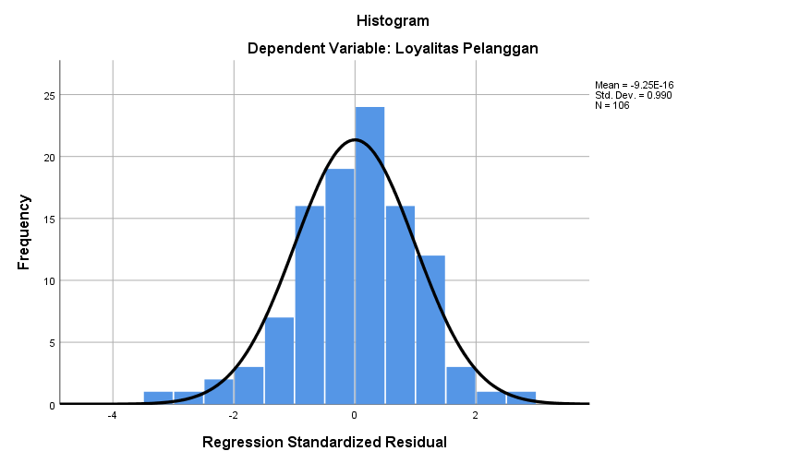

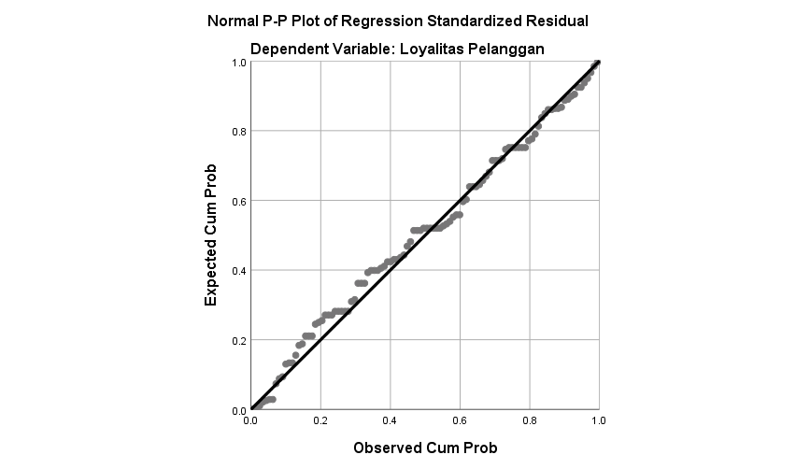

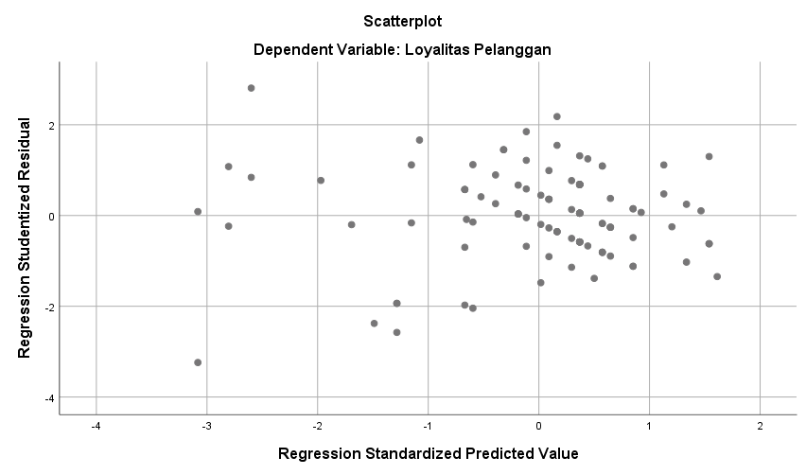

|  |  |  |
| --- | --- | --- |
| **One-Sample Kolmogorov-Smirnov Test** | | |
|  | | Unstandardized Residual |
| N | | 106 |
| Normal Parametersa,b | Mean | .0000000 |
| Std. Deviation | 1.57539422 |
| Most Extreme Differences | Absolute | .063 |
| Positive | .045 |
| Negative | -.063 |
| Test Statistic | | .063 |
| Asymp. Sig. (2-tailed) | | .200c,d |
| a. Test distribution is Normal. | | |
| b. Calculated from data. | | |
| c. Lilliefors Significance Correction. | | |
| d. This is a lower bound of the true significance. | | |

|  |  |  |  |  |  |  |  |  |
| --- | --- | --- | --- | --- | --- | --- | --- | --- |
| **Coefficientsa** | | | | | | | | |
| Model | | Unstandardized Coefficients | | Standardized Coefficients | t | Sig. | Collinearity Statistics | |
| B | Std. Error | Beta | Tolerance | VIF |
| 1 | (Constant) | 4.507 | .940 |  | 4.792 | .000 |  |  |
| Customer Bonding | -.102 | .071 | -.215 | -1.432 | .155 | .385 | 2.597 |
| Persepsi Harga | -.061 | .069 | -.133 | -.885 | .378 | .385 | 2.597 |
| a. Dependent Variable: abs_res | | | | | | | | |

**Lampiran 06**

**Tabel r**

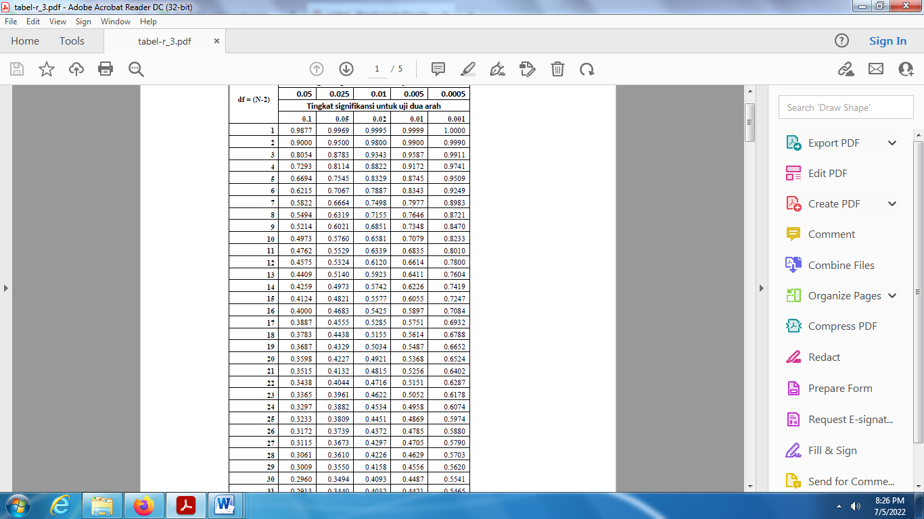

**Tabel t**

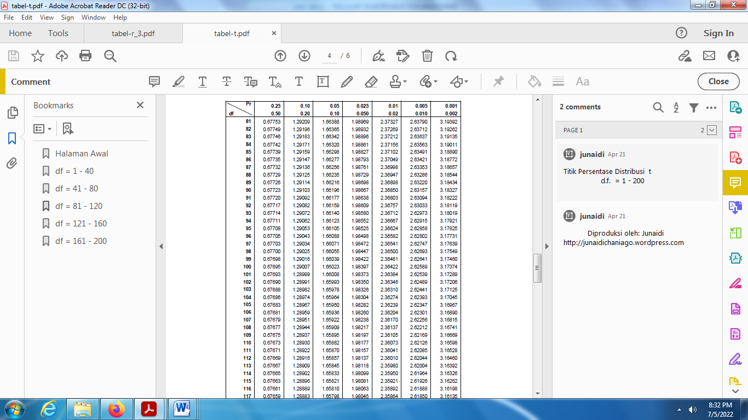

**Tabel F**

