Lampiran 1. Herbarium Medanense (MEDA)
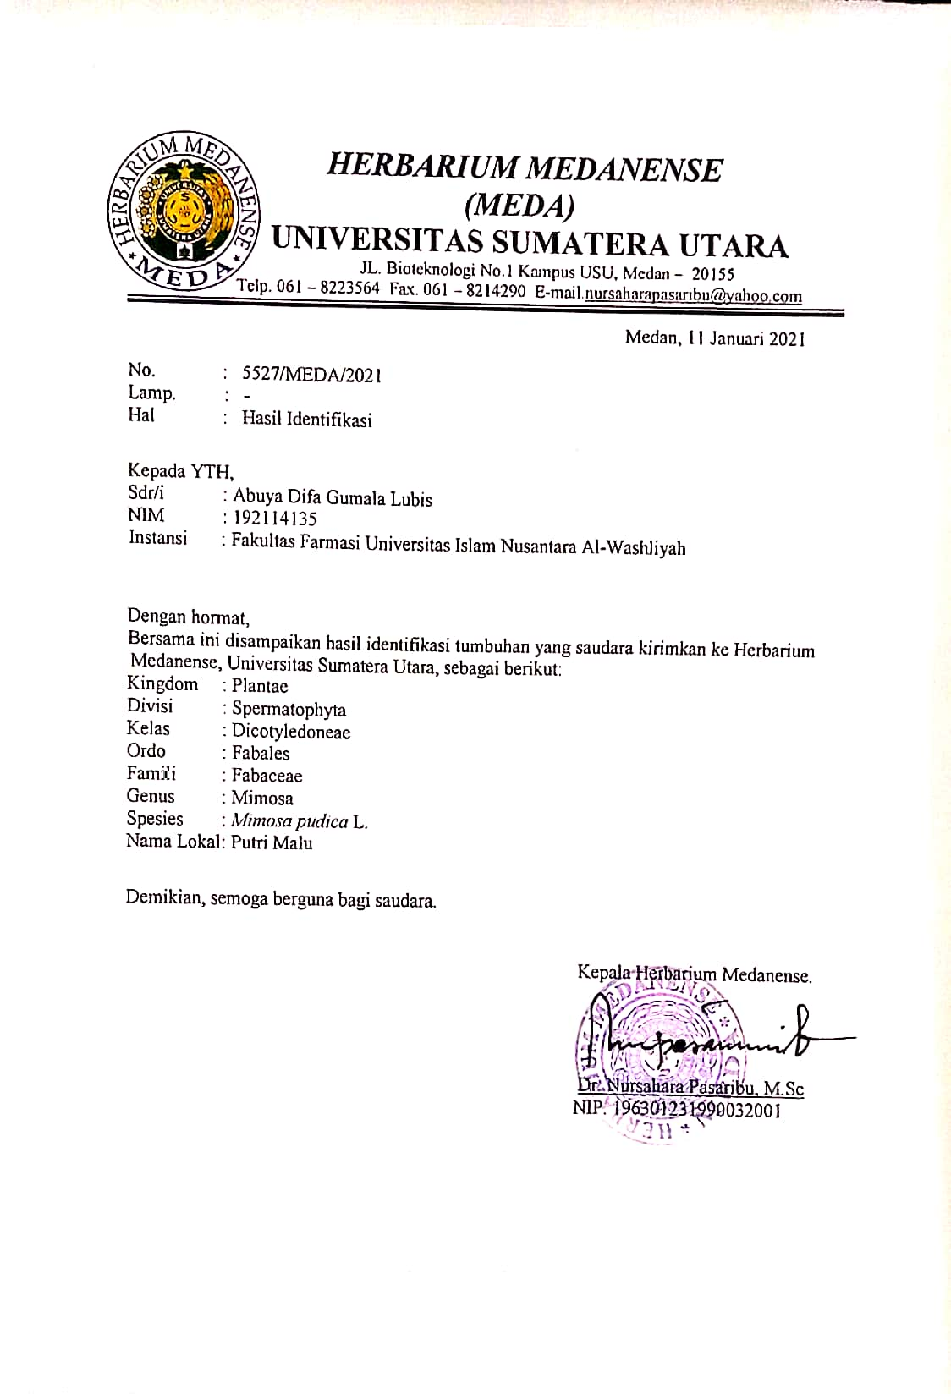

Lampiran 2. Rekomendasi Persetujuan Etik

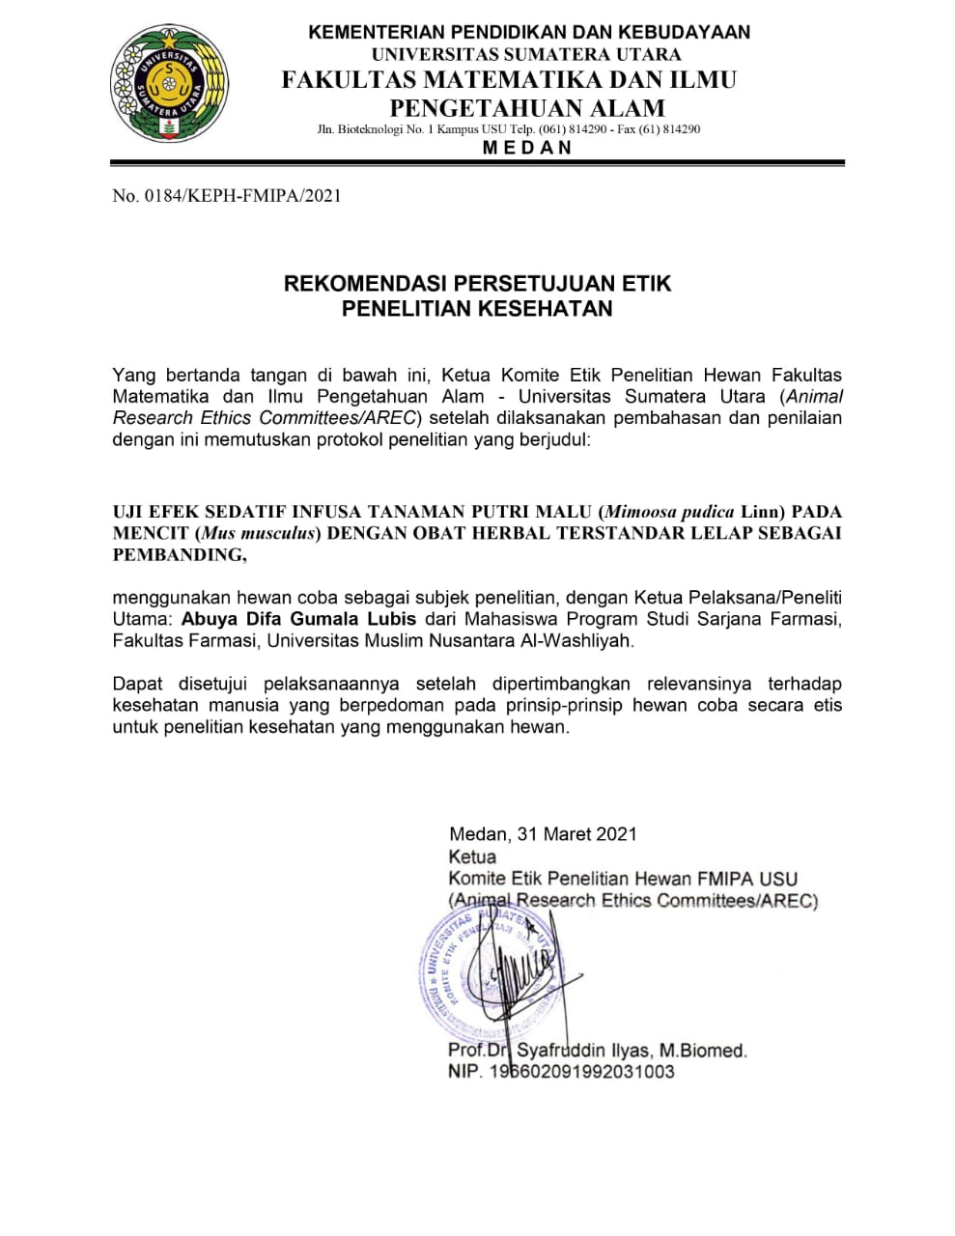

Lampiran 3. Tanaman Putri Malu (Mimosa pudica Linn)
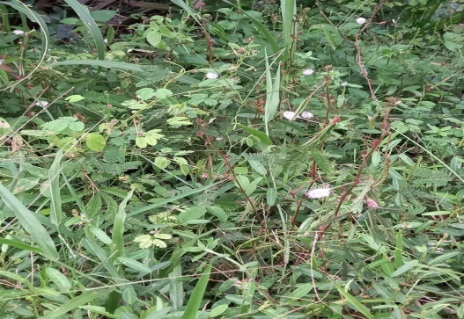

Tanaman Putri Malu (Mimosa pudica Linn)

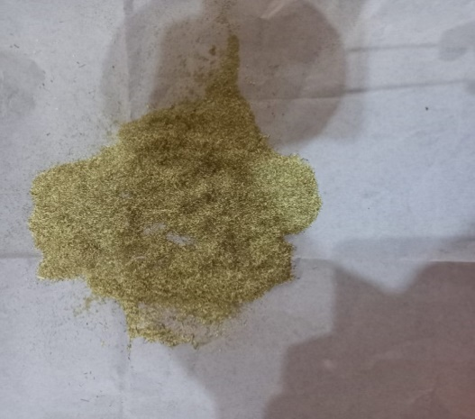

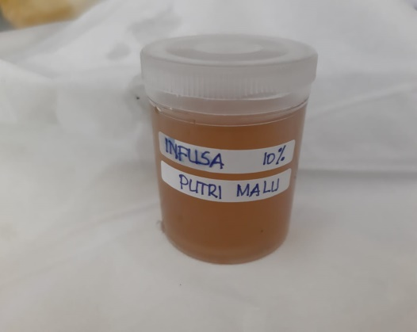
Simplisia Tanaman Putri Malu (Mimosa pudica Linn)

Infusa Tanaman Putri Malu (Mimosa pudica Linn)

Lampiran 3. Pengujian hewan
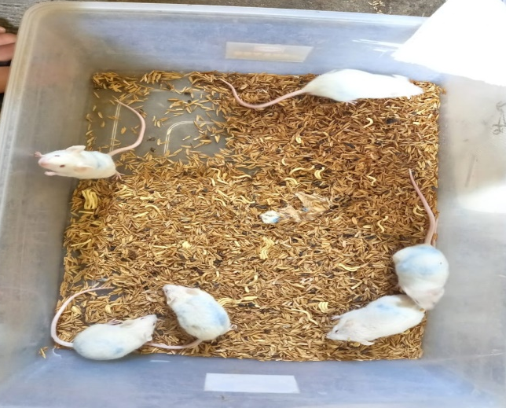

Mencit Putih (Mus musculus)

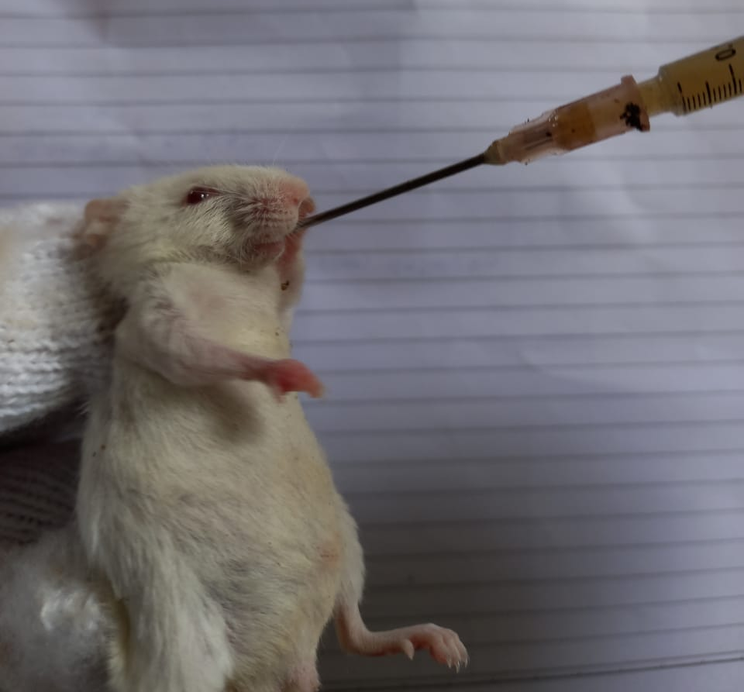

Pemberian Oral Pada Mencit

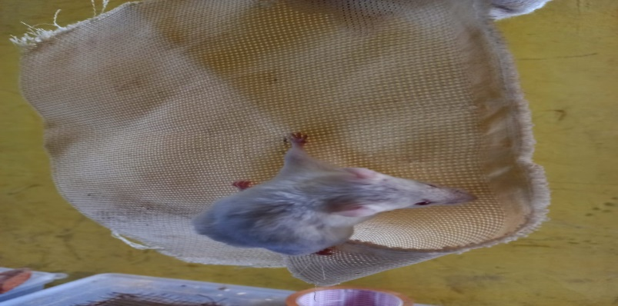

Pengamatan Uji Efek Sedatif Pada Daya Cengkeram Pada Mencit

Lampiran 3. (Lanjutan)
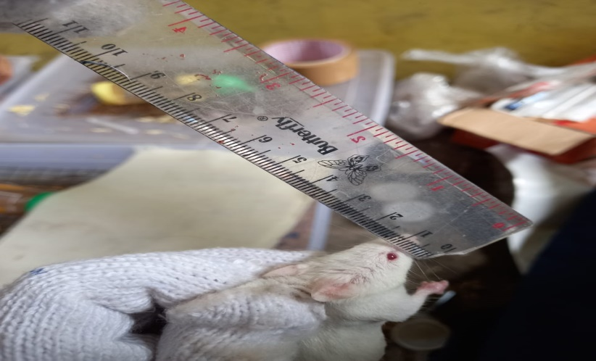

Pengamatan Uji Efek Sedatif Pada
Perubahan Diameter Pupil Mata

Lampiran 4. Sediaan Uji Efek Sedatif

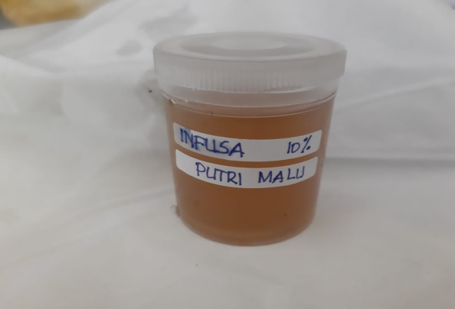

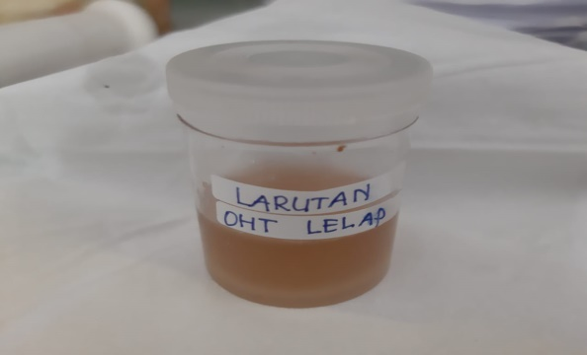
Infusa 10% Tanaman Putri Malu (Dosis 1200, 2400 dan 3600) mg/KgBB

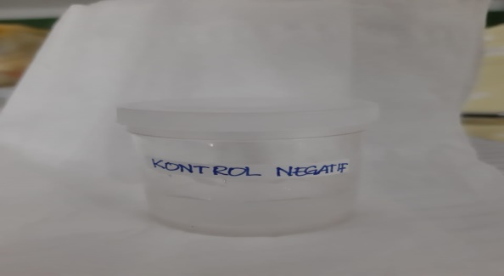
Kontrol Positif OHT Lelap 78 mg/KgBB

Kontrol Negatif Aquadest 1% KgBB

Lampiran 5. Bagan alir penelitian
Tanaman putri malu 5,9 kg

dibersihkan dari pengotor
dicuci bersih dan ditiriskan
diangin-anginkan
ditimbang
Tanaman putri malu utuh

dikeringkan pada suhu 40˚C
ditimbang
Simplisia kering 1,5 kg
dihaluskan
ditimbang
Serbuk simplisia 1,3 kg

Karakterisasi simplisia :
- Pemeriksaan makroskopik dan mikroskopik
- Penetapan kadar air
- Penetapan kadar sari larut dalam air
- Penetapan kadar sari larut dalam etanol
- Penetapan kadar abu total
- Penetapan kadar abu tidak larut dalam asam
diekstraksi dengan pelarut air
dalam bejana infusa
Infusa
Skrining fitokimia
- Alkaloid
- Flavonoid
- Glikosida
- Saponin
- Steroid/triterpenoid
- Tanin
Uji Efek Sedatif

- Uji daya cengkeram
- Uji perubahan diameter pupil mata
- Uji reflek balik badan

Lampiran 6. Bagan alir pembuatan simplisia
Tanaman putri malu

Dibersihkan dari pengotor
Dicuci bersih dengan air mengalir
Ditiriskan
Diangin-anginkan
Ditimbang
Berat tanaman putri malu setelah dibersihkan

Dikeringkan didalam
lemari pengering
pada suhu 40℃
Disortasi kering
Ditimbang
Berat simplisia 1,5 kg

Dihaluskan menggunakan
blender
Ditimbang
Berat serbuk simplisia 1,3 kg

Dimasukkan kedalam
wadah tertutup rapat

Serbuk simplisia

Lampiran 7. Bagan alir pembuatan Infusa

50 g serbuk simplisia tanaman putri malu

Dimasukkan kedalam bejana

Ditambahkan Aquadest sebanyak 100 bagian (500 ml) diaduk

Dipanaskan selama 15 menit terhitung mulai suhu mencapai 90°C sambil diaduk

Serkai selagi panas melalui kain flannel, tambahkan air panas melalui ampas hingga diperoleh volume infusa 500 ml

Infusa tanaman putri malu

Lampiran 8. Bagan alir pengujian efek sedatif
Mencit putih Jantan
Dikondisikan selama 2 minggu
Ditimbang berat badan & diberi tanda pada bagian kepala
Dipuasakan selama 16 jam
25 ekor Mencit Putih Jantan

Diberikan perlakuan secara oral setiap kelompok
K1: Diberikan Kontrol Negatif Aquadest 1% KgBB
K2: Diberikan ITPM Dosis 1200 mg/KgBB
K3: Diberikan ITPM Dosis 2400 mg/KgBB
K4: Diberikan ITPM Dosis 3600 mg/KgBB
K5: Diberikan Kontrol Positif OHT Lelap 78 mg/KgBB
Diamati parameter efek sedatif mulai dari menit ke-15,30,60,120.
Uji Efek sedatif
- Daya cengkeram
- Perubahan diameter pupil mata
- Reflek balik badan

Persentase rata-rata efek sedatif pada mencit putih jantan setelah pemberian bahan uji berbagai dosis

Lampiran 9. Makroskopik Simplisia Tanaman Putri Malu (Mimosa pudica Linn)
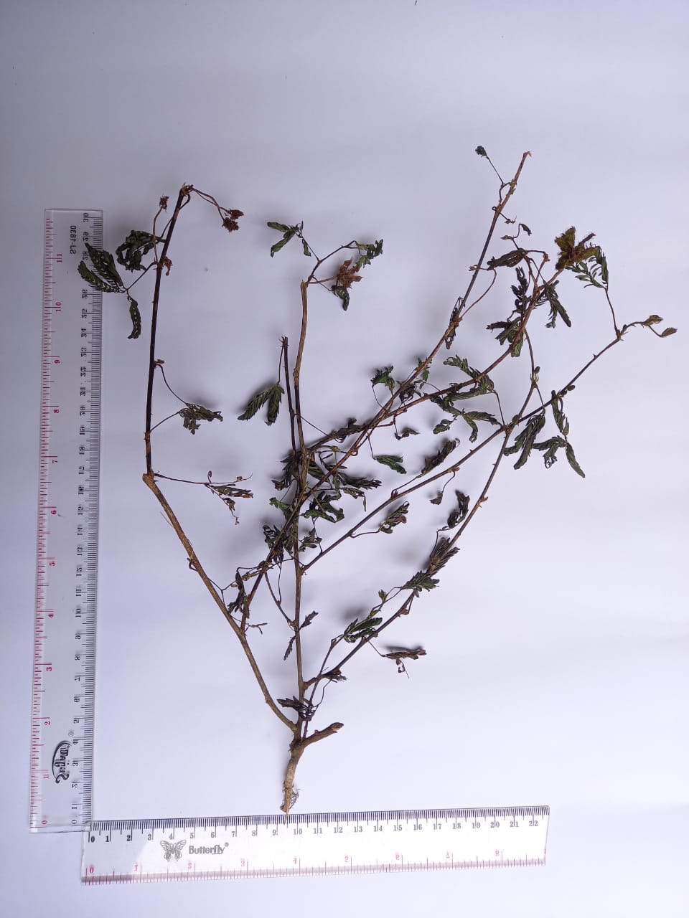
Keterangan
Bentuk : Batang bulat, berbulu dan berduri. Daun kecil-kecil, tersusun majemuk, bentuk lonjong dengan ujung lancip. Bunga bulat seperti bola dan bertangkai, buah berbentuk lonjong.
Warna : Batang berwarna coklat, daun berwarna hijau, bunga berwarna merah mudah, buah berwarna hijau kecoklatan,buah berwarna hijau dan coklat dan akar berwarna coklat.
Ukuran : Tinggi tanaman 30 cm
Lebar Batang 0,5 cm
Panjang Ranting 4 cm
Lebar Ranting 0,1 cm
Panjang Akar 3 cm
Panjang Daun 0,6 cm
Lebar Daun 0,1 cm
Aroma/Bau : Bau khas rerumputan
Uraian Serbuk : Hablur berwarna kuning kecoklatan dan berserat.

Lampiran 10. Mikroskopik Simplisia Tanaman Putri Malu (Mimosa pudica Linn)
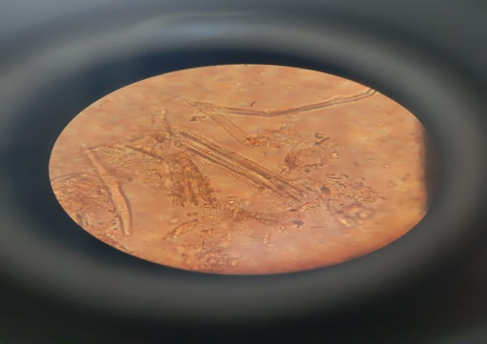
- Mikroskopik serbuk tanaman putri malu
1. Jaringan tiang
2. Floem
3. Xilem

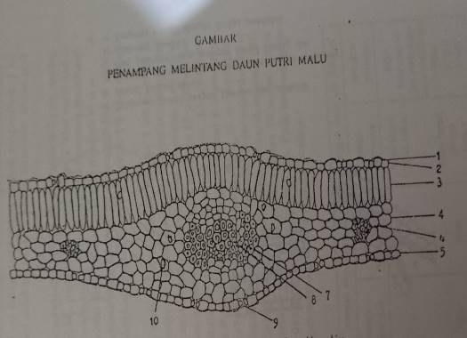
- Pembanding mikroskopik serbuk daun putri malu (Depkes Ri, 1995)
1. Kutikula
2. Epidermis atas
3. Jaringan tiang
4. Jaringan bunga karang
5. Epidermis bawah
6. Serabut Sklerenkim
7. Xilem
8. Floem
9. Stomata
10. Kristal kalsium oksalat

Lampiran 11. Perhitungan Karakterisasi Simplisia Tanaman Putri Malu
- Penetapan Kadar Air
$$\text{Kadar Air = }\frac{\text{Volume Akhir-Volume Awal}}{\text{Berat Sampel (g)}}\text{ x 100\%}$$

No. | Berat Sampel (gram) | Volume Awal (ml) | Volume Akhir (ml)
1. | 5,0011 | 2 | 2,2
2. | 5,0011 | 2 | 2,4
3. | 5,0011 | 2 | 2,3

- Kadar Air = $\frac{\text{2,2-2}}{\text{5,0011}}\text{ x 100\% = 3,99\%}$
- Kadar Air = $\frac{\text{2,4-2}}{\text{5,0011}}\text{ x 100\% = 7,99\%}$
- Kadar Air = $\frac{\text{2,3-2}}{\text{5,0011}}\text{ x 100\%} \text{=} \text{5,99\%}$
Kadar Air Rata-rata = $\frac{\left(\text{3}\text{,99}\text{+7,99+5,99}\right)\text{\%}}{\text{3}}\text{ = 5,99\% }{\text{v}}/{\text{b}}$
- Penetapan Kadar Sari Larut Dalam Air
$$\text{Kadar Sari Larut Air = }\frac{\text{Berat Sari Air (g)}}{\text{Berat Sampel (g)}}\text{ x} \frac{\text{100}}{\text{20}}\text{ x 100\%}$$

No. | Berat Sampel (gram) | Berat Cawan Kosong (gram) | Berat Cawan + Sari (gram) | Berat Sari (gram)
1. | 5 | 54,5175 | 54,6263 | 0,1088
2. | 5,0011 | 49,2079 | 49,3102 | 0,1023
3. | 5,0011 | 48,3616 | 48,4496 | 0,0880
- Kadar Sari Larut dalam Air = $\frac{\text{0,1088}}{\text{5}}\text{ x} \frac{\text{100}}{\text{20}}\text{ x 100\% = 10,88\%}$
- Kadar Sari Larut dalam Air = $\frac{\text{0,1023}}{\text{5,0011}}\text{ x }\frac{\text{100}}{\text{20}}\text{ x 100\%} \text{=} \text{10,22\%}$
- Kadar Sari Larut dalam Air = $\frac{\text{0,0880}}{\text{5,0011}}\text{ x }\frac{\text{100}}{\text{20}}\text{ x 100\%} \text{=} \text{8,79\%}$
Lampiran 11. (Lanjutan)
Kadar Sari Larut dalam Air Rata-rata = $\frac{ \left(\text{10}\text{,88}\text{+10,22+8,79}\right)\text{\%}}{\text{3}}\text{ = 9,96\% b/b}$
- Penetapan Kadar Sari Larut dalam Etanol
$$\text{Kadar Sari Larut dalam Etanol = }\frac{\text{Berat Sari Etanol (g)}}{\text{Berat Sampel (g)}}\text{ x }\frac{\text{100}}{\text{20}}\text{ x 100\%}$$

No. | Berat Sampel (gram) | Berat Cawan Kosong (gram) | Berat Cawan + Sari (gram) | Berat Sari (gram)
1. | 5 | 48,3385 | 48,4110 | 0,0725
2. | 5 | 60,9792 | 61,0505 | 0,0713
3. | 5 | 55,3786 | 55,4507 | 0,0721

- Kadar Sari Larut dalam Etanol = $\frac{\text{0,0725}}{\text{5}}\text{ x }\frac{\text{100}}{\text{20}}\text{ x 100\% = 7,25\%}$
- Kadar Sari Larut dalam Etanol = $\frac{\text{ 0,0713}}{\text{5}}\text{ x }\frac{\text{100}}{\text{20}}\text{ x 100\% = 7,13}$%
- Kadar Sari Larut dalam Etanol = $\frac{\text{0,0721}}{\text{5}}\text{ x }\frac{\text{100}}{\text{20}}\text{ x 100\% =7,21\%}$
Kadar Sari Larut dalam Etanol Rata-rata = $\frac{\left(\text{7,25+7,13+7,21}\right)\text{\%}}{\text{3}}\text{ = 7,20\% b/b}$
- Penetapan Kadar Abu Total
$$\text{Kadar Abu Total} \text{=}\frac{\text{Berat Abu (g)}}{\text{Berat Sampel (g)}}\text{ x 100\%}$$

No. | Berat Sampel (gram) | Berat Krus Kosong (gram) | Berat Krus + Abu (gram) | Berat Abu (gram)
1. | 2,0011 | 60,5935 | 60,7248 | 0,1313
2. | 2,0019 | 65,0168 | 65,1544 | 0,1376
3. | 2,0011 | 60,5934 | 60,7248 | 0,1314

Lampiran 11. (Lanjutan)
- Kadar Abu Total = $\frac{\text{0,13131}}{\text{2,0011}}\text{ x 100\% = 6,56\%}$
- Kadar Abu Total = $\frac{\text{0,1376}}{ \text{2,0019}}\text{ x 100\%} \text{= 6,87\%}$
- Kadar Abu Total = $\frac{\text{0,1314}}{\text{2,0011}}\text{ x 100\%} \text{= 6,56\%}$
Kadar Abu Total Rata-rata = $\frac{\left(\text{6}\text{,56}\text{+6,87+6,56}\right)\text{\%}}{\text{3}}\text{= 6,66\% }{\text{b}}/{\text{b}}$
- Penetapan Kadar Abu Tidak Larut Asam
$$\text{Kadar Abu Tidak Larut Asam = }\frac{\text{Berat Abu (g)}}{\text{Berat Sampel (g)}}\text{ x 100\%}$$

No. | Berat Sampel (gram) | Berat Krus Kosong (gram) | Berat Krus + Abu (gram) | Berat Abu (gram)
1. | 2,0011 | 65,1544 | 65,1368 | 0,0176
2. | 2,0019 | 64,7687 | 64,7762 | 0,0075
3. | 2,0011 | 65,2293 | 65,2401 | 0,0108
- Kadar Abu Tidak Larut Asam = $\frac{\text{0,0176}}{\text{2,0011}}\text{ x 100\% = 0,87\%}$
- Kadar Abu Tidak Larut Asam = $\frac{\text{0,0075}}{\text{2,0019}}\text{ x 100\%} \text{=} \text{0,37\%}$
- Kadar Abu Tidak Larut Asam = $\frac{\text{0,0108}}{\text{2,0011}}\text{ x 100\%} \text{=} \text{0,53\%}$
Kadar Abu Tidak Larut Asam Rata-rata = $\frac{\left(\text{0,87+0,37+0,53}\right)\text{\%}}{\text{3}} \text{=} \text{0,59\%}$

Lampiran 12. Hasil Skrining Fitokimia Serbuk Simplisia Dan Infusa Tanaman Putri Malu
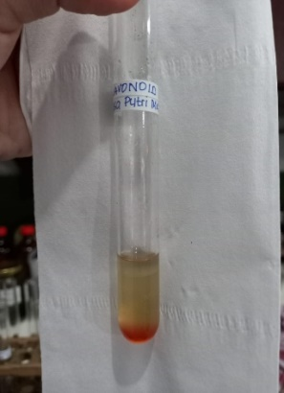
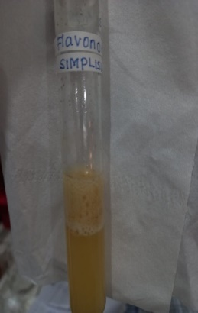
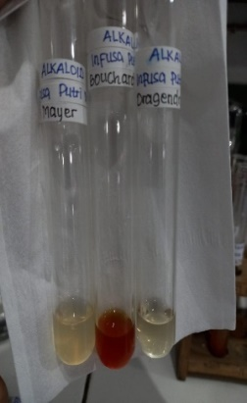
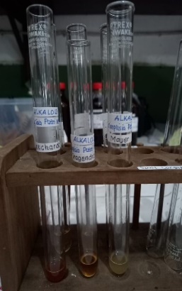

(A1) (A2) (B1) (B2)
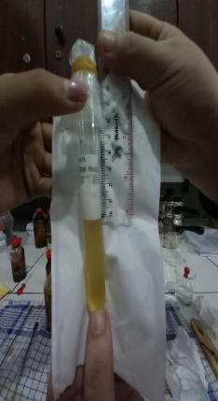
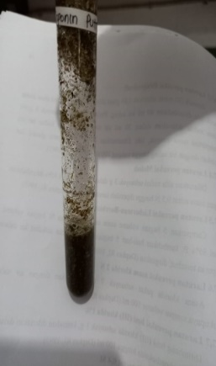
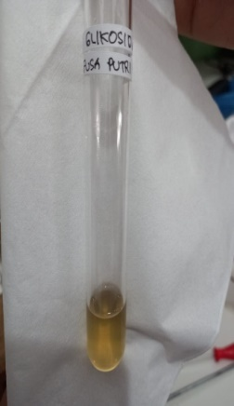
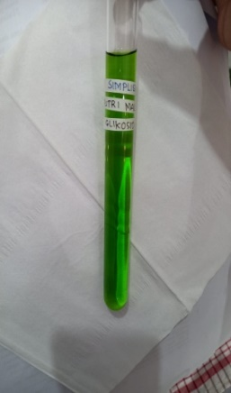

(C1) (C2) (D1) (D2)

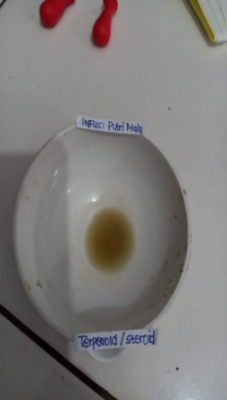
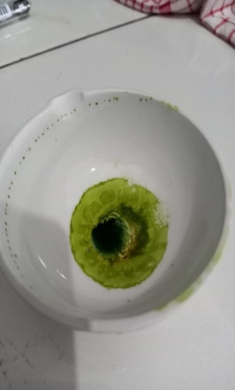

(E1) (E2)

Lampiran 12. (Lanjutan)

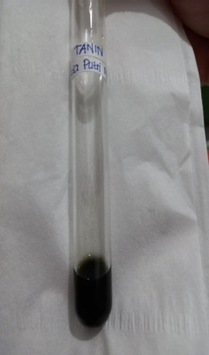
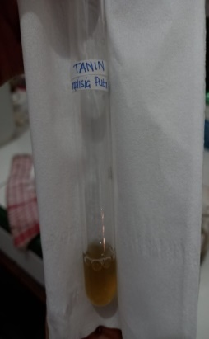
Keterangan:
A1 : Hasil Skrining Alkaloid Simplisia A2 : Hasil Skrining Alkaloid Infusa
B1 : Hasil Skrining Flavonoid Simplisia
B2 : Hasil Skrining Flavonoid Infusa
C1 : Hasil Skrining Glikosida Simplisia
C2 : Hasil Skrining Glikosida Infusa
D1 : Hasil Skrining Saponin Simplisia
D2 : Hasil Skrining Saponin Infusa
E1 : Hasil Skrining Steroid/triterpenoid
(F1) (F2) Simplisia
E2 : Hasil Skrining Steroid/triterpenoid Infusa
F1 : Hasil Skrining Tanin Simplisia
F2 : Hasil Skrining Tanin Infusa

Lampiran 13. Tabel konversi perhitungan dosis
Tabel konversi dosis antara jenis hewan dengan manusia
Hewan dan BB Rata-rata | Mencit 20 g | Tikus 200 g | Marmot 400 g | Kelinci 1,5 kg | Kucing 2 kg | Kera 4 kg | Anjing 12 kg | Manusia 70 kg
Mencit 20 g | 1.0 | 7.0 | 12.25 | 27.8 | 29.7 | 64.1 | 124.2 | 387.9
Tikus 200 g | 0.14 | 1.0 | 1.74 | 3.9 | 4.2 | 9.2 | 17.8 | 56.0
Marmut 400 g | 0.08 | 0.57 | 1.0 | 2.25 | 2.4 | 5.2 | 10.2 | 31.5
Kelinci 1,5 kg | 0.04 | 0.25 | 0.44 | 1.0 | 1.08 | 2.4 | 4.5 | 14.2
Kucing  2 kg | 0.03 | 0.23 | 0.41 | 0.92 | 1.0 | 2.2 | 4.1 | 13.0
Kera 4 kg | 0.016 | 0.11 | 0.19 | 0.42 | 0.45 | 1.0 | 1.9 | 6.1
Anjing 12 kg | 0.008 | 0.06 | 0.1 | 0.22 | 0.24 | 0.52 | 1.0 | 3.1
Manusia 70 kg | 0.0026 | 0.018 | 0.031 | 0.07 | 0.076 | 0.16 | 0.32 | 1.0
(Laurence and Bacharach, 1964)

Tabel volume maksimal larutan sediaan uji yang diberikan pada hewan
Jenis | Volume Maksimal (Ml)
Hewan Uji | i.v | i.m | i.p | s.c | p.o
Mencit (20-30 g) | 0,5 | 0,05 | 1,0 | 05-1,0 | 1,0
Tikus (100 g) | 1,0 | 0,1 | 2,5 | 2,5 | 5,0
Hamster (50 g) | - | 0,1 | 1-2 | 2,5 | 2,5
Marmut (250 g) | - | 0,25 | 2-5 | 5,0 | 10,0
Merpati (300 g) | 2,0 | 0,5 | 2,0 | 2,0 | 10,0
Kelinci (2,5 Kg) | 5-10 | 0,5 | 10-20 | 5-10 | 20,0
Kucing (3 Kg) | 5-10 | 1,0 | 10-20 | 5-10 | 50,0
Anjing (5 Kg) | 10-20 | 5,0 | 20-50 | 10,0 | 100,0
(Laurence and Bacharach, 1964)

Lampiran 13. (Lanjutan)

Keterangan :
i.v = intra vena
i.m = intra muscular
i.p = intra peritoneal
s.c = sub cutan
p.o = per oral

Dosis absolut mencit 20 gr = 3600 mg/KgBB x 0,02 Kg
= 72 mg
Dosis Manusia = 72 mg x 387,9
= 27928,8 mg
Untuk Manusia = 27928,8 mg/70 Kg
= 398,98 mg/KgBB

Lampiran 14. Contoh Perhitungan Dosis
- Contoh Perhitungan Aquadest 1% KgBB (Kontrol Negatif)
- Misal BB Mencit 20 g
= $\frac{\text{1 }}{\text{100 ml}} \text{x}$ $\frac{\text{1000 g}}{\text{20 g}}$
= 0,5 ml
- Contoh Perhitungan Dosis OHT Lelap 78 mg/KgBB (Kontrol Positif)
- Dosis OHT Lelap untuk manusia = 600 mg
- Dosis mencit (BB = 20 g)
= 600 mg x 0,0026 x $\frac{\text{1000 g}}{\text{20 g}}$
= 78 mg/KgBB
Menurut FI edisi III, keseragaman bobot = 20 tablet, maka diambil 20 tablet OHT Lelap, digerus dan ditimbang berat totalnya = 14103 mg.
Berat bahan aktif OHT Lelap dalam 20 tablet OHT Lelap adalah :
= 600 mg/tab x 20 tab = 12000 mg
Serbuk tablet OHT Lelap yang ditimbang untuk digunakan adalah:
$\frac{\text{78 mg}}{\text{12000 mg}}\text{ = }\frac{\text{x}}{\text{14103 mg}}$
Maka X = 91,67 mg ≈ 92 mg
- Cara pembuatan larutan OHT Lelap :
Ditimbang 92 mg serbuk tablet OHT Lelap dilarutkan dalam 10 ml aquadest.
- Jumlah OHT Lelap dosis 78 mg/KgBB (misal, BB Mencit = 20 g)
= $\frac{\text{78 mg}}{\text{1000 g}} \text{x }\text{20 g}$
Lampiran 14. (Lanjutan)
= 1,56 mg
- Volume larutan OHT Lelap yang diberikan :
=$\frac{\text{1}\text{,56}\text{ mg}}{\text{78 mg}} \text{x 10 ml}$
= 0,2 ml
- Contoh perhitungan ITPM yang akan diberikan pada mencit secara per oral (p.o)
- Dosis ITPM adalah 1200, 2400, dan 3600 mg/KgBB
Konsentrasi larutan ITPM yang dibuat 10%
= 10 g/ 100 ml
= 10000 mg/ 100 ml
= 100 mg/ml
- Jumlah ITPM yang diberikan :
- Untuk dosis 1200 mg/KgBB
- Jumlah ITPM dosis 1200 mg/KgBB (misal BB Mencit = 20 g)
= $\frac{\text{1200 mg}}{\text{1000 g}} \text{x 20 g = 24 mg}$
- Volume larutan ITPM yang diberikan :
= 24 mg / 100 mg/ml
= 0,24 ml ≈ 0,2 ml
- Untuk dosis 2400 mg/KgBB
- Jumlah ITPM dosis 2400 mg/KgBB (misal BB Mencit = 20 g)
= $\frac{\text{2400 mg}}{\text{1000 g}} \text{x 20 g = 48 mg}$

Lampiran 14. (Lanjutan)
- Volume larutan ITPM yang diberikan :
= 48 mg / 100 mg/ml
= 0,48 ml ≈ 0,5 ml
- Untuk dosis 3600 mg/KgBB
- Jumlah ITPM dosis 3600 mg/KgBB (misal BB Mencit = 20 g)
= $\frac{\text{3600 mg}}{\text{1000 g}} \text{x 20 g} \text{=} \text{72 mg}$
- Volume larutan ITPM yang diberikan :
= 78 mg / 100 mg/ml
= 0,78 ml ≈ 0,8 ml

Lampiran 15. Perhitungan Hewan
Rumus Federer :
(t-1) (n-1) ≥ 15
(5-1) (n-1) ≥ 15
4n-4 ≥ 15
4n ≥ 19
n ≥ 4,75
maka, n ≥ 4,75 sehingga hewan yang dipakai adalah 5 ekor
keterangan :
t = jumlah perlakuan
n = banyaknya sampel setiap perlakuan

Lampiran 16. Hasil Data Uji Statistik
Daya Cengkeram
- Uji Normalitas
Tests of Normality
 | PERLAKUAN | Kolmogorov-Smirnovª |  |  | Shapiro-Wilk
 |  | Statistic | df | Sig. | Statistic | Df | Sig.
MENIT 15 | KONTROL NEGATIF AQUADEST 1% KgBB | .473 | 5 | .001 | .552 | 5 | .000
 | ITPM DOSIS 1200 mg/Kg BB | .473 | 5 | .001 | .552 | 5 | .000
 | ITPM DOSIS 2400 mg/Kg BB | .367 | 5 | .026 | .684 | 5 | .006
 | ITPM DOSIS 3600 mg/Kg BB | .367 | 5 | .026 | .684 | 5 | .006
 | KONTROL POSITIF LELAP 78 mg/KgBB | .367 | 5 | .026 | .684 | 5 | .006
MENIT 30 | KONTROL NEGATIF AQUADEST 1% KgBB | . | 5 | . | . | 5 | .
 | ITPM DOSIS 1200 mg/Kg BB | .367 | 5 | .026 | .684 | 5 | .006
 | ITPM DOSIS 2400 mg/Kg BB | . | 5 | . | . | 5 | .
 | ITPM DOSIS 3600 mg/Kg BB | .367 | 5 | .026 | .684 | 5 | .006
 | KONTROL POSITIF LELAP 78 mg/KgBB | .367 | 5 | .026 | .684 | 5 | .006
MENIT 60 | KONTROL NEGATIF AQUADEST 1% KgBB | .473 | 5 | .001 | .552 | 5 | .000
 | ITPM DOSIS 1200 mg/Kg BB | .473 | 5 | .001 | .552 | 5 | .000
 | ITPM DOSIS 2400 mg/Kg BB | .367 | 5 | .026 | .684 | 5 | .006
 | ITPM DOSIS 3600 mg/Kg BB | .473 | 5 | .001 | .552 | 5 | .000
 | KONTROL POSITIF LELAP 78 mg/KgBB | . | 5 | . | . | 5 | .
MENIT 120 | KONTROL NEGATIF AQUADEST 1% KgBB | . | 5 | . | . | 5 | .
 | ITPM DOSIS 1200 mg/Kg BB | . | 5 | . | . | 5 | .
 | ITPM DOSIS 2400 mg/Kg BB | .367 | 5 | .026 | .684 | 5 | .006
 | ITPM DOSIS 3600 mg/Kg BB | . | 5 | . | . | 5 | .
 | KONTROL POSITIF LELAP 78 mg/KgBB | . | 5 | . | . | 5 | .
a. Lilliefors Significance Correction

- Uji Kruskal Wallis
Test Statistics^{a,b}
 | MENIT 15 | MENIT 30 | MENIT 60 | MENIT 120
Kruskal-Wallis H | 14.341 | 17.628 | 18.034 | 21.333
Df | 4 | 4 | 4 | 4
Asymp. Sig. | .006 | .001 | .001 | .000
a. Kruskal Wallis Test
b. Grouping Variable: PERLAKUAN

Lampiran 16. (Lanjutan)
- Uji Mann-Whitney
Kontrol Negatif Aquadest 1% mg/KgBB dengan ITPM Dosis 1200 mg/KgBB
Test Statisticsª
 | MENIT 15 | MENIT 30 | MENIT 60 | MENIT 120
Mann-Whitney U | 12.500 | 7.500 | 5.000 | .000
Wilcoxon W | 27.500 | 22.500 | 20.000 | 15.000
Z | .000 | -1.500 | -1.800 | -3.000
Asymp. Sig. (2-tailed) | 1.000 | .134 | .072 | .003
Exact Sig. [2*(1-tailed Sig.)] | 1.000^{b} | .310^{b} | .151^{b} | .008^{b}
a. Grouping Variable: PERLAKUAN
b. Not corrected for ties.
Kontrol Negatif Aquadest 1% mg/KgBB dengan ITPM Dosis 2400 mg/KgBB
Test Statisticsª
 | MENIT 15 | MENIT 30 | MENIT 60 | MENIT 120
Mann-Whitney U | 7.500 | .000 | 1.500 | .000
Wilcoxon W | 22.500 | 15.000 | 16.500 | 15.000
Z | -1.225 | -3.000 | -2.460 | -2.835
Asymp. Sig. (2-tailed) | .221 | .003 | .014 | .005
Exact Sig. [2*(1-tailed Sig.)] | .310^{b} | .008^{b} | .016^{b} | .008^{b}
a. Grouping Variable: PERLAKUAN
b. Not corrected for ties.
Kontrol Negatif Aquadest 1% mg/KgBB dengan ITPM Dosis 3600 mg/KgBB
 | Test Statisticsª
 |  | MENIT 15 | MENIT 30 | MENIT 60 | MENIT 120
Mann-Whitney U |  | 1.500 | .000 | .500 | .000
Wilcoxon W |  | 16.500 | 15.000 | 15.500 | 15.000
Z |  | -2.460 | -2.835 | -2.683 | -3.000
Asymp. Sig. (2-tailed) |  | .014 | .005 | .007 | .003
Exact Sig. [2*(1-tailed Sig.)] |  | .016^{b} | .008^{b} | .008^{b} | .008^{b}
 | a. Grouping Variable: PERLAKUAN
 | b. Not corrected for ties.
Kontrol Negatif Aquadest 1% mg/KgBB dengan Kontrol Positif OHT Lelap 78 mg/KgBB
Test Statisticsª
 | MENIT 15 | MENIT 30 | MENIT 60 | MENIT 120
Mann-Whitney U | 1.500 | .000 | .000 | .000
Wilcoxon W | 16.500 | 15.000 | 15.000 | 15.000
Z | -2.460 | -2.835 | -2.887 | -3.000
Asymp. Sig. (2-tailed) | .014 | .005 | .004 | .003
Exact Sig. [2*(1-tailed Sig.)] | .016^{b} | .008^{b} | .008^{b} | .008^{b}
a. Grouping Variable: PERLAKUAN
b. Not corrected for ties.
ITPM Dosis 1200 mg/KgBB dengan ITPM Dosis 2400 mg/KgBB
Test Statisticsª
 | MENIT 15 | MENIT 30 | MENIT 60 | MENIT 120
Mann-Whitney U | 7.500 | 5.000 | 6.000 | 5.000
Wilcoxon W | 22.500 | 20.000 | 21.000 | 20.000
Z | -1.225 | -1.964 | -1.678 | -1.964
Asymp. Sig. (2-tailed) | .221 | .050 | .093 | .050
Exact Sig. [2*(1-tailed Sig.)] | .310^{b} | .151^{b} | .222^{b} | .151^{b}
a. Grouping Variable: PERLAKUAN
b. Not corrected for ties.
Lampiran 16. (Lanjutan)
ITPM Dosis 1200 mg/KgBB dengan ITPM Dosis 3600 mg/KgBB
Test Statisticsª
 | MENIT 15 | MENIT 30 | MENIT 60 | MENIT 120
Mann-Whitney U | 1.500 | 3.000 | 2.000 | .000
Wilcoxon W | 16.500 | 18.000 | 17.000 | 15.000
Z | -2.460 | -2.154 | -2.425 | -3.000
Asymp. Sig. (2-tailed) | .014 | .031 | .015 | .003
Exact Sig. [2*(1-tailed Sig.)] | .016^{b} | .056^{b} | .032^{b} | .008^{b}
a. Grouping Variable: PERLAKUAN
b. Not corrected for ties.
ITPM Dosis 1200 mg/KgBB dengan Kontrol Positif OHT Lelap 78 mg/KgBB
Test Statisticsª
 | MENIT 15 | MENIT 30 | MENIT 60 | MENIT 120
Mann-Whitney U | 1.500 | 2.000 | .000 | .000
Wilcoxon W | 16.500 | 17.000 | 15.000 | 15.000
Z | -2.460 | -2.324 | -2.887 | -3.000
Asymp. Sig. (2-tailed) | .014 | .020 | .004 | .003
Exact Sig. [2*(1-tailed Sig.)] | .016^{b} | .032^{b} | .008^{b} | .008^{b}
a. Grouping Variable: PERLAKUAN
b. Not corrected for ties.
ITPM Dosis 2400 mg/KgBB dengan ITPM Dosis 3600 mg/KgBB
Test Statisticsª
 | MENIT 15 | MENIT 30 | MENIT 60 | MENIT 120
Mann-Whitney U | 4.500 | 7.500 | 7.500 | 7.500
Wilcoxon W | 19.500 | 22.500 | 22.500 | 22.500
Z | -1.897 | -1.500 | -1.225 | -1.500
Asymp. Sig. (2-tailed) | .058 | .134 | .221 | .134
Exact Sig. [2*(1-tailed Sig.)] | .095^{b} | .310^{b} | .310^{b} | .310^{b}
a. Grouping Variable: PERLAKUAN

Test Statisticsª
 | MENIT 15 | MENIT 30 | MENIT 60 | MENIT 120
Mann-Whitney U | 4.500 | 5.000 | 5.000 | 7.500
Wilcoxon W | 19.500 | 20.000 | 20.000 | 22.500
Z | -1.897 | -1.964 | -1.964 | -1.500
Asymp. Sig. (2-tailed) | .058 | .050 | .050 | .134
Exact Sig. [2*(1-tailed Sig.)] | .095^{b} | .151^{b} | .151^{b} | .310^{b}
a. Grouping Variable: PERLAKUAN
b. Not corrected for ties.
ITPM Dosis 2400 mg/KgBB dengan Kontrol Positif OHT Lelap 78 mg/KgBB
ITPM Dosis 3600 mg/KgBB dengan Kontrol Positif OHT Lelap 78 mg/KgBB
Test Statisticsª
 | MENIT 15 | MENIT 30 | MENIT 60 | MENIT 120
Mann-Whitney U | 12.500 | 10.000 | 10.000 | 12.500
Wilcoxon W | 27.500 | 25.000 | 25.000 | 27.500
Z | .000 | -.600 | -1.000 | .000
Asymp. Sig. (2-tailed) | 1.000 | .549 | .317 | 1.000
Exact Sig. [2*(1-tailed Sig.)] | 1.000^{b} | .690^{b} | .690^{b} | 1.000^{b}
a. Grouping Variable: PERLAKUAN
b. Not corrected for ties.

Lampiran 16. (Lanjutan)
Perubahan Diameter Pupil Mata
- Uji Normalitas
Tests of Normality
 | PERLAKUAN | Kolmogorov-Smirnovª |  |  | Shapiro-Wilk
 |  | Statistic | df | Sig. | Statistic | Df | Sig.
MENIT 15 | KONTROL NEGATIF AQUADEST 1% KgBB | .473 | 5 | .001 | .552 | 5 | .000
 | ITPM DOSIS 1200 mg/Kg BB | .473 | 5 | .001 | .552 | 5 | .000
 | ITPM DOSIS 2400 mg/Kg BB | .367 | 5 | .026 | .684 | 5 | .006
 | ITPM DOSIS 3600 mg/Kg BB | .367 | 5 | .026 | .684 | 5 | .006
 | KONTROL POSITIF LELAP 78 mg/KgBB | .367 | 5 | .026 | .684 | 5 | .006
MENIT 30 | KONTROL NEGATIF AQUADEST 1% KgBB | . | 5 | . | . | 5 | .
 | ITPM DOSIS 1200 mg/Kg BB | .367 | 5 | .026 | .684 | 5 | .006
 | ITPM DOSIS 2400 mg/Kg BB | . | 5 | . | . | 5 | .
 | ITPM DOSIS 3600 mg/Kg BB | .367 | 5 | .026 | .684 | 5 | .006
 | KONTROL POSITIF LELAP 78 mg/KgBB | .367 | 5 | .026 | .684 | 5 | .006
MENIT 60 | KONTROL NEGATIF AQUADEST 1% KgBB | .473 | 5 | .001 | .552 | 5 | .000
 | ITPM DOSIS 1200 mg/Kg BB | .473 | 5 | .001 | .552 | 5 | .000
 | ITPM DOSIS 2400 mg/Kg BB | .367 | 5 | .026 | .684 | 5 | .006
 | ITPM DOSIS 3600 mg/Kg BB | .473 | 5 | .001 | .552 | 5 | .000
 | KONTROL POSITIF LELAP 78 mg/KgBB | . | 5 | . | . | 5 | .
MENIT 120 | KONTROL NEGATIF AQUADEST 1% KgBB | . | 5 | . | . | 5 | .
 | ITPM DOSIS 1200 mg/Kg BB | .473 | 5 | .001 | .552 | 5 | .000
 | ITPM DOSIS 2400 mg/Kg BB | .367 | 5 | .026 | .684 | 5 | .006
 | ITPM DOSIS 3600 mg/Kg BB | . | 5 | . | . | 5 | .
 | KONTROL POSITIF LELAP 78 mg/KgBB | . | 5 | . | . | 5 | .
a. Lilliefors Significance Correction

- Uji Kruskal Wallis
Test Statistics^{a,b}
 | MENIT 15 | MENIT 30 | MENIT 60 | MENIT 120
Kruskal-Wallis H | 14.341 | 17.628 | 18.034 | 19.407
Df | 4 | 4 | 4 | 4
Asymp. Sig. | .006 | .001 | .001 | .001
a. Kruskal Wallis Test
b. Grouping Variable: PERLAKUAN

Lampiran 16. (Lanjutan)
- Uji Mann-Whitney
Kontrol Negatif Aquadest 1% KgBB dengan ITPM Dosis 1200 mg/KgBB
Test Statisticsª
 | MENIT 15 | MENIT 30 | MENIT 60 | MENIT 120
Mann-Whitney U | 12.500 | 7.500 | 5.000 | .000
Wilcoxon W | 27.500 | 22.500 | 20.000 | 15.000
Z | .000 | -1.500 | -1.800 | -2.887
Asymp. Sig. (2-tailed) | 1.000 | .134 | .072 | .004
Exact Sig. [2*(1-tailed Sig.)] | 1.000^{b} | .310^{b} | .151^{b} | .008^{b}
a. Grouping Variable: PERLAKUAN
b. Not corrected for ties.

Kontrol Negatif Aquadest 1% KgBB dengan ITPM Dosis 2400 mg/KgBB
Test Statisticsª
 | MENIT 15 | MENIT 30 | MENIT 60 | MENIT 120
Mann-Whitney U | 7.500 | .000 | 1.500 | .000
Wilcoxon W | 22.500 | 15.000 | 16.500 | 15.000
Z | -1.225 | -3.000 | -2.460 | -2.835
Asymp. Sig. (2-tailed) | .221 | .003 | .014 | .005
Exact Sig. [2*(1-tailed Sig.)] | .310^{b} | .008^{b} | .016^{b} | .008^{b}
a. Grouping Variable: PERLAKUAN
b. Not corrected for ties.

Kontrol Negatif Aquadest 1% KgBB dengan ITPM Dosis 3600 mg/KgBB
Test Statisticsª
 | MENIT 15 | MENIT 30 | MENIT 60 | MENIT 120
Mann-Whitney U | 1.500 | .000 | .500 | .000
Wilcoxon W | 16.500 | 15.000 | 15.500 | 15.000
Z | -2.460 | -2.835 | -2.683 | -3.000
Asymp. Sig. (2-tailed) | .014 | .005 | .007 | .003
Exact Sig. [2*(1-tailed Sig.)] | .016^{b} | .008^{b} | .008^{b} | .008^{b}
a. Grouping Variable: PERLAKUAN
b. Not corrected for ties.

Kontrol Negatif Aquadest 1% KgBB dengan Kontrol Positif OHT Lelap 78 mg/KgBB
Test Statisticsª
 | MENIT 15 | MENIT 30 | MENIT 60 | MENIT 120
Mann-Whitney U | 1.500 | .000 | .000 | .000
Wilcoxon W | 16.500 | 15.000 | 15.000 | 15.000
Z | -2.460 | -2.835 | -2.887 | -3.000
Asymp. Sig. (2-tailed) | .014 | .005 | .004 | .003
Exact Sig. [2*(1-tailed Sig.)] | .016^{b} | .008^{b} | .008^{b} | .008^{b}
a. Grouping Variable: PERLAKUAN
b. Not corrected for ties.

ITPM Dosis 1200 mg/KgBB dengan ITPM Dosis 2400 mg/KgBB
Test Statisticsª
 | MENIT 15 | MENIT 30 | MENIT 60 | MENIT 120
Mann-Whitney U | 7.500 | 5.000 | 6.000 | 7.500
Wilcoxon W | 22.500 | 20.000 | 21.000 | 22.500
Z | -1.225 | -1.964 | -1.678 | -1.225
Asymp. Sig. (2-tailed) | .221 | .050 | .093 | .221
Exact Sig. [2*(1-tailed Sig.)] | .310^{b} | .151^{b} | .222^{b} | .310^{b}
a. Grouping Variable: PERLAKUAN
b. Not corrected for ties.
Lampiran 16. (Lanjutan)
ITPM Dosis 1200 mg/KgBB dengan ITPM Dosis 3600 mg/KgBB
Test Statisticsª
 | MENIT 15 | MENIT 30 | MENIT 60 | MENIT 120
Mann-Whitney U | 1.500 | 3.000 | 2.000 | 2.500
Wilcoxon W | 16.500 | 18.000 | 17.000 | 17.500
Z | -2.460 | -2.154 | -2.425 | -2.449
Asymp. Sig. (2-tailed) | .014 | .031 | .015 | .014
Exact Sig. [2*(1-tailed Sig.)] | .016^{b} | .056^{b} | .032^{b} | .032^{b}
a. Grouping Variable: PERLAKUAN
b. Not corrected for ties.
ITPM Dosis 1200 mg/KgBB dengan Kontrol Positif OHT Lelap 78 mg/KgBB
Test Statisticsª
 | MENIT 15 | MENIT 30 | MENIT 60 | MENIT 120
Mann-Whitney U | 1.500 | 2.000 | .000 | 2.500
Wilcoxon W | 16.500 | 17.000 | 15.000 | 17.500
Z | -2.460 | -2.324 | -2.887 | -2.449
Asymp. Sig. (2-tailed) | .014 | .020 | .004 | .014
Exact Sig. [2*(1-tailed Sig.)] | .016^{b} | .032^{b} | .008^{b} | .032^{b}
a. Grouping Variable: PERLAKUAN
b. Not corrected for ties.

ITPM Dosis 2400 mg/KgBB dengan ITPM Dosis 3600 mg/KgBB
Test Statisticsª
 | MENIT 15 | MENIT 30 | MENIT 60 | MENIT 120
Mann-Whitney U | 4.500 | 7.500 | 7.500 | 7.500
Wilcoxon W | 19.500 | 22.500 | 22.500 | 22.500
Z | -1.897 | -1.500 | -1.225 | -1.500
Asymp. Sig. (2-tailed) | .058 | .134 | .221 | .134
Exact Sig. [2*(1-tailed Sig.)] | .095^{b} | .310^{b} | .310^{b} | .310^{b}
a. Grouping Variable: PERLAKUAN
b. Not corrected for ties.
ITPM Dosis 2400 mg/KgBB dengan Kontrol Positif OHT Lelap 78 mg/KgBB
Test Statisticsª
 | MENIT 15 | MENIT 30 | MENIT 60 | MENIT 120
Mann-Whitney U | 4.500 | 5.000 | 5.000 | 7.500
Wilcoxon W | 19.500 | 20.000 | 20.000 | 22.500
Z | -1.897 | -1.964 | -1.964 | -1.500
Asymp. Sig. (2-tailed) | .058 | .050 | .050 | .134
Exact Sig. [2*(1-tailed Sig.)] | .095^{b} | .151^{b} | .151^{b} | .310^{b}
a. Grouping Variable: PERLAKUAN
b. Not corrected for ties.
ITPM Dosis 3600 mg/KgBB dengan Kontrol Positif OHT Lelap 78 mg/KgBB
Test Statisticsª
 | MENIT 15 | MENIT 30 | MENIT 60 | MENIT 120
Mann-Whitney U | 12.500 | 10.000 | 10.000 | 12.500
Wilcoxon W | 27.500 | 25.000 | 25.000 | 27.500
Z | .000 | -.600 | -1.000 | .000
Asymp. Sig. (2-tailed) | 1.000 | .549 | .317 | 1.000
Exact Sig. [2*(1-tailed Sig.)] | 1.000^{b} | .690^{b} | .690^{b} | 1.000^{b}
a. Grouping Variable: PERLAKUAN
b. Not corrected for ties.

Lampiran 16. (Lanjutan)
Reflek Balik Badan
- Uji Normalitas
Tests of Normality
 | PERLAKUAN | Kolmogorov-Smirnovª |  |  | Shapiro-Wilk
 |  | Statistic | Df | Sig. | Statistic | df | Sig.
MENIT 15 | KONTROL NEGATIF AQUADEST 1% KgBB | .473 | 5 | .001 | .552 | 5 | .000
 | ITPM DOSIS 1200 mg/Kg BB | .473 | 5 | .001 | .552 | 5 | .000
 | ITPM DOSIS 2400 mg/Kg BB | .367 | 5 | .026 | .684 | 5 | .006
 | ITPM DOSIS 3600 mg/Kg BB | .367 | 5 | .026 | .684 | 5 | .006
 | KONTROL POSITIF LELAP 78 mg/KgBB | .367 | 5 | .026 | .684 | 5 | .006
MENIT 30 | KONTROL NEGATIF AQUADEST 1% KgBB | . | 5 | . | . | 5 | .
 | ITPM DOSIS 1200 mg/Kg BB | .367 | 5 | .026 | .684 | 5 | .006
 | ITPM DOSIS 2400 mg/Kg BB | . | 5 | . | . | 5 | .
 | ITPM DOSIS 3600 mg/Kg BB | .367 | 5 | .026 | .684 | 5 | .006
 | KONTROL POSITIF LELAP 78 mg/KgBB | .367 | 5 | .026 | .684 | 5 | .006
MENIT 60 | KONTROL NEGATIF AQUADEST 1% KgBB | . | 5 | . | . | 5 | .
 | ITPM DOSIS 1200 mg/Kg BB | .473 | 5 | .001 | .552 | 5 | .000
 | ITPM DOSIS 2400 mg/Kg BB | .367 | 5 | .026 | .684 | 5 | .006
 | ITPM DOSIS 3600 mg/Kg BB | .473 | 5 | .001 | .552 | 5 | .000
 | KONTROL POSITIF LELAP 78 mg/KgBB | . | 5 | . | . | 5 | .
MENIT 120 | KONTROL NEGATIF AQUADEST 1% KgBB | . | 5 | . | . | 5 | .
 | ITPM DOSIS 1200 mg/Kg BB | .473 | 5 | .001 | .552 | 5 | .000
 | ITPM DOSIS 2400 mg/Kg BB | .367 | 5 | .026 | .684 | 5 | .006
 | ITPM DOSIS 3600 mg/Kg BB | . | 5 | . | . | 5 | .
 | KONTROL POSITIF LELAP 78 mg/KgBB | . | 5 | . | . | 5 | .
a. Lilliefors Significance Correction

- Uji Kruskal Wallis
Test Statistics^{a,b}
 | MENIT 15 | MENIT 30 | MENIT 60 | MENIT 120
Kruskal-Wallis H | 14.341 | 17.628 | 19.336 | 19.407
Df | 4 | 4 | 4 | 4
Asymp. Sig. | .006 | .001 | .001 | .001
a. Kruskal Wallis Test
b. Grouping Variable: PERLAKUAN

Lampiran 16. (Lanjutan)
- Uji Mann-Whitney
Kontrol Negatif Aquadest 1% KgBB dengan ITPM Dosis 1200 mg/KgBB
Test Statisticsª
 | MENIT 15 | MENIT 30 | MENIT 60 | MENIT 120
Mann-Whitney U | 12.500 | 7.500 | 2.500 | .000
Wilcoxon W | 27.500 | 22.500 | 17.500 | 15.000
Z | .000 | -1.500 | -2.449 | -2.887
Asymp. Sig. (2-tailed) | 1.000 | .134 | .014 | .004
Exact Sig. [2*(1-tailed Sig.)] | 1.000^{b} | .310^{b} | .032^{b} | .008^{b}
a. Grouping Variable: PERLAKUAN
b. Not corrected for ties.
Kontrol Negatif Aquadest 1% KgBB dengan ITPM Dosis 2400 mg/KgBB
Test Statisticsª
 | MENIT 15 | MENIT 30 | MENIT 60 | MENIT 120
Mann-Whitney U | 7.500 | .000 | .000 | .000
Wilcoxon W | 22.500 | 15.000 | 15.000 | 15.000
Z | -1.225 | -3.000 | -2.835 | -2.835
Asymp. Sig. (2-tailed) | .221 | .003 | .005 | .005
Exact Sig. [2*(1-tailed Sig.)] | .310^{b} | .008^{b} | .008^{b} | .008^{b}
a. Grouping Variable: PERLAKUAN
b. Not corrected for ties.
Kontrol Negatif Aquadest 1% KgBB dengan ITPM Dosis 3600 mg/KgBB
Test Statisticsª
 | MENIT 15 | MENIT 30 | MENIT 60 | MENIT 120
Mann-Whitney U | 1.500 | .000 | .000 | .000
Wilcoxon W | 16.500 | 15.000 | 15.000 | 15.000
Z | -2.460 | -2.835 | -2.887 | -3.000
Asymp. Sig. (2-tailed) | .014 | .005 | .004 | .003
Exact Sig. [2*(1-tailed Sig.)] | .016^{b} | .008^{b} | .008^{b} | .008^{b}
a. Grouping Variable: PERLAKUAN
b. Not corrected for ties.
Kontrol Negatif Aquadest 1% KgBB dengan Kontrol Positif OHT Lelap 78 mg/KgBB
Test Statisticsª
 | MENIT 15 | MENIT 30 | MENIT 60 | MENIT 120
Mann-Whitney U | 1.500 | .000 | .000 | .000
Wilcoxon W | 16.500 | 15.000 | 15.000 | 15.000
Z | -2.460 | -2.835 | -3.000 | -3.000
Asymp. Sig. (2-tailed) | .014 | .005 | .003 | .003
Exact Sig. [2*(1-tailed Sig.)] | .016^{b} | .008^{b} | .008^{b} | .008^{b}
a. Grouping Variable: PERLAKUAN
b. Not corrected for ties.
ITPM Dosis 1200 mg/KgBB dengan ITPM Dosis 2400 mg/KgBB
Test Statisticsª
 | MENIT 15 | MENIT 30 | MENIT 60 | MENIT 120
Mann-Whitney U | 7.500 | 5.000 | 6.000 | 7.500
Wilcoxon W | 22.500 | 20.000 | 21.000 | 22.500
Z | -1.225 | -1.964 | -1.678 | -1.225
Asymp. Sig. (2-tailed) | .221 | .050 | .093 | .221
Exact Sig. [2*(1-tailed Sig.)] | .310^{b} | .151^{b} | .222^{b} | .310^{b}
a. Grouping Variable: PERLAKUAN
b. Not corrected for ties.

Lampiran 16. (Lanjutan)
ITPM Dosis 1200 mg/KgBB dengan ITPM Dosis 3600 mg/KgBB
Test Statisticsª
 | MENIT 15 | MENIT 30 | MENIT 60 | MENIT 120
Mann-Whitney U | 1.500 | 3.000 | 2.000 | 2.500
Wilcoxon W | 16.500 | 18.000 | 17.000 | 17.500
Z | -2.460 | -2.154 | -2.425 | -2.449
Asymp. Sig. (2-tailed) | .014 | .031 | .015 | .014
Exact Sig. [2*(1-tailed Sig.)] | .016^{b} | .056^{b} | .032^{b} | .032^{b}
a. Grouping Variable: PERLAKUAN
b. Not corrected for ties.
ITPM Dosis 1200 mg/KgBB dengan Kontrol Positif OHT Lelap 78 mg/KgBB
Test Statisticsª
 | MENIT 15 | MENIT 30 | MENIT 60 | MENIT 120
Mann-Whitney U | 1.500 | 2.000 | .000 | 2.500
Wilcoxon W | 16.500 | 17.000 | 15.000 | 17.500
Z | -2.460 | -2.324 | -2.887 | -2.449
Asymp. Sig. (2-tailed) | .014 | .020 | .004 | .014
Exact Sig. [2*(1-tailed Sig.)] | .016^{b} | .032^{b} | .008^{b} | .032^{b}
a. Grouping Variable: PERLAKUAN
b. Not corrected for ties.
ITPM Dosis 2400 mg/KgBB dengan ITPM Dosis 3600 mg/KgBB
Test Statisticsª
 | MENIT 15 | MENIT 30 | MENIT 60 | MENIT 120
Mann-Whitney U | 4.500 | 7.500 | 7.500 | 7.500
Wilcoxon W | 19.500 | 22.500 | 22.500 | 22.500
Z | -1.897 | -1.500 | -1.225 | -1.500
Asymp. Sig. (2-tailed) | .058 | .134 | .221 | .134
Exact Sig. [2*(1-tailed Sig.)] | .095^{b} | .310^{b} | .310^{b} | .310^{b}
a. Grouping Variable: PERLAKUAN
b. Not corrected for ties.

ITPM Dosis 2400 mg/KgBB dengan Kontrol Positif OHT Lelap 78 mg/KgBB
Test Statisticsª
 | MENIT 15 | MENIT 30 | MENIT 60 | MENIT 120
Mann-Whitney U | 4.500 | 5.000 | 5.000 | 7.500
Wilcoxon W | 19.500 | 20.000 | 20.000 | 22.500
Z | -1.897 | -1.964 | -1.964 | -1.500
Asymp. Sig. (2-tailed) | .058 | .050 | .050 | .134
Exact Sig. [2*(1-tailed Sig.)] | .095^{b} | .151^{b} | .151^{b} | .310^{b}
a. Grouping Variable: PERLAKUAN
b. Not corrected for ties.
ITPM Dosis 3600 mg/KgBB dengan Kontrol Positif OHT Lelap 78 mg/KgBB
Test Statisticsª
 | MENIT 15 | MENIT 30 | MENIT 60 | MENIT 120
Mann-Whitney U | 12.500 | 10.000 | 10.000 | 12.500
Wilcoxon W | 27.500 | 25.000 | 25.000 | 27.500
Z | .000 | -.600 | -1.000 | .000
Asymp. Sig. (2-tailed) | 1.000 | .549 | .317 | 1.000
Exact Sig. [2*(1-tailed Sig.)] | 1.000^{b} | .690^{b} | .690^{b} | 1.000^{b}
a. Grouping Variable: PERLAKUAN
b. Not corrected for ties.

