LAMPIRAN-LAMPIRAN
- Data Sampel
No | Kode Emiten | Tahun | Karakteristik Perusahaan |  |  | Nilai Perusahaan  (PBV)
 |  |  | Leverage  (DER) | Profitabilitas  (ROA) | Pertumbuhan Perusahaan  ( Growth)
1 | AKSI | 2016 | 0.12 | 0.04 | 0.12 | 1.33
 |  | 2017 | 0.39 | 0.13 | 0.34 | 2.71
 |  | 2018 | 1.50 | 0.10 | 0.58 | 3.18
2 | ASSA | 2016 | 2.35 | 0.02 | 0.04 | 0.75
 |  | 2017 | 2.36 | 0.03 | 0.08 | 0.72
 |  | 2018 | 2.56 | 0.03 | 0.18 | 1.12
3 | BIRD | 2016 | 0.57 | 0.07 | 0.02 | 1.66
 |  | 2017 | 0.32 | 0.06 | 0.12 | 1.80
 |  | 2018 | 1.42 | 0.06 | 0.06 | 1.40
4 | BULL | 2016 | 1.42 | 2.03 | 0.13 | 0.20
 |  | 2017 | 0.97 | 0.04 | 0.23 | 0.33
 |  | 2018 | 0.70 | 0.04 | 0.06 | 0.29
5 | CASS | 2016 | 1.07 | 0.17 | 0.22 | 2.56
 |  | 2017 | 1.39 | 0.16 | 0.06 | 2.40
 |  | 2018 | 1.40 | 0.10 | 0.05 | 1.65
6 | HITS | 2016 | 3.71 | 0.03 | 0.13 | 11.91
 |  | 2017 | 3.23 | 0.05 | 0.06 | 9.85
 |  | 2018 | 1.54 | 0.06 | 0.11 | 6.56
7 | KARW | 2016 | -1.67 | 0.09 | 0.07 | -0.30
 |  | 2017 | -1.74 | 0.09 | 0.03 | -0.11
 |  | 2018 | -1.75 | 0.03 | 0.02 | -0.10
8 | NELY | 2016 | 0.11 | 0.03 | 0.03 | 0.49
 |  | 2017 | 0.08 | 0.06 | 0.01 | 0.72
 |  | 2018 | 0.12 | 0.11 | 0.12 | 0.76
9 | SMDR | 2016 | 0.90 | 0.02 | 0.07 | 0.23
 |  | 2017 | 0.92 | 0.10 | 0.03 | 0.32
 |  | 2018 | 0.95 | 0.01 | 0.02 | 0.23
10 | SOCI | 2016 | 0.88 | 0.04 | 0.08 | 0.63
 |  | 2017 | 0.86 | 0.04 | 0.05 | 0.40
 |  | 2018 | 1.05 | 0.02 | 0.12 | 0.19
11 | TMAS | 2016 | 1.54 | 0.09 | 0.29 | 2.17
 |  | 2017 | 1.56 | 0.02 | 0.13 | 1.37
 |  | 2018 | 1.65 | 0.12 | 0.03 | 0.91
12 | TPMA | 2016 | 0.85 | 0.01 | -0.08 | 0.98
 |  | 2017 | 0.94 | 0.04 | 0.05 | 0.47
 |  | 2018 | 0.47 | 0.07 | -0.03 | 0.59

Tabel 4.1 statistik Deskriptif

Descriptive Statistics
 | N | Minimum | Maximum | Mean | Std. Deviation
Leverage | 36 | -175.00 | 371.00 | 98.7222 | 115.49016
profitabilitas | 36 | 1.00 | 203.00 | 11.6944 | 33.05132
Growth | 36 | -8.00 | 58.00 | 9.8056 | 11.81239
PBV | 36 | 10.00 | 1191.00 | 170.5278 | 258.12251
Valid N (listwise) | 36

Hasil Uji Asumsi Klasik
- Hasil Uji Normalitas
- Grafik Histogram

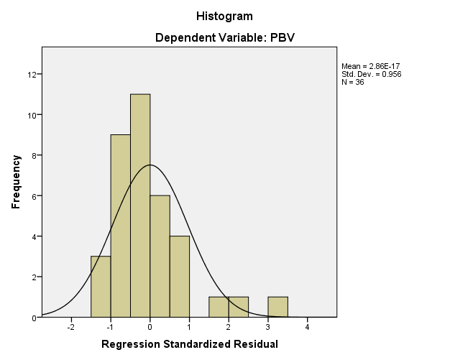

- P-P Plot

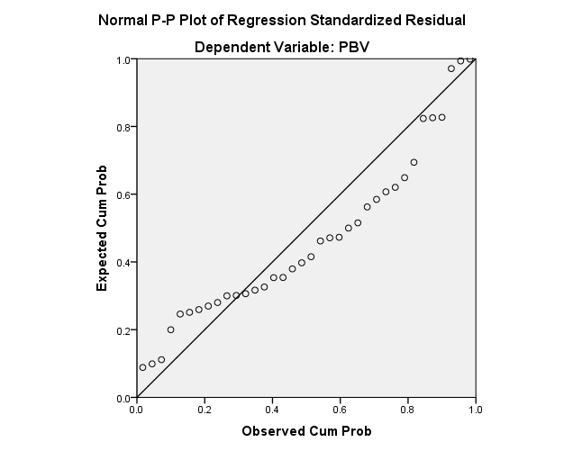

- Kolmogorov-Smirnov Test

One-Sample Kolmogorov-Smirnov Test
 |  | Unstandardized Residual
N |  | 36
Normal Parameters^{a,b} | Mean | 0E-7
 | Std. Deviation | 204.92686219
Most Extreme Differences | Absolute | .152
 | Positive | .152
 | Negative | -.125
Kolmogorov-Smirnov Z |  | .913
Asymp. Sig. (2-tailed) |  | .375
a. Test distribution is Normal.
b. Calculated from data.

- Hasil Uji Multikolonieritas
Coefficientsª
Model |  | Unstandardized Coefficients |  | Standardized Coefficients | T | Sig. | Collinearity Statistics
 |  | B | Std. Error | Beta |  |  | Tolerance | VIF
1 | (Constant) | 29.688 | 54.337 |  | .546 | .589
 | Leverage | 1.265 | .319 | .566 | 3.971 | .000 | .969 | 1.032
 | Profitabilitas | -1.013 | 1.101 | -.130 | -.920 | .364 | .991 | 1.009
 | Growth | 2.834 | 3.124 | .130 | .907 | .371 | .964 | 1.038
a. Dependent Variable: PBV

- Hasil Uji Heteroskedastisitas

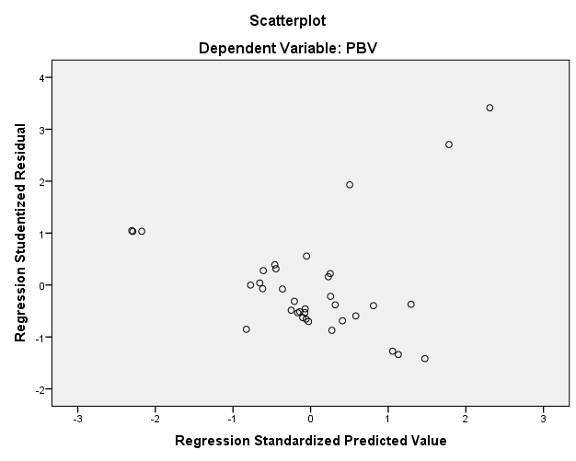

- Hasil Uji Autokorelasi

Model Summary^{b}
Model | R | R Square | Adjusted R Square | Std. Error of the Estimate | Durbin-Watson
1 | .608ª | .370 | .311 | 214.31764 | 1.455
a. Predictors: (Constant), growth, profitabilitas, Leverage
b. Dependent Variable: PBV

Tabel 4.2 Statistik Deskriptif sesudah transformasi

Descriptive Statistics
 | N | Minimum | Maximum | Mean | Std. Deviation
LN_Y | 36 | 2.30 | 7.08 | 4.4362 | 1.16824
LN_X1 | 33 | 2.40 | 5.92 | 4.5364 | .86453
LN_X2 | 36 | .00 | 5.31 | 1.6977 | .94972
LN_X3 | 34 | .00 | 4.06 | 1.9476 | .93018
Valid N (listwise) | 31

- Hasil Uji Normalitas
- Grafik Histogram
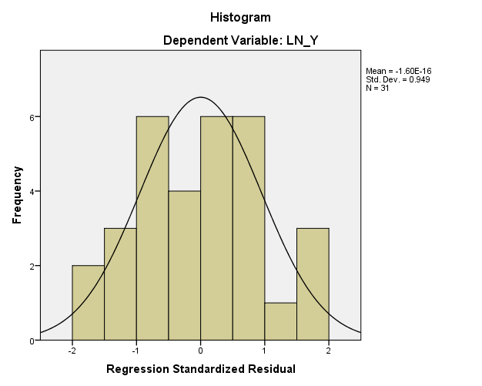

- P-P Plot

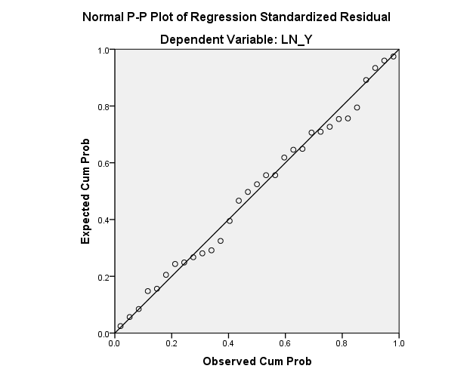
- Kolmogorov-Smirnov
One-Sample Kolmogorov-Smirnov Test
 |  | Unstandardized Residual
N |  | 31
Normal Parameters^{a,b} | Mean | 0E-7
 | Std. Deviation | .97609998
Most Extreme Differences | Absolute | .073
 | Positive | .073
 | Negative | -.046
Kolmogorov-Smirnov Z |  | .409
Asymp. Sig. (2-tailed) |  | .996
a. Test distribution is Normal.
b. Calculated from data.
- Hasil Uji Multikolonieritas

Coefficientsª
Model |  | Unstandardized Coefficients |  | Standardized Coefficients | t | Sig. | Collinearity Statistics
 |  | B | Std. Error | Beta |  |  | Tolerance | VIF
1 | (Constant) | 2.241 | 1.083 |  | 2.070 | .048
 | LN_X1 | .312 | .213 | .249 | 1.465 | .155 | .995 | 1.005
 | LN_X2 | .009 | .204 | .008 | .046 | .963 | .915 | 1.092
 | LN_X3 | .461 | .211 | .388 | 2.188 | .038 | .913 | 1.095
a. Dependent Variable: LN_Y

- Hasil Uji Heteroskedastisitas

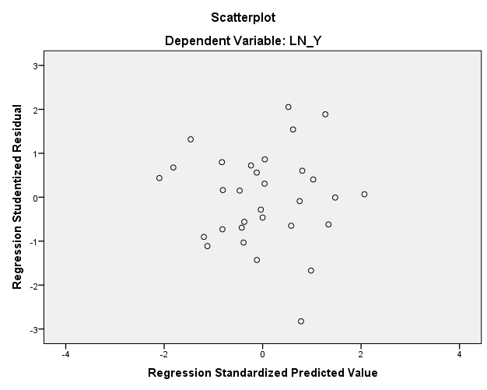
- Hasil Uji Autokorelasi

Model Summary^{b}
Model | R | R Square | Adjusted R Square | Std. Error of the Estimate | Durbin-Watson
1 | .475ª | .225 | .139 | 1.02890 | 2.127
a. Predictors: (Constant), LN_X3, LN_X1, LN_X2
b. Dependent Variable: LN_Y

4.3 Hasil Analisis Regresi LinierBerganda

Coefficientsª
Model |  | Unstandardized Coefficients |  | Standardized Coefficients | t | Sig.
 |  | B | Std. Error | Beta
1 | (Constant) | 2.241 | 1.083 |  | 2.070 | .048
 | LN_X1 | .312 | .213 | .249 | 1.465 | .155
 | LN_X2 | .009 | .204 | .008 | .046 | .963
 | LN_X3 | .461 | .211 | .388 | 2.188 | .038
a. Dependent Variable: LN_Y

4.4 Uji Hipotesis
- Koefisien Determinasi (R²)
Model Summary^{b}
Model | R | R Square | Adjusted R Square | Std. Error of the Estimate
1 | .475ª | .225 | .139 | 1.02890
a. Predictors: (Constant), LN_X3, LN_X1, LN_X2
b. Dependent Variable: LN_Y

- Uji Secara Parsial (Uji-t)
Coefficientsª
Model |  | Unstandardized Coefficients |  | Standardized Coefficients | T | Sig.
 |  | B | Std. Error | Beta
1 | (Constant) | 2.241 | 1.083 |  | 2.070 | .048
 | LN_X1 | .312 | .213 | .249 | 1.465 | .155
 | LN_X2 | .009 | .204 | .008 | .046 | .963
 | LN_X3 | .461 | .211 | .388 | 2.188 | .038
a. Dependent Variable: LN_Y

- Uji Secara Simultan (Uji F)
ANOVAª
Model |  | Sum of Squares | Df | Mean Square | F | Sig.
1 | Regression | 8.309 | 3 | 2.770 | 2.616 | .071^{b}
 | Residual | 28.583 | 27 | 1.059
 | Total | 36.892 | 30
a. Dependent Variable: LN_Y
b. Predictors: (Constant), LN_X3, LN_X1, LN_X2

