Lampiran
No | Nama | DAFTAR HADIR SISWA 7.6
 |  | 1 | 2 | 3 | 4
1 | Adelia Nazwa Haqi
2 | Ahmad Fahri
3 | Aiga Yasmin
4 | Alfredo Sijabat
5 | Annisa Mutiara
6 | Anugrah Syahputra
7 | Aulia Tusifa
8 | Elsi Olivia
9 | Farel Merdeka
10 | Febrian Sikumbang
11 | Greatson Ozul
12 | Ibnu Anshari Noor
13 | Indah Permata Sari
14 | Kevin Ockstar
15 | Linggana Faura
16 | M. Hafiz Byan
17 | Michael Saputra
18 | M. Fauzan
19 | M. Rayhan
20 | Naura Zahra
21 | Putri Dameria
22 | Revlina Gheisa
23 | Sulastri Pakpahan
24 | Syifa Linta Haulika
25 | Teguh Manurung
26 | Trilian Apentus
27 | Tyara Savira
28 | Wendi Felix
29 | Yehzekiel Junior
30 | Yessy Febbryantika
Lampiran 1 Absensi Siswa

No | Nama | DAFTAR HADIR SISWA 7.8
 |  | 1 | 2 | 3 | 4
1 | Abi Ananda
2 | Abraham Siregar
3 | Alfredo
4 | Arifin Nugraha
5 | Azril Afiza
6 | Bella Mutiara Simamora
7 | Clarine Nalani Chandra
8 | Fandi Syahputra Harefa
9 | Fikri Fadhillah Fitra
10 | Gisela Aprila Anjelica
11 | Isakhar Pardamean
12 | Jacinda Valisha
13 | Jessica Cicilia Sitorus
14 | Khaira Nafisa
15 | M. Ridho Jailani
16 | M. Yusuf Juliansar
17 | Meyman Jaya Nazara
18 | Muhammad Raffa Adhitiya
19 | Nabil Octavian
20 | Nasya Rizki Rudiani
21 | Nency Olivia Nainggolan
22 | Nur Aini
23 | Rafa Syahputra
24 | Raihan Ahmad Muzzaki Lubis
25 | Rara Namira Thalisa Azzura
26 | Tri Najwa Afifah
27 | Tari Kurnia Sari
28 | Valintino Syahputra Pasaribu
29 | Vandi Notatema Natanael
30 | Wilandri Selvia Samosir

No | Nama | DAFTAR HADIR SISWA 7.7
 |  | 1 | 2 | 3 | 4
1 | Aditiya Pratama
2 | Afifah Sofiah
3 | Andreas Roganda Siregar
4 | Angga Kuriawan
5 | Aryan Radhi
6 | Assyfa Siregar
7 | Aulia Dea Zhafira
8 | Bunga Olivia Harahap
9 | Dinda Amelia
10 | Ebenezer
11 | Farhan Hidayat
12 | Febi Febiola
13 | Fernando Satkya Ongh
14 | Glen Gabriel Tambunan
15 | Hafiza Hanum
16 | Icha Anastasya Putri Waruwu
17 | Jose Piter Steven Sitorus
18 | Kevin Chicco Sandria Tampubolon
19 | Naftalim Sianturi
20 | Naura Permata Kasih
21 | Nessia Athaya
22 | Nurhayati
23 | Radia Maulana Amri
24 | Rafael Manullang
25 | Rejani Syahputir
26 | Rendi Saputra
27 | Suny Mahardika
28 | Syahrezi Narendra
29 | Tegar Nainggolan
30 | Yunika Sabrina
31 | Zacky Erzain Irawan
32 | Zahanara

Lampiran 2 Pre-Test Siswa
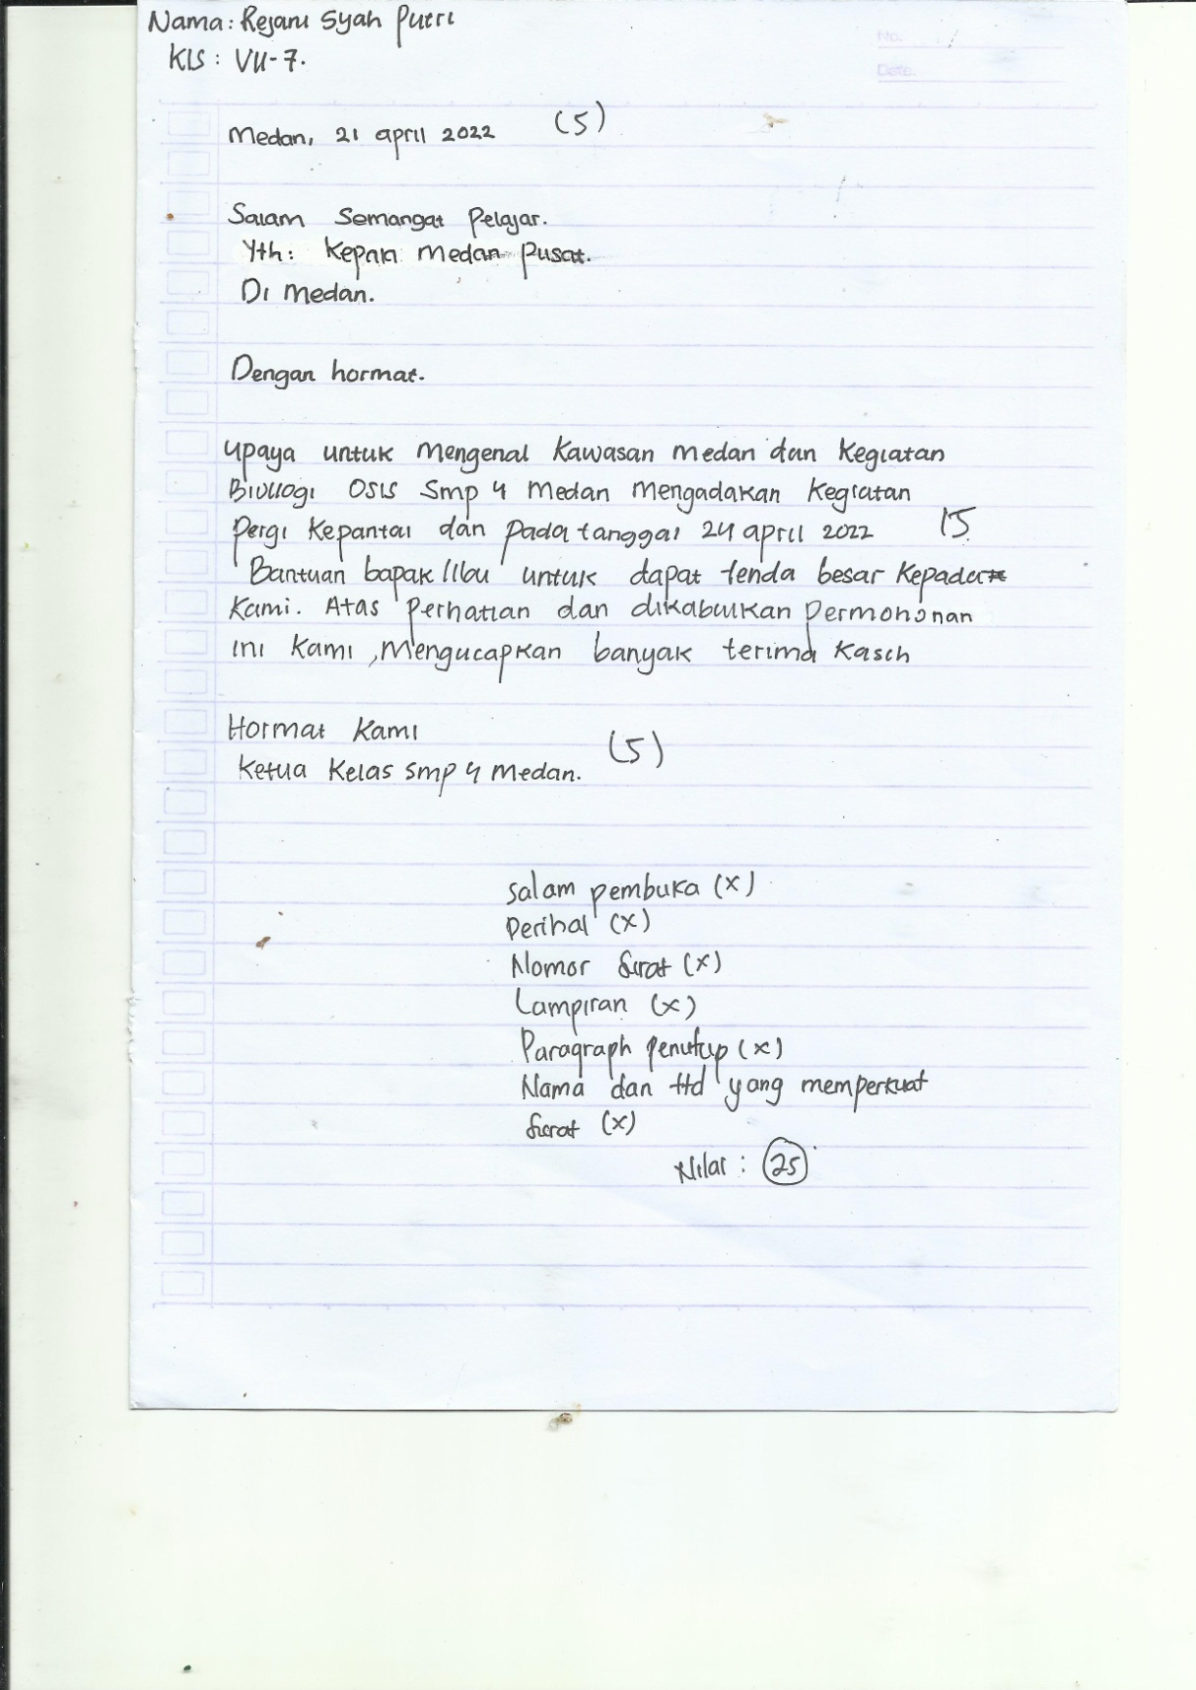

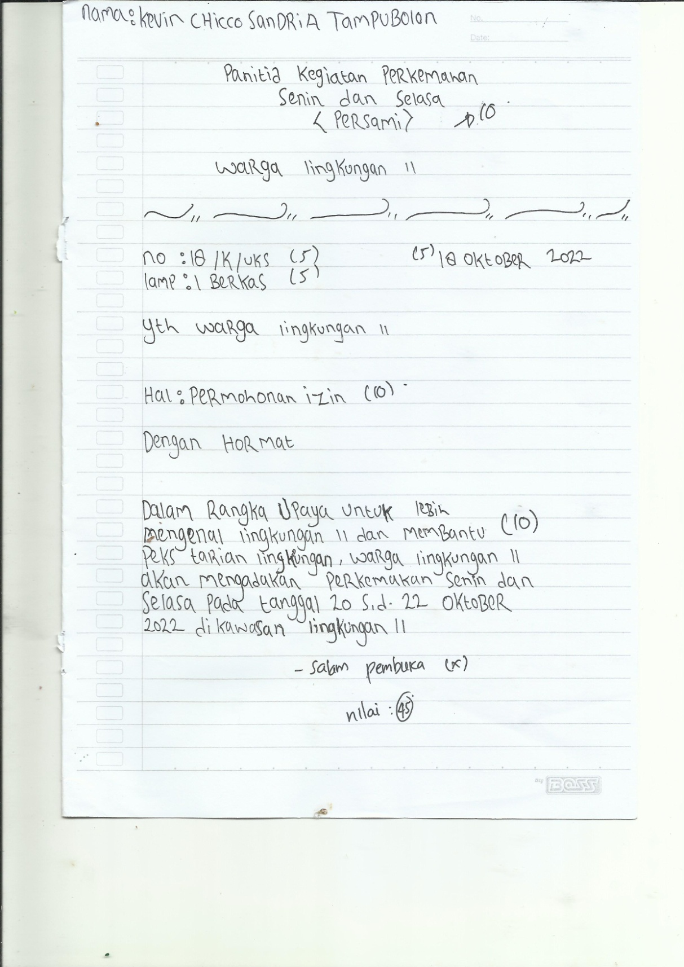

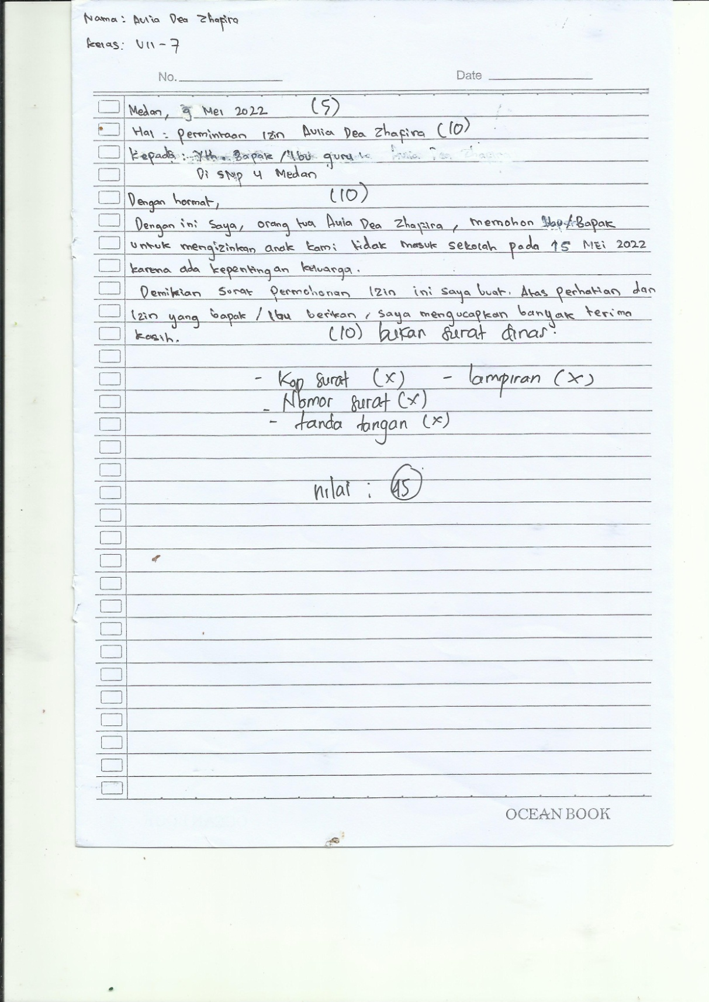

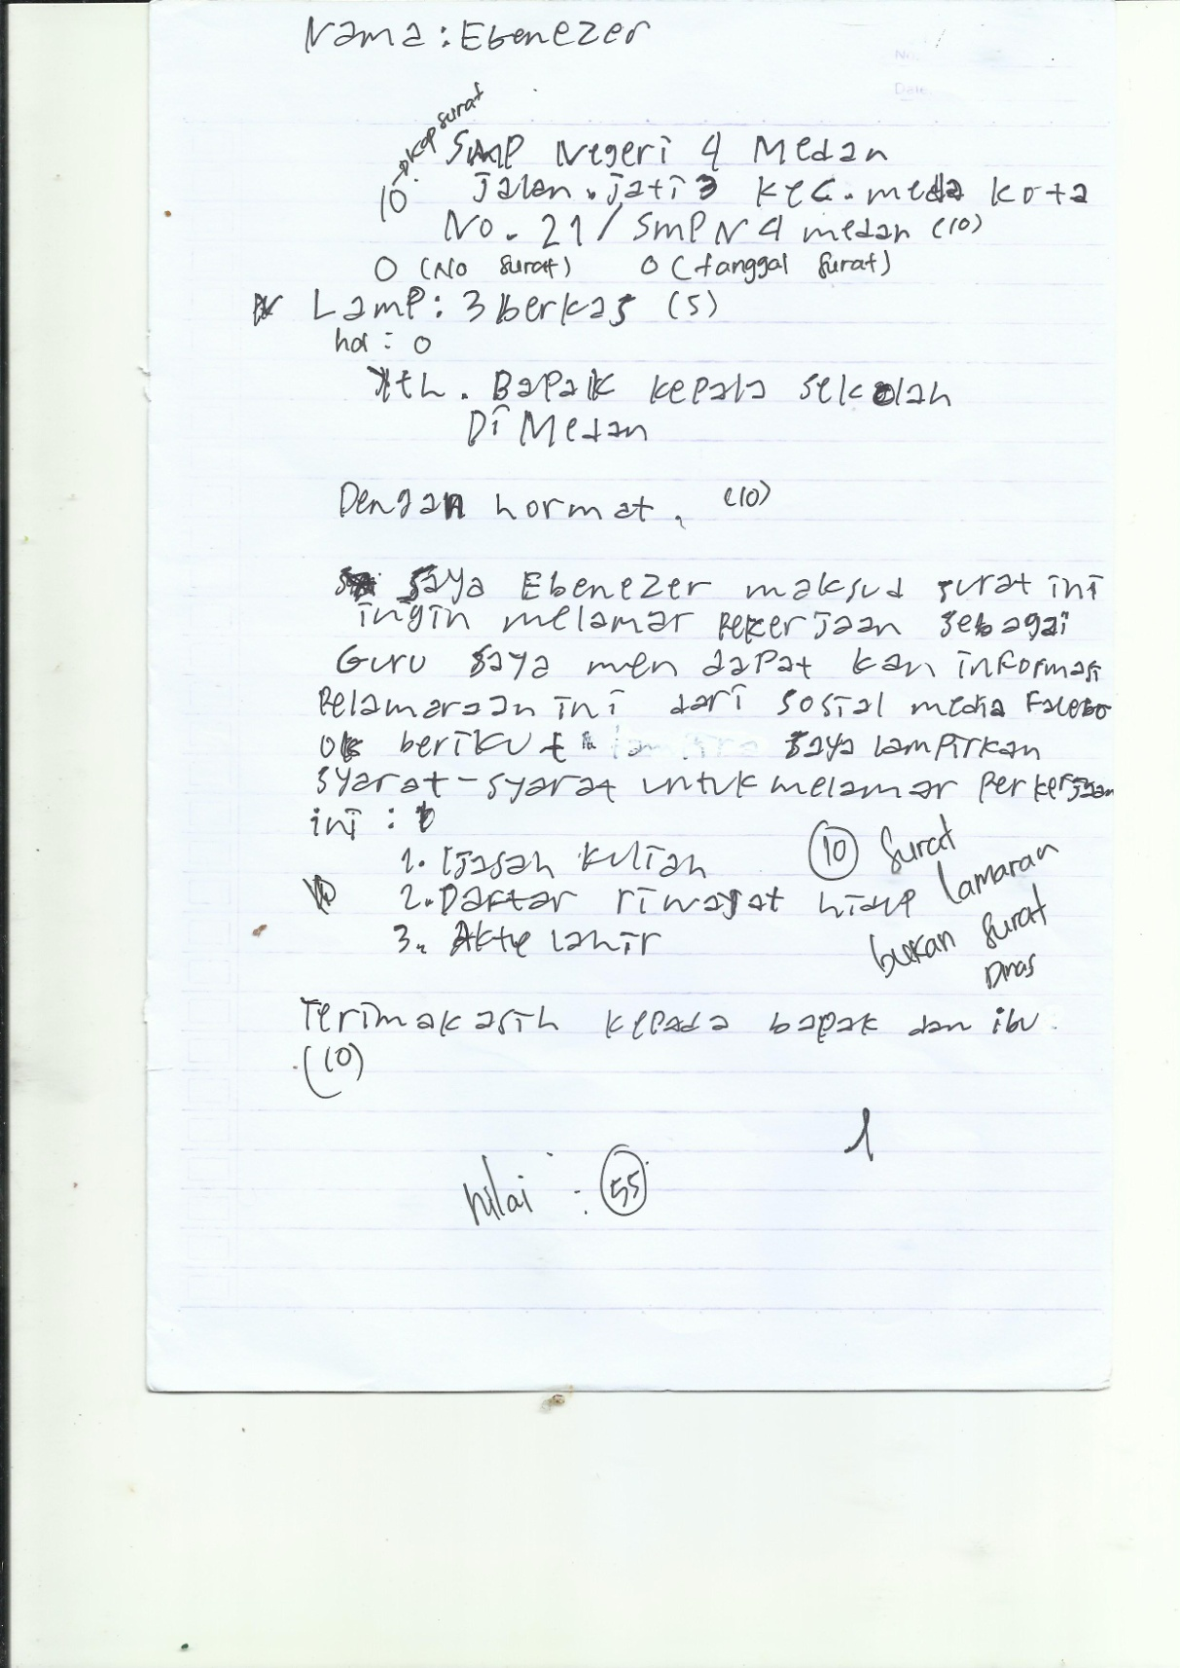

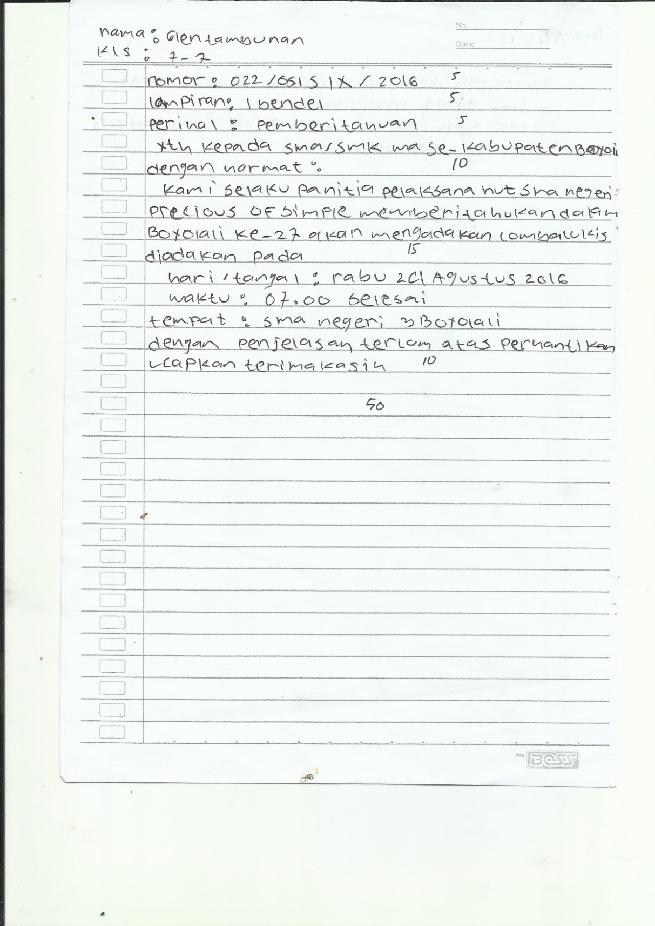

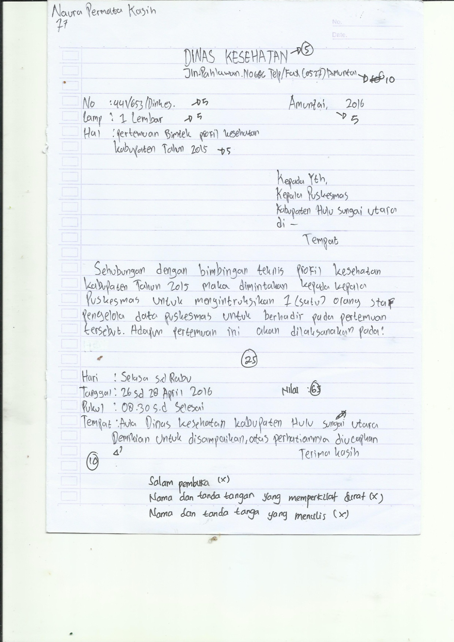

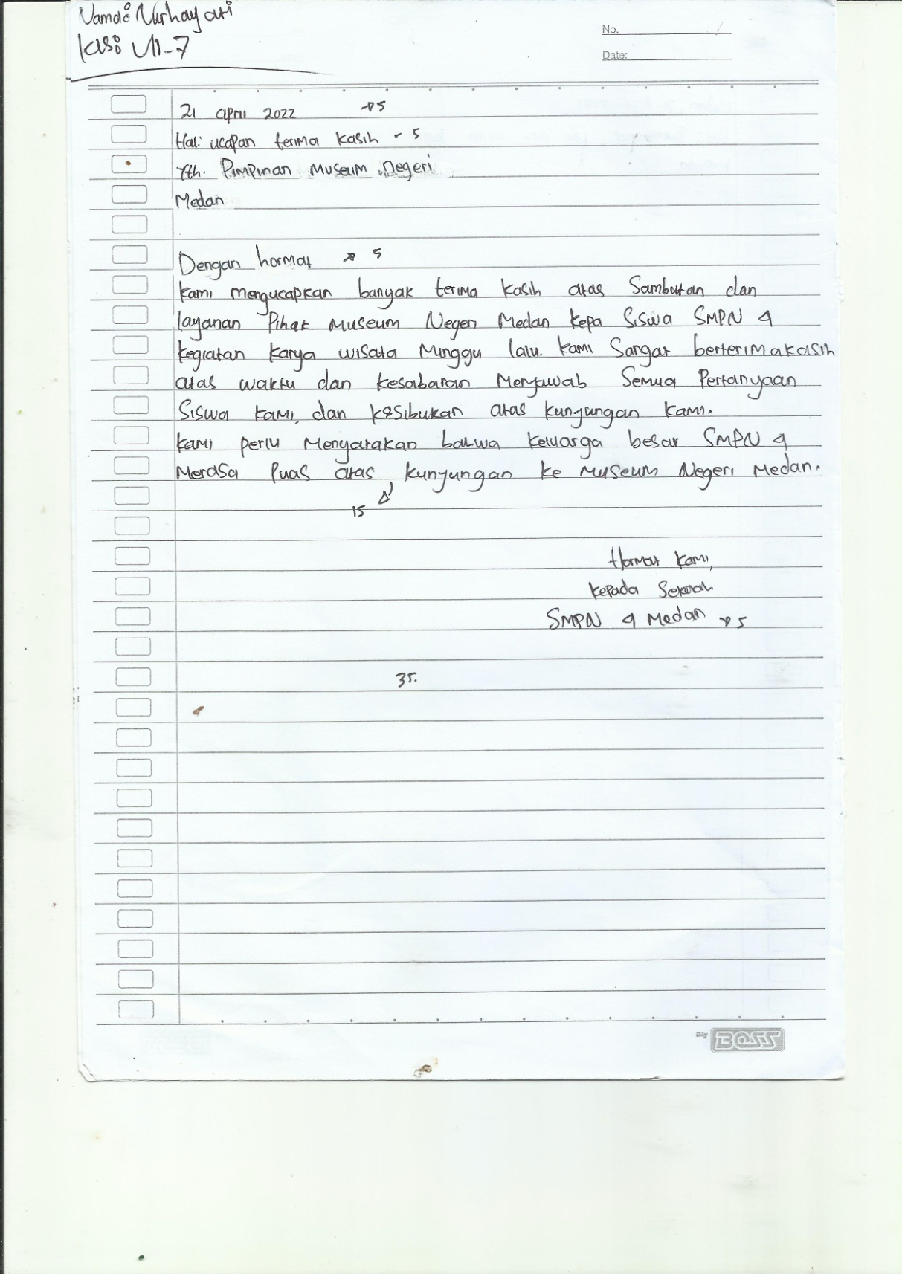

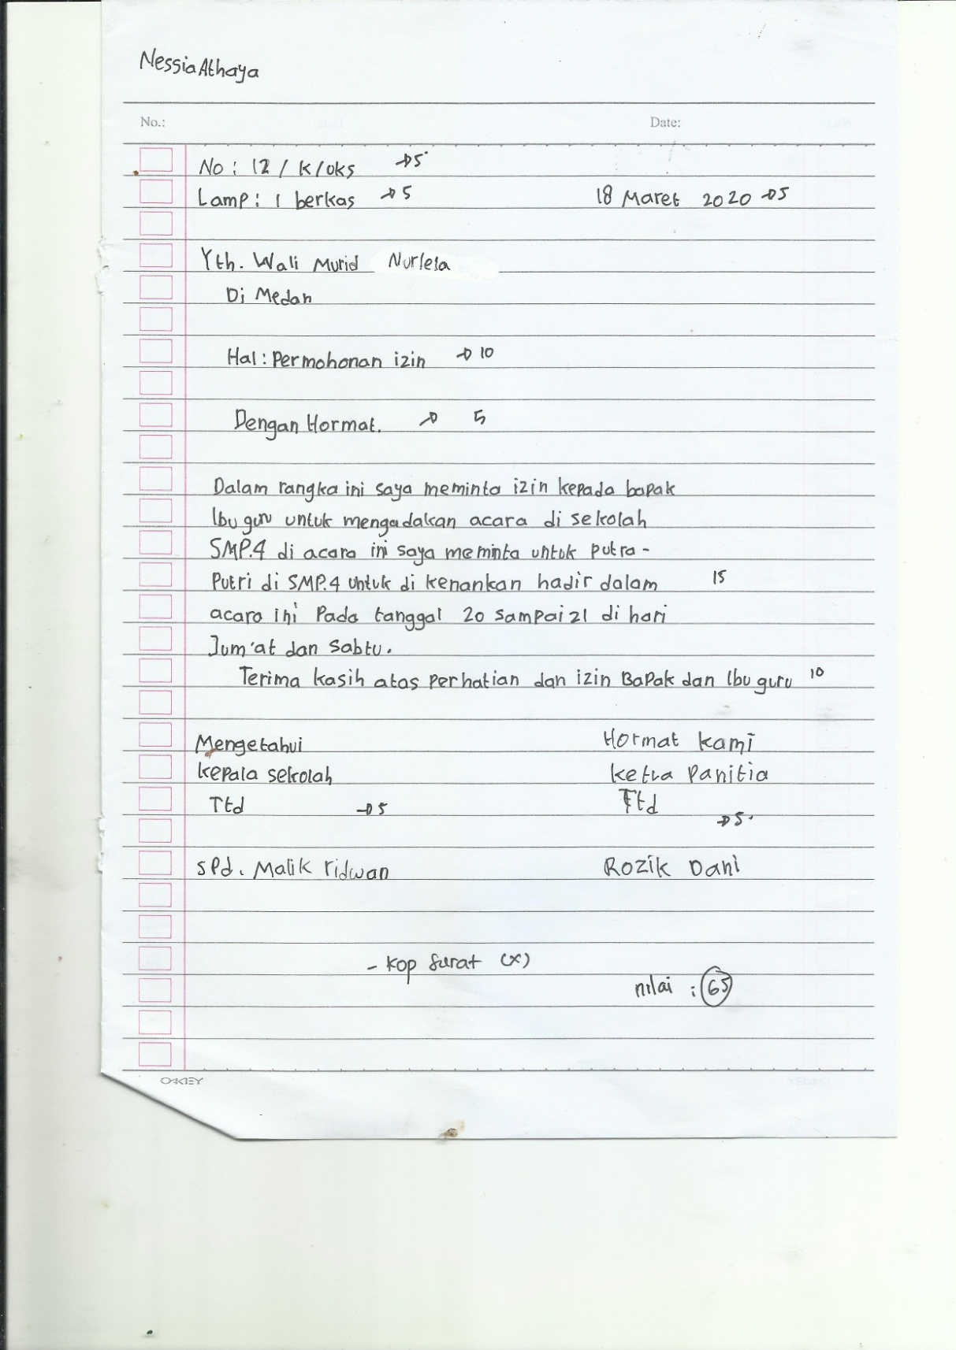

Lampiran 3 Hasil Post Test
