LAMPIRAN

Lampiran 1. Hasil indentifikasi Sampel Minyak zaitun (Olive oil)
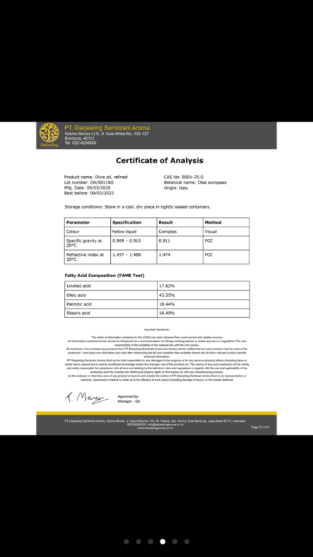

Lampiran 2. Bagan Alir Pembuatan Basis Skin Balm
Vaselin album

di masukkan dalam cawan porselin
di masukkan dalam cawan porselin

Cera alba

dileburkan diatas penangas air pada suhu 80̊ - 86̊ C sampai meleleh sempurna

dileburkan diatas penangas air pada suhu 80ͦ - 86ͦ C sampai meleleh sempurna

Massa ll

Massa l

dicampurkan massa ll yang telah meleleh ke dalam massa l hingga sampai homogen

Basis a

Lampiran 3. Bagan Alir Pembuatan Sediaan Skin Balm F0 (Blanko)
Cera alba

Vaselin album

di masukkan dalam cawan porselin
di masukkan dalam cawan porselin

dileburkan diatas penangas air pada suhu 80̊ - 86̊ C sampai meleleh sempurna

dileburkan diatas penangas air pada suhu 80ͦ - 86ͦ C sampai meleleh sempurna

Massa l

Massa ll

dicampurkan massa ll yang telah meleleh ke dalam massa l yang telah meleleh
Basis a

parafin liquidum ditambahkan sedikit demi sedikit kedalam basis a, aduk homogen

ditambahkan BHT dan Natrium metabisulfit, aduk homogen

ditambahkan parfum secukupnya, aduk homogen,masukkan dalam wadah
Sediaan skin balm blanko

Lampiran 4. Bagan Alir Pembuatan Sediaan Skin Balm F1 14%
Cera alba

Vaselin album

di masukkan dalam cawan porselin
di masukkan dalam cawan porselin

dileburkan diatas penangas air pada suhu 80̊ - 86̊ C sampai meleleh sempurna

dileburkan diatas penangas air pada suhu 80ͦ - 86ͦ C sampai meleleh sempurna

Massa l

Massa ll

dicampurkan massa ll yang telah meleleh ke dalam massa l yang telah meleleh
Basis a

minyak zaitun 14 g dan parafin liquidum ditambahkan sedikit demi sedikit kedalam basis a, aduk homogen

ditambahkan BHT dan Natrium metabisulfit, aduk homogen

ditambahkan parfum secukupnya, aduk homogen,masukkan dalam wadah
Sediaan skin balm F1(minyak zaitun ) 14%

Lampiran 5. Bagan Alir Pembuatan Sediaan Skin Balm F1 17%
Cera alba

Vaselin album

di masukkan dalam cawan porselin
di masukkan dalam cawan porselin

dileburkan diatas penangas air pada suhu 80ͦ - 86ͦ C sampai meleleh sempurna

dileburkan diatas penangas air pada suhu 80̊ - 86̊ C sampai meleleh sempurna

Massa l

Massa ll

dicampurkan massa ll yang telah meleleh ke dalam massa l yang telah meleleh
Basis a

minyak zaitun 17 g dan parafin liquidum ditambahkan sedikit demi sedikit kedalam basis a, aduk homogen

ditambahkan BHT dan Natrium metabisulfit, aduk homogen

ditambahkan parfum secukupnya, aduk homogen,masukkan dalam wadah
Sediaan skin balm F2(minyak zaitun ) 17%

Lampiran 6.Bagan Alir Pemeriksaan Organoleptis
Sediaan Skin Balm Minyak Zaitun

diamati bentuk, warna dan bau

Hasil
Uji organoleptis

F2
Bentuk sediaan
setengah padat, warna
kekuningan dan bau
baby powder

F1
Bentuk sediaan setengah
padat, warna krim
kekuningan dan bau
baby powder

F0
Bentuk sediaan setengah
padat, warna putih susu
dan bau baby powder

Lampiran 7. Bagan Alir Pemeriksaan Homogenitas
Sediaan Skin Balm Minyak Zaitun

diambil sediaan skin balm kemudian dioleskan pada sekeping objek glass.

Hasil uji homogen

F0: Homogen

F1: Homogen

F2: Homogen

Lampiran 8. Bagan Alir Pemeriksaan pH
Sediaan Skin Balm Minyak Zaitun

1g sediaan skin balm yang telah diencerkan dengan 10 mL aquadest

dilakukan 6 kali pengulangan

Hasil uji pH

F2: Hari ke-0 (5.3 ± 0.06), Hari ke-7 (5.6± 0.05), Hari ke-14 (5 ± 0.06), Hari ke-21(5.5 ± 0.05), Hari ke-28 (5.6 ± 0.10)

F1: Hari ke-0 (5.1 ± 0.00),
Hari ke-7 (5.1 ± 0.06),
Hari ke-14 (5.3 ± 0.05),
Hari ke-21 (5.4 ± 0.18),
Hari ke-28 (5.5 ± 0.05)

F0: Hari 0 (4.7± 0.08),
Hari ke-7 (5 ± 0.08), Harike-14 (5.4 ± 0.05), Hari ke-21 (5 ± 0.18), Hari ke-28 (5.5 ± 0.53)

Lampiran 9. Bagan Alir Pemeriksaan Daya Sebar
Sediaan Skin Balm Minyak Zaitun

0,5gram sediaan skin balm diletakkan ditengah cawan petri lalu kaca lainnya diletakkan diatasnya

tambahkan beban 100g dan didiamkan selama 1 menit

dkur diameter menggunakan penggaris

dilakukan 6 kali pengulangan
Hasil uji daya sebar

F2: Hari ke-0 (5.7 ± 0.17),
Hari ke-7 (5.9 ± 0.09),
Hari ke-14 (5.2 ± 0.08),
Hari ke-21 (5.5 ± 0.11),
Hari ke-28 (5.5 ± 0.15)

F1: Hari ke-0 (5.2 ± 0.29), Hari ke-7 (5.5 ± 0.13), Hari ke-14 (5.5 ± 0.17), Hari ke-21 (5.6 ± 0.32), Hari ke-28 (5.7 ± 0.17)

F0: Hari ke-0 (5.3 ± 0.12), Hari ke-7(5.5 ± 0.24), Hari ke-14 (5.4 ± 0.10), Hari ke-21 (5.8 ± 0.15), Hari ke-28 (5.8 ± 0.15)

Lampiran 10. Bagan Alir Pemeriksaan Iritasi
Sediaan Skin Balm Minyak Zaitun

dioleskan sediaan skin balm pada belakang telinga sukarelawan

dilakukan 3 kali pengulangan

Hasil Uji iritasi

F2:
Tidak terjadi iritasi alergi

F1:
Tidak terjadi iritasi alergi

F0:
Tidak terjadi iritasi alergi

Lampiran 11. Perhitungan Formula Sediaan Skin Balm
Formula 0 (blanko) sediaan tanpa minyak zaitun (Olive oil)
- Paraffin liquidum = $\frac{20}{100}×100 g$ = 20 g
- Cera alba = $\frac{15}{100}×100 g$ = 15 g
- BHT = $\frac{0,1}{100}×100 g$ = 0,1 g
- Natrium metabisulfit = $\frac{0,1}{100}×100 g$ = 0,1 g
- Vaselin album ad 100 = 100-(20+15+0,1+0,1)g = 64,8 g

Formula 1 yaitu sediaan menggunakan minyak zaitun (Olive oil) 14%
- Paraffin liquidum = $\frac{20}{100}×100 g$ = 20 g
- Cera alba = $\frac{15}{100}×100 g$ = 15 g
- BHT = $\frac{0,1}{100}×100 g$ = 0,1 g
- Natrium metabisulfit = $\frac{0,1}{100}×100 g$ = 0,1 g
- Minyak zaitun = $\frac{14}{100}×100 g$ = 14 g
- Vaselin album ad 100 = 100-(20+15+0,1+0,1+14)g = 50,8 g

Formula 1 yaitu sediaan menggunakan minyak zaitun (Olive oil) 14%
- Paraffin liquidum = $\frac{20}{100}×100 g$ = 20 g
- Cera alba = $\frac{15}{100}×100 g$ = 15 g
- BHT = $\frac{0,1}{100}×100 g$ = 0,1 g
- Natrium metabisulfit = $\frac{0,1}{100}×100 g$ = 0,1 g
- Minyak zaitun = $\frac{17}{100}×100 g$ = 17 g
- Vaselin album ad 100 = 100-(20+15+0,1+0,1+17)g = 47,8 g

Lampiran 12. Gambar bahan yang digunakan

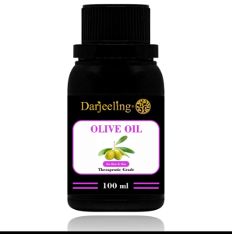
Minyak Zaitun

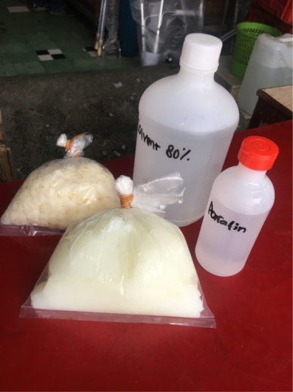
Bahan

Parfum
Lampiran 13. Hasil Sediaan Skin Balm Minyak zaitun (olive oil)

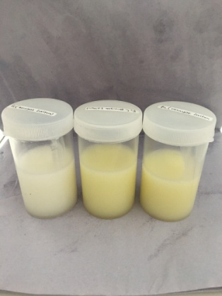
F0
F1
F2

Keterangan: Formula 0 = Blanko (dasar skin balm tanpa minyak zaitun)
Formula 1 = Konsentrasi minyak zaitun 14%
Formula 2 = Konsentrasi minyak zaitun 17%

Lampiran 14. Hasil Uji Homogenitas
FO F1 F2
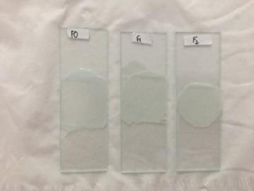
Keterangan: F0: Dasar Skin balm (Blanko)
F1: Minyak zaitun konsentrasi 14%
F2: Minyak zaitun konsentrasi 17%

Lampiran 15. Gambar Hasil Uji Organoleptis
F0 F1 F2
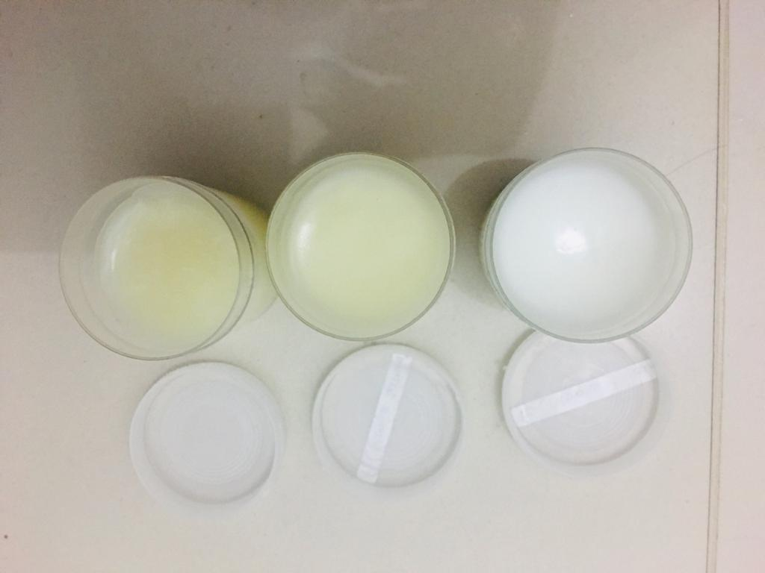
Keterangan: F0: Dasar Skin balm (Blanko)
F1: Minyak zaitun konsentrasi 14%
F2: Minyak zaitun konsentrasi 17%

Lampiran 16. Uji pH
F2
F1
FO

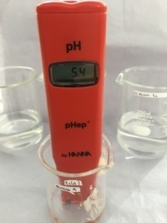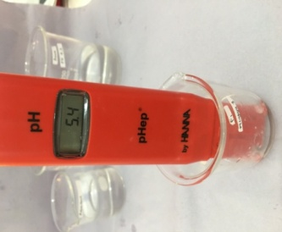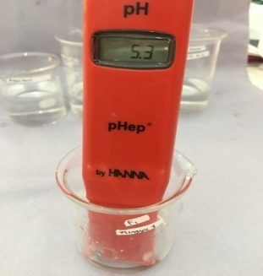
Keterangan :Dilakukan uji pH selama 4 minggu sebanyak 6 kali pengulangan
F0 : Dasar Skin balm (Blanko)
F1 : Minyak zaitun konsentrasi 14%
F2 : Minyak zaitun konsentrasi 17%

Lampiran 17. Uji Daya Sebar
F1
F2
FO
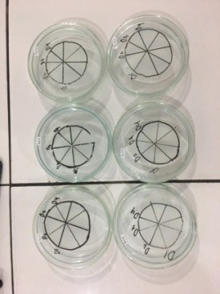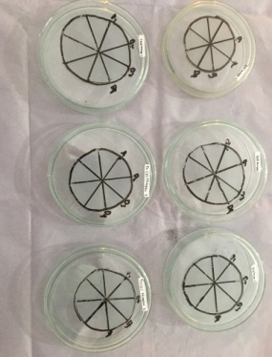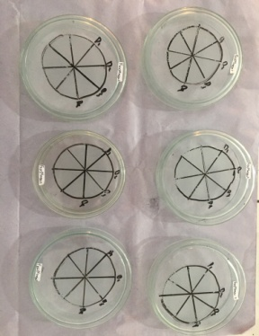
Keterangan : Dilakukan uji daya sebar selama 4 minggu sebanyak 6 kali pengulangan
F0 : Dasar Skin balm (Blanko)
F1 : Minyak zaitun konsentrasi 14%
F2 : Minyak zaitun konsentrasi 17%

Lampiran 18. Hasil Uji Iritasi
Hasil Setelah Pemakaian Sediaan Skin Balm
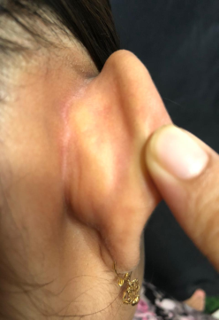
F2 (17%)
F1 (14%)
Blanko

Keterangan:
F0: Dasar Skin balm (Blanko)
F1: Minyak zaitun konsentrasi 14%
F2: Minyak zaitun konsentrasi 17%

Lampiran 19. Gambar Hasil Uji Efektivitas kelembaban kulit
F0 (Blanko)
F2 (17%)
F1 (14%)
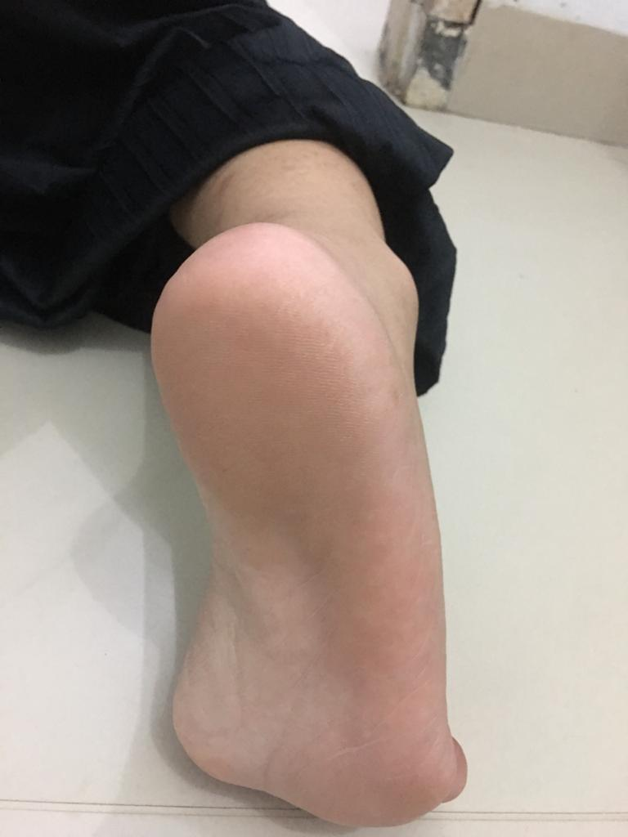
Minggu 0
Minggu 0
Minggu 0

- Kondisi Awal Kelembaban Xerosis Tumit Kaki Sebelum Pemakaian Sedian Skin Balm Pada Minggu 0

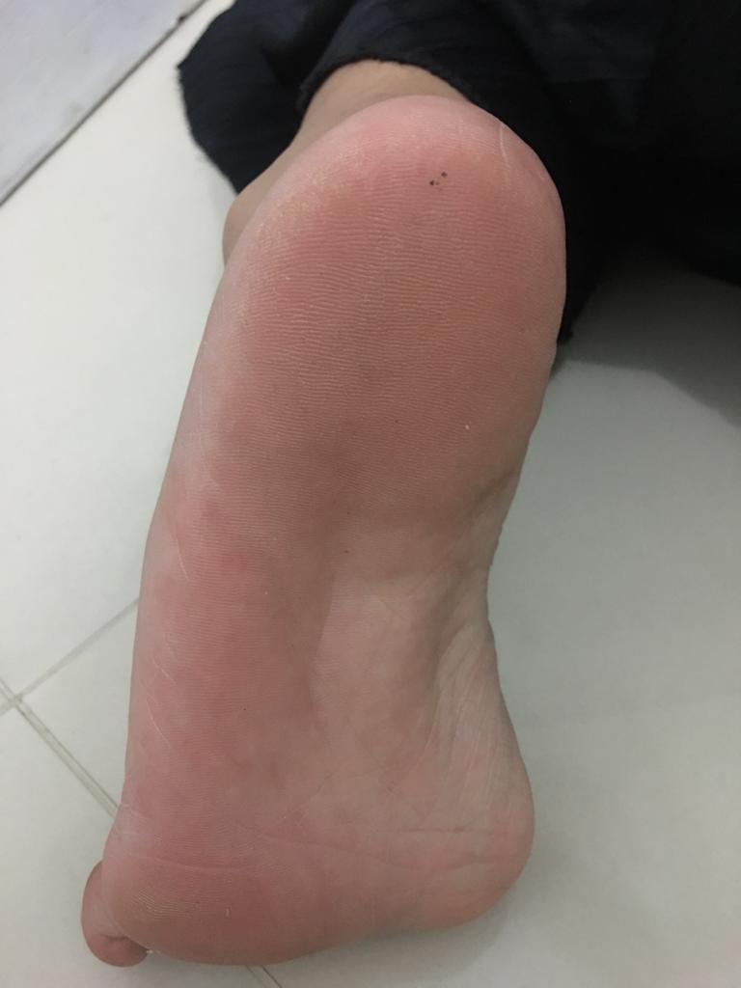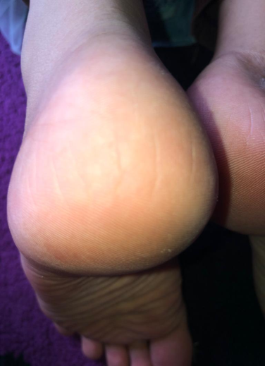
Minggu 2
Minggu 2
Minggu 2

- Kondisi Kelembaban Xerosis Tumit Kaki Setelah Pemakaian Sedian Skin Balm Selama 2 Minggu Adanya Sedikit Perubahan Kelembaban

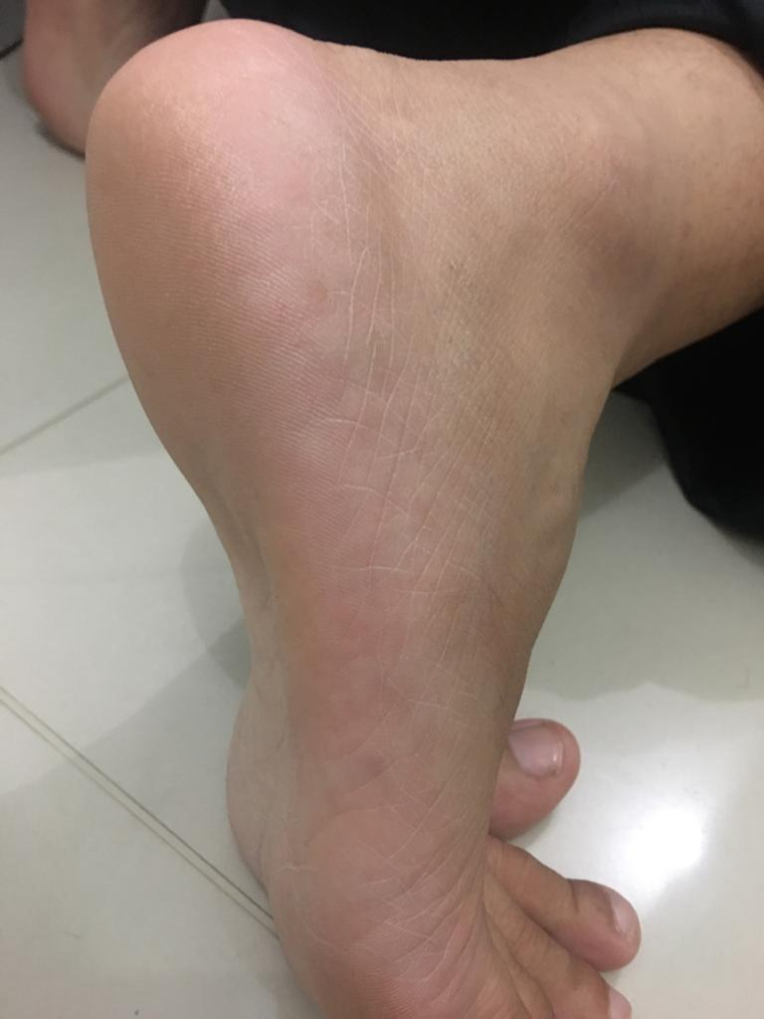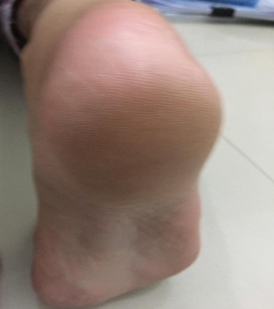
Minggu 4
Minggu 4
Minggu 4

- Kondisi Kelembaban Xerosis Tumit Kaki Setelah Pemakaian Sedian Skin Balm Selama 4 Minggu Adanya Perubahan Kelembaban

Lampiran 20 Data SPSS Kelembaban Sediaan Skin Balm Minyak Zaitun (Olive oil) sukarelawan

Tests of Normality^{c,d}
 | Sediaan | Kolmogorov-Smirnovª |  |  | Shapiro-Wilk
 |  | Statistic | df | Sig. | Statistic | df | Sig.
Kondisiawal | F0 | ,222 | 6 | ,200* | ,932 | 6 | ,597
 | F1 | ,392 | 6 | ,004 | ,701 | 6 | ,006
 | F2 | ,319 | 6 | ,056 | ,683 | 6 | ,004
kelembaban7 | F0 | ,241 | 6 | ,200* | ,866 | 6 | ,212
 | F2 | ,392 | 6 | ,004 | ,701 | 6 | ,006
kelembaban14 | F0 | ,184 | 6 | ,200* | ,919 | 6 | ,500
 | F1 | ,319 | 6 | ,056 | ,683 | 6 | ,004
 | F2 | ,293 | 6 | ,117 | ,766 | 6 | ,029
kelembaban21 | F0 | ,325 | 6 | ,047 | ,827 | 6 | ,101
 | F1 | ,306 | 6 | ,083 | ,826 | 6 | ,100
 | F2 | ,183 | 6 | ,200* | ,960 | 6 | ,820
kelembaban28 | F1 | ,281 | 6 | ,149 | ,836 | 6 | ,121
 | F2 | ,212 | 6 | ,200* | ,858 | 6 | ,183
*. This is a lower bound of the true significance.
a. Lilliefors Significance Correction
c. kelembaban 7 is constant when Sediaan = F1. It has been omitted.
d. kelembaban 28 is constant when Sediaan = F0. It has been omitted.

Signifikan>0.05 Data terdistribusi Normal

Descriptives
 |  | N | Mean | Std. Deviation | Std. Error | 95% Confidence Interval for Mean |  | Minimum | Maximum
 |  |  |  |  |  | Lower Bound | Upper Bound
Kondisiawal | F0 | 6 | 28,600 | 1,4142 | ,5774 | 27,116 | 30,084 | 27,0 | 31,0
 | F1 | 6 | 29,500 | ,8367 | ,3416 | 28,622 | 30,378 | 29,0 | 31,0
 | F2 | 6 | 30,500 | ,5477 | ,2236 | 29,925 | 31,075 | 30,0 | 31,0
 | Total | 18 | 29,533 | 1,2329 | ,2906 | 28,920 | 30,146 | 27,0 | 31,0
kelembaban7 | F0 | 6 | 30,700 | 1,0733 | ,4382 | 29,574 | 31,826 | 29,5 | 32,0
 | F1 | 6 | 31,000 | ,0000 | ,0000 | 31,000 | 31,000 | 31,0 | 31,0
 | F2 | 6 | 32,500 | ,8367 | ,3416 | 31,622 | 33,378 | 32,0 | 34,0
 | Total | 18 | 31,400 | 1,0960 | ,2583 | 30,855 | 31,945 | 29,5 | 34,0
kelembaban14 | F0 | 6 | 32,500 | 1,9277 | ,7870 | 30,477 | 34,523 | 30,3 | 35,0
 | F1 | 6 | 37,500 | ,5477 | ,2236 | 36,925 | 38,075 | 37,0 | 38,0
 | F2 | 6 | 40,600 | ,4899 | ,2000 | 40,086 | 41,114 | 40,0 | 41,0
 | Total | 18 | 36,867 | 3,6114 | ,8512 | 35,071 | 38,663 | 30,3 | 41,0
kelembaban21 | F0 | 6 | 33,500 | 1,2247 | ,5000 | 32,215 | 34,785 | 32,0 | 35,0
 | F1 | 6 | 39,500 | ,5797 | ,2366 | 38,892 | 40,108 | 39,0 | 40,3
 | F2 | 6 | 42,500 | 1,0488 | ,4282 | 41,399 | 43,601 | 41,0 | 44,0
 | Total | 18 | 38,500 | 3,9607 | ,9335 | 36,530 | 40,470 | 32,0 | 44,0
kelembaban28 | F0 | 6 | 34,000 | ,0000 | ,0000 | 34,000 | 34,000 | 34,0 | 34,0
 | F1 | 6 | 40,800 | ,9011 | ,3679 | 39,854 | 41,746 | 40,0 | 42,0
 | F2 | 6 | 44,833 | ,9973 | ,4072 | 43,787 | 45,880 | 43,8 | 46,0
 | Total | 18 | 39,878 | 4,6575 | 1,0978 | 37,562 | 42,194 | 34,0 | 46,0

ANOVA
 |  | Sum of Squares | df | Mean Square | F | Sig.
Kondisiawal | Between Groups | 10,840 | 2 | 5,420 | 5,420 | ,017
 | Within Groups | 15,000 | 15 | 1,000
 | Total | 25,840 | 17
kelembaban7 | Between Groups | 11,160 | 2 | 5,580 | 9,039 | ,003
 | Within Groups | 9,260 | 15 | ,617
 | Total | 20,420 | 17
kelembaban14 | Between Groups | 200,440 | 2 | 100,220 | 70,644 | ,000
 | Within Groups | 21,280 | 15 | 1,419
 | Total | 221,720 | 17
kelembaban21 | Between Groups | 252,000 | 2 | 126,000 | 128,747 | ,000
 | Within Groups | 14,680 | 15 | ,979
 | Total | 266,680 | 17
kelembaban28 | Between Groups | 359,738 | 2 | 179,869 | 298,675 | ,000
 | Within Groups | 9,033 | 15 | ,602
 | Total | 368,771 | 17
Signifikansi< 0.05 Ada pengaruh penambahan minyak terhadap kelembaban kulit, atau ada perbedaan kelembapan kulit terhadap perbedaan konsentrasi minyak
Post Hoc Tests
Multiple Comparisons
Tukey HSD
Dependent Variable | (I) Sediaan | (J) Sediaan | Mean Difference (I-J) | Std. Error | Sig. | 95% Confidence Interval
 |  |  |  |  |  | Lower Bound | Upper Bound
Kondisiawal | F0 | F1 | -,9000 | ,5774 | ,293 | -2,400 | ,600
 |  | F2 | -1,9000* | ,5774 | ,013 | -3,400 | -,400
 | F1 | F0 | ,9000 | ,5774 | ,293 | -,600 | 2,400
 |  | F2 | -1,0000 | ,5774 | ,226 | -2,500 | ,500
 | F2 | F0 | 1,9000* | ,5774 | ,013 | ,400 | 3,400
 |  | F1 | 1,0000 | ,5774 | ,226 | -,500 | 2,500
kelembaban7 | F0 | F1 | -,3000 | ,4536 | ,789 | -1,478 | ,878
 |  | F2 | -1,8000* | ,4536 | ,003 | -2,978 | -,622
 | F1 | F0 | ,3000 | ,4536 | ,789 | -,878 | 1,478
 |  | F2 | -1,5000* | ,4536 | ,013 | -2,678 | -,322
 | F2 | F0 | 1,8000* | ,4536 | ,003 | ,622 | 2,978
 |  | F1 | 1,5000* | ,4536 | ,013 | ,322 | 2,678
kelembaban14 | F0 | F1 | -5,0000* | ,6877 | ,000 | -6,786 | -3,214
 |  | F2 | -8,1000* | ,6877 | ,000 | -9,886 | -6,314
 | F1 | F0 | 5,0000* | ,6877 | ,000 | 3,214 | 6,786
 |  | F2 | -3,1000* | ,6877 | ,001 | -4,886 | -1,314
 | F2 | F0 | 8,1000* | ,6877 | ,000 | 6,314 | 9,886
 |  | F1 | 3,1000* | ,6877 | ,001 | 1,314 | 4,886
kelembaban21 | F0 | F1 | -6,0000* | ,5712 | ,000 | -7,484 | -4,516
 |  | F2 | -9,0000* | ,5712 | ,000 | -10,484 | -7,516
 | F1 | F0 | 6,0000* | ,5712 | ,000 | 4,516 | 7,484
 |  | F2 | -3,0000* | ,5712 | ,000 | -4,484 | -1,516
 | F2 | F0 | 9,0000* | ,5712 | ,000 | 7,516 | 10,484
 |  | F1 | 3,0000* | ,5712 | ,000 | 1,516 | 4,484
kelembaban28 | F0 | F1 | -6,8000* | ,4480 | ,000 | -7,964 | -5,636
 |  | F2 | -10,8333* | ,4480 | ,000 | -11,997 | -9,670
 | F1 | F0 | 6,8000* | ,4480 | ,000 | 5,636 | 7,964
 |  | F2 | -4,0333* | ,4480 | ,000 | -5,197 | -2,870
 | F2 | F0 | 10,8333* | ,4480 | ,000 | 9,670 | 11,997
 |  | F1 | 4,0333* | ,4480 | ,000 | 2,870 | 5,197
*. The mean difference is significant at the 0.05 level.

Homogeneous Subsets

Kondisi awal
Tukey HSDª
Sediaan | N | Subset for alpha = 0.05
 |  | 1 | 2
F0 | 6 | 28,600
F1 | 6 | 29,500 | 29,500
F2 | 6 |  | 30,500
Sig. |  | ,293 | ,226
Means for groups in homogeneous subsets are displayed.
a. Uses Harmonic Mean Sample Size = 6,000.

Kelembaban hari ke-7
Tukey HSDª
Sediaan | N | Subset for alpha = 0.05
 |  | 1 | 2
F0 | 6 | 30,700
F1 | 6 | 31,000
F2 | 6 |  | 32,500
Sig. |  | ,789 | 1,000
Means for groups in homogeneous subsets are displayed.
a. Uses Harmonic Mean Sample Size = 6,000.

Kelembaban hari ke-14
Tukey HSDª
Sediaan | N | Subset for alpha = 0.05
 |  | 1 | 2 | 3
F0 | 6 | 32,500
F1 | 6 |  | 37,500
F2 | 6 |  |  | 40,600
Sig. |  | 1,000 | 1,000 | 1,000
Means for groups in homogeneous subsets are displayed.
a. Uses Harmonic Mean Sample Size = 6,000.

Kelembaban hari ke-21
Tukey HSDª
Sediaan | N | Subset for alpha = 0.05
 |  | 1 | 2 | 3
F0 | 6 | 33,500
F1 | 6 |  | 39,500
F2 | 6 |  |  | 42,500
Sig. |  | 1,000 | 1,000 | 1,000
Means for groups in homogeneous subsets are displayed.
a. Uses Harmonic Mean Sample Size = 6,000.

Kelembaban hari ke-28
Tukey HSDª
Sediaan | N | Subset for alpha = 0.05
 |  | 1 | 2 | 3
F0 | 6 | 34,000
F1 | 6 |  | 40,800
F2 | 6 |  |  | 44,833
Sig. |  | 1,000 | 1,000 | 1,000
Means for groups in homogeneous subsets are displayed.
a. Uses Harmonic Mean Sample Size = 6,000.

