ABSTRAK

PENGEMBANGAN MEDIA VIDEO BERBASIS APLIKASI KINEMASTER PADA TEMA INDAHNYA KERAGAMAN
NEGERIKU DI KELAS IV SD

HANISAH HUTASUHUT

Penelitian ini dilatarbelakangi dengan media yang digunakan guru belum bervariasi. Pembelajaran secara konvensional ini cenderung membosankan siswa. Penelitian ini bertujuan untuk mengembangkan media video berbasis aplikasi kinemaster tema indahnya keragaman negeriku di kelas IV SD. Penelitian menggunakan pengembangan atau research and developmend (R&D) dengan model borg and gall yang terdiri dari lima langkah , yaitu; (1) potensi dan masalah, (2) pengumpulan data, (3) desain produk, (4) validasi desain, (5) revisi desain, untuk menguji kevalidan dan kelayakan suatu media yang dikembangkan. Penelitian yang dilakukan di kelas IV SD Negeri 060925 Medan tema indahnya keragaman negeriku. Teknik pengumpulan data menggunakan angket ahli media, angket ahli materi dan guru. Validasi ahli media dengan persentase kelayakan 82% yang termasuk kedalam kategori "layak". Hasil dari ahli materi dengan persentase kelayakan 77% yang termasuk kedalam kategori "layak" dan hasil validasi dari guru dengan persentase kelayakan 83% yang termasuk kedalam kategori "layak". Dapat disimpulkan bahwa media video berbasis aplikasi kinemaster pada tema indahnya keragaman negeriku layak digunakan.

Kata kunci: Pengembangan, Media video, Kinemaster

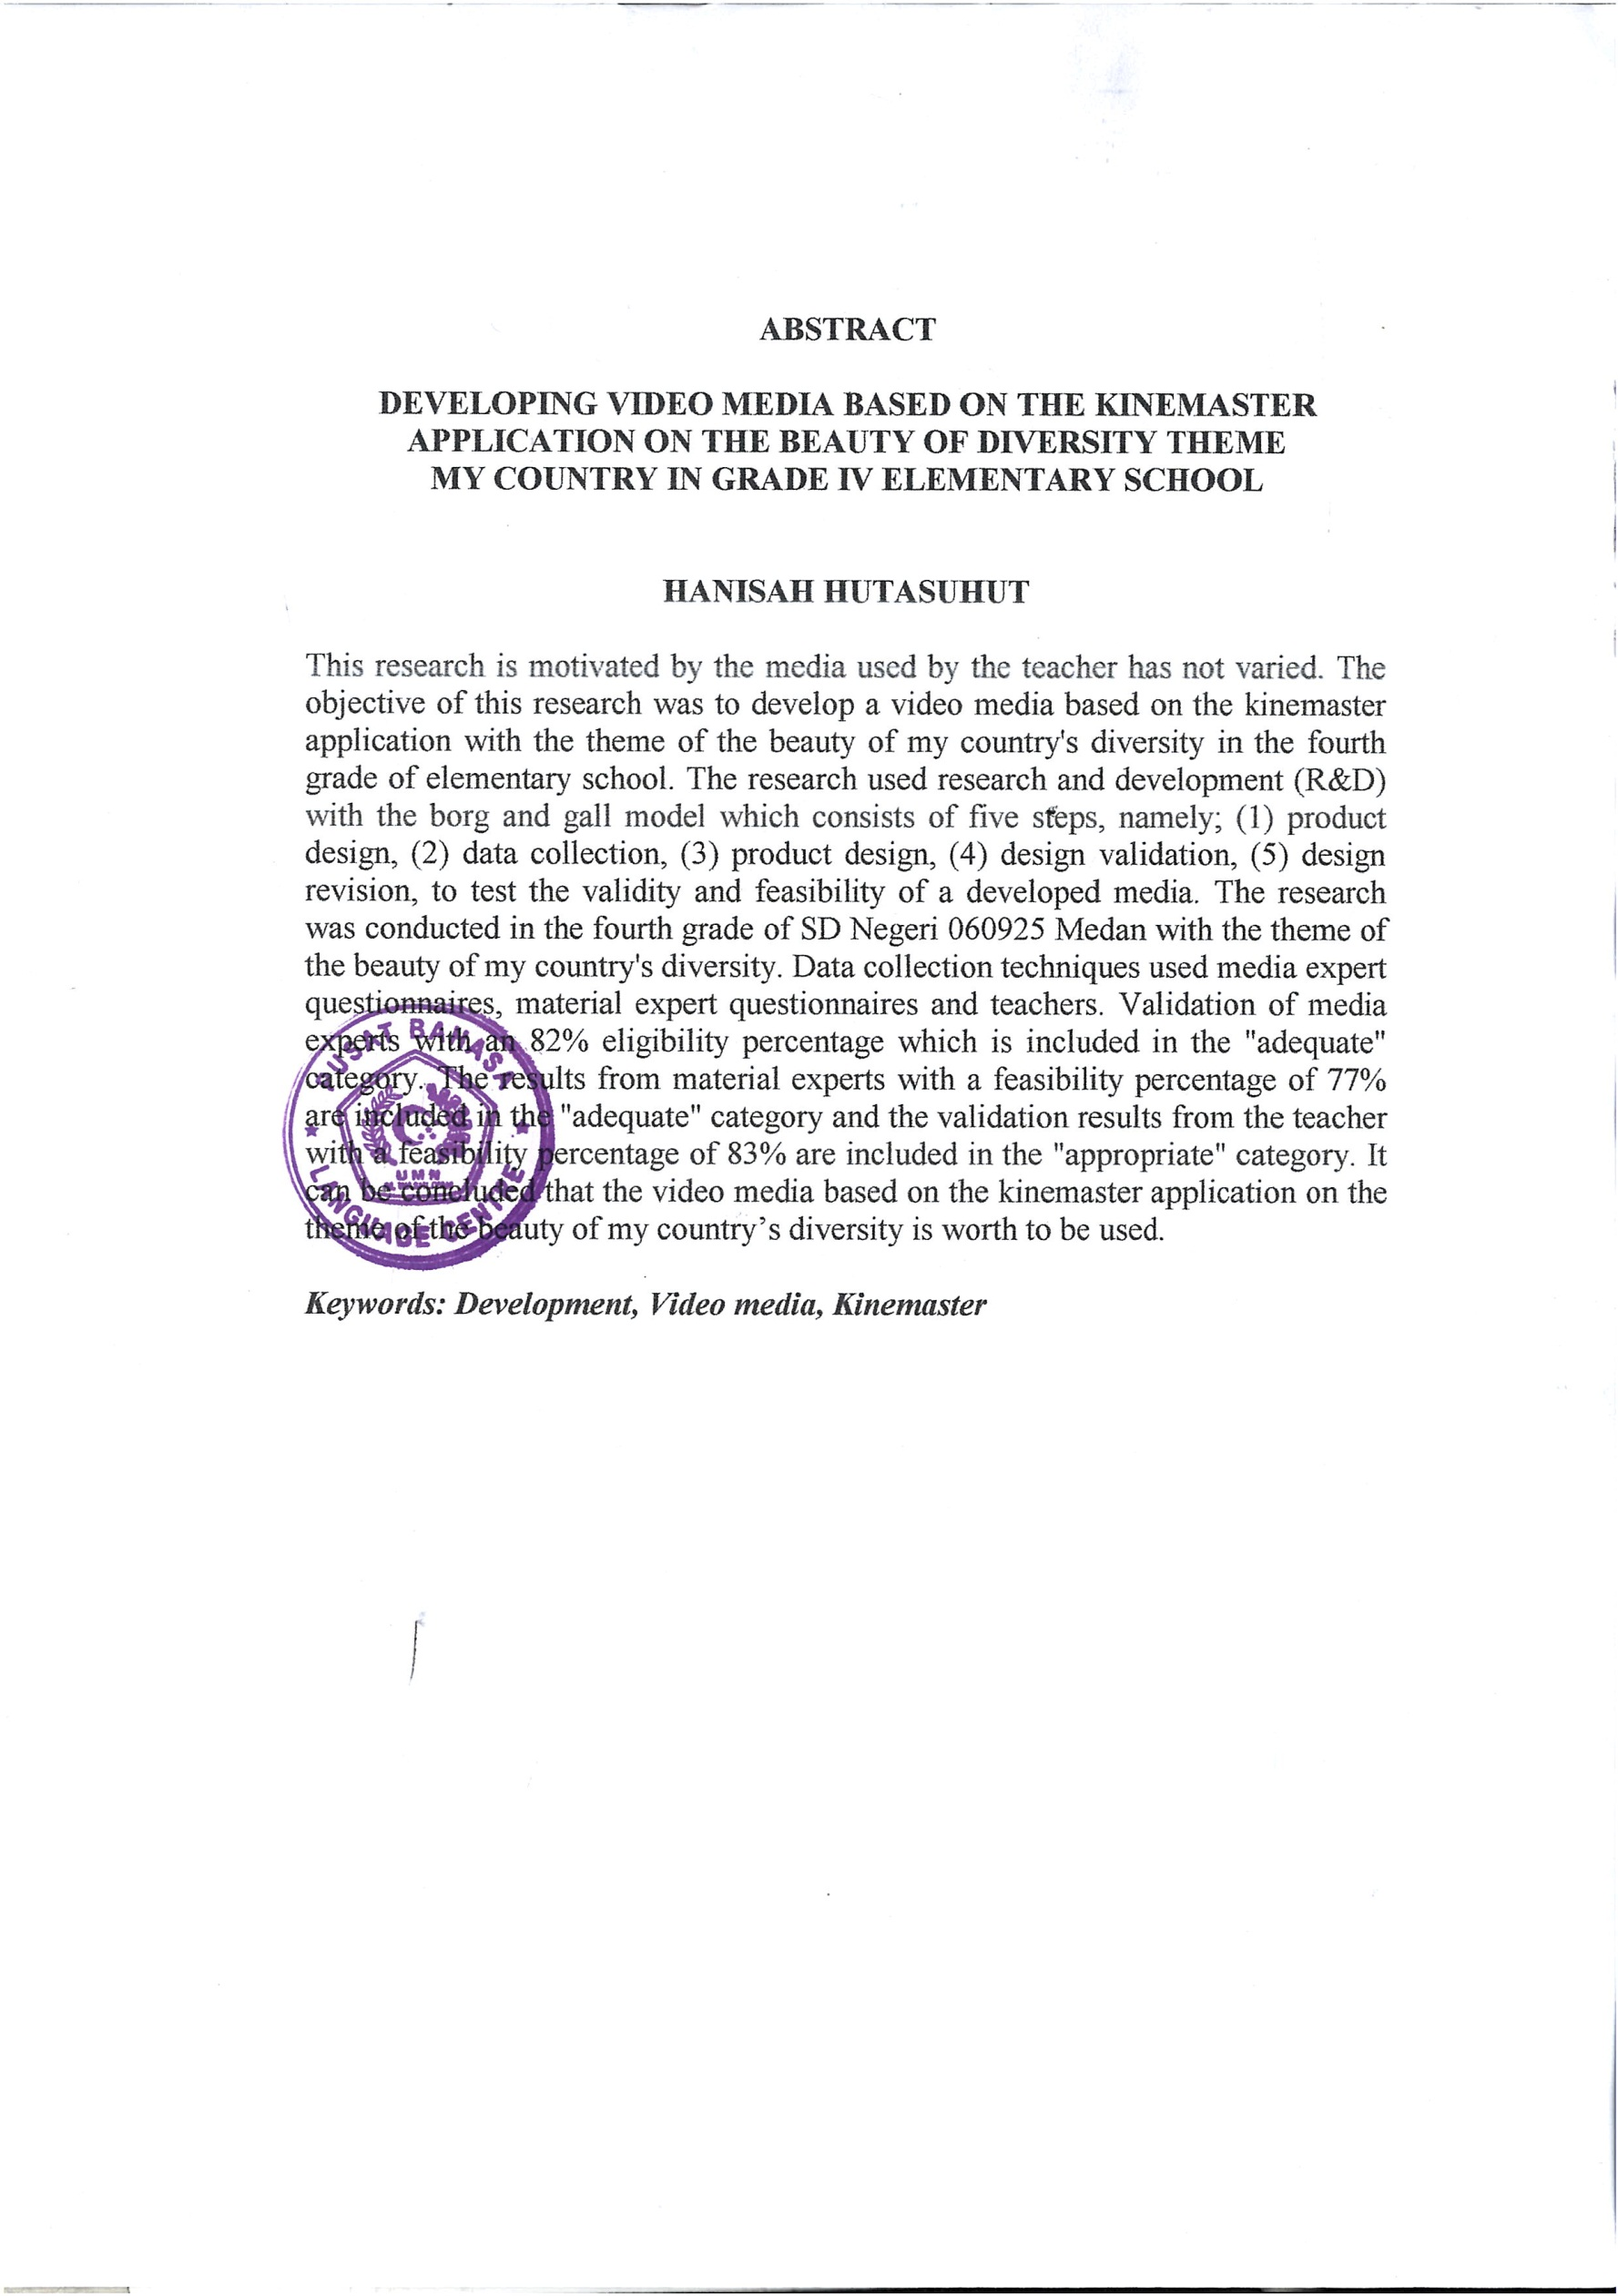
ABSTRACT

THE DEVELOPMENT OF VIDEO MEDIA BASED ON KINEMASTER APPLICATION TOWARD THE BEAUTY OF DIVERSITY OF
MY COUNTY IN CLASS IV SD

HANISAH HUTASUHUT

This research was background by the media used by the teacher had not varied. This study aims to develop a video media based on the Kinemaster application with the theme of the beauty of my country's diversity in the fourth grade of elementary school. The research used research and development (R&D) with the Borg and gall model which consists of five steps, namely; (1) potential and problems, (2) collection data, (3) design product, (4) design validation, (5) design revision, to test the validity and feasibility of a developed media. The research was conducted in the fourth grade of SD Negeri 060925 Medan with the theme of the beauty of my country's diversity. The technique of collected data used a media expert questionnaire, a material expert questionnaire and a teacher. Validation of media was expert with an 82% eligibility percentage which was included in the "adequate" category. The resulted from material experts with a feasibility percentage of 77% were included in the "adequate" category and the validation results from the teacher with a feasibility percentage of 83% are included in the "appropriate" category. It could be concluded that the video media based on the Kinemaster application on the theme of the beauty of my country's diversity was worth using.

Keyword: Development, Video Media, Kinemaster

