Lampiran 1. Surat Determinasi

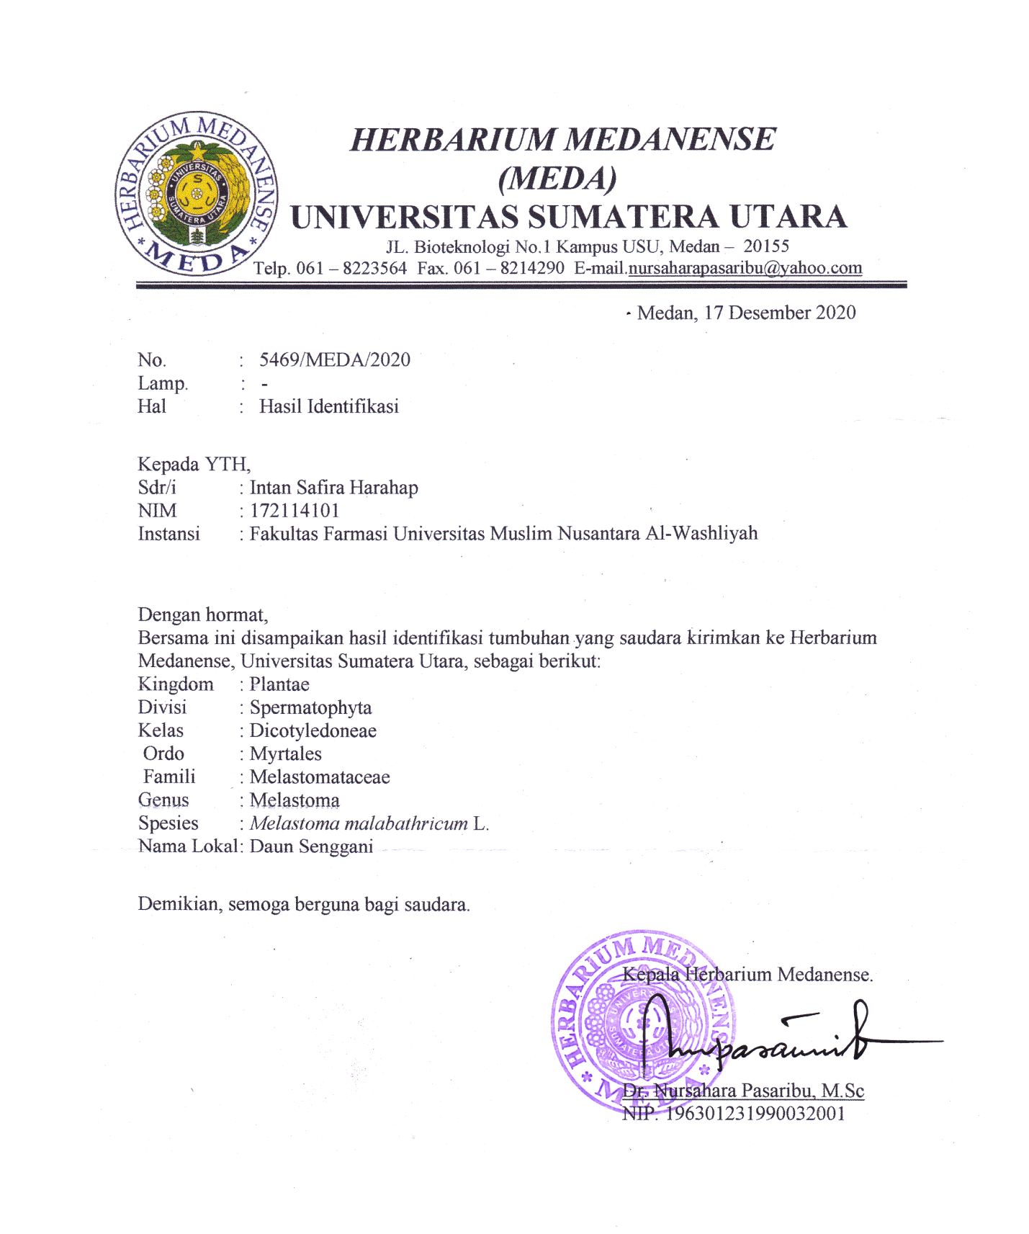

Lampiran 2. Etichal Clearance

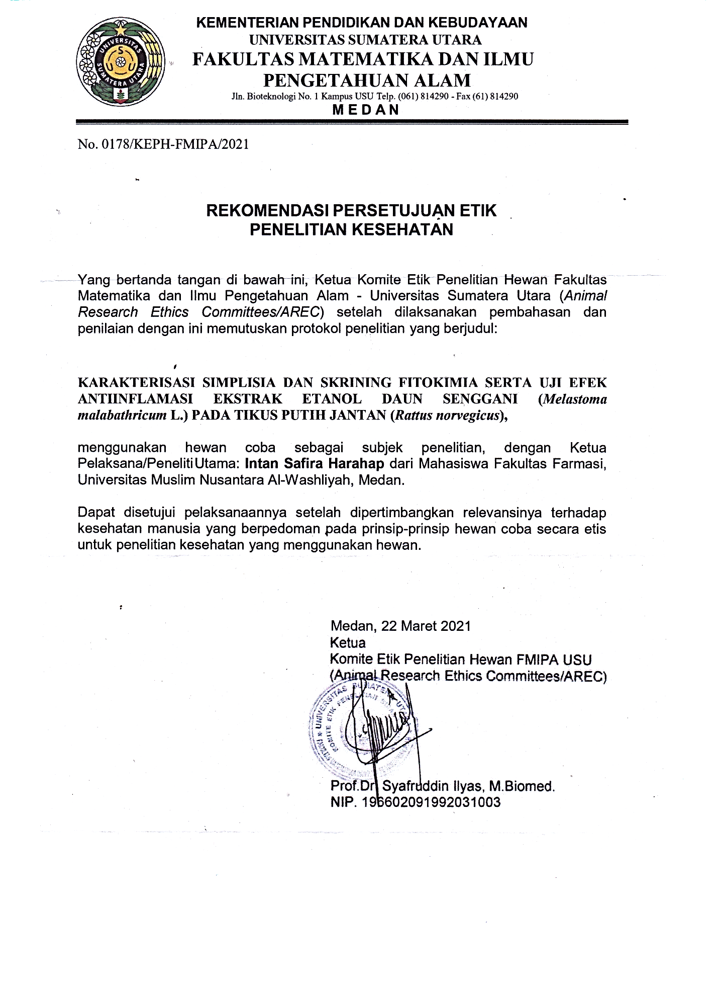

Lampiran 3. Simplisia Daun Senggani, Serbuk Daun Senggani, Ekstrak Etanol Daun Senggani

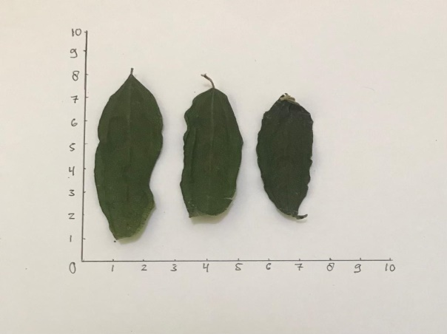
a. Simplisia Daun Senggani (Melastoma Folium)

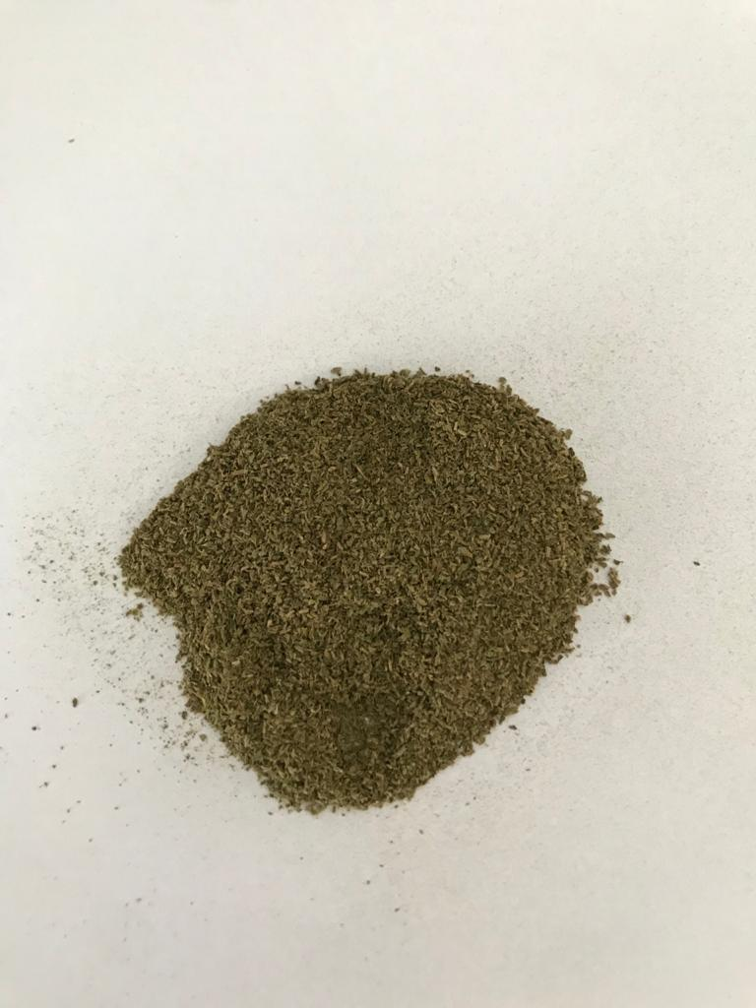
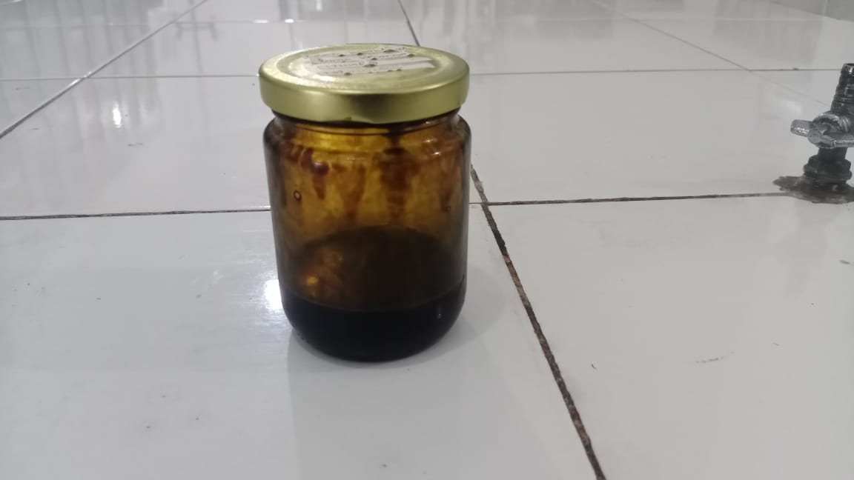

c. Serbuk Simplisia Daun Senggani d. Ekstrak Etanol Daun Senggani

Lampiran 4. Rotary evaporator

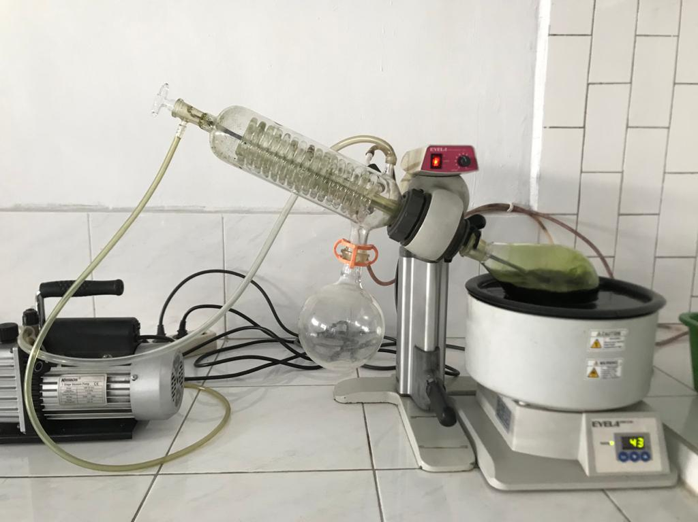

Lampiran 5. Proses Maserasi

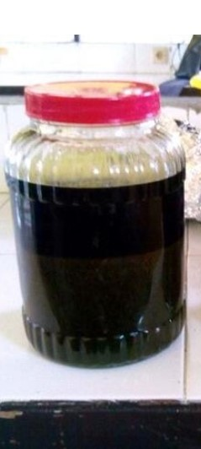

Lampiran 6. Hasil Skrining Fitokimia

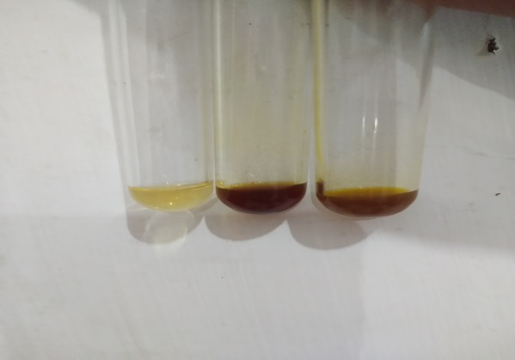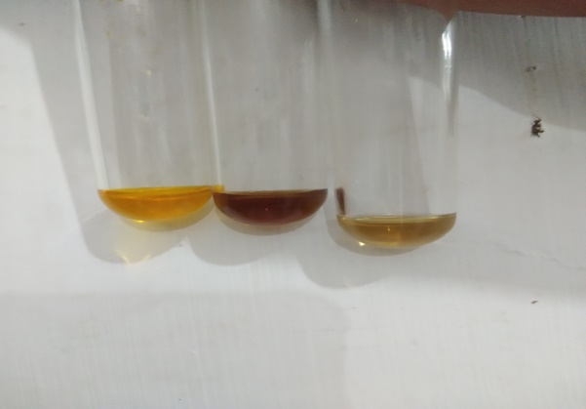
a. Hasil Skrining Alkaloid Serbuk Simplisia b. Hasil Skrining Alkaloid Ekstrak Etanol Daun Senggani Daun Senggani

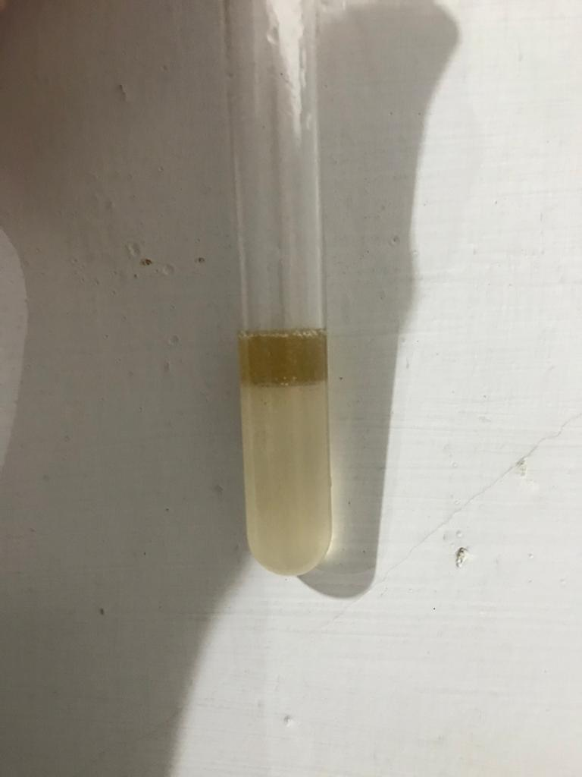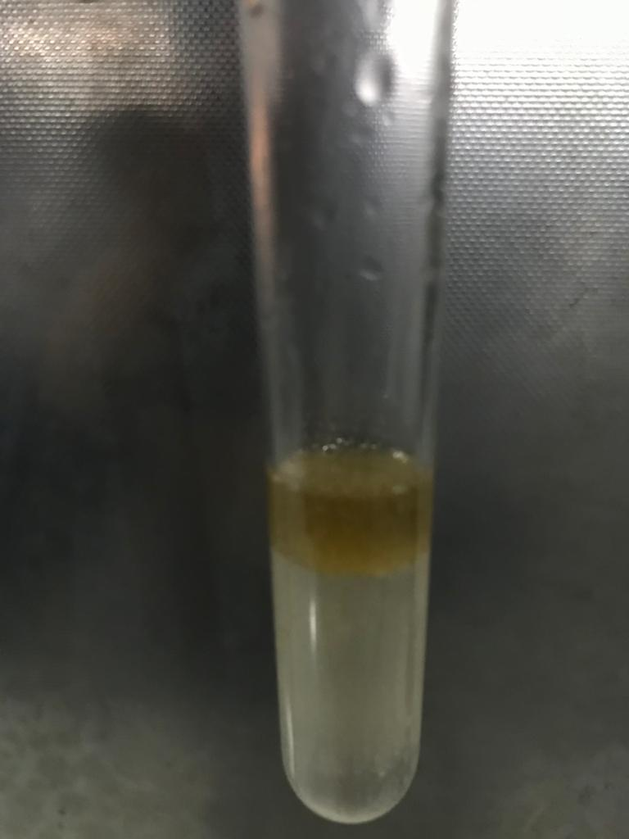

c. Hasil Skrining Flavonoid Serbuk Simplisia d. Hasil Skrining Flavonoid Ekstrak Etanol Daun Senggani Daun Senggani

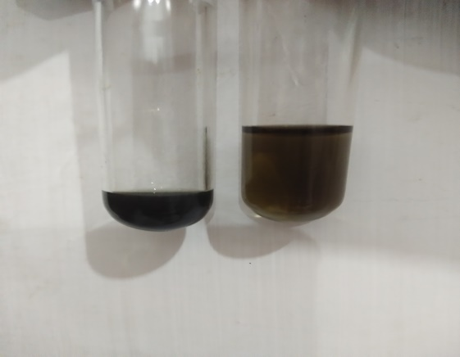
h. Hasil Skrining Tanin Serbuk Simplisia
Dan Ekstrak Etanol Daun Senggani

Lampiran 6. Lanjutan

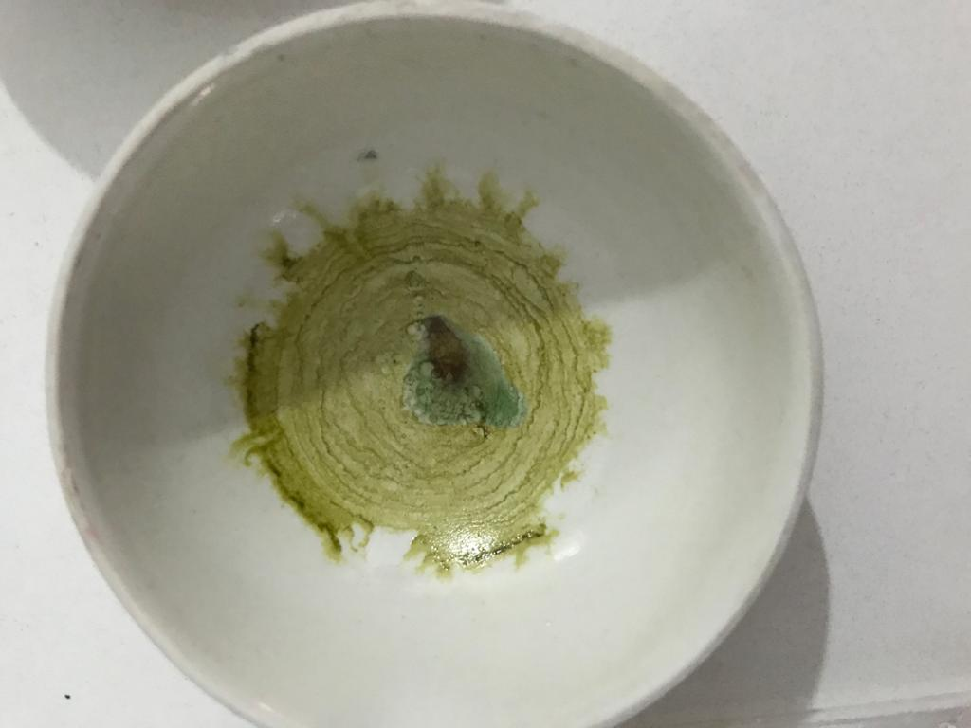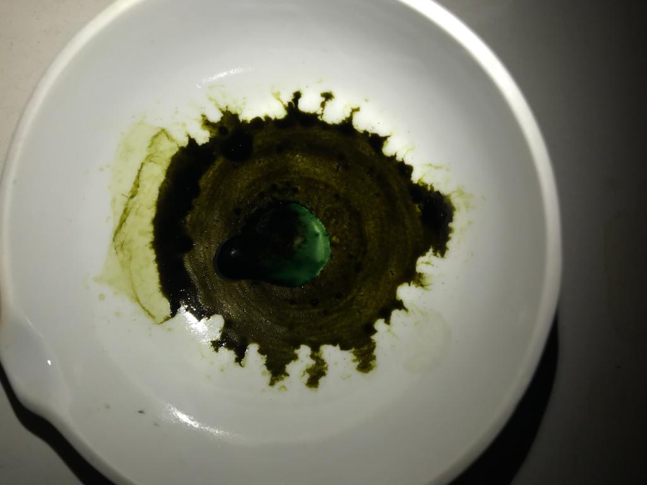

i. Hasil Skrining Steroid/Triterpenoid Serbuk j. Hasil Skrining Steroid/Triterpenoid Ekstrak Simplisia Daun Senggani Etanol daun Senggani

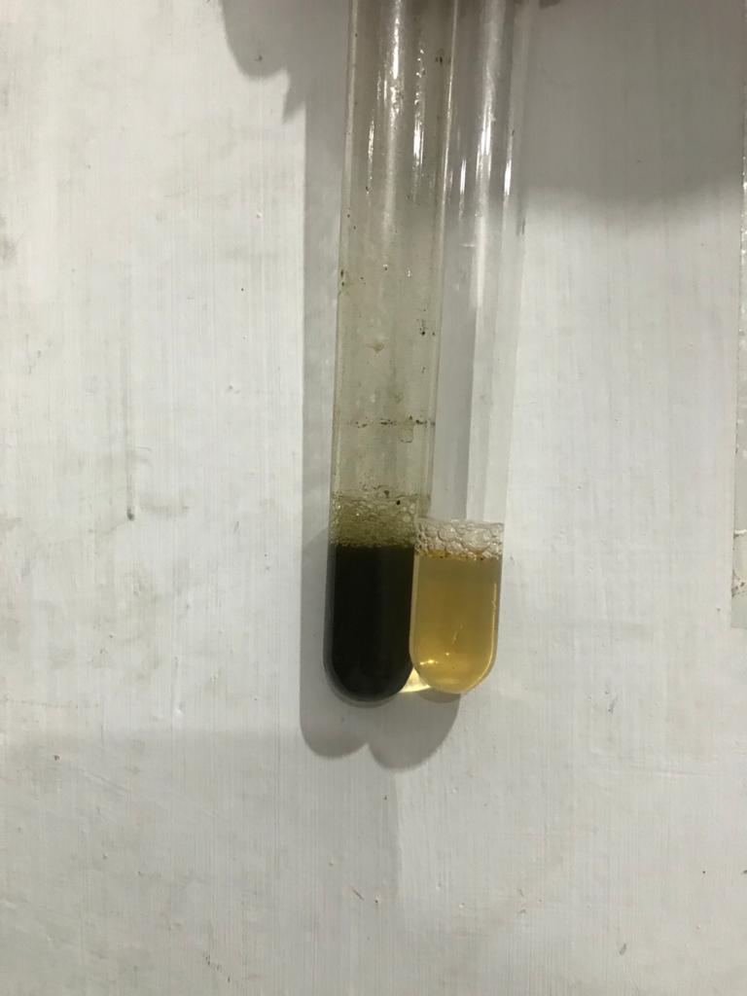

k. Hasil Skrining Saponin Serbuk Simplisia Dan
Ekstrak Etanol Daun Senggani

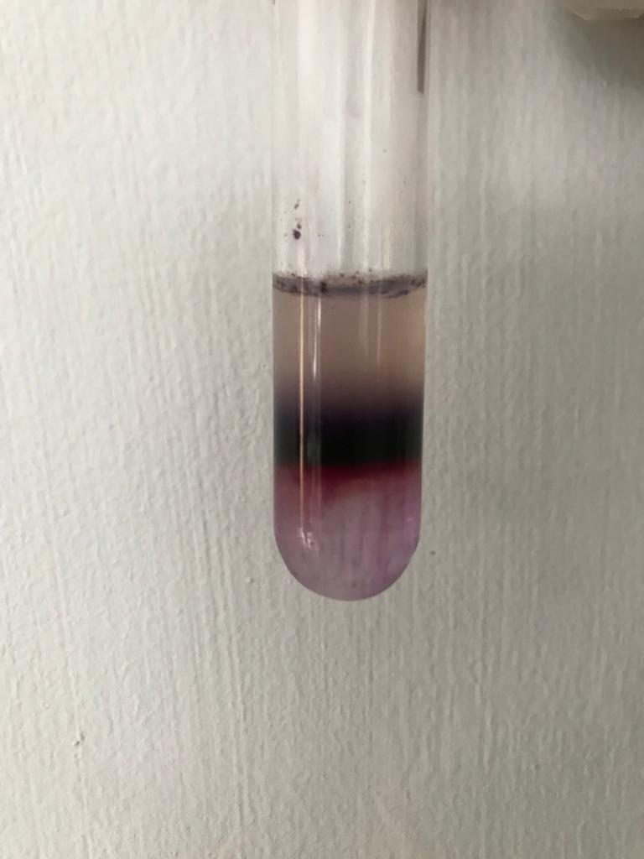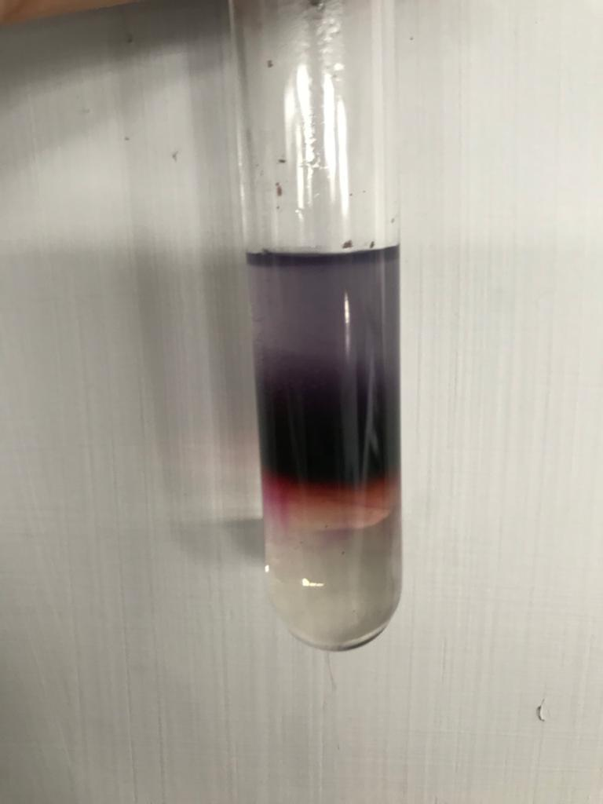
l. Hasil Skrining Glikosida Serbuk Simplisia m. Hasil Skrining Glikosida Ekstrak Etanol
Daun Senggani Daun Senggani
Lampiran 7. Mikroskopik Daun Senggani (Melastoma malabathricum L.)

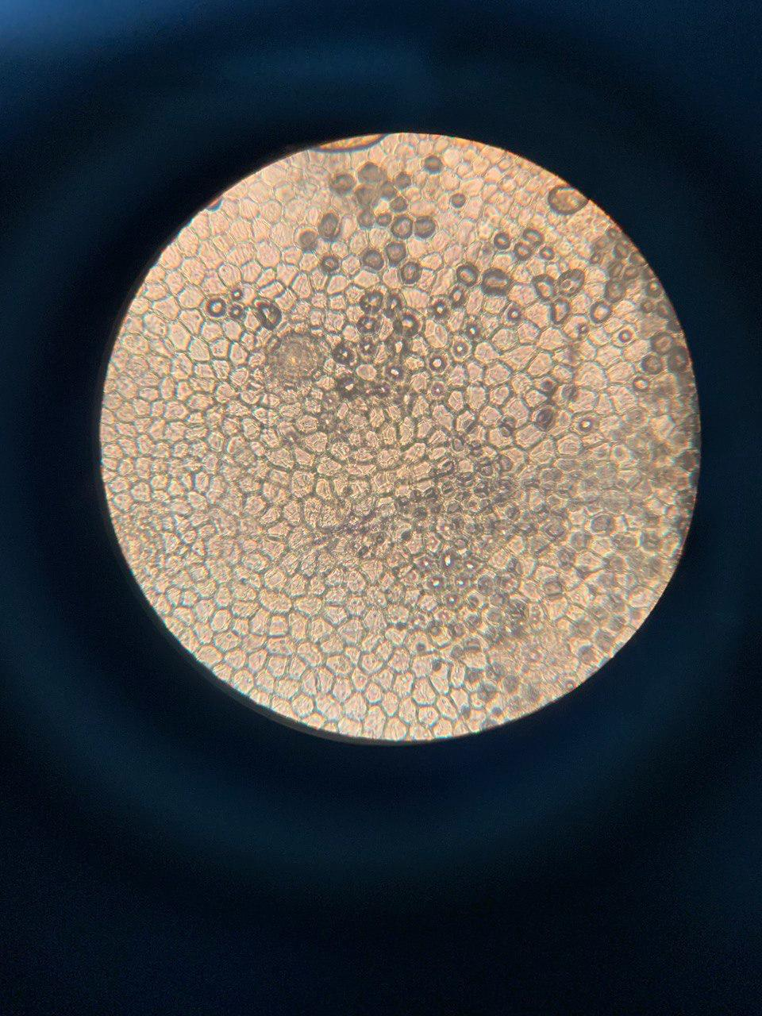
1

Keterangan: 1. Stoma anomositik

Lampiran 8. Proses Pemberian Perlakuan

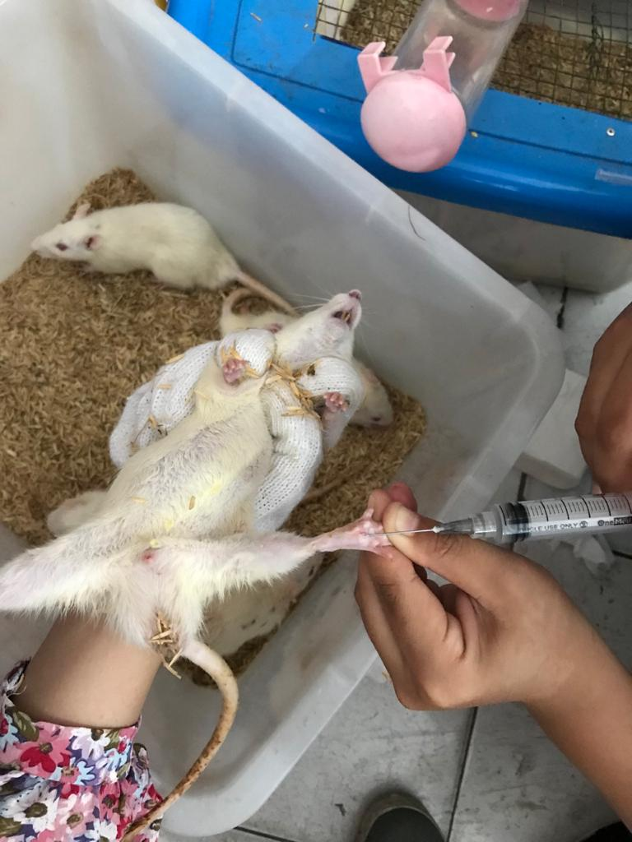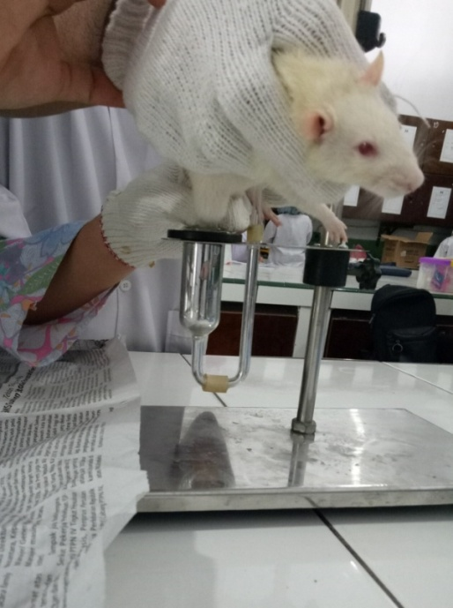

a. Penyuntikan kaki tikus secara intraplantar b. Pengukuran inflamasi dengan pletismometer

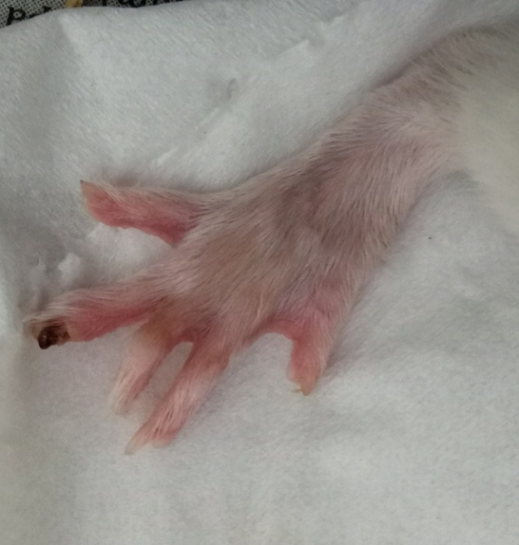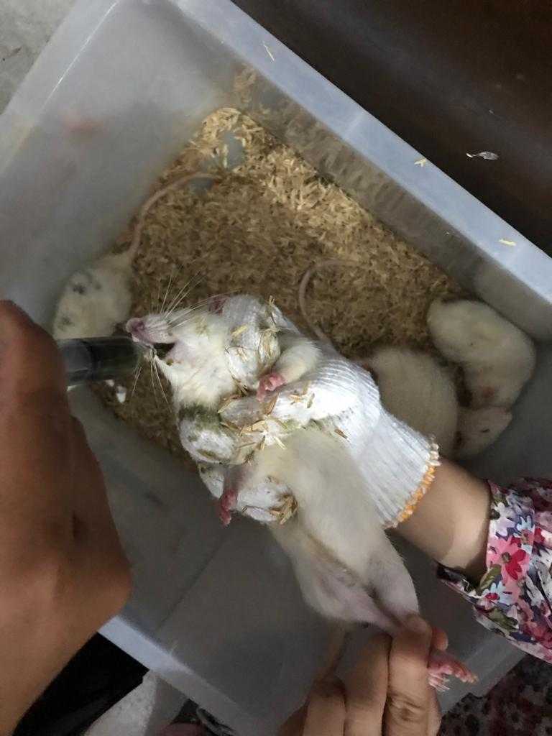

c. Kaki tikus setelah radang d. Pemberian obat secara oral

Lampiran 9. Bagan Alir Prosedur Kerja
Pengumpulan sampel Daun Senggani

Disortasi basah
Daun Senggani 10 Kg
Di cuci dengan air mengalir
Ditimbang
Ditiriskan
Daun Senggani
Dikeringkan Dalam Lemari Pengeringan pada suhu ± 40⁰C
Disortasi Kering
Ditimbang kembali
Berat kering simplisia daun senggani 7 Kg
Dihaluskan menggunakan blender
Disimpan dalam wadah tertutup rapat

Serbuk Simplisia daun senggani 500 gram
Karakterisasi simplisia

Lampiran 10. Bagan Alir Karakerisasi Simplisia Daun Senggani

Simplisia
Pemeriksaan makroskopik simplisia
Dihaluskan
Serbuk simplisia daun senggani (Melastoma malabathricum L.)

Karakterisasi Simplisia

Parameter non spesifik
Parameter spesifik

Mikroskopik serbuk simplisia

- -
- - Kadar air
- - Kadar sari larut air
- - Kadar sari larutetanol
- - Kadar abu total
- - Kadar abu tidak larut asam

Lampiran 11. Bagan Alir Pembuatan Ekstrak Daun Senggani

Serbuk Simplisia 500g
Dimasukan dalam bejana
Dituangkan dengan 75 bagian etanol 96%
Ditutup dan dibiarkan selama 5 hari sambil diaduk-aduk sesekali

Setelah 5 hari maserat diserkai dan ampasnya diperas

Maserat I
Ampas
Dicuci dengan 25 bagian etanol 96%

Disaring dan ampasnya diperas

Maserat II

Dimasukan kedalam bejana tertutup, dibiarkan selama 2 hari
Maserat I + Maserat II

Dipekatkan dengan Rotary Evaporator
Ekstrak etanol kental 96 g

Lampiran 12. Bagan Alir Penelitian
Tikus jantan 25 ekor

Induksi dengan karagenan 2%

Dibagi menjadi 5/kelompok

EEDS 300mg/kgBB
Kontrol Negatif

Kontrol positif
EEDS 100 mg/kgBB
EEDS 200 mg/kgBB

Pengamatan Selama 6 Jam
Analisis Data

Lampiran 13. Tabel Maksimum Larutan Sediaan Uji Untuk Hewan
Volume maksimum larutan uji yang dapat diberikan pada beberapa hewan uji (Ritschel, 1974).

Jenis Hewan Uji | Volume Maksimum (ml) Selesai Jalur Pemberian  i.v i.m i.p s.c p.o
Mencit 20-30 g | 0,5 0,05 1,0 0,5-1,0 1,0
Tikus 200 g | 1,0 0,1 2-5 2-5 5,0
Hamster 50 g | - 0,1 1-2 2-5 2,5
Marmut 250 g | - 0,25 2-5 2,5 2,5
Kelinci 2,5 Kg | 5-10 0,5 10-20 5-10 20,0
Kucing 3 Kg | 5-10 1,0 10-20 5-10 50,0
Anjing 5 Kg | 10-20 5,0 20-50 10,0 100,0

Lampiran 14. Tabel Konversi Dosis Hewan dengan Manusia
Konversi dosis antara jenis hewan dengan manusia (Laurence dan Bacharach, 1964).

 | Mencit  20 g | Tikus  200 g | Marmut  400 g | Kelinci 1,2 Kg | Kera  4 Kg | Anjing 12 Kg | Manusia 70 Kg
Mencit 20 g | 1,0 | 7,0 | 12, 25 | 27,8 | 64,1 | 124,2 | 387,9
Tikus 200 g | 0,14 | 1,0 | 1,74 | 3,9 | 9,2 | 17,8 | 56,0
Marmut 400 g | 0,08 | 0,57 | 1,0 | 2,25 | 5,2 | 10,2 | 31,5
Kelinci 1,2 Kg | 0,04 | 0,25 | 0,44 | 1,0 | 2,4 | 4,5 | 14,2
Kera  4 Kg | 0,016 | 0,11 | 0,19 | 0,42 | 1,0 | 1,9 | 6,1
Anjing 12 Kg | 0,008 | 0,06 | 0,10 | 0,22 | 0,52 | 1,0 | 3,1
Manusia 70 Kg | 0,0026 | 0,018 | 0,031 | 0,07 | 0,16 | 0,32 | 1,0

Lampiran 15. Data Karakterisasi Serbuk Simplisia Daun Senggani
- Perhitungan Hasil Penetapan Kadar Air (≤10%)
Kadar Air = $\frac{volume II-volume I}{berat sampel}$ x 100%

Sampel I
Berat sampel : 5,00 g
Volume I : 1,30 ml
Volume II : 1,60 ml
Kadar air = $\frac{1,60 ml-1,30 ml}{5,00 g}$x 100%
= $\frac{0,30 ml}{5,00 g}$ x 100% = 6,00 %
Sampel II
Berat sampel : 5,00 g
Volume I : 0,90 ml
Volume II : 1,40 ml
Kadar air = $\frac{1,40 ml-0,90 ml}{5,00 g}$ x 100%
= $\frac{0,50 ml}{5,00 g}$ x 100% = 10,00 %
Sampel III
Berat sampel : 5,00 g
Volume I : 0,60 ml
Volume II : 0,10 ml
Kadar air = $\frac{0,10 ml-0,60 ml}{5,00 g}$ x 100%
= $\frac{0,40 ml}{5,00 g}$ x 100% = 8,00 %
Lampiran 15. Lanjutan
Kadar air rata-rata = $\frac{6,00 \%+10,00 \%+8,00 \%}{3}$ = 8,00 %
Kadar air pada daun senggani memenuhi syarat yaitu 8%, tidak lebih dari 10%

- Perhitungan kadar sari yang larut dalam air (≥ 7%)
Kadar sari larut air = $\frac{\left(Berat cawan berisi-Berat cawan kosong\right)x pengenceran}{berat sampel}$ x 100%

Sampel I
Berat sampel : 5,00 g
Berat cawan kosong : 67,90 g
Berat cawan + sampel : 68,60 g
= $\frac{\left(68,60 g-67,90 g\right)x5 }{5,00 g}$ x 100%
= $\frac{3,50 g}{5,00 g}$ x 100% = 70,00%
Sampel II
Berat sampel : 5,00 g
Berat cawan kosong : 65,00 g
Berat cawan + sampel : 65,30 g
= $\frac{\left(65,30 g-65,00 g\right)x 5}{5,00 g}$ x 100%
= $\frac{1,50 g}{5,00 g}$ x 100% = 30,00%
Sampel III
Berat sampel : 5,00 g
Lampiran 15. Lanjutan
Berat cawan kosong : 66,20 g
Berat cawan + sampel : 66,40 g
= $\frac{\left(66,40 g-66,20 g\right)x 5}{5,00 g}$ x 100%
= $\frac{1,00 g}{5,00 g}$ x 100% = 20,00%
Kadar sari larut dalam air rata-rata = $\frac{70,00\%+30,00\%+20,00\%}{3}$ = 40,00%
Kadar sari larut dalam air pada daun senggani memenuhi syarat yaitu 40% tidak kurang dari 7%
- Perhitungan kadar sari larut dalam etanol (≥3%)
Kadar sari larut etanol= $\frac{\left(Berat cawan berisi-Berat cawan kosong\right)x pengenceran}{berat sampel}$ x 100%

Sampel I
Berat sampel : 5,00 g
Berat cawan kosong : 123,70 g
Berat cawan + sampel : 123,35 g
= $\frac{\left(123.35 g-123,70 g\right)x 5}{5,00 g}$ x 100%
= $\frac{0,40 g}{5,00 g}$ x 100% = 8,00%
Sampel II
Berat sampel : 5,00 g
Berat cawan kosong : 125,62 g
Berat cawan + sampel : 125,74 g
Lampiran 15. Lanjutan
= $\frac{\left(125,74 g-125,62 g\right)x 5}{5,00 g}$ x 100%
= $\frac{0,60 g}{5,00 g }$ x 100% = 12,00%
Sampel III
Berat sampel : 5,00 g
Berat cawan kosong : 127,12 g
Berat cawan + sampel : 127,15 g
= $\frac{\left(127,15 g-127,12 g\right)x 5}{5,00 g}$ x 100%
= $\frac{0,15 g}{5,00 g}$ x 100% = 3,00%
Kadar sari larut dalam etanol rata-rata = $\frac{8,00\%+12,00\%+3,00\%}{3}$ = 7,60%
Kadar sari larut dalam etanol pada daun senggani memenuhi syarat yaitu 7,60% tidak kurang dari 3%
- Perhitungan kadar abu (≤15%)
Kadar abu = $\frac{berat cawan berisi-berat cawan kosong}{berat sampel}$ x 100%

Sampel I
Berat sampel : 2,00 g
Berat cawan kosong : 122,63 g
Berat cawan + sampel : 122,77 g
= $\frac{122,77 g-122,63 g}{2,00 g}$ x 100%
Lampiran 15. Lanjutan
= $\frac{0,14 g}{2,00 g}$ x 100% = 7,00%
Sampel II
Berat sampel : 2,00 g
Berat cawan kosong : 121,17 g
Berat cawan + sampel : 121, 29 g
= $\frac{121,29 g-121,17 g}{2,00 g}$ x 100%
= $\frac{0,12 g}{2,00 g}$ x 100% = 6,00%
Sampel III
Berat sampel : 2,00 g
Berat cawan kosong : 127,20 g
Berat cawan + sampel : 127,36 g
= $\frac{127,36 g-127,20 g}{2,00 g}$ x100%
= $\frac{0,16 g}{2,00 g}$ x 100% = 8,00%
Kadar abu total rata-rata = $\frac{7,00\%+6,00\%+8,00\%}{3}$ = 7,00%
Kadar abu total pada daun senggani memenuhi syarat yaitu 7% tidak lebih dari 15%
- Perhitungan kadar abu tidak larut dalam asam ($≤$ 1%)
Kadar abu = $\frac{berat cawan berisi-berat cawan kosong}{berat sampel}$ x 100%

Sampel I
Lampiran 15. Lanjutan
Berat sampel : 2,00 g
Berat cawan kosong : 122,63 g
Berat cawan + sampel : 122,77 g
= $\frac{122,77 g-122,63 g}{2,00 g}$ x 100%
= $\frac{0,01 g}{2,00 g}$ x 100% = 0,50%
Sampel II
Berat sampel : 2,00 g
Berat cawan kosong : 121,17 g
Berat cawan + sampel : 121,19 g
= $\frac{121,19 g-121,17 g}{2,00 g}$ x 100%
= $\frac{0,02 g}{2,00 g}$ x 100% = 1,00%
Sampel III
Berat sampel : 2,00 g
Berat cawan kosong : 127,20 g
Berat cawan + sampel : 127,21 g
= $\frac{127,21 g-127,20 g}{2,00 g}$ x 100%
= $\frac{0,01 g}{2,00 g}$ x 100% = 0,50%
Kadar abu tidak larut dalam asam rata-rata = $\frac{0,50\%+1,00\%+0,50\%}{3}$ = 0,60%
Kadar abu tidak larut dalam asam pada daun senggani memenuhi syarat yaitu 0,60% tidak lebih dari 1%
Lampiran 16. Perhitungan Dosis
1. Perhitungan Dosis Suspensi Na-CMC 0,5%
Kontrol Negatif CMC (0,5 g ) dalam 100 ml
Berat = 200 g
= $\frac{200}{100}$ x 0.5%
= 1,00 ml
2.Perhitungan Dosis suspensi Na diklofenak
Kontrol Positif (Na diklofenak 25 mg) dalam 100 ml
Konversi dosis pada tikus = 0,018
Dosis = 25 mg x 0,018 = 0,45 mg / 0,2 kg = 2,25 mg/kgBB
Berat = 170 g
= $\frac{2,25}{1000}$x 170
= 0,3825
= $\frac{0,3825}{0,25}$
= 1,53 ml
3. Perhitungan dosis suspense ekstrak etanol daun senggani 100 mg/kgBB
Berat = 200 g
= $\frac{100}{1000}$x 200
= 20 mg
Konsentrasi 2 % = 20 mg/ml
Pemerian = $\frac{20}{20}$ = 1 ml
4. Perhitungan dosis suspense ekstrak etanol daun senggani 200 mg/kgBB
Berat = 180 g

Lampiran 16. Lanjutan
= $\frac{100}{1000}$x 180
= 36 mg
Konsentrasi 2 % = 20 mg/ml
Pemerian = $\frac{36}{20}$ = 1,80 ml
5. Perhitungan dosis suspense ekstrak etanol daun senggani 300 mg/kgBB
Berat = 175 g
= $\frac{100}{1000}$x 175
= 52,50 mg
Konsentrasi 2 % = 20 mg/ml
Pemerian = $\frac{52,5}{20}$ = 2,60 ml

Lampiran 17. Data Hewan Uji Setiap Perlakuan
Perlakuan | V₀ | 60 menit |  | 120 menit |  | 180 menit |  | 240 menit |  | 300 menit |  | 360 menit
 |  | V1 | % Radang | V2 | % Radang | V3 | % Radang | V4 | % Radang | V5 | % Radang | V6 | % Radang
CMC 0,5% | 0,050  0,050  0,060  0,050  0,060 | 0,091  0,093  0,089  0,095  0,097 | 82  86  48,333  90  61,667 | 0,094  0,097  0,095  0,099  0,097 | 88  94  58,333  98  61,667 | 0,092  0,094  0,091  0,095  0,092 | 84  88  51,667  90  53,333 | 0,084  0,088  0,085  0,089  0,088 | 68  76  41,667  78  46,667 | 0,082  0,084  0,079  0,083  0,080 | 64  68  31,667  66  33,333 | 0,071  0,072  0,075  0,073  0,078 | 42  44  25  46  30
Rata-rata |  |  | 73,6 |  | 80 |  | 73,4 |  | 62,066 |  | 52,6 |  | 37,4
Na Diklofenak | 0,050  0,070  0,060  0,070  0,060 | 0,090  0,096  0,094  0,095  0,094 | 80  37,142  58,333  35,714  56,667 | 0,094  0,097  0,094  0,098  0,099 | 88  38,571  56,667  40  65 | 0,087  0,089  0,089  0,090  0,092 | 74  27,142  48,333  28.571  53,333 | 0,074  0,079  0,081  0,087  0,085 | 48  12.857  35  24,286  41,667 | 0,066  0,077  0,073  0,078  0,076 | 32  10  21,667  11,428  26,667 | 0,054  0,072  0,071  0,063  0,062 | 8  2,857  8,333  4,286  3,333
Rata-rata |  |  | 53,671 |  | 57,647 |  | 46,275 |  | 32,362 |  | 20,350 |  | 5,362
EEDS 100 | 0,050  0,050  0,060  0,050  0,060 | 0,087  0,085  0,091  0,090  0,092 | 74  70  51,666  80  53.333 | 0,094  0,095  0,097  0,096  0,098 | 88  90  61,667  92  63.333 | 0,089  0,090  0,093  0,092  0,094 | 78  80  55  84  56,667 | 0,084  0,082  0,086  0,087  0,090 | 68  64  43.333  74  50 | 0,076  0,075  0,080  0,077  0,087 | 52  50  33,333  54  45 | 0,071  0,070  0,073  0,072  0,075 | 42  40  21.667  44  25
Rata-rata |  |  | 65,799 |  | 79 |  | 70,733 |  | 59,86 |  | 46,86 |  | 34,533
EEDS 200 | 0,060  0,060  0,050  0,050  0,060 | 0,091  0,090  0,086  0,085  0,089 | 51,667  50  72  70  48 | 0,097  0,096  0,093  0,090  0,095 | 61.667  60  86  80  58.333 | 0,094  0,093  0,091  0,088  0,093 | 56,667  55  82  76  55 | 0,087  0,084  0,083  0,084  0,086 | 45  40  66  68  43.333 | 0,076  0,073  0,074  0,075  0,075 | 26.667  21,667  48  50  25 | 0,067  0,064  0,070  0,065  0,070 | 11.666  6,666  40  30  16,667
Rata-rata |  |  | 58,333 |  | 69,2 |  | 64,93 |  | 52,466 |  | 34,26 |  | 20,999  6,667  10  12  14  8,333
EEDS 300 | 0,060  0,050  0,050  0,050  0,060 | 0,088  0,086  0,087  0,087  0,089 | 46,667  72  74  74  48,333 | 0,094  0,092  0,095  0,093  0,096 | 56,667  84  90  86  60 | 0,086  0,083  0,088  0,082  0,088 | 43,333  66  76  64  46,667 | 0,079  0,076  0,080  0,075  0,081 | 31,667  52  60  50  35 | 0,070  0,067  0,069  0,066  0,072 | 16.667  34  38  32  20 | 0,064  0,055  0,056  0,057  0,062
Rata-rata |  |  | 63 |  | 75,333 |  | 59,2 |  | 45,733 |  | 28,133 |  | 10,2
Lanjutan

Lampiran 18. Perhitungan SPSS Versi 16,0
Tests of Normality
 | Perlakuan |  | Kolmogorov-Smirnovª |  |  |  |  | Shapiro-Wilk
 |  |  | Statistic | df |  | Sig. |  | Statistic | df |  | Sig.
VO | Kontrol negatif |  | .367 | 5 |  | .026 |  | .984 | 5 |  | .626
 | EEDS 300 |  | .231 | 5 |  | .200* |  | .881 | 5 |  | .314
 | EEDS 100 |  | .367 | 5 |  | .026 |  | .984 | 5 |  | .506
 | EEDS 200 |  | .367 | 5 |  | .026 |  | .974 | 5 |  | .806
 | Kontrol positif |  | .367 | 5 |  | .026 |  | .954 | 5 |  | .116
60 MENIT | Kontrol negatif |  | .220 | 5 |  | .200* |  | .956 | 5 |  | .777
 | EEDS 300 |  | .241 | 5 |  | .200* |  | .903 | 5 |  | .427
 | EEDS 100 |  | .198 | 5 |  | .200* |  | .951 | 5 |  | .742
 | EEDS 200 |  | .323 | 5 |  | .096 |  | .840 | 5 |  | .166
 | Kontrol positif |  | .237 | 5 |  | .200* |  | .961 | 5 |  | .814
120 MENIT | Kontrol negatif |  | .198 | 5 |  | .200* |  | .957 | 5 |  | .787
 | EEDS 300 |  | .268 | 5 |  | .200* |  | .896 | 5 |  | .290
 | EEDS 100 |  | .136 | 5 |  | .200* |  | .987 | 5 |  | .967
 | EEDS 200 |  | .310 | 5 |  | .131 |  | .871 | 5 |  | .272
 | Kontrol positif |  | .136 | 5 |  | .200* |  | .987 | 5 |  | .967
180 MENIT | Kontrol negatif |  | .141 | 5 |  | .200* |  | .979 | 5 |  | .928
 | EEDS 400 |  | .136 | 5 |  | .200* |  | .987 | 5 |  | .967
 | EEDS 100 |  | .213 | 5 |  | .200* |  | .963 | 5 |  | .826
 | EEDS 200 |  | .221 | 5 |  | .200* |  | .915 | 5 |  | .501
 | Kontrol positif |  | .224 | 5 |  | .200* |  | .865 | 5 |  | .246
240 MENIT | Kontrol negatif |  | .180 | 5 |  | .200* |  | .952 | 5 |  | .754
 | EEDS 400 |  | .212 | 5 |  | .200* |  | .936 | 5 |  | .635
 | EEDS 100 |  | .166 | 5 |  | .200* |  | .989 | 5 |  | .977
 | EEDS 200 |  | .229 | 5 |  | .200* |  | .867 | 5 |  | .254
 | Kontrol positif |  | .221 | 5 |  | .200* |  | .915 | 5 |  | .501
300 MENIT | Kontrol negatif |  | .265 | 5 |  | .200* |  | .836 | 5 |  | .154
 | EEDS 300 |  | .207 | 5 |  | .200* |  | .921 | 5 |  | .535
 | EEDS 100 |  | .284 | 5 |  | .200* |  | .860 | 5 |  | .228
 | EEDS 200 |  | .159 | 5 |  | .200* |  | .990 | 5 |  | .980
 | Kontrol positif |  | .175 | 5 |  | .200* |  | .974 | 5 |  | .899
360 MENIT | Kontrol negatif |  | .237 | 5 |  | .200* |  | .961 | 5 |  | .814
 | EEDS 400 |  | .220 | 5 |  | .200* |  | .917 | 5 |  | .509
 | EEDS 100 |  | .254 | 5 |  | .200* |  | .914 | 5 |  | .492
 | EEDS 200 |  | .224 | 5 |  | .200* |  | .865 | 5 |  | .246
 | Kontrol positif |  | .180 | 5 |  | .200* |  | .952 | 5 |  | .754
*. This is a lower bound of the true significance.
Test of Homogeneity of Variances
 |  | Levene Statistic |  |  | df1 |  | df2 |  |  | Sig.
VO |  | .542 |  |  | 4 |  | 20 |  |  | .706
60 MENIT |  | 1.041 |  |  | 4 |  | 20 |  |  | .411
120 MENIT |  | .585 |  |  | 4 |  | 20 |  |  | .677
180 MENIT |  | 1.360 |  |  | 4 |  | 20 |  |  | .283
240 MENIT |  | 1.734 |  |  | 4 |  | 20 |  |  | .182
300 MENIT |  | .821 |  |  | 4 |  | 20 |  |  | .527
360 MENIT |  | .770 |  |  | 4 |  | 20 |  |  | .501

ANOVA
 |  | Sum of Squares | Df | Mean Square | F | Sig.
VO | Between Groups | .000 | 4 | .000 | 1.579 | .019
 | Within Groups | .001 | 20 | .000
 | Total | .001 | 24
60 MENIT | Between Groups | .000 | 4 | .000 | 6.524 | .002
 | Within Groups | .000 | 20 | .000
 | Total | .000 | 24
120 MENIT | Between Groups | .000 | 4 | .000 | 6.235 | .002
 | Within Groups | .000 | 20 | .000
 | Total | .000 | 24
180 MENIT | Between Groups | .000 | 4 | .000 | 13.612 | .000
 | Within Groups | .000 | 20 | .000
 | Total | .000 | 24
240 MENIT | Between Groups | .000 | 4 | .000 | 8.240 | .000
 | Within Groups | .000 | 20 | .000
 | Total | .000 | 24
300 MENIT | Between Groups | .001 | 4 | .000 | 11.037 | .000
 | Within Groups | .000 | 20 | .000
 | Total | .001 | 24
360 MENIT | Between Groups | .000 | 4 | .000 | 9.854 | .000
 | Within Groups | .000 | 20 | .000
 | Total | .001 | 24

VO
TukeyHSDª
Perlakuan | N | Subset for alpha = 0.05
 |  | 1
kontrol positif | 5 | .05400
EEDS 300 | 5 | .05400
EEDS 200 | 5 | .05400
EEDS 100 | 5 | .05600
Kontrol negative | 5 | .06200
Sig. |  | .279
Means for groups in homogeneous subsets are displayed.
a. Uses Harmonic Mean Sample Size = 5.000.

60 MENIT
TukeyHSDª
Perlakuan | N | Subset for alpha = 0.05
 |  | 1 | 2
Kontrol positif | 5 | .09180
EEDS 300 | 5 | .09400
EEDS 200 | 5 | .09640
EEDS 100 | 5 | .09700
Kontrol negative | 5 |  | .09720
Sig. |  | .473 | .148
Means for groups in homogeneous subsets are displayed.
a. Uses Harmonic Mean Sample Size = 5.000.

120 MENIT
TukeyHSDª
Perlakuan | N | Subset for alpha = 0.05
 |  | 1 | 2 | 3
Kontrol positif | 5 | .08740
EEDS 300 | 5 | .08840 | .08840
EEDS 200 | 5 | .08960 | .08960
EEDS 100 | 5 |  | .09260
Kontrol negative | 5 |  |  | .09440
Sig. |  | .662 | .111 | .054
Means for groups in homogeneous subsets are displayed.
a. Uses Harmonic Mean Sample Size = 5.000.

180 MENIT
TukeyHSDª
Perlakuan | N | Subset for alpha = 0.05
 |  | 1 | 2 | 3
Kontrol positif | 5 | .08540
EEDS 300 | 5 | .09000 | .09000
EEDS 200 | 5 | .09240 | .09240
EEDS 100 | 5 |  | .09380
Kontrol negative | 5 |  |  | .09420
Sig. |  | 1.000 | .082 | .695
Means for groups in homogeneous subsets are displayed.
a. Uses Harmonic Mean Sample Size = 5.000.

240 MENIT
TukeyHSDª
Perlakuan | N | Subset for alpha = 0.05
 |  | 1 | 2 | 3
Kontrol positif | 5 | .07820
EEDS 300 | 5 | .08200 | .08200
EEDS 200 | 5 | .08560 | .08560
EEDS 100 | 5 | .08600 | .08600
Kontrol negative | 5 |  |  | .08760
Sig. |  | .283 | .239 | .817
Means for groups in homogeneous subsets are displayed.
a. Uses Harmonic Mean Sample Size = 5.000.

300 MENIT
TukeyHSDª
Perlakuan | N | Subset for alpha = 0.05
 |  | 1 | 2 | 3 | 4
Kontrol positif | 5 | .06880
EEDS 300 | 5 | .07340 | .07340
EEDS 200 | 5 |  | .07480 | .07480
EEDS 100 | 5 |  |  | .07980
Kontrol negative | 5 |  |  |  | .08200
Sig. |  | .054 | .093 | .065 | .859
Means for groups in homogeneous subsets are displayed.
a. Uses Harmonic Mean Sample Size = 5.000.

360 MENIT
TukeyHSDª
Perlakuan | N | Subset for alpha = 0.05
 |  | 1 | 2 | 3 | 4
Kontrol positif | 5 | .06160
EEDS 300 | 5 | .06480 | .06480
EEDS 200 | 5 |  | .06740 | .06740
EEDS 100 | 5 |  |  | .07160
Kontrol negative | 5 |  |  |  | .07260
Sig. |  | .056 | .176 | .084 | .263
Means for groups in homogeneous subsets are displayed.
a. Uses Harmonic Mean Sample Size = 5.000.

