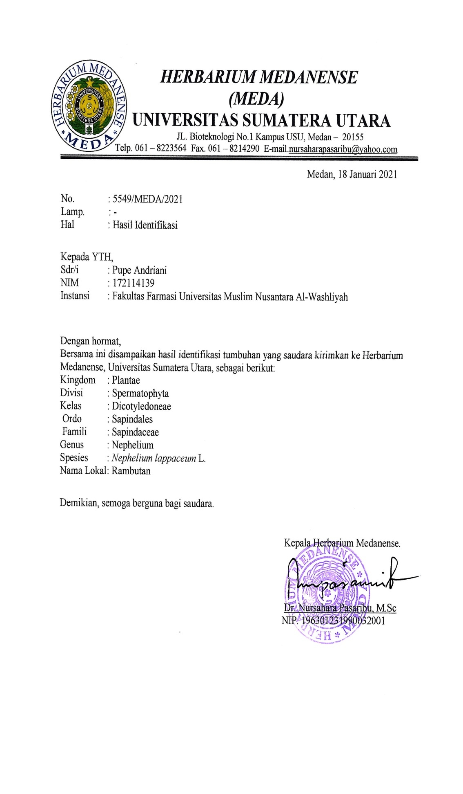
Lampiran 1. Hasil Determinasi Tumbuhan

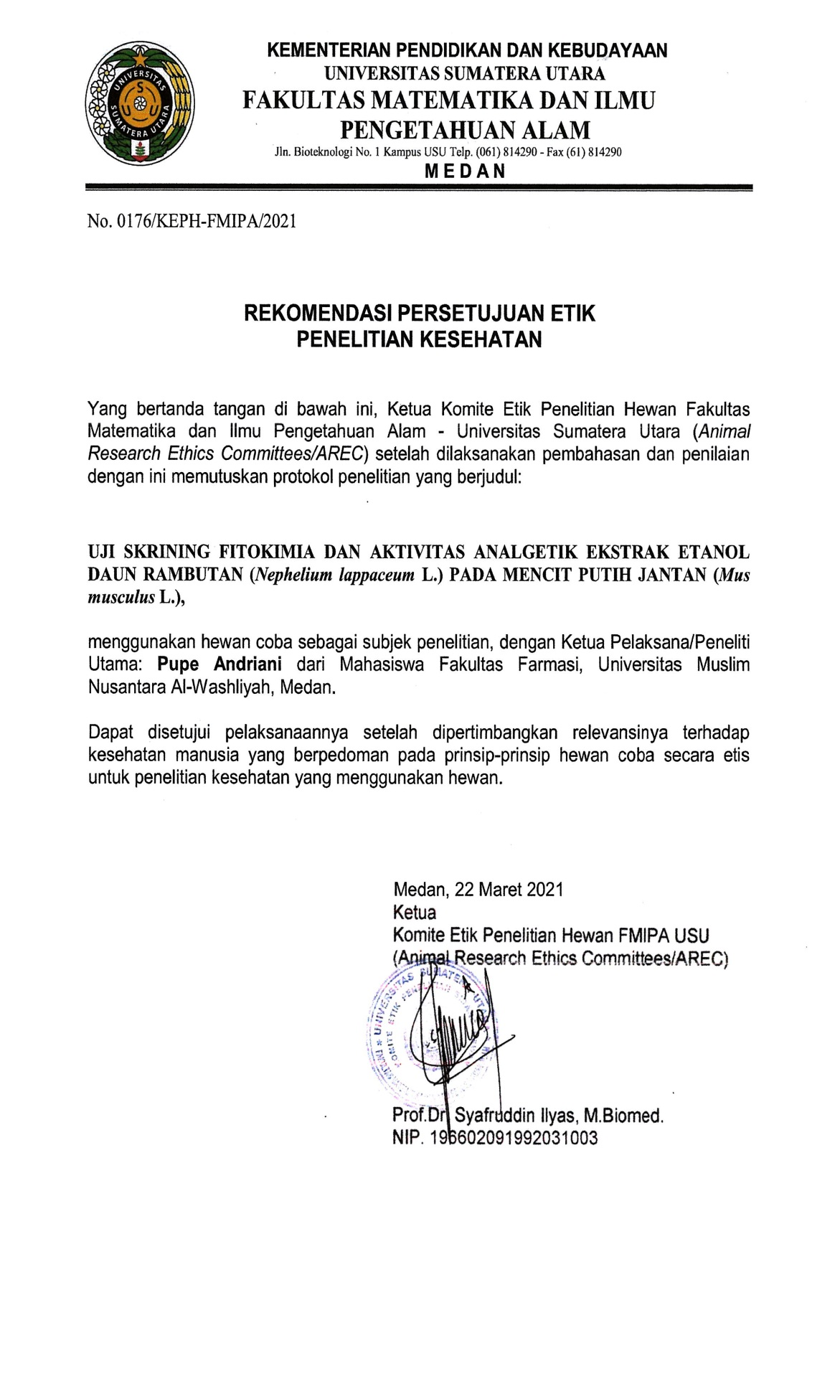
Lampiran 2. Rekomendasi Persetujuan Etik Penelitian

Lampiran 3. Bagan Alir Penelitian
Rotary evaporator
Hasil
Uji efektivitas Analgetik
Suspensi ekstrak daun rambutan
Ekstrak kental
Maserat
Hasil
Hasil
Karakterisasi
Skrining fitokimia
Serbuk kering
Serbuk kering
Serbuk kering
Dicuci bersih,ditiriskan, lalu dikeringkan lalu dihaluskan
Daun Rambutan

Maserasi dengan pelarut etanol 96%

Lampiran 4.Bagan Alir Pembuatan Simplisia
Tumbuhan daun Rambutan 5 kg

Disortasi basah
Dicuci
Digunting/Dipotong

Berat basah 4,9 kg

Dikeringkan dilemari pengering

Disortasi kering
Berat kering 825 g

Dihaluskan dengan menggunakan blender

Serbuk simplisia daun Rambutan 700 g

Lampiran 5.Bagan Alir Pembuatan Ekstrak Daun Rambutan
Serbuk simplisia daun rambutan 500 gram
Swartz)

Dimasukkan dalam bejana
Ditambah dengan 75 bagian
etanol 96%
Ditutup dan dibiarkan selama 5 hari sambil diaduk-aduk sesekali
Setelah 5 hari maserat diserkai dan ampasnya diperas

Ampas
Maserat I
Dicuci dengan 25 bagian etanol 96%
Dimasukkan kedalam bejana tertutup, di biarkan selama 2 hari dan disaring
Maserat II
Maserat I + Maserat II
Dipekatkan dengan Rotary Evaporator
Ekstrak kental 120 g

Lampiran 6.Bagan Alir Skrining Fitokimia dan Karakterisasi
Serbuk Simplisia Daun
Rambutan

Serbuk Simplisia Daun Rambutan
Serbuk Simplisia Daun Rambutan

Di maserasi menggunakan pelarut etanol 96%
Skrining Fitokimia
Karakterisasi
Ekstrak Etanol Daun Rambutan

1.PemeriksaanAlkaloida
2.PemeriksaanFlavonoida
3.PemeriksaanTanin
4.PemeriksaanSaponin
5.PemeriksaanSteroida/Triterpenoida
1.Makroskopik
2.Mikroskopik
3.Penetapan Kadar Air
4.Penetapan Kadar Sari Larut Air
5.Penetapan Kadar Sari Larut Etanol
6.Penetapan Kadar Abu Total
7.Penetapan Kadar Abu Tidak Larut dalam Asam
Uji Farmakologi
1.Pemeriksaan Alkaloida
2.Pemeriksaan Flavonoida
3.Pemeriksaan Tanin
4.Pemeriksaan Saponin
5.Pemeriksaan Steroida/Triterpenoida

Lampiran 7. Bagan Alir Uji Analgetik
Mencit

Dikondisikan selama 2 minggu

Dipuasakan selama 18- 24 jam

Di kelompokan secara acak menjadi 5 kelompok, masing-masing kelompok 5 ekor

Diinduksi asam asetat 1% secara intraperitonial

Mencit Nyeri
Dihitung jumlah geliat tiap 5 menit sampe menit ke 10

Setelah 10 menit diamati, setiap kelompok diberi perlakuan secara peroral:
Kel I CMC 0,5%
Kel II Methampiron 1%
Kel III EEDR 50 mg/kg BB
Kel IV EEDR 100 mg/kg BB
Kel V EEDR 200 mg/kg BB

Diamati geliatnya dan di hitung jumlah geliat tiap 5 menit sampai ke 60 menit

Jumlah geliat mencit

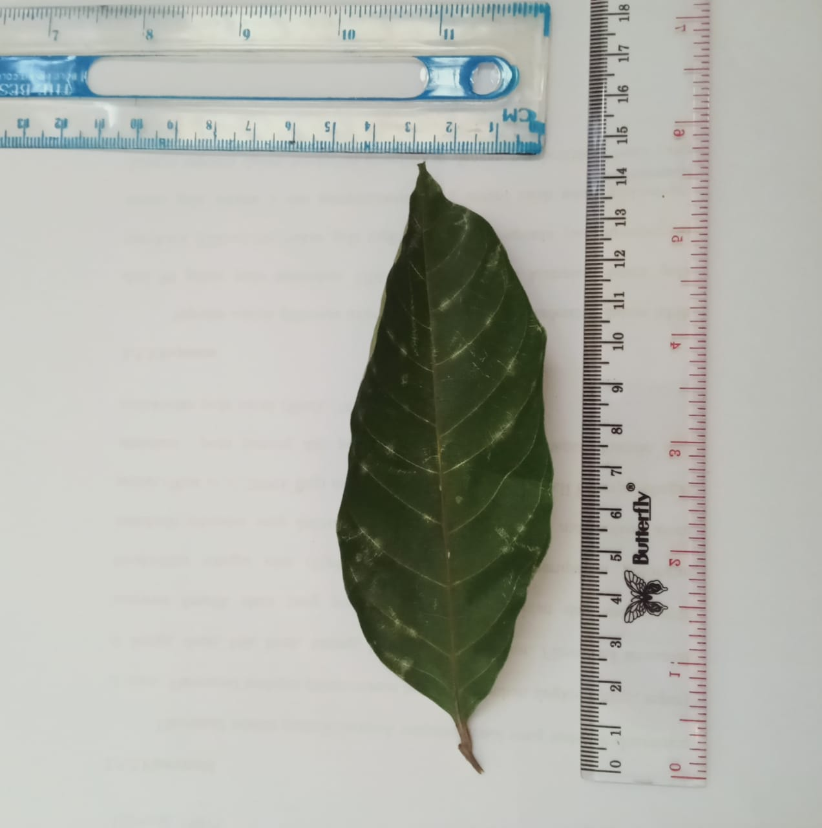
Lampiran 8. Daun Rambutan Segar, Simplisia dan Serbuk simplisia Daun Rambutan

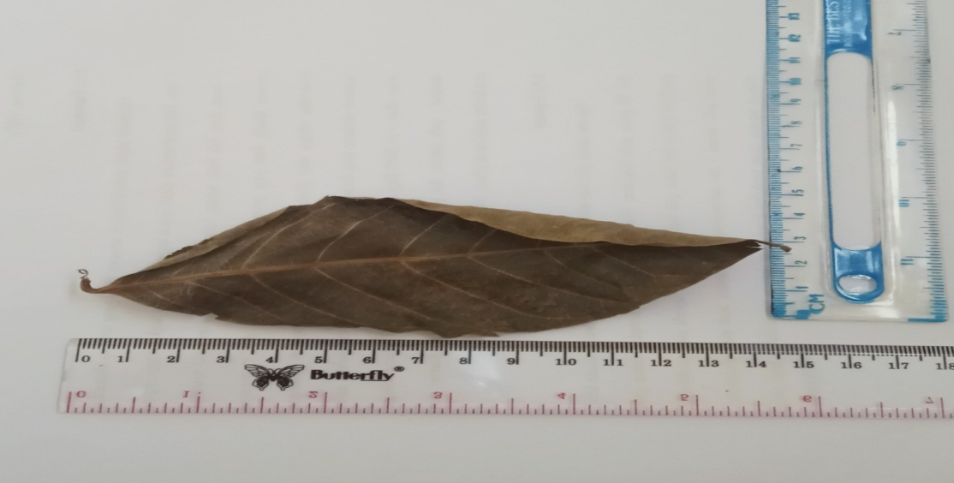
Daun Rambutan Segar

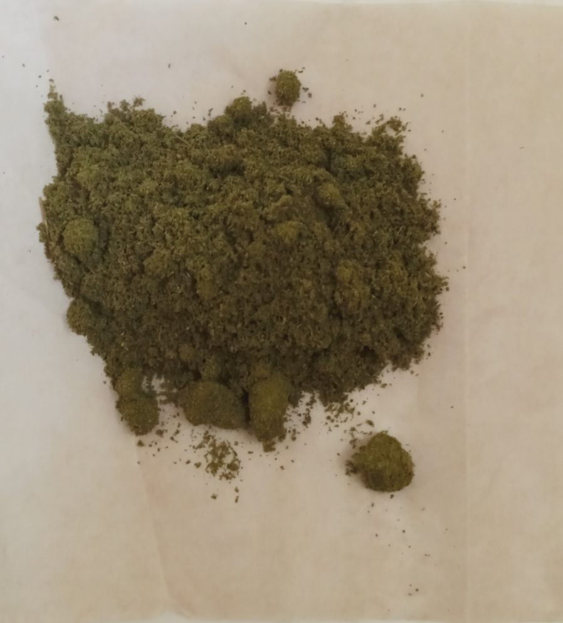

Simplisia Daun Rambutan (Nepheii lappacei folium)

Serbuk Simplisia Daun Rambutan (Nepheii lappacei folium)

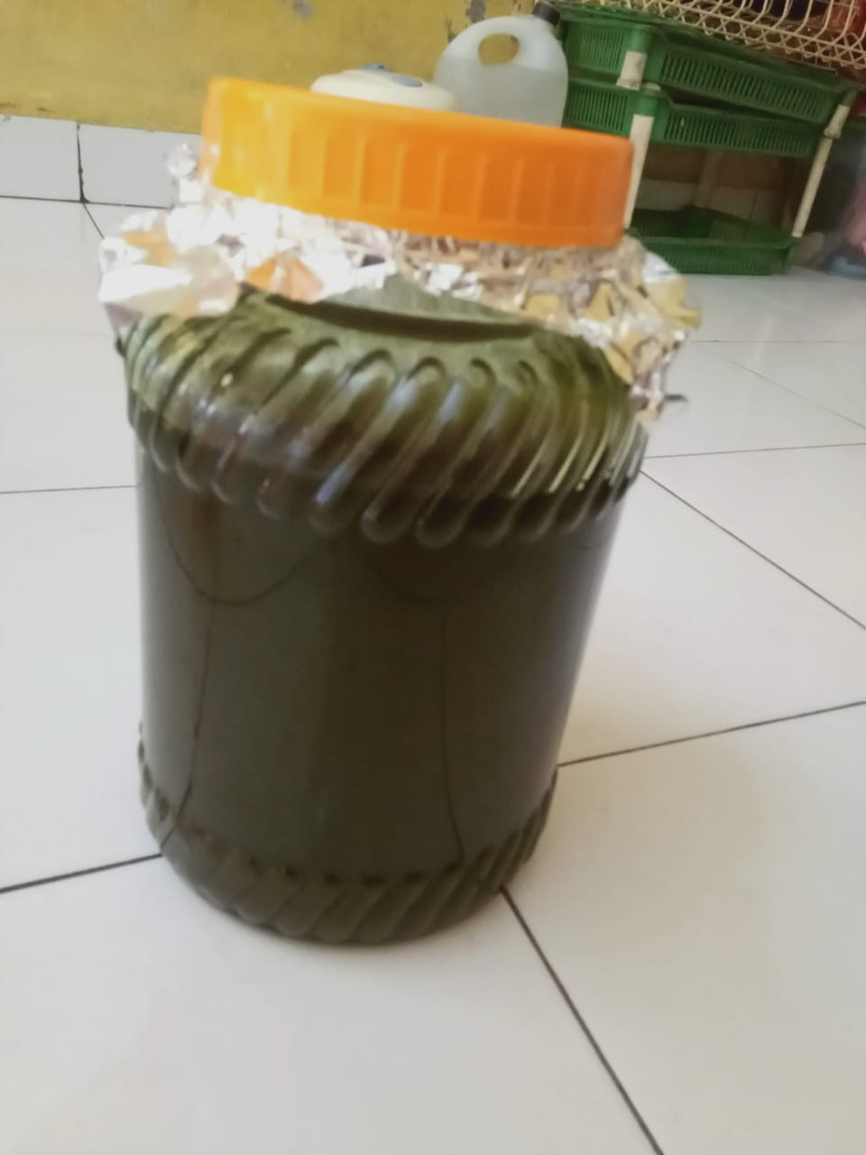
Lampiran 9. Maserasi dan Ekstrak Rambutan

Maserasi Daun Rambutan
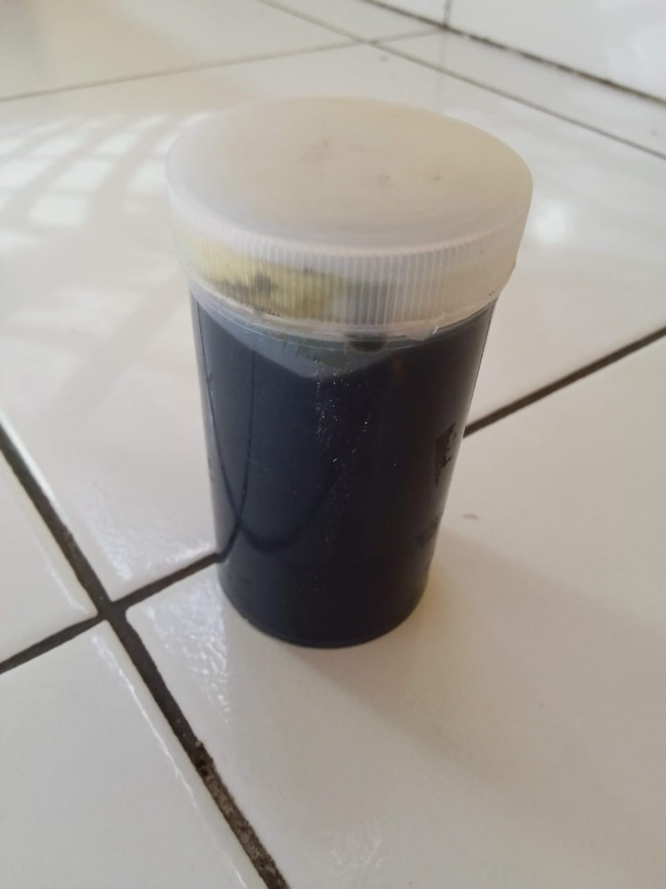

Ekstrak Daun Rambutan

Lampiran 10. Mikroskopik Daun Rambutan (Nephelium lappaceum L.)
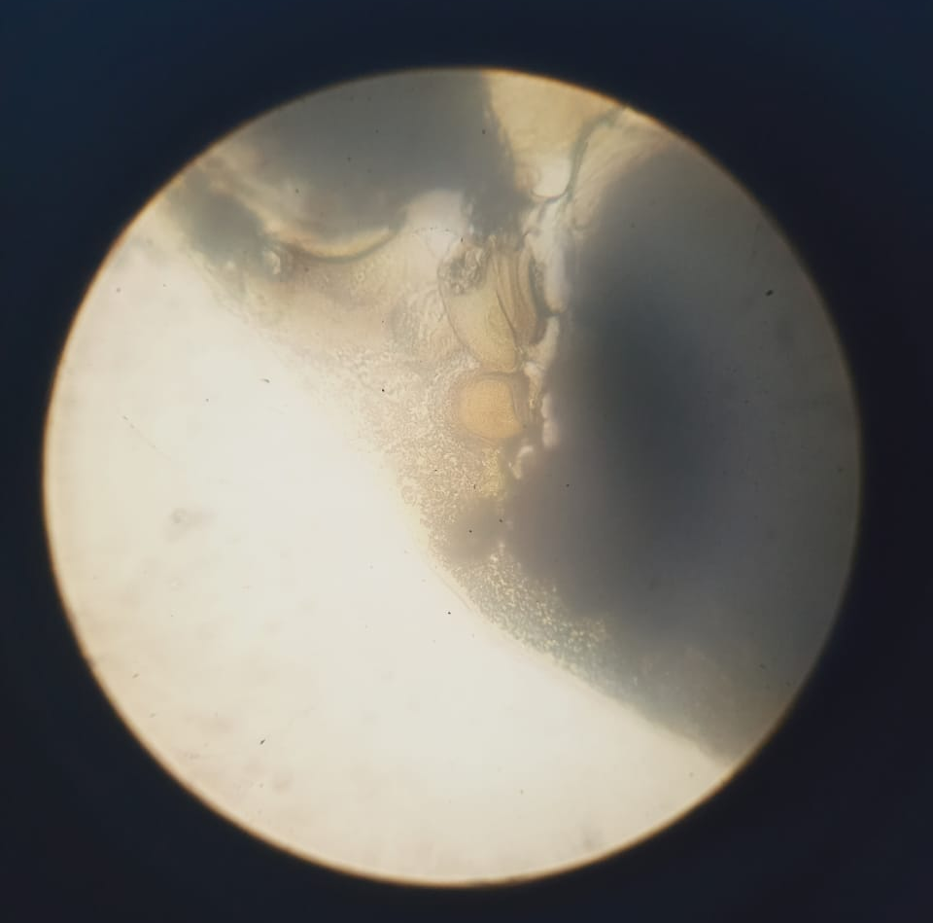
Stomata tipe Siklositik

Epidermis

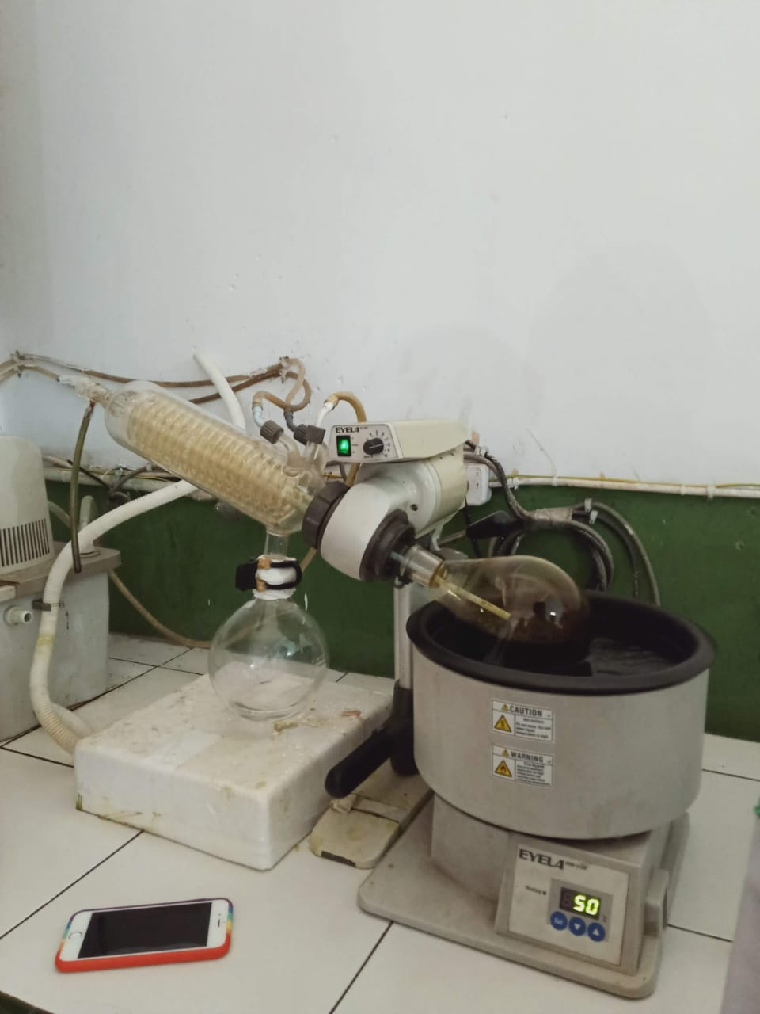
Lampiran 11. Alat Rotary Evaporator, Alat Azeotrop, Tanur

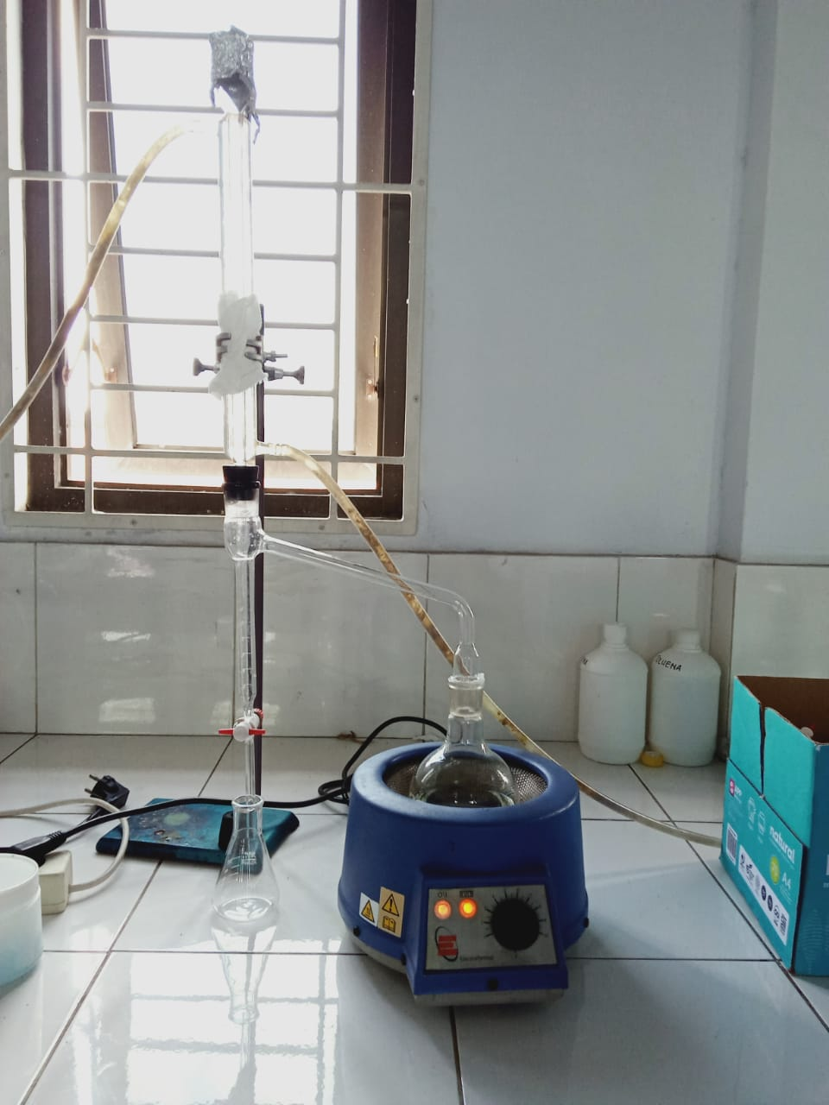
Alat Rotary Evaporator

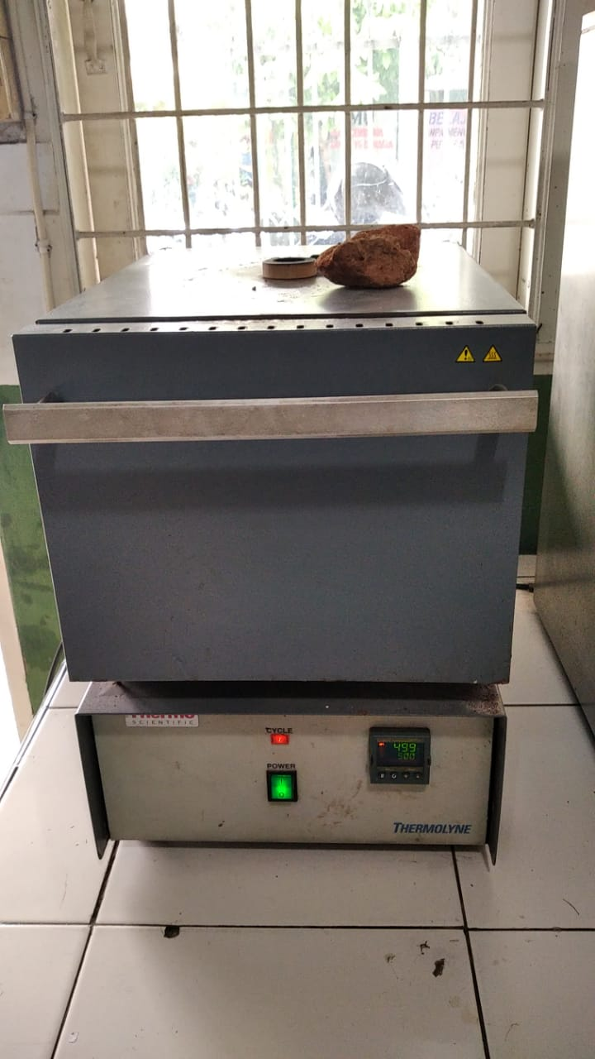
Alat Azeotrop (Penetapan kadar air)

Alat Tanur (Penetapan kadar abu)

Lampiran 12. Hasil Skrining Ekstrak Daun Rambutan
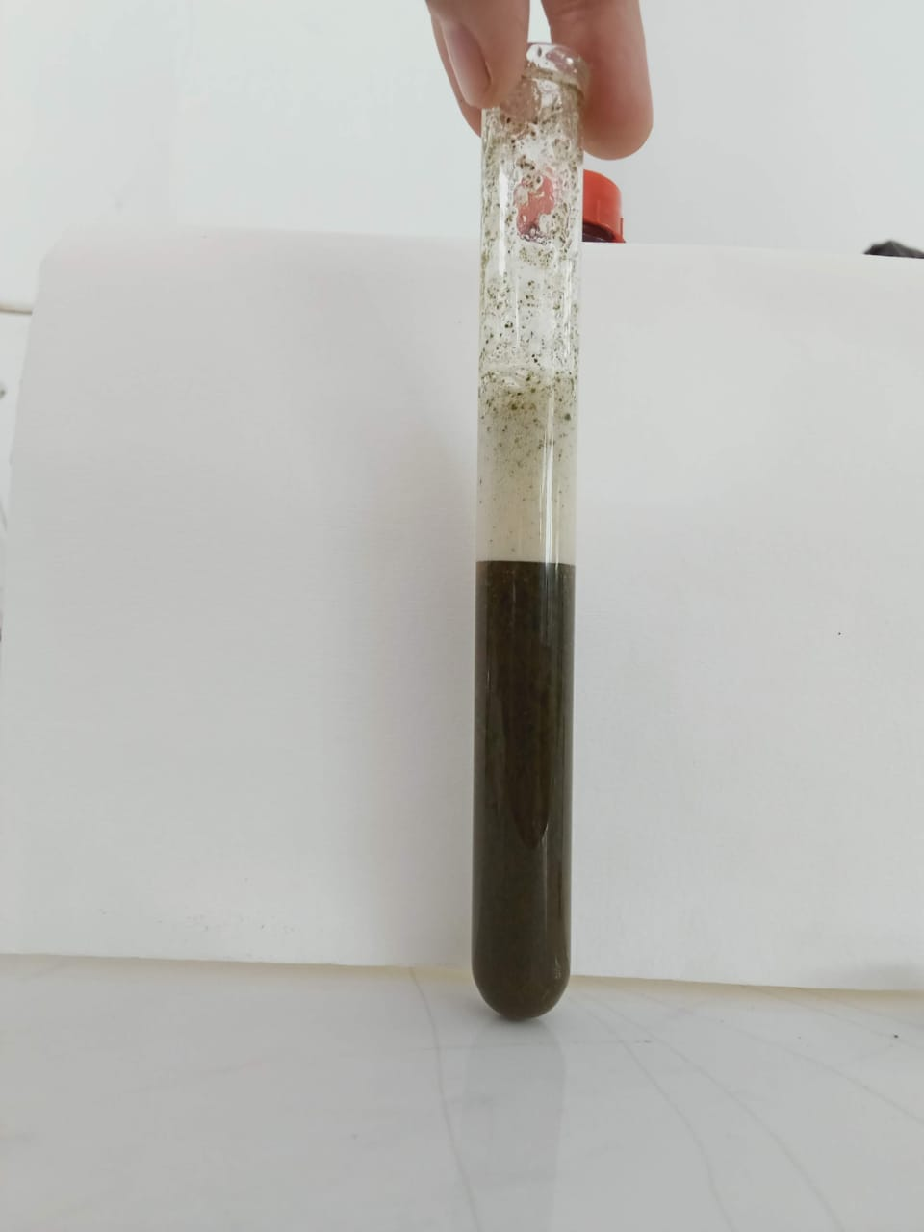
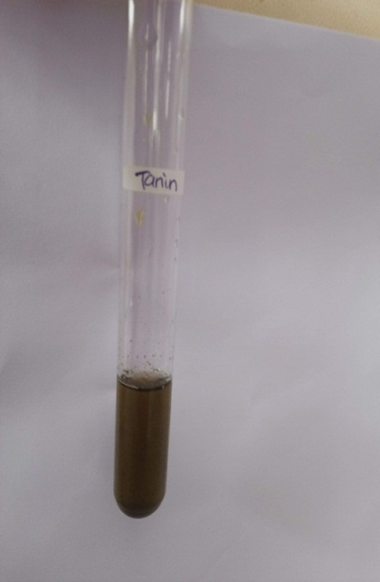

Saponin (+) Tanin (+)
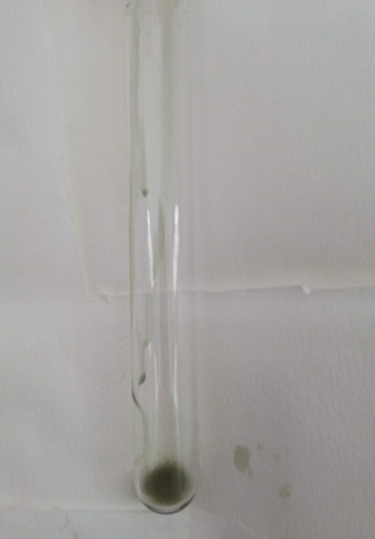
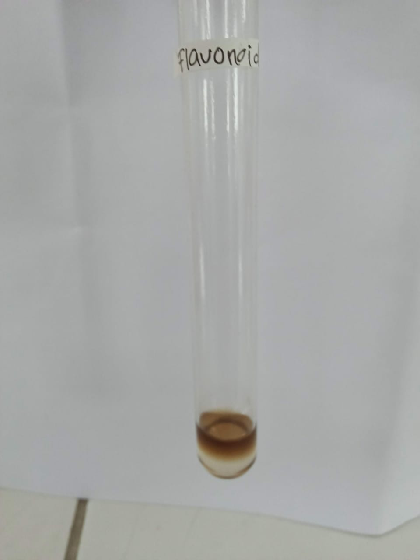

Flavonoid (+) Steroid/Terpenoid (-)

Lampiran 12. (Lanjutan)
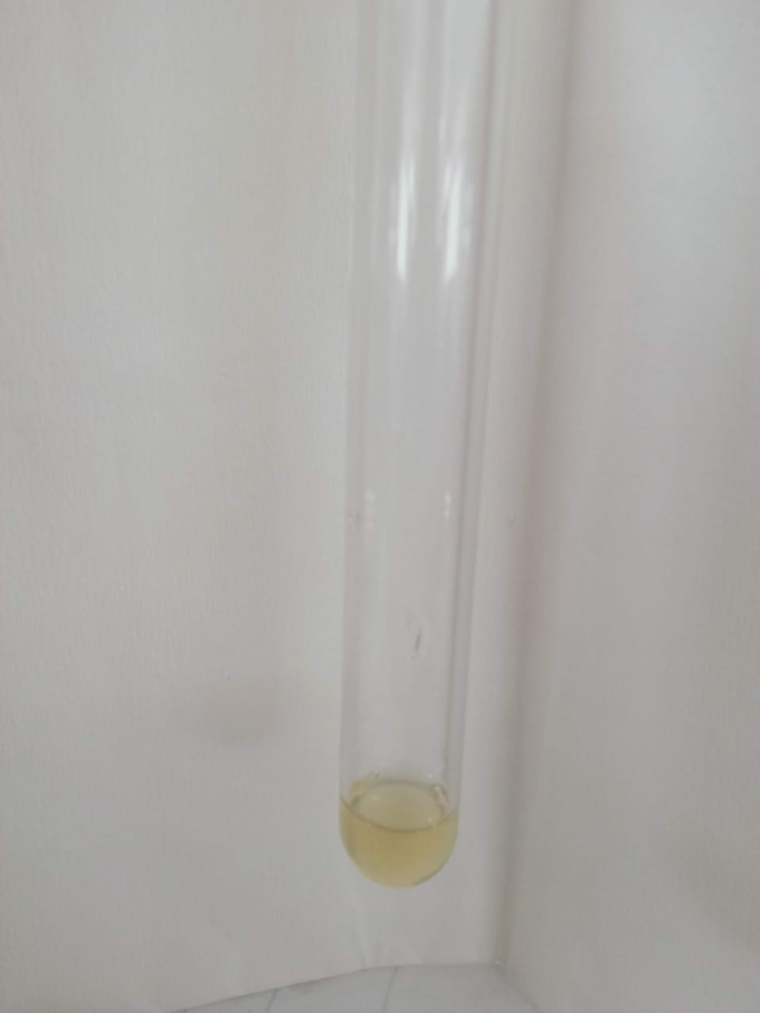
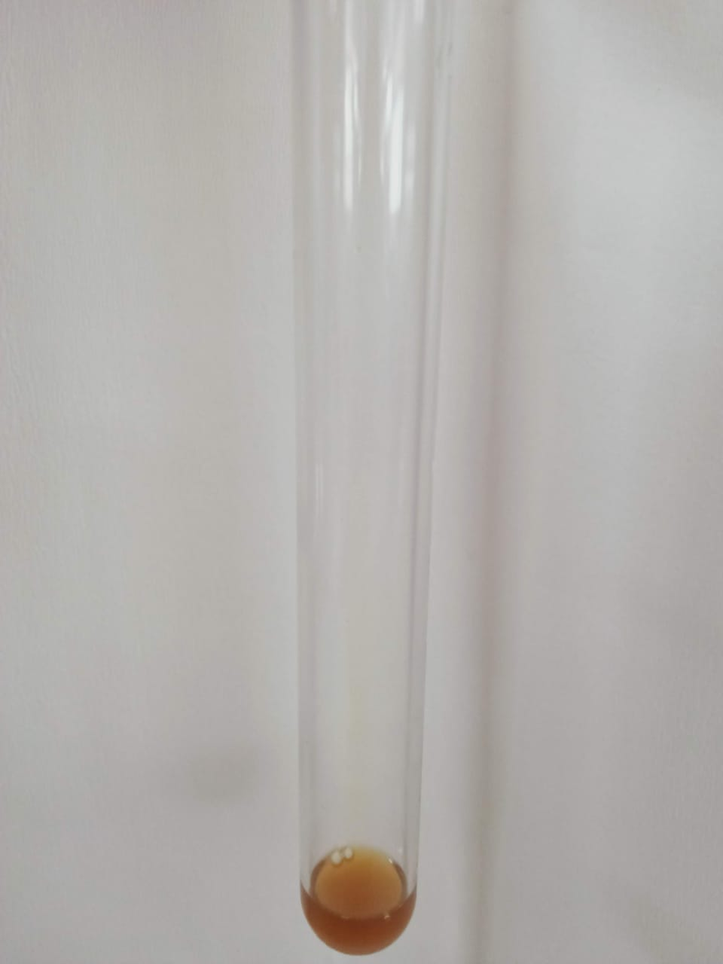

Dragendorf (+) Mayer (-)

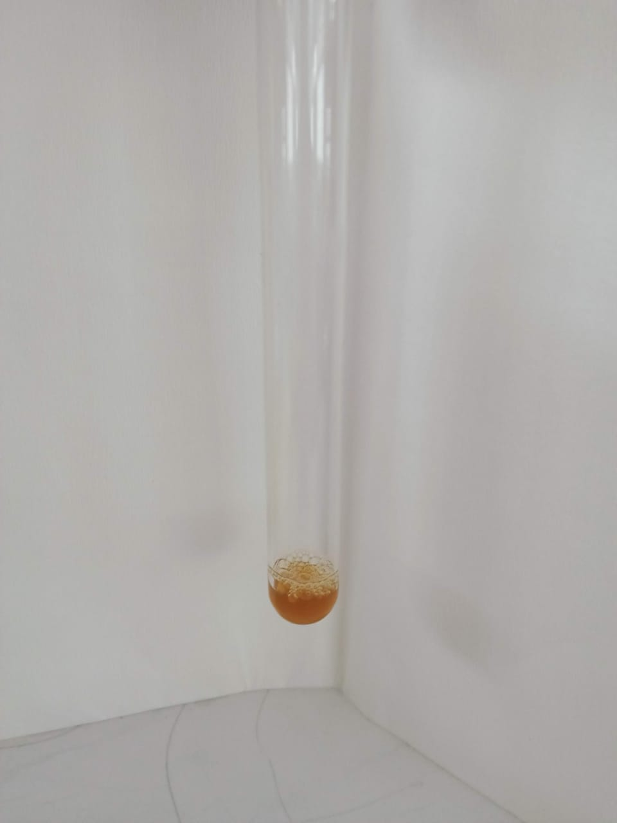

Bouchardat (-)

Lampiran 13. Hasil Perhitungan Parameter Karakteristik Simplisia
Berat kering = 825 gram
Berat serbuk = 500 gram
Berat ekstrak = 120 gram
% Randemen = $\frac{Bobot ekstrak yang di dapat}{Bobot bahan simplisia yang di ekstrak}×100\%$
=$\frac{120gram}{500 gram}×100\%=$24 %

- Perhitungan Hasil Penetapan Kadar Air (Tidak lebih dari 10 %).
$$Kadar Air :\frac{volume II-Volume I}{Berat Sampel}×100 \%$$

Sampel I
Berat sampel : 5 g
Volume I : 1,8 ml
Volume II : 2,1 ml
= $\frac{2,1 ml-1,8 ml}{5g}×100 \%=6 \%$
Sampel II
Berat sampel : 5 g
Volume I : 1,6 ml
Volume II : 1,9 ml
= $\frac{1,9 ml-1,6 ml}{5g}×100 \%=6 \%$
Sampel III
Berat sampel : 5 g
Volume I : 1,7ml
Volume II : 2 ml
= $\frac{2 ml-1,7 ml}{5g}×100 \%=6 \%$
Kadar air rata-rata: =$\frac{ 6\%+6\%+6 \%}{3}$ = 6%
Kadar air pada daun Rambutan memenuhi syarat yaitu 6 %, tidak lebih dari 10%.

Lampiran 13. (Lanjutan)
- Perhitungan Kadar Sari Larut dalam Air (8-35 %).
$$kadar sari larut air=\frac{Berat sari ×Faktor pengenceran}{Berat sampel}×100\%$$

Sampel 1
Berat sampel : 5 g
Berat cawan kosong : 35,6 g
Berat cawan$+$sampel : 35,8 g
=$\frac{\left(35,8 g-35,6 g\right)×5}{5 g}×100 \%$
=$\frac{0,2 g X 5}{5 g}×100\%$ = 20 %
Sampel II
Berat sampel :5 g
Berat cawan kosong :36,4 g
Berat cawan$+$ sampel :36,7 g
= $\frac{\left(36,7 g-36,4 g\right)×5}{5 g}100 \%$
=$\frac{0,3 g X 5}{5 g}×100 \%$ = 30 %
Sampel III
Berat sampel :5 g
Berat cawan kosong :35,9 g
Berat cawan$+$sampel :36,1 g
= $\frac{(36,1 g-35,9 g)}{5 g}×100 \%$
= $\frac{0,2 g X 5}{5 g}×100 \%$ = 20 %
Kadar sari larut dalam air rata-rata: =$\frac{20\%+30\%+20 \%}{3}$ = 23 %
Kadar sari larut dalam air pada daun Rambutan memenuhi syarat yaitu 23% lebih dari 8-35%.

Lampiran 13. (Lanjutan)
3. Perhitungan Kadar Sari Larut Dalam Etanol (lebih dari 5-26 %).

Kadar sari larut dalam etanol = $\frac{Berat sari ×Faktor pengenceran }{Berat sampel}×100 \%$

Sampel I
Berat sampel :5 g
Berat cawan kosong :36,8 g
Berat cawan$+$sampel :37,0 g
=$\frac{(37,0 g-36,8 g×5}{5 g}×100 \%$
= $\frac{0,2gX5}{5 g}×100 \%$ = 20 %
Sampel II
Berat sampel :5 g
Berat cawan kosong :33,0 g
Berat cawan$+$ sampel :33,2 g
= $\frac{\left( 33,2 g-33,0 g\right)×5}{5 g}×100 \%$
= $\frac{o,2gx5}{5 g}×100 \%$ = 20 %
Sampel III
Berat sampel :5 g
Berat cawan kosong :32,1 g
Berat cawan$+$ sampel :32,3 g
= $\frac{\left(32,3 g-32,1 g\right)×5}{5 g}×100 \%$
= $\frac{0,2 gx5}{5 g}×100 \%$ = 20 %

Kadar sari larutdalametanol rata-rata: = $\frac{20\%+20\%+20 \%}{3}$= 20 %
Kadar sari larut dalam etanol pada daun Rambutan memenuhi syarat yaitu 20 %, lebih dari 5-26 %.

Lampiran 13. (Lanjutan)
4. Perhitungan Penetapan Kadar Abu Total (Tidak lebih dari 7-14 %)
Kadar Abu = $\frac{Berat abu }{Berat sampel }×100 \%$

Sampel I
Berat sampel :2,5 g
Berat cawan kosong :64,2 g
Berat cawan$+$ sampel :64,7 g
= $\frac{\left(64,7g-64,2g\right)}{2,5 g}×100 \%$
= $\frac{0,5 g}{2,5 g}×100 \%$ = 20 %
Sampel II
Berat sampel :2 g
Berat cawan kosong :64,9 g
Berat cawan$+$ sampel :65,2 g
= $\frac{(65,2g-64,9 g}{2 g}×100 \%$
= $\frac{0,3 g}{2,5 g}×100 \%$ = 12 %
Sampel III
Berat sampel :2,5 g
Berat cawan kosong :62,4 g
Berat cawan$+$ sampel :62,9 g
= $\frac{(62,9 g-62,4 g)}{2,5 g}×100 \%$
= $\frac{0,5 g}{2,5 g}×100 \%$= 20 %

Kadar abu total rata-rata :=$\frac{20 \% +20 \% +20 \%}{3}$= 20 %
Kadar abu total pada daun Rambutan tidak memenuhi syarat yaitu 20%, lebih dari 7-14%.

Lampiran13. (lanjutan)
5. Perhitungan Kadar Abu tidak Larut dalam Asam (tidak lebih dari 1-10%).
Kadar abu tidak larut asam = $\frac{Berat abu}{Berat sampel}×100 \%$

Sampel I
Berat sampel :2,5 g
Berat cawan kosong :62,4 g
Berat cawan$+$ sampel :63 g
= $\frac{63,0 g-62,4 g}{2,5 g}×100 \%$
= $\frac{0,6 g}{2,5 g}×100 \%$ = 24 %
Sampel II
Berat sampel :2,5 g
Berat cawan kosong :62,6 g
Berat cawan$+$ sampel :63,1 g
= $\frac{63,1 g-62,6 g}{2,5 g}×100 \%$
= $\frac{0,5 g}{2,5 g}×100 \%$ = 20 %
Sampel III
Berat sampel :2,5 g
Berat cawan kosong :64,6 g
Berat cawan$+$sampel :65,1 g
= $\frac{65,1 g-64,6 g}{2,5 g}×100 \%$
= $\frac{0,5 g}{2,5 g}×100 \%$ = 20 %
Kadar abutidaklarutdalamasam rata-rata:=$\frac{24 \% +20 \% +20 \% }{3}$ = 21,3 %
Kadar abu tidak larut dalam asam pada daun Rambutan tidak memenuhi syarat yaitu 21,3%, lebih dari 1-10 %

Lampiran 14. Tabel Konversi Perhitungan Dosis antara Jenis Hewan dan Manusia
Tabel . Konversi Perhitungan Dosis antara Jenis Hewan dan Manusia
Hewan dan BB rata-rata | Men-cit  20 g | Tikus  200 g | Mar-mut  400 g | Kelin-ci  1,5 Kg | Kuci-ng  2 Kg | Kera  4 Kg | Anji-ng  12 Kg | Manu-sia  70 Kg
Mencit  20 g | 1,0 | 7,0 | 12,29 | 27,8 | 28,7 | 64,1 | 124,2 | 387,9
Tikus  200 g | 0,14 | 1,0 | 1,74 | 3,9 | 4,2 | 9,2 | 17,8 | 60,5
Marmut  400 g | 0,08 | 0,57 | 1,0 | 2,25 | 2,4 | 5,2 | 10,2 | 31,5
Kelinci  1,5 Kg | 0,04 | 0,25 | 0,44 | 1,0 | 1,06 | 2,4 | 4,5 | 14,2
Kucing  2 Kg | 0,03 | 0,23 | 0,41 | 0,92 | 1,0 | 2,2 | 4,1 | 13,0
Kera  4 Kg | 0,016 | 0,11 | 0,19 | 0,42 | 0,45 | 1,0 | 1,9 | 6,1
Anjing  12 Kg | 0,008 | 0,06 | 0,10 | 0,22 | 0,24 | 0,52 | 1,0 | 3,1
Manusia  70 Kg | 0,0026 | 0,018 | 0,031 | 0,07 | 0,76 | 0,16 | 0,32 | 1,0

Jenis Hewan  Uji | Volume maksimum (mL) sesuai jalur pemberian
 | i.v |  | i.m | i.p |  | s.c | p.o
Mencit (20-30 g) | 0,5 |  | 0,05 | 1,0 |  | 0,5-1,0 | 1,0
Tikus (200 g) | 1,0 |  | 0,1 | 2-5 |  | 2-5 | 5,0
Hamster (50 g) | - |  | 0,1 | 2-5 |  | 2-5 | 2,5
Marmut (250 g) | - |  | 0,25 | 5,0 |  | 5,0 | 10,0
Kelinci (2,5 kg) | 5-10 |  | 0,5 | 5-10 |  | 5-10 | 20,0
Kucing (3 kg) | 5-10 |  | 1,0 | 5-10 |  | 5-10 | 50,0
Anjing (5 kg) | 10-20 | 5,0 |  | 10,0 | 10,0 |  | 100,0
Lampiran 15. Tabel Volume Maksimum Larutan Sediaan Uji Yang Dapat Diberikan Pada Beberapa Hewan Uji

Lampiran 16. Perhitungan Dosis
1. Dosis Methampiron (Antalgin)
Konversi dosis manusia ke dosis tikus
Dosis lazim methampiron pada manusia : 500 mg
Dosis mencit : 0,0026
Berat badan mencit : 20 g
500 mg x 0,0026 = 1,3 mg/20 g
= 1,3 mg/0,02 Kg
= 65 mg/kg BB
Konsentrasi 1% =1 g/100 mL = 0,01 g/mL=10mg/mL
Dosis =$\frac{Dosis methampiron}{1000} x berat badan mencit$

$$Volume=\frac{Dosis}{Konsentrasi}$$

Contoh :
$Dosis=\frac{65 mg/Kg BB}{1000}X 20 g$ = 1,3 mg
Volume$=\frac{1,3 mg}{10 mg/mL}=0,13$ mL
2. Dosis CMC
Volume suspensi yang di berikan = 0,5mL
Suspensi CMC 0,5 %
0,5 % = 0,5 g/ 100 mL = 500 mg/100 mL = 5 mg/mL

Lampiran 16. (Lanjutan)
3. EEDR dosis 50 mg/kg BB
Berat Badan Mencit = 20 g
Konsentrasi = 1%= 1g/100mL= 0,01g/mL= 10mg/mL
Dosis =$\frac{Dosis (mg)}{1000} x berat badan mencit (g)$
$$Volume=\frac{Dosis}{Konsentrasi}$$

Contoh :
$Dosis=\frac{50 mg/Kg BB}{1000}X 20 g$ = 1 mg
Volume$=\frac{1 mg}{10 mg/mL}=0,1$ mL
4. EEDR dosis 100 mg/kg BB
Berat Badan Mencit = 20 g
Konsentrasi = 1%= 1g/100mL= 0,01g/mL= 10mg/mL
Dosis =$\frac{Dosis (mg)}{1000} x berat badan mencit (g)$
$$Volume=\frac{Dosis}{Konsentrasi}$$

Contoh :
$Dosis=\frac{100 mg/Kg BB}{1000}X 20 g$ = 2 mg
Volume$=\frac{2 mg}{10 mg/mL}=0,2$ mL

Lampiran 16. (Lanjutan)
5. EEDR dosis 200 mg/kg BB
Berat Badan Mencit = 20 g
Konsentrasi = 1%= 1g/100mL= 0,01g/mL= 10mg/mL
Dosis =$\frac{Dosis (mg)}{1000} x berat badan mencit (g)$
$$Volume=\frac{Dosis}{Konsentrasi}$$

Contoh :
$Dosis=\frac{200 mg/Kg BB}{1000}X 20 g$ = 4 mg
Volume$=\frac{4 mg}{10 mg/mL}=0,4$ mL

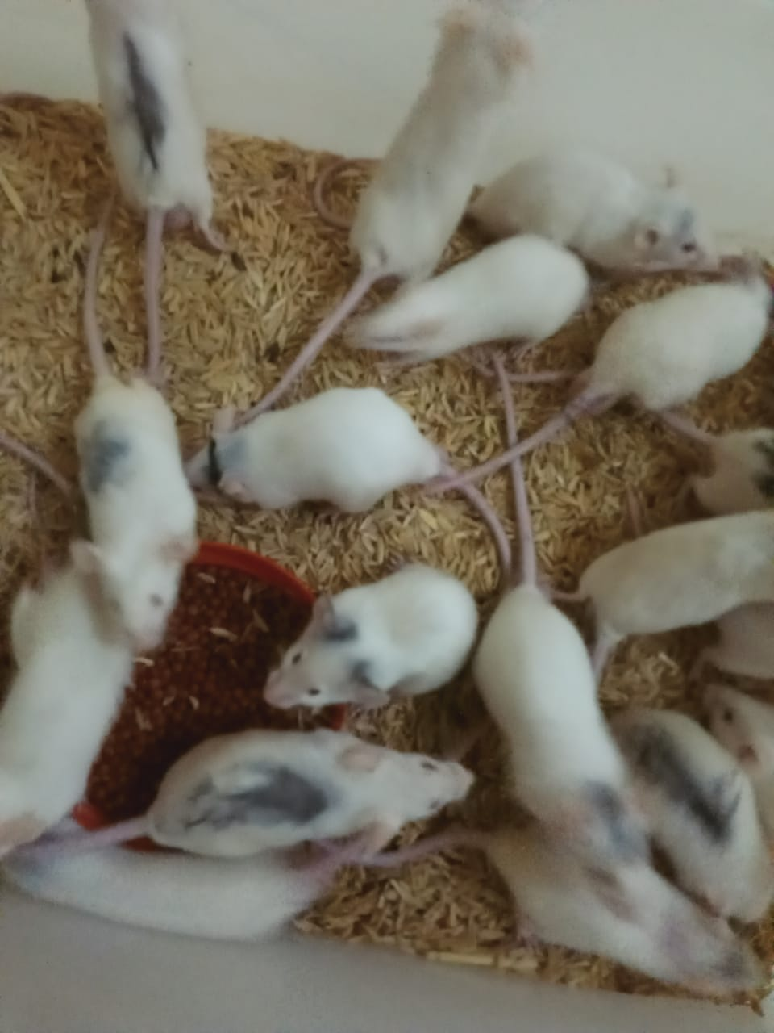
Lampiran 17. Hewan Percobaan, Pemberian induksi As.asetat 1% ,pemberian oral, Pengamatan geliat

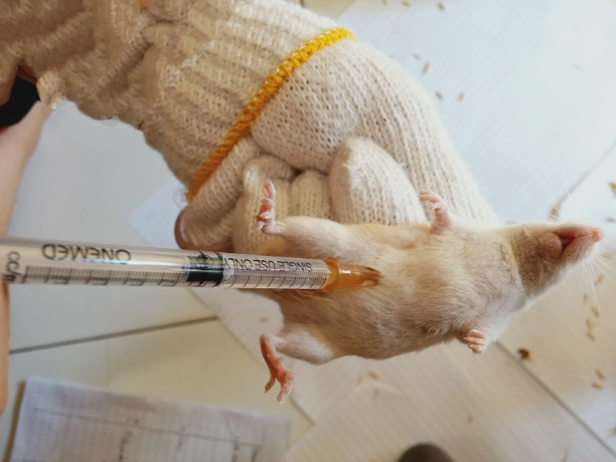
Mencit (Mus musculus)

Pemberian Induksi As.asetat 1%

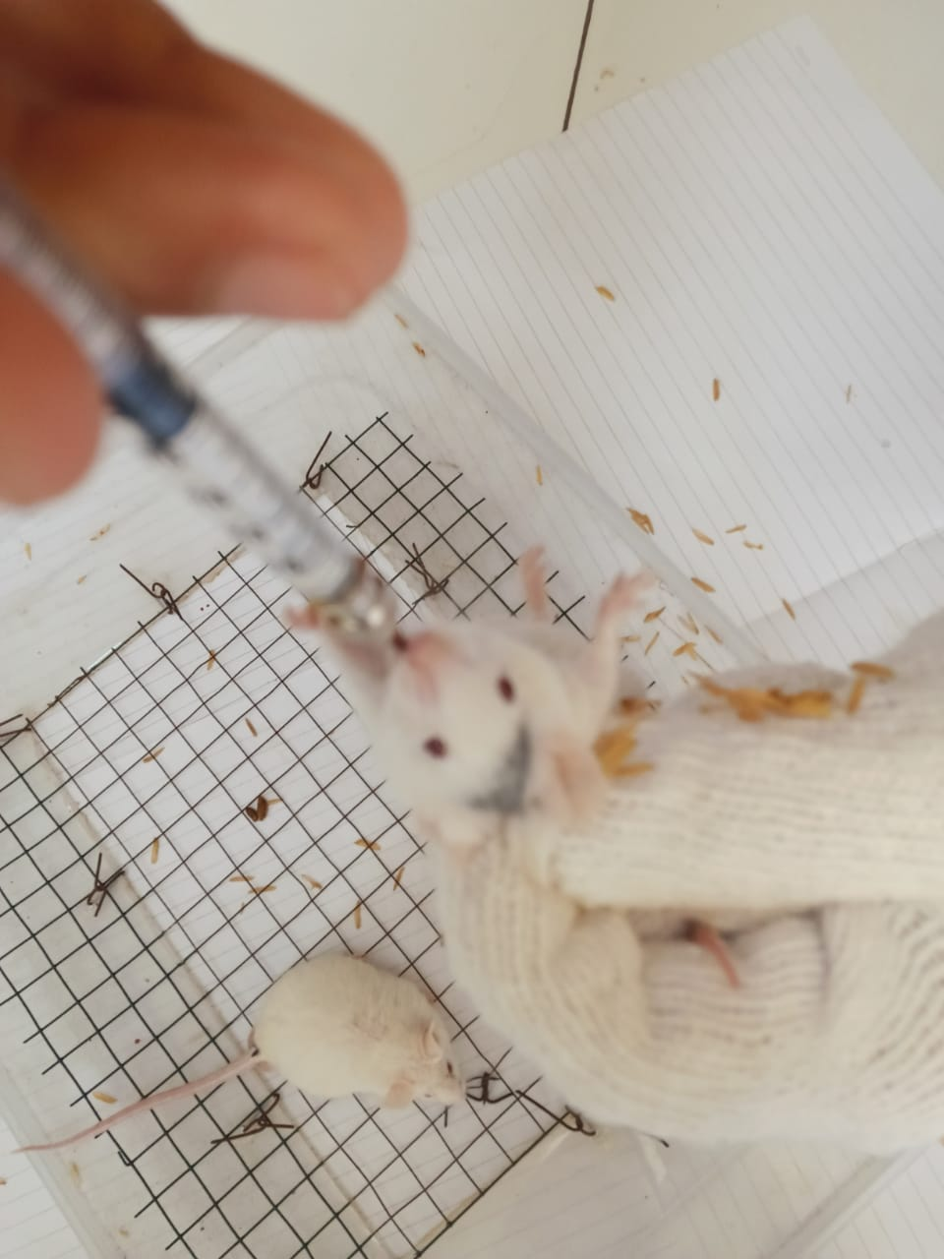
Lampiran 17. (Lanjutan)

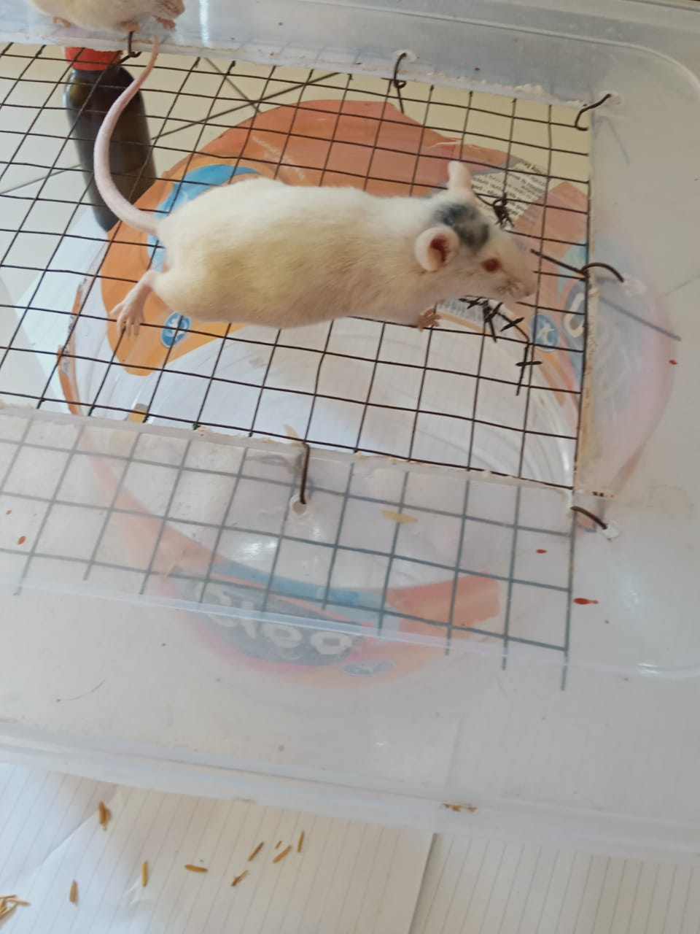
Pemberian secara oral

Proses pengamatan geliat

Lampiran 18. Data Jumlah Geliat Mencit Putih Jantan yang diinduksi Asam Asetat 0,5% volume 0,5ml dan Asam Asetat 1% volume 0,2ml

Perlakuan | Menit  Mencit  Ke | 5' | 10' | 15' | 20' | 25' | 30' | 35' | 40' | 45' | 50' | 55' | 60' | Jumlah  geliat
Asam asetat  0,5%  Vol 0,5 ml | 1 | 15 | 18 | 22 | 20 | 19 | 18 | 16 | 14 | 12 | 10 | 8 | 6 | 178
 | 2 | 17 | 20 | 23 | 22 | 21 | 20 | 19 | 17 | 15 | 13 | 12 | 10 | 209
 | 3 | 19 | 23 | 25 | 23 | 22 | 21 | 19 | 17 | 16 | 15 | 13 | 11 | 224
 | 4 | 16 | 20 | 24 | 22 | 20 | 18 | 16 | 14 | 12 | 10 | 8 | 6 | 186
 | 5 | 15 | 17 | 20 | 18 | 16 | 14 | 13 | 11 | 10 | 8 | 6 | 4 | 152
 | Rata-rata | 16,4 | 19,6 | 22,8 | 21 | 19,6 | 18,2 | 16,6 | 14,6 | 13 | 11,2 | 9,4 | 7,4 | 189,8
Asam asetat  1%  Vol 0,2 ml | 1 | 16 | 19 | 23 | 22 | 21 | 20 | 19 | 17 | 15 | 13 | 11 | 8 | 204
 | 2 | 18 | 21 | 25 | 24 | 23 | 22 | 20 | 18 | 16 | 15 | 13 | 12 | 227
 | 3 | 20 | 22 | 24 | 21 | 20 | 19 | 17 | 15 | 13 | 11 | 10 | 8 | 200
 | 4 | 19 | 21 | 25 | 23 | 21 | 20 | 18 | 16 | 14 | 12 | 13 | 9 | 211
 | 5 | 14 | 17 | 21 | 19 | 18 | 17 | 16 | 14 | 12 | 10 | 10 | 9 | 177
 | Rata-rata | 17,4 | 20 | 23,6 | 21,8 | 20,6 | 19,6 | 18 | 16 | 14 | 12,2 | 11,4 | 9,2 | 203,8

Lampiran 19. Data Hasil Pengamatan Geliat Mencit Putih Jantan Setelah Pemberian Suspensi CMC 0,5%, Suspensi Metampiron 1%
Suspensi Ekstrak Etanol Daun Rambutan Dosis 50,100 dan 200 mg/kg BB Selang Waktu 5 Menit Selama 1 Jam

Perlakuan | Menit Mencit Ke- | 5' | 10' | 15' | 20' | 25' | 30' | 35' | 40' | 45' | 50' | 55' | 60' | Jumlah
CMC 0,5% | 1 | 19 | 37 | 31 | 28 | 25 | 23 | 22 | 20 | 18 | 15 | 12 | 10 | 260
 | 2 | 18 | 34 | 29 | 26 | 24 | 22 | 23 | 21 | 18 | 16 | 13 | 9 | 253
 | 3 | 20 | 36 | 31 | 27 | 25 | 23 | 20 | 18 | 16 | 14 | 12 | 9 | 251
 | 4 | 17 | 33 | 28 | 25 | 22 | 19 | 17 | 15 | 13 | 11 | 10 | 8 | 218
 | 5 | 20 | 36 | 30 | 28 | 26 | 23 | 20 | 18 | 16 | 14 | 12 | 10 | 253
 | Rata-rata | 18,8 | 35,2 | 29,8 | 26,8 | 24,4 | 22 | 20,4 | 18,4 | 16,2 | 14 | 11,8 | 9,2 | 247
Metampiron  1% | 1 | 16 | 25 | 18 | 14 | 10 | 7 | 5 | 3 | 1 | 0 | 0 | 0 | 99
 | 2 | 17 | 26 | 19 | 16 | 11 | 8 | 6 | 5 | 4 | 2 | 1 | 0 | 115
 | 3 | 14 | 23 | 17 | 14 | 10 | 7 | 5 | 3 | 2 | 1 | 0 | 0 | 96
 | 4 | 15 | 25 | 18 | 15 | 11 | 8 | 7 | 5 | 4 | 2 | 1 | 0 | 111
 | 5 | 16 | 26 | 19 | 12 | 9 | 6 | 4 | 2 | 1 | 0 | 0 | 0 | 95
 | Rata-rata | 15,6 | 25 | 18,2 | 14,2 | 10,2 | 7,2 | 5,4 | 3,6 | 2,4 | 1 | 0,4 | 0 | 103,2
EDR  50 mg/kg BB | 1 | 19 | 36 | 28 | 25 | 21 | 19 | 17 | 15 | 9 | 7 | 5 | 3 | 204
 | 2 | 18 | 32 | 25 | 21 | 18 | 16 | 14 | 12 | 12 | 10 | 8 | 6 | 192
 | 3 | 17 | 33 | 26 | 23 | 20 | 17 | 15 | 13 | 11 | 9 | 7 | 5 | 197
 | 4 | 18 | 35 | 28 | 24 | 21 | 18 | 16 | 14 | 12 | 10 | 8 | 7 | 210
 | 5 | 17 | 33 | 25 | 22 | 19 | 17 | 14 | 12 | 10 | 8 | 5 | 3 | 185
 | Rata-rata | 17,8 | 33,8 | 26,4 | 23 | 19,8 | 17,4 | 15,2 | 13,2 | 10,8 | 8,8 | 6,6 | 4,8 | 197,6
EDR  100 mg/kg BB | 1 | 17 | 31 | 24 | 19 | 17 | 14 | 12 | 9 | 7 | 6 | 4 | 2 | 162
 | 2 | 15 | 29 | 23 | 18 | 15 | 13 | 11 | 8 | 6 | 5 | 3 | 2 | 148
 | 3 | 17 | 30 | 24 | 21 | 18 | 15 | 12 | 9 | 6 | 4 | 4 | 1 | 161
 | 4 | 18 | 31 | 25 | 22 | 19 | 16 | 13 | 9 | 8 | 5 | 3 | 2 | 171
 | 5 | 16 | 29 | 22 | 19 | 16 | 14 | 11 | 10 | 7 | 6 | 3 | 4 | 157
 | Rata-rata | 16,6 | 30 | 23,6 | 19,8 | 17 | 14,4 | 11,8 | 9 | 6,8 | 5,2 | 3,4 | 2,2 | 159,8
EDR  200 mg/kg BB | 1 | 18 | 32 | 25 | 21 | 16 | 14 | 12 | 9 | 6 | 4 | 2 | 1 | 160
 | 2 | 15 | 27 | 21 | 17 | 14 | 12 | 9 | 7 | 5 | 3 | 1 | 0 | 131
 | 3 | 17 | 31 | 19 | 15 | 13 | 10 | 7 | 5 | 2 | 1 | 1 | 0 | 121
 | 4 | 16 | 28 | 23 | 18 | 15 | 12 | 9 | 7 | 3 | 1 | 0 | 0 | 132
 | 5 | 14 | 25 | 19 | 16 | 14 | 11 | 8 | 6 | 4 | 2 | 1 | 0 | 120
 | Rata-rata | 16 | 28,6 | 21,4 | 17,4 | 14,4 | 11,8 | 9 | 6,8 | 4 | 2,2 | 1 | 0,2 | 132,8

Lampiran 20. Distribusi Normalitas Terhadap Jumlah Geliat Masing-masing
kelompok

Hipotesis :
Ho: Data jumlah geliat terdistribusi normal
Ha: Data jumlah geliat tidak terdistribusi normal
Kriteria uji:
Ho ditolak bila Sig.<0,05
Ha diterima bila Sig.>0,05
Hasil:
Tests of Normality^{c}
 | Perlakuan | Kolmogorov-Smirnovª |  |  | Shapiro-Wilk
 |  | Statistic | df | Sig. | Statistic | Df | Sig.
Menit_5 | Kontrol positif | ,237 | 5 | ,200* | ,961 | 5 | ,814
 | Kontrol negatif | ,221 | 5 | ,200* | ,902 | 5 | ,421
 | EDR 50 mg/kg BB | ,231 | 5 | ,200* | ,881 | 5 | ,314
 | EDR 100 mg/kg BB | ,237 | 5 | ,200* | ,961 | 5 | ,814
 | EDR 200 mg/kg BB | ,136 | 5 | ,200* | ,987 | 5 | ,967
Menit_10 | Kontrol positif | ,300 | 5 | ,161 | ,833 | 5 | ,146
 | Kontrol negatif | ,287 | 5 | ,200* | ,914 | 5 | ,490
 | EDR 50 mg/kg BB | ,287 | 5 | ,200* | ,914 | 5 | ,490
 | EDR 100 mg/kg BB | ,241 | 5 | ,200* | ,821 | 5 | ,119
 | EDR 200 mg/kg BB | ,198 | 5 | ,200* | ,951 | 5 | ,742
Menit_15 | Kontrol positif | ,231 | 5 | ,200* | ,881 | 5 | ,314
 | Kontrol negatif | ,221 | 5 | ,200* | ,902 | 5 | ,421
 | EDR 50 mg/kg BB | ,254 | 5 | ,200* | ,803 | 5 | ,086
 | EDR 100 mg/kg BB | ,237 | 5 | ,200* | ,961 | 5 | ,814
 | EDR 200 mg/kg BB | ,221 | 5 | ,200* | ,902 | 5 | ,421
Menit_20 | Kontrol positif | ,246 | 5 | ,200* | ,956 | 5 | ,777
 | Kontrol negatif | ,221 | 5 | ,200* | ,902 | 5 | ,421
 | EDR 50 mg/kg BB | ,136 | 5 | ,200* | ,987 | 5 | ,967
 | EDR 100 mg/kg BB | ,287 | 5 | ,200* | ,914 | 5 | ,490
 | EDR 200 mg/kg BB | ,197 | 5 | ,200* | ,943 | 5 | ,685
Menit_25 | Kontrol positif | ,231 | 5 | ,200* | ,881 | 5 | ,314
 | Kontrol negatif | ,254 | 5 | ,200* | ,914 | 5 | ,492
 | EDR 50 mg/kg BB | ,221 | 5 | ,200* | ,902 | 5 | ,421
 | EDR 100 mg/kg BB | ,136 | 5 | ,200* | ,987 | 5 | ,967
 | EDR 200 mg/kg BB | ,237 | 5 | ,200* | ,961 | 5 | ,814
Menit_30 | Kontrol positif | ,231 | 5 | ,200* | ,881 | 5 | ,314
 | Kontrol negatif | ,318 | 5 | ,109 | ,701 | 5 | ,010
 | EDR 50 mg/kg BB | ,237 | 5 | ,200* | ,961 | 5 | ,814
 | EDR 100 mg/kg BB | ,237 | 5 | ,200* | ,961 | 5 | ,814
 | EDR 200 mg/kg BB | ,246 | 5 | ,200* | ,956 | 5 | ,777
Menit_35 | Kontrol positif | ,237 | 5 | ,200* | ,961 | 5 | ,814
 | Kontrol negatif | ,231 | 5 | ,200* | ,943 | 5 | ,685
 | EDR 50 mg/kg BB | ,221 | 5 | ,200* | ,902 | 5 | ,421
 | EDR 100 mg/kg BB | ,231 | 5 | ,200* | ,881 | 5 | ,314
 | EDR 200 mg/kg BB | ,300 | 5 | ,161 | ,908 | 5 | ,453
Menit_40 | Kontrol positif | ,273 | 5 | ,200* | ,852 | 5 | ,201
 | Kontrol negatif | ,231 | 5 | ,200* | ,943 | 5 | ,685
 | EDR 50 mg/kg BB | ,221 | 5 | ,200* | ,902 | 5 | ,421
 | EDR 100 mg/kg BB | ,300 | 5 | ,161 | ,883 | 5 | ,325
 | EDR 200 mg/kg BB | ,246 | 5 | ,200* | ,956 | 5 | ,777
Menit_45 | Kontrol positif | ,254 | 5 | ,200* | ,803 | 5 | ,086
 | Kontrol negatif | ,261 | 5 | ,200* | ,862 | 5 | ,236
 | EDR 50 mg/kg BB | ,221 | 5 | ,200* | ,902 | 5 | ,421
 | EDR 100 mg/kg BB | ,231 | 5 | ,200* | ,881 | 5 | ,314
 | EDR 200 mg/kg BB | ,136 | 5 | ,200* | ,987 | 5 | ,967
Menit_50 | Kontrol positif | ,241 | 5 | ,200* | ,821 | 5 | ,119
 | Kontrol negatif | ,300 | 5 | ,161 | ,908 | 5 | ,453
 | EDR 50 mg/kg BB | ,221 | 5 | ,200* | ,902 | 5 | ,421
 | EDR 100 mg/kg BB | ,231 | 5 | ,200* | ,881 | 5 | ,314
 | EDR 200 mg/kg BB | ,221 | 5 | ,200* | ,902 | 5 | ,421
Menit_55 | Kontrol positif | ,367 | 5 | ,026 | ,684 | 5 | ,006
 | Kontrol negatif | ,372 | 5 | ,022 | ,828 | 5 | ,135
 | EDR 50 mg/kg BB | ,254 | 5 | ,200* | ,803 | 5 | ,086
 | EDR 100 mg/kg BB | ,367 | 5 | ,026 | ,684 | 5 | ,006
 | EDR 200 mg/kg BB | ,300 | 5 | ,161 | ,883 | 5 | ,325
Menit_60 | Kontrol negatif | ,231 | 5 | ,200* | ,881 | 5 | ,314
 | EDR 50 mg/kg BB | ,243 | 5 | ,200* | ,894 | 5 | ,377
 | EDR 100 mg/kg BB | ,372 | 5 | ,022 | ,828 | 5 | ,135
 | EDR 200 mg/kg BB | ,473 | 5 | ,001 | ,552 | 5 | ,000
*. This is a lower bound of the true significance.
a. Lilliefors Significance Correction
c. Menit_60 is constant when perlakuan = Kontrol positif. It has been omitted.
Keterangan:
df= degree of freedom/ derajat kebebasan adalah jumlah total pengamatan dalam sampel (N) dikurangi banyaknya kendali (linear) bebas
Sig= Signifikan (p-value) adalah tingkat kepercayaan
Kesimpulan: Ho diterima artinya uji normalitas jumlah geliat seluruh kelompok hewan uji terdistribusi normal

Lampiran 21. Uji Homogenitas Varians terhadap Jumlah Geliat Masing-masing Kelompok
Tujuan: Untuk mengetahui homogenitas varians jumlah geliat masing-masing kelompok
Hipotesis:
Ho: Data jumlah geliat bervariasi homogen
Ha: Data jumlah geliat tidak bervariasi homogen
Kriteria uji:
Ho ditolok bila Sig.<0,05
Ha diterima bila Sig.>0,05
Test of Homogeneity of Variances
 | Levene Statistic | df1 | df2 | Sig.
Menit_5 | ,573 | 4 | 20 | ,686
Menit_10 | 2,970 | 4 | 20 | ,045
Menit_15 | 3,038 | 4 | 20 | ,041
Menit_20 | ,442 | 4 | 20 | ,777
Menit_25 | ,536 | 4 | 20 | ,711
Menit_30 | ,375 | 4 | 20 | ,824
Menit_35 | ,877 | 4 | 20 | ,495
Menit_40 | 1,472 | 4 | 20 | ,248
Menit_45 | ,749 | 4 | 20 | ,570
Menit_50 | ,443 | 4 | 20 | ,776
Menit_55 | 2,879 | 4 | 20 | ,049
Menit_60 | 5,093 | 4 | 20 | ,005

Kesimpulan: Ho diterima artinya data bervariasi homogen

Lampiran 22. Analisis Varians Satu Arah Masing-masing Kelompok Perlakuan Terhadap Jumlah Geliat
ANOVA
 |  | Sum of Squares | df | Mean Square | F | Sig.
Menit_5 | Between Groups | 34,960 | 4 | 8,740 | 5,827 | ,003
 | Within Groups | 30,000 | 20 | 1,500
 | Total | 64,960 | 24
Menit_10 | Between Groups | 335,440 | 4 | 83,860 | 25,883 | ,000
 | Within Groups | 64,800 | 20 | 3,240
 | Total | 400,240 | 24
Menit_15 | Between Groups | 399,440 | 4 | 99,860 | 39,008 | ,000
 | Within Groups | 51,200 | 20 | 2,560
 | Total | 450,640 | 24
Menit_20 | Between Groups | 476,960 | 4 | 119,240 | 41,403 | ,000
 | Within Groups | 57,600 | 20 | 2,880
 | Total | 534,560 | 24
Menit_25 | Between Groups | 577,360 | 4 | 144,340 | 84,906 | ,000
 | Within Groups | 34,000 | 20 | 1,700
 | Total | 611,360 | 24
Menit_30 | Between Groups | 626,160 | 4 | 156,540 | 92,082 | ,000
 | Within Groups | 34,000 | 20 | 1,700
 | Total | 660,160 | 24
Menit_35 | Between Groups | 663,760 | 4 | 165,940 | 66,376 | ,000
 | Within Groups | 50,000 | 20 | 2,500
 | Total | 713,760 | 24
Menit_40 | Between Groups | 664,000 | 4 | 166,000 | 72,174 | ,000
 | Within Groups | 46,000 | 20 | 2,300
 | Total | 710,000 | 24
Menit_45 | Between Groups | 619,360 | 4 | 154,840 | 67,912 | ,000
 | Within Groups | 45,600 | 20 | 2,280
 | Total | 664,960 | 24
Menit_50 | Between Groups | 558,160 | 4 | 139,540 | 81,128 | ,000
 | Within Groups | 34,400 | 20 | 1,720
 | Total | 592,560 | 24
Menit_55 | Between Groups | 439,360 | 4 | 109,840 | 119,391 | ,000
 | Within Groups | 18,400 | 20 | ,920
 | Total | 457,760 | 24
Menit_60 | Between Groups | 293,840 | 4 | 73,460 | 69,302 | ,000
 | Within Groups | 21,200 | 20 | 1,060
 | Total | 315,040 | 24

Lampiran 23. Uji Tukey/ Uji Beda Nyata Antar Kelompok Perlakuan
Tujuan: Untuk mengetahui pada kelompok mana terdapat pebedaan jumlah geliat yang bermakna
Hipotesis:
Ho : Data jumlah geliat antar kelompok perlakuan tidak berbeda secara bermakna
Ha : Data jumlah geliat antar kelompok perlakuan berbeda secara bermakna
Kriteria hasil uji:
Ho ditolak bila Sig.<0,05
Ha diterima bila Sig.>0,05
Hasil
Multiple Comparisons
Tukey HSD
Dependent Variable | (I) perlakuan | (J) perlakuan | Mean Difference (I-J) | Std. Error | Sig. | 95% Confidence Interval
 |  |  |  |  |  | Lower Bound | Upper Bound
Menit_5 | Kontrol positif | Kontrol negative | -3,200* | ,775 | ,004 | -5,52 | -,88
 |  | EDR 50 mg/kg BB | -2,200 | ,775 | ,068 | -4,52 | ,12
 |  | EDR 100 mg/kg BB | -1,000 | ,775 | ,699 | -3,32 | 1,32
 |  | EDR 200 mg/kg BB | -,400 | ,775 | ,985 | -2,72 | 1,92
 | Kontrol negatif | Kontrol positif | 3,200* | ,775 | ,004 | ,88 | 5,52
 |  | EDR 50 mg/kg BB | 1,000 | ,775 | ,699 | -1,32 | 3,32
 |  | EDR 100 mg/kg BB | 2,200 | ,775 | ,068 | -,12 | 4,52
 |  | EDR 200 mg/kg BB | 2,800* | ,775 | ,013 | ,48 | 5,12
 | EDR 50 mg/kg BB | Kontrol positif | 2,200 | ,775 | ,068 | -,12 | 4,52
 |  | Kontrol negative | -1,000 | ,775 | ,699 | -3,32 | 1,32
 |  | EDR 100 mg/kg BB | 1,200 | ,775 | ,545 | -1,12 | 3,52
 |  | EDR 200 mg/kg BB | 1,800 | ,775 | ,178 | -,52 | 4,12
 | EDR 100 mg/kg BB | Kontrol positif | 1,000 | ,775 | ,699 | -1,32 | 3,32
 |  | Kontrol negative | -2,200 | ,775 | ,068 | -4,52 | ,12
 |  | EDR 50 mg/kg BB | -1,200 | ,775 | ,545 | -3,52 | 1,12
 |  | EDR 200 mg/kg BB | ,600 | ,775 | ,935 | -1,72 | 2,92
 | EDR 200 mg/kg BB | Kontrol positif | ,400 | ,775 | ,985 | -1,92 | 2,72
 |  | Kontrol negative | -2,800* | ,775 | ,013 | -5,12 | -,48
 |  | EDR 50 mg/kg BB | -1,800 | ,775 | ,178 | -4,12 | ,52
 |  | EDR 100 mg/kg BB | -,600 | ,775 | ,935 | -2,92 | 1,72
Menit_10 | Kontrol positif | Kontrol negative | -10,200* | 1,138 | ,000 | -13,61 | -6,79
 |  | EDR 50 mg/kg BB | -8,800* | 1,138 | ,000 | -12,21 | -5,39
 |  | EDR 100 mg/kg BB | -5,000* | 1,138 | ,002 | -8,41 | -1,59
 |  | EDR 200 mg/kg BB | -3,600* | 1,138 | ,035 | -7,01 | -,19
 | Kontrol negatif | Kontrol positif | 10,200* | 1,138 | ,000 | 6,79 | 13,61
 |  | EDR 50 mg/kg BB | 1,400 | 1,138 | ,735 | -2,01 | 4,81
 |  | EDR 100 mg/kg BB | 5,200* | 1,138 | ,002 | 1,79 | 8,61
 |  | EDR 200 mg/kg BB | 6,600* | 1,138 | ,000 | 3,19 | 10,01
 | EDR 50 mg/kg BB | Kontrol positif | 8,800* | 1,138 | ,000 | 5,39 | 12,21
 |  | Kontrol negative | -1,400 | 1,138 | ,735 | -4,81 | 2,01
 |  | EDR 100 mg/kg BB | 3,800* | 1,138 | ,024 | ,39 | 7,21
 |  | EDR 200 mg/kg BB | 5,200* | 1,138 | ,002 | 1,79 | 8,61
 | EDR 100 mg/kg BB | Kontrol positif | 5,000* | 1,138 | ,002 | 1,59 | 8,41
 |  | Kontrol negative | -5,200* | 1,138 | ,002 | -8,61 | -1,79
 |  | EDR 50 mg/kg BB | -3,800* | 1,138 | ,024 | -7,21 | -,39
 |  | EDR 200 mg/kg BB | 1,400 | 1,138 | ,735 | -2,01 | 4,81
 | EDR 200 mg/kg BB | Kontrol positif | 3,600* | 1,138 | ,035 | ,19 | 7,01
 |  | Kontrol negative | -6,600* | 1,138 | ,000 | -10,01 | -3,19
 |  | EDR 50 mg/kg BB | -5,200* | 1,138 | ,002 | -8,61 | -1,79
 |  | EDR 100 mg/kg BB | -1,400 | 1,138 | ,735 | -4,81 | 2,01
Menit_15 | Kontrol positif | Kontrol negative | -11,600* | 1,012 | ,000 | -14,63 | -8,57
 |  | EDR 50 mg/kg BB | -8,200* | 1,012 | ,000 | -11,23 | -5,17
 |  | EDR 100 mg/kg BB | -5,400* | 1,012 | ,000 | -8,43 | -2,37
 |  | EDR 200 mg/kg BB | -3,200* | 1,012 | ,035 | -6,23 | -,17
 | Kontrol negatif | Kontrol positif | 11,600* | 1,012 | ,000 | 8,57 | 14,63
 |  | EDR 50 mg/kg BB | 3,400* | 1,012 | ,023 | ,37 | 6,43
 |  | EDR 100 mg/kg BB | 6,200* | 1,012 | ,000 | 3,17 | 9,23
 |  | EDR 200 mg/kg BB | 8,400* | 1,012 | ,000 | 5,37 | 11,43
 | EDR 50 mg/kg BB | Kontrol positif | 8,200* | 1,012 | ,000 | 5,17 | 11,23
 |  | Kontrol negative | -3,400* | 1,012 | ,023 | -6,43 | -,37
 |  | EDR 100 mg/kg BB | 2,800 | 1,012 | ,079 | -,23 | 5,83
 |  | EDR 200 mg/kg BB | 5,000* | 1,012 | ,001 | 1,97 | 8,03
 | EDR 100 mg/kg BB | Kontrol positif | 5,400* | 1,012 | ,000 | 2,37 | 8,43
 |  | Kontrol negative | -6,200* | 1,012 | ,000 | -9,23 | -3,17
 |  | EDR 50 mg/kg BB | -2,800 | 1,012 | ,079 | -5,83 | ,23
 |  | EDR 200 mg/kg BB | 2,200 | 1,012 | ,230 | -,83 | 5,23
 | EDR 200 mg/kg BB | Kontrol positif | 3,200* | 1,012 | ,035 | ,17 | 6,23
 |  | Kontrol negative | -8,400* | 1,012 | ,000 | -11,43 | -5,37
 |  | EDR 50 mg/kg BB | -5,000* | 1,012 | ,001 | -8,03 | -1,97
 |  | EDR 100 mg/kg BB | -2,200 | 1,012 | ,230 | -5,23 | ,83
Menit_20 | Kontrol positif | Kontrol negative | -12,600* | 1,073 | ,000 | -15,81 | -9,39
 |  | EDR 50 mg/kg BB | -8,800* | 1,073 | ,000 | -12,01 | -5,59
 |  | EDR 100 mg/kg BB | -5,600* | 1,073 | ,000 | -8,81 | -2,39
 |  | EDR 200 mg/kg BB | -3,200 | 1,073 | ,051 | -6,41 | ,01
 | Kontrol negatif | Kontrol positif | 12,600* | 1,073 | ,000 | 9,39 | 15,81
 |  | EDR 50 mg/kg BB | 3,800* | 1,073 | ,016 | ,59 | 7,01
 |  | EDR 100 mg/kg BB | 7,000* | 1,073 | ,000 | 3,79 | 10,21
 |  | EDR 200 mg/kg BB | 9,400* | 1,073 | ,000 | 6,19 | 12,61
 | EDR 50 mg/kg BB | Kontrol positif | 8,800* | 1,073 | ,000 | 5,59 | 12,01
 |  | Kontrol negative | -3,800* | 1,073 | ,016 | -7,01 | -,59
 |  | EDR 100 mg/kg BB | 3,200 | 1,073 | ,051 | -,01 | 6,41
 |  | EDR 200 mg/kg BB | 5,600* | 1,073 | ,000 | 2,39 | 8,81
 | EDR 100 mg/kg BB | Kontrol positif | 5,600* | 1,073 | ,000 | 2,39 | 8,81
 |  | Kontrol negative | -7,000* | 1,073 | ,000 | -10,21 | -3,79
 |  | EDR 50 mg/kg BB | -3,200 | 1,073 | ,051 | -6,41 | ,01
 |  | EDR 200 mg/kg BB | 2,400 | 1,073 | ,207 | -,81 | 5,61
 | EDR 200 mg/kg BB | Kontrol positif | 3,200 | 1,073 | ,051 | -,01 | 6,41
 |  | Kontrol negative | -9,400* | 1,073 | ,000 | -12,61 | -6,19
 |  | EDR 50 mg/kg BB | -5,600* | 1,073 | ,000 | -8,81 | -2,39
 |  | EDR 100 mg/kg BB | -2,400 | 1,073 | ,207 | -5,61 | ,81
Menit_25 | Kontrol positif | Kontrol negative | -14,200* | ,825 | ,000 | -16,67 | -11,73
 |  | EDR 50 mg/kg BB | -9,600* | ,825 | ,000 | -12,07 | -7,13
 |  | EDR 100 mg/kg BB | -6,800* | ,825 | ,000 | -9,27 | -4,33
 |  | EDR 200 mg/kg BB | -4,200* | ,825 | ,000 | -6,67 | -1,73
 | Kontrol negatif | Kontrol positif | 14,200* | ,825 | ,000 | 11,73 | 16,67
 |  | EDR 50 mg/kg BB | 4,600* | ,825 | ,000 | 2,13 | 7,07
 |  | EDR 100 mg/kg BB | 7,400* | ,825 | ,000 | 4,93 | 9,87
 |  | EDR 200 mg/kg BB | 10,000* | ,825 | ,000 | 7,53 | 12,47
 | EDR 50 mg/kg BB | Kontrol positif | 9,600* | ,825 | ,000 | 7,13 | 12,07
 |  | Kontrol negative | -4,600* | ,825 | ,000 | -7,07 | -2,13
 |  | EDR 100 mg/kg BB | 2,800* | ,825 | ,021 | ,33 | 5,27
 |  | EDR 200 mg/kg BB | 5,400* | ,825 | ,000 | 2,93 | 7,87
 | EDR 100 mg/kg BB | Kontrol positif | 6,800* | ,825 | ,000 | 4,33 | 9,27
 |  | Kontrol negative | -7,400* | ,825 | ,000 | -9,87 | -4,93
 |  | EDR 50 mg/kg BB | -2,800* | ,825 | ,021 | -5,27 | -,33
 |  | EDR 200 mg/kg BB | 2,600* | ,825 | ,036 | ,13 | 5,07
 | EDR 200 mg/kg BB | Kontrol positif | 4,200* | ,825 | ,000 | 1,73 | 6,67
 |  | Kontrol negative | -10,000* | ,825 | ,000 | -12,47 | -7,53
 |  | EDR 50 mg/kg BB | -5,400* | ,825 | ,000 | -7,87 | -2,93
 |  | EDR 100 mg/kg BB | -2,600* | ,825 | ,036 | -5,07 | -,13
Menit_30 | Kontrol positif | Kontrol negative | -14,800* | ,825 | ,000 | -17,27 | -12,33
 |  | EDR 50 mg/kg BB | -10,200* | ,825 | ,000 | -12,67 | -7,73
 |  | EDR 100 mg/kg BB | -7,200* | ,825 | ,000 | -9,67 | -4,73
 |  | EDR 200 mg/kg BB | -4,600* | ,825 | ,000 | -7,07 | -2,13
 | Kontrol negatif | Kontrol positif | 14,800* | ,825 | ,000 | 12,33 | 17,27
 |  | EDR 50 mg/kg BB | 4,600* | ,825 | ,000 | 2,13 | 7,07
 |  | EDR 100 mg/kg BB | 7,600* | ,825 | ,000 | 5,13 | 10,07
 |  | EDR 200 mg/kg BB | 10,200* | ,825 | ,000 | 7,73 | 12,67
 | EDR 50 mg/kg BB | Kontrol positif | 10,200* | ,825 | ,000 | 7,73 | 12,67
 |  | Kontrol negative | -4,600* | ,825 | ,000 | -7,07 | -2,13
 |  | EDR 100 mg/kg BB | 3,000* | ,825 | ,013 | ,53 | 5,47
 |  | EDR 200 mg/kg BB | 5,600* | ,825 | ,000 | 3,13 | 8,07
 | EDR 100 mg/kg BB | Kontrol positif | 7,200* | ,825 | ,000 | 4,73 | 9,67
 |  | Kontrol negative | -7,600* | ,825 | ,000 | -10,07 | -5,13
 |  | EDR 50 mg/kg BB | -3,000* | ,825 | ,013 | -5,47 | -,53
 |  | EDR 200 mg/kg BB | 2,600* | ,825 | ,036 | ,13 | 5,07
 | EDR 200 mg/kg BB | Kontrol positif | 4,600* | ,825 | ,000 | 2,13 | 7,07
 |  | Kontrol negative | -10,200* | ,825 | ,000 | -12,67 | -7,73
 |  | EDR 50 mg/kg BB | -5,600* | ,825 | ,000 | -8,07 | -3,13
 |  | EDR 100 mg/kg BB | -2,600* | ,825 | ,036 | -5,07 | -,13
Menit_35 | Kontrol positif | Kontrol negative | -15,000* | 1,000 | ,000 | -17,99 | -12,01
 |  | EDR 50 mg/kg BB | -9,800* | 1,000 | ,000 | -12,79 | -6,81
 |  | EDR 100 mg/kg BB | -6,400* | 1,000 | ,000 | -9,39 | -3,41
 |  | EDR 200 mg/kg BB | -3,600* | 1,000 | ,014 | -6,59 | -,61
 | Kontrol negatif | Kontrol positif | 15,000* | 1,000 | ,000 | 12,01 | 17,99
 |  | EDR 50 mg/kg BB | 5,200* | 1,000 | ,000 | 2,21 | 8,19
 |  | EDR 100 mg/kg BB | 8,600* | 1,000 | ,000 | 5,61 | 11,59
 |  | EDR 200 mg/kg BB | 11,400* | 1,000 | ,000 | 8,41 | 14,39
 | EDR 50 mg/kg BB | Kontrol positif | 9,800* | 1,000 | ,000 | 6,81 | 12,79
 |  | Kontrol negative | -5,200* | 1,000 | ,000 | -8,19 | -2,21
 |  | EDR 100 mg/kg BB | 3,400* | 1,000 | ,021 | ,41 | 6,39
 |  | EDR 200 mg/kg BB | 6,200* | 1,000 | ,000 | 3,21 | 9,19
 | EDR 100 mg/kg BB | Kontrol positif | 6,400* | 1,000 | ,000 | 3,41 | 9,39
 |  | Kontrol negative | -8,600* | 1,000 | ,000 | -11,59 | -5,61
 |  | EDR 50 mg/kg BB | -3,400* | 1,000 | ,021 | -6,39 | -,41
 |  | EDR 200 mg/kg BB | 2,800 | 1,000 | ,074 | -,19 | 5,79
 | EDR 200 mg/kg BB | Kontrol positif | 3,600* | 1,000 | ,014 | ,61 | 6,59
 |  | Kontrol negative | -11,400* | 1,000 | ,000 | -14,39 | -8,41
 |  | EDR 50 mg/kg BB | -6,200* | 1,000 | ,000 | -9,19 | -3,21
 |  | EDR 100 mg/kg BB | -2,800 | 1,000 | ,074 | -5,79 | ,19
Menit_40 | Kontrol positif | Kontrol negative | -14,800* | ,959 | ,000 | -17,67 | -11,93
 |  | EDR 50 mg/kg BB | -9,600* | ,959 | ,000 | -12,47 | -6,73
 |  | EDR 100 mg/kg BB | -5,400* | ,959 | ,000 | -8,27 | -2,53
 |  | EDR 200 mg/kg BB | -3,200* | ,959 | ,024 | -6,07 | -,33
 | Kontrol negatif | Kontrol positif | 14,800* | ,959 | ,000 | 11,93 | 17,67
 |  | EDR 50 mg/kg BB | 5,200* | ,959 | ,000 | 2,33 | 8,07
 |  | EDR 100 mg/kg BB | 9,400* | ,959 | ,000 | 6,53 | 12,27
 |  | EDR 200 mg/kg BB | 11,600* | ,959 | ,000 | 8,73 | 14,47
 | EDR 50 mg/kg BB | Kontrol positif | 9,600* | ,959 | ,000 | 6,73 | 12,47
 |  | Kontrol negative | -5,200* | ,959 | ,000 | -8,07 | -2,33
 |  | EDR 100 mg/kg BB | 4,200* | ,959 | ,002 | 1,33 | 7,07
 |  | EDR 200 mg/kg BB | 6,400* | ,959 | ,000 | 3,53 | 9,27
 | EDR 100 mg/kg BB | Kontrol positif | 5,400* | ,959 | ,000 | 2,53 | 8,27
 |  | Kontrol negative | -9,400* | ,959 | ,000 | -12,27 | -6,53
 |  | EDR 50 mg/kg BB | -4,200* | ,959 | ,002 | -7,07 | -1,33
 |  | EDR 200 mg/kg BB | 2,200 | ,959 | ,188 | -,67 | 5,07
 | EDR 200 mg/kg BB | Kontrol positif | 3,200* | ,959 | ,024 | ,33 | 6,07
 |  | Kontrol negative | -11,600* | ,959 | ,000 | -14,47 | -8,73
 |  | EDR 50 mg/kg BB | -6,400* | ,959 | ,000 | -9,27 | -3,53
 |  | EDR 100 mg/kg BB | -2,200 | ,959 | ,188 | -5,07 | ,67
Menit_45 | Kontrol positif | Kontrol negative | -13,800* | ,955 | ,000 | -16,66 | -10,94
 |  | EDR 50 mg/kg BB | -8,400* | ,955 | ,000 | -11,26 | -5,54
 |  | EDR 100 mg/kg BB | -4,400* | ,955 | ,001 | -7,26 | -1,54
 |  | EDR 200 mg/kg BB | -1,600 | ,955 | ,470 | -4,46 | 1,26
 | Kontrol negatif | Kontrol positif | 13,800* | ,955 | ,000 | 10,94 | 16,66
 |  | EDR 50 mg/kg BB | 5,400* | ,955 | ,000 | 2,54 | 8,26
 |  | EDR 100 mg/kg BB | 9,400* | ,955 | ,000 | 6,54 | 12,26
 |  | EDR 200 mg/kg BB | 12,200* | ,955 | ,000 | 9,34 | 15,06
 | EDR 50 mg/kg BB | Kontrol positif | 8,400* | ,955 | ,000 | 5,54 | 11,26
 |  | Kontrol negative | -5,400* | ,955 | ,000 | -8,26 | -2,54
 |  | EDR 100 mg/kg BB | 4,000* | ,955 | ,004 | 1,14 | 6,86
 |  | EDR 200 mg/kg BB | 6,800* | ,955 | ,000 | 3,94 | 9,66
 | EDR 100 mg/kg BB | Kontrol positif | 4,400* | ,955 | ,001 | 1,54 | 7,26
 |  | Kontrol negative | -9,400* | ,955 | ,000 | -12,26 | -6,54
 |  | EDR 50 mg/kg BB | -4,000* | ,955 | ,004 | -6,86 | -1,14
 |  | EDR 200 mg/kg BB | 2,800 | ,955 | ,057 | -,06 | 5,66
 | EDR 200 mg/kg BB | Kontrol positif | 1,600 | ,955 | ,470 | -1,26 | 4,46
 |  | Kontrol negative | -12,200* | ,955 | ,000 | -15,06 | -9,34
 |  | EDR 50 mg/kg BB | -6,800* | ,955 | ,000 | -9,66 | -3,94
 |  | EDR 100 mg/kg BB | -2,800 | ,955 | ,057 | -5,66 | ,06
Menit_50 | Kontrol positif | Kontrol negative | -13,000* | ,829 | ,000 | -15,48 | -10,52
 |  | EDR 50 mg/kg BB | -7,800* | ,829 | ,000 | -10,28 | -5,32
 |  | EDR 100 mg/kg BB | -4,200* | ,829 | ,001 | -6,68 | -1,72
 |  | EDR 200 mg/kg BB | -1,200 | ,829 | ,606 | -3,68 | 1,28
 | Kontrol negatif | Kontrol positif | 13,000* | ,829 | ,000 | 10,52 | 15,48
 |  | EDR 50 mg/kg BB | 5,200* | ,829 | ,000 | 2,72 | 7,68
 |  | EDR 100 mg/kg BB | 8,800* | ,829 | ,000 | 6,32 | 11,28
 |  | EDR 200 mg/kg BB | 11,800* | ,829 | ,000 | 9,32 | 14,28
 | EDR 50 mg/kg BB | Kontrol positif | 7,800* | ,829 | ,000 | 5,32 | 10,28
 |  | Kontrol negative | -5,200* | ,829 | ,000 | -7,68 | -2,72
 |  | EDR 100 mg/kg BB | 3,600* | ,829 | ,003 | 1,12 | 6,08
 |  | EDR 200 mg/kg BB | 6,600* | ,829 | ,000 | 4,12 | 9,08
 | EDR 100 mg/kg BB | Kontrol positif | 4,200* | ,829 | ,001 | 1,72 | 6,68
 |  | Kontrol negative | -8,800* | ,829 | ,000 | -11,28 | -6,32
 |  | EDR 50 mg/kg BB | -3,600* | ,829 | ,003 | -6,08 | -1,12
 |  | EDR 200 mg/kg BB | 3,000* | ,829 | ,013 | ,52 | 5,48
 | EDR 200 mg/kg BB | Kontrol positif | 1,200 | ,829 | ,606 | -1,28 | 3,68
 |  | Kontrol negative | -11,800* | ,829 | ,000 | -14,28 | -9,32
 |  | EDR 50 mg/kg BB | -6,600* | ,829 | ,000 | -9,08 | -4,12
 |  | EDR 100 mg/kg BB | -3,000* | ,829 | ,013 | -5,48 | -,52
Menit_55 | Kontrol positif | Kontrol negative | -11,400* | ,607 | ,000 | -13,22 | -9,58
 |  | EDR 50 mg/kg BB | -6,200* | ,607 | ,000 | -8,02 | -4,38
 |  | EDR 100 mg/kg BB | -3,000* | ,607 | ,001 | -4,82 | -1,18
 |  | EDR 200 mg/kg BB | -,600 | ,607 | ,857 | -2,42 | 1,22
 | Kontrol negatif | Kontrol positif | 11,400* | ,607 | ,000 | 9,58 | 13,22
 |  | EDR 50 mg/kg BB | 5,200* | ,607 | ,000 | 3,38 | 7,02
 |  | EDR 100 mg/kg BB | 8,400* | ,607 | ,000 | 6,58 | 10,22
 |  | EDR 200 mg/kg BB | 10,800* | ,607 | ,000 | 8,98 | 12,62
 | EDR 50 mg/kg BB | Kontrol positif | 6,200* | ,607 | ,000 | 4,38 | 8,02
 |  | Kontrol negative | -5,200* | ,607 | ,000 | -7,02 | -3,38
 |  | EDR 100 mg/kg BB | 3,200* | ,607 | ,000 | 1,38 | 5,02
 |  | EDR 200 mg/kg BB | 5,600* | ,607 | ,000 | 3,78 | 7,42
 | EDR 100 mg/kg BB | Kontrol positif | 3,000* | ,607 | ,001 | 1,18 | 4,82
 |  | Kontrol negative | -8,400* | ,607 | ,000 | -10,22 | -6,58
 |  | EDR 50 mg/kg BB | -3,200* | ,607 | ,000 | -5,02 | -1,38
 |  | EDR 200 mg/kg BB | 2,400* | ,607 | ,006 | ,58 | 4,22
 | EDR 200 mg/kg BB | Kontrol positif | ,600 | ,607 | ,857 | -1,22 | 2,42
 |  | Kontrol negative | -10,800* | ,607 | ,000 | -12,62 | -8,98
 |  | EDR 50 mg/kg BB | -5,600* | ,607 | ,000 | -7,42 | -3,78
 |  | EDR 100 mg/kg BB | -2,400* | ,607 | ,006 | -4,22 | -,58
Menit_60 | Kontrol positif | Kontrol negative | -9,200* | ,651 | ,000 | -11,15 | -7,25
 |  | EDR 50 mg/kg BB | -4,800* | ,651 | ,000 | -6,75 | -2,85
 |  | EDR 100 mg/kg BB | -2,200* | ,651 | ,022 | -4,15 | -,25
 |  | EDR 200 mg/kg BB | -,200 | ,651 | ,998 | -2,15 | 1,75
 | Kontrol negatif | Kontrol positif | 9,200* | ,651 | ,000 | 7,25 | 11,15
 |  | EDR 50 mg/kg BB | 4,400* | ,651 | ,000 | 2,45 | 6,35
 |  | EDR 100 mg/kg BB | 7,000* | ,651 | ,000 | 5,05 | 8,95
 |  | EDR 200 mg/kg BB | 9,000* | ,651 | ,000 | 7,05 | 10,95
 | EDR 50 mg/kg BB | Kontrol positif | 4,800* | ,651 | ,000 | 2,85 | 6,75
 |  | Kontrol negative | -4,400* | ,651 | ,000 | -6,35 | -2,45
 |  | EDR 100 mg/kg BB | 2,600* | ,651 | ,006 | ,65 | 4,55
 |  | EDR 200 mg/kg BB | 4,600* | ,651 | ,000 | 2,65 | 6,55
 | EDR 100 mg/kg BB | Kontrol positif | 2,200* | ,651 | ,022 | ,25 | 4,15
 |  | Kontrol negative | -7,000* | ,651 | ,000 | -8,95 | -5,05
 |  | EDR 50 mg/kg BB | -2,600* | ,651 | ,006 | -4,55 | -,65
 |  | EDR 200 mg/kg BB | 2,000* | ,651 | ,042 | ,05 | 3,95
 | EDR 200 mg/kg BB | Kontrol positif | ,200 | ,651 | ,998 | -1,75 | 2,15
 |  | Kontrol negative | -9,000* | ,651 | ,000 | -10,95 | -7,05
 |  | EDR 50 mg/kg BB | -4,600* | ,651 | ,000 | -6,55 | -2,65
 |  | EDR 100 mg/kg BB | -2,000* | ,651 | ,042 | -3,95 | -,05
*. The mean difference is significant at the 0.05 level.

Menit_5
Tukey HSD
perlakuan | N | Subset for alpha = 0.05
 |  | 1 | 2
Kontrol positif | 5 | 15,60
EDR 200 mg/kg BB | 5 | 16,00
EDR 100 mg/kg BB | 5 | 16,60 | 16,60
EDR 50 mg/kg BB | 5 | 17,80 | 17,80
Kontrol negatif | 5 |  | 18,80
Sig. |  | ,068 | ,068
Means for groups in homogeneous subsets are displayed.
a. Uses Harmonic Mean Sample Size = 5,000.

Menit_10
Tukey HSD
perlakuan | N | Subset for alpha = 0.05
 |  | 1 | 2 | 3
Kontrol positif | 5 | 25,00
EDR 200 mg/kg BB | 5 |  | 28,60
EDR 100 mg/kg BB | 5 |  | 30,00
EDR 50 mg/kg BB | 5 |  |  | 33,80
Kontrol negatif | 5 |  |  | 35,20
Sig. |  | 1,000 | ,735 | ,735
Means for groups in homogeneous subsets are displayed.
Menit_15
Tukey HSD
perlakuan | N | Subset for alpha = 0.05
 |  | 1 | 2 | 3 | 4
Kontrol positif | 5 | 18,20
EDR 200 mg/kg BB | 5 |  | 21,40
EDR 100 mg/kg BB | 5 |  | 23,60 | 23,60
EDR 50 mg/kg BB | 5 |  |  | 26,40
Kontrol negatif | 5 |  |  |  | 29,80
Sig. |  | 1,000 | ,230 | ,079 | 1,000
Means for groups in homogeneous subsets are displayed.
a. Uses Harmonic Mean Sample Size = 5,000.
Menit_20
Tukey HSD
perlakuan | N | Subset for alpha = 0.05
 |  | 1 | 2 | 3 | 4
Kontrol positif | 5 | 14,20
EDR 200 mg/kg BB | 5 | 17,40 | 17,40
EDR 100 mg/kg BB | 5 |  | 19,80 | 19,80
EDR 50 mg/kg BB | 5 |  |  | 23,00
Kontrol negatif | 5 |  |  |  | 26,80
Sig. |  | ,051 | ,207 | ,051 | 1,000
Means for groups in homogeneous subsets are displayed.
a. Uses Harmonic Mean Sample Size = 5,000.

Menit_25
Tukey HSD
perlakuan | N | Subset for alpha = 0.05
 |  | 1 | 2 | 3 | 4 | 5
Kontrol positif | 5 | 10,20
EDR 200 mg/kg BB | 5 |  | 14,40
EDR 100 mg/kg BB | 5 |  |  | 17,00
EDR 50 mg/kg BB | 5 |  |  |  | 19,80
Kontrol negatif | 5 |  |  |  |  | 24,40
Sig. |  | 1,000 | 1,000 | 1,000 | 1,000 | 1,000
Means for groups in homogeneous subsets are displayed.
a. Uses Harmonic Mean Sample Size = 5,000.

Menit_30
Tukey HSD
perlakuan | N | Subset for alpha = 0.05
 |  | 1 | 2 | 3 | 4 | 5
Kontrol positif | 5 | 7,20
EDR 200 mg/kg BB | 5 |  | 11,80
EDR 100 mg/kg BB | 5 |  |  | 14,40
EDR 50 mg/kg BB | 5 |  |  |  | 17,40
Kontrol negatif | 5 |  |  |  |  | 22,00
Sig. |  | 1,000 | 1,000 | 1,000 | 1,000 | 1,000
Means for groups in homogeneous subsets are displayed.
a. Uses Harmonic Mean Sample Size = 5,000.

Menit_35
Tukey HSD
perlakuan | N | Subset for alpha = 0.05
 |  | 1 | 2 | 3 | 4
Kontrol positif | 5 | 5,40
EDR 200 mg/kg BB | 5 |  | 9,00
EDR 100 mg/kg BB | 5 |  | 11,80
EDR 50 mg/kg BB | 5 |  |  | 15,20
Kontrol negatif | 5 |  |  |  | 20,40
Sig. |  | 1,000 | ,074 | 1,000 | 1,000
Means for groups in homogeneous subsets are displayed.
a. Uses Harmonic Mean Sample Size = 5,000.
Menit_40
Tukey HSD
perlakuan | N | Subset for alpha = 0.05
 |  | 1 | 2 | 3 | 4
Kontrol positif | 5 | 3,60
EDR 200 mg/kg BB | 5 |  | 6,80
EDR 100 mg/kg BB | 5 |  | 9,00
EDR 50 mg/kg BB | 5 |  |  | 13,20
Kontrol negatif | 5 |  |  |  | 18,40
Sig. |  | 1,000 | ,188 | 1,000 | 1,000
Means for groups in homogeneous subsets are displayed.
a. Uses Harmonic Mean Sample Size = 5,000.

Menit_45
Tukey HSD
perlakuan | N | Subset for alpha = 0.05
 |  | 1 | 2 | 3 | 4
Kontrol positif | 5 | 2,40
EDR 200 mg/kg BB | 5 | 4,00 | 4,00
EDR 100 mg/kg BB | 5 |  | 6,80
EDR 50 mg/kg BB | 5 |  |  | 10,80
Kontrol negatif | 5 |  |  |  | 16,20
Sig. |  | ,470 | ,057 | 1,000 | 1,000
Means for groups in homogeneous subsets are displayed.
a. Uses Harmonic Mean Sample Size = 5,000.

Menit_50
Tukey HSD
perlakuan | N | Subset for alpha = 0.05
 |  | 1 | 2 | 3 | 4
Kontrol positif | 5 | 1,00
EDR 200 mg/kg BB | 5 | 2,20
EDR 100 mg/kg BB | 5 |  | 5,20
EDR 50 mg/kg BB | 5 |  |  | 8,80
Kontrol negatif | 5 |  |  |  | 14,00
Sig. |  | ,606 | 1,000 | 1,000 | 1,000
Means for groups in homogeneous subsets are displayed.
a. Uses Harmonic Mean Sample Size = 5,000.

Menit_55
Tukey HSD
perlakuan | N | Subset for alpha = 0.05
 |  | 1 | 2 | 3 | 4
Kontrol positif | 5 | ,40
EDR 200 mg/kg BB | 5 | 1,00
EDR 100 mg/kg BB | 5 |  | 3,40
EDR 50 mg/kg BB | 5 |  |  | 6,60
Kontrol negatif | 5 |  |  |  | 11,80
Sig. |  | ,857 | 1,000 | 1,000 | 1,000
Means for groups in homogeneous subsets are displayed.
a. Uses Harmonic Mean Sample Size = 5,000.
Menit_60
Tukey HSD
perlakuan | N | Subset for alpha = 0.05
 |  | 1 | 2 | 3 | 4
Kontrol positif | 5 | ,00
EDR 200 mg/kg BB | 5 | ,20
EDR 100 mg/kg BB | 5 |  | 2,20
EDR 50 mg/kg BB | 5 |  |  | 4,80
Kontrol negatif | 5 |  |  |  | 9,20
Sig. |  | ,998 | 1,000 | 1,000 | 1,000
Means for groups in homogeneous subsets are displayed.
a. Uses Harmonic Mean Sample Size = 5,000.
Kesimpulan:
1. Kontrol positif (suspensi Metampiron 1%) dan suspensi EDR 50,100 dan 200mg/kg BB menunjukkan efek analgetik yang berbeda bermakna terhadap kelompok kontrol negatif
2. Kontrol positif (suspensi Metampiron 1%) menunjukaan efek analgetik yang berbeda bermakna terhadap kelompok kontrol negatif (CMC 0,5%)

Lampiran 24. Perhitungan Persen Daya Analgetik

$\% Daya Analgetik=100-(\frac{Jumlah rata-rata kelompok bahan uji}{Jumlah rata-rata kelompok kontrol negati}x 100\%)$

1. Kontrol positif (metampiron 1%)
Menit ke 5 $=100-(\frac{15,6}{18,8}x 100\%)$
= 100 $-$ 82,98
= 17,02%
Dengan cara yang sama dihitung menit selanjutnya sampai menit ke-60,
diperoleh:
Menit ke 10 = 28,98%
Menit ke 15 = 38,93%
Menit ke 20 = 47,02%
Menit ke 25 = 58,2%
Menit ke 30 = 67,27%
Menit ke 35 = 73,53%
Menit ke 40 = 80,43%
Menit ke 45 =85,19%
Menit ke 50 = 92,86%
Menit ke 55 = 96,61%
Menit ke 60 = 100%

Lampiran 24. (Lanjutan)
2. Ekstrak Etanol Daun Rambutan (EEDR) 50mg/kg BB
Menit ke 5 $=100-(\frac{17,8}{18,8}x 100\%)$
= 100 $-$ 94,68
= 5,32%
Dengan cara yang sama dihitung menit selanjutnya sampai menit ke-60,
diperoleh:
Menit ke 10 = 3,98%
Menit ke 15 = 11,41%
Menit ke 20 = 14,18%
Menit ke 25 = 18,85%
Menit ke 30 = 20,91%
Menit ke 35 = 25,5%
Menit ke 40 = 28,26%
Menit ke 45 = 34,15%
Menit ke 50 = 37,14%
Menit ke 55 = 44,07%
Menit ke 60 = 47,83%
3. Ekstrak Etanol Daun Rambutan (EEDR) 100 mg/kg BB
Menit ke 5 $=100-(\frac{16,6}{18,8}x 100\%)$
= 100 $-$ 88,30 = 11,7%

Lampiran 24. (Lanjutan)
Dengan cara yang sama dihitung menit selanjutnya sampai menit ke-60,
diperoleh:
Menit ke 10 = 14,77%
Menit ke 15 = 20,81%
Menit ke 20 = 26,12%
Menit ke 25 = 30,33%
Menit ke 30 = 35,55%
Menit ke 35 = 42,16%
Menit ke 40 = 51,09%
Menit ke 45 = 58,04%
Menit ke 50 = 62,86%
Menit ke 55 = 71,19%
Menit ke 60 = 76,09%
4. Ekstrak Etanol Daun Rambutan (EEDR) 200 mg/kg BB
Menit ke 5 $=100-(\frac{16}{18,8}x 100\%)$
= 100 $-$ 85,11
= 14,89%
Dengan cara yang sama dihitung menit selanjutnya sampai menit ke-60,
diperoleh:
Menit ke 10 = 18,75%

Lampiran 24. (Lanjutan)
Menit ke 15 = 28,19%
Menit ke 20 = 35,07%
Menit ke 25 = 40,98%
Menit ke 30 = 46,36%
Menit ke 35 = 55,88%
Menit ke 40 = 63,04%
Menit ke 45 =75,31%
Menit ke 50 = 84,29%
Menit ke 55 = 91,53%
Menit ke 60 = 97,83%

