Appendix1

RENCANA PELAKSANAAN PEMBELAJARAN
(RPP)

Nama Sekolah : SMA Ma’arif I Metro
Mata Pelajaran : Bahasa Inggris
Kelas/ Semester : XI/2
Alokasi Waktu : 2x 45 Menit (1x pertemuan)
Topik Pembelajaran : Narrative Text
Ketrampilan : Reading
Pertemuan ke :1

- Standar Kompetensi

Membaca
11 Memahami makna teks fungsional pendek dan esei berbentuk narrative, spoof dan hortatory exposition dalam konteks kehidupan sehari-hari dan untuk mengakses ilmu pengetahuan
Menulis
12 Mengungkapkan makna dalam teks fungsional pendek dan esei berbentuk narrative, spoof dan hortatory exposition dalam konteks kehidupan sehari-hari

- Kompetensi Dasar
11.2 Merespon makna dan langkah retorika dalam esei yang menggunakan ragam bahasa tulis secara akurat, lancar dan berterima dalam konteks kehidupan sehari-hari dan untuk mengakses ilmu pengetahuan dalam teks berbentuk narrative, spoof, dan hortatory exposition
12.2 Mengungkap-kan makna dan langkah retorika dalam esei dengan menggunakan ragam bahasa tulis secara akurat, lancar dan berterima dalam konteks kehidupan sehari-hari dalam teks berbentuk: narrative, spoof, dan hortatory exposition

- Indikator
Indikatoor Pencapaian Kompetensi | Nilai Budaya Dan Karakter Bangsa
Merespon wacana monolog text : Narative  Mengidentifikasi makna yang ada dalam teks narative yang dibaca  Mengidentifikasi langkah-langkah retorika dari teks  Menggunakan kalimat past | Senang membaca, Komunikatif, Teliti, Kreative, Kerja keras, Mandiri.

- Tujuan Pembelajaran
  - Siswa mampu mengidentifikasi berbagai aspek dari teks seperti isi, struktur teks.
  - Siswa dapat mengidentifikasi makna yang ada dalam teks yang dibaca
  - Siswa dapat mengidentifikasi langkah-langkah retorika dari teks

- Materi Pokok

1. Narrative Text
Narrative text is a kind of text to retell the story that past tense. The purpose of the text is to entertain or to amuse the readers or listeners about the story

The generic structure of Narrative text:
- Orientation: It set the scene and introduce the participants (it answers the question: who, when, what, and where).
- Complication: Tells the problems of the story and how the main characters solve them.
- Resolution: The crisis is revolved, for better or worse.
- Re-orientation: The ending of the story.

The Legend of the Kesodo Ceremony

Once upon a time on Mount Bromo, East Java, there was a couple living there. The new couple wanted to have a child. They had married for a long time but they hadn’t got a baby. Every time they prayed to the Gods, asking for a child.
One day, there was a loud voice in the sky when they were praying.
“You are going to born a baby, and later you will birth too many children. But I have a requirement for you to obey, if you really want to have children”, said the voice.
“Whatever you ask, my Lord”, the couple answered, “We will do it”,
“You must sacrifice your first son for the gods”.
The couple agreed to sacrifice their first son in the time that was asked by the voice. Then, the wife got pregnant and gave birth to a son. The baby grew up into a handsome, taught man. He was named Kesuma. The couple loved Kesuma very much. The wife gave birth to eleven more children after Kesuma. And, they forget their promise to sacrifice their first son to the god.
One day, the volcano erupted. Before that, there were series of earthquakes followed by thunders in the sky. The sky was very dark, as if it was going to fall down. On the next occasion, there was a voice in the sky, reminding the couple about their promise. The couple was very afraid, but they just couldn’t sacrifice their beloved son, Kesuma. However, because the earthquakes and the thunders were becoming more and more horrifying, Kesuma couldn’t let his family and all the people in the village die.
Kesuma knew the situation. Then he said to his parents. “I would sacrifice myself in order that our family and all the people in our village will live in peace. For the next times, you all have to sacrifice animals and crops to the gods.” Then he jumped onto the crater of the volcano. Amazingly, the earthquakes and the eruption stopped at once.

1. What does the first paragraph talk about?
a. The earthquakes and thunders in the sky
b. The voice in the sky
c. The couple’s promise
d. The condition of the volcano on one day sky
e. The condition of Kesuma’s family

2. How is Kesuma’s personal characteristic?
a. Melancholic c.tragic e.shameful b. Heroic d. fearful

3. What problem was faced by Kesuma’s parents?
a. They had to give sacrifices for the Gods
b. They couldn’t get a baby after getting married for a long time
c. They couldn’t bring all of their children to the Gods to be sacrificed
d. The villagers would force them to sacrifice themselves
e. They couldn’t save all their children from the earthquake

4. What lesson can we get from the story?
a. Kesuma is very brave
b. Kesuma’s parents loved him very much
c. Every one must keep his promise
d. A promise must be said clearly
e. Gods want sacrifices from the people.

5. “The baby grew up into a handsome, tough man.” What is the synonym of the underlined word?
a. strong b. handsome c. hard d. very firm
e. easily offended

- Metode Pembelajaran / teknik:
Cooperative Teaching and Learning
- Strategi Pembelajaran
Tatap Muka | Terstruktur | Mandiri
- Siswa mampu mengidentifikasi makna yang ada dalam text narrative yang dibaca  - Membahas unsur dan langkah retorika dalam teks narrative  - Membahas ciri-ciri leksikogramatika dalam teks. | - Siswa mampu menganalisa berbagai aspek dari teks seperti isi, struktur teks, dalam kelompok.  - Siswa membaca sebuah teks narrative yang diberikan oleh guru dan menjawab pertanyaan-pertanyaan yang berhubungan dengan teks tersebut , dalam kelompok. | - Siswa mencari teks-teks narrative pendek (how to make, how to use, dan how to do something) berbahasa Inggris tertulis yang lain dari surat kabar, majalah dan dari internet, serta mempelajarinya dari segi tujuan komunikatif, generic structure, dan language features, serta content-nya

Langkah langkah Kegiatan Pembelajaran
Kegiatan Pendahuluan (5 menit)
- Mengucapkan salam dengan ramah ketika masuk ruang kelas
- Mengecek kehadiran siswa
- Apersepsi
- Memotivasi siswa
- Menyampaikan tujuan pembelajaran
- Menyampaikan cakupan materi dan uraian kegiatan
Kegiatan Inti (80 menit)

Eksplorasi (15 menit)
- Siswa membaca contoh teks narrative yang ditampilkan, dibagi, atau dari buku.
- Siswa dan guru mendiskusikan materi mengenai teks narative
- Guru menjelaskan unsur dan langkah retorika dan ciri lexico grammatica dalam teks narrative
- Guru menjelaskan langkah pembuatan teks narrative.
Elaborasi (50 menit)
- Guru membuat kelompok dan membagi teks narrative sejumlah kelompok
- Siswa bekerja dalam kelompok untuk membahas generic structure dan isi teks berupa topik teks, gagasan utama suatu paragraf dalam teks tersebut, informasi rinci, informasi tertentu, dan makna kata-kata tertentu.
- Menjawab soal-soal tentang text yang dibahas
Konfirmasi (15 menit)
- Guru memberikan umpan balik positif dan penguatan terhadap keberhasilan siswa dalam mengerjakan tugas
- Guru menjadi narasumber dan fasilitator menjawab pertanyaan peserta didik dalam memahami teks dan penggunaan struktur text narrative serta menggunakan Simple Past tense dalam text narrative.
- Guru meminta siswa untuk membuat teks narrative sebagai tugas diluar kelas.
- Guru memberi motivasi siswa untuk lebih aktif dalam pembelajaran berikutnya.

Kegiatan Penutup (5 menit)
1. Membuat kesimpulan tentang materi yang sudah dipelajari hari itu.
2. Guru meminta siswa untuk membuat teks narrative sebagai tugas rumah
3. Melakukan refleksi terhadap jalannya proses pembelajaran pada hari itu.
4. Guru menyampaikan rencana pembelajaran yang akan datang.

- Sumber/Bahan/Alat
- Kamus
- Bahan Internet
- Buku Interlangguage

- Penilaian
I. Indikator :- Merespon wacana text
- Mempraktikkan pembuatan teks narrative
Teknik : Tes tertulis
Bentuk : Pertanyaan pilihan ganda, tugas essay pembuatan narrative text.

II. Instrument:
The Lion and the Mouse
Once when a Lion was asleep a little Mouse began running up and down on his face; this soon wakened the Lion, who placed his huge paw upon him, and opened his big jaws to swallow him. "Pardon, O King," cried the little Mouse: "forgive me this time, I shall never forget it: who knows but I may be able to do you a turn someday?" The Lion was so tickled at the idea of the Mouse being able to help him that he lifted up his paw and let him go.
Some time after the Lion was caught in a net, and the hunters who desired to carry him alive to the King, tied him to a tree while they went in search of a waggon to carry him on. Just then the little Mouse happened to pass by, and seeing the Lion in the net she went up to him and soon gnawed away the ropes that bound the King of the Beasts, and then she said, "Was I not right?"

1. What problem did the little mouse have?
a. She was trapped in a net
b. The lion caught her
c. She gnawed the ropes
d. She was caught by hunters
e. She didn’t have food
2. What problem did the lion have?
a. The mouse awakened him
b. He was killed by some hunters’
c. He couldn’t get the mouse
d. He was caught in a net
e. The mouse gnawed the ropes
3. What did the mouse mean when he said, “who knows but what I may be able to do you a turn some of these days?"
a. The mouse would give the lion some food
b. The mouse would help the lion some day
c. The mouse release the lion from a danger
d. The mouse would not run over the lion’s face
e. The mouse would turn to the left direction
4. What did the mouse do to help the lion?
a. She ran up and down on his face
b. She cried and begged the lion
c. She cut the ropes with a knife
d. She asked the hunters to help her
e. She gnawed the ropes
5. “…she went up to him and soon gnawed away the ropes that bound the King of the Beasts, and then she said, "Was I not right …” (last line). What does the underlined word refer to?

a. The lion
b. The mouse
c. The King
d. The hunters
e. The monster

III. Pedoman Penilaian:

Pedoman penskoraan: masing-masing soal jika di jawab benar dengan proses yang benar mendapat skor 2.
Perhitungan nilai akhir
dalam skala 0 – 100 sebagai berikut :

Skor Perolehan
Nilai Akhir: --------------------- X 100
Skor maksimal

Untuk pensekoran tugas pembuatan narrative text, perhitungannya sebagai berikut:
    - :Jika penggunaan kalimat benar, tanda baca benar, tulisan benar, penggunaan ungkapan waktu benar, dan coheren.
    - :Jika penggunaan kalimat benar, tanda baca benar, tulisan benar, penggunaan ungkapan kurang tepat, kuarang coheren.

- : Jika penggunaan kalimat kuarng tepat, tanda baca kurang tepat, tulisan kurang tepat, penggunaan ungkapan waktu kurang tepat, kuarang coheren.

Mengetahui  Guru Pamong  Sumariati, S.Pd  NIP. | Metro, 08 Februari 2012  Praktikan  Dinda Suryani  NPM. 181224064

Kepala Sekolah

Henni Afriani, S.Pd
NIP.

Appendix 2
Reading Test for Pre-Test and Post Test (Control Class)
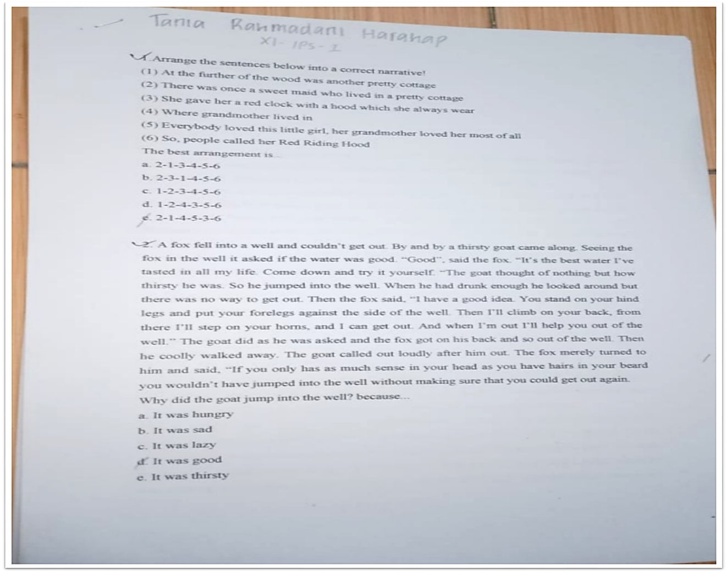

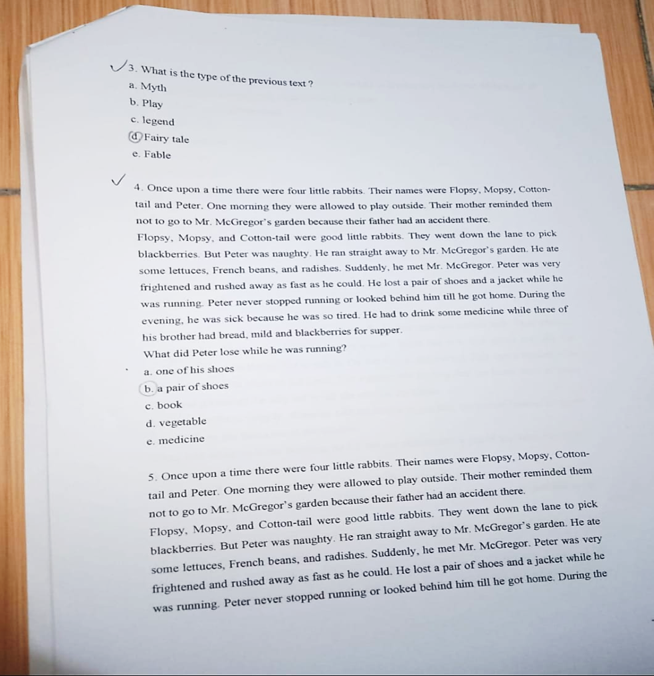

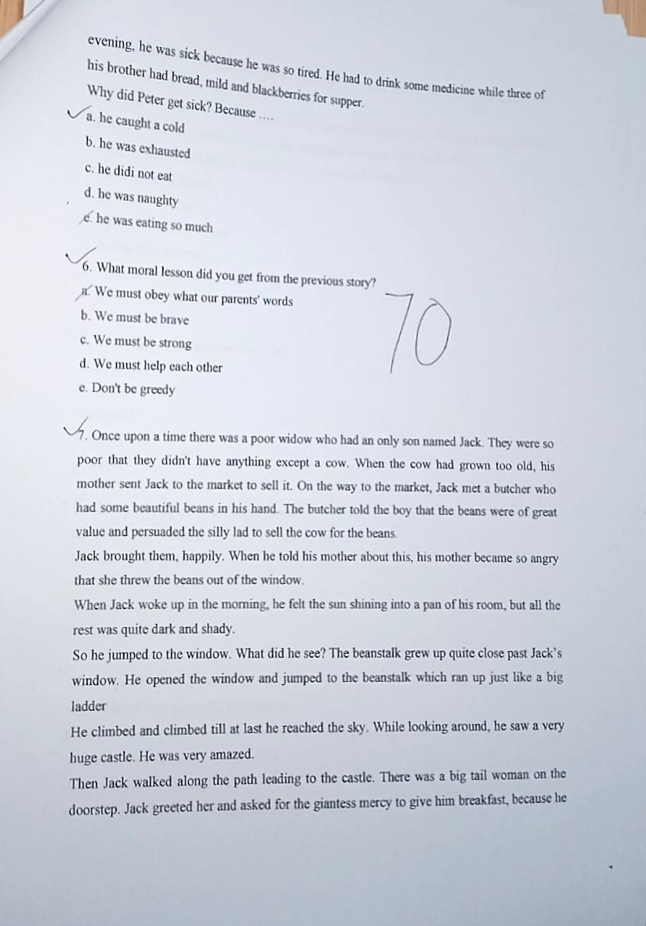

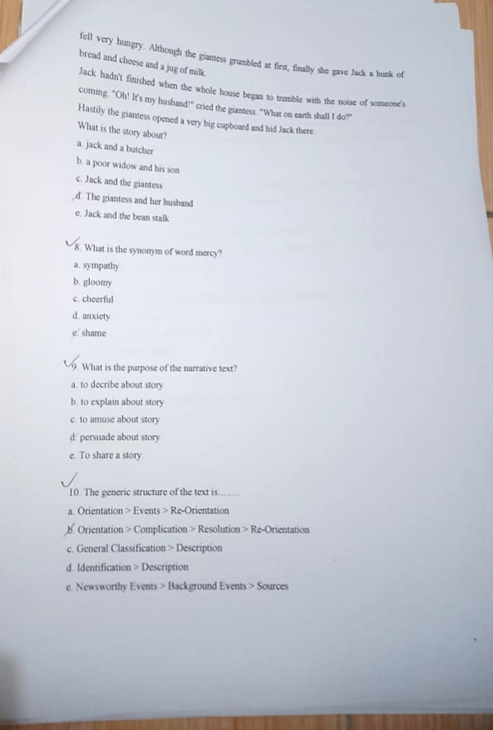

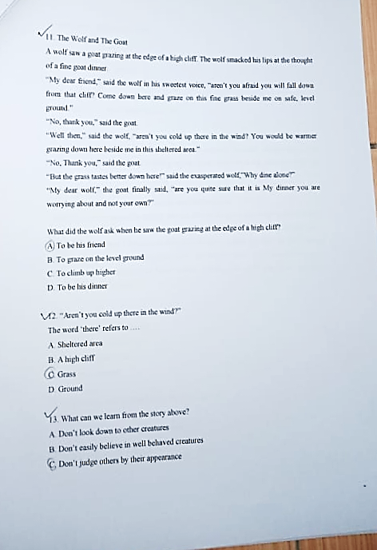

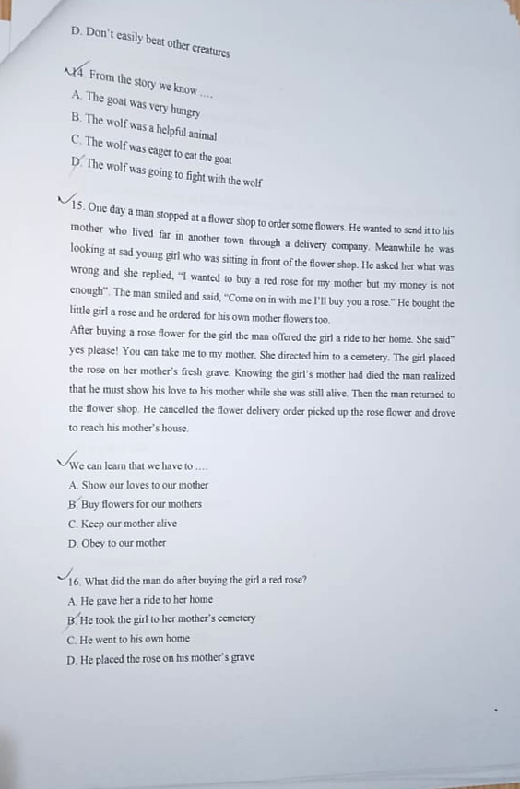

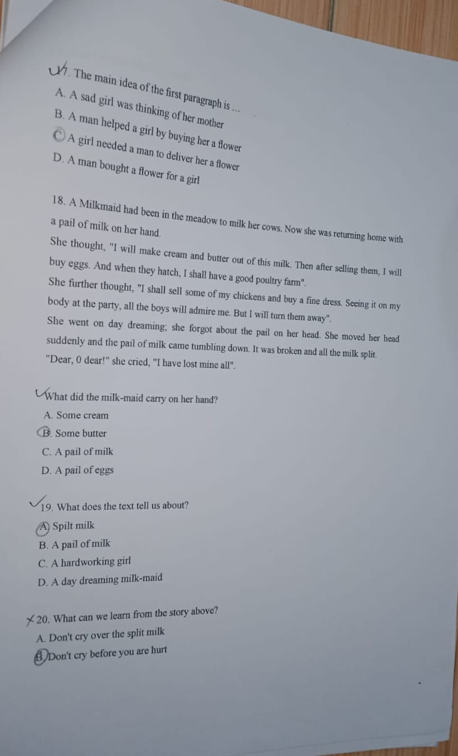

Appendix 3
Reading Test for Pre-Test and Post Test (Experiment Class)
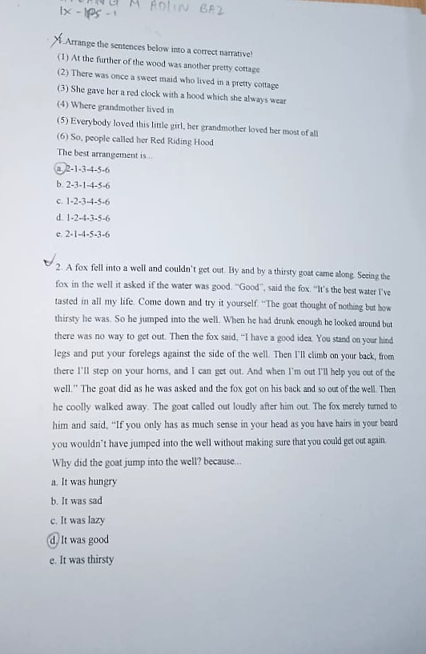

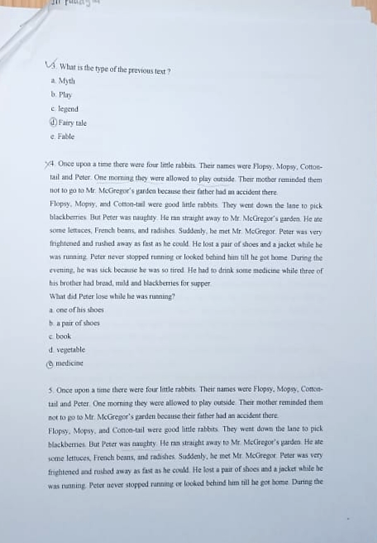

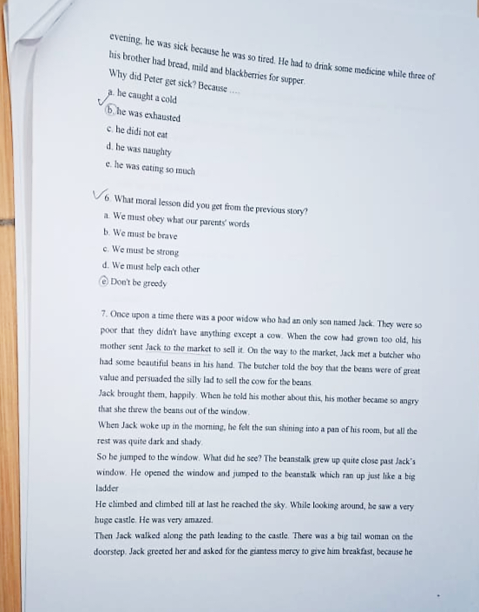

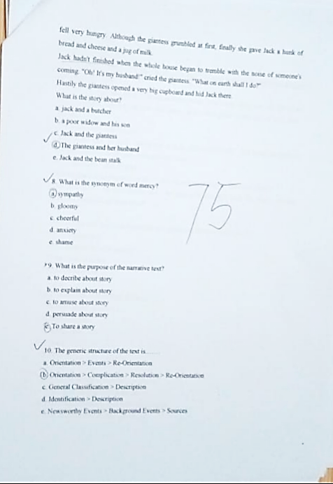

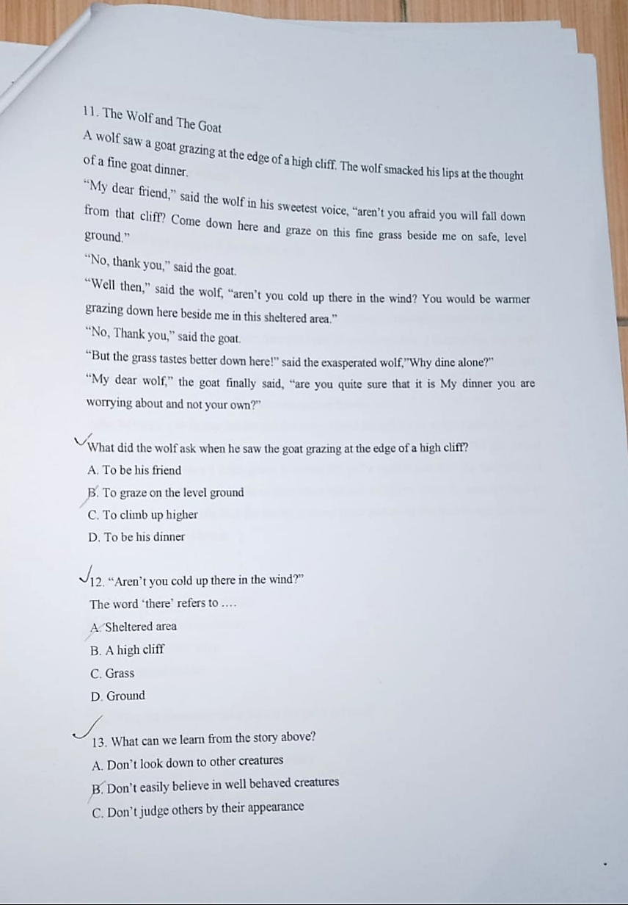
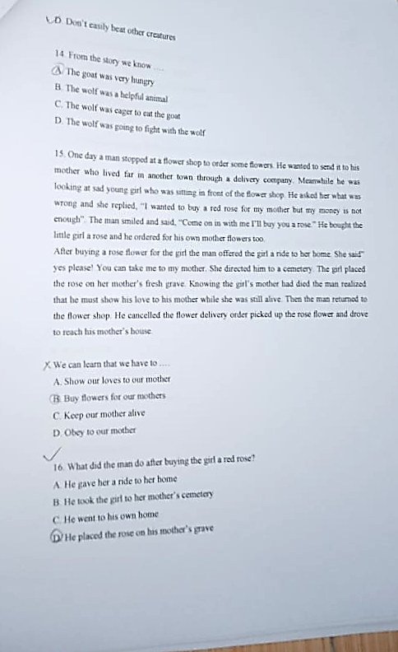

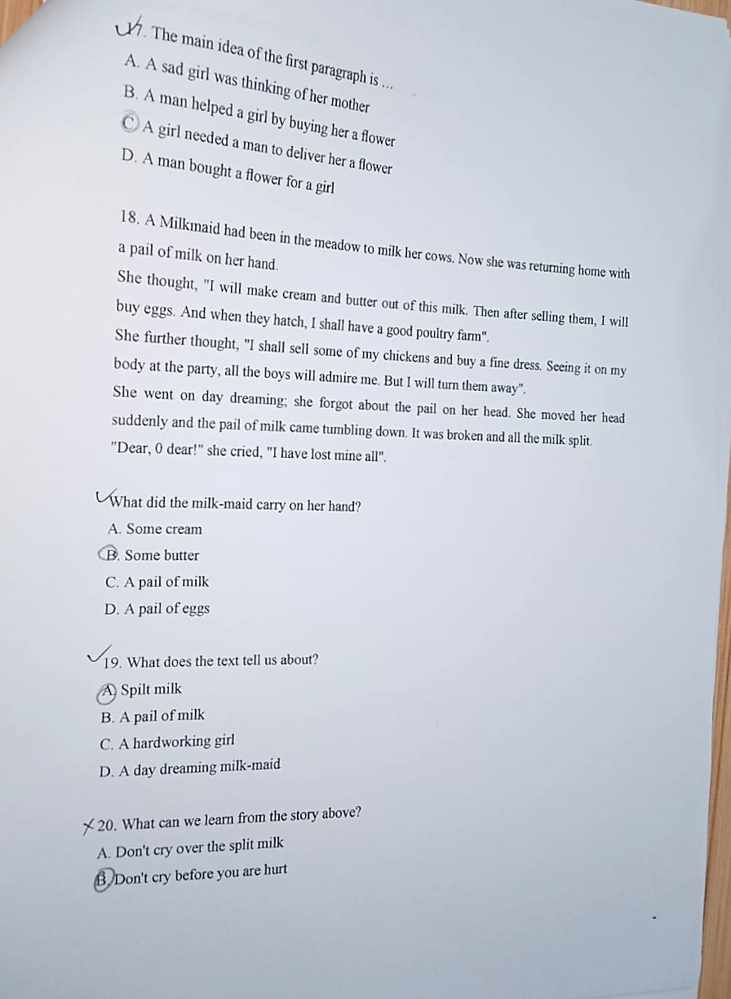

Appendix 4
DOCUMENTATION
Kelas Eksperimen
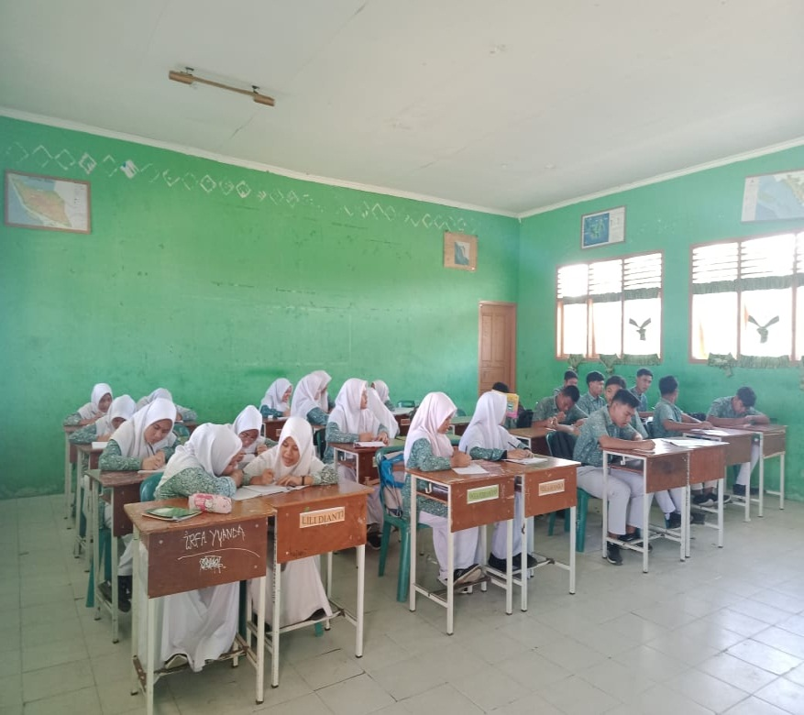
Kelas Control
