ACKNOWLEDGEMENT
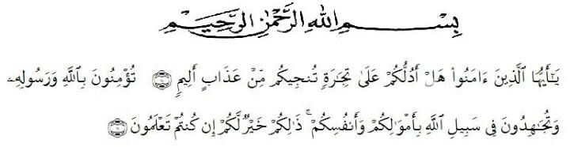
Artinya: “ Hai orang-orang yang beriman, maukah kamu aku tunjukkan suatu perniagaan yang dapat menyelamatkanmu dari azab yang pedih? (10). (yaitu) kamu beriman kepada Allah dan Rasul-nya dan berjihad di jalan Allah dengan harta dan jiwamu. Itulah yang lebih baik bagimu, jika kamu mengetahuinya. (11)”.
By saying Alhamdulillah all the praise and gratitude of the writer for the presence of Allah SWT, because thanks to grace and guidance, the preparation of a proposal entitled “ English Language Learning Motivation on Eight Grade Students at SMP Satria Dharma Perbaungan“ can be completed in order to fulfill one of the requirements in completing education at the Department of English Education Faculty of the Teacher Training and Education, the University of Muslim Nusantara Al Washliyah Medan.
Shalawat and Salam to our beloved Prophet Muhammad SAW, the greatest man ever who teaches us the kindness and good life in order to ben the good Muslim. We hope his salutation in future day.
In the process of finishing this thesis, the writer has been given many supports and valuable knowledge from many people. Therefore, the reseaecher would like to express her great appreciation and thanks:
- Dr. KRT. Hardi Mulyono K. Surbakti, as theRector of Universitas Muslim Nusantara Al Washliyah Medan.
- Drs. Samsul Bahri, M. Si, as the Dean of FKIP of Universitas Muslim Nusantara Al WAshliyah Medan.
- Zulfitri, S.S., M.A, as the Head of the English Education Department of Universitas Muslim Nusantara Al Washliyah Medan.
- YugiDiragaPrawiyata, S.Pd., M.Hum, as the consultant who give the suggestion toward the writer in finishing the thesis.
- All of the lecturers of the English Education Department of Universitas Muslim Nusantara Al Washliyah Medan.
- All of the Academic Administration Staff of Universitas Muslim Nusantara Al Washliyah Medan.
- Her beloved parents, Riwan and Suratmi, S.Ag and all her family, thank you for their support, motivation, patient and prayer.
- Her beloved little brother, Agung Wira Darma and Habib Azhar, thank you for being a good little brother.
- Her beloved friend’s Wahyuni Dwi Tiya, Windy Puspita, Widya Santiwi Br Simanjuntak, Sabrina Timami Putri, thank you so much for your help, care, and motivation until the end of present day.
- Her beloved sister, Fatma Sari, thank you so much for your care and enthusiasm given.
- All her friends, thank you so much for your support until the end of present day.
- Last but not least, I wanna thank me for believing in me, I wanna thank me for doing all this hard work, I wanna thank me for having no days off, I wanna thank me for never quitting, I wanna thank me for always being me at all times.

Medan,28 June 2022
The Researcher,

RizkaHasni

