ACKNOWLEDGEMENTS

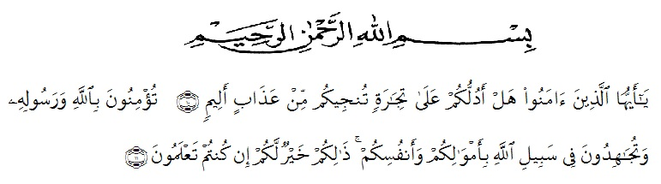

10. O ye who believe! Shall I show you a commerce that will save you from a painful doom? 11. Ye should believe in Allah and His messenger, and should strive for the cause of Allah with your wealth and your lives. That is better for you, if ye did but know.
As praise of thanks to Allah SWT, most gracious and most merciful, Firstly, I would like to thanks to the Almighty Allah SWT for all the blessing that gave to me for finishing this proposal.
Secondly, i also give my thanks because of blessing and peace be upon our Prophet Muhammad SAW, who has brought human being from the foolish era to the science era as we be held today, in completing of research, Many people given their participation such as their academic support. I realizes this proposal would not have been completed without support by family, lectures, friends and people around her while give great contibution. Therefore, in this research would like to delivery the writer’s thanks to :
1. Dr. KRT. Hardi Mulyono K. Surbakti., as a Rector of Muslim
Nusantara University Al Washliyah Medan.
2. Drs. Samsul Bahri, M.Si., as the Dekan of the Teachers’ Training and
Education Faculty of Muslim Nusantara University Al Washliyah
Medan.
3. Zulfitri, S.S.,M.A the head of the English Education Department
of Muslim Nusantara University Al Washliyah Medan.
4. Yusnita Nasution, S.Pd., M.Hum., the consultant who gives the command, critic and suggestion toward the writer in finishing the proposal.
5. All of the lecturers of the English Education Department of Muslim Nusantara University Al Washliyah Medan.
7. All of the Academic Administration Staffs of Muslim Nusantara University Al Washliyah Medan.
8. All of the Librarians of Muslim Nusantara University Al Washliyah Medan.
9. All her colleagues at the English department who always make her happy and many memories, and also her beloved friend Filza Khairunisa, S.Pd
- Her dearest parent Eny Rustam, S.S that give her spirit, support, motivation who she loves her forever and her grand father Sidi Rustam Tanjung, her grand mother Zuliana Chaniago who gives her support.
Finally, she admits that this proposal is still far from being perfect, therefore she would like to invite the readers to give some suggestions, comments, and criticism for the improvement of this proposal in the future. Furthermore, she expects it has meaningful contribution for teachers, students, and the readers.

Medan, 2021
The Reseacher

Nanda Aribah Ridhani

