**ACKNOWLEDGEMENT**

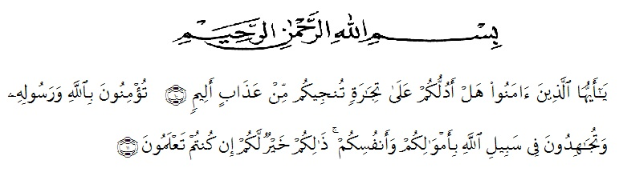

Artinya : “Hai orang-orang yang beriman, sukakah kamu aku tunjukkan suatu perniagaan yang dapat menyelamatkanmu dari adzab yang pedih. (10). Engkau beriman kepada Allah dan Rasulnya dan berjihad di jalan Allah dengan harta dan jiwamu. Itulah yang lebih baik bagimu jika kamu mengetahuinya. (11) (as-shaff ayat 10-11)” praise belongs to allah almighty, the lord of universe, by his guidance and blessings, the researcher can finish and complate this academic requirement. the researcher says peace be upon prophet Muhammad S.A.W who has brought the human beings from the darkness to the lightness and from the bad character to be good one. special gratitude and sincere thanks to researchers beloved father and mother , Hermansyah Lubis and Heni Susilawati who always pray for her, give her motivation, love, advice, supports and time.

this paper is written and intended to fulfill one of the requirements for award of bachelor degree at the English education department and teacher training faculty of Universitas Muslim Nusantara Al- Washliyah . the title of this thesis is " ***The Effect of Using Instagram Social Media On Students’ English Writing Skill of Procedure Text Eighth Grade of SMP Islam Al-Ulum Terpadu*** " in finishing this paper. The researcher got many valueble things from many people, such as supports, nice advice, suggestion, and help. therefor, the researcher wishes to express her sincere thanks to many different persons, they are:

On this occation the writer would like to give especially thanks to :

1. DR.KRT. H. Hardi Mulyon K. Surbakti., as the Rector of Universitas Muslim Nusantara Al Washliyah Medan.
2. Drs. Samsul Bahri, M.Si. as the Dean of faculty of Teacher Training and Education of Universitas Muslim Nusantara Al-Washliyah.
3. Zulfitri, S.S., M.A. The Head of English Education Department of FKIP Universitas Muslim Nusantara Al-Washliyah. who has given suggestion in implementing this research.
4. Wariyati, S.Pd., M.Hum as the consultant, who has given a lot of valuable suggestion, comments and criticism for completing this research.who has never stopped helping in guiding and correcting the pattern of this research.
5. Nurhafni Siregar, S.Pd., M.Hum as my examiner I, who has given a lot of valuable suggestions, comments and criticism for completing this research.
6. H. Asnawi, S.Pd., M.Hum as my examiner II, who has given a lot of valuable suggestions, comments and criticism for completing this research.
7. All lecturers, Especially those of English Education Department for their guidance, advices, suggestion, and encouragements during her academic years at Universitas Muslim Nusantara Al-Washliyah.
8. All of the academic administration staff of Universitas Muslim Nusantara Al-Washliyah.
9. Suhendrik, S.Pd. as the Headmaster of SMP Islam Al-Ulum Terpadu has given permission for her to conduct this research at that school.
10. The librarians of Universitas Muslim Nusantara Al-Washliyah. for the needed books in writing this research.
11. The Writer’s beloved parents (Hermansyah Lubis & Heni Susilawati ) who has given every effection, prayer, and endless support, and struggle and sacrifice which has been done for the writer so far.
12. Her beloved partner Boby Prayoga who has given her support, accompany, attention, and motivation for the writer to finish this skripsi.
13. Her adored friends, Dwi Ajeng Tristaknti, Bagas Wari Bogoh, Arni Mutiara Indah, Wika Hafsari M. Lubis . Thank you for giving support, motivation, help and for our togetherness and beautifull memories.
14. All the classmate regular a morning English Class and all her friends who had support and help her, may Allah bless them all.
15. Last but not least, I wanna thank me, I wanna thank me for believing in me, I wanna thank me for doing all this hard work, I wanna thank me for having no days, I wanna thank me for never quiting, I wanna thank me for tryna do more right than wrong, I wanna thank me for just being me at all times.

Finally, the researcher realizes that this thesis is still far from perfections. Therefore, constructive critiques and suggestion are needed in order to improvr this thesis . may Allah SWT always give guidance and blessing to us. *Aamiin Ya Rabbal Alaamiin.*

Medaan, Juli 2022

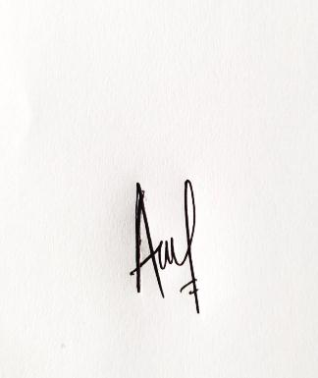The researcher,

**AIN TASZKIAH FADILLAH LUBIS**

**NPM : 181224072**