IMPROVING STUDENTS’ ABILITY IN WRITING PROCEDURE TEXT BY USING PROJECT-BASED LEARNING AT SECOND GRADE STUDENTS OF SMA SWASTA AL WASHLIYAH TANJUNG MORAWA

A THESIS

BY
INTAN SARI
NPM: 181224055

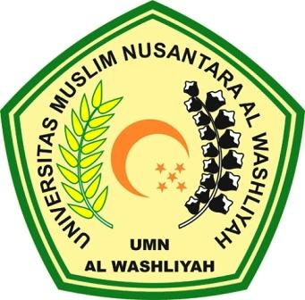

ENGLISH EDUCATION DEPARTMENT
FACULTY OF TEACHER TRAINING AND EDUCATION
UNIVERSITAS MUSLIM NUSANTARA AL WASHLIYAH
MEDAN
2022

