LAMPIRAN
Lampiran 1
KUESIONER PENELITIAN
      - IDENTITAS DIRI
Untuk keperluan keabsahan data penelitian ini, saya mengharapkan kepada Bapak/Ibu/Sdr/i untuk mengisi data-data berikut ini:
- Jenis Kelamin :
- Usia :
- Jenjang Pendidikan :
- Jabatan :

      - PETUNJUK PENGISIAN
- Bacalah setiap pernyataan dengan seksama.
- Isilah semua nomor dengan memilih satu diantara lima alternatif jawaban dengan memberikan tanda centang (✓) pada kolom yang sudah di tentukan.
- Alternatif jawaban adalah sebagai berikut:
STS = Sangat Tidak Setuju
TS = Tidak Setuju
KS = Kurang Setuju
S = Setuju
SS = Sangat Setuju
Kuesioner Variabel Bebas (X₁) Perspektif Pelanggan
No | Pernyataan | Jawaban
No | Pernyataan | SS | S | KS | TS | STS
Hubungan dengan Pelanggan
1 | PTPN III (Persero) konsisten dalam menjalankan prosedur pelayanan
2 | PTPN III (Persero) selalu berusaha memberikan bantuan dan perhatian atas keluhan dari pelanggan
3 | PTPN III (Persero) selalu berusaha dalam menjaga hubungan baik dengan pelanggan
4 | PTPN III (Persero) selalu berusaha menjaga kepercayaan pelanggan atas pelayanan yang diberikan
Reputasi Organisasi
5 | PTPN III (Persero) merupakan perusahaan yang memiliki kemampuan bersaing dengan para pesaingnya
6 | PTPN III (Persero) melaksanakan tanggung jawab sosial
7 | PTPN III (Persero) merupakan tempat kerja yang baik bagi karyawannya
8 | PTPN III (Persero) menyediakan produk-produk yang baik dengan pelayanan yang baik
Atribut Produk
9 | PTPN III (Persero) menghasilkan produk berkualitas untuk memuaskan pelanggan
10 | PTPN III (Persero) mengutamakan mutu produk untuk menarik pelanggan

Kuesioner Variabel Bebas (X₂) Perspektif Proses Bisnis Internal
No | Pernyataan | Jawaban
No | Pernyataan | SS | S | KS | TS | STS
Proses Inovasi
1 | PTPN III (Persero) selalu berinovasi untuk mengembangkan produk baru
2 | PTPN III (Persero) selalu meneliti untuk mengambangkan suatu produknya agar diterima oleh pelanggan
3 | PTPN III (Persero) menggunakan teknologi (mesin) baru dalam memproduksi produk dalam beberapa periode tertentu
4 | PTPN III (Persero) menggunakan jenis bahan baku lain selain bahan baku utama agar tercipta produk yang lebih inovatif
Proses Operasi
5 | PTPN III (Persero) selalu menyesuaikan proses operasinya dengan teknologi baru
6 | PTPN III (Persero) dalam melakukan kegiatan operasinya sudah sesuai dengan target biaya, waktu dan kualitas
7 | PTPN III (Persero) selalu melakukan evaluasi dan perbaikan berkelanjutan dalam operasi untuk meningkatkan kualitas pelayanan
Layanan Purna Jual
8 | PTPN III (Persero) melakukan layanan purna jual untuk mengatasi keluhan pelanggan
9 | PTPN III (Persero) menggunakan aplikasi website sebagai media penjualan sekaligus transaksi
10 | PTPN III (Persero) memberikan garansi produk jika tejadi kerusakan akibat produksi

Kuesioner Variabel Bebas (X₃) Perspektif Pembelajaran dan Pertumbuhan
No | Pernyataan | Jawaban
No | Pernyataan | SS | S | KS | TS | STS
Infrastruktur Teknologi
1 | Fasilitas yang disediakan PTPN III (Persero) sudah menunjang pekerjaan setiap karyawan
2 | Setiap karyawan dapat mengakses semua informasi yang ada di dalam perusahaan
3 | Sistem Informasi yang diterapkan oleh PTPN III (Persero) sudah memenuhi standar
4 | Tingkat ketepatan/ keakuratan informasi yang diterapkan PTPN III (Persero) sudah memenuhi standar
Kultur Organisasi
5 | PTPN III (Persero) mendorong unit-unit organisasi untuk berkerja dengan cara yang terkoordinasi untuk meningkatkan kualitas dan kuantitas pekerjaan yang dihasilkan
6 | Tenaga pengawas seperti atasan atau tim khusus membantu mengontrol untuk mengendalikan perilaku karyawan dalam perusahaan
7 | Karyawan mampu mengidentifikasikan dirinya sebagai satu kesatuan dalam perusahaan bukan sebagai kelompok kerja atau keahlian profesional tertentu.
Kompetensi Karyawan
8 | PTPN III (Persero) memberikan reward berupa kenaikan golongan kepada karyawan yang dapat memberikan ide-ide kreatif dan inovatif untuk perubahan, perbaikan dan peningkatan metode kerja setiap tahunnya
9 | PTPN III (Persero) melakukan peningkatan kinerja dengan pelatihan dan pendidikan
10 | PTPN III (Persero) rutin mengadakan seminar untuk meningkatkan kualitas sumber daya karyawan
Kuesioner Variabel Terikat (Y) Kinerja Keuangan
No | Pernyataan | Jawaban
No | Pernyataan | SS | S | KS | TS | STS
Kecukupan Modal (CAR)
1 | Modal dapat menjalankan operasional PTPN III (Persero) dengan baik
2 | PTPN III (Persero) sering mendapatkan tawaran dari pihak pembiayaan sebagai modal tambahan dari lembaga keuangan seperti koperasi, bank dll
3 | Besarnya modal yang PTPN III (Persero) miliki mampu memenuhi kebutuhan produksi dan berpengaruh terhadap pendapatan yang akan diterima
Likuiditas
4 | PTPN III (Persero) dalam mengelola dan mengendalikan likuiditas tidak mengorbankan rentabilitas
5 | PTPN III (Persero) melakukan pemantauan dan pencatatan tagihan dan kewajiban jatuh tempo untuk mencegah kemungkinan timbulnya kesulitan likuiditas
6 | PTPN III (Persero) mengantisipasi kemungkinan terjadinya mismatch antara sumber dan penanaman dana
Profitabilitas
7 | Keuntungan yang diperoleh PTPN III (Persero) sudah sesuai dengan modal yang dikeluarkan
8 | Keuntungan yang diperoleh PTPN III (Persero) dipengaruhi oleh modal dan tenaga kerja yang dimiliki
9 | PTPN III (Persero) melengkapi peralatan produksi dengan keuntungan yang ada
10 | Biaya membeli bahan baku dan upah tenaga kerja tidak menghabiskan pendapatan yang didapatkan PTPN III (Persero) dari hasil produksi

Lampiran 2
Data Tabulasi Variabel X₁ (Perspektif Pelanggan)
DATA TABULASI PERSPEKTIF PELANGGAN (X₁)
NO RESPONDEN | NO. ITEM PERNYATAAN |  |  |  |  |  |  |  |  |  | JUMLAH
NO RESPONDEN | 1 | 2 | 3 | 4 | 5 | 6 | 7 | 8 | 9 | 10 | JUMLAH
1 | 5 | 5 | 5 | 5 | 5 | 4 | 4 | 4 | 5 | 5 | 47
2 | 4 | 4 | 4 | 4 | 4 | 4 | 4 | 4 | 4 | 4 | 40
3 | 5 | 5 | 5 | 5 | 5 | 5 | 5 | 5 | 5 | 5 | 50
4 | 5 | 5 | 5 | 5 | 5 | 5 | 5 | 5 | 5 | 5 | 50
5 | 4 | 4 | 4 | 4 | 4 | 4 | 4 | 4 | 4 | 4 | 40
6 | 4 | 4 | 4 | 4 | 4 | 4 | 4 | 4 | 4 | 4 | 40
7 | 5 | 5 | 5 | 5 | 4 | 5 | 5 | 5 | 5 | 5 | 49
8 | 5 | 4 | 5 | 5 | 5 | 5 | 4 | 5 | 5 | 4 | 47
9 | 4 | 4 | 4 | 4 | 4 | 4 | 4 | 4 | 4 | 4 | 40
10 | 4 | 2 | 4 | 4 | 4 | 5 | 4 | 5 | 5 | 5 | 42
11 | 5 | 4 | 5 | 4 | 5 | 4 | 5 | 4 | 5 | 4 | 45
12 | 4 | 3 | 4 | 4 | 4 | 4 | 4 | 4 | 4 | 4 | 39
13 | 5 | 3 | 4 | 4 | 4 | 4 | 5 | 4 | 5 | 4 | 42
14 | 4 | 3 | 4 | 4 | 4 | 4 | 4 | 5 | 4 | 5 | 41
15 | 5 | 3 | 4 | 4 | 4 | 3 | 4 | 4 | 4 | 4 | 39
16 | 5 | 3 | 4 | 4 | 4 | 4 | 4 | 4 | 4 | 4 | 40
17 | 5 | 4 | 5 | 4 | 5 | 5 | 5 | 4 | 5 | 4 | 46
18 | 4 | 4 | 4 | 4 | 4 | 4 | 4 | 4 | 5 | 4 | 41
19 | 5 | 5 | 4 | 4 | 4 | 5 | 4 | 4 | 5 | 4 | 44
20 | 5 | 5 | 5 | 5 | 5 | 5 | 5 | 5 | 5 | 5 | 50
21 | 5 | 5 | 5 | 5 | 5 | 5 | 5 | 5 | 5 | 5 | 50
22 | 5 | 5 | 5 | 4 | 4 | 4 | 4 | 4 | 4 | 4 | 43
23 | 4 | 3 | 4 | 4 | 3 | 3 | 4 | 3 | 4 | 3 | 35
24 | 4 | 4 | 4 | 4 | 4 | 4 | 4 | 4 | 4 | 4 | 40
25 | 4 | 4 | 4 | 4 | 4 | 4 | 4 | 4 | 4 | 4 | 40
26 | 4 | 4 | 4 | 4 | 4 | 4 | 4 | 4 | 4 | 4 | 40
27 | 4 | 4 | 4 | 4 | 4 | 4 | 4 | 4 | 4 | 4 | 40
28 | 5 | 5 | 5 | 5 | 5 | 5 | 4 | 5 | 5 | 5 | 49
29 | 5 | 5 | 5 | 5 | 5 | 5 | 5 | 5 | 5 | 5 | 50
30 | 1 | 1 | 1 | 1 | 1 | 1 | 1 | 1 | 1 | 1 | 10
31 | 5 | 4 | 4 | 5 | 5 | 4 | 4 | 4 | 5 | 5 | 45
32 | 4 | 4 | 4 | 4 | 4 | 4 | 4 | 4 | 4 | 4 | 40
33 | 4 | 4 | 4 | 4 | 4 | 4 | 4 | 4 | 4 | 4 | 40
34 | 5 | 4 | 5 | 5 | 4 | 4 | 4 | 4 | 4 | 4 | 43
35 | 4 | 2 | 4 | 4 | 4 | 5 | 4 | 5 | 5 | 5 | 42
36 | 5 | 4 | 5 | 4 | 5 | 4 | 5 | 4 | 5 | 4 | 45
37 | 4 | 3 | 4 | 4 | 4 | 4 | 4 | 4 | 4 | 4 | 39
38 | 5 | 3 | 4 | 4 | 4 | 4 | 5 | 4 | 5 | 4 | 42
39 | 4 | 3 | 4 | 4 | 4 | 4 | 4 | 5 | 4 | 5 | 41
40 | 4 | 3 | 4 | 3 | 4 | 4 | 4 | 4 | 4 | 4 | 38
41 | 3 | 2 | 5 | 4 | 2 | 3 | 5 | 4 | 4 | 2 | 34
42 | 4 | 4 | 4 | 4 | 4 | 4 | 4 | 4 | 5 | 5 | 42
43 | 5 | 5 | 5 | 5 | 4 | 4 | 4 | 4 | 5 | 5 | 46
44 | 5 | 5 | 5 | 5 | 5 | 5 | 5 | 5 | 5 | 5 | 50
45 | 5 | 5 | 5 | 4 | 5 | 4 | 4 | 4 | 5 | 4 | 45
46 | 4 | 4 | 4 | 4 | 5 | 5 | 5 | 5 | 4 | 4 | 44
47 | 4 | 4 | 4 | 4 | 5 | 5 | 5 | 5 | 4 | 4 | 44
48 | 4 | 4 | 4 | 4 | 4 | 4 | 4 | 4 | 4 | 4 | 40
49 | 4 | 4 | 5 | 5 | 5 | 5 | 4 | 4 | 5 | 5 | 46
50 | 5 | 5 | 5 | 5 | 4 | 4 | 4 | 4 | 5 | 4 | 45
51 | 4 | 4 | 4 | 4 | 4 | 4 | 4 | 4 | 4 | 4 | 40
52 | 3 | 4 | 4 | 2 | 2 | 1 | 4 | 2 | 3 | 1 | 26
53 | 5 | 4 | 4 | 5 | 4 | 5 | 4 | 3 | 4 | 4 | 42
54 | 4 | 3 | 4 | 3 | 2 | 1 | 2 | 3 | 4 | 2 | 28
55 | 4 | 3 | 4 | 3 | 3 | 3 | 2 | 1 | 3 | 4 | 30
56 | 5 | 3 | 2 | 4 | 4 | 4 | 4 | 4 | 1 | 1 | 32
TOTAL | 245 | 216 | 239 | 232 | 230 | 228 | 232 | 228 | 241 | 227 | 2318

Lampiran 3
Data Tabulasi Variabel X₂ (Perspektif Proses Bisnis Internal)
DATA TABULASI PERSPEKTIF PROSES BISNIS INTERNAL (X₂)
NO RESPONDEN | NO. ITEM PERNYATAAN |  |  |  |  |  |  |  |  |  | JUMLAH
NO RESPONDEN | 1 | 2 | 3 | 4 | 5 | 6 | 7 | 8 | 9 | 10 | JUMLAH
1 | 4 | 4 | 4 | 5 | 5 | 5 | 5 | 4 | 5 | 5 | 46
2 | 4 | 4 | 3 | 3 | 4 | 4 | 4 | 4 | 4 | 4 | 38
3 | 5 | 5 | 5 | 5 | 5 | 5 | 5 | 5 | 5 | 5 | 50
4 | 5 | 5 | 5 | 5 | 5 | 5 | 5 | 5 | 5 | 5 | 50
5 | 4 | 4 | 4 | 4 | 4 | 4 | 4 | 4 | 5 | 4 | 41
6 | 2 | 2 | 2 | 2 | 4 | 4 | 4 | 4 | 5 | 4 | 33
7 | 5 | 5 | 5 | 5 | 5 | 5 | 5 | 5 | 5 | 5 | 50
8 | 4 | 3 | 4 | 4 | 3 | 3 | 4 | 3 | 4 | 3 | 35
9 | 4 | 4 | 4 | 4 | 4 | 4 | 4 | 4 | 4 | 4 | 40
10 | 4 | 4 | 4 | 4 | 4 | 4 | 4 | 4 | 4 | 4 | 40
11 | 4 | 4 | 4 | 4 | 4 | 4 | 4 | 4 | 4 | 4 | 40
12 | 4 | 4 | 4 | 4 | 4 | 4 | 4 | 4 | 4 | 4 | 40
13 | 5 | 3 | 3 | 3 | 4 | 3 | 3 | 4 | 4 | 4 | 36
14 | 4 | 4 | 5 | 5 | 4 | 5 | 4 | 5 | 5 | 5 | 46
15 | 5 | 3 | 4 | 4 | 4 | 3 | 4 | 4 | 4 | 4 | 39
16 | 5 | 3 | 4 | 4 | 4 | 4 | 4 | 4 | 4 | 4 | 40
17 | 5 | 4 | 5 | 4 | 5 | 5 | 5 | 4 | 5 | 4 | 46
18 | 4 | 4 | 4 | 4 | 4 | 4 | 4 | 4 | 5 | 4 | 41
19 | 5 | 5 | 4 | 4 | 4 | 5 | 4 | 4 | 5 | 4 | 44
20 | 5 | 5 | 5 | 5 | 5 | 5 | 5 | 5 | 5 | 5 | 50
21 | 5 | 5 | 5 | 5 | 5 | 5 | 5 | 5 | 5 | 5 | 50
22 | 4 | 4 | 4 | 4 | 4 | 4 | 4 | 4 | 5 | 4 | 41
23 | 5 | 5 | 5 | 4 | 4 | 5 | 5 | 4 | 5 | 4 | 46
24 | 4 | 4 | 4 | 4 | 4 | 4 | 4 | 4 | 5 | 4 | 41
25 | 4 | 4 | 4 | 4 | 4 | 4 | 4 | 4 | 5 | 4 | 41
26 | 4 | 4 | 4 | 4 | 4 | 4 | 4 | 4 | 5 | 4 | 41
27 | 4 | 4 | 4 | 4 | 3 | 4 | 4 | 4 | 5 | 4 | 40
28 | 4 | 4 | 4 | 5 | 4 | 4 | 4 | 4 | 5 | 4 | 42
29 | 5 | 5 | 5 | 5 | 5 | 5 | 5 | 5 | 5 | 5 | 50
30 | 1 | 1 | 1 | 1 | 1 | 1 | 1 | 1 | 1 | 1 | 10
31 | 4 | 4 | 4 | 4 | 5 | 5 | 4 | 4 | 5 | 4 | 43
32 | 4 | 4 | 4 | 4 | 4 | 4 | 4 | 4 | 5 | 4 | 41
33 | 4 | 4 | 4 | 4 | 4 | 4 | 4 | 4 | 5 | 4 | 41
34 | 4 | 4 | 4 | 4 | 5 | 4 | 4 | 4 | 5 | 4 | 42
35 | 5 | 5 | 4 | 5 | 4 | 4 | 4 | 4 | 5 | 4 | 44
36 | 4 | 5 | 4 | 4 | 5 | 4 | 4 | 4 | 5 | 4 | 43
37 | 4 | 4 | 4 | 4 | 4 | 4 | 4 | 4 | 5 | 4 | 41
38 | 4 | 4 | 4 | 4 | 4 | 4 | 4 | 4 | 5 | 4 | 41
39 | 5 | 3 | 3 | 3 | 4 | 3 | 3 | 4 | 4 | 4 | 36
40 | 4 | 4 | 5 | 5 | 4 | 5 | 4 | 5 | 5 | 5 | 46
41 | 5 | 3 | 4 | 4 | 4 | 3 | 4 | 4 | 4 | 4 | 39
42 | 5 | 3 | 4 | 4 | 4 | 4 | 4 | 4 | 4 | 4 | 40
43 | 5 | 3 | 5 | 5 | 5 | 4 | 5 | 5 | 5 | 5 | 47
44 | 4 | 4 | 4 | 4 | 4 | 4 | 4 | 4 | 5 | 4 | 41
45 | 4 | 4 | 4 | 4 | 4 | 4 | 4 | 4 | 5 | 4 | 41
46 | 4 | 4 | 4 | 4 | 5 | 5 | 5 | 4 | 5 | 4 | 44
47 | 4 | 5 | 4 | 5 | 4 | 5 | 4 | 5 | 5 | 5 | 46
48 | 5 | 4 | 5 | 4 | 4 | 4 | 5 | 4 | 5 | 4 | 44
49 | 4 | 4 | 5 | 4 | 5 | 5 | 4 | 4 | 5 | 5 | 45
50 | 4 | 5 | 4 | 5 | 4 | 5 | 4 | 5 | 5 | 5 | 46
51 | 4 | 4 | 4 | 4 | 3 | 4 | 4 | 3 | 5 | 4 | 39
52 | 1 | 4 | 3 | 4 | 4 | 1 | 3 | 1 | 5 | 4 | 30
53 | 5 | 3 | 4 | 4 | 3 | 2 | 1 | 4 | 5 | 2 | 33
54 | 3 | 4 | 4 | 3 | 3 | 2 | 2 | 1 | 5 | 2 | 29
55 | 4 | 5 | 5 | 4 | 5 | 5 | 4 | 4 | 5 | 4 | 45
56 | 3 | 3 | 2 | 3 | 3 | 4 | 4 | 3 | 5 | 1 | 31
TOTAL | 233 | 222 | 227 | 228 | 230 | 227 | 225 | 223 | 264 | 226 | 2305

Lampiran 4
Data Tabulasi Variabel X₃ (Perspektif Pembelajaran dan Pertumbuhan)
DATA TABULASI PERSPEKTIF PEMBELAJARAN DAN PERTUMBUHAN (X₃)
NO RESPONDEN | NO. ITEM PERNYATAAN |  |  |  |  |  |  |  |  |  | JUMLAH
NO RESPONDEN | 1 | 2 | 3 | 4 | 5 | 6 | 7 | 8 | 9 | 10 | JUMLAH
1 | 4 | 4 | 5 | 5 | 4 | 4 | 5 | 5 | 4 | 5 | 45
2 | 4 | 4 | 4 | 4 | 4 | 4 | 4 | 4 | 4 | 4 | 40
3 | 5 | 5 | 5 | 5 | 5 | 5 | 5 | 5 | 5 | 5 | 50
4 | 5 | 5 | 5 | 5 | 5 | 5 | 5 | 5 | 5 | 5 | 50
5 | 4 | 4 | 4 | 4 | 4 | 4 | 4 | 4 | 4 | 4 | 40
6 | 4 | 4 | 4 | 4 | 4 | 4 | 4 | 4 | 4 | 4 | 40
7 | 5 | 5 | 5 | 5 | 5 | 5 | 5 | 5 | 5 | 5 | 50
8 | 4 | 3 | 4 | 4 | 4 | 4 | 4 | 5 | 4 | 4 | 40
9 | 4 | 3 | 4 | 4 | 4 | 4 | 4 | 4 | 4 | 4 | 39
10 | 5 | 5 | 5 | 5 | 5 | 5 | 4 | 5 | 5 | 5 | 49
11 | 5 | 5 | 5 | 5 | 5 | 5 | 5 | 5 | 5 | 5 | 50
12 | 5 | 4 | 5 | 5 | 5 | 4 | 5 | 5 | 5 | 4 | 47
13 | 5 | 4 | 5 | 5 | 5 | 4 | 5 | 5 | 5 | 4 | 47
14 | 5 | 4 | 5 | 5 | 5 | 4 | 5 | 5 | 5 | 4 | 47
15 | 5 | 4 | 5 | 5 | 5 | 4 | 5 | 5 | 5 | 4 | 47
16 | 5 | 5 | 5 | 5 | 5 | 5 | 5 | 5 | 5 | 5 | 50
17 | 5 | 4 | 5 | 5 | 5 | 4 | 5 | 5 | 5 | 4 | 47
18 | 4 | 4 | 4 | 4 | 4 | 4 | 4 | 4 | 4 | 4 | 40
19 | 4 | 4 | 5 | 5 | 4 | 4 | 4 | 4 | 4 | 5 | 43
20 | 5 | 5 | 5 | 5 | 5 | 5 | 5 | 5 | 5 | 5 | 50
21 | 5 | 5 | 5 | 5 | 5 | 5 | 5 | 5 | 5 | 5 | 50
22 | 4 | 4 | 4 | 4 | 4 | 4 | 3 | 4 | 4 | 4 | 39
23 | 5 | 4 | 4 | 4 | 4 | 4 | 4 | 4 | 5 | 5 | 43
24 | 4 | 4 | 4 | 4 | 4 | 4 | 4 | 5 | 5 | 4 | 42
25 | 4 | 4 | 4 | 4 | 4 | 4 | 4 | 4 | 4 | 4 | 40
26 | 4 | 4 | 4 | 4 | 4 | 4 | 4 | 4 | 4 | 4 | 40
27 | 4 | 4 | 4 | 4 | 4 | 4 | 4 | 4 | 4 | 4 | 40
28 | 4 | 4 | 4 | 4 | 4 | 4 | 4 | 4 | 4 | 4 | 40
29 | 5 | 5 | 5 | 5 | 5 | 5 | 5 | 5 | 5 | 5 | 50
30 | 1 | 1 | 1 | 1 | 1 | 1 | 1 | 1 | 1 | 1 | 10
31 | 4 | 4 | 4 | 4 | 5 | 5 | 4 | 5 | 5 | 5 | 45
32 | 4 | 4 | 4 | 4 | 4 | 4 | 4 | 3 | 3 | 3 | 37
33 | 4 | 4 | 4 | 4 | 4 | 4 | 4 | 4 | 4 | 4 | 40
34 | 4 | 4 | 4 | 4 | 5 | 4 | 4 | 5 | 4 | 4 | 42
35 | 4 | 4 | 4 | 4 | 4 | 4 | 5 | 4 | 4 | 5 | 42
36 | 4 | 4 | 4 | 4 | 4 | 4 | 4 | 4 | 4 | 4 | 40
37 | 4 | 4 | 4 | 4 | 4 | 4 | 4 | 4 | 4 | 4 | 40
38 | 4 | 4 | 4 | 4 | 4 | 4 | 4 | 4 | 4 | 4 | 40
39 | 5 | 5 | 5 | 5 | 4 | 5 | 4 | 4 | 4 | 4 | 45
40 | 5 | 5 | 5 | 5 | 4 | 4 | 4 | 5 | 4 | 5 | 46
41 | 5 | 3 | 3 | 3 | 4 | 3 | 3 | 4 | 4 | 4 | 36
42 | 4 | 4 | 5 | 5 | 4 | 5 | 4 | 5 | 5 | 5 | 46
43 | 5 | 3 | 4 | 4 | 4 | 3 | 4 | 4 | 4 | 4 | 39
44 | 5 | 3 | 4 | 4 | 4 | 4 | 4 | 4 | 4 | 4 | 40
45 | 5 | 3 | 5 | 5 | 5 | 4 | 5 | 5 | 5 | 5 | 47
46 | 4 | 2 | 4 | 4 | 4 | 5 | 4 | 5 | 5 | 5 | 42
47 | 5 | 4 | 5 | 4 | 5 | 4 | 5 | 4 | 5 | 4 | 45
48 | 4 | 3 | 4 | 4 | 4 | 4 | 4 | 4 | 4 | 4 | 39
49 | 5 | 3 | 4 | 4 | 4 | 4 | 5 | 4 | 5 | 4 | 42
50 | 4 | 3 | 4 | 4 | 4 | 4 | 4 | 5 | 4 | 5 | 41
51 | 4 | 3 | 4 | 3 | 4 | 4 | 4 | 4 | 4 | 4 | 38
52 | 3 | 2 | 1 | 4 | 2 | 3 | 1 | 4 | 4 | 2 | 26
53 | 5 | 4 | 4 | 4 | 3 | 3 | 4 | 4 | 4 | 4 | 39
54 | 4 | 4 | 3 | 4 | 4 | 4 | 3 | 2 | 2 | 2 | 32
55 | 4 | 3 | 4 | 4 | 4 | 4 | 4 | 4 | 4 | 4 | 39
56 | 2 | 3 | 4 | 3 | 3 | 4 | 3 | 2 | 1 | 1 | 26
TOTAL | 242 | 216 | 237 | 238 | 235 | 230 | 232 | 240 | 237 | 232 | 2339

Lampiran 5
Data Tabulasi Variabel Y (Kinerja Keuangan)
DATA TABULASI KINERJA KEUANGAN (Y)
NO RESPONDEN | NO. ITEM PERNYATAAN |  |  |  |  |  |  |  |  |  | JUMLAH
NO RESPONDEN | 1 | 2 | 3 | 4 | 5 | 6 | 7 | 8 | 9 | 10 | JUMLAH
1 | 5 | 4 | 4 | 4 | 5 | 4 | 4 | 4 | 4 | 5 | 43
2 | 4 | 3 | 3 | 4 | 4 | 4 | 4 | 4 | 4 | 4 | 38
3 | 5 | 5 | 5 | 5 | 5 | 5 | 5 | 5 | 5 | 5 | 50
4 | 5 | 5 | 5 | 5 | 5 | 5 | 5 | 5 | 5 | 5 | 50
5 | 4 | 4 | 4 | 4 | 4 | 4 | 4 | 4 | 4 | 4 | 40
6 | 4 | 4 | 4 | 4 | 4 | 4 | 4 | 4 | 4 | 4 | 40
7 | 5 | 5 | 5 | 5 | 5 | 5 | 5 | 5 | 5 | 5 | 50
8 | 4 | 4 | 4 | 4 | 4 | 4 | 4 | 4 | 4 | 4 | 40
9 | 4 | 4 | 4 | 4 | 4 | 4 | 4 | 4 | 4 | 4 | 40
10 | 5 | 4 | 5 | 5 | 5 | 4 | 4 | 5 | 5 | 4 | 46
11 | 5 | 5 | 5 | 5 | 5 | 5 | 5 | 5 | 5 | 5 | 50
12 | 4 | 3 | 4 | 4 | 5 | 4 | 4 | 4 | 5 | 5 | 42
13 | 4 | 3 | 4 | 4 | 5 | 4 | 4 | 4 | 5 | 5 | 42
14 | 4 | 3 | 4 | 4 | 5 | 4 | 4 | 4 | 5 | 5 | 42
15 | 4 | 3 | 4 | 4 | 5 | 4 | 4 | 4 | 5 | 5 | 42
16 | 5 | 4 | 4 | 4 | 4 | 4 | 4 | 4 | 4 | 4 | 41
17 | 4 | 3 | 4 | 4 | 5 | 4 | 4 | 4 | 5 | 5 | 42
18 | 4 | 3 | 4 | 4 | 4 | 4 | 4 | 4 | 3 | 4 | 38
19 | 4 | 4 | 4 | 4 | 4 | 4 | 4 | 4 | 5 | 4 | 41
20 | 5 | 5 | 5 | 5 | 5 | 5 | 5 | 5 | 5 | 5 | 50
21 | 5 | 3 | 5 | 5 | 5 | 5 | 5 | 5 | 5 | 5 | 48
22 | 4 | 3 | 4 | 4 | 3 | 3 | 4 | 3 | 4 | 3 | 35
23 | 4 | 4 | 4 | 4 | 4 | 4 | 4 | 4 | 4 | 4 | 40
24 | 4 | 4 | 4 | 4 | 4 | 4 | 4 | 4 | 4 | 4 | 40
25 | 4 | 4 | 4 | 4 | 4 | 4 | 4 | 4 | 4 | 4 | 40
26 | 4 | 4 | 4 | 4 | 4 | 4 | 4 | 4 | 4 | 4 | 40
27 | 4 | 4 | 4 | 4 | 4 | 4 | 4 | 4 | 4 | 4 | 40
28 | 4 | 4 | 4 | 4 | 4 | 4 | 4 | 5 | 4 | 4 | 41
29 | 5 | 5 | 5 | 5 | 5 | 5 | 5 | 5 | 5 | 5 | 50
30 | 1 | 1 | 1 | 1 | 1 | 1 | 1 | 1 | 1 | 1 | 10
31 | 4 | 4 | 4 | 4 | 4 | 4 | 4 | 4 | 4 | 4 | 40
32 | 4 | 4 | 4 | 4 | 4 | 4 | 4 | 4 | 4 | 4 | 40
33 | 4 | 4 | 4 | 4 | 4 | 4 | 4 | 4 | 4 | 4 | 40
34 | 4 | 4 | 4 | 4 | 5 | 4 | 4 | 4 | 4 | 4 | 41
35 | 4 | 4 | 4 | 5 | 5 | 5 | 5 | 4 | 4 | 4 | 44
36 | 4 | 4 | 4 | 4 | 4 | 4 | 4 | 4 | 4 | 5 | 41
37 | 4 | 4 | 4 | 4 | 4 | 4 | 4 | 4 | 4 | 4 | 40
38 | 4 | 4 | 4 | 4 | 4 | 4 | 4 | 4 | 4 | 5 | 41
39 | 4 | 4 | 4 | 4 | 4 | 4 | 4 | 5 | 4 | 4 | 41
40 | 4 | 4 | 5 | 4 | 4 | 4 | 5 | 4 | 5 | 4 | 43
41 | 3 | 4 | 3 | 3 | 4 | 4 | 4 | 4 | 4 | 3 | 36
42 | 4 | 4 | 4 | 4 | 4 | 4 | 5 | 5 | 5 | 5 | 44
43 | 4 | 4 | 4 | 3 | 4 | 4 | 4 | 4 | 4 | 4 | 39
44 | 4 | 4 | 4 | 4 | 5 | 4 | 5 | 5 | 4 | 4 | 43
45 | 4 | 4 | 4 | 4 | 4 | 4 | 4 | 4 | 4 | 4 | 40
46 | 4 | 4 | 4 | 5 | 4 | 5 | 4 | 4 | 4 | 4 | 42
47 | 4 | 4 | 4 | 5 | 4 | 5 | 5 | 5 | 5 | 5 | 46
48 | 4 | 4 | 4 | 5 | 4 | 4 | 4 | 4 | 5 | 5 | 43
49 | 5 | 5 | 5 | 4 | 4 | 4 | 5 | 4 | 5 | 4 | 45
50 | 5 | 5 | 5 | 4 | 4 | 4 | 5 | 4 | 5 | 4 | 45
51 | 4 | 4 | 4 | 4 | 3 | 4 | 4 | 4 | 3 | 4 | 38
52 | 4 | 4 | 2 | 2 | 1 | 2 | 1 | 1 | 2 | 2 | 21
53 | 4 | 4 | 4 | 4 | 4 | 4 | 4 | 4 | 4 | 5 | 41
54 | 3 | 3 | 4 | 4 | 4 | 4 | 2 | 2 | 3 | 4 | 33
55 | 4 | 4 | 5 | 3 | 5 | 4 | 5 | 4 | 4 | 4 | 42
56 | 1 | 2 | 3 | 2 | 3 | 5 | 4 | 4 | 4 | 2 | 30
TOTAL | 228 | 217 | 228 | 226 | 233 | 229 | 231 | 228 | 236 | 234 | 2290

Lampiran 6
Hasil Uji Validitas dan Reliabilitas Variabel X₁ (Perspektif Pelanggan)
Correlations
 |  | X1.1 | X1.2 | X1.3 | X1.4 | X1.5 | X1.6 | X1.7 | X1.8 | X1.9 | X1.10 | Perspektif Pelanggan (X1)
X1.1 | Pearson Correlation | 1 | .623** | .632** | .767** | .731** | .604** | .567** | .515** | .605** | .532** | .795**
X1.1 | Significance(2-tailed) |  | .000 | .000 | .000 | .000 | .000 | .000 | .000 | .000 | .000 | .000
X1.1 | N | 56 | 56 | 56 | 56 | 56 | 56 | 56 | 56 | 56 | 56 | 56
X1.2 | Pearson Correlation | .623** | 1 | .655** | .635** | .625** | .477** | .451** | .384** | .519** | .471** | .715**
X1.2 | Significance(2-tailed) | .000 |  | .000 | .000 | .000 | .000 | .000 | .003 | .000 | .000 | .000
X1.2 | N | 56 | 56 | 56 | 56 | 56 | 56 | 56 | 56 | 56 | 56 | 56
X1.3 | Pearson Correlation | .632** | .655** | 1 | .697** | .574** | .482** | .597** | .499** | .808** | .593** | .791**
X1.3 | Significance(2-tailed) | .000 | .000 |  | .000 | .000 | .000 | .000 | .000 | .000 | .000 | .000
X1.3 | N | 56 | 56 | 56 | 56 | 56 | 56 | 56 | 56 | 56 | 56 | 56
X1.4 | Pearson Correlation | .767** | .635** | .697** | 1 | .750** | .767** | .611** | .698** | .672** | .708** | .891**
X1.4 | Significance(2-tailed) | .000 | .000 | .000 |  | .000 | .000 | .000 | .000 | .000 | .000 | .000
X1.4 | N | 56 | 56 | 56 | 56 | 56 | 56 | 56 | 56 | 56 | 56 | 56
X1.5 | Pearson Correlation | .731** | .625** | .574** | .750** | 1 | .844** | .664** | .723** | .636** | .739** | .895**
X1.5 | Significance(2-tailed) | .000 | .000 | .000 | .000 |  | .000 | .000 | .000 | .000 | .000 | .000
X1.5 | N | 56 | 56 | 56 | 56 | 56 | 56 | 56 | 56 | 56 | 56 | 56
X1.6 | Pearson Correlation | .604** | .477** | .482** | .767** | .844** | 1 | .663** | .774** | .591** | .753** | .859**
X1.6 | Significance(2-tailed) | .000 | .000 | .000 | .000 | .000 |  | .000 | .000 | .000 | .000 | .000
X1.6 | N | 56 | 56 | 56 | 56 | 56 | 56 | 56 | 56 | 56 | 56 | 56
X1.7 | Pearson Correlation | .567** | .451** | .597** | .611** | .664** | .663** | 1 | .726** | .587** | .435** | .762**
X1.7 | Significance(2-tailed) | .000 | .000 | .000 | .000 | .000 | .000 |  | .000 | .000 | .001 | .000
X1.7 | N | 56 | 56 | 56 | 56 | 56 | 56 | 56 | 56 | 56 | 56 | 56
X1.8 | Pearson Correlation | .515** | .384** | .499** | .698** | .723** | .774** | .726** | 1 | .598** | .650** | .806**
X1.8 | Significance(2-tailed) | .000 | .003 | .000 | .000 | .000 | .000 | .000 |  | .000 | .000 | .000
X1.8 | N | 56 | 56 | 56 | 56 | 56 | 56 | 56 | 56 | 56 | 56 | 56
X1.9 | Pearson Correlation | .605** | .519** | .808** | .672** | .636** | .591** | .587** | .598** | 1 | .765** | .829**
X1.9 | Significance(2-tailed) | .000 | .000 | .000 | .000 | .000 | .000 | .000 | .000 |  | .000 | .000
X1.9 | N | 56 | 56 | 56 | 56 | 56 | 56 | 56 | 56 | 56 | 56 | 56
X1.10 | Pearson Correlation | .532** | .471** | .593** | .708** | .739** | .753** | .435** | .650** | .765** | 1 | .825**
X1.10 | Significance(2-tailed) | .000 | .000 | .000 | .000 | .000 | .000 | .001 | .000 | .000 |  | .000
X1.10 | N | 56 | 56 | 56 | 56 | 56 | 56 | 56 | 56 | 56 | 56 | 56
Perspektif Pelanggan (X1) | Pearson Correlation | .795** | .715** | .791** | .891** | .895** | .859** | .762** | .806** | .829** | .825** | 1
Perspektif Pelanggan (X1) | Significance(2-tailed) | .000 | .000 | .000 | .000 | .000 | .000 | .000 | .000 | .000 | .000
Perspektif Pelanggan (X1) | N | 56 | 56 | 56 | 56 | 56 | 56 | 56 | 56 | 56 | 56 | 56
**. Correlation at 0.01(2-tailed):...

Case Processing Summary
 |  | N | %
Cases | Valid | 56 | 100.0
Cases | Excludedª | 0 | .0
Cases | Total | 56 | 100.0
  - Listwise deletion based on all variables

Reliability Statistics
Cronbachs Alpha | N of Items
.943 | 10

Lampiran 7
Hasil Uji Validitas dan Reliabilitas Variabel X₂ (Perspektif Proses Bisnis Internal)
Correlations
 |  | X2.1 | X2.2 | X2.3 | X2.4 | X2.5 | X2.6 | X2.7 | X2.8 | X2.9 | X2.10 | Perspektif Proses Bisnis Internal (X2)
X2.1 | Pearson Correlation | 1 | .397** | .671** | .561** | .488** | .500** | .481** | .707** | .275* | .459** | .697**
X2.1 | Significance(2-tailed) |  | .002 | .000 | .000 | .000 | .000 | .000 | .000 | .040 | .000 | .000
X2.1 | N | 56 | 56 | 56 | 56 | 56 | 56 | 56 | 56 | 56 | 56 | 56
X2.2 | Pearson Correlation | .397** | 1 | .681** | .715** | .592** | .647** | .550** | .468** | .635** | .583** | .773**
X2.2 | Significance(2-tailed) | .002 |  | .000 | .000 | .000 | .000 | .000 | .000 | .000 | .000 | .000
X2.2 | N | 56 | 56 | 56 | 56 | 56 | 56 | 56 | 56 | 56 | 56 | 56
X2.3 | Pearson Correlation | .671** | .681** | 1 | .806** | .647** | .626** | .611** | .610** | .555** | .667** | .853**
X2.3 | Significance(2-tailed) | .000 | .000 |  | .000 | .000 | .000 | .000 | .000 | .000 | .000 | .000
X2.3 | N | 56 | 56 | 56 | 56 | 56 | 56 | 56 | 56 | 56 | 56 | 56
X2.4 | Pearson Correlation | .561** | .715** | .806** | 1 | .609** | .604** | .611** | .668** | .592** | .727** | .853**
X2.4 | Significance(2-tailed) | .000 | .000 | .000 |  | .000 | .000 | .000 | .000 | .000 | .000 | .000
X2.4 | N | 56 | 56 | 56 | 56 | 56 | 56 | 56 | 56 | 56 | 56 | 56
X2.5 | Pearson Correlation | .488** | .592** | .647** | .609** | 1 | .678** | .725** | .637** | .561** | .753** | .828**
X2.5 | Significance(2-tailed) | .000 | .000 | .000 | .000 |  | .000 | .000 | .000 | .000 | .000 | .000
X2.5 | N | 56 | 56 | 56 | 56 | 56 | 56 | 56 | 56 | 56 | 56 | 56
X2.6 | Pearson Correlation | .500** | .647** | .626** | .604** | .678** | 1 | .799** | .784** | .528** | .677** | .859**
X2.6 | Significance(2-tailed) | .000 | .000 | .000 | .000 | .000 |  | .000 | .000 | .000 | .000 | .000
X2.6 | N | 56 | 56 | 56 | 56 | 56 | 56 | 56 | 56 | 56 | 56 | 56
X2.7 | Pearson Correlation | .481** | .550** | .611** | .611** | .725** | .799** | 1 | .643** | .485** | .702** | .825**
X2.7 | Significance(2-tailed) | .000 | .000 | .000 | .000 | .000 | .000 |  | .000 | .000 | .000 | .000
X2.7 | N | 56 | 56 | 56 | 56 | 56 | 56 | 56 | 56 | 56 | 56 | 56
X2.8 | Pearson Correlation | .707** | .468** | .610** | .668** | .637** | .784** | .643** | 1 | .410** | .743** | .840**
X2.8 | Significance(2-tailed) | .000 | .000 | .000 | .000 | .000 | .000 | .000 |  | .002 | .000 | .000
X2.8 | N | 56 | 56 | 56 | 56 | 56 | 56 | 56 | 56 | 56 | 56 | 56
X2.9 | Pearson Correlation | .275* | .635** | .555** | .592** | .561** | .528** | .485** | .410** | 1 | .444** | .664**
X2.9 | Significance(2-tailed) | .040 | .000 | .000 | .000 | .000 | .000 | .000 | .002 |  | .001 | .000
X2.9 | N | 56 | 56 | 56 | 56 | 56 | 56 | 56 | 56 | 56 | 56 | 56
X2.10 | Pearson Correlation | .459** | .583** | .667** | .727** | .753** | .677** | .702** | .743** | .444** | 1 | .843**
X2.10 | Significance(2-tailed) | .000 | .000 | .000 | .000 | .000 | .000 | .000 | .000 | .001 |  | .000
X2.10 | N | 56 | 56 | 56 | 56 | 56 | 56 | 56 | 56 | 56 | 56 | 56
Perspektif Proses Bisnis Internal (X2) | Pearson Correlation | .697** | .773** | .853** | .853** | .828** | .859** | .825** | .840** | .664** | .843** | 1
Perspektif Proses Bisnis Internal (X2) | Significance(2-tailed) | .000 | .000 | .000 | .000 | .000 | .000 | .000 | .000 | .000 | .000
Perspektif Proses Bisnis Internal (X2) | N | 56 | 56 | 56 | 56 | 56 | 56 | 56 | 56 | 56 | 56 | 56
**. Correlation at 0.01(2-tailed):...
*. Correlation at 0.05(2-tailed):...

Case Processing Summary
 |  | N | %
Cases | Valid | 56 | 100.0
Cases | Excludedª | 0 | .0
Cases | Total | 56 | 100.0
a. Listwise deletion based on all variables

Reliability Statistics
Cronbachs Alpha | N of Items
.939 | 10

Lampiran 8
Hasil Uji Validitas dan Reliabilitas Variabel X₃ (Perspektif Pembelajaran dan Pertumbuhan)
Correlations
 |  | X3.1 | X3.2 | X3.3 | X3.4 | X3.5 | X3.6 | X3.7 | X3.8 | X3.9 | X3.10 | Perspektif Pembelajaran dan Pertumbuhan (X3)
X3.1 | Pearson Correlation | 1 | .610** | .710** | .743** | .776** | .527** | .747** | .687** | .784** | .695** | .850**
X3.1 | Significance(2-tailed) |  | .000 | .000 | .000 | .000 | .000 | .000 | .000 | .000 | .000 | .000
X3.1 | N | 56 | 56 | 56 | 56 | 56 | 56 | 56 | 56 | 56 | 56 | 56
X3.2 | Pearson Correlation | .610** | 1 | .725** | .721** | .681** | .696** | .621** | .479** | .467** | .554** | .762**
X3.2 | Significance(2-tailed) | .000 |  | .000 | .000 | .000 | .000 | .000 | .000 | .000 | .000 | .000
X3.2 | N | 56 | 56 | 56 | 56 | 56 | 56 | 56 | 56 | 56 | 56 | 56
X3.3 | Pearson Correlation | .710** | .725** | 1 | .813** | .831** | .728** | .889** | .671** | .626** | .706** | .897**
X3.3 | Significance(2-tailed) | .000 | .000 |  | .000 | .000 | .000 | .000 | .000 | .000 | .000 | .000
X3.3 | N | 56 | 56 | 56 | 56 | 56 | 56 | 56 | 56 | 56 | 56 | 56
X3.4 | Pearson Correlation | .743** | .721** | .813** | 1 | .751** | .725** | .721** | .765** | .716** | .671** | .886**
X3.4 | Significance(2-tailed) | .000 | .000 | .000 |  | .000 | .000 | .000 | .000 | .000 | .000 | .000
X3.4 | N | 56 | 56 | 56 | 56 | 56 | 56 | 56 | 56 | 56 | 56 | 56
X3.5 | Pearson Correlation | .776** | .681** | .831** | .751** | 1 | .745** | .850** | .732** | .735** | .684** | .906**
X3.5 | Significance(2-tailed) | .000 | .000 | .000 | .000 |  | .000 | .000 | .000 | .000 | .000 | .000
X3.5 | N | 56 | 56 | 56 | 56 | 56 | 56 | 56 | 56 | 56 | 56 | 56
X3.6 | Pearson Correlation | .527** | .696** | .728** | .725** | .745** | 1 | .642** | .626** | .601** | .657** | .804**
X3.6 | Significance(2-tailed) | .000 | .000 | .000 | .000 | .000 |  | .000 | .000 | .000 | .000 | .000
X3.6 | N | 56 | 56 | 56 | 56 | 56 | 56 | 56 | 56 | 56 | 56 | 56
X3.7 | Pearson Correlation | .747** | .621** | .889** | .721** | .850** | .642** | 1 | .674** | .697** | .715** | .883**
X3.7 | Significance(2-tailed) | .000 | .000 | .000 | .000 | .000 | .000 |  | .000 | .000 | .000 | .000
X3.7 | N | 56 | 56 | 56 | 56 | 56 | 56 | 56 | 56 | 56 | 56 | 56
X3.8 | Pearson Correlation | .687** | .479** | .671** | .765** | .732** | .626** | .674** | 1 | .890** | .823** | .861**
X3.8 | Significance(2-tailed) | .000 | .000 | .000 | .000 | .000 | .000 | .000 |  | .000 | .000 | .000
X3.8 | N | 56 | 56 | 56 | 56 | 56 | 56 | 56 | 56 | 56 | 56 | 56
X3.9 | Pearson Correlation | .784** | .467** | .626** | .716** | .735** | .601** | .697** | .890** | 1 | .810** | .859**
X3.9 | Significance(2-tailed) | .000 | .000 | .000 | .000 | .000 | .000 | .000 | .000 |  | .000 | .000
X3.9 | N | 56 | 56 | 56 | 56 | 56 | 56 | 56 | 56 | 56 | 56 | 56
X3.10 | Pearson Correlation | .695** | .554** | .706** | .671** | .684** | .657** | .715** | .823** | .810** | 1 | .860**
X3.10 | Significance(2-tailed) | .000 | .000 | .000 | .000 | .000 | .000 | .000 | .000 | .000 |  | .000
X3.10 | N | 56 | 56 | 56 | 56 | 56 | 56 | 56 | 56 | 56 | 56 | 56
Perspektif Pembelajaran dan Pertumbuhan (X3) | Pearson Correlation | .850** | .762** | .897** | .886** | .906** | .804** | .883** | .861** | .859** | .860** | 1
Perspektif Pembelajaran dan Pertumbuhan (X3) | Significance(2-tailed) | .000 | .000 | .000 | .000 | .000 | .000 | .000 | .000 | .000 | .000
Perspektif Pembelajaran dan Pertumbuhan (X3) | N | 56 | 56 | 56 | 56 | 56 | 56 | 56 | 56 | 56 | 56 | 56
**. Correlation at 0.01(2-tailed):...

Case Processing Summary
 |  | N | %
Cases | Valid | 56 | 100.0
Cases | Excludedª | 0 | .0
Cases | Total | 56 | 100.0
a. Listwise deletion based on all variables

Reliability Statistics
Cronbachs Alpha | N of Items
.959 | 10

Lampiran 9
Hasil Uji Validitas dan Reliabilitas Variabel Y (Kinerja Keuangan)
Correlations
 |  | Y.1 | Y.2 | Y.3 | Y.4 | Y.5 | Y.6 | Y.7 | Y.8 | Y.9 | Y.10 | Kinerja Keuangan (Y)
Y.1 | Pearson Correlation | 1 | .760** | .766** | .750** | .590** | .453** | .576** | .556** | .588** | .687** | .796**
Y.1 | Significance(2-tailed) |  | .000 | .000 | .000 | .000 | .000 | .000 | .000 | .000 | .000 | .000
Y.1 | N | 56 | 56 | 56 | 56 | 56 | 56 | 56 | 56 | 56 | 56 | 56
Y.2 | Pearson Correlation | .760** | 1 | .675** | .588** | .390** | .501** | .572** | .534** | .457** | .462** | .699**
Y.2 | Significance(2-tailed) | .000 |  | .000 | .000 | .003 | .000 | .000 | .000 | .000 | .000 | .000
Y.2 | N | 56 | 56 | 56 | 56 | 56 | 56 | 56 | 56 | 56 | 56 | 56
Y.3 | Pearson Correlation | .766** | .675** | 1 | .768** | .755** | .715** | .806** | .722** | .760** | .703** | .907**
Y.3 | Significance(2-tailed) | .000 | .000 |  | .000 | .000 | .000 | .000 | .000 | .000 | .000 | .000
Y.3 | N | 56 | 56 | 56 | 56 | 56 | 56 | 56 | 56 | 56 | 56 | 56
Y.4 | Pearson Correlation | .750** | .588** | .768** | 1 | .713** | .744** | .670** | .706** | .691** | .784** | .877**
Y.4 | Significance(2-tailed) | .000 | .000 | .000 |  | .000 | .000 | .000 | .000 | .000 | .000 | .000
Y.4 | N | 56 | 56 | 56 | 56 | 56 | 56 | 56 | 56 | 56 | 56 | 56
Y.5 | Pearson Correlation | .590** | .390** | .755** | .713** | 1 | .731** | .730** | .747** | .764** | .797** | .859**
Y.5 | Significance(2-tailed) | .000 | .003 | .000 | .000 |  | .000 | .000 | .000 | .000 | .000 | .000
Y.5 | N | 56 | 56 | 56 | 56 | 56 | 56 | 56 | 56 | 56 | 56 | 56
Y.6 | Pearson Correlation | .453** | .501** | .715** | .744** | .731** | 1 | .785** | .798** | .696** | .641** | .834**
Y.6 | Significance(2-tailed) | .000 | .000 | .000 | .000 | .000 |  | .000 | .000 | .000 | .000 | .000
Y.6 | N | 56 | 56 | 56 | 56 | 56 | 56 | 56 | 56 | 56 | 56 | 56
Y.7 | Pearson Correlation | .576** | .572** | .806** | .670** | .730** | .785** | 1 | .877** | .791** | .629** | .882**
Y.7 | Significance(2-tailed) | .000 | .000 | .000 | .000 | .000 | .000 |  | .000 | .000 | .000 | .000
Y.7 | N | 56 | 56 | 56 | 56 | 56 | 56 | 56 | 56 | 56 | 56 | 56
Y.8 | Pearson Correlation | .556** | .534** | .722** | .706** | .747** | .798** | .877** | 1 | .757** | .675** | .875**
Y.8 | Significance(2-tailed) | .000 | .000 | .000 | .000 | .000 | .000 | .000 |  | .000 | .000 | .000
Y.8 | N | 56 | 56 | 56 | 56 | 56 | 56 | 56 | 56 | 56 | 56 | 56
Y.9 | Pearson Correlation | .588** | .457** | .760** | .691** | .764** | .696** | .791** | .757** | 1 | .743** | .861**
Y.9 | Significance(2-tailed) | .000 | .000 | .000 | .000 | .000 | .000 | .000 | .000 |  | .000 | .000
Y.9 | N | 56 | 56 | 56 | 56 | 56 | 56 | 56 | 56 | 56 | 56 | 56
Y.10 | Pearson Correlation | .687** | .462** | .703** | .784** | .797** | .641** | .629** | .675** | .743** | 1 | .847**
Y.10 | Significance(2-tailed) | .000 | .000 | .000 | .000 | .000 | .000 | .000 | .000 | .000 |  | .000
Y.10 | N | 56 | 56 | 56 | 56 | 56 | 56 | 56 | 56 | 56 | 56 | 56
Kinerja Keuangan (Y) | Pearson Correlation | .796** | .699** | .907** | .877** | .859** | .834** | .882** | .875** | .861** | .847** | 1
Kinerja Keuangan (Y) | Significance(2-tailed) | .000 | .000 | .000 | .000 | .000 | .000 | .000 | .000 | .000 | .000
Kinerja Keuangan (Y) | N | 56 | 56 | 56 | 56 | 56 | 56 | 56 | 56 | 56 | 56 | 56
**. Correlation at 0.01(2-tailed):...

Case Processing Summary
 |  | N | %
Cases | Valid | 56 | 100.0
Cases | Excludedª | 0 | .0
Cases | Total | 56 | 100.0
a. Listwise deletion based on all variables

Reliability Statistics
Cronbachs Alpha | N of Items
.955 | 10

Lampiran 10
Hasil Pengolahan Data (Output SPSS 25)
- Hasil Uji Statistik Deskriptif
Descriptive Statistics
 | N | Minimum | Maximum | Mean | Std. Deviation
Perspektif Pelanggan (X₁) | 56 | 10 | 50 | 41.39 | 6.808
Perspektif Proses Bisnis Internal (X₂) | 56 | 10 | 50 | 41.16 | 6.525
Perspektif Pembelajaran dan Pertumbuhan (X₃) | 56 | 10 | 50 | 41.77 | 6.878
Kinerja Keuangan (Y) | 56 | 10 | 50 | 40.89 | 6.480
Valid N (listwise) | 56

- Hasil Uji Normalitas
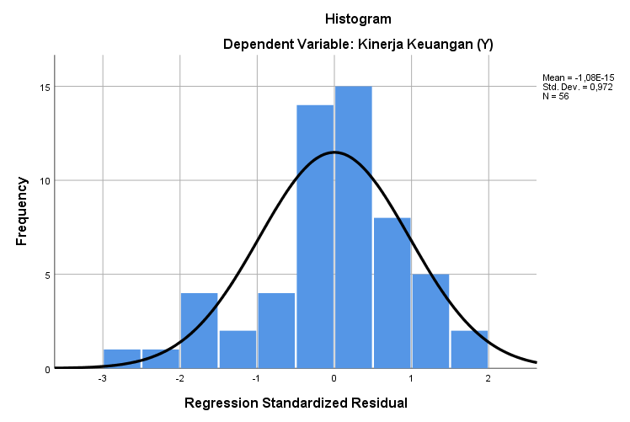

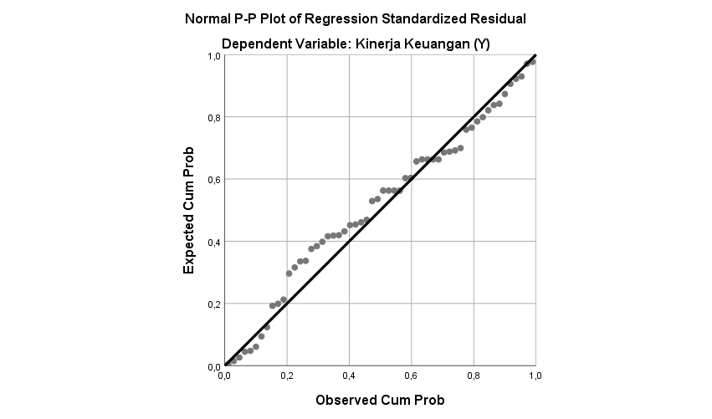

One-Sample Kolmogorov-Smirnov Test
 |  | Unstandardized Residual
N |  | 56
Normal Parameters^{a,b} | Mean | .0000000
Normal Parameters^{a,b} | Std. Deviation | 2.15965306
Most Extreme Differences | Absolute | .104
Most Extreme Differences | Positive | .063
Most Extreme Differences | Negative | -.104
Test Statistic |  | .104
Asymptotic Significance (2-tailed) |  | .200^{c,d}
a. Test Distribution is Normal
b. Calculated from data
c. Lilliefors Significance Correction
d. This is a lower bound ...

- Hasil Uji Multikolonieritas
Coefficientsª
Model |  | Collinearity Statistics
 |  | Tolerance | VIF
1 | (Constant)
1 | Perspektif Pelanggan (X₁) | .301 | 3.327
1 | Perspektif Proses Bisnis Internal (X₂) | .309 | 3.238
1 | Perspektif Pembelajaran dan Pertumbuhan (X₃) | .298 | 3.360
a. Dependent Variable: Kinerja Keuangan (Y)

- Hasil Uji Heteroskedastisitas
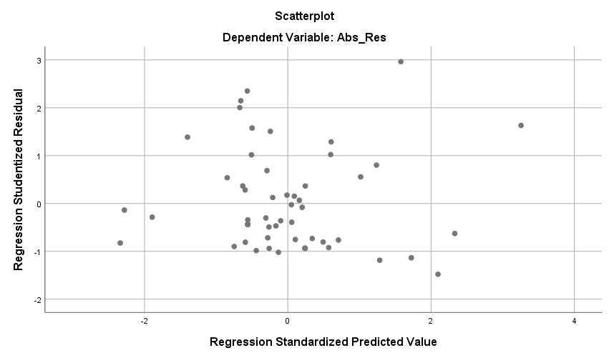

- Hasil Uji Regresi Linier Berganda
Coefficientsª
Model |  | Unstandardized Coefficients
 |  | B | Std. Error
1 | (Constant) | 0,807 | 2,014
1 | Perspektif Pelanggan (X₁) | 0,228 | 0,080
1 | Perspektif Proses Bisnis Internal (X₂) | 0,234 | 0,083
1 | Perspektif Pembelajaran dan Pertumbuhan (X₃) | 0,503 | 0,080
a. Dependent Variable: Kinerja Keuangan (Y)

- Hasil Uji Simultan (Uji-F)
ANOVAª
Model |  | Sum of Squares | df | Mean Square | F | Significance
1 | Regression | 2052.832 | 3 | 684.277 | 138.709 | .000^{b}
1 | Residual | 256.526 | 52 | 4.933
1 | Total | 2309.357 | 55
a. Dependent Variable: Kinerja Keuangan (Y)
b. Predictors: (constant) Perspektif Pembelajaran dan Pertumbuhan (X3), Perspektif Proses Bisnis Internal (X2), Perspektif Pelanggan (X1)...

- Hasil Uji Koefisien Determinasi
Model Summary^{b}
Model | R | R Square | Adjusted R Square | Std. Error of the Estimate
1 | .943ª | .889 | .883 | 2.221
a. Predictors: (constant) Perspektif Pembelajaran dan Pertumbuhan (X3), Perspektif Proses Bisnis Internal (X2), Perspektif Pelanggan (X1)...
b. Dependent Variable: Kinerja Keuangan (Y)

Lampiran 11
Tabel r
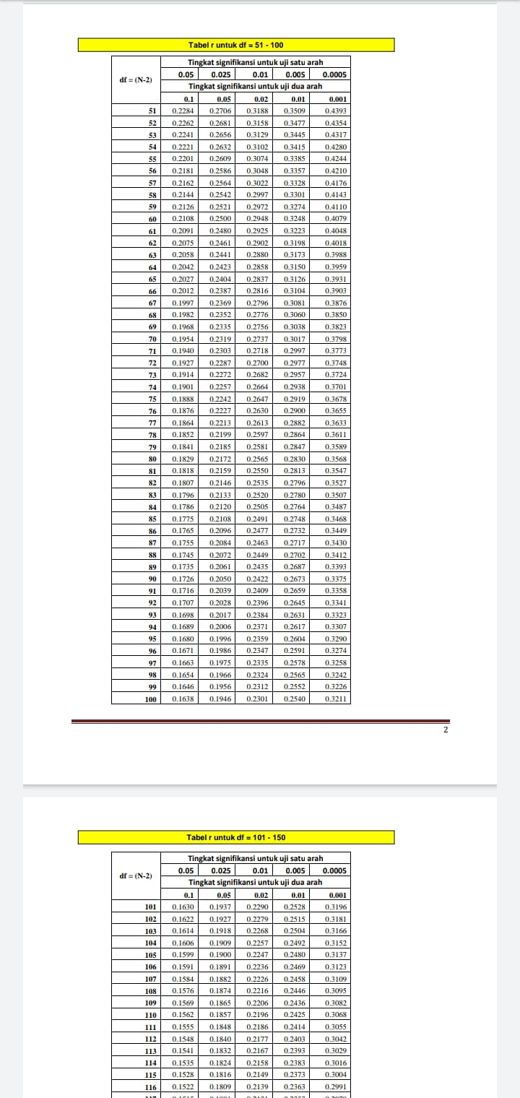
Lampiran 12
Tabel t
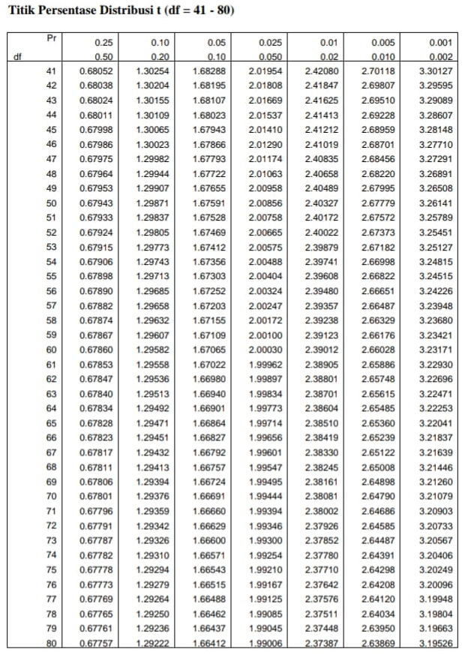

Lampiran 13
Tabel F
