APPENDIX A
FIELD NOTE OBSERVATION I
Place : Class X IPA
Date : Wednesday, 24 Mei 2023
Time : 09.00

The researcher came to class X IPA at 09.10 and before entering class the researcher met with Mam Yulia as an English subject teacher. Researcher will carry out research activities in the learning process in class, researcher also follow Mam Yulia to class.

Mam Yulia opened the lesson using Indonesian and English because in class it was not required to use English, they were still allowed to mix with Indonesian. Previously, Mam Yulia checked the attendance of students using English and the students also answered in English, such as: "how are you?" you today"? the student replied "I'm fine mam". Today's class material is about expressing of congratulating. Mam Yulia explained the example and then students were required to make examples of expressing of congratulating and then conveying them to the front in turn. In this activity students were able to convey expressions of greeting and praise well, because before this meeting students had been appointed to appear today. Students must have prepared material before entering class, students must prepare material from books or the internet.

There were some students who asked for help from their friends to find examples of other expressions. Students read the notes they made about the expressing of congratulating , the students' utterances used pantomime and emphasized the right words so that what the students meant reached the listeners, if students found it difficult to find words or check their pronunciation, students used a dictionary to check, at the end Mam Yulia's lesson provides an assessment of the contents of the expressing of congratulating and the grammatical errors such as the words "through" and "enough", so that students can correct their mistakes. and if there is new vocabulary that they hear, students can use it in everyday conversation. The speaking class finished at 10 am, this observation ended, the researcher thank to Mam yulia for her help.

FIELD NOTE OBSERVATION II

Place : Class X IPA
Date : Friday, 26 Mei 2023
Time : 10.00

This is the second time the researcher made observations in class XIpa, before entering the class the researcher first met with Mam Yulia as a teacher in English lessons. Researcher come to class at 10.00. The researcher immediately followed Mam Yulia.

The teacher opened the lesson and checked student attendance. The students had to prepare today's material, namely expressing gratitude and after Mam Yulia explained, the students each made an example of expressing gratitude, one of the students was late, and asked permission to take lessons in English "excuse me mam ?" "may I come to class"? "Yes" said Mam, this is spontaneous because in English lessons students are required to get used to using English in interactions.
During class, the researcher observed students making examples of expressing gratitude that they would convey in class before it was their turn to perform. Students use a dictionary or ask a friend to check for misspelled or unfamiliar words. If one of the students makes and makes a mistake, it will be checked through the dictionary, after the student has progressed, the teacher provides corrections related to reminding, correct pronunciation, and always reminding that students' daily problems in speaking are pronunciation, the researcher also found, when the teacher spoke and students find new things in their vocabulary, they will record and use these words in everyday conversation so they don't forget and add to their vocabulary. After the lesson, the researcher thanked Mam Yulia who was willing to take the time so that the researcher could obtain data.

APPENDIX B
INTERVIEW TRANSCRIPT

Name:MN
Class:Xipa
Date/day:26 Mei 2023/Friday

Question 1: How about speaking lesson in class, so how was your speaking learning process in class?
Answer: We are in ordinary class, mam always mix Indonesian and English when speaking and give the explanation.
Question 2:How is the process of learning English in class, are you prepared before starting learning?
Answer:Before English class starts I usually prepare materials and alsoin advance with books and I summarize it
Question3: how about your strategies in learningEnglish to improve your speaking?
Answer:I usually use pictures to remember vocabulary, like I often read English webtoons so because I often read them it makes it easier for me to remember new vocabulary.
Question 4: how do you apply this strategy?
Answer:“I apply it by reading webtoons more often to memorize new vocabulary by looking at pictures and writing it makes it easier for me to remember it better”
Question 5: why do you use that strategy to improve speaking?
Answer :because it's easier to remember from pictures and while reading and in my opinion it's easier to understandfor me to remember new vocabulary.

Name:RPR
Class:Xipa
Date/day:26 Mei 2023/Friday

Question 1:I want to ask about your learning English process, in improving speaking, what strategy do you use?
Answer: I usually have to prepare material that will be delivered by the teacher. And I also memorize or remember the contents of the points to be conveyed
Question 2: why do you use that strategy to improve speaking?
Answer : Because whenI often watch English films or videos to increase my vocabulary and to be able to speak English fluently.
Question 3:how do you apply this strategy?
Answer : After being given the vocabulary by watching movie, I look for the meaning of the vocabulary and write it down so I don't forget and read it, then repeat it and try to apply it in everyday life.
Question 4:What strategies do you do to be able to memorize new vocabulary?
Answer: Usually asking my friend to listen to memorize me to improve my sentence. Because if the pronunciation is correct, it's easier to memorize and practice.

Name:NI
Class:Xipa
Date/day:26 Mei 2023/Friday

Question1:how about your strategies in learningEnglish to improve your speaking?
Answer:the strategy that I use I often watch English films and from there I get a lot of new vocabulary and I memorize it.
Question 2: why do you use that strategy to improve speaking?
Answer : because by watching movies it's easier for me to know new vocabulary and it's easier to remember too.
Question 3: how do you apply this strategy?
Answer: usually if I find a new vocabulary I will try to memorize as much as possible and then apply it in everyday life, especially when talking with my friend.
Question 4: What strategy do you use to ensure the pronunciation is correct?
Answer :I usually use Google Voice to ensure the correct pronunciation, I can correct the correct pronouns

Name:DN
Class:Xipa
Date/day:26 Mei 2023/Friday

Question1:how about your strategies in learning English to improve your speaking?
Answer:My strategy in improving speaking skills is listen to English songs and read English book.
Question 2: why do you use that strategy to improve speaking?
Answer : because when I listen to English songs and sing along, I also know the pronunciation it correctly, and also by reading English books, I know new vocabulary.
Question 3: how do you apply this strategy?
Answer: When I am in the free time, I listen to English songs almost every day, and every time I hear new vocabulary I will look up the meaning and remember it.
Question 4:Did you use a dictionary to check the word and unknown pronunciation?
Answer: I have to use a dictionary because I don't know a lot of vocabulary and pronouns. I usually use a book dictionary and sometimes also use an online dictionary through a mobile application
Question 5 :What strategy do you use to ensure the pronunciation you are going to use is correct?
Answer: When studying in class, I usually always listen to what the teacher says to make sure the pronunciation that I will say later is the same and correct.

Name:RP
Class:Xipa
Date/day:26 Mei 2023/Friday

Question1:How about your strategies in learningEnglish to improve your speaking?
Answer:I like to practice pronunciation to improve English.
Question 2: how do you apply this strategy?
Answer:I apply it by often inviting my friends to speak English and repeating the vocabulary that we memorized even though sometimes it's still mixed up too.
Question 3: why do you use that strategy to improve speaking?
Answer :because when I often practice pronunciation and vocabulary and how to pronounce it will improve my speaking skills.
Question 4: Did you use the dictionary to check words and pronunciations that you do not know?
Answer: Yes. I usually use a dictionary to check words that I don't know the pronunciation of, and also ask friends who do and also ask the teacher.
Question 5: What strategies do you use to ensure correct pronunciation?
Answer: I usually ask my friends to listen to my memorization to correct sentences to make sure they are pronounced correctly

APPENDIX C
DOCUMENTATION

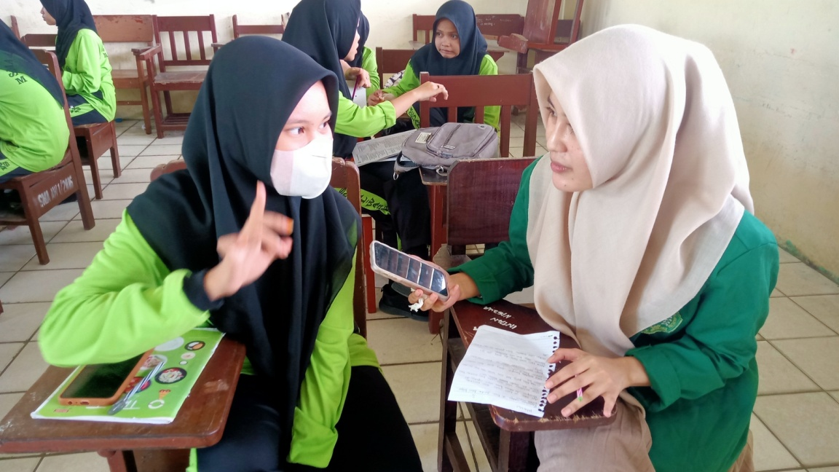

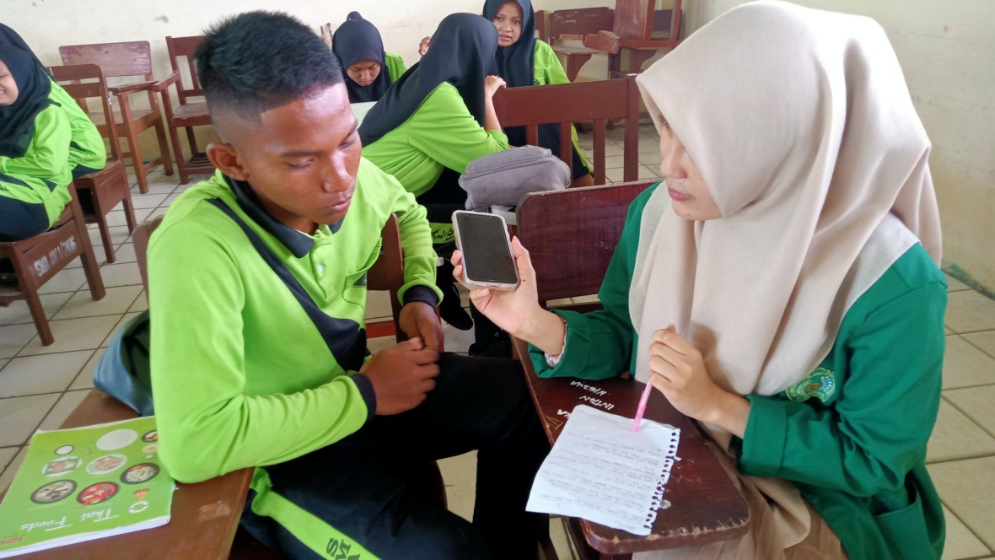
DOCUMENTATION
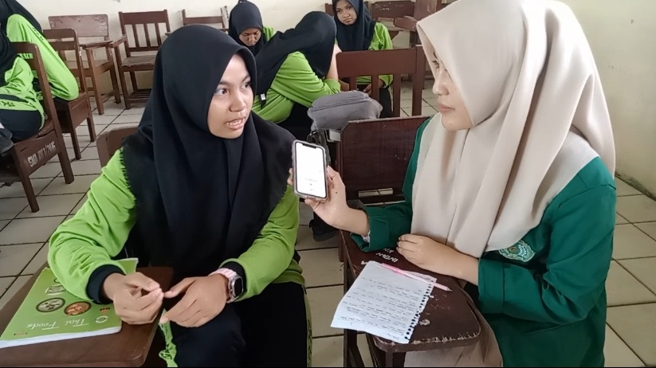

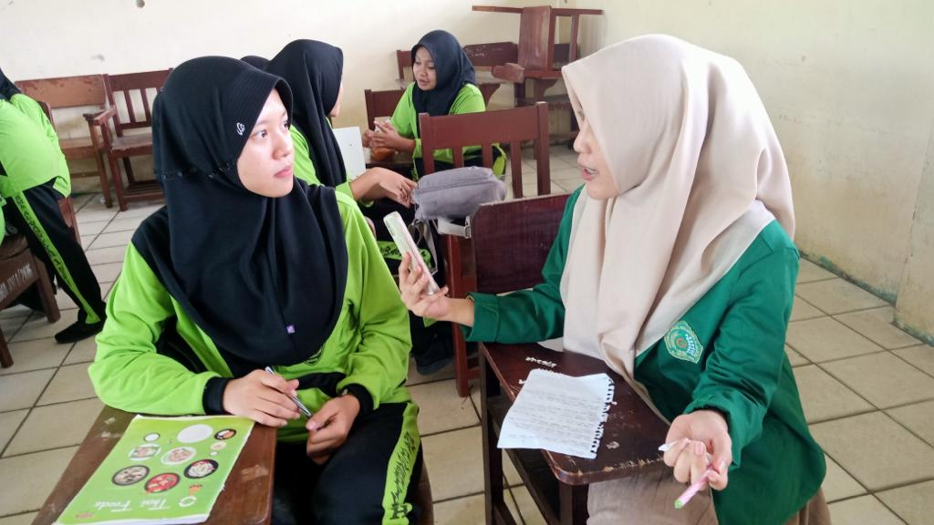

DOCUMENTATION

