ACKNOWLEDGEMENTS

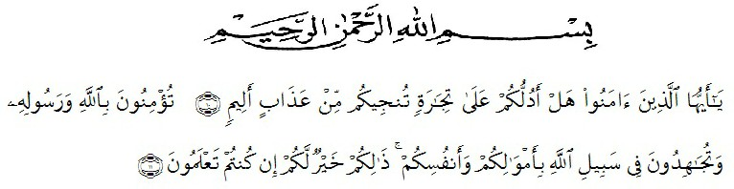
Artinya : “Wahai orang-orang yang beriman! Maukah kamu Aku tunjukkan suatu perdagangan yang dapat menyelamatkan kamu dari azab yang pedih? (10) (Yaitu) kamu beriman kepada Allah danRasul- Nya dan berjihad di jalan Allah dengan harta dan jiwamu. Itulah yang lebih baik bagi kamu jika kamu mengetahui,(11)”. (Q.S.As –Saffayat 100-11)

All praise is to Allah, the Almighty, the Merciful, for the blessing given to the researcher so that can finish this thesis. Shalawat and Salam are delivered to the prophet Muhammad SAW. Hopefully the researcher will get intercession from him in hereafter later
In this ocasion with great humility, the researcher would like to thank to all of those who have given her help and guidance so that this thesis can be finished on time. Therefore, the researcher would like to thank :
- Dr. H. Hardi Mulyono Surbakti, SE., M.AP, The Rector of Muslim Nusantara Al-Washliyah University Medan.
- Drs. Samsul Bahri, M. Si,The Dean of the Faculty of Teachers Training education, University of Muslim Nusantara Al-Washliyah Medan.
- Zulfitri, S.S, M.A., M.Pd as the Head of English Education Department.
- Dr. Asnawi, M. Hum as the Adviser who has guided and provided from the suggestioning for the completion of this thesis.
- All lecturers of English Language Education study program along with faculty administrative staff who have provided guidance and knowledge to the author and smooth administration during the course of lectures.
- All the classmate who are in class 8A that I can not mentioned one by one that has given colorful moment during friends and experiences that we have been through together during the lecture process.
- Beloved parents who always motivate, support, pray all the time and also my sisters and my brothers.
- Beloved friends Dilla anglia, Maulina, Aulia ade, Suci anggi, Selvi habibah, Divia ayu, Juni ari, Ferdy hasan, Iwan rizky.
Last but not least the researcher hopes that this thesis can be useful for all of us and may Allah SWT blesses all the people who have participated in the process of writing this thesis. Finally the researcher expects constructive criticism and suggestions and apologizes for all mistakes.
Medan, 17 June 2023
Author

Sekar Dewi Andini
191224029

