**ACKNOWLEDGEMENT**

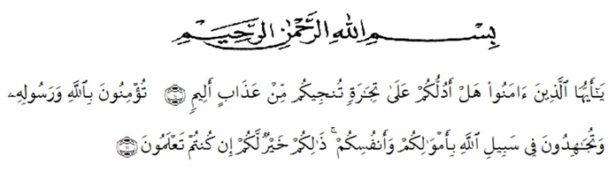Artinya : "Wahai orang-orang yang beriman! Maukah kamu Aku tunjukkan suatuperdagangan yang dapat menyelamatkan kamu dari azab yang pedih? (Yaitu) kamu beriman kepada Allah dan Rasul-Nya dan berjihad di jalan Allah dengan harta dan jiwamu. Itulah yang lebih baik bagi kamu jika kamu mengetahui,"

(QS. As-Saff 61: Ayat 10-11)

All praise to Allah SWT, the Almighty, the Merciful, for the blessing given to the researcher so that can finish the thesis. Shalawat and Salam are delivered to the prophet Muhammad SAW. Hopefully, the researcher will get intercession from him in hereafter later

This occasion with great humility, the researcher would like to thank all of those who have given her help and guidance so that this thesis can be finished on time. Therefore, the researcher would like to thank:

1. Dr. KRT. Hardi Mulyono K.Surbakti. The Rector of Muslim Nusantara Al Washliyah University.
2. Dr. Samsul Bahri, M.Si, The Dean of Faculty of Teachers’ Training and Aducation University of Muslim Nusantara Al-Washliyah Medan.
3. Zulfitri, S.S., M.A., M.Pd., The Head of the English Education Study Program for all directions and help.
4. Dr. Asnawi, M.Hum., as the Adviser who has given a lot of valuable suggestions, attention, comments, and criticism for completing this research.
5. All lecturers in the Teachers’ Training and Education Faculty, especially in English Education Study Program. Thanks for teaching during this time.
6. Misrayani, S.Pd, M.Si., as the Headmaster in Smk Negeri 1 Lubuk Pakam, and all the teachers especially all English teachers as well as the students in the school where the researcher did the research.
7. The biggest and most special thanks to the researcher’s beloved mother, Nurmayani, S.Pd., and the researcher’s younger sister Nabila Tasya. Who always motivates supports, and prays for her.
8. Muhammad Dwi Angga S.I.Kom., as someone who has taken the time to provide suggestions and directions to researchers until the completion of this thesis.
9. The researcher’s beloved friends, Dilla Anglia and Sekar Dewi Andini, always give support.
10. All of her colleagues in the 8A English Department.

Last but not least, the researhers’ sicerely hopes that this thesis can be useful for all of us and may Allah SWT blesses all the people who have participated the process of writing this thesis. Finally the researcher expects contructive critics and suggestions. She also apologizes for all mistakes.

Galang, 12 Juni 2023

The Researcher

AULIA ADE TIARA

191224045