ACKNOWLEDGEMENTS
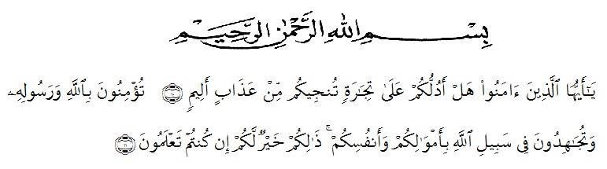
Meaning: "Hai orang-orang yang beriman! Maukah kamu Aku tunjukkan suatu perdagangan yang dapat menyelamatkan kamu dari azab yang pedih? (10) (Yaitu) kamu beriman kepada Allah dan Rasul-Nya dan berjihad di jalan Allah dengan harta dan jiwamu. Itulah yang lebih baik bagi kamu jika kamu mengetahui (11)" (As-Shaf ayat 10-11).

Alhamdulillahirabbil’alamin. Firstly, the researcher express Thank Allah AWT, becaus His bless and grace, the researcher could complate this thesis entiled “The Effect of Duolingo Online Application on Students’ English Vocabulary Mastery of VII Grade Class At SMP Al Razi Sinar Harapan”. As the fullfillment of the requierment to get the Degree of Bachelor of Education in Universitas Muslim Nusantara AL-Washliyah Medan. Secondly, sholawat and salam always be given to our Prophet Muhammad SAW who has guided us from the darkness to the lightness.
The researchers are fully aware that without it, this thesis could not be completed help of others. Therefore this opportunity to express her deep gratitude and appreciate to :
- Dr.KRT. H. Hardi Mulyono K. Surbakti., as the Rector of Universitas Muslim Nusantara Al Washliyah Medan.
- Drs. Samsul Bahri, M.Si., as the dean of faculty of Teaching Training and Education of Universitas Muslim Nusantara Al-Wahliyah Medan.
- Zulfitri, S.S., M.A.,M.Pd, as the Head Department of English Education and as my adviser who has given guidance, advice, correction, help, information and support the researcher during process of writing the thesis.
- All lecturers of the English Education for teaching precious knowledge, always give motivation and giving wonderful experience.
- All of the academic administration staff of Universitas Muslim Nusantara Al Washliyah Medan.
- Deni Ramadhani Saragih, S.Si., as the Headmaster of SMP Al Razi Sinar Harapan Medan for given permission to conduct the researcher.
- The researcher’s beloved parents, (Hollad Suhunan S.Sos and Dra. Azwani Lubis) for their endless love, support, patience, material, continuous prayer and everything that will never forgotten.
- The researcher’s beloved brothers (Abdul Gani S.Pd., and Nazlan Syahputra S.E.) and beloved sister (Khairin Nadia Str.Keb.) who always kindness helped and supported me to finish this thesis.
- The researcher’s beloved sister-in-law (Ismasiah Harahap S.Pd. dan Welisa S.Pd.) who also always kindness, help and support me to finish this thesis.
- The researcher’s beloved friends, Kharisma Vivi Alfiana, Maulia Nifa, Annisa, Suci Anggi Harianja, Maulina and Mawaddatul Muthmainnah, for all friendship, happiness, help, support, and patient to face my under pressure during completed this thesis.
- All classmate in this 8th semester, who help each other to provide information.
- Everyone who has helped in finishing the thesis and whose names cannot be mentioned on by one.
Finally, The researcher relize that this thesis is still far from being perfect.
Therefore, we need constructive suggestions for further research. The researcher hopes that this study will make an important contribution to the English Education Department. May God always bless us and guide us in His right way. Amin.

Medan, June 2023

Khairani Mahfuza

