Appendix I: Observation

Transcript of the teacher and students communication
- Transcript of teacher and students’ communication
Teacher : Good morning. Do you still remember the previous material?
Students : Yes, Sir! We still remember online learning media.
Teacher : Great! Now explain what online learning media is.
Students : A type of teaching and learning that allows the delivery of teaching materials to students using the internet or other computer network media.
Teacher : Very Good! Next, try to mention what examples of the media were used.
Student 1 : Examples of media used are zoom meetings and google meet.
Teacher : Excellent! Now, do you still have any questions about online learning media before we start today's lesson?
Students : No, Sir. Let’s start the lesson today.

- Transcript of teacher and students’ communication
Teacher : Today, we will learn a new method. Do you know about Teaching English Speaking?
Students : Some students said they knew, but some students did not know.
Teacher : Okay. Try to explain briefly for those who know before I explain it in detail.
Student 2 : English Speaking is the process of building and sharing meaning through the use of verbal and non-verbal symbols in a variety of contexts.
Teacher : Great! It turns out that someone already knows about our lesson today, but I will still explain it in detail.
Students : Yes, Sir!
Teacher : One of the skills is to communicate with the other person using English. It can also be an ability in English to express opinions, comment, and the ability to ask and answer questions from the other person.
Students : How about an example, Sir?
Teacher : Okay, let me show you some examples (showing some examples of English speaking in the share screen on zoom meeting). Those were some examples of English speaking. So, today we will learn about teaching English speaking in online learning media in the pandemic era.
Students : (Raises hand), So sir, learning to speak in English is the same as speaking in other languages?
Teacher : Yes, that’s right.
- Transcript of teacer and students communication
Teacher : Class, now we will form a group of two for practice speaking in English.
Students : Yes, Sir!
Teacher : Good. Now I will call your names one by one and form a team with two people in one team.
Students : (Simultaneously) yes, sir!
Teacher : Alright, let me start.

Appendix II: Interview

Interview Sheet with Teacher
- Interview with teacher 1
Writer : How long have you been teaching English?
Teacher 1 : I had been teaching English about twelve years
Writer : How do you feel teaching at this school?
Teacher 1 : Glad, because the students here have a very high learning spirit
Writer : Does this school implement an online learning system during this pandemic?
Teacher 1 : Yes, during the current pandemic, schools have closed all students and continue lessons through the online learning system.
Writer : What is your opinion about the implementation of online English learning?
Teacher 1 : In my opinion, online learning makes it very difficult for students to understand the material I teach.
Writer : What method do you use when teaching English in online learning?
Teacher 1 : I used the teaching english speaking method when online learning.
Writer : Teaching English speaking? Why do you only use the speaking method, even though there are many methods or skills in learning English.
Teacher 1 : Yes, I know that it is not only speaking skills in learning English, but when learning this online system, I appreciate students more for learning to speak in English so that they were more active during the learning process.
Writer : When carrying out English learning activities, especially speaking, do the students experience difficulties with online learning?
Teacher 1 : The students have difficulty learning to speak in English because they feel ashamed that they are not fluent in English.
Writer : How is the development and understanding of English learning materials, especially speaking in English, for students since using the online system?
Teacher 1 : The development after I gave the essential points in speaking English properly and correctly, they became more fluent in speaking English with the people around them. They also became more enthusiastic about speaking in English when I taught.
- Interview with the teacher 2
Writer : How long have you been teaching English?
Teacher 2 : I had been teaching in this school for about five years from 2018
Writer : How do you feel teaching at this school?
Teacher 2 : I am happy to be able to teach at this school. The environment and people at this school are excellent and comfortable.
Writer : Does this school implement an online learning system during this pandemic?
Teacher 2 : During the pandemic, the school closed all students and teachers to teaching and learning at home via laptops or mobile phones.
Writer : What is your opinion about the implementation of online English learning?
Teacher 2 : In my opinion, the online learning system makes it difficult for students to understand what the teacher had explained. Therefore students often complain if they need help understanding some material.
Writer : What method do you used when teaching English in online learning?
Teacher 2 : I used English speaking and listening methods so students can speak English more fluently.
Writer : Speaking and listening? Why do you only used both of them, even though there are many methods or skills in learning English.
Teacher 2 : Why do I only used both methods? Because these two methods were essential in online learning during a pandemic, students might even understand learning better by listening to a few words in English.
Writer : When carrying out English learning activities, especially speaking, do the students experience difficulties with online learning?
Teacher 2 : The students had great difficulty learning and felt uncomfortable with the system.
Writer : How is the development and understanding of English learning materials, especially speaking in English, for students since using the online system?
Teacher 2 : The student's progress has been quite good with some of the material taught and the practice of speaking in public, making students more courageous in communicating with friends using fluent English.

Interview Sheet
Interview Sheet with Students
- Interview with the student 1
Writer : What do you think about delivering English-speaking material during online learning?
Student 1: Pretty good, but I can't translate one sentence directly in conversation. So we must solve one by one vocabulary spoken in English.
Writer : What obstacles did you experience in learning English speaking, which is carried out online?
Student 1 : They cannot convey excellent and correct vocabulary and feel less confident because they fear being wrong when pronouncing it.
Writer : In your opinion, what are the advantages of learning to speak English while studying online?
Student 1 : Being able to learn some new vocabulary and also giving a mentally strong advantage to start speaking English.
Writer : Do you and your friends comfortable with the online learning system?
Student 1 : In my opinion, it is less comfortable in online learning because the network is less supportive, so the material provided by the teacher is not understood, and the time is concise to explain the material.
- Interview with the student 2
Writer : What do you think about delivering English-speaking material during online learning?
Student 2 : Quite good because the teacher provides speaking material through youtube so that if sentences are not understood, they can be repeated and translated through youtube translations.
Writer : What obstacles you experience in learning English speaking, which is carried out online?
Student 2 : Lack of self-confidence and less learn vocabulary.
Writer : In your opinion, what are the advantages of learning to speak English while studying online?
Student 2 : Learning English online made me more confident, trained me to use English in speaking, and made me an independent learner.
Writer : Do you and your friends comfortable with the online learning system?
Student 2 : No, because if the learning system was done online, there are always obstacles, such as a weak network, so they do not understand the material from learning.
- Interview with the student 3
Writer : What do you think about delivering English-speaking material during online learning?
Student 3 : I don't understand, and some can be understood because, through speaking, I can learn and speak English quite correctly.
Writer : What obstacles you experience in learning English speaking, which is carried out online?
Student 3 : The obstacles I experienced, such as the missing network that often missed learning, made it difficult to understand the material given by the teacher.
Writer : In your opinion, what are the advantages of learning to speak English while studying online?
Student 3 : Many modules and materials were provided, and online learning can be done anytime and anywhere, as well as learning English online so friends can easily find and get study friends from various cities and even countries. Learning English online can be obtained for free and safe.
Writer : Do you and your friends comfortable with the online learning system?
Student 3 : It is uncomfortable because students can not learn how to socialize with teachers, friends, and the environment, or students don't make an effort to understand the material thoroughly.

Appendix III : The Data of Students Online Learning Teaching English Speaking in Pandemic Era
No | Name | Address
1 | Safirah Razanah Rambey | Jl. Roso Komplek Taman Marendal Mas
2 | Fatin Nur Rizkya | Komplek Graha Deli Permai Blok A4 No. 20
3 | Christy Br Samosir | Jl. Pintu Air IV Gg. Persatuan Lr. Sinar
4 | Putra Hatoguan Simanjorang | Jl. Pintu Air 4 Gg. Sekolah Kp. Dalam/Duku
5 | Tirta A. Arfans | Jl. Bunga Kantil No. 121 Padang Bulan
6 | Ditha Felliza | Jl. Karya Darma Komplek Palazzo, Johor
7 | Rachel Chyutia Sianturi | Jl. Masjid Syuhada Gg. Bersama No. 3 Padang Bulan
8 | Syifa Nayana Azzaira | Jl. Karya Wisata Ujung
9 | Angelina Indriani Barus | Jl. A.H. Nasution Gg. Horas No. 22
10 | Mulani Putri Manullang | Jl. Pintu Air IV Gg. Persatuan
11 | M.Febriansyah Nasution | Jl. DC. Barito No. 30 Medan
12 | Rasya Hafiz Al Faqih | Jl. Antariksa Gg. Sawit No. 45 Medan
13 | Nur Ainun | Jl. Luku 1 Kwala Bekala Medan Johor
14 | Daanya | Jl. Garu I Gg. Delima Medan
15 | Rike Crisjulyani Lumban Raja | Komplek Kesatriaan F. Sihombing Asrama Paskhas TNI-AU No. 73 Blok D Medan Polonia
16 | Drie Youngen Ginting S | Dusun Desa 1 Batu Penjemuran
17 | Allyana Nadiansha | Jl. STM Gg. Syukur Barat Medan
18 | Mellisa Christi Siallagan | Jl. Bunga Rampai III Medan
Figure 1. Name and Address of Eighteen Students in SMA Negeri 2 Medan
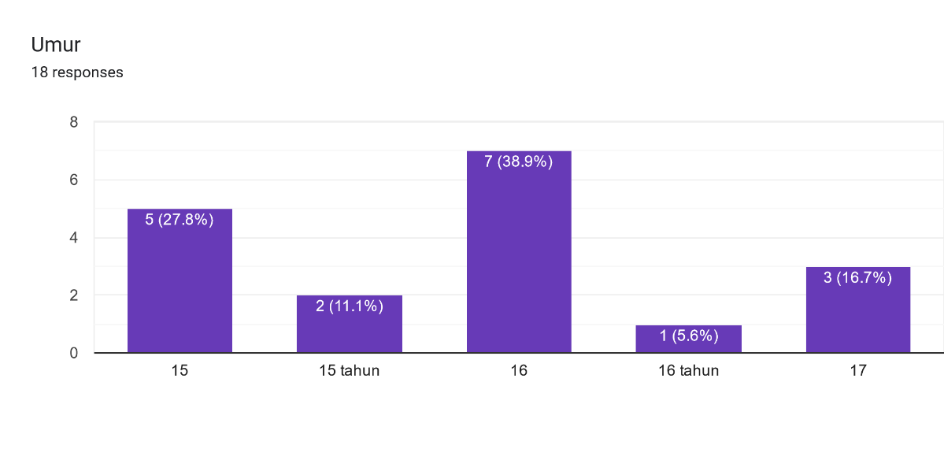
Figure 2. The Age of the Students
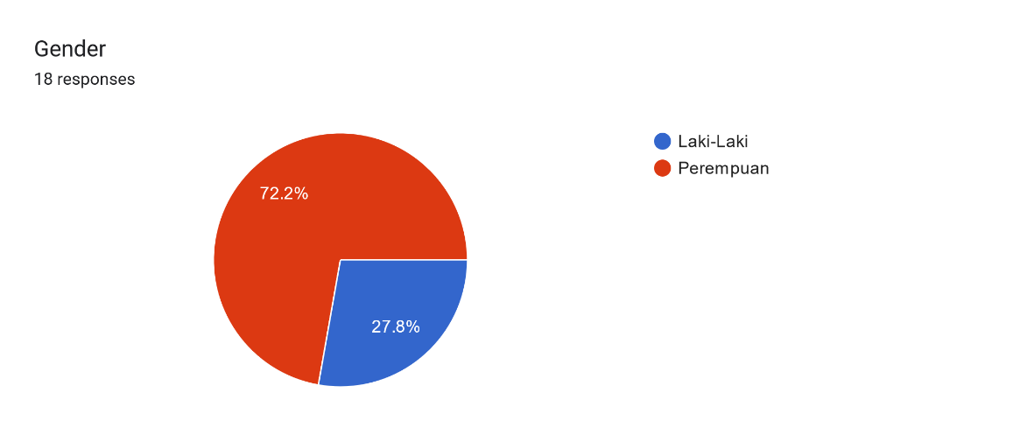
Figure 3. The Gender of the Students
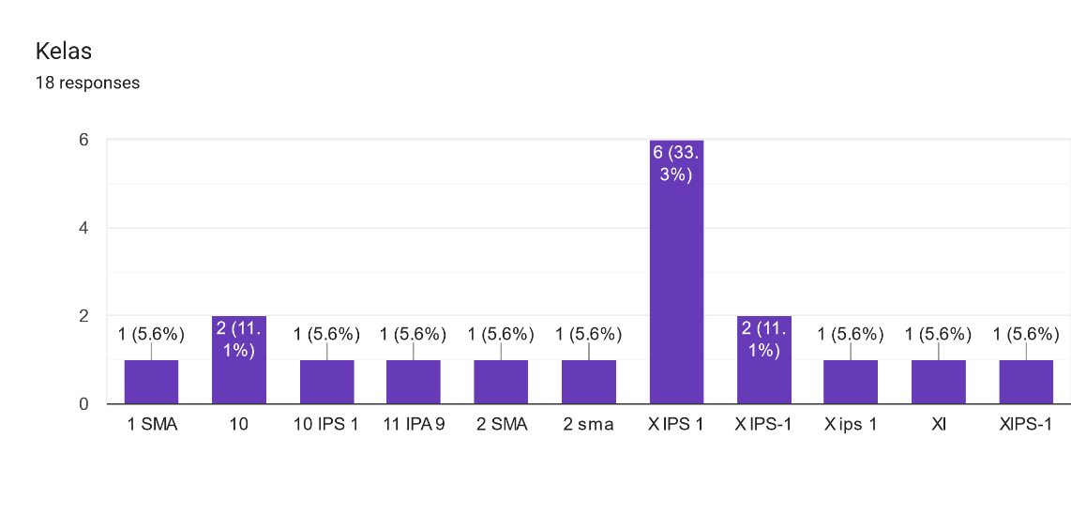
Figure 4. The Class of the Eighteen Respondense

