PENETAPAN KADAR FLAVONOID TOTAL EKSTRAK KAYU BAJAKAH TAMPALA(Spatholobus littoralis Hassk) DENGAN PELARUT METANOL DAN ETIL ASETAT TERHADAP BAKTERI Staphylococcus aureus

LIYA ALVIANA
NPM. 212114117

ABSTRAK
Penggunaan tumbuhan sebagai antibakteri sangat berkaitan dengan kandungan kimia yang terdapat dalam tumbuhan tersebut terutama zat aktif biologisnya. Senyawa bioaktif yang terdapat dalam tumbuh-tumbuhan biasanya merupakan senyawa metabolit sekunder. Salah satu tanaman yang mengandung senyawa metabolit sekunder yaitu kayu bajakah tampala (Spatholobus littoralis Hassk). Tujuan penelitian ini adalah untuk mengetahui senyawa kimia yang terdapat didalam ekstrak metanol dan etil asetat, mengetahui nilai flavonoid total dan aktivitas antibakteri dari ekstrak metanol dan etil asetat kayu bajakah tampala.
Tahapan penelitian ini meliputi pengolahan bahan tumbuhan, pembuatan ekstrak metanol dan etil asetat secara maserasi, pemeriksaan karakterisasi, skrining fitokimia, penetapan kadar flavonoid total ekstrak metanol dan etil asetat kayu bajakah tampala dengan metode spektrofotometri Visible, dan aktivitas antibakteri terhadap Staphylococcus aureus.
Hasil skrining fitokimia kayu bajakah tampala menunjukkan bahwa terdapat kandungan golongan senyawa kimia seperti alkaloid, flavonoid, saponin, tanin, dan steroid/triterpenoid. Hasil penentuan kadar flavonoid total pada ekstrak metanol kayu bajakah tampala sebesar 33,1193 ± 0,3545 mg QE/g sedangkan pada ekstrak etil asetat sebesar 25,9251 ± 0,0934 mg QE/g. Hasil aktivitas antibakteri ekstrak metanol kayu bajakah tampala dengan konsentrasi 40%, 45%, dan 50% terhadap bakteri Staphylococcus aureus memiliki rata-rata daya hambat sebesar 12,1 mm, 12,66 mm, dan 13,75 mm. Sedangkan ekstrak etil asetat memiliki rata-rata daya hambat sebesar 9,3 mm, 9,88 mm, dan 10,86 mm.

Kata kunci: Kayu Bajakah Tampala (Spatholobus littoralis Hassk.), Flavonoid, Spektrofotometri visible, Staphylococcus aureus, Pelarut Metanol dan Etil Asetat.

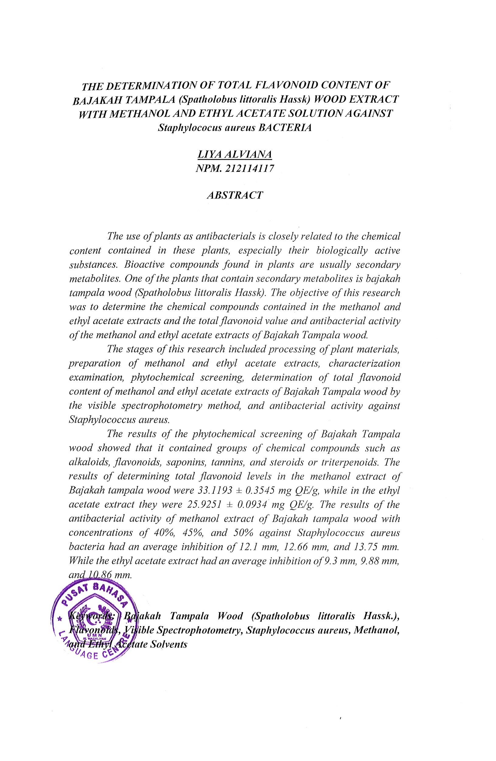
DETERMINATION OF TOTAL FLAVONOID CONTENT OF BAJAKAH TAMPALA (Spatholobus littoralis Hassk) WOOD EXSTRACT WITH METHANOL AND ETHYL ACETATE SOLUTION AGAINTS Staphylococcus aureus BACTERIA
LIYA ALVIANA
NPM. 212114117

ABSTRACT
The use of plants as antibacterials is closely related to the chemical content contained in these plants, especially their biologically active substances. Bioactive compounds found in plants are usually secondary metabolites. One of the plants that contain secondary metabolites is bajakah tampala wood (Spatholobus littoralis Hassk). The purpose of this study was to determine the chemical compounds contained in the methanol and ethyl acetate extracts to determine the total flavonoid value and antibacterial activity of the methanol and ethyl acetate extracts of Bajakah Tampala wood.
The stages of this research included processing of plant materials, preparation of methanol and ethyl acetate extracts, characterization examination, phytochemical screening, determination of total flavonoid content of methanol and ethyl acetate extracts of Bajakah Tampala wood by Visible spectrophotometry method, and antibacterial activity. Bajakah tampala wood extract was prepared by the maceration method using methanol and ethyl acetate, the extract obtained was concentrated with a rotary evaporator, then the total flavonoid content was determined using the Visible spectrophotometry method and the antibacterial activity test was carried out against Staphylococcus aureus.
The results of the phytochemical screening of Bajakah Tampala wood showed that it contained groups of chemical compounds such as alkaloids, flavonoids, saponins, tannins, and steroids/triterpenoids. The results of determining total flavonoid levels in the methanol extract of Bajakah tampala wood were 33.1193 ± 0.3545 mg QE/g while in the ethyl acetate extract they were 25.9251 ± 0.0934 mg QE/g. The results of the antibacterial activity of methanol extract of Bajakah tampala wood with concentrations of 40%, 45%, and 50% against Staphylococcus aureus bacteria had an average inhibition of 12.1 mm, 12.66 mm, and 13.75 mm. While the ethyl acetate extract had an average inhibition of 9.3 mm, 9.88 mm and 10.86 mm.

Keywords: Bajakah Tampala Wood (Spatholobus littoralis Hassk.), Flavonoids, Visible Spectrophotometry, Staphylococcus aureus, Methanol and Ethyl Acetate Solnvents.

