SKRINING FITOKIMIA DAN UJI AKTIVITAS ANTIBAKTERI EKSTRAK ETANOL DAUN KAYU JAWA (Lannea coromandelia)
(Houtt) Merr. TERHADAP BAKTERI Propionibacterium acnes
dan Staphylococcus epidermidis

MUNAZIATUL JANNAH
NPM.212114082

ABSTRAK

Kayu Jawa (Lannea coromandelica) (Houtt.) Merr. adalah tumbuhan tropis yang berpotensi sebagai tanaman obat. Hampir semua bagian tumbuhan ini dapat dimanfaatkan sebagai obat tradisional. Tujuannya untuk mengetahui ekstrak etanol daun kayu jawa (Lannea coromandelia) (Houtt.) Merr. dapat memberikan aktivitas antibakteri terhadap pertumbuhan Propionibacterium acnes dan Staphylococcus epidermidis.
Penelitian ini dilakukan dengan menggunakan metode eksperimental yang meliputi pengumpulan sampel, pemeriksaaan makroskopis, pemeriksaan mikroskopis, pembuatan simplisia, pemeriksaan karakteristik, Skrining Fitokimia dan Uji Aktivitas Antibakteri Ekstrak Etanol Daun Kayu Jawa (Lannea coromandelia) (Houtt) Merr. Terhadap Bakteri Propionibacterium acnes dan Staphylococcus epidermidis, dengan metode difusi agar.
Hasil pemeriksaan makroskopik yang dilakukan terhadap daun Hasil makroskopik daun kayu jawa memiliki daun meruncing dan berjumlah 7-11. Kemudian memiliki bunga berkelamin tunggal dan berwarna hijau kekuningan, dan memiliki buah berbiji, hingga panjang. Dan hasil mikroskopis memiliki epidermis atas, fragmen palisade dan bungakarang, Pembuluh kayu berpenebalan spiral dan tangga. Hasil karakteristik simplisia diperoleh kadar air 4%, kadar sari larut dalam air 21%, kadar sari larut dalam etanol 23%, kadar abu total 4,8% dan kadar abu tidak larut asam 0,4%. Skrining fitokimia serbuk simplisia dan ekstrak etanol daun kayu jawa menunjukkan adanya kandungan alakaloid, tanin, flavonoid, steroid/triterpenoid, saponindan glikosida. Hasil uji kayu jawa dapat dijadikan sebagai antibakteri karena memiliki daya hambat yang sedang di konsentrasi 20% dan yang paling kuat di konsentrasi 80% terhadap bekteri Propionibacterium acnes yaitu 20%, 6,85 mm dan 14,15 mm, dan pada bakteri Staphylococcus epidermidis yaitu 20%, 5.75 mm dan 80%, 11,75 mm.

Kata kunci : Daun, kayu jawa, ekstrak, Propionibacterium acnes dan Staphylococcus epidermidis dan Antibakteri.

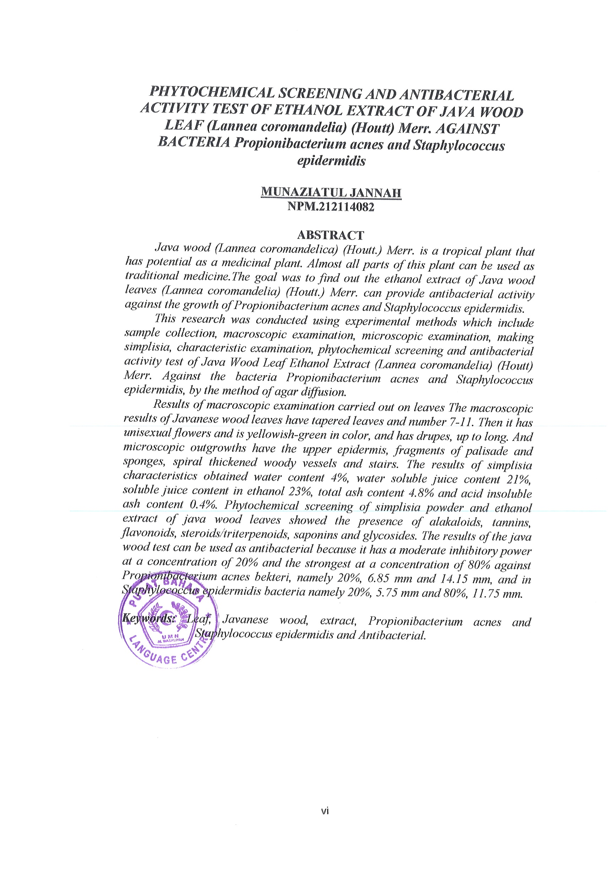
PHYTOCHEMICAL SCREENING AND ANTIBACTERIAL ACTIVITY TEST OF ETHANOL EXTRACT OF JAVA WOOD LEAF (Lannea coromandelia) (Houtt) Merr. AGAINST BACTERIA Propionibacterium acnes and Staphylococcus epidermidis

MUNAZIATUL JANNAH
NPM.212114082

ABSTRACT
Java wood (Lannea coromandelica) (Houtt.) Merr. is a tropical plant that has potential as a medicinal plant. Almost all parts of this plant can be used as traditional medicine.The goal was to find out the ethanol extract of Java wood leaves (Lannea coromandelia) (Houtt.) Merr. can provide antibacterial activity against the growth of Propionibacterium acnes and Staphylococcus epidermidis.
This research was conducted using experimental methods which include sample collection, macroscopic examination, microscopic examination, making simplisia, characteristic examination, phytochemical screening and antibacterial activity test of Java Wood Leaf Ethanol Extract (Lannea coromandelia) (Houtt) Merr. Against the bact eria Propionibacterium acnes and Staphylococcus epidermidis, by the method of agar diffusion.
Results of macroscopic examination carried out on leaves The macroscopic results of Javanese wood leaves have tapered leaves and number 7-11. Then it has unisexual flowers and is yellowish-green in color, and has drupes, up to long. And microscopic outgrowths have the upper epidermis, fragments of palisade and sponges, spiral thickened woody vessels and stairs. The results of simplisia characteristics obtained water content 4%, water soluble juice content 21%, soluble juice content in ethanol 23%, total ash content 4.8% and acid insoluble ash content 0.4%. Phytochemical screening of simplisia powder and ethanol extract of java wood leaves showed the presence of alakaloids, tannins, flavonoids, steroids/triterpenoids, saponins and glycosides. The results of the java wood test can be used as antibacterial because it has a moderate inhibitory power at a concentration of 20% and the strongest at a concentration of 80% against Propionibacterium acnes bekteri, namely 20%, 6.85 mm and 14.15 mm, and in Staphylococcus epidermidis bacteria namely 20%, 5.75 mm and 80%, 11.75 mm.

Keywords: Leaf, Javanese wood, extract, Propionibacterium acnes and Staphylococcus epidermidis and Antibacterial.

