EFEKTIVITAS ANTIBAKTERI EKSTRAK ETANOL DAUN BISBUL (Diospyros discolor Willd) TERHADAP BAKTERI Propionibacterium acnes

NANDA NADIA
NPM. 212114081

ABSTRAK

Tanaman bisbul (Diospyros discolor Willd) merupakan tanaman yang sudah sering dikonsumsi buahnya oleh masyarakat. Daun bisbul diketahui mempunyai aktivitas antibakteri dan antijamur. Tujuan penelitian ini adalah untuk mengetahui apakah ekstrak etanol daun bisbul (Diospyros discolor Willd) memiliki efektivitas antibakteri terhadap bakteri Propionibacterium acnes.
Penelitian ini dilakukan dengan menggunakan metode eksperimental yang meliputi pengumpulan sampel, pemeriksaaan makroskopis, pemeriksaan mikroskopis, pembuatan simplisia, pemeriksaan karakteristik, skrining fitokimia, pembuatan ekstrak etanol, dan pengujian efektivitas antibakteri terhadap bakteri Propionibacterium acnes dengan metode difusi agar.
Hasil pemeriksaan makroskopik yang dilakukan terhadap simplisia daun bisbul yaitu daun berwarna hijau kekuningan, pinggir rata, panjang daun 5 cm, lebar daun 4 cm, memiliki bau yang khas dan rasa sedikit pahit. Hasil karakteristik simplisia diperoleh kadar air 4%, kadar sari larut dalam air 21%, kadar sari larut dalam etanol 23%, kadar abu total 4,8% dan kadar abu tidak larut asam 0,3%. Skrining fitokimia serbuk simplisia dan ekstrak etanol daun bisbul menunjukkan adanya kandungan alkaloid, tanin, flavonoid, steroid/triterpenoid, saponin dan glikosida. Hasil uji efektivitas antibakteri ekstrak etanol daun bisbul menunjukkan diameter zona hambat lebih besar pada konsentrasi 80% yaitu 15,98 mm dibandingkan dengan konsentrasi 70% dan 60% yaitu 15,43 mm dan 14,18 mm. Dari hasil penelitian dapat disimpulkan bahwa ekstrak etanol daun bisbul dapat memberikan efektivitas antibakteri terhadap bakteri Propionibacterium acnes.

Kata kunci : Diospyros discolor Willd, Propionibacterium acnes dan Efektivitas antibakteri

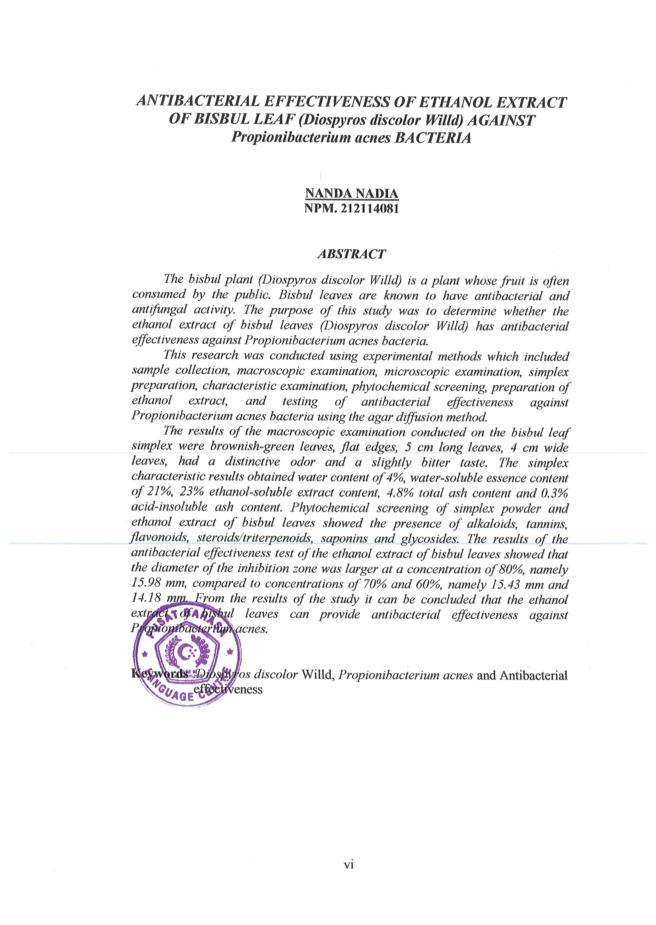
ANTIBACTERIAL EFFECTIVENESS OF ETHANOL EXTRACT OF BISBUL LEAF (Diospyros discolor Willd) AGAINST Propionibacterium acnes BACTERIA

NANDA NADIA
NPM. 212114081

ABSTRACT
The bisbul plant (Diospyros discolor Willd) is a plant whose fruit is often consumed by the public. Bisbul leaves are known to have antibacterial and antifungal activity. The purpose of this study was to determine whether the ethanol extract of bisbul leaves (Diospyros discolor Willd) has antibacterial effectiveness against Propionibacterium acnes bacteria.
This research was conducted using experimental methods which included sample collection, macroscopic examination, microscopic examination, simplex preparation, characteristic examination, phytochemical screening, preparation of ethanol extract, and testing of antibacterial effectiveness against Propionibacterium acnes bacteria using the agar diffusion method.
The results of the macroscopic examination conducted on the bisbul leaf simplex were brownish-green leaves, flat edges, 5 cm long leaves, 4 cm wide leaves, had a distinctive odor and a slightly bitter taste. The simplex characteristic results obtained water content of 4%, water-soluble essence content of 21%, 23% ethanol-soluble extract content, 4.8% total ash content and 0.3% acid-insoluble ash content. Phytochemical screening of simplex powder and ethanol extract of bisbul leaves showed the presence of alkaloids, tannins, flavonoids, steroids/triterpenoids, saponins and glycosides. The results of the antibacterial effectiveness test of the ethanol extract of bisbul leaves showed that the diameter of the inhibition zone was larger at a concentration of 80%, namely 15.98 mm, compared to concentrations of 70% and 60%, namely 15.43 mm and 14.18 mm. From the results of the study it can be concluded that the ethanol extract of bisbul leaves can provide antibacterial effectiveness against Propionibacterium acnes.

Keywords :Diospyros discolor Willd, Propionibacterium acnes and Antibacterial effectiveness

