ACKNOWLEDGEMENTS
Assalamu’alaikum Wr.Wb
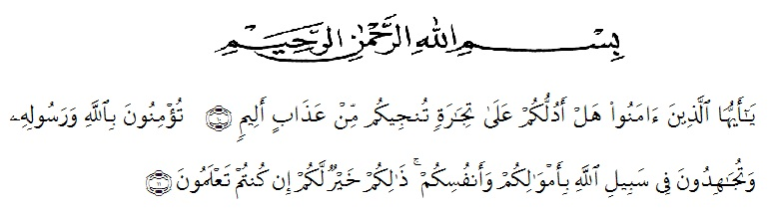
10. O ye who believes! Shall I show you a commere that will save you from a painful doom?
11. Ye should believe in Allah and His messenger, and should strive for the cause of Allah with your wealth and your lives. That is better for you, if ye did, but know.
First and foremost, the writer would praise and thanks to Almighty God, because of His blessings she can complete this research.She got suggestions, criticism and guidance from many people. Therefore, she would like to extend her sincere and special thanks to
- Dr. KRT. Hardi Mulyono K. Surbakti S.E., M.AP., the Rector of Universitas Muslim Nusantara Al- Washliyah.
- Drs. Samsul Bahri, M.Si., the Dean of Teacher Training and Education Department Universitas Muslim Nusantara Al- Washliyah.
- Zulfitri, S.S., M.A., M. Pd., the Head of English Education Department.
- Nazriani lubis S.Pd., M.Hum, the first consultant, who has given correction, suggestion, comments, criticism for completing her research,
- Rini Fadhillah Putri, S.Pd., M.Hum., the Examiner 1 who has provided criticism and directions.
- Dr. Yulia Arfanti, S.S., M.Hum., the Examiner 2 who has provided criticism and directions.
- The lecturers of the English Department of FKIP UMN Al Washliyah Medan who have taught her,
- The writer’s beloved parents, Rampis Harahap and Arinun Siregar S.Pd, who always support her financial, moral and for their love and praying in finishing her study at FKIP UMN Al Washliyah Medan,
- The writer’s beloved brother,Henry Wijaya Harahap SH and Raja Putra Madani Harahap, who always give her financial support, motivation, pray, and everything.
- The writer’s beloved younger sister, Rika Mardyana, who always give her spirit to finishing her study at FKIP UMN Al Washliyah Medan. The writer loves her so much,
- The beloved friends, Ali Muddin Damanik, Neza Puspita Harahap and Gaul Siregar who always provide support, motivation and enthusiasm so that I can complete my thesis. Finally, the writer hopes that all of suggestions and critism can be useful and meaningful for her. May God Bless Us.
Medan, February 2023
The writer

Susi Melyana Harahap

