Lampiran 1. Bagan Alir
Skema Pembuatan Media
- Pembuatan Media LB

Timbang 13 g media LB

Larutkan dalam 1000 mL aquadest dalam erlemeyer

Masak sampai mendidih di atas hot plate, aduk dengan batang pengaduk

Kemudian sterilkan ke dalam autoclave pada suhu 121°C selama 15 menit

Media LB

Lampiran 1. (Lanjutan)
- Pembuatan Media EMBA

Timbang 37,2 g Media EMBA

Masukkan ke dalam erlemeyer 1000 mL dan tambahkan aquadest hingga 1000 mL

Masak sampai mendidih di atas hot plate, aduk dengan batang pengaduk

Kemudian sterilkan ke dalam autoclave pada suhu 121°C selama 15 menit

Media EMBA di tuangkan ke dalam petridis steril secara aseptik

Media EMBA

Lampiran 1. (Lanjutan)
- Pembuata Media NA

Timbang 20 g Media NA

Masukkan ke dalam erlemeyer 1000mL dan tambahkan aquadest hingga 1000 mL

Masak sampai mendidih di atas hot plate, aduk dengan batang pengaduk

Kemudian sterilkan ke dalam autoclave pada suhu 121°C selama 15 menit

Media NA

Lampiran 1. (Lanjutan)

- Pembuatan Media SIM
Timbang 36,22 g Media SIM

Masukkan ke dalam erlemeyer 1000 mL dan tambahkan aquadest hingga 1000 mL

Masak sampai mendidih di atas hot plate, aduk dengan batang pengaduk

Kemudian sterilkan ke dalam autoclave pada suhu 121°C selama 15 menit

Media SIM

Lampiran 1. (Lanjutan)
- Pembuatan Media MR-VP
Timbang 17 g Media MR-VP

Masukkan ke dalam erlemeyer 1000 mL dan tambahkan aquadest hingga 1000 mL

Masak sampai mendidih di atas hot plate, aduk dengan batang pengaduk

Kemudian sterilkan ke dalam autoclave pada suhu 121°C selama 15 menit

Media MR-VP

Lampiran 1. (Lanjutan)
- Pembuatan Media SCA
Timbang 24,2 g Media SCA

Masukkan ke dalam erlemeyer 1000 mL dan tambahkan aquadest hingga 1000 mL

Masak sampai mendidih di atas hot plate, aduk dengan batang pengaduk

Kemudian sterilkan ke dalam autoclave pada suhu 121°C selama 15 menit

Diambil dari autovlave, kemudian tabung reaksi tersebut di letakkan secara miring

Media SCA

Lampiran 1. (Lanjutan)
- Struktur kerja ALT
25 ml Sampel

Diencerkan dengan 225 ml Lactose Broth (LB), dan dilakukan pengenceran bertingkat

Dimasukkan 1 ml dari setiap pengenceran kedalam cawan petri

Dituangkan 15 ml media PCA kedalam cawan petri

Media PCA + Pengenceran sampel

Inkubasi 24 jam pada suhu 37°C dengan posisi terbalik

Diamati koloni yang tumbuh

Dicatat dan dilakukan perhitungan

Koloni Bakteri

Lampiran 1. (Lanjutan)
- Struktur Kerja MPN Praduga
25 ml Sampel

Diencerkan dengan 225 ml Lactose Broth (LB), dan dilakukan pengenceran bertingkat

Setiap pengenceran dibuat 3 tabung reaksi berisi 9 ml MCB ( Mac Conkey Broth) dilengkapi tabung durham

Dimasukkan 1 ml larutan pengenceran bertingkat ke semua tabung

Media MCB

Inkubasi 24-48 jam pada suhu 37°C

Diamati pembentukan gas dalam tabung durham

(-) Tidak terbentuk gas di dalam tabung
(+) Terbentuknya gas di dalam tabung durham

Lampiran 1. (Lanjutan)
Struktur Kerja MPN Penegasan
Tabung Positif MPN Praduga

Dimasukkan 1 sengkelit kedalam tabung berisi10 ml media BGLB

Media BGLB
(-) Tidak terbentuk gas di dalam tabung
(+) Terbentuknya gas di dalam tabung durham
Inkubasi 24-48 jam pada suhu 37°C

Diamati pembentukan gas dalam tabung durham

Lampiran 1. (Lanjutan)
- Struktur Kerja Identifikasi bakteri Escherichia coli pada saus cabai
Tabung positif MPN Penegasan

Di inokulasikan
Diinkubasikan selama 24 jam pada suhu 37°C
Media EMBA

(+) Tumbuh koloni yang menunjukkan kilap logam dan bintik biru kehijauan
(-) Tidak tumbuh koloni yang menunjukkan kilap logam dan bintik biru kehijauan

Media NA
Diinkubasikan selama 24 jam pada suhu 37°C
Uji Citrate
Uji Indol
Uji MR
Uji VP
Pewarnaan gram
Media SCA (-)
Media VP (-)
Media SIM (+)
- Berwarna merah
Media MR (+)
- Berbentuk basil/batang
Positif: warna biru
Negatif: warna hijau
Positif: warna merah muda-merah tua
Negatif: warna tidak berubah
Positif: warna merah
Negatif: warna kuning
Positif: warna merah muda

Lampiran 2. Sampel yang diteliti
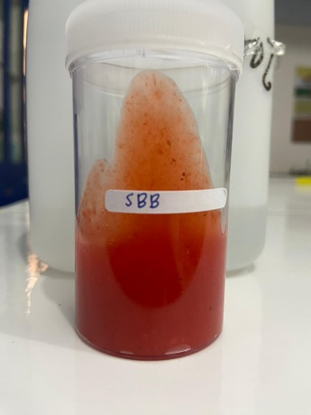  Saus Bakso Bakar | Saus Dimsum
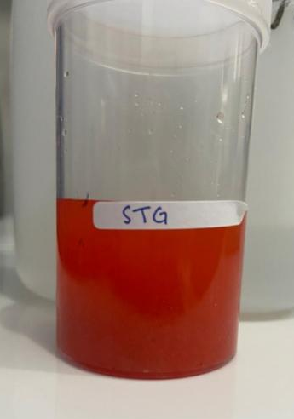  Saus Telur Gulung | 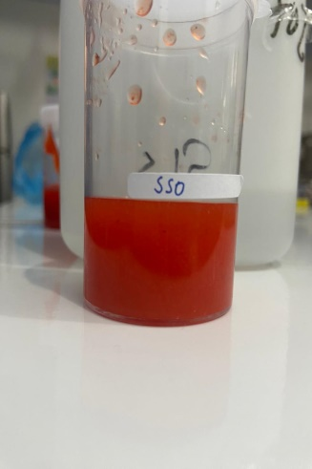  Saus Siomay
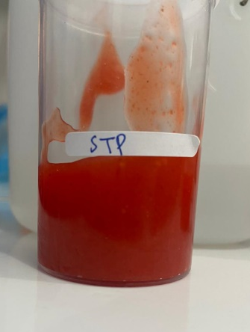
Saus Tempura

Lampiran 3. Alat Dan Bahan
- Alat
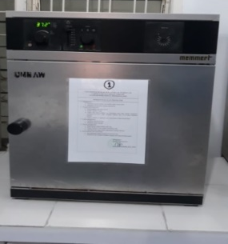  Oven | 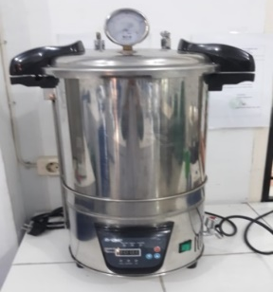  Autoclaf | 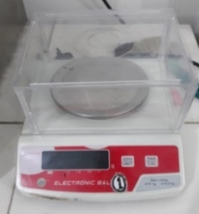  Timbangan Analitik | Colony Counter  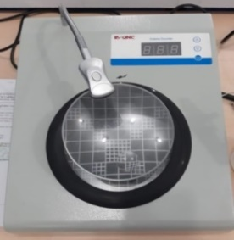
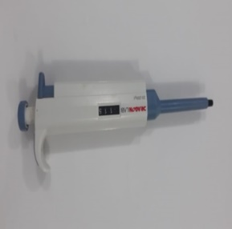  Mikropipet | 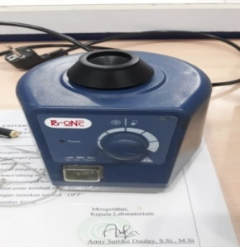  Vortex | Object Glass | 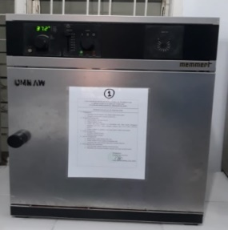  Inkubator

- Bahan
Aquades | 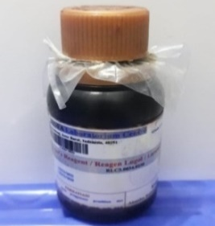  Lugol | 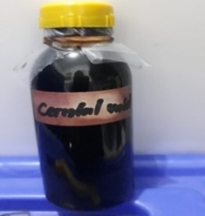  Cristal violet | 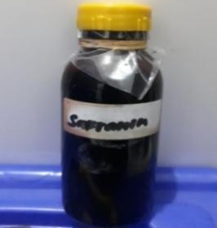  Safranin
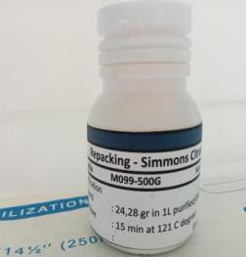  Media SCA | 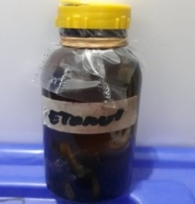  Etanol | 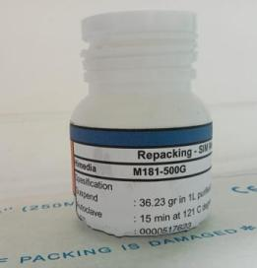  Media SIM | 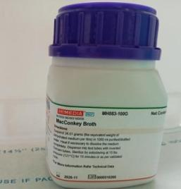  Media MCB

Lampiran 3. (Lanjutan)
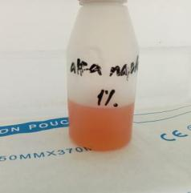  Alfa Naftol | 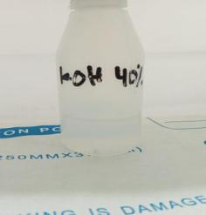  KOH 40% | 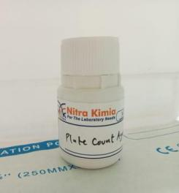  Media PCA | 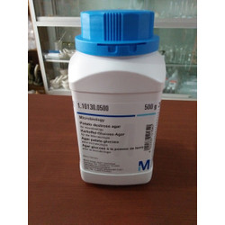  Media LB
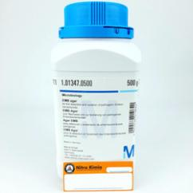  Media NA | 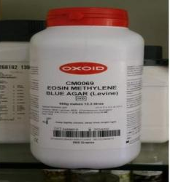  Media EMBA | 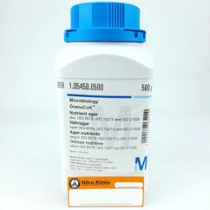  Media BGLB

Lampiran 4. Prosedur Penelitian
- Sterilisasi Alat | 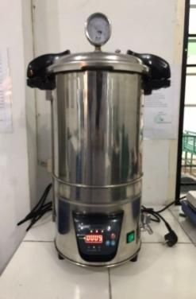  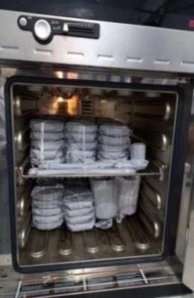
- Penimbangan Media | 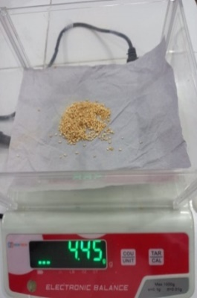  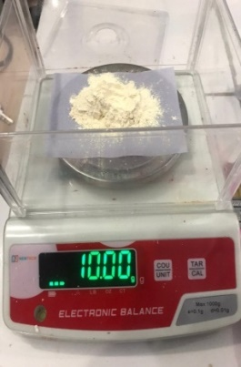
- Pemanasan Media | 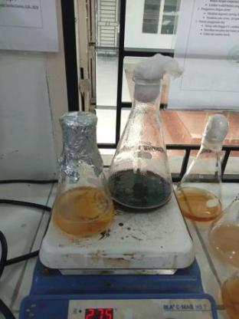  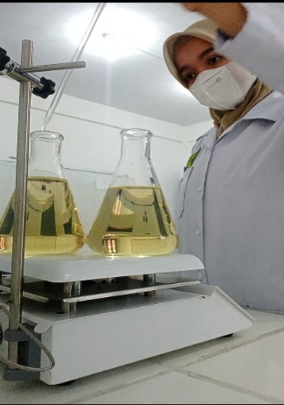
- Pengambilan Sampel Di Sekitar SMK Kota Medan | 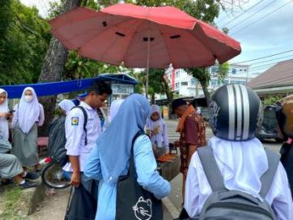  Saus Dimsum Saus Bakso Bakar
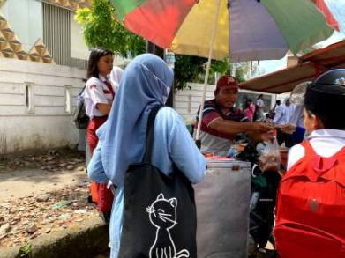
Saus Siomay Saus Tempura

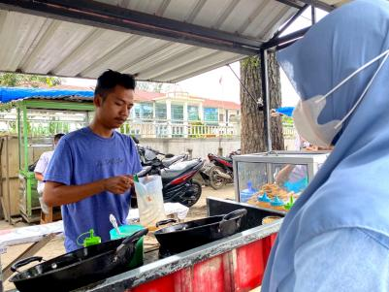
Saus Telur Gulung

- Pengenceran Sampel | 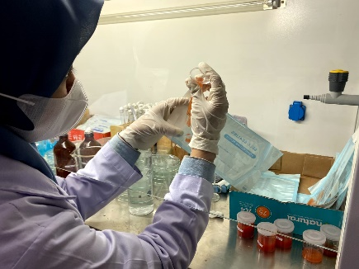
- Pengujian ALT (Angka Lempeng Total) | 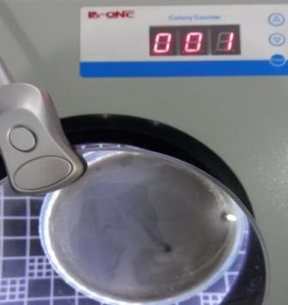
- Pengujian MPN (Most Probable Number) | 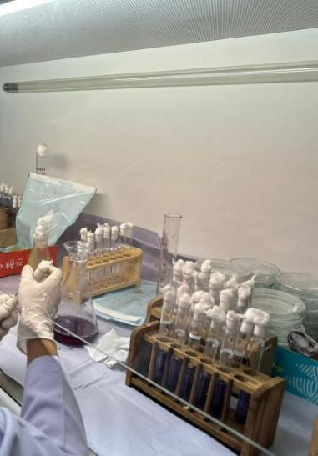
- Pengujian Pada Media EMBA | 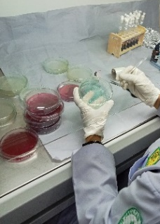  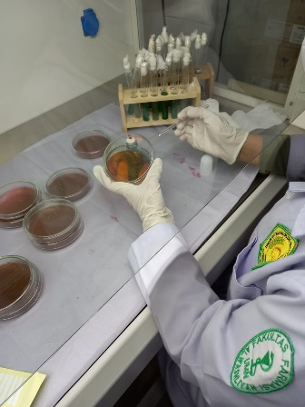
- Uji Pewarnaan Gram Bakteri

- Uji IMVIC (Indol, MR, VP, Citrate) | 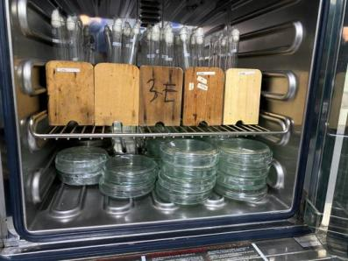  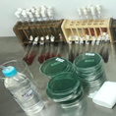

Lampiran 5. Hasil Penelitian
- ALT(Angka Lempeng Total)
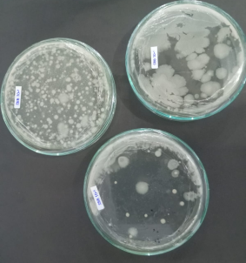  SBB | 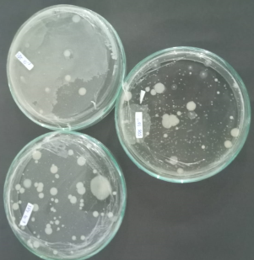  STG
SSO | 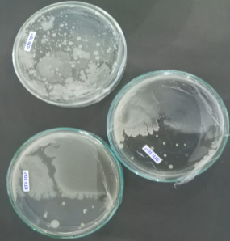  STP
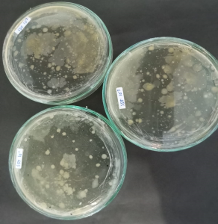
SDS

- MPN ( Most Probable Number) Praduga
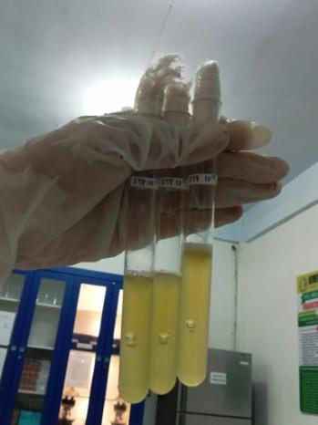  SBB | 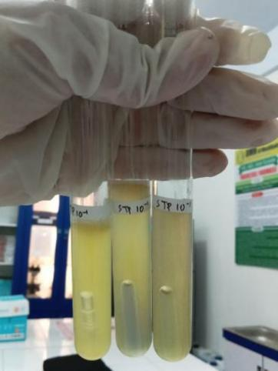  STG | 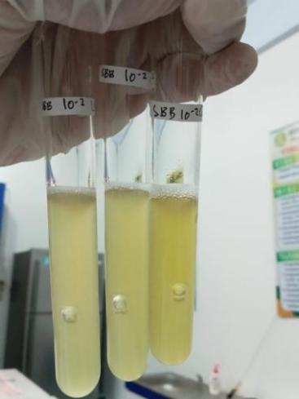  SSO
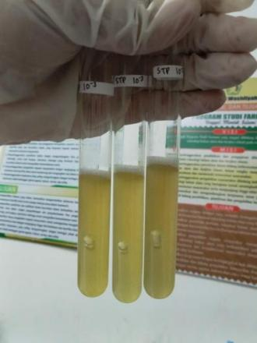  STP | 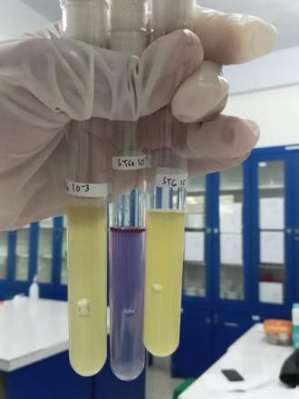  SDS

- MPN ( Most Probable Number) Penegasan
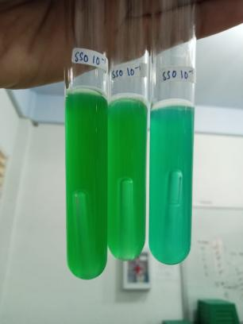  SBB | 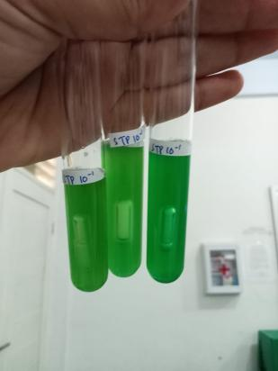  STG | 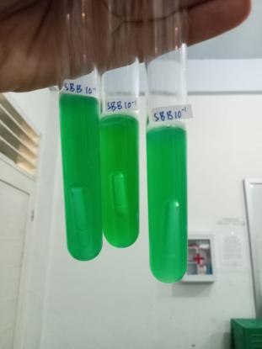  SSO
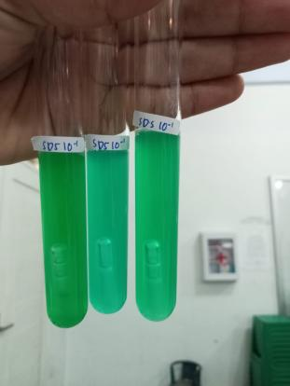  STP | 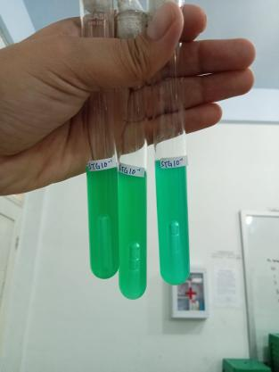  SDS

Lampiran 5. (Lanjutan)

- Identidikasi Pada Media EMBA dan NA
(Terbentuk koloni berwarna hijau metalik pada permukaan media EMBA)
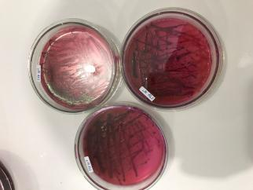  SBB | 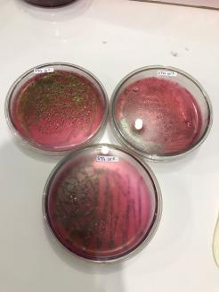  STG | 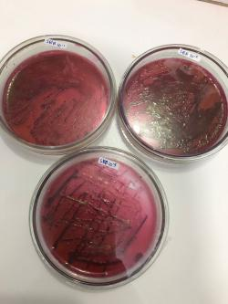  SSO
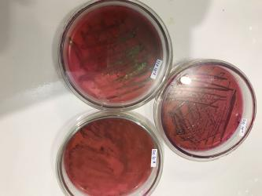  STP | 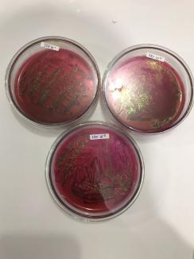  SDS
Peremajaan pada media NA
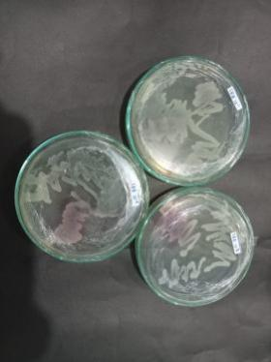  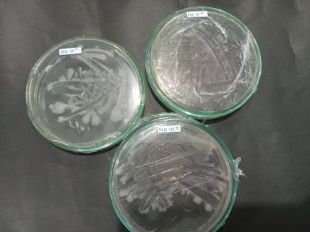  SBB | STG | 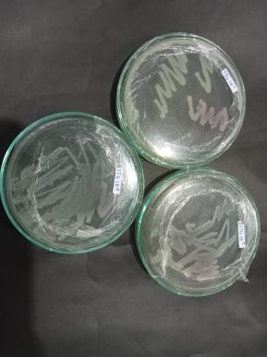  SSO
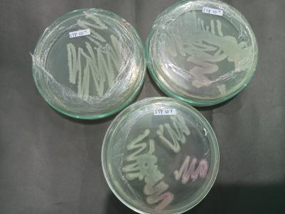  STP | 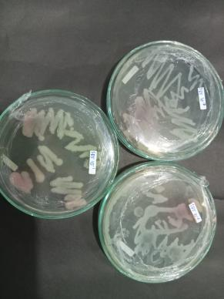  SDS
Uji IMVIC
Indol( Terbentuk cincin kuning pada permukaan media)
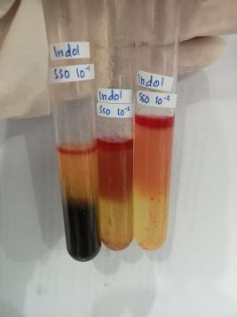  SBB | 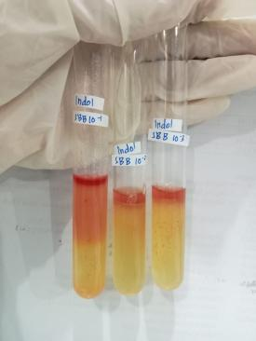  STG | 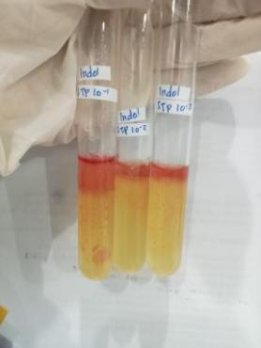  SSO
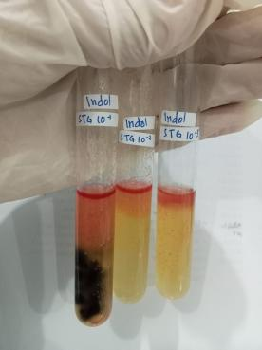  STP | 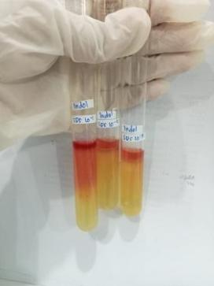  SDS

MR (Methyl Red)
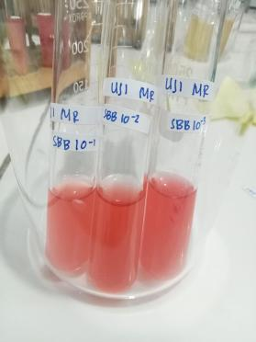  SBB | 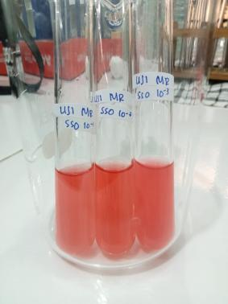  STG | 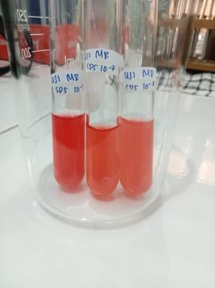  SSO
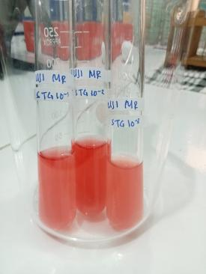  STP | 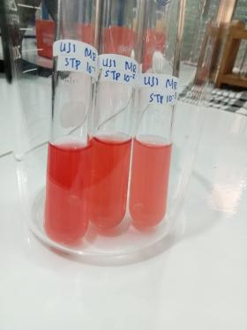  SDS
VP (Voges Proskauer)
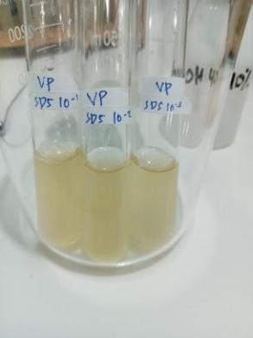  SBB | 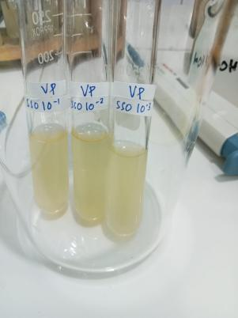  STG | 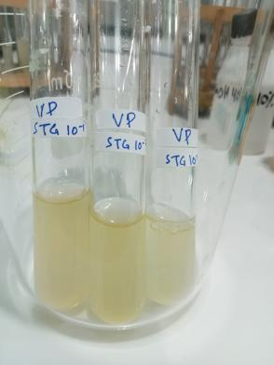  SSO
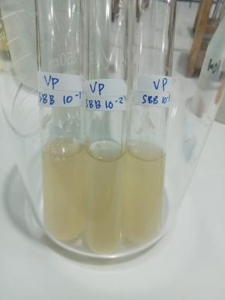  STP | 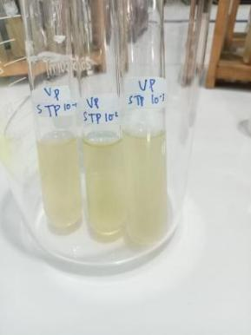  SDS

Citrate
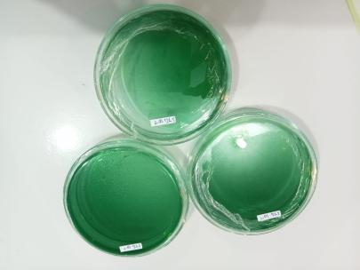  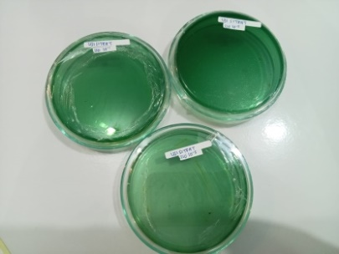  SBB | 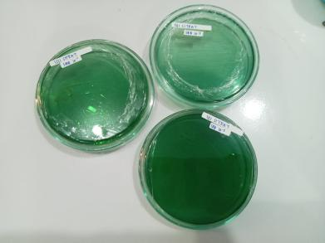  STG | SSO
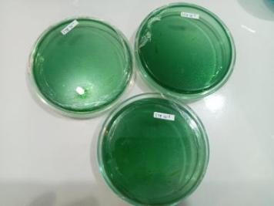  STP | 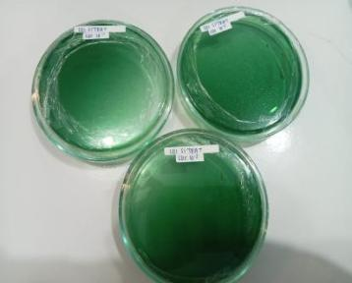  SDS

Lampiran 6. Perhitungan ALT dan MPN
- Perhitungan ALT
Nilai ALT (koloni/g) = $\frac{Jumlah koloni x pengenceran}{volume}$
Pengulangan 1
- SDS 10̄¹ = 36
= $\frac{36 x\frac{1}{10 ֿ ¹}}{1 ml}$
= $\frac{36 x 10 ¹}{1 ml}$
= 36 x 10¹ koloni/g
= 3,6 x 10² koloni/g
- SDS 10⁻² = 110 koloni
= $\frac{110 x\frac{1}{10 ֿ ²}}{1 ml}$
= $\frac{110 x 10 ²}{1 ml}$
= 110 x 10 ² koloni/g
SDS 10⁻³ = 37 koloni
= $\frac{37 x\frac{1}{10 ֿ ³}}{1 ml}$
= $\frac{37 x 10 ³}{1 ml}$
= 37 x 10 ³ koloni/g
= 370 x 10² koloni/g
$$Rata²=\frac{3,6+110+370}{3}$$
= 161,2 x 10² koloni/g
= 1,6 x 10⁴ koloni/g
Lampiran 6. (Lanjutan)
SBB 10⁻¹ = 72 koloni
= $\frac{72 x\frac{1}{10 ֿ ¹}}{1 ml}$
= $\frac{72 x 10 ¹}{1 ml}$
= 72 x 10¹ koloni/g
= 7,2 x 10² koloni/g
SBB 10⁻² = 34 koloni
= $\frac{34 x\frac{1}{10 ֿ ²}}{1 ml}$
= $\frac{34 x 10 ²}{1 ml}$
= 34 x 10² koloni/g
SBB 10⁻³ = 25 koloni
= $\frac{25 x\frac{1}{10 ֿ ³}}{1 ml}$
= $\frac{25 x 10 ³}{1 ml}$
= 25 x 10³ koloni/g
= 250 x 10² koloni/g
$$Rata²=\frac{7,2+34+250}{3}$$
= 97 x 10² koloni/g
= 0,9 x 10⁴ koloni/g
- STG 10⁻¹ = 25 koloni (TFTC)
- STG 10⁻² = 112 koloni

Lampiran 6. (Lanjutan)
= $\frac{112 x\frac{1}{10 ֿ ²}}{1 ml}$
= $\frac{112 x 10 ²}{1 ml}$
= 112 x 10² koloni/g
STG 10⁻³ = 82 koloni
= $\frac{82 x\frac{1}{10 ֿ ³}}{1 ml}$
= $\frac{82 x 10³}{1 ml}$
= 82 x 10³ koloni/g
= 820 x 10² koloni/g
$$Rata²=\frac{112+820}{2}$$
= 466 x 10² koloni/g
= 4,6 x 10⁴ koloni/g
- SSO 10⁻¹ = 82 koloni
= $\frac{82 x\frac{1}{10 ֿ ¹}}{1 ml}$
= $\frac{82 x 10 ¹}{1 ml}$
= 82 x 10¹ koloni/g
= 8,2 x 10² koloni/g
SSO 10⁻² = 66 koloni
= $\frac{66 x\frac{1}{10 ֿ ²}}{1 ml}$
= $\frac{66 x 10²}{1 ml}$
Lampiran 6. (Lanjutan)
= 66 x 10² koloni/g
SSO 10⁻³ = 29 koloni (TFTC)
$$Rata²=\frac{8,2+66}{2}$$
= 37,1 x 10² koloni/g

= 0,3 x 10⁴ koloni/g
- STP 10⁻¹ = 54 koloni
= $\frac{54 x\frac{1}{10 ֿ ¹}}{1 ml}$
= $\frac{54 x 10 ¹}{1 ml}$
= 54 x 10¹ koloni/g
= 5,4 x 10² koloni/g
STP 10⁻² = 61 koloni
= $\frac{61 x\frac{1}{10 ֿ ²}}{1 ml}$
= $\frac{61 x 10 ²}{1 ml}$
= 61 x 10² koloni/g
STP 10⁻³ = 34 koloni
= $\frac{34 x\frac{1}{10 ֿ ³}}{1 ml}$
= $\frac{34 x 10³}{1 ml}$
= 34 x 10³ koloni/g
= 340 x 10² koloni/g
$$Rata²=\frac{5,4+61+340}{3}$$
Lampiran 6. (Lanjutan)
= 135,4 x 10² koloni/g = 1,3 x 10⁴ koloni/g
Pengulangan 2
- SDS 10̄¹ = 65 koloni
= $\frac{65 x\frac{1}{10 ֿ ¹}}{1 ml}$
= $\frac{65 x 10 ¹}{1 ml}$
= 65 x 10¹ koloni/g
= 6,5 x 10² koloni/g
SDS 10⁻² = 156 koloni
= $\frac{156 x\frac{1}{10 ֿ ²}}{1 ml}$
= $\frac{156 x 10²}{1 ml}$
= 156 x 10² koloni/g
SDS 10⁻³ = 101 koloni
= $\frac{101 x\frac{1}{10 ֿ ³}}{1 ml}$
= $\frac{101 x 10 ³}{1 ml}$
= 101 x 10³ koloni/g
= 1010 x 10² koloni/g
$$Rata²=\frac{16,5+156+1010}{3}$$
= 394,1 x 10²koloni/g
= 3,94 x 10⁴ koloni/g
Lampiran 6. (Lanjutan)
- SBB 10⁻¹ = 40 koloni
= $\frac{40 x\frac{1}{10 ֿ ¹}}{1 ml}$
= $\frac{40 x 10 ¹}{1 ml}$
= 40 x 10¹ koloni/g
= 4 x 10² koloni/g
SBB 10⁻² = 62 koloni

= $\frac{62 x\frac{1}{10 ֿ ²}}{1 ml}$
= $\frac{62 x 10 ²}{1 ml}$
= 6,2 x 10² koloni/g
SBB 10⁻³ = 50 koloni
= $\frac{50 x\frac{1}{10 ֿ ³}}{1 ml}$
= $\frac{50 x 10 ³}{1 ml}$
= 50 x 10 ³ koloni/g
= 500 x 10² koloni/g
$$Rata²=\frac{4+62+500}{3}$$
= 188,6 x 10² koloni/g
= 1,8 x 10⁴ koloni/ g
- STG 10⁻¹ = 251 koloni

Lampiran 6. (Lanjutan)
= $\frac{251 x\frac{1}{10 ֿ ¹}}{1 ml}$
= $\frac{251 x 10 ¹}{1 ml}$
= 251 x 10¹ koloni/g
= 25,1x 10² koloni/g
STG 10⁻² = 102 koloni
= $\frac{102 x\frac{1}{10 ֿ ²}}{1 ml}$
= $\frac{102 x 10 ²}{1 ml}$
= 102 x 10² koloni/g
STG 10⁻³ = 207 koloni
= $\frac{207 x\frac{1}{10 ֿ ³}}{1 ml}$
= $\frac{207 x 10³}{1 ml}$
= 207 x 10 ³ koloni/g
= 2070 x 10² koloni/g
$$Rata²=\frac{25,1+102+2070}{3}$$
= 732,3 x 10²koloni/g
= 7,3 x 10⁴ koloni/g
- SSO 10⁻¹ = 111 koloni
= $\frac{111 x\frac{1}{10 ֿ ¹}}{1 ml}$
= $\frac{111 x 10 ¹}{1 ml}$
Lampiran 6. (Lanjutan)
= 111 x 10¹ koloni/g
= 11,1 x 10² koloni/g
SSO 10⁻² = 124 koloni
= $\frac{124 x\frac{1}{10 ֿ ²}}{1 ml}$
= $\frac{124 x 10 ²}{1 ml}$
= 124 x 10² koloni/g
SSO 10⁻³ = 105 koloni
= $\frac{105 x\frac{1}{10 ֿ ³}}{1 ml}$
= $\frac{105 x 10 ³}{1 ml}$
= 105 x 10³ koloni/g
= 1050 x 10² koloni/g
$$Rata²=\frac{11,1+124+1050}{3}$$
= 395 x 10²koloni/g
= 3,9 x 10⁴ koloni/g
- STP 10⁻¹ = 84 koloni
= $\frac{84 x\frac{1}{10 ֿ ¹}}{1 ml}$
= $\frac{84 x 10 ¹}{1 ml}$
= 84 x 10¹ koloni/g
= 8,4 x 10² koloni/g
STP 10⁻² = 86 koloni
Lampiran 6. (Lanjutan)
= $\frac{86 x\frac{1}{10 ֿ ²}}{1 ml}$
= $\frac{86 x 10 ²}{1 ml}$
= 86 x 10² koloni/g
STP 10⁻³ = 102 koloni
= $\frac{102 x\frac{1}{10 ֿ ³}}{1 ml}$
= $\frac{102 x 10 ³}{1 ml}$
= 102 x 10³ koloni/g
= 1020 x 10² koloni/g
$$Rata²=\frac{18,4+86+1020}{3}$$
= 374,8 x 10²koloni/g
= 3,7 x 10⁴ koloni/g
Pengulangan 3
- SDS 10̄¹ = 185 koloni
= $\frac{185 x\frac{1}{10 ֿ ¹}}{1 ml}$
= $\frac{185 x 10 ¹}{1 ml}$
= 185 x 10¹ koloni/g
= 18,5 x 10² koloni/g
SDS 10⁻² = 29 koloni ( TFTC)
- SDS 10⁻³ = 72 koloni
= $\frac{72 x\frac{1}{10 ֿ ³}}{1 ml}$
Lampiran 6. (Lanjutan)
= $\frac{72 x 10 ³}{1 ml}$
= 72 x 10³ koloni/g
= 720 x 10² koloni/g
$$Rata²=\frac{18,5+720}{2}$$
= 369,2 x 10²koloni/g
= 3,6 x 10⁴ koloni/g
- SBB 10⁻¹ = 3 koloni ( TFTC)
- SBB 10⁻² = 5 koloni ( TFTC)
- SBB 10⁻³ = 13 koloni ( TFTC)
- STG 10⁻¹ = 37 koloni
= $\frac{37 x\frac{1}{10 ֿ ¹}}{1 ml}$
= $\frac{37 x 10 ¹}{1 ml}$
= 37 x 10¹ koloni/g
= 3,7 x 10² koloni/g
STG 10⁻² = 27 koloni ( TFTC)
- STG 10⁻³ = 28 koloni ( TFTC)
Rata-rata = 37 x 10¹ koloni/g
=0,03 x 10⁴ koloni/g
- SSO 10⁻¹ = 231 koloni
= $\frac{231 x\frac{1}{10 ֿ ¹}}{1 ml}$

Lampiran 6. (Lanjutan)
= $\frac{232 x 10 ¹}{1 ml}$
= 231 x 10¹ koloni/g
= 23,1 x 10² koloni/g
SSO 10⁻² = 31 koloni
= $\frac{31 x\frac{1}{10 ֿ ²}}{1 ml}$
= $\frac{31 x 10 ²}{1 ml}$
= 31 x 10² koloni/g
- SSO 10⁻³ = 77 koloni
= $\frac{77 x\frac{1}{10 ֿ ³}}{1 ml}$
= $\frac{77 x 10 ³}{1 ml}$
= 77 x 10³ koloni/g
= 770 x 10² koloni/g
$$Rata²=\frac{23,1+31+770}{3}$$
= 412 x 10²koloni/g
= 4,1 x 10⁴ koloni/g
- STP 10⁻¹ = 42 koloni
= $\frac{42 x\frac{1}{10 ֿ ¹}}{1 ml}$
= $\frac{42 x 10 ¹}{1 ml}$
= 42 x 10¹ koloni/g
Lampiran 6. (Lanjutan)
= 4,2 x 10² koloni/g
STP 10⁻² = 46 koloni
= $\frac{46 x\frac{1}{10 ֿ ²}}{1 ml}$
= $\frac{46 x 10 ²}{1 ml}$
= 46 x 10² koloni/g
- STP 10⁻³ = 32 koloni
= $\frac{32 x\frac{1}{10 ֿ ³}}{1 ml}$
= $\frac{32 x 10 ³}{1 ml}$
= 32 x 10³ koloni/g
= 320 x 10² koloni/g
$$Rata²=\frac{4,2+46+320}{3}$$
= 123,4 x 10²koloni/g
= 1,2 x 10⁴ koloni/g
Pengulangan 4
- SDS 10̄¹ = 197 koloni
= $\frac{197 x\frac{1}{10 ֿ ¹}}{1 ml}$
= $\frac{197 x 10 ¹}{1 ml}$
= 197 x 10¹ koloni/g
= 19,7 x 10² koloni/g
Lampiran 6. (Lanjutan)
- SDS 10⁻² = 69 koloni
= $\frac{69 x\frac{1}{10 ֿ ²}}{1 ml}$
= $\frac{69 x 10 ²}{1 ml}$
= 69 x 10² koloni/g
- SDS 10⁻³ = 25 koloni (TFTC)
$$Rata²=\frac{19,7+69}{2}$$
= 44,3 x 10²koloni/g
= 0,4 x 10⁴ koloni/g
- SBB 10⁻¹ = >300 koloni (TNTC)
- SBB 10⁻² = 51 koloni
= $\frac{51 x\frac{1}{10 ֿ ²}}{1 ml}$
= $\frac{51 x 10 ²}{1 ml}$
= 51 x 10² koloni/g
SBB 10⁻³ = 31 koloni
= $\frac{31 x\frac{1}{10 ֿ ³}}{1 ml}$
= $\frac{31 x 10 ³}{1 ml}$
= 31 x 10³ koloni/g
= 310 x 10² koloni/g
$$Rata²=\frac{51+310}{2}$$
= 180,5 x 10²koloni/g
Lampiran 6. (Lanjutan)
= 1,8 x 10⁴ koloni/g

- STG 10⁻¹ = 251 koloni
= $\frac{251 x\frac{1}{10 ֿ ¹}}{1 ml}$
= $\frac{251 x 10 ¹}{1 ml}$
= 251 x 10¹ koloni/g
= 25,1 x 10² koloni/g
- STG 10⁻² = >300 koloni (TNTC)
- STG 10⁻³ = 98 koloni
= $\frac{98 x\frac{1}{10 ֿ ³}}{1 ml}$
= $\frac{ 98 x 10 ³}{1 ml}$
= 98 x 10³ koloni/g
= 980 x 10² koloni/g
$$Rata²=\frac{25,1+980}{2}$$
= 502,5 x 10²koloni/g
= 5,0 x 10⁴ koloni/g
- SSO 10⁻¹ =>300 koloni (TNTC)
- SSO 10⁻² = >300 koloni (TNTC)
- SSO 10⁻³ = 51 koloni
= $\frac{51 x\frac{1}{10 ֿ ³}}{1 ml}$
Lampiran 6. (Lanjutan)
= $\frac{51 x 10 ³}{1 ml}$
= 51 x 10³ koloni/g
= 510 x 10² koloni/g
Rata-rata = 510 x 10² koloni/g
= 5,1 x 10⁴ koloni/g
- STP 10⁻¹ = 380 koloni (TFTC)
- STP 10⁻² = 320 koloni (TFTC)
- STP 10⁻³ = 275 koloni
= $\frac{275 x\frac{1}{10 ֿ ³}}{1 ml}$
= $\frac{275 x 10 ³}{1 ml}$
= 275 x 10³ koloni/g
= 2750 x 10² koloni/g
Rata-rata = 750 x 10² koloni/g
= 27,5 x 10⁴ koloni/g
Pengulangan 5
- SDS 10̄¹ = 87 koloni
= $\frac{87 x\frac{1}{10 ֿ ¹}}{1 ml}$
= $\frac{87 x 10 ¹}{1 ml}$
= 87 x 10¹ koloni/g
= 8,7 x 10² koloni/g
Lampiran 6. (Lanjutan)
SDS 10⁻² = 105 koloni
= $\frac{105 x\frac{1}{10 ֿ ²}}{1 ml}$
= $\frac{105 x 10 ²}{1 ml}$
= 105 x 10² koloni/g
SDS 10⁻³ = 76 koloni
= $\frac{76 x\frac{1}{10 ֿ ³}}{1 ml}$
= $\frac{76 x 10 ³}{1 ml}$
= 76 x 10³ koloni/g
= 760 x 10² koloni/g
$$Rata²=\frac{18,7+105+760}{3}$$
= 294,5 x 10²koloni/g
= 2,9 x 10⁴ koloni/g
- SBB 10⁻¹ = > 300 koloni ( TNTC)
- SBB 10⁻² = 105 koloni
= $\frac{105 x\frac{1}{10 ֿ ²}}{1 ml}$
= $\frac{105 x 10 ²}{1 ml}$
= 105 x 10² koloni/g
SBB 10⁻³ = 97 koloni
= $\frac{97x\frac{1}{10 ֿ ³}}{1 ml}$
Lampiran 6. (Lanjutan)
= $\frac{97 x 10 ³}{1 ml}$
= 97 x 10³ koloni/g
= 970 x 10² koloni/g
$$Rata²=\frac{105+970}{2}$$
= 537,5 x 10²koloni/g
= 5,3 x 10⁴ koloni/g
- STG 10⁻¹ = 35 koloni
= $\frac{35 x\frac{1}{10 ֿ ¹}}{1 ml}$
= $\frac{35 x 10 ¹}{1 ml}$
= 35 x 10¹ koloni/g
= 3,5 x 10² koloni/g
- STG 10⁻² = 41 koloni
= $\frac{41 x\frac{1}{10 ֿ ²}}{1 ml}$
= $\frac{41 x 10 ²}{1 ml}$
= 41 x 10² koloni/g
STG 10⁻³ = >300 koloni (TNTC)
$$Rata²=\frac{3,5+41}{2}$$
= 22,2 x 10²koloni/g
= 0,2x 10⁴ koloni/g
- SSO 10⁻¹ = 69 koloni
Lampiran 6. (Lanjutan)
= $\frac{69 x\frac{1}{10 ֿ ¹}}{1 ml}$
= $\frac{69 x 10 ¹}{1 ml}$
= 69 x 10¹ koloni/g
= 6,9 x 10² koloni/g
- SSO 10⁻² = >300 koloni (TNTC)
- SSO 10⁻³ = 51 koloni
= $\frac{51 x\frac{1}{10 ֿ ³}}{1 ml}$
= $\frac{51 x 10 ³}{1 ml}$
= 51 x 10³ koloni/g
= 510 x 10² koloni/g
$$Rata²=\frac{69+510}{2}$$
= 289,5 x 10²koloni/g
= 2,8 x 10⁴ koloni/g
- STP 10⁻¹ = 40 koloni
= $\frac{40 x\frac{1}{10 ֿ ¹}}{1 ml}$
= $\frac{40 x 10 ¹}{1 ml}$
= 40 x 10¹ koloni/g
= 4 x 10² koloni/g
STP 10⁻² = 31 koloni
Lampiran 6. (Lanjutan)
= $\frac{31 x\frac{1}{10 ֿ ²}}{1 ml}$
= $\frac{31 x 10 ²}{1 ml}$
= 31 x 10² koloni/g
- STP 10⁻³ = 30 koloni
= $\frac{30 x\frac{1}{10 ֿ ³}}{1 ml}$
= $\frac{30 x 10 ³}{1 ml}$
= 30 x 10³ koloni/g
= 300 x 10² koloni/g
$$Rata²=\frac{4+31+300}{3}$$
= 111,6 x 10²koloni/g
= 1,1 x 10⁴ koloni/g
- Perhitungan MPN
$$MPN sampel=Indeks MPN x \frac{ 1}{Pengenceran tabung }$$
Pengulangan 1
- SDS = (3.2.1) ≈ Nilai indeks 150
= $150 x\frac{ 1}{10 ֿ ¹}$
= 150 x 10
= 1500 / ml
- SBB = ( 3.3.3 )≈ Nilai indeks ≥ 1100
= $1100 x\frac{ 1}{10 ֿ ¹}$
= 1100 x 10
Lampiran 6. (Lanjutan)
= >11000 / ml
- STG = ( 3.3.3 )≈ Nilai indeks ≥ 1100
= $1100 x\frac{ 1}{10 ֿ ¹}$
= 1100 x 10
= >11000 / ml
- SSO = ( 3.3.3 )≈ Nilai indeks ≥ 1100
= $1100 x\frac{ 1}{10 ֿ ¹}$
= 1100 x 10
= >11000 / ml
- STP = ( 3.3.3 )≈ Nilai indeks ≥ 1100
= $1100 x\frac{ 1}{10 ֿ ¹}$
= 1100 x 10
= >11000 / ml
Pengulangan 2
- SDS = (3.2.1) ≈ Nilai indeks 150
= $150 x\frac{ 1}{10 ֿ ¹}$
= 150 x 10
= 1500 / ml
- SBB = (2.2.2) ≈ Nilai indeks 35
= $35 x\frac{ 1}{10 ֿ ¹}$
= 35 x 10
= 350 / ml
- STG = ( 3.3.3 )≈ Nilai indeks ≥ 1100
Lampiran 6. (Lanjutan)
= $1100 x\frac{ 1}{10 ֿ ¹}$
= 1100 x 10
= >11000 / ml
- SSO = ( 2.2.2 )≈ Nilai indeks 35
= $35 x\frac{ 1}{10 ֿ ¹}$
= 35 x 10
= 350 / ml
- STP = (3.2.2) Nilai indeks 210
= $210 x\frac{ 1}{10 ֿ ¹}$
= 210 x 10
= 2100 / ml
- Pengulangan 3
- SDS = ( 3.3.3 )≈ Nilai indeks ≥ 1100
= $1100 x\frac{ 1}{10 ֿ ¹}$
= 1100 x 10
= >11000 / ml
- SBB = ( 3.2.2 ) ≈ Nilai indeks 210
= $210 x\frac{ 1}{10 ֿ ¹}$
= 210 x 10
= 2100 / ml
- STG = ( 2.3.2 ) ≈ Nilai indeks 38
= $38 x\frac{ 1}{10 ֿ ¹}$
= 38 x 10
Lampiran 6. (Lanjutan)
= 380 / ml
- SSO = ( 3.2.1 )≈ Nilai indeks 150
= $150 x\frac{ 1}{10 ֿ ¹}$
= 150 x 10
= 1500/ ml
- STP = ( 2.1.2 ) ≈ Nilai indeks 27
= $27 x\frac{ 1}{10 ֿ ¹}$
= 27 x 10
= 270 / ml
- Pengulangan 4
- SDS = ( 3.3.3 )≈ Nilai indeks ≥ 1100
= $1100 x\frac{ 1}{10 ֿ ¹}$
= 1100 x 10
= >11000 / ml
- SBB = ( 3.3.3 )≈ Nilai indeks ≥ 1100
= $1100 x\frac{ 1}{10 ֿ ¹}$
= 1100 x 10
= >11000 / ml
- STG = ( 3.3.2 )≈ Nilai indeks 1100
= $1100 x\frac{ 1}{10 ֿ ¹}$
= 1100 x 10
= 11000 / ml
- SSO = ( 3.3.2 )≈ Nilai indeks 1100
Lampiran 6. (Lanjutan)
= $1100 x\frac{ 1}{10 ֿ ¹}$
= 1100 x 10
= 11000 / ml
- STP = ( 3.3.3 )≈ Nilai indeks ≥ 1100
= $1100 x\frac{ 1}{10 ֿ ¹}$
= 1100 x 10
= >1100 0/ ml
- Pengulangan 5
- SDS = ( 3.3.3 )≈ Nilai indeks ≥ 1100
= $1100 x\frac{ 1}{10 ֿ ¹}$
= 1100 x 10
= >11000 / ml
- SBB = ( 3.3.3 )≈ Nilai indeks ≥ 1100
= $1100 x\frac{ 1}{10 ֿ ¹}$
= 1100 x 10
= >11000 / ml
- STG = ( 3.3.3 )≈ Nilai indeks ≥ 1100
= $1100 x\frac{ 1}{10 ֿ ¹}$
= 1100 x 10
= >11000 / ml
- SSO = ( 3.2.2 )≈ Nilai indeks 210
= $210 x\frac{ 1}{10 ֿ ¹}$
= 210 x 10
Lampiran 6. (Lanjutan)
= 2100 / ml
- STP = ( 3.3.2 )≈ Nilai indeks 1100
= $1100 x\frac{ 1}{10 ֿ ¹}$
= 1100 x 10
= 11000 / ml

Lampiran 7. Tabel perhitungan ALT
Sampel | Pengulangan | Angka Lempeng Total | Standar SNI koloni/g | Keterangan
SDS | SDS UL 1 | 1,6 x 10⁴ CFU/ml | 1 x 10⁴ | TMS
 | SDS UL 2 | 3,94 x 10⁴ CFU/ml | 1 x 10⁴ | TMS
 | SDS UL 3 | 3,6 x 10⁴ CFU/ml | 1 x 10⁴ | TMS
 | SDS UL 4 | 0,4 x 10⁴ CFU/ml | 1 x 10⁴ | MS
 | SDS UL 5 | 2,9 x 10⁴ CFU/ml | 1 x 10⁴ | TMS
SBB | SBB UL 1 | 0,9 x 10⁴ CFU/ml | 1 x 10⁴ | MS
 | SBB UL 2 | 1,8 x 10⁴ CFU/ml | 1 x 10⁴ | TMS
 | SBB UL 3 | TFTC | 1 x 10⁴ | TMS
 | SBB UL 4 | 1,8 x 10⁴ CFU/ml | 1 x 10⁴ | TMS
 | SBB UL 5 | 5,3 x 10⁴ CFU/ml | 1 x 10⁴ | TMS
STG | STG UL 1 | 4,6 x 10⁴ CFU/ml | 1 x 10⁴ | TMS
 | STG UL 2 | 7,3 x 10⁴ CFU/ml | 1 x 10⁴ | TMS
 | STG UL 3 | 0,03 x 10⁴ CFU/ml | 1 x 10⁴ | MS
 | STG UL 4 | 5,0 x 10⁴ CFU/ml | 1 x 10⁴ | TMS
 | STG UL 5 | 0,2 x 10⁴ CFU/ml | 1 x 10⁴ | MS
SSO | SSO UL 1 | 0,3 x 10⁴ CFU/ml | 1 x 10⁴ | MS
 | SSO UL 2 | 3,9 x 10⁴ CFU/ml | 1 x 10⁴ | TMS
 | SSO UL 3 | 4,1 x 10⁴ CFU/ml | 1 x 10⁴ | TMS
 | SSO UL 4 | 5,1 x 10⁴ CFU/ml | 1 x 10⁴ | TMS
 | SSO UL 5 | 2,8 x 10⁴ CFU/ml | 1 x 10⁴ | TMS
STP | STP UL 1 | 1,3 x 10⁴ CFU/ml | 1 x 10⁴ | TMS
 | STP UL 2 | 3,7 x 10⁴ CFU/ml | 1 x 10⁴ | TMS
 | STP UL 3 | 1,2 x 10⁴ CFU/ml | 1 x 10⁴ | TMS
 | STP UL 4 | 27,5 x 10⁴ CFU/ml | 1 x 10⁴ | TMS
 | STP UL 5 | 1,1 x 10⁴ CFU/ml | 1 x 10⁴ | TMS

Lampiran 8. Tabel perhitungan MPN
Sampel | Pengulangan | Jumlah tabung (＋) |  |  | Indeks MPN / g (ml) | Coliform | Standar SNI  MPN/g | Ket
 |  | 10̄¹ | 10ֿ² | 10ֿ³
SDS | Ul1 | 3 | 2 | 1 | 150 | 1500 | 100 | TMS
 | Ul2 | 3 | 2 | 1 | 150 | 1500 | 100 | TMS
 | Ul3 | 3 | 3 | 3 | >1100 | >11000 | 100 | TMS
 | Ul4 | 3 | 3 | 3 | >1100 | >11000 | 100 | TMS
 | Ul5 | 3 | 3 | 3 | >1100 | >11000 | 100 | TMS
SBB | Ul1 | 3 | 3 | 3 | >1100 | >11000 | 100 | TMS
 | Ul2 | 2 | 2 | 2 | 35 | 350 | 100 | TMS
 | Ul3 | 3 | 2 | 2 | 210 | 2100 | 100 | TMS
 | Ul4 | 3 | 3 | 3 | >1100 | >11000 | 100 | TMS
 | Ul5 | 3 | 3 | 3 | >1100 | >11000 | 100 | TMS
STG | Ul1 | 3 | 3 | 3 | >1100 | >11000 | 100 | TMS
 | Ul2 | 3 | 3 | 3 | >1100 | >11000 | 100 | TMS
 | Ul3 | 2 | 3 | 2 | 38 | 3800 | 100 | TMS
 | Ul4 | 3 | 3 | 2 | 1100 | 11000 | 100 | TMS
 | Ul5 | 3 | 3 | 3 | >1100 | >11000 | 100 | TMS
SSO | Ul1 | 3 | 3 | 3 | >1100 | >11000 | 100 | TMS
 | Ul2 | 2 | 2 | 2 | 35 | 350 | 100 | TMS
 | Ul3 | 3 | 2 | 1 | 150 | 1500 | 100 | TMS
 | Ul4 | 3 | 3 | 2 | 1100 | 11000 | 100 | TMS
 | Ul5 | 3 | 2 | 2 | 210 | 2100 | 100 | TMS
STP | Ul1 | 3 | 3 | 3 | >1100 | >11000 | 100 | TMS
 | Ul2 | 3 | 2 | 2 | 210 | 2100 | 100 | TMS
 | Ul3 | 2 | 1 | 2 | 27 | 270 | 100 | TMS
 | Ul4 | 3 | 3 | 3 | >1100 | >11000 | 100 | TMS
 | Ul5 | 3 | 3 | 2 | 1100 | 11000 | 100 | TMS

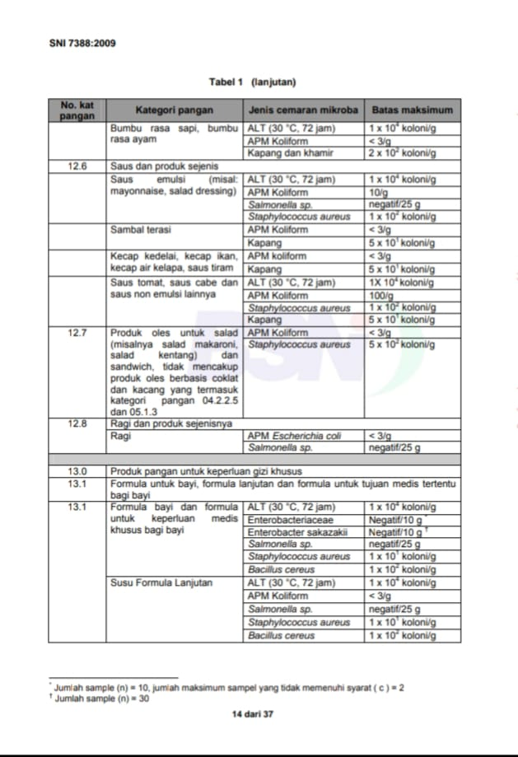
Lampiran 9. Tabel Batas Cemaran Mikroba Dalam Makanan SNI 7388-2009

Lampiran 10. Tabel MPN 333 United States Department of Agriculture
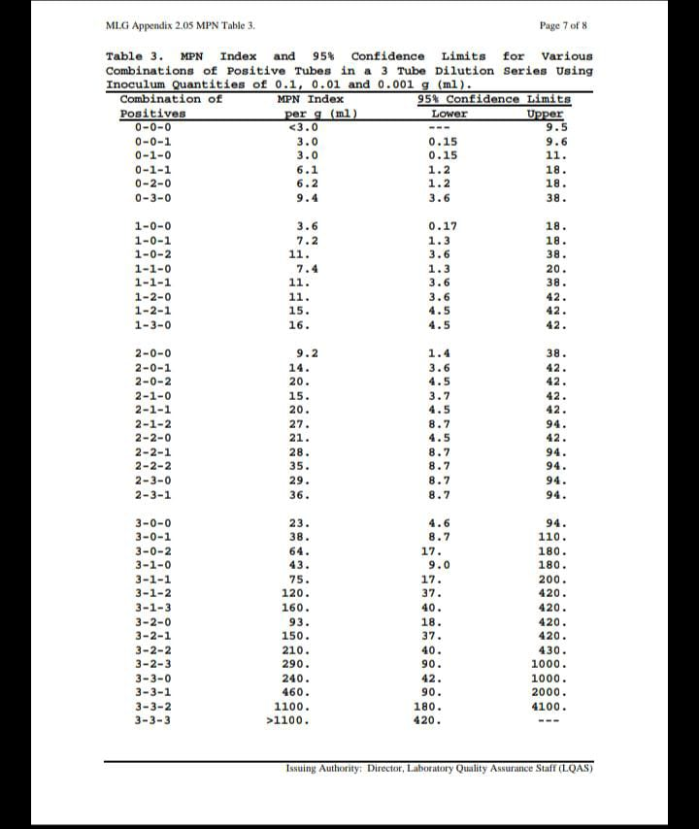

Lampiran 11. Surat Persetujuan Pelaksaan Penelitian Dari Tempat Penelitian
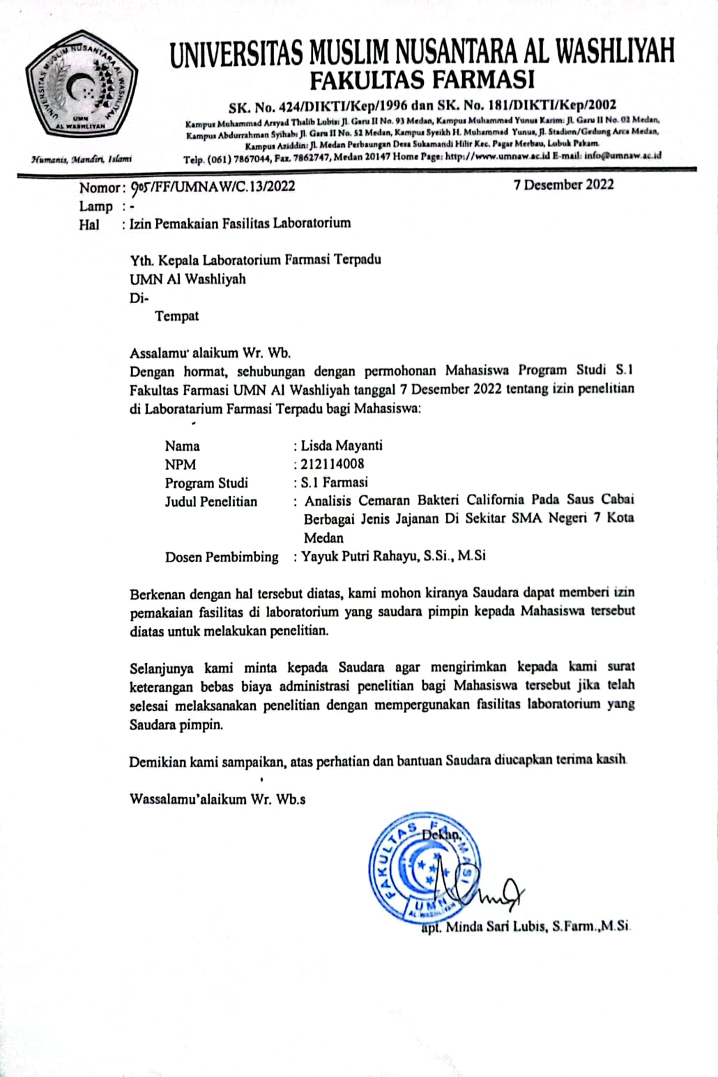

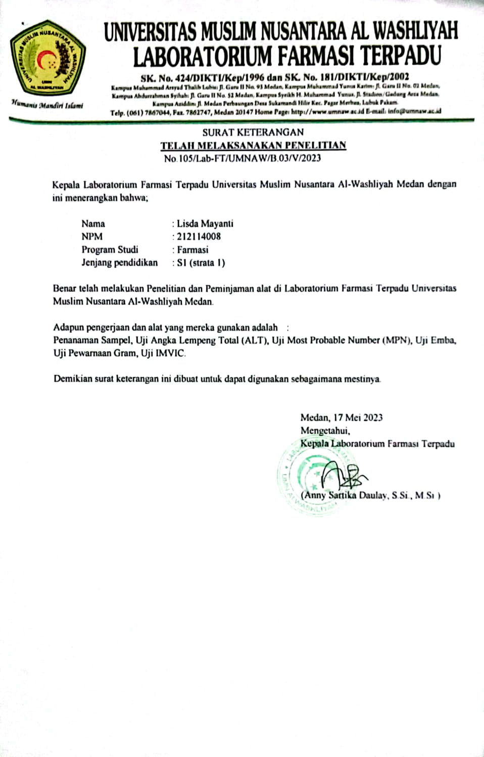
Lampiran 12. Surat Telah Melaksanakan Penelitian

Lampiran 13 . Surat Keterangan Bebas Laboratorium
