APPENDIX 1
Documentation
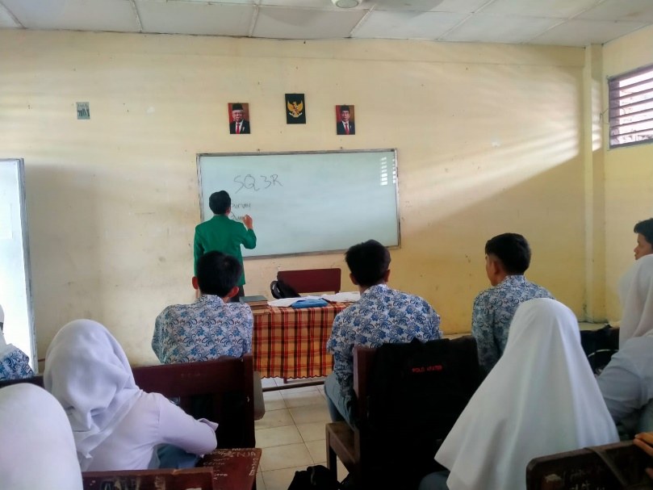
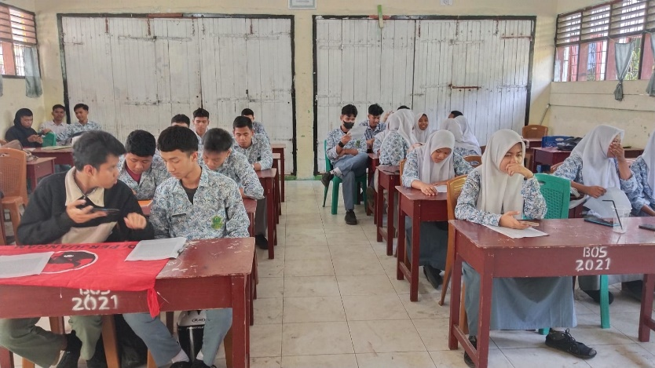
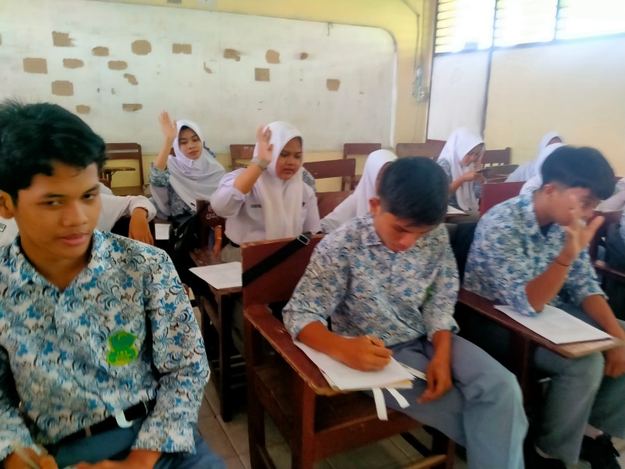
APPENDIX 2
LESSON PLAN
(EXPERIMENTAL GROUP)

School : SMA Al-Washliyah 1 Medan
Class : XI IPA
Subject : Narrative Text
Skill : Reading Comprehension
Time/Allocation: 2 x 30 minutes
Meeting : First

    - Standard of Competency

  - To understand the form of oral monologue text, reports, narrative accurately, smoothly, and acceptable in the context of daily life and access to knowledge
  - Expressing the meaning in the shaped monologue text, reports, narrative accurately, smoothly, and acceptable in the context of daily life and access to knowledge

    - Basic of Competency

  - Responding to the meaning of formal and informal short functional texts in writing and accurately in the context of daily life in narrative texts.
  - Responding to the meaning of story text visually in the context of everyday life in legend narrative texts
  - Expressing meaning in formal and informal short functional texts orally and accurately in the context of everyday life in legendary narrative texts.
  - Expressing the meaning of story text orally and also in writing accurately, fluently, and acceptable in the context of daily life and access to knowledge.
    - Indicators
3.1 Identify the topic in short narrative text
3.2 Identify specific information in narrative story text
3.3 Identify the purpose of communication from a short narrative functional text
3.4 Using spoken and written language in providing functional text.
3.5 Identify the characters in the text
3.6 Conduct a survey in narrative text Legend.

    - The Objective of Learning
4.1 Students can understand the meaning of the narrative text story
4.2 Students can dissect generic text structures in narrative text
4.3 can achieve students' understanding in reading narrative texts

    - The Main Topic
- Narrative text is related to the story. This story includes several events that are presented to entertain readers or listeners. So, written narrative text is intended to entertain the reader.
- The steps for constructing a narrative are:
- Orientation, where the writer tells the audience about who the characters in the story are, where the story takes place, and when the action takes place.
- Complication, where the story is driven by a series of events, where normally we expect some kind of complication or problem to appear.
- Reorientation is the final step in a statement that involves elaboration
F. Method
SQ3R (Survey, Question, Read, Recite, Review)

G. Teaching and Learning Process
Openig  Main Activities | - Greeting the Students  - Checking the attendance list  - Introducing today’s activity  Eksploration  - The teacher prepared the students to study and ask the question related to the topic  Elaboration  - The teacher gives a copy of a text of narrative and asks the students to read the text.  Confirmation  Giving feedbacl to the students to give them support to the students who brave to give their opinion about the story Giving motivation to the students who have not understand about narrative text. | 10  minutes  40 minutes
Closing | - The teacher concludes the lesson  - Praying | 10 minutes

H. Source/Media
1. Paper
2. Dictionary
3. Marker

LESSON PLAN
(CONTROL GROUP)

School : SMA Al-Washliyah 1 Medan
Class : XI-IPS
Subject : Narrative Text
Skill : Reading
Time/ Allocation : 2x30 minutes
Meeting :

      - Standard of Competency
  - Understanding the generic structure of narrative text accurately, fluently, and acceptable in the context of daily life and access to knowledge.
  - Expressing meaning in texts in the form of monologues, writings, narratives accurately, fluently, and acceptable in the context of daily life and access to knowledge.

      - Basic of Competency

2.1 Responding the meaning in the short functional formal or informal orally and accurate in the context of daily life in narrative legenda text.
2.2 Responding the meaning in teks monologue orally in the context of daily life in narrative legenda text.
2.3 Expressing the meaning in the short functional formal or informal orally and accurate in the context of daily life in narrative legenda text.
2.4 Expressing the meaning in teks monologue orally accurately, smoothly, and acceptable in the context of daily life and access to knowledge.

      - Indicators
  - Identifying the topic in the short narrative text
  - Identifying the spesific information in spoken text
  - Identifying the objective of communication from short spoken functional text
  - Using spoken language in giving short functional text
  - Identifying the characters in the text
  - Doing the monologue in narrative legenda text
  - Using past tense in telling narrative Legenda text

      - The Objective of Learning
  - The students can response the narrative monologue
  - The students can do monologue in narrative legenda text
  - Can improve their speaking skills

      - The Main Topic
Legenda is concerning with a story. The story includes some events which is presented to amuse the readers or listeners. So, written narrative texts are aimed to entertain the readers.
The steps for constructing a legenda are:

- Orientation, in which the writer tells the audience about who the character in the story are, where the story is taking place, and when the action is happen.
- Complication, where the story is pushed along by a series of events, during which we usually expect some sort of complication or problem to arise.
- Reorientation is the final step in a statement that involves elaboration
      - Method
Reading

Teaching and LearningProcess
Openig  MainActivities | - Greeting the students  - Checking the attendance list  - Introducing today’s activity  Eksploration  - The teacher introduces the story“The Legend of Toba Lake“to the students  - Discussing the story with the students  - The teacher teach the students how to read the text  Elaboration  - Sharing the printed paper to the students and ask them to read it  Confirmation  - Giving feedback to the students’ reading performance to give them support  - Giving motivation to the students who have not understand about narrative text | 10 Minutes  40 minutes
Closing | - The teacher concludes the less on today  - Praying | - nit

Source/Media:
  - Script Narrative text
  - Dictionary
  - RelevantSource

APPENDIX 3
Instrument Pre-Test
Nama:
Kelas:

Pilihan Ganda!
Read the following text to answer questions number 1-6
Once upon a time there lived a little girl named Snow White. She lived with her aunt and uncle because her parents were dead. One day she heard her uncle and aunt talking about leaving Snow White in the castle because they both wanted to go to America and they didn’t have enough money to take Snow White. Snow White didn’t want her uncle and aunt to do that so she decided that it would be best if she ran away.
The next morning, she ran away into the woods. She was very tired and hungry. Then she saw a little cottage. She knocked but no one answered so she went inside and fell asleep.
Meanwhile, the seven dwarfs were coming home from work. There they found Snow White sleeping. Then Snow White woke up. She saw the dwarfs.
The dwarfs said, “What is your name?”
Snow White said, “My name is Snow White.”
Then, Snow White told the dwarfs the whole story.
The dwarfs said, “If you want, you may live here with us.”
Snow White answered, “Oh, could I? Thank you.”
Finally, Snow White and the seven dwarfs lived happily ever after.

1. What type of the text is used by the writer?
A. narrative
B. report
C. anecdote
D. comparative
E. news item

2. To tell the plot, the writers uses…
A. a rhetorical question and an exclamation
B. time sequences
C. contrastive evidences
D. past tense
E. concessive conjunctions

3. Why Snow White ran away to the woods?
A. Her parents passed away
B. Her uncle was angry with her
C. Her uncle and aunt would go to America
D. Snow White was happy to run away
E. Snow White liked playing in the woods.

4. When did Snow White run away to the woods?
A. In the afternoon
B. In the morning
C. In the evening
D. In the full moon
E. In the middle of night

5. Where did Snow White live after she ran away to the woods?
A. She lived in the cave
B. She lived in the lion nest
C. She lived everywhere in the woods
D. She lived in the dwarfs’ cottage
E. She lived on the street

6. According to the text, before she ran away into the woods, why did Snow White live with her uncle and aunt?
A. because she loved them very much
B. as a result of forcing attitude from them
C. because her parents were dead
D. because she were afraid of the dwarfs
E. because she ran away from a monster

Read the following text to answer questions number 7-10

A man in Puerto Rico had a wonderful parrot. There was no other parrot like it.
It was very, very smart. This parrot would say any word-except one. He would not say the name of the town where he was born. The name of the town was Catano. The man tried to teach the parrot to say Catano. But the bird would not say the word. At first the man was very nice, but then he got angry. “You are a stupid bird! Why can’t you say the word? Say Catano, or I will kill you!” but the parrot would not say it. Then the man got to so angry that the shouted over and over, “Say Catano, or I’ll kill you!” but the bird wouldn’t talk.
One day after trying for many hours to make the bird say Catano, the man got very angry. He picked up the bird and threw him into the chicken house. “You are more stupid than the chickens. Soon I will eat them, and I will eat you, too.” In the chicken house there are four old chickens. They were for Sunday’s dinner. The man put the parrot in the chicken house and left. The next day the man came back to the chicken house. He opened the door and stopped. He was very surprised at what he saw! He saw three dead chickens on the floor. The parrot was screaming at the fourth chicken, “Say Catano, or I’ll kill you!

7. Where does the story take place?
A. Indonesia
B. Brazil
C. Puerto Rico
D. New York
E. Jepang

8. From the text we learn that…
A. We have to follow others
B. We have to respect pet owner
C. We have to imitate others
D. We are not allowed to force others
E. We are not allowed to help others

9. Which statement is false according to the text?
A. Catano was the name of the city where the parrot came from
B. The man got angry at the parrot
C. The parrot couldn’t say Catano
D. The man killed the parrot
E. The parrot could say Catano

10. “It was very, very smart”. The underlined word “It “refers to…
A. The chicken
B. The man
C. The Catano
D. The city
E. The bird

Instrument Post-Test
Nama:
Kelas:
Waktu: 60 menit
PILIHAN GANDA
Read the following text to answer questions number 1 - 5.

Long, long ago, when the gods and goddesses used to mingle in the affairs of mortals, there was a small kingdom on the slope of Mount Wayang in West Java. The King, named Sang Prabu, was a wise man. He had an only daughter, called Princess Teja Nirmala, who was famous for her beauty but she was not married. One day Sang Prabu made up his mind to settle the matter by a show of strength.
After that, Prince of Blambangan, named Raden Begawan had won the competition. Unfortunately, the wicked fairy, Princess Segara fell in love with Raden Begawan and used magic power to render him unconscious and he forgot his wedding. When Sang Prabu was searching, Raden Begawan saw him and soon realized that he had been enchanted by the wicked fairy. The fairy could not accept this, so she killed Raden Begawan. When Princess Teja Nirmala heard this, she was very sad. So nice a fairy took her to the Kahyangan.

1. Which one of the following statements is false
about Sang Prabu?
A. Sang Prabu was a father of his only
daughter
B. Sang Prabu was a king of a kingdom in
West Java
C. Sang Prabu was taken to Kahyangan
by a wicked fairy
D. Sang Prabu was a wise man
E. Sang Prabu didn’t have a son

2. Why the wicked fairy did used her magic to make Raden Begawan unconscious?
A. She didn’t like Raden Begawan
B. She didn’t want Raden Prabu marry the
princess
C. She wanted Teja Nirmala to forget about her
wedding
D. She didn’t want the prince of Blambangan
marry the princess
E. She didn’t want the prince of Blambangan feel
love with her

3. What do you think will happen if gods or goddesses cannot mingle in the affairs of people in the earth at that time?
A. Princess Segara will have married with Raden
Begawan
B. Sang Prabu will not hold strength competition
C. Raden Begawan will not die
D. Teja Nirmala will stay in the Kahyangan
E. Wicked Fairy will not take Raden Begawan’s life

4. So a nice fairy took her to the Kahyangan. (Paragraph 2) The word her in the sentence refers to…
A. The wicked fairy
B. The nice fairy
C. Princess Nirmala
D. Prince Teja
E. The prince of Blambangan

5. The similarity between fairy and human according to the text.
A. The place they live
B. The jealousy that they posses
C. The way they don’t feel a love
D. The strength they have
E. Their life that is immortal

Read the following text to answer questions number 6 - 9.

The old witch locked Hansel in a cage and set Gretel to clean the house. She planned to eat them both. Each night the children cried and begged the witch to let them go.
Meanwhile, at home, their stepmother was beginning to wish she had never tried to get rid of the children. “I must find them,” she said and set off into the forest.
Many hours later, when her feet were tired from walking and her lips were dry from thirst, she came to the cottage belonging to the witch. The stepmother peeped through the window. Her heart cried out when she saw the two children.
She picked up the broom leaning against the door and crept inside. The witch was putting some stew in the oven when the stepmother gave her an almighty push. The witch fell into the oven and the stepmother shut the door.
‘Children, I have come to save you,’ she said hugging them tightly. I have done a dreadful thing.
I hope in time you will forgive me. Let me take you home and become a family again. They returned to their home and the stepmother became the best mother anyone could wish to have, and of course they lived happily ever after!

6. The story is about….
A. Two children went to school for the first time
B. A witch who is really kind
C. A father who begged a witch for money
D. A stepmother who saved her children from a witch
E. Two children saved their stepmother from a witch

7. Which statement is FALSE about the witch?
A. She locked Hansel in a cage
B. She planned to eat Hansel & Gretel
C. She fell into the ocean
D. She hated the children
E. She set Gretel to clean the house

8. “The witch fell into the oven and the stepmother shut the door.” (Paragraph 4). The underlined word “shut” can be replaced by the word…
A. Marked
B. Painted
C. Opened
D. Polished
E. Closed

9. How did the stepmother find her children?
A. She walked into the forest
B. She got tired and met her children
C. She peeped through the window of the witch’s cottage
D. She fell into the cliff
E. She was pushed against the wall

Read the following text to answer questions number 10 - 17.

Once upon a time there lived a little girl named Snow White. She lived with her aunt and uncle because her parents were dead.
One day she heard her uncle and aunt talking about leaving Snow White in the castle because they both wanted to go to America and they didn’t have enough money to take Snow White. Snow White didn’t want her uncle and aunt to do that so she decided that it would be best if she ran away. The next morning, she ran away into the woods. She was very tired and hungry. Then she saw a little cottage. She knocked but no one answered so she went inside and fell asleep.
Meanwhile, the seven dwarfs were coming home from work. There they found Snow White sleeping. Then Snow White woke up. She saw the dwarfs. The dwarfs said, “What is your name?” Snow White said, “My name is Snow White.” Then, Snow White told the dwarfs the whole story. The dwarfs said, “If you want, you may live here with us.” Snow White answered, “Oh, could I? Thank you.” Finally, Snow White and the seven dwarfs lived happily ever after.

10. What type of the text is used by the writer?
A. narrative
B. report
C. anecdote
D. comparative
E. news item

11. To tell the plot, the writers uses…
A. a rhetorical question and an exclamation
B. time sequences
C. contrastive evidences
D. past tense
E. concessive conjunctions

12. Why Snow White ran away to the woods?
A. Her parents passed away
B. Her uncle was angry with her
C. Her uncle and aunt would go to America
D. Snow White was happy to run away
E. Snow White liked playing in the woods.

13. When did Snow White run away to the woods?
A. In the afternoon
B. In the morning
C. In the evening
D. In the full moon
E. In the middle of night

14. Where did Snow White live after she ran away to the woods?
A. She lived in the cave
B. She lived in the lion nest
C. She lived everywhere in the woods
D. She lived in the dwarfs’ cottage
E. She lived on the street

15. According to the text, before she ran away into the woods, why did Snow White live with her uncle and aunt?
A. because she loved them very much
B. as a result of forcing attitude from them
C. because her parents were dead
D. because she were afraid of the dwarfs
E. because she ran away from a monster

16. The communicative purpose of this text is…..
A. to inform the readers about important and newsworthy events
B. to entertain readers with fairy tale
C. to share an account of an unusual event
D. to persuade readers to accept his/her opinions
E. to denote or propose something as the case

17. The organization of the text above is…..
A. abstract, orientation, crisis, incident,coda
B. thesis, argument: plot-elaboration, argument: plot-
elaboration, argument: plot-elaboration, conclusion
C. orientation, major complication, resolution,
complication, resolution, complication, major
complication
D. description, background events, sources
E. orientation, event, event, event

Read the following text to answer questions number 18 - 20.

Once upon a time there was a poor widow who had an only son named Jack. They were so poor that they didn’t have anything except a cow. When the cow had grown too old, his mother sent Jack to the market to sell it. On the way to the market, Jack met a butcher who had some beautiful beans in his hand. The butcher told the boy that the beans were of great value and persuaded the silly lad to sell the cow for the beans.
Jack brought them, happily. When he told his mother about this, his mother became so angry that she threw the beans out of the window. When Jack woke up in the morning, he felt the sun shining into a pan of his room, but all the rest was quite dark and shady. So, he jumped to the window. What did he see? The beanstalk grew up quite close past Jack’s window. He opened the window and jumped to the beanstalk which ran up just like a big ladder
He climbed and climbed till at last he reached the sky. While looking around, he saw a very huge castle. He was very amazed. Then Jack walked along the path leading to the castle. There was a big tail woman on the doorstep. Jack greeted her and asked for the giantess mercy to give him breakfast, because he feels very hungry. Although the giantess grumbled at first, finally she gave Jack a hunk of bread and cheese and a jug of milk.
Jack hadn’t finished when the whole house began to tremble with the noise of someone’s coming. “Oh! It’s my husband!” cried the giantess. “What on earth shall I do?” Hastily the giantess opened a very big cupboard and hid Jack there.

18. what is the story about
A. jack and a butcher
B. jack and the giantess
C. a poor widow and his son
D. Jack and the bean stalk
E. The giantess and her husband

19. “Oh! It’s my husband!” cried the giantess” (paragraph 7). From the sentence we know that the giantess is…her husband
A. afraid of
B. angry with
C. fed up with
D. annoyed with
E. displeased with

20. Jack’s mother looked very furious when jack told that…
A. the beans were precious
B. the butcher bought his cow
C. he traded his cow for the beans
D. he had sold his cow to a butcher
E. he met a butcher in the way to the market
APPENDIX 4
Key Answer Pre-Test
No | A | B | C | D | E
1
2
3
4
5
6
7
8
9
10

Key Answer Post-Test
No | A | B | C | D | E
1
2
3
4
5
6
7
8
9
10
11
12
13
14
15
16
17
18
19
20

APPENDIX 5
Studens’ Highest Score using SQ3R Method
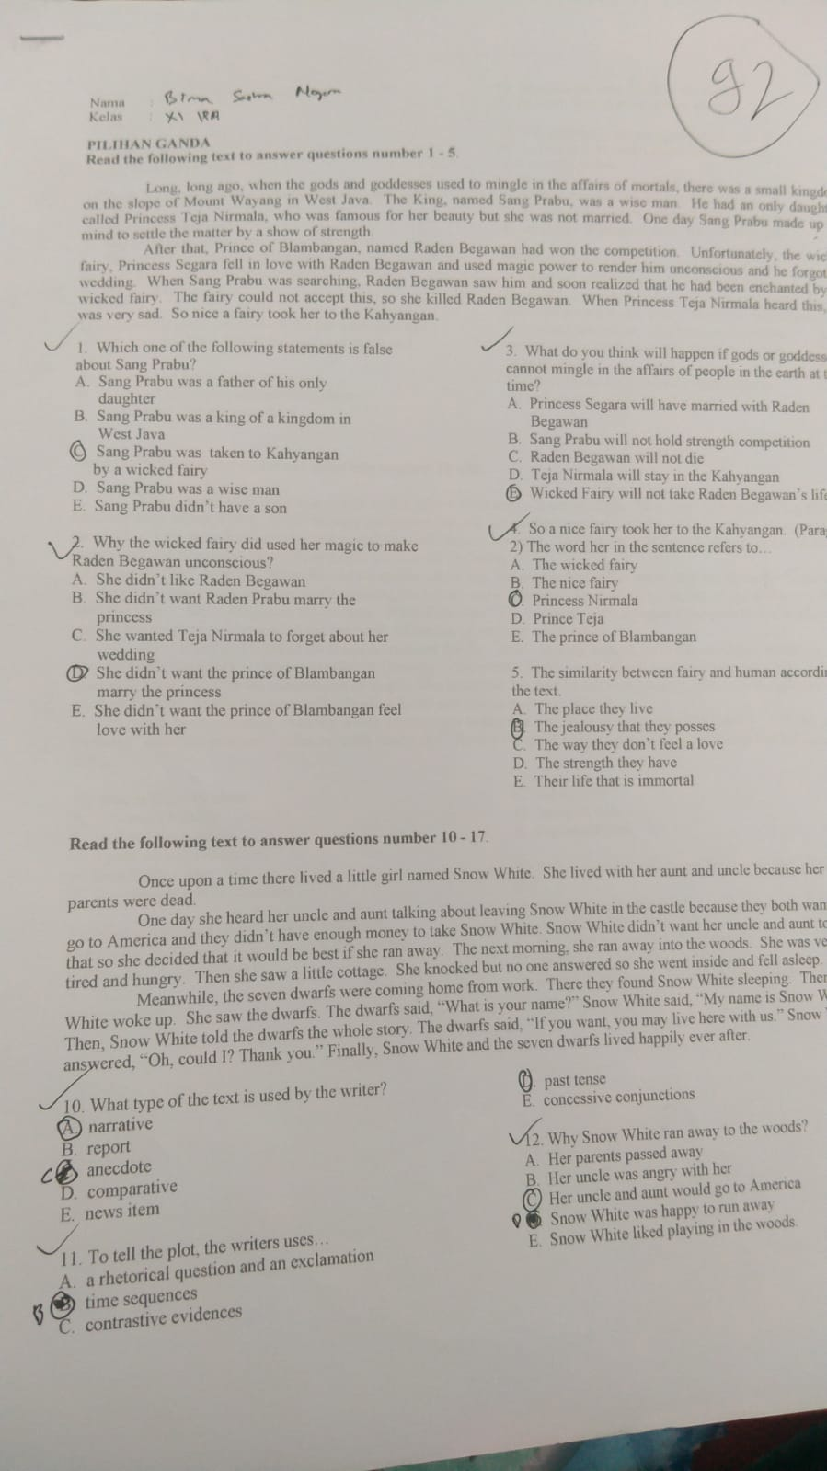
Students’ Highest Score in Conventional Method
