ANALISIS KESANTUNAN BERBAHASA INDONESIA DALAM TINDAK TUTUR MASYARAKAT SEKITAR BELAWAN BAHAGIA (LINGKUNGAN XIX)

RUWINA
NPM. 191214011

ABSTRAK

Penelitian ini bertujuan untuk mendeskripsikan tentang bentuk kesantunan berbahasa Indonesia dalam tindak tutur masyarakat sekitar Belawan Bahagia (lingkungan XIX). Penelitian ini menggunakan metode penelitian kualitatif dengan teori kesantunan berbahasa oleh Leech dalam proses pemerolehan data. Dalam pengumpulan data, peneliti menggunakan metode simak dan sadap yang disertai dengan teknik simak libat cakap, teknik simak bebas cakap, dan teknik catat. Dari penelitian yang dilakukan, diperoleh hasil analisis data dan pembahasan dari penelitian kesantunan berbahasa Indonesia dalam tindak tutur masyarakat sekitar Belawan Bahagia (lingkungan XIX), peneliti menemukan 3 bentuk tindak tutur yaitu (1) tindak tutur lokusi sebanyak 2 data, (2) tindak tutur perlokusi sebanyak 1 data, (3) tindak tutur ilokusi sebanyak 1 data. Dan menemukan 6 maksim kesantunan berbahasa yaitu (1) maksim kebijaksanaan sebanyak 1 data, (2) maksim penerimaan sebanyak 1 data, (3) maksim kemurahan sebanyak 1 data, (4) maksim kerendahan hati sebanyak 1 data, (5) maksim kecocokan sebanyak 1 data, dan (6) maksim kesimpatian sebanyak 2 data. Tindak tutur lokusi dan maksim kesimpatian paling banyak ditemukan peneliti dibandingkan dengan jumlah tindak tutur dan maksim kesantunan berbahasa lainnya. Dari banyaknya data yang ditemukan oleh peneliti, dapat diketahui bahwa tidak semua masyarakat sekitar Belawan Bahagia khususnya Lingkungan XIX berbahasa kurang santun, namun terdapat beberapa masyarakat yang berbahasa dengan kurang santun baik itu dilakukan oleh anak-anak, remaja hingga orang dewasa.

Kata kunci: Belawan Bahagia, kesantunan berbahasa, ilokusi, lokusi, perlokusi, tindak tutur

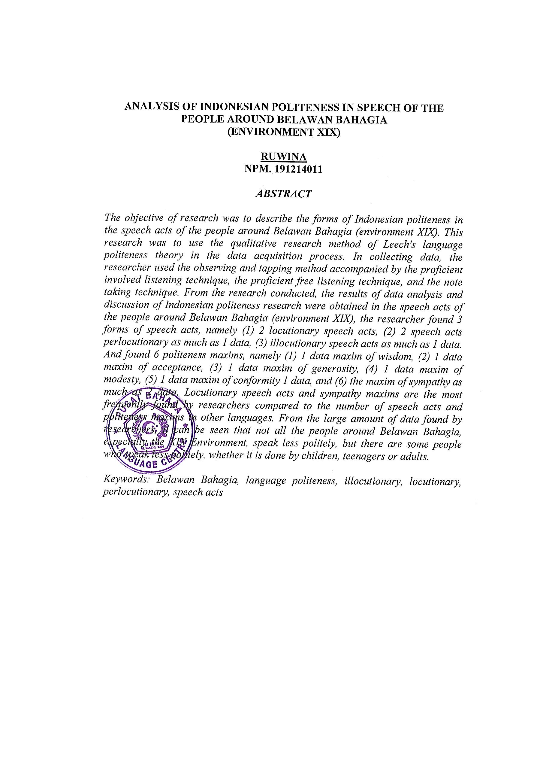
ANALYSIS OF INDONESIAN POLITENESS IN SPEECH OF THE PEOPLE AROUND BELAWAN BAHAGIA
(ENVIRONMENT XIX)

RUWINA
NPM. 191214011

ABSTRACT

The objective of research was to describe the forms of Indonesian politeness in the speech acts of the people around Belawan Bahagia (environment XIX). This research was to use the qualitative research method of Leech's language politeness theory in the data acquisition process. In collecting data, the researcher used the observing and tapping method accompanied by the proficient involved listening technique, the proficient free listening technique, and the note taking technique. From the research conducted, the results of data analysis and discussion of Indonesian politeness research were obtained in the speech acts of the people around Belawan Bahagia (environment XIX), the researcher found 3 forms of speech acts, namely (1) 2 locutionary speech acts, (2) 2 speech acts perlocutionary as much as 1 data, (3) illocutionary speech acts as much as 1 data. And found 6 politeness maxims, namely (1) 1 data maxim of wisdom, (2) 1 data maxim of acceptance, (3) 1 data maxim of generosity, (4) 1 data maxim of modesty, (5) 1 data maxim of conformity 1 data, and (6) the maxim of sympathy as much as 2 data. Locutionary speech acts and sympathy maxims are the most frequently found by researchers compared to the number of speech acts and politeness maxims in other languages. From the large amount of data found by researchers, it can be seen that not all the people around Belawan Bahagia, especially the XIX Environment, speak less politely, but there are some people who speak less politely, whether it is done by children, teenagers or adults.

Keywords: Belawan Bahagia, language politeness, illocutionary, locutionary, perlocutionary, speech acts

