ABSTRAK
PENGEMBANGAN MEDIA TANGGA PINTAR
BERBANTUAN ALAT MUSIK KOLINTANG
DI KELAS I SD IT BUSTANUL ULUM
Oleh:
TASYA WULAN DARI
NPM. 191434080
Penelitian ini bertujuan untuk mengembangkan media tangga pintar berbantuan alat musik kolintang, mengetahui kelayakan dan minat belajar siswa kelas I di SD IT Bustanul Ulum Tahun Pembelajaran 2022-2023. Penelitian ini merupakan jenis penelitian pengembangan menggunakan model ADDIE. Instrumen yang digunakan adalah angket. Teknik analisis data yang digunakan dalam penelitian ini adalah deskriptif kualitatif dan deskriptif kuantitatif. Berdasarkan analisis data yang diperoleh melalui uji validitas ahli materi, ahli desain media, tanggapan guru, dan respon siswa. Hasil validasi oleh ahli materi yaitu 80% termasuk kategori baik/layak. Hasil validasi oleh ahli desain media yaitu 80% termasuk kategori baik/layak. Hasil validasi dari tanggapan guru kelas I yaitu 90% termasuk kategori sangat baik/sangat layak, sedangkan untuk respon siswa yaitu 86,8% termasuk kategori sangat baik/sangat layak. Kemudian dihitung rata-ratanya diperoleh hasil 84,2% termasuk dalam kategori sangat baik/sangat layak digunakan dalam proses pembelajaran. Berdasarkan hasil pretest dan posttest yang telah dilakukan adanya peningkatan minat dan hasil belajar siswa sebelum dan setelah menggunakan media tangga pintar berbantuan alat musik kolintang pada materi penjumlahan dan pengurangan yang telah dikembangkan sebesar 12% sehingga dapat meningkatkan minat dan mempengaruhi hasil belajar siswa kelas I SD.

Kata kunci: Media Pembelajaran, Pembelajaran Matematika, Penjumlahan dan Pengurangan, Minat Belajar

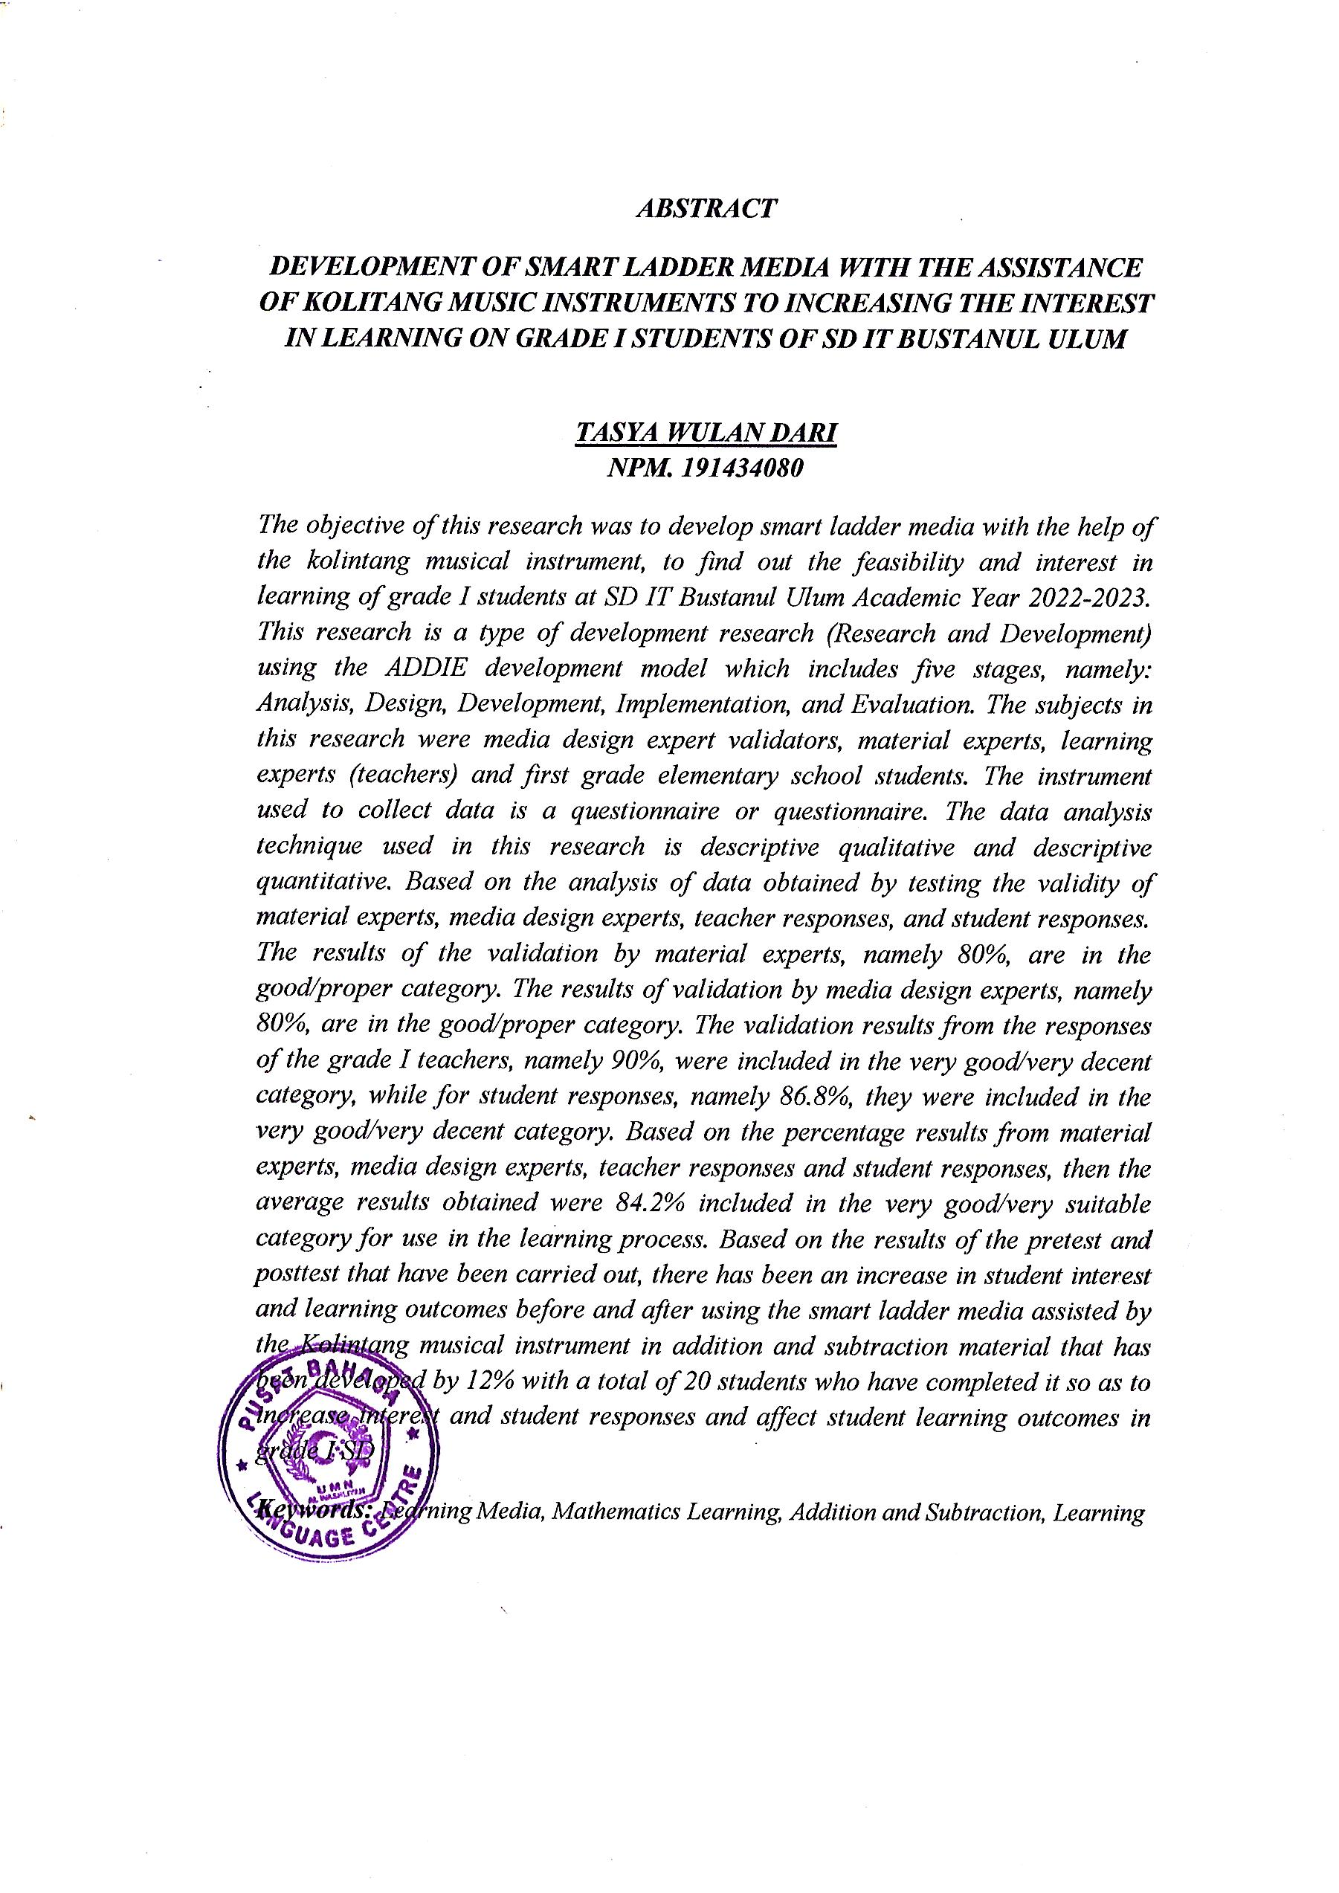
ABSTRACT
DEVELOPMENT OF SMART STAIRS MEDIA WITH THE HELP OF KOLINTANG MUSICAL INSTRUMENTS IN CLASS I SD IT BUSTANUL ULUM
By:
TASYA WULAN DARI
NPM. 191434080
This research aims to develop smart ladder media with the help of the kolintang musical instrument, to find out the feasibility and interest in learning of class I students at SD IT Bustanul Ulum for the 2022-2023 Academic Year. This research is a type of development research using the ADDIE model. The instrument used is a questionnaire. The data analysis technique used in this research is descriptive qualitative and descriptive quantitative. Based on the analysis of data obtained by testing the validity of material experts, media design experts, teacher responses, and student responses. The results of the validation by material experts, namely 80%, are in the good/proper category. The results of validation by media design experts, namely 80%, are in the good/proper category. The validation results from the responses of class I teachers were 90% included in the very good/very decent category, while for student responses, 86.8% were included in the very good/very decent category. Then it is calculated that the average result is 84.2% included in the very good/very suitable category for use in the learning process. Based on the results of the pretest and posttest that have been carried out, there has been an increase in student interest and learning outcomes before and after using the smart ladder media assisted by the Kolintang musical instrument in addition and subtraction material that has been developed by 12% so that it can increase interest and influence student learning outcomes in class I SD.
Keywords: Learning Media, Mathematics Learning, Addition and Subtraction, Learning Interest

