ACKNOWLEDGEMENT

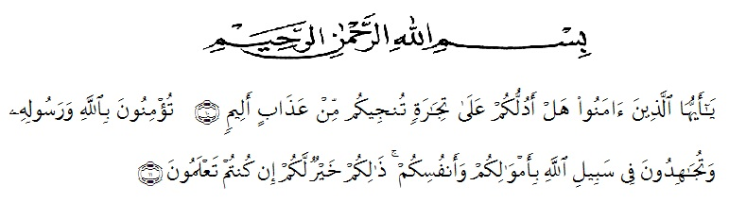

O ye who believe! Shall I show you a commerce that will save you from a painful doom? Ye should believe in Allah and His messenger, and should strive for the cause of Allah with your wealth and your lives. That is better for you, if ye did but know. (Q.S Ash-Shaff: 10-11)
Alhamdulillah, all praise to Allah SWT, the Lord of the Worlds, who has blessed the researcher with strength, health, and resolve in finishing this thesis entitle” The Student’s Motivation Of The Reel’s Instagram Used By Teaching Speaking Of The Eleventh Grade Student At Sma Negeri 2 Lubuk Pakam Academic Year 2022-2023” as the final assignment in her study. Peace and salutation may always be upon the Prophet Muhammad, the savior of the human kind, who has brought the light onto this world and turn edit into a better place.
This thesis a scientific paper that is presented as one of the requirements for the degree “S.Pd.” in English Education. There are many people who have been very helpful and supportive during the writing of this thesis. At this opportunity, the researcher would like to convey her utmost gratitude to them. The first ones are her small family ; her dearest father Sucipto and her dearest mother Siti Rohani for their incomparable love and kindness. The researcher would also like to express her gratitude and appreciation to:
- Dr. KRT. Hardi Mulyono K. Surbakti S.E., M.AP., as the rector of Universitas Muslim Nusantara Al- Washliyah
- Drs. Samsul Bahri, M.Si., as a Dean of Teacher Training and Education Department Universitas Muslim Nusantara Al- Washliyah
- Zulfitri, S.S., M.A., M. Pd., as the Head of English Education Department and as an academic advisor.
- Nurlaili, S.Pd.I., M.Hum., as the lovely advisor who gave the dearest motivations, commands, critics, suggestions, supports and love to the researcher in finishing this thesis.
- All of the lectures of the English Education Department of Muslim Nusantara Al Washliyah University Medan, who have given much knowledge, the writer deeply thank you all.
- All of the Academic Administration Staffs of Muslim Nusantara Al Washliyah University Medan.
- Her beloved parents, Mr. Sucipto and Mrs. Siti Rohani. Thank you for the unconditional love, pray, and support that always given to her. May Allah always bless you.
- Her beloved siblings, Mutya Nur Fadhillah and Al Badar Athaya. Thank you for the unconditional love, pray,and support that always given to her.
- Her beloved friends from Department of English Education, especially the members of class A of 2019, for the friendship, love, knowledge, support, and time that they have provided unconditionally.
- Her beloved precious friends in finishing this thesis, Miftahul Isnaini Siregar and Dhea Aprilia Nasution, for always giving support, pray, accompanied the researcher in many situation and become a good listener with an irreplaceable friendship.
- Everyone who has helped the researcher, not only in the finishing of this thesis, but through the ups and downs of her university life. She cannot mention them one by one; all she can say is she could not be more grateful for their contribution. May Allah bless them all.
Lastly, the researcher realizes that this thesis is still far from being perfect. Despite the help from the aforementioned people, there are weaknesses and shortages in this thesis that remain as the researcher’s responsibility. Therefore, she welcomes all kinds of correction and suggestions for a better writing.

Medan, 13 June 2023

Utari Nur Zannah

