**THE USE OF SHORT FILM *NADIA* TO IMPROVE STUDENTS’ MASTERY IN IDIOM THROUGH DISCUSSION METHOD**

**AT SMA N 1 RAYA KAHEAN ACADEMIC**

**YEAR 2021/2022**

**A Thesis**

**By:**

**SELA RASMITA**

**NPM:161244008**

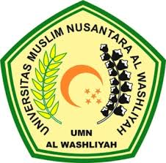

**FACULTY OF TEACHER TRAINING AND EDUCATION**

**UNIVERSITAS MUSLIM NUSANTARA AL WASHLIYAH**

**2022**

**THE USE OF SHORT FILM *NADIA* TO IMPROVE STUDENTS’ MASTERY IN IDIOM THROUGH DISCUSSION METHOD AT SMA NEGERI 1 RAYA KAHEAN ACADEMIC YEAR 2021/2022**

**A THESIS**

Submitted to the Department of English Language Education In Partial

Fulfillment of the Requirements for the Degree of

Bachelor of Education

**BY**

**SELA RASMITA**

**NPM 161244008**

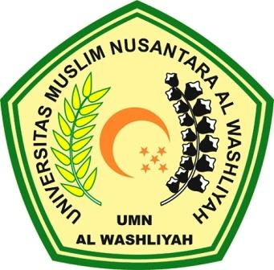

**FAKULTAS KEGURUAN DAN ILMU PENDIDIKAN**

**UNIVERSITAS MUSLIM NUSANTARA AL WASHLIYAH**

**MEDAN**

**2022**