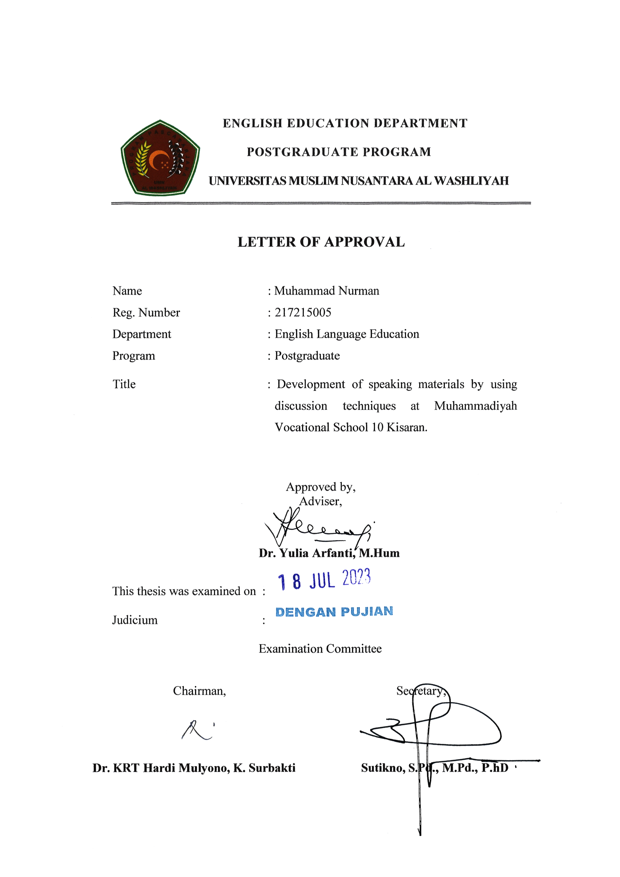
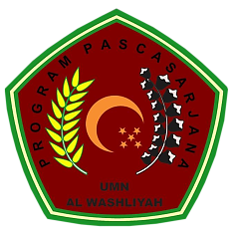
ENGLISH EDUCATION DEPARTMENT
POSTGRADUATE PROGRAM
UNIVERSITAS MUSLIM NUSANTARA AL WASHLIYAH

LETTER OF APPROVAL

Name : Muhammad Nurman
Reg. Number : 217215005
Department : English Language Education
Program : Postgraduate
Title : Development of speaking materials by using discussion techniques at Muhammadiyah Vocational School 10 Kisaran.

Approved by,
Adviser,

Dr. Yulia Arfanti, M.Hum

This thesis was examined on :
Judicium :
Examination Committee

Chairman, |  | Secretary,
Dr. KRT Hardi Mulyono, K. Surbakti |  | Sutikno, S.Pd., M.Pd., P.hD

