ACKNOWLEDEGMENTS

First of all, the greatest gratitude to Allah SWT, the Almighty God for the blessing which has been given to the researcher so that the researcher finally completed this thesis in partial fulfillment of the requirements for the degree of master of education, the University of Muslim Nusantara Al Washliyah Medan. This thesis could not have been accomplished without the guidances, suggetions, and comments from several people so that in this opportunity the researcher would like to express her deep gratitude to the following people:
  - Dr. KRT. Hardi Mulyono K. Surbakti., the rector of Muslim Nusantara University Al Washliyah.
  - Sutikno, S.Pd., M.Pd., P.h.D, the directur of the postgraduate program of Muslim Nusantara University Al Washliyah Medan.
  - Dr. Yulia Arfanti, M.Hum., the adviser who gave the command, critic and suggestion toward the researcher in finishing the proposal.
  - Dr. H. Asnawi, M.Hum, the head of the English Education Department of postgraduate program of Muslim Nusantara University Al Washliyah Medan.
  - All of the lectures of the postgraduate program of English Education Department of Muslim Nusantara University Al Washliyah Medan.
  - All of the Academic Administration Staffs of postgraduate program of Muslim Nusantara University Al Washliyah Medan.
  - Especially for my beloved parents, Rustam Efendi and Tumirah who have inspired me and offered the prayer. Until the end of his life, his services will always be remembered

  - For my beloved wife, Dwi Sulistiyani and my beloved children, Ahmad Dzaqi Annaufal, Ahmad Tsaqif Zam Zam, and Ahmad Fairuz Al Ayubi who have given support and the sincere encouragement to the author to finish his study in the postgraduate program. The author hope that the knowledge will be useful to the family.

Finally, the researcher realized that this thesis was far from being perfect. Therefore, constructive suggestion was needed for the researcher to continue the research.

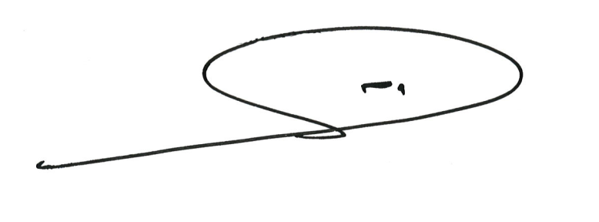
Medan, Juni 2023

The Researcher

