THE EFFECT OF USING SMALL GROUP DISCUSSION TOWARD STUDENTS’ SPEAKING ABILITY AT
SMA AL-WASHLIYAH 1 MEDAN

A THESIS

BY :

TRI SULISTIANINGSIH
Registration Number : 191224034

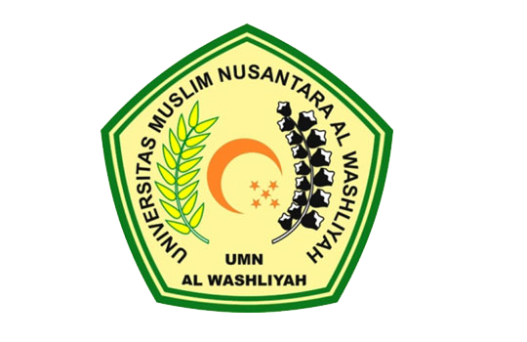

ENGLISH EDUCATION DEPARTEMENT
FACULTY OF TEACHER TRAINING AND EDUCATION
UNIVERSITAS MUSLIM NUSANTARA AL-WASHLIYAH
MEDAN
2023

