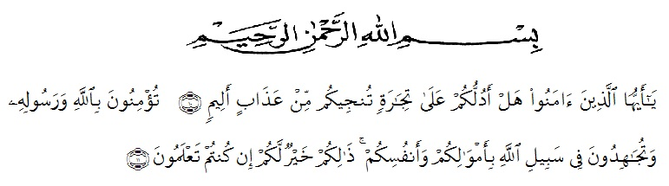
ACKNOWLEDGEMENTS

Artinya: “Hai orang-orang yang beriman, sukakah kamu Aku tunjukkan suatu perniagaan yang dapat menyelamatkan kamu dari azab yang pedih? (Yaitu) kamu beriman kepada Allah dan Rasul-Nya dan berjihad di jalan Allah dengan harta dan jiwamu. Itulah yang lebih baik bagimu jika kamu mengetahuinya”. (As-Saff 10-11).

Assalamualaikum wr.wb
Alhamdulillahi rabbil ‘alamin, all praises belong to Allah STW who had bestowed mercy, chance and knowledge to the Researcher. Secondly, peace and salutation always be given prophet Muhammad SAW who has guided us from the darkness to the lightness. therefore the Researcher can finish this graduating paper as one of the requiretment for Sarjana English Department of Education Faculty of Universitas Muslim Nusantara AL- Washliyah. However, this success would not be achieved without those supports, guidance, advice, help and encouragement from individual and institution, and the writer somehow realize that an appropriate moment for her deepest gratitude for:
- Mr. Dr. KRT. Hardi Mulyono K. Surbakti as a Rector of the Universitas Muslim Nusantara Al Washliyah who has given the researcher the opportunity to study at the institution he leads.
- Mr. Drs. Samsul Bahri, M.Si as the Dean of FKIP UMN Al Washliyah who has given this research permission.
- Mrs. Zulfitri S.S.,M.A the head of English Language Education Department which has provide invaluable guidance and ssistance for researcher.
- Mr. Yugi Diraga Prawiyata, S.Pd., M.Hum., M.P.d as adviser who has given a bunch of reliance, guidance,supports,suggestions and corrections in order to finish this thesis from the very start to the last.
- Mrs. Nurhafni Siregar, S.Pd., M.Pd and Mrs. Nurlaili, S.Pd.I., M.Pd as examiner who has provided criticism and suggestions on the shortcomings of proposal and thesis so that it becomes a good and correct writing
- All of the lectures in FKIP UMN Al Washliyah for the precious knowledge sharing, and giving wonderful study experiences which had built who the researcher is now.
- Mrs. Ir. Hj. Nursiah Abe as the head of SMAS Al-Washliyah 1 Medan and teacher adviser
- For the researcher who has given her permission to do research at the school he controls and who has helped her with that research.
- Her beloved parents of the Research Alm Mr. H. Suradi , Mrs. Hj. Sri Mulyani who always love the researcher unconditionally, support, facilitate the researcher to finished study.

