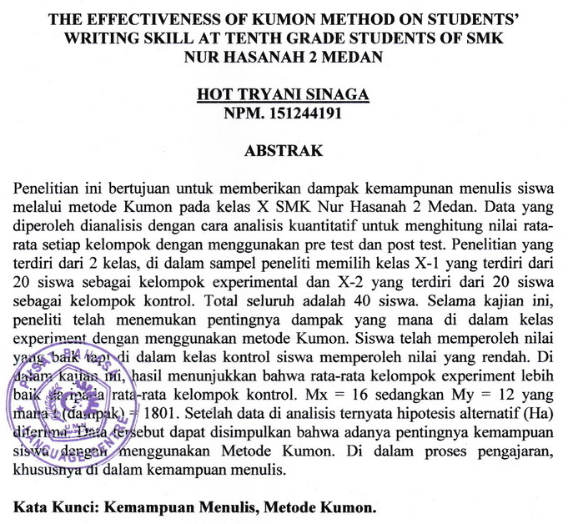

THE EFFECTIVENESS OF KUMON METHOD ON STUDENTS' WRITING SKILL AT TENTH GRADE STUDENTS OF SMK
NUR HASANAH 2 MEDAN

HOT TRYANI SINAGA
NPM. 151244191

ABSTRACT

This study aims to provide an impact on students' writing skills through the Kumon method in class X SMK Nur Hasanah 2 Medan. The data obtained were analyzed by means of quantitative analysis to calculate the average value of each group using pre-test and post-test. The study consisted of 2 classes, in the sample the researcher chose class X-1 which consisted of 20 students as the experimental group and X-2 which consisted of 20 students as the control group. The total is 40 students. During this study, researchers have discovered the importance of which impact in classroom experiments using the Kumon method. Students have obtained good grades but in the control class students have obtained low grades. In this study, the results show that the average of the experimental group is better than the average of the control group. Mx = 16 while My = 12 where t (impact) = 1801. After the data is analyzed, it turns out that the alternative hypothesis (Ha) is accepted. The data can be concluded that the importance of students' abilities using the Kumon Method. In the teaching process, especially in writing skills.

Keywords: Writing Ability, Kumon Method.

