ACKNOWLEDGEMENTS
Assalamu’alaikum Wr.Wb
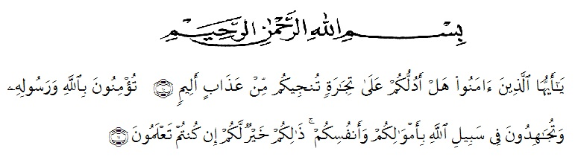
Artinya:
“Hai orang-orang yang beriman, sukakah kamu aku tunjukkan suatu perniagaan yang dapat menyelamat kamu dari azab yang pedih?¹⁰.(yaitu kamu beriman kepada Allah SWT dan Rasul-Nya dan berjihad di jalan Allah dengan harta dan jiwamu. Itulah yang lebih baik bagimu jika kamu mengetahuinya¹¹.Qs (As-Shaff 10 : 11)
First and foremost, the writer would praise and thanks to Almighty God, because of His blessings the writer can complete this research. The writer got suggestions, criticism and guidance from many people. Therefore, the writer would like to extend her sincere and special thanks to
- Dr. KRT. Hardi Mulyono K. Surbakti, as the Rector of UMN Al-Washliyah Medan,
- Drs. M. Ayyub Lubis, M.Pd., Ph.D., as the Dean of the Faculty of Teachers’ Training and Education of Muslim Nusantara University,
- Zulfitri, S.S., M.A, as the leader of English Department of UMN Al-Washliyah Medan

