**ACKNOWLEDGEMENTS**

*Assalamu’alaikum Wr.Wb*

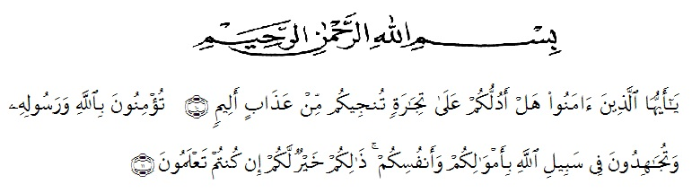

Artinya:  
*“Hai orang-orang yang beriman, sukakah kamu aku tunjukkan suatu perniagaan yang dapat menyelamat kamu dari azab yang pedih?10.*

*(yaitu kamu beriman kepada Allah SWT dan Rasul-Nya dan berjihad di jalan Allah dengan harta dan jiwamu. Itulah yang lebih baik bagimu jika kamu mengetahuinya11.*Qs (As-Shaff 10 : 11)

First and foremost, the writer would praise and thanks to Almighty God, because of His blessings the writer can complete this research. The writer got suggestions, criticism and guidance from many people. Therefore, the writer would like to extend her sincere and special thanks to

1. Dr. KRT. Hardi Mulyono K. Surbakti, as the Rector of UMN Al-Washliyah Medan,
2. Dr. Samsul Bahri., M.Si as the Dean of the Faculty of Teachers’ Training and Education of Muslim Nusantara University,
3. Zulfitri, S.S., M.A, as the leader of English Department of UMN Al-Washliyah Medan,
4. Nurhafni Siregar, S.Pd., M.Hum, as the first consultant, who has given correction, suggestion, comments, criticism for completing her research,
5. The lectures of the English Department of FKIP UMN Al Washliyah Medan who have taught her,
6. The writer’s beloved parents, Suyatno and Halimatussa'diah S.E, who always support her financial, moral and for their love and praying in finishing her study at FKIP UMN Al Washliyah Medan,
7. The writer’s beloved brother, Yoza Saputra S.Kom and Kiki Putri Hartini A.Md.AK, who always support her financial, motivation, praying, and everything.
8. The writer’s beloved younger sister, Mahyani, who always given be spirit to finishing her study at FKIP UMN Al Washliyah Medan. The writer loves her so much,
9. The writer’s beloved best friend, Rini Surya Ningsih, S.Pd who always remember her in finishing her proposal skripsi and praying to success her.

Finally, the writer hoes all of suggestions and critism can be useful and meaningful for the writer. God Bless Us.

Medan, 20 June 2023

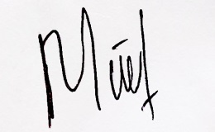The writer

Maulina