**THE APPLICATION OF ESA (ENGAGE, STUDY, ACTIVE) TO INCREASE STUDENTS’ VOCABULARY ABILITY AT**

**SMP ROKITA SARI BANGUN PURBA**

**SKRIPSI**

**By :**

**SRI WAHYUNI BARUS**

**NPM 181224015**

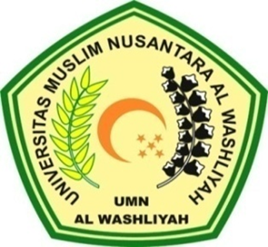

**FACULTY OF TEACHER TRAINING AND EDUCATION UNIVERSITAS MUSLIM NUSANTARA AL WASHLIYAH**

**MEDAN**

**2022**