**ACKNOWLEDGEMENTS**

First and foremost, the writer would praise and thanks to the God, because his blessing she able to completes this research. She got suggestion, criticism and guidance from many people.

She would like to extent her sincere and special thanks to:

1. Dr. KRT Hardi Mulyono, K. Surbakti, as the Rector of UMN AL Washliyah Medan,
2. Dr. Samsul Bahri, M.Si as the Dekan of FKIP UMN AL Washliyah Medan and his staffs for facilities given to her during studies in the faculty,
3. Zulfitri S.S., M.A as the Head of English Department of UMN AL Washliyah Medan,
4. Nurlaili, S.Pd. I., M.Hum as the adviser, who has given her a lot of valuable suggestion , comments and criticism.
5. The Lecturers of English Department of FKIP UMN AL Washliyah Medan, who have taught her.
6. The Headmaster, English teacher, all teacher and all students class VII of SMP Rokita Sari for facilities given to her in conducting this research.
7. Her beloved parents, Edison Barus and Ernawati Br Damanik who always support and motivate her financial, moral and for their endless love and their pray in finishing her study at FKIP UMN AL Washliyah Medan,
8. Her beloved brother, Fije Wardana Barus, Sirjon Lion Barus, Levi Karpok Tiger Barus, who always gives motivated and support.
9. Her beloved friend, especially Marko Frans Hernandes Damanik who always support my mood, financially and spirit to keep trying, to move forward, to reach higher education and knowledge
10. Her best friend, Seven Angels, Deviani Saragih, Coki Andriano Tarigan, Siti Yohana, Indriani Ginting, Yohana Oktavia Damanik, who Give motivation for her in finishing her skripsi.
11. Her beloved Kpop Idol, Kim Namjoon, Kim Soekjin, Min Yoongi, J-hope, Kim Tehyung, Park Jimin, Jeon Jungkook, who always motivates me to be passionate about doing everything.
12. Finally, she hopes this skripsi give benefit for all reader, it is able to increase the development education in Indonesia.

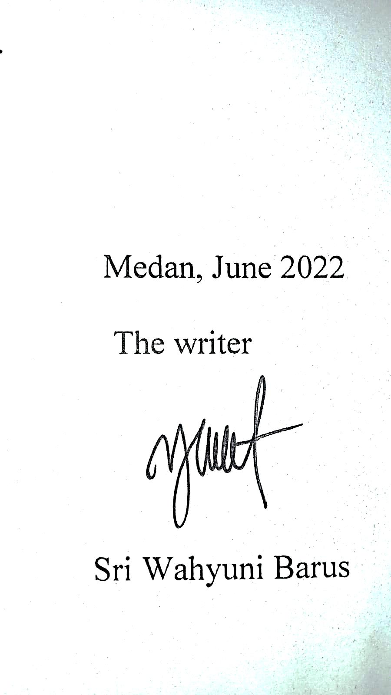

Medan, June 2022

The writer

Sri Wahyuni Barus