DEVELOPING OF WRITING PARAGRAPH MATERIAL BY USING ARGUMENTATIVE TEXT AT THE EIGHTH GRADE STUDENTS OF MADRASAH TSANAWIYAH NEGRI 4
MANDAILING NATAL

THESIS

By

MEGASARI
Register Number : 217215006

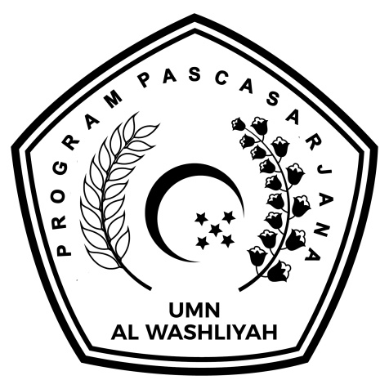

ENGLISH EDUCATION DEPARTMENT

POST GRADUATE PROGRAM
MUSLIM NUSANTARA AL-WASHLIYAH UNIVERSITY
MEDAN
2023
DEVELOPING OF WRITING PARAGRAPH MATERIAL BY USING ARGUMENTATIVE TEXT AT THE EIGHTH GRADE STUDENTS OF MADRASAH TSANAWIYAH NEGRI 4
MANDAILING NATAL

THESIS

This Thesis was Submitted as a Requirement to Obtain A Master’s Degree in
Education in the English Language Education Study Program

By

MEGASARI
Register Number : 217215006

ENGLISH EDUCATION DEPARTMENT

POST GRADUATE PROGRAM
MUSLIM NUSANTARA AL-WASHLIYAH UNIVERSITY
MEDAN
2023

