ACKNOWLEDGMENT
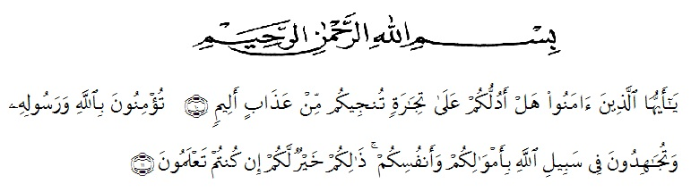
O ye who believe! Shall I show you a commerce that will save you from a painful doom? Ye should believe in Allah and His messenger, and should strive for the cause of Allah with your wealth and your lives. That is better for you, if ye did but know. (Q.S Ash-Shaff: 10-11)
The meanings
Hai orang-orang yang beriman maukah kamu aku nampakkan suatu perniagaan yang dapat menyelamatkanmu dari azab yang pedih? (10). (yaitu) kamu beriman kepada Allah dan Rasul-Nya dan berjihad di jalan Allah dengan harta dan jiwamu. Inilah yang lebih baik bagimu, jika kamu mengetahuinya (11).
Alhamdulillah, all praise to Allah SWT, the Lord of the Worlds, who has blessed the researcher with strength, health, and resolve in finishing this thesis entitle”The Effect Of Tiktok Video In Learning Pronunciation Skill At Grade Tenth Of SMA Negeri 2 Lubuk Pakam Academic Year 2022/2023” as the final assignment in her study. Peace and salutation may always be upon the Prophet Muhammad, the savior of the human kind, who has brought the light onto this world and turn edit into a better place.
This thesis a scientific paper that is presented as one of the requirements for the degree “S.Pd.” in English Education. There are many people who have been very helpful and supportive during the writing of this thesis. At this opportunity, the researcher would like to convey her utmost gratitude to them. The first ones are her small family ; her dearest father Hamdan Mansuri Nst for his incomparable love and kindness. The researcher would also like to express her gratitude and appreciation to:
- Dr. KRT. Hardi Mulyono K. Surbakti S.E., M.AP., as the rector of Universitas Muslim Nusantara Al- Washliyah
- Drs. Samsul Bahri, M.Si., as a Dean of Teacher Training and Education Department Universitas Muslim Nusantara Al- Washliyah
- Zulfitri, S.S., M.A., M. Pd., as the Head of English Education Department
- Nurlaili, S.Pd.I., M. Hum., as the lovely advisor who gave the dearest motivations, commands, critics, suggestions, supports and love to the researcher in finishing this thesis.
- Drs. M. Khalid, M.Hum., as academic advisor.
- All of the lectures of the English Education Department of Muslim Nusantara Al Washliyah University Medan, who have given much knowledge, the writer deeply thank you all.
- All of the Academic Administration Staffs of Muslim Nusantara Al Washliyah University Medan.
- Her beloved parents, Mr Hamdan Mansuri Nasution and Mrs Nurhayani. Thank you for the unconditional love, pray, and support that always given to me. May Allah always bless you.
- Her beloved precious friends in finishing this thesis, Miftahul Isnaini Siregar, Utari Nur Zannah and Tiara Amanda, for always giving support, pray, accompanied the researcher in many situation and become a good listener with an irreplaceable friendship.
- Her beloved friends from Department of English Education, especially the members of class A of 2019, for the friendship, love, knowledge, support, and time that they have provided unconditionally.
- Everyone who has helped the researcher, not only in the finishing of this thesis, but through the ups and downs of his university life. She cannot mention them one by one; all she can say is she could not be more grateful for their contribution. May Allah bless them all.
- Last but not least, I wanna thank me for believing in me, for doing all this hard work, for having no days off, for never quitting, for just being me at all times.
The researcher realizes that this thesis is still far from being perfect. Despite the help from the aforementioned people, there are weaknesses and shortages in this thesis that remain as the researcher’s responsibility. Therefore, she welcomes all kinds of correction and suggestions for a better writing.

Tanjung Morawa, June 2023
The Researcher,

Dhea Aprilia Nasution
191224019

