ACKNOWLEDGMENT

بسم الله الرَّحْمَنِ الرَّحِيم
يا أَيُّهَا الَّذِينَ آمَنُوا هَلْ أذلكم على تجارة تنجيكم من عذاب أليم (۱۰) تُؤْمِنُونَ باللهِ وَرَسُولِهِ وَتُجَاهِدُونَ فِي سبيل الله بأموالكم وانفسكم ذلِكُمْ خَيْرٌ لَكُمْ إِن كُنتُمْ تَعْلَمُونَ (۱۱)
O ye who believes! Shall I show you a commere that will save you from a painful doom? Ye should believe in Allah and His messenger, and should strive for the cause of Allah with your wealth and your lives. That is better for you, if ye did, but know. The meanings
Hai orang-orang yang beriman maukah kamu aku nampakkan suatu perniagaan yang dapat menyelamatkanmu dari azab yang pedih? (yaitu) kamu beriman kepada Allah dan Rasul-Nya dan berjihad di jalan Allah dengan harta dan jiwamu. Inilah yang lebih baik bagimu, jika kamu. mengetahuinya.
Alhamdulillah, all praise to Allah SWT, the Lord of the Worlds, who has blessed the researcher with strength, health, and resolve in finishing this thesis entitled
" An analysis student's reading strategis in Comprehending of analytical exposition texts at SMAS Perguruan Sumatera tanjung morawa as the final assignment in her study. Peace and salutation may always be upon the Prophet Muhammad SAW, the savior of the human kind, who has brought the light onto this world and turn edit into a better place.
This thesis a scientific paper that is presented as one of the requirementsfor the degree "S.Pd." in English Education. There are many people who have been very helpful and supportive during the writing of this thesis. At this opportunity, the researcher would like to convey her utmost gratitude to them. The first ones are her small family; her dearest father Sabarudin for his incomparable love and kindness. The researcher would also like to express her gratitude and appreciation. to:
- Dr. KRT. Hardi Mulyono K. Surbakti S.E., M.AP., as the rector of Universitas Muslim Nusantara Al-Washliyah
- Drs. Samsul Bahri, M.Si., as a Dean of Teacher Training and Education. Department Universitas Muslim Nusantara Al-Washliyah
- Zulfitri, S.S., M.A., M. Pd., as the Head of English Education Department
- Dr. Asnawi, M. Hum as the lovely advisor who gave the dearest motivations, commands, critics, suggestions, supports and love to the researcher in finishing this thesis.
- Teguh Satria Amin, S.Pd., M.Hum., as academic advisor,
- Prof Ahmad Laut Hasibuan, S.Pd., M.Pd as academic advisor
- All of the Academic Administration Staffs of Muslim Nusantara Al Washliyah University Medan.
- All of the lectures of the English Education Department of Muslim Nusantara Al Washliyah University Medan, who have given much knowledge, the writer deeply thank you all.
- Her beloved parents, bapak, Nawawi Sihotang dan ibu, My Mother Karli Sitanggang Thank you for the unconditional love, pray, and support that always given to her. May Allah always bless you.
- I would also like to express my deepest gratitude to my work boss who cannot be named who has supported me in my studies since the first semester.
- Her beloved precious friends in finishing this thesis, Sheila Novita, Indah Ayu br. Tarigan, Emya gresta for always giving support, pray, accompanied the researcher in many situation and become a good listener with an irreplaceable friendship.
- Her heloved friends from Department of English Education, especially the members of class A of 2019, for the friendship, love, knowledge, support, and time that they have provided unconditionally.
- and All parties who have helped the researcher, not only in completing this thesis, but also in the ups and downs of his study life. He couldn't name them one by one, he could only express his deepest gratitude for their contributions. May Allah bless them all.
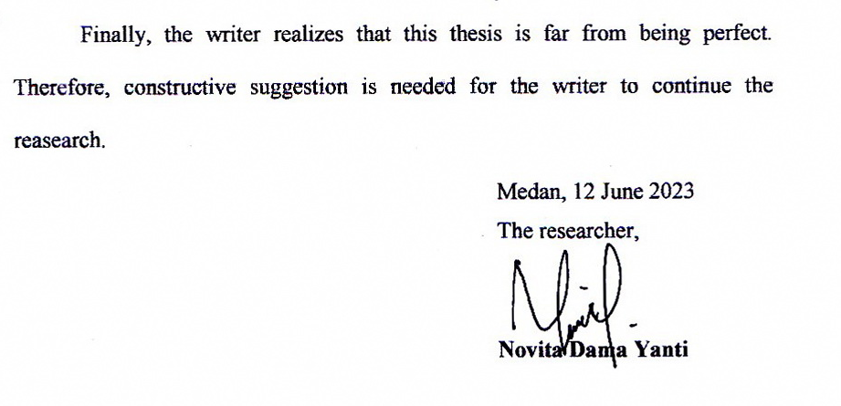
Finally, the researcher realizes that this thesis is still far from perfections.
Therefore, constructive critiques and suggestions are needed in order to improve
this thesis. May Allah Almighty, the lord of universe blesses you All. Aamiin.

Sincerely.

Researcher

