**CHAPTER III**

**RESEARCH METHOD**

**3.1 Research Setting**

This research is conducted at the MTs Al Washliyah Kolam. MTs Al Washliyah Kolam is a school equivalent to Junior High School. MTs Al Washliyah Kolam is located in Kolam Village, Percut Sei Tuan District, Deli Serdang Regency, North Sumatra Province - Indonesia. This research is conducted in March 2023. The subject of this research is the students and English teachers of MTs Al Washliyah Kolam.

**3.2 Data and Data Source**

The data of this research are observed, and the resulting questionnaire needs analysis. The data source is the students, teachers, and experts in speaking instruction development.

**3.3 Research Method**

The method used in this research is *Research and Development* (R & D) by using Borg and Gall model. According to Sugiyono (2011), R & D is a method or step to produce new products or develop and improve existing products and is used to test the effectiveness of these products. There are ten steps of the development model, Borg & Gall (1983), namely : (1) Research and information collecting, (2) Planning, (3)Early product development, (4) Preliminary field testing, (5) Main product revision, (6) Main field testing, (7) Operational product revision, (8) Operational field testing, (9)Final product revision, and (10)Dissemination and implementation. But according to research needs, researchers limit and simplify it to just four steps namely : (1) Research & Information collection, (2) Planning, ( Design of Product), and (4) Expert Judgment

Planning

Research & Information collecting

Design of Product

Expert Judgment

*Figure 2 : Steps of Research and Development*

**3.4 Procedure of development**

1. Research and information collecting

In this phase, two activities is carried out by researchers:

1. Literature study

finding concepts and theoretical foundations that strengthen the product so that the most appropriate steps can be identified for developing the product.

1. Field studies.

in the form of collecting data, information, and problem data are taken based on the results of observations, interview, and the results of questioners of need analysis conducted by researchers at MTs Al Washliyah Kolam.

1. Research Planning

After collecting data, getting information and problems researcher carried out planning including:

1. Determine the purpose of using the product and the goals to be

achieved at each stage.

b. Determine who is the user of the product and the product description.

c. Determine who is the expert judgment to valid the model

1. Design of Product

The design of product is designing by researchers working together or asking for help from supervisor, it can be a new work design or a new product. In this research, the product is the new approach to developing speaking instruction. The process of assessing whether a new design or a new product is rationally better and more effective than the old one is by seeking the judgment of a more experienced expert.

The final result at this stage is the initial product model to be consulted with the supervisor. Then validation will be carried out by experts to obtain responses about the feasibility of the product to be tested.

1. Expert Judgment

Expert Judgment is an activity of validating of collecting data or information from experts in their field (validators) to determine wheater the model being developed is valid or invalid.

**3.5 Technique of Collecting Data**

Based on the research stage, the instruments of this research are divided into three categories:

1. **Instrument on preliminary research:**

An instrument used by the researcher in preliminary research is Observation, interview, and questionnaire of need analysis.

1. Observation;

In the pre-research, the researcher will observe the students and the teachers about the condition or problems of learning the English process in the classroom especially learning to speak and identify learning resources.

*Table 2 : ( Instrument of learning activities in the classroom)*

|  |  |  |  |
| --- | --- | --- | --- |
| **Description** | **Note** | **Reflection** | **Hypothesis** |
| Opening class activity  includes the situation of the teacher entering the room |  |  |  |
| Student preparation activities before learning |  |  |  |
| Core activities during the learning process includes delivery of material, discussion, and questions and answers |  |  |  |
| Evaluation activity |  |  |  |
| Closing activities |  |  |  |

1. Interview

Interview is conducted to Headmaster ang English Teacher at MTs Al Washliyah Kolam.

Table 3: *questionnaire of interview*

|  |  |
| --- | --- |
| Questions (researcher) | Answers (The Headmaster) |
| * 1. Has research been conducted at this madrasah on learning English? |  |
| * 1. Has there been any developmental research in this school? |  |
| * 1. Has there been any research on the development of English Speaking learning at this school? |  |
| * 1. Does this school need research on the development of learning English, especially English speaking? |  |
| * 1. What are the hopes for research on developing English speaking in the future? |  |
| Table 4 : *Questionnaire of interview to English Teacher* | |
| Questions (researcher) | Answers (The English Teacher) |
| * 1. How long have you been teaching English at this school? |  |
| * 1. According to you, do your students like English lessons, how many presentations are there? |  |
| * 1. During the three years at this school, can students speak English? |  |
| * 1. In learning English Speaking, what obstacles did you and your students face? |  |
| * 1. Do you use various speaking teaching methods? if so please explain! |  |

1. Questionnaire of need analysis.

The researcher uses a need analysis of speaking instruction. Needs analysis involves the process of identification and evaluation of needs. This questionnaire consists of three indicators of speaking instruction namely *Preparation, Implementation, and Evaluation.*

Questions asked to see what students need to improve speaking skills.

*Table 5: Instrument Questionnaire of need analysis*

|  |  |  |
| --- | --- | --- |
| No | INDICATORS | QUESTIONS |
| 1 | Preparation | In your opinion, what should be prepared before learning to speak English? |
| To master speaking English, who do you need to help you? |
| 2 | Implementation | . So that you understand, what should the teacher give you in terms of speaking English? |
| How should the English-speaking material be delivered by the teacher? |
| In your opinion, what does the teacher explain first in learning to speak English? |
| When explaining the material, did the teacher give concrete examples to you? |
| After the teacher explained the material, were you asked to practice it? What forms of exercise? |
| 3 | Evaluation | After practicing speaking English, were you given the opportunity to ask questions and discuss? If yes, what is the process? |
| After the question and answer process, did your teacher give you further practice? What form of follow-up practice is provided? |
| In your opinion, what does the teacher do to end the lesson? |

1. **Instrument on expert judgment**

The instrument used by the researcher on expert judgment is a questionnaire of validation.

*Table 6: (Instrument of Expert Judgment)*

There are three components of validations: *Eligibility of Content, Language, and Serving.* Each component will be validated with reference to the five assessment criteria, as follows :

Score 1 = if the model is very poor/ very less appropriate (invalid)

Score 2 = if the model is not good/less appropriate (less invalid)

Score 3 = if the model is quite good/ appropriate (quite valid)

Score 4 = if the model is good/ appropriate (valid)

Score 5 = if the model is very good/ appropriate (very valid)

|  |  |  |  |  |  |  |
| --- | --- | --- | --- | --- | --- | --- |
| No | Component | 1 | 2 | 3 | 4 | 5 |
| ELIGIBILITY OF CONTENT | |  |  |  |  |  |
| 1 | The model appropriate with students' needs |  |  |  |  |  |
| 2 | Appropriateness of the approach component with the speaking component |  |  |  |  |  |
| 3 | Compatibility of the Metacognitive Approach Procedure with the speaking process |  |  |  |  |  |
| 4 | Appropriateness of the benefits of developing students' speaking |  |  |  |  |  |
| LANGUAGE | |  |  |  |  |  |
| 1 | Use of language effectively and efficiently |  |  |  |  |  |
| 2 | The use of language that is easy to understand in theoretical models |  |  |  |  |  |
| SERVING | |  |  |  |  |  |
| 1 | Clarity of Development Goals |  |  |  |  |  |
| 2 | Presentation of an appropriate and sequential Theoretical Model |  |  |  |  |  |
| 3 | Interactivity (stimulus and Response) |  |  |  |  |  |

*Supproting Questions*

Supporting question is made to strengthen theanswer. The validator can answer by “ Yes/No”, comment and suggestion.

Table 7 *: Supporting questions*

|  |  |  |
| --- | --- | --- |
| **Indicators of Instruction** | **Question** | **Response**  **(Answers)** |
| Preparation | Does this model comply with competency standards and basic competencies? |  |
| Does this model include a component of the speaking process and a component of Metacognitive approach? |  |
| Implementation | Does this model of each component relate to each other? |  |
| Does this Model suit the needs of students? |  |
| Can this model improve students' speaking skills? Please give reasons! |  |
| Evaluation | Can the development objectives be achieved through this model? |  |
| What are the advantages and disadvantages of this model? Please provide an explanation |  |

**3.6 Technique of Analyzing Data**

After collecting the data, the next step is analyzing data. In this study, the researcher used qualitative and quantitative techniques for analyzing the data. In the qualitative technique, verbal data were obtained from interviews and written notes in the form of comments, suggestions, and input written on the assessment questionnaire. In technique analysis data by Miles and Huberman model, activities include data reduction, data display, and conclusion drawing/verification (Miles and Huberman, 1984).

* 1. Data reduction

Data reduction means summarizing, choosing the main things, focusing on the important things, and looking for themes and patterns so that the researcher gets a clear description.

* 1. Data display

Presentation using graphs, timelines, tables, etc. Thus the data will be organized, and arranged in a relationship pattern, making it easier to understand and usually presented in narrative text

* 1. Conclusion drawing/verification

Conclusions here are new findings that have never existed before. This conclusion is a hypothesis, and when supported by other, broader data, it can become a theory.

In the quantitative technique, the researcher uses a simple technique (percentage). Where data is obtained from a questionnaire assessment of product feasibility. The Simple Technique is done by calculating the percentage of answers to the question items of questionnaires of need analysis. Analyzed using the formula:

1. 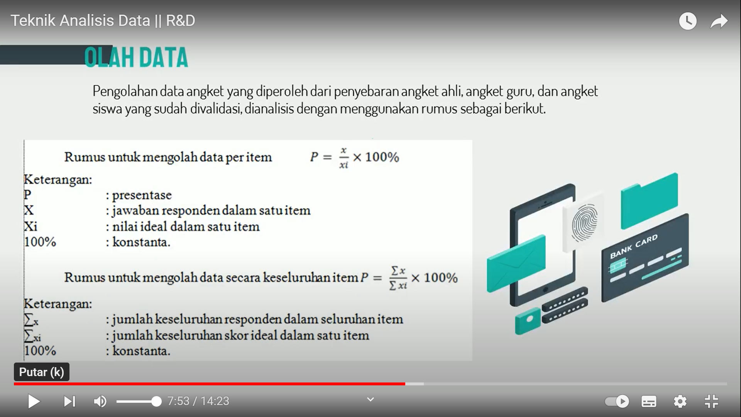The formula for processing data per item :

*Note :*

*P = Percentage*

*X= Respondent's answer in one item*

*Xi= Ideal value in one item*

1. The formula for processing data all items :

*Note :*

*P = Percentage*

*∑x =Total respondent's answer in all items*

*∑xi =Total ideal score in all items*

**3.7 Technique of Establishing Trustworthiness**

Trustworthiness is a step to reduce errors in the data collection process that affect the validity of the research result. According to Semiawan (2010) there are several techniques to ensure the accuracy and credibility of research results. They are triangulation, member checking, and auditing. In this study, the researcher used the triangulation source technique to validate the data. Triangulation of sources is a technique for testing the credibility and validity of the data. This technique is performed by checking the data obtained from various sources. In this research, the researcher focuses only on the credibility of the data. In this study, the data were obtained through interviews, observations, and documentation of respondents, they are English teacher and students at MTs Al Washliyah Kolam and experts in speaking instruction development.