**ACKNOWLEDEGMENTS**



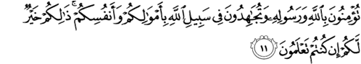

Meaning: O ye who believe! Shall I show you a commeree that will save you from a painful doom? Ye should believe in Allah and His messenger and should strive for the cause of Allah with your wealth and your lives. That is better for you, if ye did but know. *(QS. Ash-Shaff:10-11).*

Artinya: *Hai orang-orang yang beriman, sukakah aku tunjukkan suatu perniagaan yang dapat menyelamatkanmu dari azab yang pedih? (yaitu) kamu beriman kepada Allah dan Rasul-Nya dan berjihad di jalan Allah dengan harta dan jiwamu. Itulah yang lebih baik bagimu, jika kamu mengetahuinya. (QS. Ash-Shaff:10-11).*

First of all, the writer would like to thank Allah SWT for the blessings, safety, health and most importantly the opportunity that has been given to the writer so that she can complete this thesis with the title “The Students’ Difficulties English Short Story Into Indonesian” This thesis was written to partially fulfill the requirements for obtaining a Bachelor's degree in English Education, Faculty of Teacher Training and Education, Universitas Muslim Nusantara Al Washliyah Medan. The writer realized that in the preparation of this thesis she received a lot

of guidance, advice, and support from many peaople, on this occasion she would like to express her deepest gratitude to the following:

1. Dr. KRT. Hardi Mulyono K. Surbakti., the rector of Muslim Nusantara Al Washliyah University Medan.
2. Drs. Samsul Bahri, M.Si., the dean of the Teacher Training and Education Faculty of Muslim Nusantara Al Washliyah University Medan.
3. Zulfitri, S.S., MA., the head of the English Education Department of Muslim Nusantara Al Washliyah University Medan who gave much knowledge and information.
4. Yugi Diraga Prawiyata, S.Pd., M.Hum., as the consultant who gave the writer much knowledge, support, help, command, critic and suggestion toward the writer in finishing this thesis.
5. All of the lectures of the English Education Department of Muslim Nusantara University Al Washliyah Medan.
6. All of the Academic Administration Staffs of Muslim Nusantara Al Washliyah University Medan.
7. All of the Librarians of Muslim Nusantara Al Washliyah University Medan.
8. Special Gratitude to her Beloved Parents, Armansyah Putra and Noni Palapa Ningsih who have loved the writer.
9. Especially to the big family of the writer, Bunga Nur Afika, Mhd Luthfi Syahputra, Abizar Ramadhan, And Muhammad Fathan who has provided support, prayers, attention, enthusiasm and assistance both morally and materially to the writer.
10. Especially to Dinda Rizky Nasution S.Li who always given a lot of help to finish the writer study from university.
11. Her beloved best friends with the group name "Ingat Skripsi ya bby", Dwi Ajeng Tristanti, Ain Taszkiah Fadillah Lubis,and Wika Hafsari M Lubis Widia Sani Hasibuan, Maya Auliya S.Pd who have been willing to spend their time and never get bored and give up giving support, suggestions, criticis, enthusias, sharing proposal, lessons, experiences, problems even about love during college.
12. Her beloved Partner Rahmawan Indra Kesuma Who helped me everywere I went, started getting my examiners’ signatures, and helped me with what was in trouble, and He’s real inspiration for this thesis.
13. Last but not least, I wanna thank me, I wanna thank me for believing in me, I wanna thank me for doing all this hard work, I wanna thank me for having no days, I wanna thank me for never quiting, I wanna thank me for tryna do more right than wrong, I wanna thank me for just being me at all times.

Finally, the writer realized that this proposal is far from being perfect. Therefore, constructive suggestion is needed for the writer to continue the reasearch.

Medan, July 2022

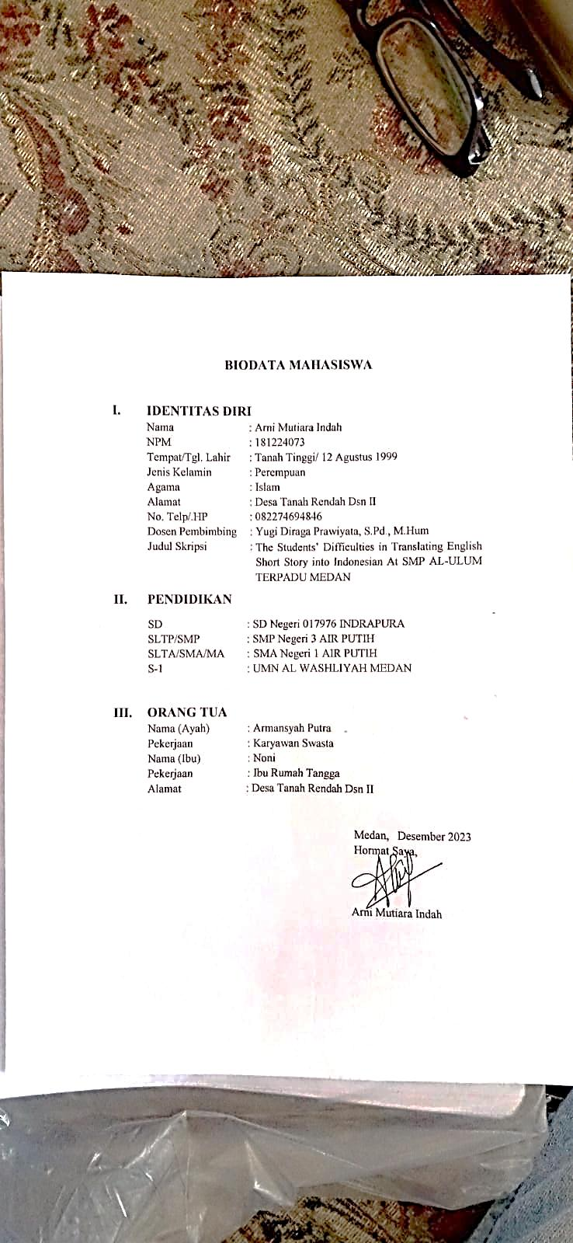 The writer,

ARNI MUTIARA INDAH